Comparison of in vitro radiosensitivity of different rose genotypes and explants

Zahra Aghcheh Kahrizi^{1, 2}, Maryam Jafarkhani Kermani*¹, Mohammad Amiri ², Syrous Vedadi ³ and Maryam Abodolmohamadi¹

1. Agriculture Biotechnology Research Institute of Iran (ABRII) P. O. Box 31535-1897, Iran.
2. Department of Horticulture, Zanjan University, Iran.
3.Agricultural, Medical Industrial Research School, Iran.
Tel:++982612703536
Fax: ++982612704539
* m.j.kermani@abrii.ac.ir

ABSTRACT
In the present research in order to determine the radiosensitivity of roses, effects of different doses of gamma-rays on in vitro nodal sections of five rose genotypes; Rosa hybrida cv ‘Apollo’, ‘Maroussia’, ‘Dolce Vita’, ‘Black Baccara’ and ‘Beauty by Ogre’ and leaf explants of two rose genotypes; Rosa hybrida cv ‘Apollo’ and ‘Maroussia’ were investigated. Nodal sections were exposed to gamma irradiation (0-100 Gray) and were immediately transferred to the proliferation medium. Percentages of survival, increase length of plantlets and increase number of green leaves were recorded 45 days after irradiation. According to higher coefficient of determination (R²) in regression analysis the survival rate was selected as a suitable parameter for determining the lethal dose for 50% (LD₅₀). Leaf explants were subjected to irradiation (0-50 Gray) and percentage of regeneration was chosen as parameter to calculate the LD₅₀. Results indicated that as the doses of irradiation were increased the growth parameters were affected significantly. The LD₅₀ was determined as 40-50 Gray for genotypes ‘Dolce vita’, ‘Black Baccara’ and ‘Beauty by Ogre’, whereas it was established as 50-60 Gray for ‘Maroussia’ and 60-70 Gray for ‘Apollo’. Genetic variation can induce significant changes in radiosensitivity of individuals; these differences were probably responsible for the variations in suggested LD₅₀ of different rose genotypes. Apart from the effect of genotype, the type of explants were also important in choosing the correct dose of irradiation. The leaf explants were more sensitive than the nodal sections and the recommended LD₅₀ for leaf explants was 20 – 30 Gray for ‘Apollo’ and ‘Mourasia’.
Key words: explant, gamma rays, genotype, in vitro, LD₅₀, Rosa hybrida
INTRODUCTION
Mutation breeding is considered as a valuable tool with considerable potential for producing sufficient genetic variability in most plant species, and the technique has been successfully exploited for development of new and novel plant cultivars in general and roses in particular (Datta & Chakrabarty, 2009; Yamaguchi et al., 2003). Mutations induced by radiation treatments are being increasingly applied by plant breeders, especially those dealing with asexually propagated ornamentals. Most of such plants are highly heterozygous, so that mutations, in most cases from dominant to recessive, can be detected in the irradiated material itself. Moreover the selection of ornamentals is very easy when such visible characters, as flower color, form and size, or leaf form and growth habit are concerned. According to Predieri & Virgilio, 2007, the physical irradiations suitable for mutagenesis are ultraviolet (UV) and ionizing radiation (X-rays, gamma-rays, alpha, beta particles, protons, and neutrons). X-rays and gamma-rays are the most convenient and easiest types of radiation to use with regards to application methods and handling, they also have a very high linear energy transfer and relative biological effectiveness (Yamaguchi et al., 2003).
The in vitro culture of vegetatively propagated crops in combination with radiation induced mutations has proven to be a valuable method to produce desired variation (IAEA, 1998). The availability of suitable proliferation method could improve its effectiveness and potential applications and to rapidly multiply the selected mutants and parental material in disease-free conditions. The availability of large populations for mutagenesis is one of the basic pre-requisites to obtain sufficient variation. Mutation techniques in combination with tissue culture has provided a powerful tool to improve clonally propagated plants such as banana, apple, pineapple, date palm, potato, sweet potato, cassava, carnation, chrysanthemums, roses and tulips (IAEA, 1998). Nearly all of these plants have been regenerated and multiplied in vitro, allowing the production of large populations in a small space and short period of time. Plant mutagenesis has been used to introduce many useful traits affecting plant size, flower color, flower shape, number of petals, leaf shape, and resistance to pathogens in ornamentals (Puchooa, 2005; Jain, 2006; Yamaguchi et al., 2003; Mandal et al., 2000; Wongpiyasatid & Hormchan, 2000; Datta & Chakrabarty, 2009 ). The suitability of physical mutagens for induction of mutation in roses has been proved by the following authours; Koh et al,. 2008; Song et al., 2005, 2006, 2008; Yamaguchi et al., 2003; Datta &Gupta, 1982; Gupta & Shukia, 1970. One of the important steps in inducing mutation is estimating the most suitable dose (lethal dose or LD₅₀) to apply. In mutation breeding with gamma rays irradiation, a survival rate of 40–60% in comparison to the control plants is taken as a criterion for a promising radiation treatment (Van Harten 1998). The aim of the present investigation was to determine the radiosensitivity of in vitro rose explants and genotypes. The effect of different doses of gamma irradiation on two explants types; leaves and nodal sections and five rose genotypes; Rosa hybrida cv ‘Apollo’, ‘Mourasia’, ‘Dolce vita’, ‘Black bacara’ and ‘Beauty by Ogre’ were studied.
MATERIAL AND METHODS
Plant material and general procedures
Five commercial rose genotypes; Rosa hybrida cv ‘Apollo’ (HAP1), ‘Maroussia’ (HMA1), ‘Dolce Vita’ (HDOL1), ‘Black Baccara’ (HBB1) and ‘Beauty by Ogre’ (HBBI1) possessing different flower color were chosen. The roses were supplied by the Rose Germplasm Collection at Agricultural Biotechnology Research Institute of Iran (ABRII). They were sterilized according to our previous report (Khosravi et al., 2007) and were transferred to induction medium containing full strength MS (Murashige & Skoog, 1962) basal medium (without hormone). Nodal sections of genotypes HMA1 and HAP1 were proliferated on MS medium supplemented with 2 μM BAP (benzylaminopurine). Nodal sections of HDOL1, HBB1 and HBBI1 were proliferated on VS (van der Salm, 1994) medium containing 2 μM BAP. The direct regeneration medium contained half – strength MS salts, full strength MS vitamins, supplemented with 7.0 µM thidiazuron (TDZ), 1.0 µM naphthalene acetic acid (NAA) and 60 µM AgNO₃ (Haghighat afshar, unpublished data). The pH of all media was adjusted to 5.8 using 1.0 N potassium hydroxide (KOH) or 1.0 N hydrochloric acid (HCl), before adding 7 g l⁻¹ plant agar. Media were autoclaved for 15 min at 121ºC and 1.2 kg.cm² pressure. All cultures were placed under high pressure metal halide lamps (PPFD 60 µmol.m⁻².s⁻¹ at the plant surface) on a 16/8 hour light/dark cycle in a culture room maintained at 20±2ºC.

In vitro irradiation with gamma rays
The irradiation of high number of explants in easy to manipulate and transport vessels, such as Petri dishes (10 cm diameter), allowed to save space and to use even small irradiation facilities (e.g. gamma cells). Explants were cut from 30-days-old proliferating shoots and placed horizontally in Petri dishes with 2-3 drops of sterile distilled water added to protect shoots from dehydration during treatment. They were transferred to Agricultural Nuclear Science and Technology Research Institute, where nodal sections were exposed to gamma irradiation (0, 20, 30, 40, 50, 60, 70, 80, 90 and 100 Gray) and leaf explants were exposed to (0, 10, 20, 30, 40 and 50 Gy) with a radiation source (⁶⁰Co). The nodal sections and leaf explants were immediately transferred to jars containing proliferation and regeneration media respectively. The experiments were conducted in a completely randomized design with five replications and five repeats. To calculate the LD₅₀, number of survived explants, increase leaf number and increase length of plantlets (for nodal sections) and percentage of regeneration (for leaf explants) were recorded after 45 days.

RESULTS AND DISCUSSION
Effect of gamma irradiation on growth of nodal sections
The analysis of variance showed (Table 1) that there was a significant difference between different genotypes in the survival rate, increase length of plantlet and increase number of green leaves when applying different doses of gamma rays. The effect of irradiation on survival rates of nodal sections are shown in Table 2A. In all of the genotypes higher doses of radiation resulted in higher death rates. Table 2A also shows that there was not a significant difference between the control plants and plants irradiated with low doses, i.e. 20 and 30 Gy. The highest survival rate 100% was observed in control explants in all of the genotypes. The lowest survival rate (0%) was detected in the genotypes HDOL1, HBB1 and HBBI1 treated with 100 Gy. whereas there was a significant difference between the genotypes in their response to different doses. Gupta and Shukia (1970) and Vedadi (2008) also reported that with increasing the gamma rays exposure, there was a significant decrease in survival rate and Gupta et al. (1970) reported that there was a significant difference between the genotypes in their response to different doses.
As doses of gamma rays were increased, the shoot length of the treated explants were decreased (Table 2B). Ndzana et al, (2008) and Barakat et al. (2010) also reported that with increasing the gamma rays exposure, there was a significant decrease in plant height. The highest length (28.64 mm) was observed in control explants of HMA1 and the lowest increase in plant height (2.08 mm) was detected in the genotype HBBI1 treated with 100 Gy. Table 1B also shows that there was not a significant difference between the control explants and explants irradiated with low doses, i.e. 20 Gy.
Table 2C indicated that in all of the genotypes a decrease number of green leaves occurred as the irradiation doses were increased. The highest number of green leaves (18.28) was observed in control explants of HMA1 and the lowest increase in number of green leaves (0.44) was detected in the genotype HBB1 treated with 100 Gy. Table 2C also shows that there was not a significant difference between the control explants and explants irradiated with low doses. Ndzana et al. (2008) also reported that with increasing the gamma rays exposure, there was a significant decrease in number of green leaves.
Effect of gamma irradiation on direct regeneration of leaf explants
There was not a significant difference in direct regeneration between the two genotypes (HAP1 and HMA1) (Fig 1). As the irradiation doses were increased from 0 to 50 Gy, the direct regeneration rates were decreased in the both genotypes. The percentages of direct regeneration were 48 and 40% in the control explants of HAP1 and HMA1, respectively, which reached to 0% when 50 Gy gamma rays was applied. Direct regeneration from leaves has been used as a system for mutation induction in roses and apples (Ibrahim., et al., 1988; Predieri and Virgilio 2007) which indicated that the differences in radiosensitivity were dependent on dose level of irradiation.

Determination of LD₅₀
One of the most important requirements for an effective use of mutation induction in plant breeding program is the analysis of radiosensitivity of the explants to radioactivity doses (Barakat et al., 2010). The results obtained from the comparison of the three parameters (Survival rate, increase length of plantlet, and increase number of green leaves) showed that since higher coefficient of determination (R²) in regression analysis based on linear regression (Wu et al., 1978) were only observed in one of the parameters (survival rate) the LD₅₀ was determined based on the percentage of survival rates. The LD₅₀ for the genotype HAP1 was calculated 67.4 Gy (Fig. 2A), therefore the suggested LD₅₀ is 60- 70 Gy. However the calculated LD₅₀ for this genotype when applying the gamma rays to the leaves was 27 Gy (Fig 3) and the suggested LD₅₀ is 20-30 Gy. The LD₅₀ for the genotype HMA1 was calculated 53.9 (Fig. 2B), when treating nodal sections, therefore the suggested LD₅₀ is 50-60. However the calculated LD₅₀ for this genotype when applying the gamma rays to the leaves was 29 Gy (Fig. 3) and the suggested LD₅₀ is 20-30 Gy. The LD₅₀ for the genotypes HDOL1, HBB1, and HBBI1 was calculated 46.06 Gy (Fig. 2C), 47.24 Gy (Fig. 2D), and 45.12 Gy (Fig. 2E) respectively, when treating nodal sections, therefore the suggested LD₅₀ is 50-60. Predieri and Virgilio (2007) also compared LD₅₀ in axillary buds and leaf tissue based on linear regression and showed that LD₅₀ for leaf explants was significantly lower than nodal sections.
Tissue-cultured based mutagenesis has been used for many years to generate innovative plant mutants and cell lines of agricultural and industrial interest (Collin & Dix, 1990). In vegetatively propagated roses a decreased rate in plant height, survival rate and flowering has been reported after mutagenic treatments (Gupta & Shukia, 1970). In the present investigation, in vitro derived shoots of five rose genotypes were exposed to gamma irradiation treatments in order to determine a suitable dose to be used as an effective mutagenic program that can induce valuable genetic changes. Vegetative growth parameters were decreased in all of the genotypes as the doses were increased. Differences observed between the five rose genotypes (HAP1, HMA1, HDOL1, HBB1, and HBBI1) in their response to irradiation gamma rays treatments, revealed that the HDOL1, HBB1, and HBBI1 were more sensitive to irradiation than the HAP1 and HMA1 (Fig 4). According to higher coefficient of determination (R²) in regression analysis the survival rate was selected as a suitable parameter for determining the LD₅₀. The LD₅₀ was determined as 40 - 50 Gy for HDOL1, HBB1, and HBBI1, whereas it was established as 50 - 60 Gy for HMA1, and 60 - 70 Gy for HAP1. Genetic variation can induce significant changes in radiosensitivity of individuals; these differences were probably responsible for the variations in suggested LD₅₀ of different rose genotypes. Apart from the effect of genotype, the type of explants were also important in choosing the correct dose of irradiation. The leaf explants were more sensitive than the nodal sections and the recommended LD₅₀ for leaf explants was 20 – 30 Gy (Fig 4).

ACKNOWLEDGEMENTS
This work was a part of MSc thesis on Plant Breeding, University of Zanjan, funded by Agricultural Biotechnology Research Institute of Iran (ABRII) and Agricultural Nuclear Science and technology research institute (Project number: 12-05-05-01-8704-88003).
REFERENCES
Barakat M.N., Abdel Fattah A., Rania S., Badr M., El-Torky M.G. 2010. In vitro mutagenesis and identification of new variants via RAPD markers for improving Chrysanthemum morifolium. Afr. J. Agric. Res. 5:748-757.
Collin A, Dix P.J. 1990. Culture systems and selection procedures. In: Weinheim and VCH Publishers, Plant Cell Line Selection. Procedures and Applications. pp. 3–18. New York
Datta S.K., Chakrabarty D. 2009. Management of Chimera and in vitro mutagenesis for development of new flower color/shape and chlorophyll variegated mutants in chrysanthemum. Food and Agri. Organ. Unit. Rome. 303-305.
Datta S.K., Gupta M.N. 1982.Gamma-ray induced white flower mutant in rose cv. 'Junior Miss'. J. Nucl. Agri. Biol. 11:32-33.1.
Gupta M.N., Shukia R. 1970. Mutation breeding of garden roses: studies on induction of somatic mutations after gamma irradiation of bud-wood. Prog. Hort. 2:69-73.
IAEA (International Atomic Energy Agency). 1998. In vitro techniques for seletion of radiation induced mutations adapted to adverse to adverse environmental conditions. Shanghai, China, 17–21 August.
Ibrahim R., Mondelaers W., and Debergh P.C. 1998. Effects of X-irradiation on adventitious bud regeneration from in vitro leaf explants of Rosa hybrid. Plant Cell, Tissue and Organ Culture 54: 37–44.
Jain S.M. 2006. Mutation-assisted breeding for improving ornamental plants. Acta. Hort. 714:85-98.
Khosravi P., Kermani J.M., Nematzadeh G.A., Bihamta M.R. 2007. A protocol for mass production of Rosa hybrida cv. Iceberg through in vitro propagation. Iranian J. Bio, Vol. 5, No. 2.
Koh G.C., Ahn K.B., Gi G.Y., Na T.S., Kang S.Y. 2008. Breeding of rose 'Honami' with red-purple flower through gamma irradiation. J. Kore. Hort. Sci. 26:302-305.
Mandal A.K.A., Chakrabarty D., Datta S.K. 2000. Application of in vitro techniques in mutation breeding of chrysantemum. Plant Cell, Tissue and Organ Culture. 60: 33–38.
Murashige T., Skoog F.1962. A revised medium for rapid growth and bio-assays with tobacco tissue cultures. Physiol. Plant. 15, 473-497.
Ndzana X., Zok S., Sama A.E. 2008. Preliminary Study on Radiation Sensitivity of In Vitro Cultures of Xanthosoma (Macabo) in Cameroon. Plant Mutation Reports, Vol. 2, No. 1.
Predieri S., Di Virgilio N. 2007. In vitro mutagenesis and mutant multiplication. In: S.M. Jain and H. Häggman (eds.), Protocols for Micropropagation of Woody Trees and Fruits. Vol 30, Bologna, Italy. p. 323–333.
Puchooa D., 2005. In Vitro Mutation Breeding of Anthurium by Gamma Radiation. Int. J. Agri. Biol., 1560:8530-07–1–11–20.
Song H.S., Park I.S., Lim Y.T., Kim J.K., Lee G.J., Kim D.S., Lee S.J., Kang S.Y. 2008. A dwarf type new rose of Sharon variety, ‘Ggoma’ developed by a mutation breeding. Kor. J. Bre. 38:293-294.
Song H.S., Park I.S., Lim Y.T., Kim J.K., Lee G.J., Kim D.S., Kim J.B., Lee S.J., Kang S.Y. 2006. A new rose of Sharon variety, ‘Changhae’ developed by a mutation breeding. Kor. J. Bre. 38:295-296.
Song H.S., Lim Y.T., Kim J.K., Park I.S., Kang S.Y., Kim D.S., SangJae L. 2005. A new rose of Sharon cultivar, ‘Seonnyo’ developed by mutation breeding. Kor. J. Bre. 37:57-58.
Van der salm T. P. M., Van der Toorn C. J. G., Hanisch ten Cate C. H., Dubois L. A., De Vries M. D. P. and Dons H. J. M. 1994. Importance of the iron chelate formola for micropropagation of Rosa hybrida L. Money way. Plant Cell Tiss. Organ Cult. 37: 73-7.
Van Harten A.M. 1998. Mutation breeding: theory and practical applications. Cambridge University Press, Cambridge, UK. pp. 353.
Vedadi S., 2008. Induce genetic variation by gamma rays in roses. MSc thesis, Payam Noor University, Tehran. Iran
Wongpiyasatid A., Hormchan P. 2000. New Mutants of Perennial Portulaca grandiflora Through Gamma Radiation. J. Kasetsart. Nat. Sci. 34: 408 - 416.
Wu F.F., Siddiqui S.H., Heinz D.J., Ladds S.L. 1978. Evaluation of mathematical methods for predicting optimum dose of gamma radiation in sugar cane. Environ. Exp. Bot. 18, 95–98.
Yamaguchi H., Nagatomi S., Morishita T., Degi K., Shikazono N., Hase Y. 2003. Mutation induced with ion beam irradiation in rose. Nucl. Instr. and Meth. In Phys. Res. 206: 561–564.

Table 1. Analysis of variance showing the effect of genotype, gamma radiation and their interaction on the survival (%), length of plantlet (mm) and number of green leaves in nodal sections.
Source | DF | Survival rate  (%) | Length of plantlet (mm) | Number of green leaves
Genotype (A) | 4 | 9.11 ** | 31.16 ** | 114.13**
Doses (B) | 9 | 108.47 ** | 120.63** | 203.69**
A×B | 36 | 1.64* | 1.41* | 6.68**
Error | 53 | 159.9 | 8.88 | 2.08
**: Highly significant at 0.01 probability level. *: significant at 0.05 probability level.

Table 2. Interactive effect of different doses of gamma irradiation on vegetative growth parameters of different genotypes 45 days after irradiation. A) Survival rate (%) B) Increase in Length of plantlet (mm) C) Increase in number of green leaves.

Genotype  Gamma doses (Gy) | HAP1 | HMA1 | HDOL1 | HBB1 | HBBI1
0  20  30  40  50  60  70  80  90  100 | 100ª  100ª  100ª  84ª  64^{b}  56^{b}  52^{bc}  36^{cd}  33^{d}  24^{d} | 100ª  100ª  92^{b}  52^{c}  50^{c}  40^{c}  28^{d}  16^{d}  0^{f}  0^{f} | 100ª  100ª  96ª  48^{b}  40^{b}  28^{b}  16^{c}  0^{c}  0^{d}  0^{d} | 100ª  100ª  92ª  48^{b}  40^{b}  32^{b}  28^{b}  0c  0^{d}  0^{d} | 100ª  100ª  86ª  52^{b}  40^{b}  16^{c}  8^{d}  0^{f}  0^{f}  0^{f}
A) B)
Genotype  Gamma doses (Gy) | HAP1 | HMA1 | HDOL1 | HBB1 | HBBI1
0  20  30  40  50  60  70  80  90  100 | 22.40ª  20.24^{b}  17.16^{c}  15.04^{d}  11.72e  11.64e  10.48^{ef}  9.28^{ef}  8.32^{f}  7.76^{f} | 28.64ª  30.32ª  25.36^{ab}  20.36^{bc}  19.18^{bcd}  15.32^{cde}  12.72de  11.72^{ef}  10.60^{ef}  7.02^{f} | 23.56ª  24.08ª  19.06^{b}  6.84^{c}  14.92^{c}  11.32^{d}  10.32de  11.82^{d}  8.08^{f}  8.74^{f} | 24.68ª  24.40ª  8.22^{b}  15.32^{c}  13.20^{d}  10.52e  9.72e  7.28f  7.24^{f}  3.88^{g} | 17.88ª  14.88ª  13.68ª  10.52^{bc}  9.28^{bc}  9.40^{d}  5.80^{ed}  3.48e  2.08e  2.08e
Genotype  Gamma doses (Gy) | HAP1 | HMA1 | HDOL1 | HBB1 | HBBI1
0  20  30  40  50  60  70  80  90  100 | 12.72ª  11.80ª  8.84^{b}  7.97^{b}  5^{c}  4.96^{c}  4.64^{cd}  4^{cd}  3.88^{cd}  3.24^{d} | 18.28  19.56ª  15.04^{b}  8.52^{c}  6.64^{cd}  5.04de  4.72de  3.32e  2.88e  0.8^{f} | 7.72ª  8.96ª  6.72^{ab}  2.98^{c}  3.44^{c}  1.58^{dc}  1.48de  0.8e  1.32e  0.8e | 13ª  13.44ª  12.80ª  6.80ª  5.40^{b}  4.56^{bc}  3.62^{c}  2.84cd  1.92de  1.04^{f} | 5.90ª  6.02ª  4.09^{ab}  2.24^{bc}  2.04^{bc}  1.90^{c}  1.11^{c}  0.60^{c}  0.57^{c}  0.44^{c}

C)
Different letters show significant differences according to Duncan’s Multiple Rang Test (p≤ 0.05).

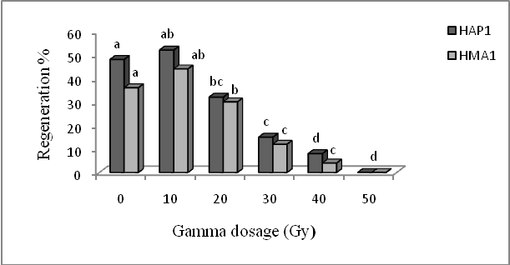

Figure. 1. Effects of gamma dose and genotype on the regeneration percentage, 4 weeks after irradiation.

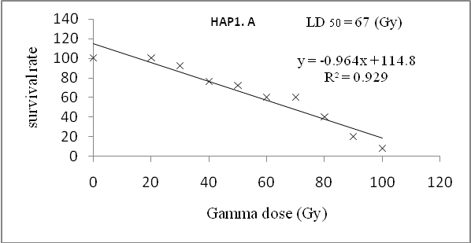
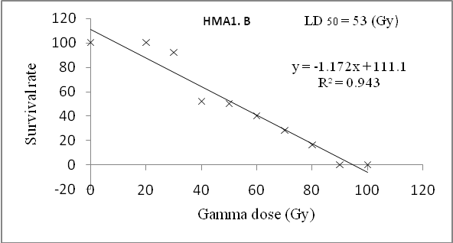
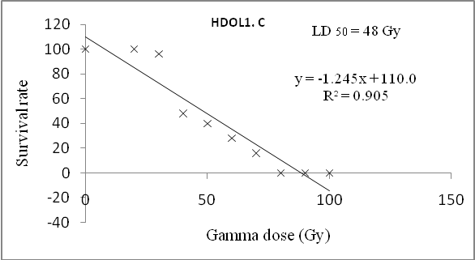
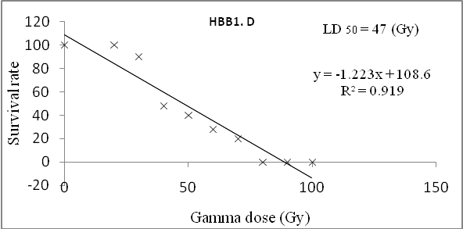
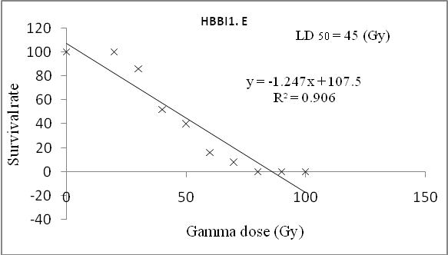
Figure 2. Regression Graph for effect of radiation doses on the survival rate of plantlets in five genotypes of rose, HAP1 (A), HMA1 (B), HDOL1 (C), HBB1 (D), HBBI1 (E).

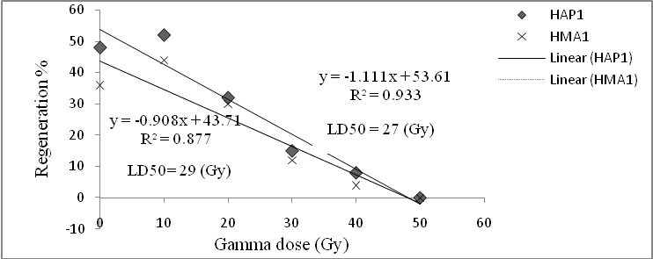
Figure 3. Regression Graph for effect of radiation doses on the direct regeneration in two genotypes of rose (HAP1and HMA1).
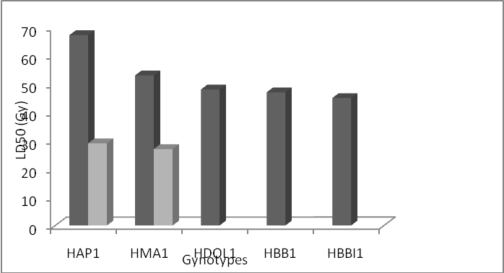
Figure 4. Comparing calculated LD₅₀ for nodal sections of five rose genotypes and two types of explants in two genotypes.

