Influences of organic ingredients on in vitro direct regeneration of Hibiscus rosa-sinensis explants
Chew Tiong Dar¹, Janna Ong Abdullah^{2*}, Parameswari Namasivayam³, Siti Habsah Roowi⁴
^{1, 2} Department of Microbiology, ³ Department of Cell and Molecular Biology, Faculty of Biotechnology and Biomolecular Sciences, Universiti Putra Malaysia, 43400 UPM Serdang, Selangor Darul Ehsan, Malaysia. Email: ctd11586@yahoo.com, janna@biotech.upm.edu.my, parameswari@biotech.upm.edu..my

⁴ Felda Biotechnology Centre, Pt 23417, Lengkuk Technology, 71760 Bandar Enstek, Negeri Sembilan, Malaysia. Email: feldatc@hotmail.com

* Corresponding author
Abstract
This paper reports on the influences of organic ingredients on facilitating the direct shoot regeneration from nodal explant of Hibiscus rosa-sinensis. Initially, 3 types of explants (node, internode, and shoot tip) were sterilised using optimized Clorox concentrations and exposure times as follows: node: 40%, 20min; internode: 10%, 15min; and shoot tip: 5%, 40min. Due to its higher survival rate and responsiveness, nodal explant was selected for the MS medium modification for direct shoot regeneration. We found that MS medium containing 40g/L sucrose, 0.3% (w/v) activated charcoal, and supplementations with myo-inositol, thiamine and nicotinic acid were conducive for in vitro regeneration of H. rosa-sinensis nodal explants. The in vitro shoot survival rate was 30% with a mean leaf numbers of 2.68 produced, and a mean leaf length of 1.71cm achieved after 5 weeks of culture on the modified medium.
Keywords
Hibiscus rosa-sinensis, Murashige and Skoog medium, axillary bud, sucrose, organic ingredient, activated charcoal
Abbreviation
NaOCl - Sodium hypochlorite
Ca(ClO)₂ - Calcium hypochlorite
HgCl₂ - Mercuric (II) chloride
PGR - Plant Growth Regulator
BAP – 6-benzylaminopurine
IAA – Indole-3-acetic acid
IBA – Indole-3-butyric acid
NAA – Naphthalene-3-acetic acid
KIN - Kinetin
MS medium - Murashige and Skoog medium
M – Myoinositol
T – Thiamine
N – Nicotinic acid
P – Pyridoxine
G - Glycine
1. Introduction
Hibiscus rosa-sinensis, commonly known as “Chinese Hibiscus”, is an evergreen perennial plant that grows in tropical and sub-tropical regions. It has a charismatic bright red, five-petal, and single layer flower and the leaves are alternate along the branch (Gilman, 1999).
Pharmacological investigations of the genus Hibiscus indicated the existence of some species with interesting biological activities such as anti-hypertensive (Chen et al. 2003), anti-inflammatory (Dafallah and al-Mustafa 1996), hepato-protective (Wang et al. 2000), anti-tumoric (Lin et al. 2007), anti-diabetic (Venkatesh et al. 2008), anti-convulsive (Kasture et al. 2000), anti-oxidative (Hirunpanich et al. 2005; Rosa et al. 2006), and anti-mutagenic (Adetutu et al. 2004; Farombi and Fakoya 2005).
Traditional propagation of Hibiscus spp. is dependent on vegetative means such as cuttings or grafting, as the seeds usually exhibit seed variations and failed to germinate (Cocoa 1990). Vegetative propagation can shorten the length of the juvenile period and also allow genotypes combination (Hartman et al. 1994). However, such traditional asexual propagation cannot circumvent the very fundamental problems of long growing period, large growing space, small plant quantity, and inefficiency. After approximately 100 years of development, plant tissue culture technique provides an alternative to solve those problems. In this propagation method, only small pieces of plant tissue are required to regenerate on plant tissue culture medium under sterile conditions. The plant tissues can be the internodes, nodes, shoot tips (stems), root tips, calli, leaves, seed embryos, or anthers.
Due to the strikingly encouraging effects of PGR in accelerating, inducing, and maintaining in vitro shoot, direct in vitro shoot establishment and multiplication from explant often involve the application of PGRs such as BAP (Herath et al. 2004; Christensen et al. 2008), zeatin (Ostrolucka et al. 2004), BAP plus KIN (Rashid and Bal, 2010), BAP plus IAA (Bazargani et al. 2011), or BAP plus NAA (Ebrahimie et al. 2007). Christensen et al. (2008) reported that the most suitable multiplication medium for H. rosa-sinensis L. was demonstrated to be a modified MS medium containing 2.2 μM BAP and increased concentrations of calcium at 9 mM and iron at 295μM provided as Fe-EDDHA. Bhalla et al. (2009) modified the MS medium strength coupled with BAP in inducing direct shooting from H. rosa-sinensis but concluded that BAP was not suitable in their study. While in other hibiscus species, H. cannabinus (kenaf), Herath et al. (2004) reported that 8.8μM of BAP was the best treatment, but was contradicting Zapata et al. (1999) who revealed BAP at 4.4μM completely suppressed shoot growth of kenaf. Both reports again contradicted Ayadi et al. (2011) who found that the additions of PGRs (BAP, IBA and NAA) to the MS medium were detrimental to the cultures as they reduced buds formation, inhibited shoot growth and root induction. Hence, it seems crucial that focus be targeted at the medium ingredients rather than exogenous supplementation of PGRs in inducing shoots formation or elongation, as an alternative to optimise direct in vitro shoot establishment and multiplication of hibiscus explants.
In this paper, we present the results on the effectiveness of shoot induction through modification of the MS medium ingredients, without involving any PGRs. We also report the effectiveness of NaOCl in controlling the balance between contamination and survival levels for three types of H. rosa-sinensis vegetative explants, and highlight the optimised conditions for explants sterilisation of this plant species which were harvested from open field. Since most of the reported studies on hibiscus species were focused on samples obtained from plants grown in greenhouses, this paper provides alternative reference for plants grown in the open fields.
Materials and methods
Culture medium
All the media used were based on MS basal salts and vitamins (Murashige and Skoog, 1962). No plant growth regulators (PGRs) were added. For media used in the sterilisation process , 20g/L of sucrose was added to half strength MS (1/2 MS) basal medium while for subsequent direct shoot induction, different sucrose concentrations (10, 20, 30, 40, 50g/L), activated charcoal [0.1, 0.2, 0.3, 0.4 and 0.5% (w/v)] and different combinations of organic ingredients [myoinositol + thiamine.HCl, myoinositol + thiamine.HCl + nicotinic acid, myoinositol + thiamine.HCl + pyridoxine.HCl, myoinositol + thiamine.HCl + nicotinic acid + pyridoxine.HCl, and myoinositol + thiamine.HCl + nicotinic acid + pyridoxine.HCl + glycine] were tested. The pH of the medium was adjusted to 5.7-5.8 using 1M NaOH before adding 2.7g/L (for sterilisation study) or 1.6g/L (for organogenesis) of Gelrite agar. The medium was autoclaved at 121˚C for 15 minutes. In the sterilisation study, the explants were cultured on solid medium in Petri dishes while for shoot induction, the explants were placed on solid medium in culture tubes (Diameter: 2.5cm; Height: 10cm). Each treatment consisted of 50 replicates and the whole experiment was carried out twice.
Explant surface sterilisation
Three types of explants – shoot tip, node, and internode - were harvested from young shoots of H. rosa-sinensis plants (the shoot harvested contained a maximum of three nodes counting from the shoot tip) that grew beside the Sultan Abdul Samad Library, Universiti Putra Malaysia, Malaysia and was authenticated with the Voucher Specimen Number: SK1560/08.
The nodes, internodes and shoot tips were cut into 2cm long before washing under running tap water for 30 minutes. One drop of detergent (Dynamo®) was added into the water and the washing was continued for an additional minute. The detergent was removed under the running tap water and the explants were rinsed with distilled water three times. Commercial Clorox® solution [5.25% (w/v) NaOCl] diluted to concentrations ranging from 5 to 50% (v/v), were tested on decontaminating all explants except the shoot tips, which were only subjected to 5 to 20% (v/v) of the Clorox® solution. All treatments (except for shoot tips) were subjected to a Clorox exposure time ranging from 5 to 30 minutes at 5-minute intervals; while for shoot tip, it was 10 to 60 minutes exposure time at 10-minute intervals (Table 1). One drop of Tween-20 was added to the Clorox® solution prior to sterilisation. After each treatment, the explants were thoroughly washed with sterile deionised water 3 times (Misra and Chakrabarty 2009), each comprising 10 minutes. After the sterilisation steps above and prior to culturing on the nutrient medium, each node, internode and shoot tip explants were trimmed into 1cm length. Each treatment for the node and internode explants, respectively, consisted of 45 replicates, while shoot tip comprised of 25 replicates due to limited samples. All cultures were maintained at 27±1˚C under a 16 h-photoperiod provided by cool-white fluorescent tubes at 25 mMol photon/m²/s.
For sterilisation, observation was taken daily for 35 days to record the percentages of contamination and survival of the explants. All experiments were carried out twice.
Direct Organogenesis
Based on the result from the sterilisation study, nodal explant having scored the highest survival percentage using 40% Clorox and 20mins exposure, and hence was chosen for subsequent MS medium modification study. Sterile nodal explants were cultured in tubes containing the relevant MS medium formulation (as described previously in culture medium). The nodal explants were first subjected to treatment of different concentrations of sucrose. Following which, the optimised sucrose concentration was chosen for subsequent assessment of the organic ingredients and activated charcoal. The explants were maintained at 27±1˚C under a 16 h-photoperiod provided by cool-white fluorescent tubes at 25 mMol photon/m²/s. Observation was taken weekly for 6 weeks to record the percentages of survival and regeneration of explants, mean leaf length (cm), mean number of leaf, and mean number of leaf. All experiments were done twice.
Statistical Analysis
The experiments were performed in a completely randomised design (CRD). Data were subjected to one-way analysis of variance (ANOVA) using SPSS ver. 16 software (SPSS, Chicago, IL.). Multiple comparisons among means were performed using Duncan’s multiple range test with the level of significance at p=.05.
Results and discussion
Explant surface sterilisation
Three types of explants (node, internode and shoot tip) were obtained from young hibiscus stems and subjected to different surface sterilisation conditions as summarized in Table 1. The best sterilisation condition for each explant type was scored based on the highest survival rate with minimal contamination.
The results show that nodal explants is the most difficult to sterilise, followed by shoot tip and internode. The nodal explant (node) bears an axillary bud located in a ‘V’ shape trough, formed between the main stem and leaf petiole. Such shape easily traps contaminants and poses a barrier to water current during sterilisation. The internodal explant has a smooth and small surface area compared to the other two explants (node and shoot tip) used in this study. A smooth surface is a poor ‘landing site’ for microbial attachment because they are often easily ousted under strong water current and hence a lower chance for the explants to get contaminated. Both of these characteristics seem to contribute to a low contamination percentage (<10%) and high survival rate (>80%) as observed for 90% of the treatments (Table 1B).
For the shoot tip and nodal explants, the results show that increasing Clorox concentration with short exposure time was not effective in removing contaminants. For a 5-min exposure time, the contamination percentage using 5% (v/v) Clorox is comparable to almost all the Clorox levels tested. However, increasing the exposure time seems to be more favourable. Indeed, most researchers used longer exposure time (≥ 10 mins) for nodal explant sterilisation from varying plant species (Odutayo et al. 2004; Jabbarzadeh and Khosh-Khui , 2005; Liu and Pijut 2008). If a shorter exposure time is required, usually HgCl₂ is used (Sujatha and Ranjitha Kumari 2008; Mahendran and Narmatha Bai 2009). In this study, 75% of the treatments were able to confine the contamination percentages within 20%, and the explants survival percentages within the range of 30-70%.

Table 1: Explants treatments at different Clorox concentrations and exposure times. Data were taken after 35 days of culture which were displayed as survival and contamination percentages: (A) node; (B) internode; (C) shoot tip. “C” denotes control. The numbers followed by different superscript letters (a, b, c, d, e) within a column are significantly different at p ≤ .05 by Duncan’s multiple range test (DMRT). Data is the mean ± SD. Means are the results of 2 experiments.

Exposure Time (min) |  | C | 5 | 10 | 15 | 20 | 25 | 30
Clorox Conc., % (v/v) |  |  | Survival, %
5 |  | 0 | 67.5± 3.5^{b} | 44.0±17.0^{ab} | 62.0± 5.7^{ab} | 36.5± 7.8ª | 67.0±15.6^{b} | 53.0± 7.1^{ab}
10 |  | 0 | 62.0±12.7^{b} | 48.0±11.3^{ab} | 67.5± 7.8^{b} | 31.5± 2.1ª | 31.5±10.6ª | 30.5± 5.0ª
15 |  | 0 | 41.5±16.3ª | 29.5± 5.0ª | 33.0± 7.1ª | 26.0± 5.7ª | 29.0± 1.4ª | 36.5± 3.5ª
20 |  | 0 | 58.0± 2.8ª | 42.0±11.3ª | 59.0± 4.2ª | 49.0±12.7ª | 55.5±14.9ª | 60.0±15.6ª
25 |  | 0 | 45.5± 7.8^{ab} | 45.0± 9.9^{ab} | 39.0± 1.4ª | 37.0± 1.4ª | 68.0±14.1^{c} | 60.0± 2.8^{bc}
30 |  | 0 | 42.0± 5.7ª | 66.0±17.0^{b} | 58.0± 2.8^{ab} | 69.5± 3.5^{b} | 74.5± 5.0^{b} | 76.5± 5.0^{b}
35 |  | 0 | 39.0± 1.4ª | 44.4± 9.2ª | 86.5± 6.4^{b} | 72.5± 0.7^{b} | 85.5±10.6^{b} | 77.0± 4.2^{b}
40 |  | 0 | 39.5±10.6ª | 60.5± 9.2^{b} | 65.5± 7.8^{bc} | 94.5± 5.0^{d} | 83.5± 7.8^{cd} | 93.5± 3.5^{d}
45 |  | 0 | 23.5± 5.0ª | 29.5± 9.2ª | 75.0±14.1^{c} | 43.5± 7.8^{ab} | 41.5± 3.5^{ab} | 67.0±15.6^{bc}
50 |  | 0 | 36.5± 7.8ª | 74.5±10.6^{b} | 81.5±13.4^{b} | 85.0± 2.8^{b} | 88.0±11.3^{b} | 49.0± 5.7ª
Exposure Time (min) |  | C | 5 | 10 | 15 | 20 | 25 | 30
Clorox Conc., % (v/v) |  |  | Contamination, %
5 |  | 100 | 20.0± 5.7^{ab} | 29.0±12.7^{b} | 16.0± 5.6^{ab} | 14.0± 2.8^{ab} | 6.5± 3.5ª | 5.5± 1.4ª
10 |  | 100 | 20.0± 2.8ª | 15.5± 6.4ª | 13.5± 3.5ª | 13.5± 3.5ª | 10.0± 1.4ª | 16.5± 5.0ª
15 |  | 100 | 58.5±16.3^{bc} | 75.5±12.0^{c} | 58.5±16.3^{bc} | 27.5± 7.8^{ab} | 23.5±10.6ª | 51.5± 6.4^{abc}
20 |  | 100 | 30.0± 4.2^{b} | 22.5± 9.2^{ab} | 17.5± 6.4^{ab} | 28.5± 9.2^{b} | 7.0± 0.0ª | 12.0± 1.4ª
25 |  | 100 | 53.0±15.6^{b} | 10.5± 3.5ª | 23.5±10.6ª | 23.5±10.6ª | 3.0± 1.4ª | 30.0±14.1^{ab}
30 |  | 100 | 31.0± 9.9^{b} | 27.5± 7.8^{b} | 31.0± 0.0^{b} | 23.0± 1.4^{b} | 20.0± 2.8^{b} | 5.5± 2.1ª
35 |  | 100 | 13.5± 6.4^{b} | 5.0± 1.4^{ab} | 3.0± 1.4ª | 12.5± 5.0^{b} | 0.0± 0.0ª | 7.5± 0.7^{ab}
40 |  | 100 | 18.0± 8.5^{b} | 13.5± 3.5^{b} | 19.0± 1.4^{b} | 2.0± 0.0aª | 4.0± 0.0ª | 0.0± 0.0ª
45 |  | 100 | 27.5± 5.0^{b} | 17.5± 6.4ª | 14.5± 5.0ª | 12.0± 1.4ª | 9.0± 0.0ª | 9.0± 2.8ª
50 |  | 100 | 36.5± 7.8^{d} | 12.5± 5.0^{bc} | 21.0± 4.2^{c} | 12.0± 1.4^{bc} | 0.0± 0.0ª | 8.0± 1.4^{ab}
(A) Node

(B) Internode

Exposure Time (min) |  | C | 5 | 10 | 15 | 20 | 25 | 30
Clorox Conc., % (v/v) |  |  | Survival, %
5 |  | 0 | 93.0±4.2^{c} | 54.0±8.5^{ab} | 60.5±10.6^{ab} | 87.0±18.4^{bc} | 56.0±14.1^{ab} | 51.0±15.6ª
10 |  | 0 | 93.0±0.0^{b} | 87.5±2.1ª | 97.0± 1.41^{c} | 92.5± 0.7^{b} | 89.5± 2.1^{ab} | 89.5± 0.7^{ab}
15 |  | 0 | 77.5±6.4^{ab} | 83.0±1.4^{ab} | 86.5± 9.2^{b} | 73.5± 6.4^{ab} | 72.0± 1.4ª | 85.0± 1.4^{ab}
20 |  | 0 | 90.5±0.7ª | 90.5±0.7ª | 90.0± 8.5ª | 93.5± 3.5ª | 88.0± 1.4ª | 92.0± 2.8ª
25 |  | 0 | 94.5±2.1^{bc} | 94.0±5.7^{bc} | 97.0± 1.4^{c} | 81.0± 1.4ª | 91.0± 0.0^{bc} | 89.5± 2.1^{b}
30 |  | 0 | 88.0±5.7ª | 86.5±5.0ª | 87.5± 6.4ª | 95.0± 1.4ª | 85.5± 5.0ª | 88.0± 1.4ª
35 |  | 0 | 91.0±0.0^{ab} | 96.0±0.0^{bc} | 99.0± 1.4^{c} | 97.0± 1.4^{c} | 96.0± 2.8^{bc} | 86.5± 3.5ª
40 |  | 0 | 92.5±0.7^{b} | 95.5±3.5^{bc} | 87.5± 0.7ª | 94.5± 2.1^{bc} | 94.5± 0.7^{bc} | 98.0± 0.0^{c}
45 |  | 0 | 93.5±6.4ª | 96.0±0.0ª | 93.5± 6.4ª | 91.0± 2.8ª | 95.5± 3.5ª | 92.0± 1.4ª
50 |  | 0 | 97.0±1.4b^{bc} | 96.0±0.0^{b} | 96.0± 0.0^{b} | 95.0± 1.4^{ab} | 93.0± 1.4ª | 99.0± 1.4^{c}
Exposure Time (min) |  | C | 5 | 10 | 15 | 20 | 25 | 30
Clorox Conc., % (v/v) |  |  | Contamination, %
5 |  | 100 | 62.5±6.4ª | 52.5±0.7ª | 49.0±2.8ª | 52.5±5.0ª | 44.5±3.5ª | 46.0±14.1ª
10 |  | 100 | 0.0±0.0ª | 1.5±0.7^{b} | 0.0±0.0ª | 0.0±0.0ª | 0.0±0.0ª | 0.0± 0.0ª
15 |  | 100 | 4.0±0.0ª | 3.0±1.4ª | 0.0±0.0ª | 3.0±1.4ª | 0.0±0.0ª | 16.0± 5.7^{b}
20 |  | 100 | 2.0±0.0ª | 7.0±0.0ª | 12.5±5.0^{b} | 2.0±0.0ª | 5.5±2.1ª | 4.0± 0.0ª
25 |  | 100 | 5.5±2.1^{b} | 0.0±0.0ª | 5.5±2.1^{b} | 17.0±1.4^{d} | 8.0±1.4^{bc} | 10.0± 1.4^{c}
30 |  | 100 | 16.5±5.0^{b} | 16.5±5.0^{b} | 17.5±6.4^{b} | 0.0±0.0ª | 14.5±5.0^{b} | 9.0± 2.8^{ab}
35 |  | 100 | 7.5±2.1^{b} | 0.0±0.0ª | 0.0±0.0ª | 2.0±0.0ª | 3.0±1.4ª | 3.0± 1.4ª
40 |  | 100 | 0.0±0.0ª | 2.0±0.0ª | 9.5±2.1^{b} | 2.0±0.0ª | 2.0±0.0ª | 0.0± 0.0ª
45 |  | 100 | 14.5±5.0^{c} | 3.0±1.4^{ab} | 10.0±4.2^{bc} | 9.0±2.8^{abc} | 7.0±0.0^{abc} | 2.0± 0.0ª
50 |  | 100 | 5.5±2.1^{c} | 0.0±0.0ª | 2.0±0.0^{ab} | 2.0±0.0^{ab} | 3.0±1.4^{bc} | 0.0± 0.0ª

(C) Shoot Tip

Exposure Time (min) |  | C | 10 | 20 | 30 | 40 | 50 | 60
Clorox Conc., % (v/v) |  |  | Survival, %
5 |  | 0 | 42.0±14.2^{b} | 38.0± 2.8^{b} | 42.0± 8.5^{b} | 60.0±5.7^{b} | 0.00± 0.0ª | 30.0± 2.8^{ab}
10 |  | 0 | 52.0± 5.7^{ab} | 50.0±14.1^{ab} | 52.0±11.3^{b} | 58.0±8.5^{ab} | 38.0±14.1ª | 35.0± 9.9ª
15 |  | 0 | 46.0±14.1^{ab} | 68.0±11.3^{b} | 64.0±17.0^{b} | 30.0±2.8^{ab} | 34.0±14.1ª | 33.0±12.7ª
20 |  | 0 | 64.0±11.3^{c} | 30.0± 8.5 | 36.0±0.0^{b} | 8.0±0.0ª | 12.0± 0.0ª | 0.0± 0.0ª
Exposure Time (min) |  | C | 10 | 20 | 30 | 40 | 50 | 60
Clorox Conc., % (v/v) |  |  | Contamination, %
5 |  | 100 | 10.0±2.8^{b} | 12.0±5.7^{b} | 0.0±0.0ª | 0.0±0.0ª | 0.0±0.0ª | 12.0±0.0^{b}
10 |  | 100 | 6.0±2.8^{bc} | 8.0±0.0^{c} | 4.0±0.0^{b} | 4.0±0.0^{b} | 0.0±0.0ª | 0.0±0.0ª
15 |  | 100 | 4.0±0.0 | 0.0±0.0 | 0.0±0.0 | 0.0±0.0 | 8.0±0.0 | 8.0±0.0
20 |  | 100 | 4.0±0.0 | 0.0±0.0 | 0.0±0.0 | 4.0±0.0 | 0.0±0.0 | 0.0±0.0

Table 2: Qualitative view of regenerated nodal explants cultured on MS media: (A) sucrose; (B) organic ingredient; (C) activated charcoal. Data were taken after 6 weeks of culture. Bar denotes 1cm. M: myo-inositol; T: thiamine.HCl; N: nicotinic acid, P: pyridoxine.HCl; G: glycine

(A) Sucrose
g/L  Week | 10 | 20 | 30 | 40 | 50
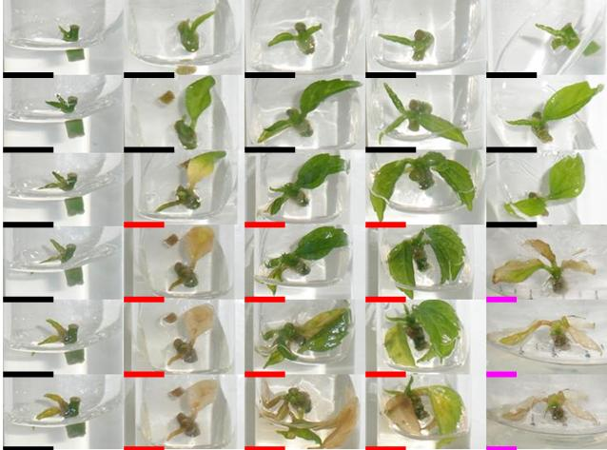
1st
2nd
3rd
4th
5th
6th

(B) Organic Ingredient

O.I.  Week | 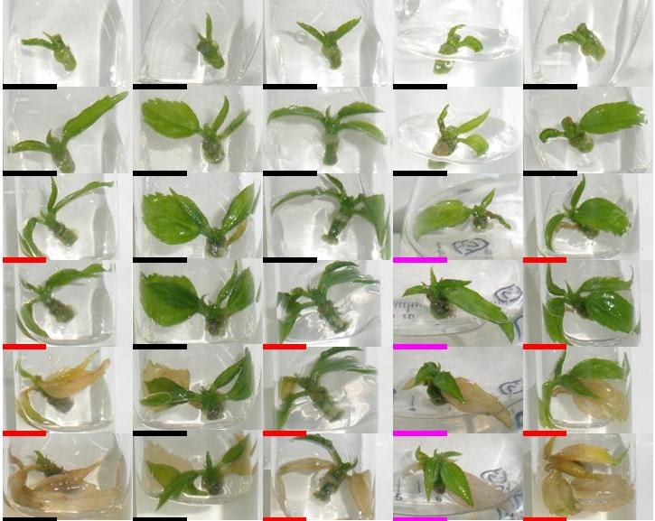  MT | MTN | MTP | MTNP | MTNPG
1st
2nd
3rd
4th
5th
6th

“O.I.” denotes Organic Ingredient
(C) Activated Charcoal
% (w/v)  Week | 0.1 | 0.2 | 0.3 | 0.4 | 0.5
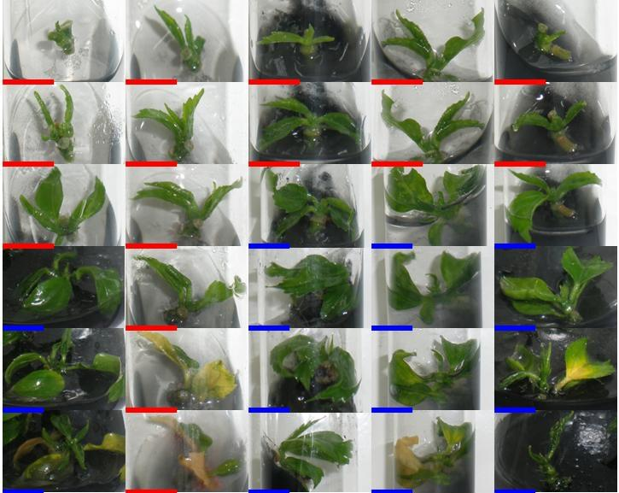
1st
2nd
3rd
4th
5th
6th

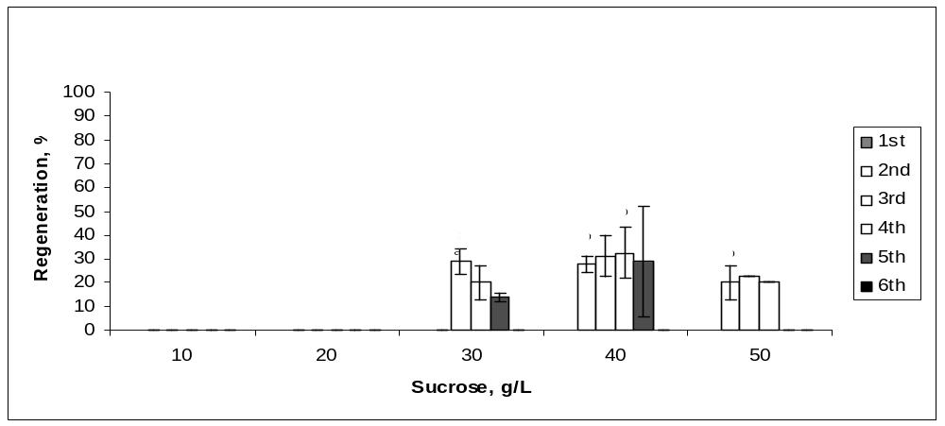
(A) Sucrose

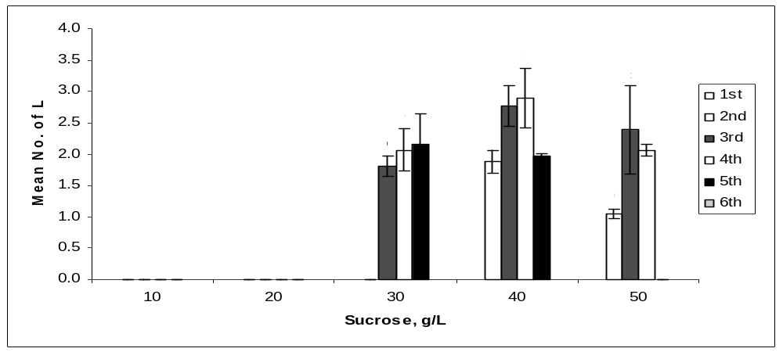

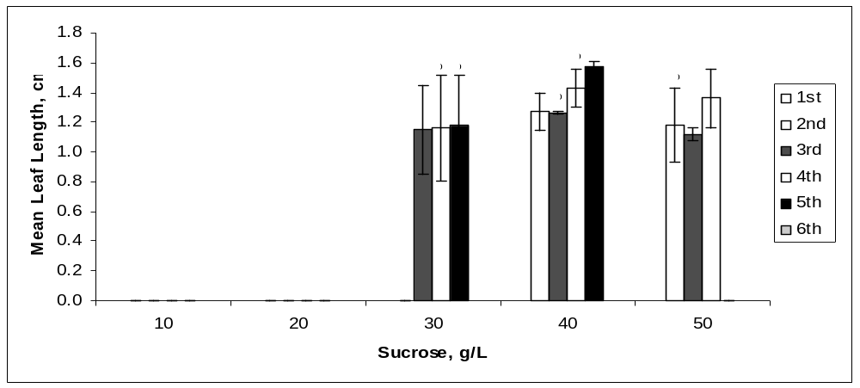

(B) Organic Ingredient
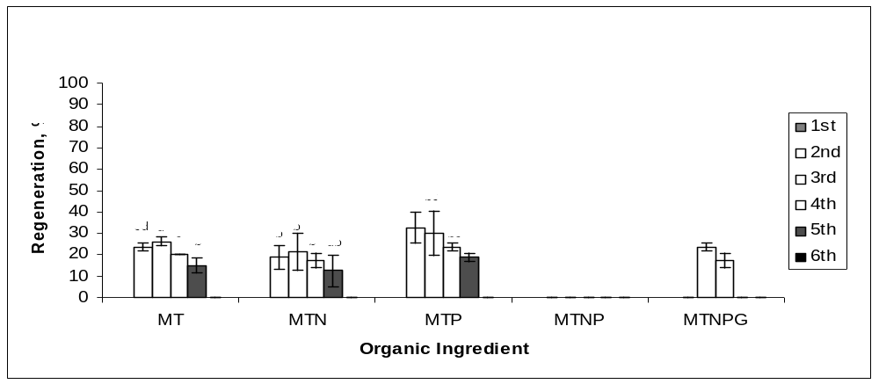

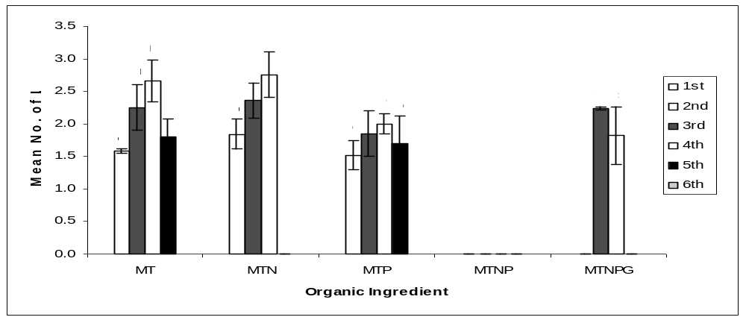

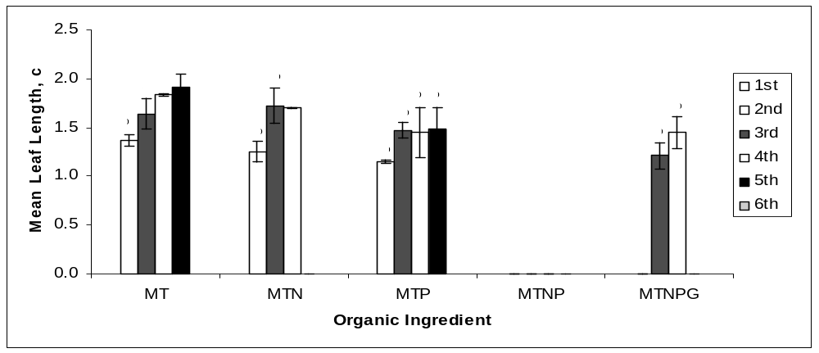

(C) Activated Charcoal
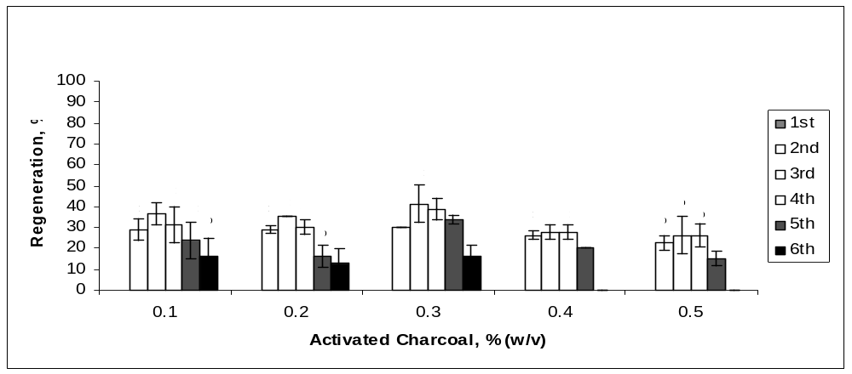

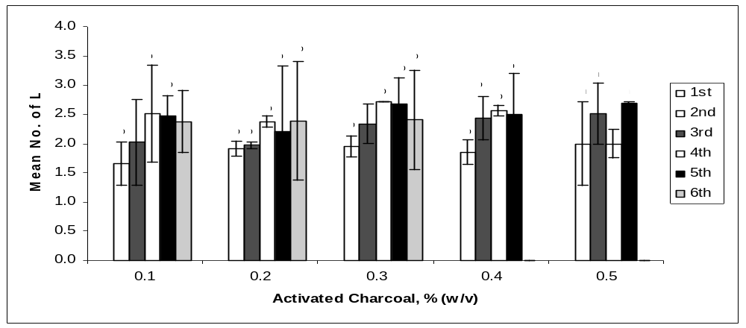

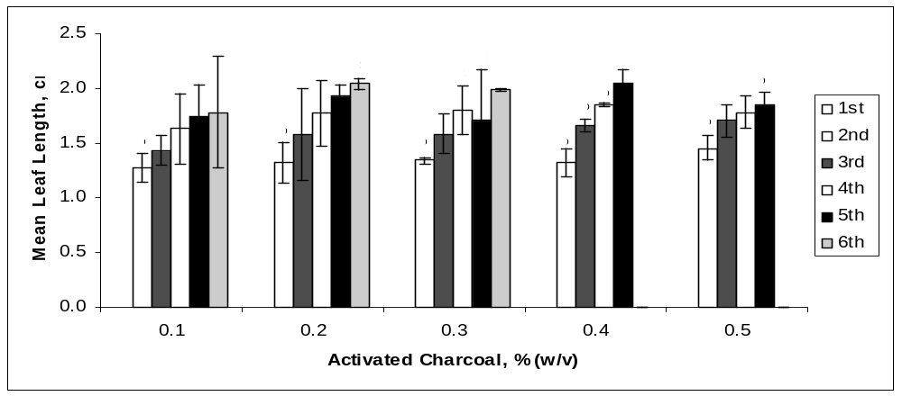

Figure 1: Regeneration of nodal explants cultured on MS media, mean number of leaf shooted, and mean leaf length obtained: (A) sucrose; (B) organic ingredient; (C) activated charcoal. Data were taken after 6 weeks of culture. Error bars indicate standard deviations (n = 2).Different letters (a, b, c, d) indicate values that are significantly different at p ≤ .05 by Duncan’s multiple range test (DMRT).

The best treatment for the node is 40%-20min [2.1% (w/v) NaOCl)], a concentration comparable to that of the seeds from other plants (Li et al. 2009; Srivatanakul et al. 2000). It is interesting to find that Christensen et al. (2008) applied 0.01% (w/v) NaOCl for H. rosa-sinensis nodal explants sterilisation, a dose 210 times lower than the best treatment for the nodal explants found in this study. Such discrepancies could be attributed to the location of the sampling site - greenhouse versus open environment. This indicates that by controlling the plants’ exposure to outside environment can limit the level of contamination on the plant itself.
By taking into account of both the contamination and survival percentages, 10%-15min is the best treatment for the internode. Internodal explants subjected to this treatment gave 0% contamination and almost 100% survival rate (Table 1B). However, under a situation where both the nodal and internodal explants were to be subjected to the disinfectant treatment simultaneously, 40%-20min is applicable because both the contamination and survival percentages are not affected significantly (Tables 1A & B).
The shoot tip was found to be susceptible to dehydration after being excised from the mother plant. We found that the shoot tips did not survive with 30% (v/v) Clorox or higher and also when the sterilisation time was 10 minutes or more. The best treatment for shoot tip is 5%-40mins [0.2625% (w/v) NaOCl], a treatment nearly comparable to Jo et al. (2009) who used about 0.15% (w/v) of NaOCl with 30 minutes exposure for shoot tip of Alocasia amazonica. In contrast, Misra and Chakrabarty (2009) used higher concentration, 4% (w/v) NaOCl, and shorter exposure time, 5 minutes, to sterilise Rosa clinophylla shoot tip.
Direct Organogenesis
Nodal explant was used in this direct regeneration study of H. rosa-sinensis because of its higher survival rate (95%) at 40%, 20 minutes Clorox treatment and also due to sample insufficiency of other potential candidate explant (one shoot tip per stem). Internodal explant was found to be an active callus-producing tissue but not an ideal candidate for direct shoot regeneration (data not shown).
Apart from exogenous supply of PGRs, growth and induction of in vitro shoots are also influenced by exogeneous carbon source. The in vitro plants are either heterotrophic or semi-autotrophic, and hence an external supply of carbon is necessary. Sucrose is readily hydrolysed into glucose and fructose during autoclave, with the former being used up first and then fructose. Sucrose at 30g/L (standard MS medium) was used for H. rosa-sinensis (Cristensen et al. 2008; Sunil et al. 2009), H. cannabinus (Herath et al. 2004; Ayadi et al. 2011), H. sabdariffa (Gomez-Leyva et al. 2008; Govinden-Soulange et al. 2009) and other in vitro cultures. From the results obtained (Table 2A), 20g/L of sucrose induced negligible (<5 shoots) number of shoots. Growth of the shoots improved significantly at 30g/L or higher. Parallel to this observation, Fig. 1 (A) also show that 30% of the explants regenerated, and the mean number of leaves produced and mean leaf length achieved were highest at 40g/L of sucrose. However, more than 40% sucrose increment did not improve the regeneration or the growth rates of the explants.
Four types of vitamins (myo-inositol, thiamine, pyridoxine, and nicotinic acid) and one amino acid, glycine, present in the standard MS medium formulation. Of the five supplements, myo-inositol and thiamine are essential for the culture of plant cells in vitro. Thiamine is an essential co-factor in carbohydrate metabolism and is involved in the biosynthesis of certain amino acids in its active form, thiamin diphosphate (Du et al. 2011). Plant cell and tissue could produce some essential vitamins in vitro but at a sub-optimal level, hence an exogenous supply of vitamin is always crucial. Similar to other plant species, all vegetative propagations of H. rosa-sinensis as reported involve the complete MS organic supplementation (Cristensen et al. 2008; Airo et al. 2009; Sunil et al. 2009). In contrast to previous reports, the results obtained in this study (Table 2B) revealed that shoots grown with organic supplements consisted of MTN gave the best result. It was also noted that shoots induction with myoinositol and thiamine supplementations only were achieved at a percentage higher than that with MTN (Fig 1B). This implies that myo-inositol and thiamine are recommended for the regeneration of H. rosa-sinensis, and any additional supplements are optional. Leaf abscission was observed from the 5th week onwards for all treatments.
Activated charcoal or carbon (AC) had been reported to be a useful supplement in the plant tissue culture medium for several purposes such as improving rooting (Makunga and Van Staden 2008), shoot elongation (Datta et al. 2006), preventing necrosis (Shrestha et al. 2007), and preventing browning (Guo et al. 2007). The fine network of pores and large surface area of AC serves as a useful scavenger to adsorb inhibitory phenolic compounds. As shown in Table 2 (C), nodal explant cultured on medium augmented with 0.3% (w/v) of activated charcoal produced bigger and healthier-looking shoots. The highest shoot regeneration rate was 40%, achieved at 3rd week with 0.3% (w/v) AC supplementation (Fig. 1C). Leaf abscission and shoot necrosis were also observed to be delayed until the 6th week, Figure 1C. However, further increment of AC concentration did not improve the observable growth performance of the shoots as shown in the Table 2(C) and Fig. 1(C). This might be due to adsorption of the nutrient ions (Cu²⁺ or Zn²⁺) and other organic supplements (vitamins) in the medium by the excess amount of AC resulting in lower amounts of nutrients and supplements being made available to the growing cultures (Pullman and Johnson, 2002).
- CONCLUSION
The morphology of the explant does affect the effectiveness of the sterilisation process. The source of the explants might also play a role in this aspect. Explant that is the most difficult to sterilise is the node while the easiest are the internode and shoot tip. However, shoot tip is prone to desiccation at high Clorox concentration. The recommended MS medium formulation for shoot induction of H. rosa-sinensis nodal explant should contain at least 40g/L of sucrose supplemented with myoinositol, thiamine.HCl, nicotinic acid and 0.3% (w/v) activated charcoal. However, the above formulation is not suitable for maintenance of the regenerated H .rosa-sinensis shoots. An alternative medium formulation is required for this aspect. .
ACKNOWLEDGEMENT
Chew Tiong Dar is a recipient of a Graduate Research Fellowship from the Universiti Putra Malaysia. Authors would like to thank Associate Professor Dr. Rusea Go, Department of Biology, Faculty of Science, Universiti Putra Malaysia, for her invaluable assistance in identifying the plant species.
REFERENCES
Adetutu A, Odunola OA, Owoade OA, Adeleke, OA., Amuda, OA (2004) Anticlastogenic effects of Hibiscus sabdariffa fruits against sodium arsenite-induced micronuclei formation in erythrocytes in mouse bone marrow. Phytotherapy Research 18: 862–864
Airo M, Giardina G, Farruggia G, Zizzo GV (2009) In vitro propagation of Hibiscus rosa-sinensis (L.). Acta Horticulturae 812: 107-112
Ayadi R, Hamrouni L, Hanana M, Bouzid S, Trifi M, Khouja ML (2011) In vitro propagation and regeneration of an industrial plant kenaf (Hibiscus cannabinus L.). Industrial Crops and Products 33(2): 474-480
Bazargani MM, Tabatabaei BES, Omidi M (2011) Multiple shoot regeneration of cotton (Gossypium hirsutum L.) via shoot apex culture system. African Journal of Biotechnology 10 (11): 2005-2011

Bhalla S, Ong Abdullah J, Sreenamanan S, Karuthan C (2009) Shoots Induction from Hibiscus Rosa-sinensis Nodal Explant Using N6-benzylaminopurine (BAP). Research Journal of Agriculture and Biological Sciences 5(4): 403-410

Bhau BS, Wakhlu AK (2003) Rapid micropropagation of five cultivars of mulberry. Biologia Plantarum 46(3): 349-355.
Chen CC, Hsu JD, Wang SF, Chiang HC, Yang MY, Kao ES, Ho YC, Wang CJ (2003) Hibiscus sabdariffa extract inhibits the development of atherosclerosis in cholesterol-fed rabbits. Journal of Agricultural and Food Chemistry 51: 5472–5477
Cocoa B (1990) The Tropical Hibiscus Handbook, American Hibiscus Society, Third Edition, America, pp. 1-31
Cristensen B, Sriskandaraja S, Serek M, Muller R (2008) In vitro culture of Hibiscus rosa-sinensis L.: Influence of iron, calcium and BAP on establishment and multiplication. Plant Cell, Tissue and Organ Culture 93: 151-161
Dafallah AA, al-Mustafa Z (1996) Investigation of the anti-inflammatory activity of Acacia nilotica and Hibiscus sabdariffa. American Journal of Chinese Medicine 24: 263–269

Datta MM, Majumder A, Jha S (2006) Organogenesis and plant regeneration in Taxus wallichiana (Zucc.). Plant Cell Reports 25: 11–18.
Du Q, Wang H, Xie J (2011) Thiamin (Vitamin B1) Biosynthesis and Regulation: A Rich Source of Antimicrobial Drug Targets? International Journal of Biological Sciences 7: 41-52
Ebrahimie E, Hosseinzadeh A, Nagavi MR (2007) Combined Direct Regeneration Protocols in Tissue Culture of Different Cumin Genotypes Based on Pre-existing Meristems. Pakistan Journal of Biological Sciences 10(9): 1359-1369
Farombi EO, Fakoya A (2005) Free radical scavenging and antigenotoxic activities of natural phenolic compounds in dried flowers of Hibiscus sabdariffa L. Molecular Nutrition and Food Research 49: 1120–1128
Gomez-Leyva JF, Martinez-Acosta LA, Lopez-Muraira IG, Silos Espino H, Ramirez-Cervantes, Andrade-Gonzalez (2008) Multiple Shoot Regeneration of Roselle (Hibiscus sabdariffa L.) from a Shoot Apex xCulture System. International Journal of Botany 4(3): 326-330
Govinden-Soulange J, Boodia N, Dussooa C, Gunowa R, Deensah S, Facknath S, Rajkomar B (2009) Vegetative Propagation and Tissue Culture Regeneration of Hibiscus sabdariffa L. (Roselle). World Journal of Agricultural Sciences 5 (5): 651-661
Guo Y, Bai J, Zhang Z (2007) Plant regeneration from embryogenic suspension-derived protoplasts of ginger (Zingiber officinale Rosc.). Plant Cell, Tissue and Organ Culture 89:151–157.

Hartman BH, Kester DE, Davies FT (1994) Plant Propagation: Principles and Techniques. Prentice Hall, New Jersey

Herald SP, Suzuki T, Hattori K (2004) Multiple shoot regeneration from young shoots of kenaf (Hibiscus cannabinus) Plant Cell, Tissue and Organ Culture 77: 49–53
Hirunpanich V, Utaipat A, Morales NP, Bunyapraphatsara N, Sato H, Herunsalee A, Suthisisang C (2005) Antioxidant effects of aqueous extracts from dried calyx of Hibiscus sabdariffa Linn. (Roselle) in vitro using rat low-density lipoprotein (LDL). Biological and Pharmaceutical Bulletin 28: 481–484
Jabbarzadeh Z, Khosh-Khui, M (2005) Factors affecting tissue culture of Damask rose (Rosa damascena Mill.). Scientia Horticulturae 105: 475–482

Jo EA, Tewari RK, Hahn EJ, Paek KY (2009) In vitro sucrose concentration affects growth and acclimatization of Alocasia amazonica plantlets. Plant Cell, Tissue and Organ Culture 96: 307-315
Kasture VS, Chopde CT, Deshmukh VK (2000) Anticonvulsive activity of Albizzia lebbeck, Hibiscus rosa sinensis and Butea monosperma in experimental animals. Journal of Ethnopharmacology 71, pp 65–75
Li YH, Gao JP, Fei SZ (2009) High frequency embryogenic callus induction and plant regeneration from mature caryposis of big bluestem and little bluestem. Scientia Horticulturae 121: 348 352
Lin HH, Chen JH, Kuo WH, Wang CJ (2007) Chemopreventive properties of Hibiscus sabdariffa L. on human gastric carcinoma cells through apoptosis induction and JNK/p38 MAPK signaling activation. Chemico-Biological Interactions 165: 59–75
Liu X, Pijut PM (2008) Plant regeneration from in vitro leaves of mature black cherry (Prunus serotina). Plant Cell, Tissue and Organ Culture 94: 113-123
Mahendran G, Narmatha Bai V (2009) Mass propogation of Satyrium nepalense D.Don.- A medicinal orchid via seed culture. Scientia Horticulturae 119: 203-207

Makunga N.P., and Van Staden, J. 2008. An efficient system for the production of clonal plantlets of the medicinally important aromatic plant: Salvia africana-lutea L. Plant Cell, Tissue and Organ Culture 92: 63–72.
Misra P, Chakrabarty D (2009) Clonal propagation of Rosa clinophylla Thory. through axillary bud culture. Scientia Horticulturae 119: 212-216

Murashige T, Skoog F (1962) A revised medium for rapid growth and bio assays with tobacco tissue cultures. Physiologia Plantarum 15:473–497
Odutayo OI, Oso RT, Akinyemi BO, Amusa NA (2004) Microbial Contaminants of Cultured Hibiscus cannabinus and Telfaria occidentalis Tissues. African Journal of Biotechnology Vol. 3 (9): 473-476
Ostrolucka MG, Libiakova G, Ondruskova E, Gajdosova A (2004) In vitro propagation of Vaccinium species. Acta Universitatis Latviensis 676: 207–212
Pullman GS, Johnson S (2002) Somatic embryogenesis in loblolly pine (Pinus taeda L.): improving culture initiation rates. Annals of Forest Science 59: 663–668.
Rashid R, Bal SS (2010) Effect of Hormones on Direct Shoot Regeneration in Hypocotyl Explants of Tomato. Notulae Scientia Biologicae 2(1): 70-73
Rosa RM, Melecchi MI, da Costa Halmenschlager R, Abad FC, Simoni CR, Caramao EB, Henriques JA, Saffi J, de Paula Ramos AL (2006) Antioxidant and antimutagenic properties of Hibiscus tiliaceus L. methanolic extract. Journal of Agricultural and Food Chemistry: 7324–7330

Shrestha BR, Tokuhara K, Mii M (2007) Plant regeneration from cell suspension-derived protoplasts of Phalaenopsis. Plant Cell Reports 26: 719–725.

Srivatanakul M, Park SH, Sanders JR, Salas MG, Smith RH (2000) Multiple shoot regeneration of kenaf (Hibiscus cannabinus L.) from a shoot apex culture system. Plant Cell Reports 19: 1165–1170

Sujana P, Naidu CV (2011) High frequency rapid plant regeneration from shoot tip and nodal explants of Mentha piperita (L.) – An important multipurpose medicinal plant. Journal of Phytology 3(5): 09-13

Sujatha G. Ranjitha Kumari BD (2008) Micropropagation, encapsulation and growth of Artemisia vulgaris node explants for germplasm preservation. South African Journal of Botany 74: 93–100

Sunil B, Janna OA, Sreeramanan S, Karuthan C (2009) Shoot induction from H. rosa-sinensis nodal explant using N⁶-benzylaminopurine (BAP). Research Journal of Agriculture and Biological Sciences 5(4): 403-410
Venkatesh S, Thilagavathi J, Shyam sundar D (2008) Anti-diabetic activity of flowers of Hibiscus rosa-sinensis. Fitoterapia 79: 79–81
Wang CJ, Wang JM, Lin WL, Chu CY, Chou FP, Tseng TH (2000) Protective effect of Hibiscus anthocyanins against tert-butyl hydroperoxide-induced hepatic toxicity in rats. Food and Chemical Toxicology 38: 411–416

Zapata C, Srivatanakul M, Park SH, Lee BM, Salas MG, Smith RH (1999) Improvements in shoot apex regeneration of two fiber crops: cotton and kenaf. Plant Cell, Tissue and Organ Culture 56: 185–191.

