TABLE 1
Effects of the different cochicine concentration on duration from shoots of C. iridioides D.
Concentration  (%) | Time  （h） | Death Rate（%）  (Mean±SE)* | Variant Rate（%）  (Mean±SE)*
0 | 24  48  72 | 0.0±0.00^{k}  0.0±0.00^{k}  0.0±0.00^{k} | 0.0±0. 00^{g}  0.0±0. 00^{g}  0.0±0. 00^{g}
0.008 | 24  48  72 | 0.00±0.00^{k}  0.00±0.00^{k}  5.00±0.03^{k} | 2.50±0.03^{g}  5.00±0.03^{g}  5.00±0.03^{g}
0.01 | 24  48  72 | 2.50±0.03^{k}  0.00±0.00^{k}  7.50±0.03^{j} | 22.5±0.00^{f}  25.0±0.03^{ef}  30.0±0.05e
0.03 | 24  48  72 | 15.0±0.03^{i}  15.0±0. 00^{i}  17.5±0.05^{hi} | 25.0±0.03^{ef}  32.5±0.04^{d}  35.0±0.03^{cd}
0.06 | 24  48  72 | 17.5±0.03^{hi}  20.0±0.03^{ghi}  22.5±0.04^{gh} | 47.5±0.05^{b}  50.0±0.03^{b}  62.5±0.04ª
0.12 | 24  48  72 | 25.0±0.03^{g}  32.5±0.04^{f}  42.5±0.04e | 47.5±0.05^{b}  50.0±0.03^{b}  52.5±0.07^{b}
0.15 | 24  48  72 | 47.5±0.04de  50.0±0.07^{cd}  55.0±0.07^{bc} | 47.5±0.03^{b}  47.5±0.04^{b}  40.0±0.03^{c}
0.20 | 24  48  72 | 55.0±0.04^{bc}  60.0±0.04^{ab}  65.0±0.03ª | 37.5±0.03^{cd}  40.0±0.04^{c}  32.5±0.03^{d}
* All values are means (n=10), and the same letters are not signiﬁcantly different at P=0.05 according to Duncan’s multiple range test.
The data were collected after culturing shoot explants on ½ MS medium added 2.5 mg l⁻¹ BA and 0.1 mg l⁻¹ NAA for 90 days.

TABLE 2

Parameters of chromosome in diploid and tetraploid plants from root tips of C. iridioides D.
Karyotype  formula | diploid plants tetraploid plants  2n=40=32m+8sm 2n=80=32m+44sm+4st
Chromosome No. | RL AR Type |  |  |  |  | Chromosome No. | RL AR Type
1 | 3.68 |  | 2.00 | sm |  | 1 | 2.09 | 1.60 |  | m
 |  |  |  |  |  | 1 | 2.02 | 1.52 |  | m
1 | 3.37 |  | 1.36 | m |  | 1 | 1.99 | 1.70 |  | m
 |  |  |  |  |  | 1 | 1.96 | 2.05 |  | sm
2 | 3.27 |  | 1.29 | m |  | 2 | 1.86 | 1.90 |  | sm
 |  |  |  |  |  | 2 | 1.80 | 2.11 |  | sm
2 | 3.27 |  | 1.13 | m |  | 2 | 1.64 | 2.92 |  | sm
 |  |  |  |  |  | 2 | 1.64 | 4.10 |  | st
3 | 3.07 |  | 1.50 | m |  | 3 | 1.67 | 2.25 |  | sm
 |  |  |  |  |  | 3 | 1.51 | 3.27 |  | st
3 | 3.07 |  | 1.31 | m |  | 3 | 1.51 | 2.92 |  | sm
 |  |  |  |  |  | 3 | 1.44 | 2.46 |  | sm
4 | 3.07 |  | 1.31 | m |  | 4 | 1.44 | 1.37 |  | m
 |  |  |  |  |  | 4 | 1.48 | 1.19 |  | m
4 | 2.97 |  | 1.23 | m |  | 4 | 1.44 | 1.37 |  | m
 |  |  |  |  |  | 4 | 1.41 | 1.59 |  | m
5 | 2.86 |  | 1.55 | m |  | 5 | 1.44 | 2.00 |  | sm
 |  |  |  |  |  | 5 | 1.44 | 2.21 |  | sm
5 | 2.86 |  | 1.55 | m |  | 5 | 1.41 | 2.14 |  | sm
 |  |  |  |  |  | 5 | 1.41 | 1.75 |  | sm
6 | 2.97 |  | 1.23 | m |  | 6 | 1.41 | 2.38 |  | sm
 |  |  |  |  |  | 6 | 1.38 | 1.87 |  | sm
6 | 2.86 |  | 1.15 | m |  | 6 | 1.38 | 2.31 |  | sm
 |  |  |  |  |  | 6 | 1.38 | 1.69 |  | m
7 | 2.66 |  | 1.60 | m |  | 7 | 1.35 | 1.86 |  | sm
 |  |  |  |  |  | 7 | 1.35 | 2.00 |  | sm
7 | 2.66 |  | 1.60 | m |  | 7 | 1.32 | 1.73 |  | sm
 |  |  |  |  |  | 7 | 1.32 | 2.42 |  | sm
8 | 2.56 |  | 1.08 | m |  | 8 | 1.32 | 2.73 |  | sm
 |  |  |  |  |  | 8 | 1.28 | 2.33 |  | sm
8 | 2.45 |  | 1.18 | m |  | 8 | 1.28 | 1.86 |  | sm
 |  |  |  |  |  | 8 | 1.28 | 1.50 |  | m
9 | 2.45 |  | 2.43 | sm |  | 9 | 1.28 | 2.08 |  | sm
 |  |  |  |  |  | 9 | 1.28 | 2.64 |  | sm
9 | 2.45 |  | 2.00 | sm |  | 9 | 1.28 | 1.86 |  | sm
 |  |  |  |  |  | 9 | 1.25 | 2.00 |  | sm
10 | 2.45 | 1.40 |  | m | 10 |  | 1.22 |  | 1.71 | sm
 |  |  |  |  | 10 |  | 1.22 |  | 1.53 | m
10 | 2.35 | 1.56 |  | m | 10 |  | 1.22 |  | 2.80 | sm
 |  |  |  |  | 10 |  | 1.22 |  | 2.45 | sm
11 | 2.35 | 1.30 |  | m | 11 |  | 1.19 |  | 1.47 | m
 |  |  |  |  | 11 |  | 1.19 |  | 1.64 | m
11 | 2.35 | 1.09 |  | m | 11 |  | 1.19 |  | 1.47 | m
 |  |  |  |  | 11 |  | 1.19 |  | 1.47 | m
12 | 2.35 | 1.88 |  | sm | 12 |  | 1.19 |  | 1.85 | sm
 |  |  |  |  | 12 |  | 1.15 |  | 1.25 | m
12 | 2.35 | 1.88 |  | sm | 12 |  | 1.15 |  | 2.60 | sm
 |  |  |  |  | 12 |  | 1.15 |  | 1.40 | m
13 | 2.35 | 1.56 |  | m | 13 |  | 1.15 |  | 2.60 | sm
 |  |  |  |  | 13 |  | 1.12 |  | 2.18 | sm
13 | 2.35 | 1.30 |  | m | 13 |  | 1.12 |  | 1.69 | m
 |  |  |  |  | 13 |  | 1.12 |  | 1.50 | m
14 | 2.25 | 1.75 |  | sm | 14 |  | 1.09 |  | 1.83 | sm
 |  |  |  |  | 14 |  | 1.09 |  | 2.40 | sm
14 | 2.25 | 1.75 |  | sm | 14 |  | 1.09 |  | 3.86 | st
 |  |  |  |  | 14 |  | 1.12 |  | 1.92 | sm
15 | 2.2 | 1.20 |  | m | 15 |  | 1.06 |  | 1.54 | m
 |  |  |  |  | 15 |  | 1.06 |  | 2.00 | sm
15 | 2.25 | 1.20 |  | m | 15  15 |  | 1.09  1.06 |  | 1.43  1.75 | m  sm
16 | 2.15 | 1.33 |  | m | 16  16 |  | 1.06  1.09 |  | 1.54  1.13 | m  m
16 | 2.15 | 1.33 |  | m | 16 |  | 1.03 |  | 1.46 | m
 |  |  |  |  | 16 |  | 1.03 |  | 3.00 | sm
17 | 2.15 | 1.10 |  | m | 17 |  | 0.99 |  | 1.39 | m
 |  |  |  |  | 17 |  | 1.03 |  | 2.20 | sm
17 | 2.04 | 1.01 |  | m | 17  17 |  | 0.99  0.99 |  | 1.82  1.82 | Sm  sm
18 | 2.04 |  | 1.50 | m |  | 18 | 0.96 |  | 1.50 | m
 |  |  |  |  |  | 18 | 0.96 |  | 1.31 | m
18 | 2.04 |  | 1.50 | m |  | 18  18 | 0.93  0.93 |  | 1.90  1.64 | sm  m
19 | 1.94 |  | 1.38 | m |  | 19  19 | 1.03  0.90 |  | 1.67  2.50 | m  sm
19 | 1.84 |  | 1.57 | m |  | 19  19 | 0.90  0.87 |  | 1.55  1.70 | m  m
20 | 1.64 |  | 2.20 | sm |  | 20 | 0.83 |  | 1.60 | m
 |  |  |  |  |  | 20 | 0.83 |  | 1.60 | m
20 | 1.53 |  | 1.50 | m |  | 20  20 | 0.67  0.77 |  | 3.20  2.43 | St  sm
RL: Relative length; AR: arm ratio; Type: type of chromosome; Arm ratio (long/short); m: metacentric; sm: submetacentric; st: subterminal.
The data were collected after culturing roots on ½ MS medium added 0.3 mg l⁻¹ NAA for 14 days.

TABLE 3
Estimate of the comparison of the leaf long (lfl) and width (lfw), the stoma length (stl) and width (stw) under optical microscope at 10 times, between the tetraploid and the control plants of C. iridioides D.
Compared tetraploid and diploid Comparison value * 4×–2× 4×–2×
Leaf No 1.10**
lfl (cm) 1.60**
lfw (cm) 0.22**
stl (µm) 28.8**
stw (µm) 8.20**
S(µm²)= stl×stw 236**
** All values are means (n=10), and those followed by a **within a column are significantly different at P=0.05 according to Duncan’s T-test test.
The data were collected after culturing shoots on ½ MS medium added 2.5 mg l⁻¹ BA and 0.1 mg l⁻¹ NAA for 90 days (4 weeks per instance), then culturing roots on ½ MS medium added 0.3 mg l⁻¹ NAA for 14 days.

FIG. 1
Chromosome number and karyotype in cell metaphase under optical microscope at 40 times from root tips of C. iridioides D. Panel A, chromosome number of diploid (2n=40); Panel A', chromosome karyotype of diploid; Panel B, chromosome number of tetraploid (2n=80); Panel B', chromosome karyotype of tetraploid

FIG. 2

Morphological features, and stoma size under optical microscope at 10 times, of diploid and tetraploid plants of C. iridioides D. Panel A, the flowering diploid plant; Panel B, diploid test-tube shoots; Panel C, axenic shoots of diploid; Panel D, test-tube seedling of diploid; Panel E, test-tube seedling of tetraploid; Panel F, leaf of tetraploid; Panel G, stoma size of diploid; Panel H, stoma size of tetraploid.

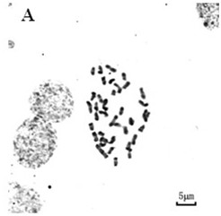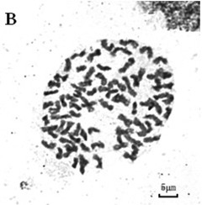

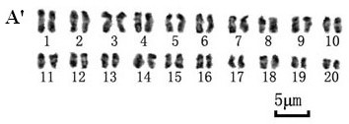
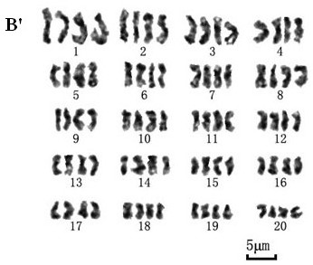

FIG. 1

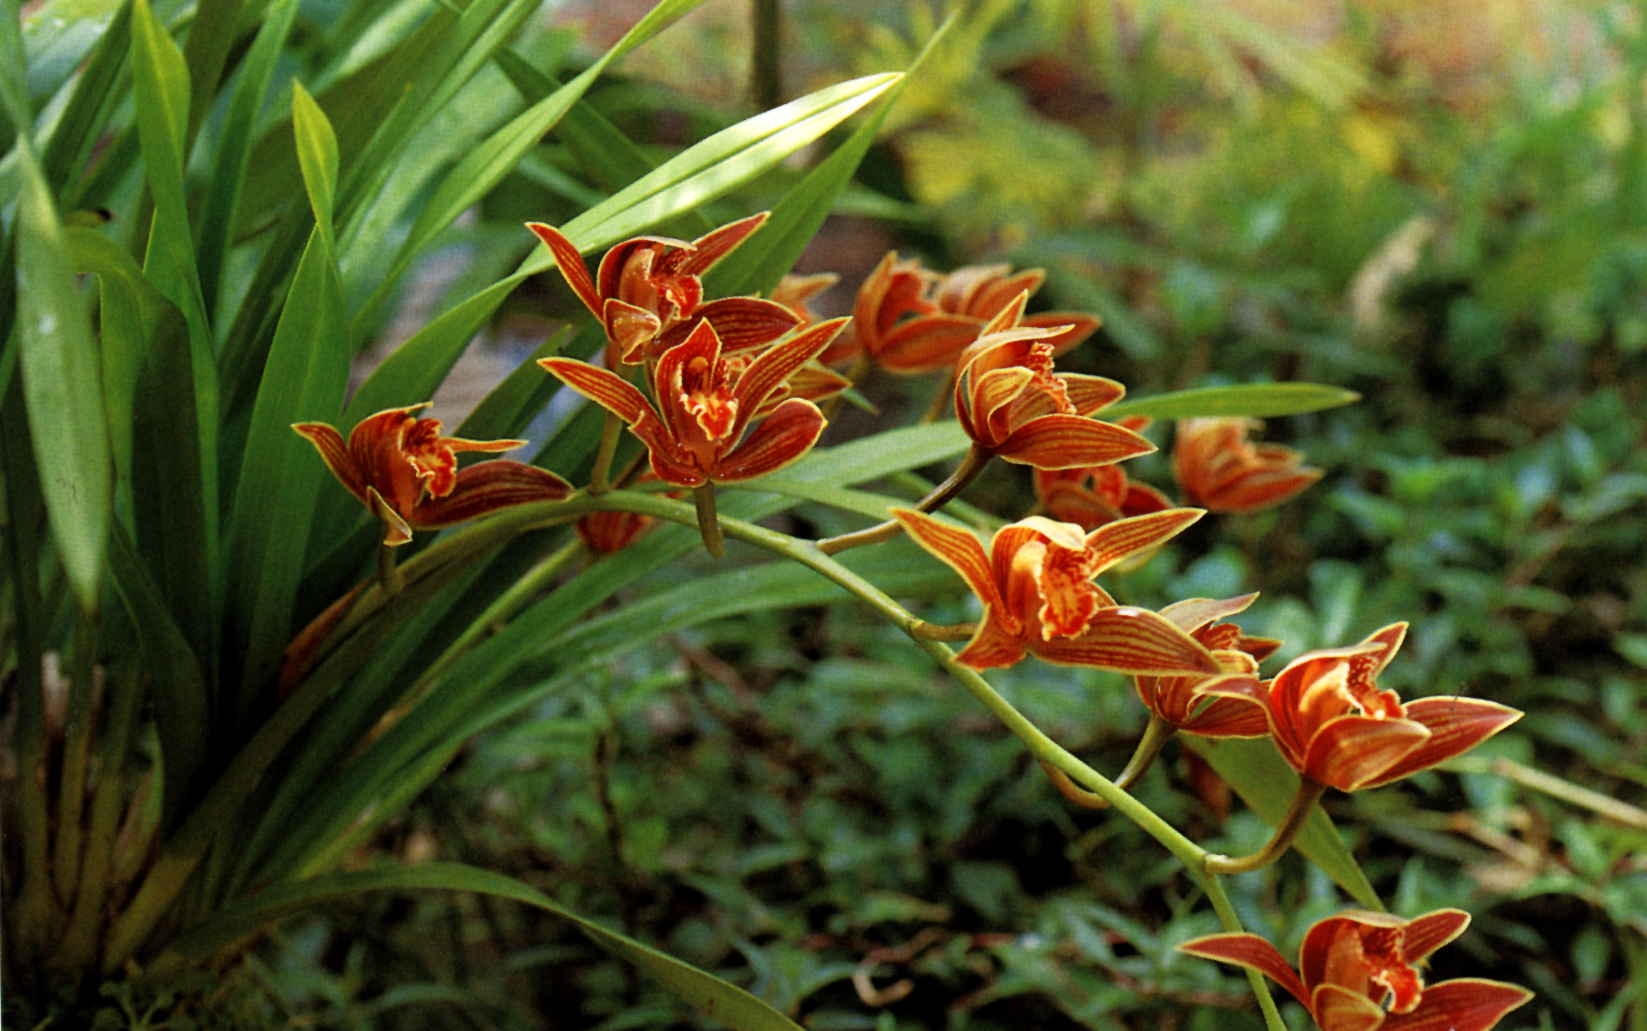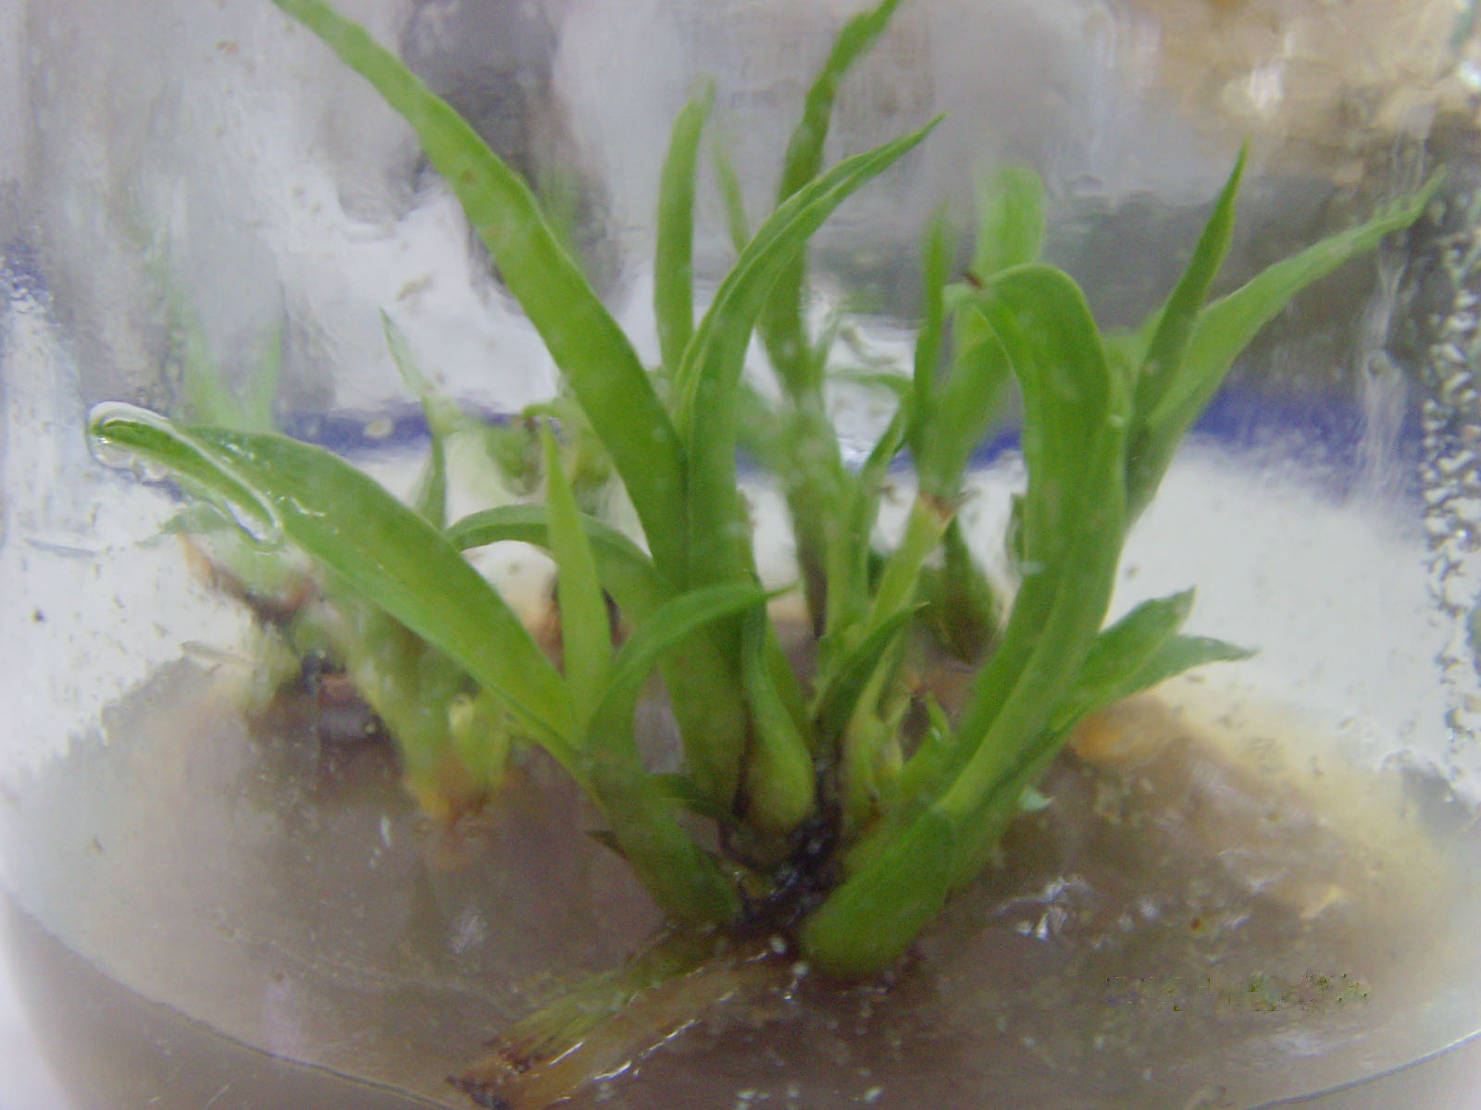
A
B

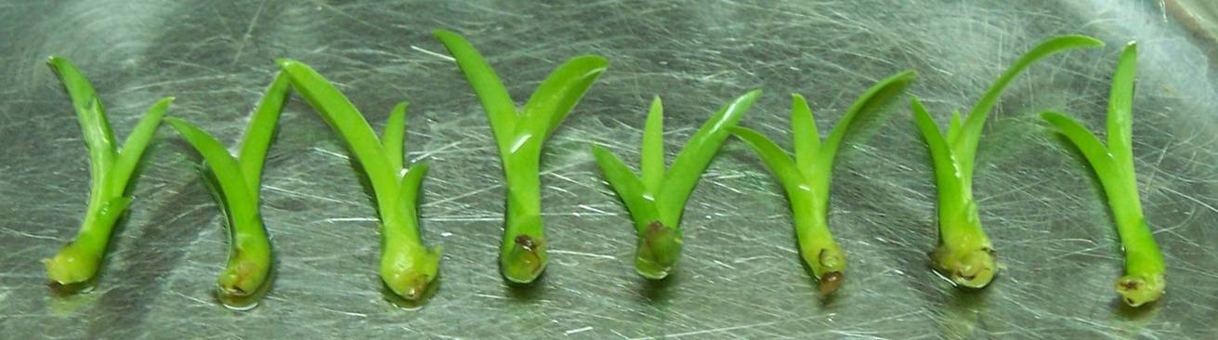
C

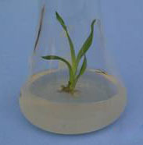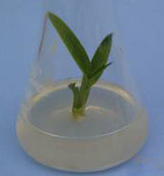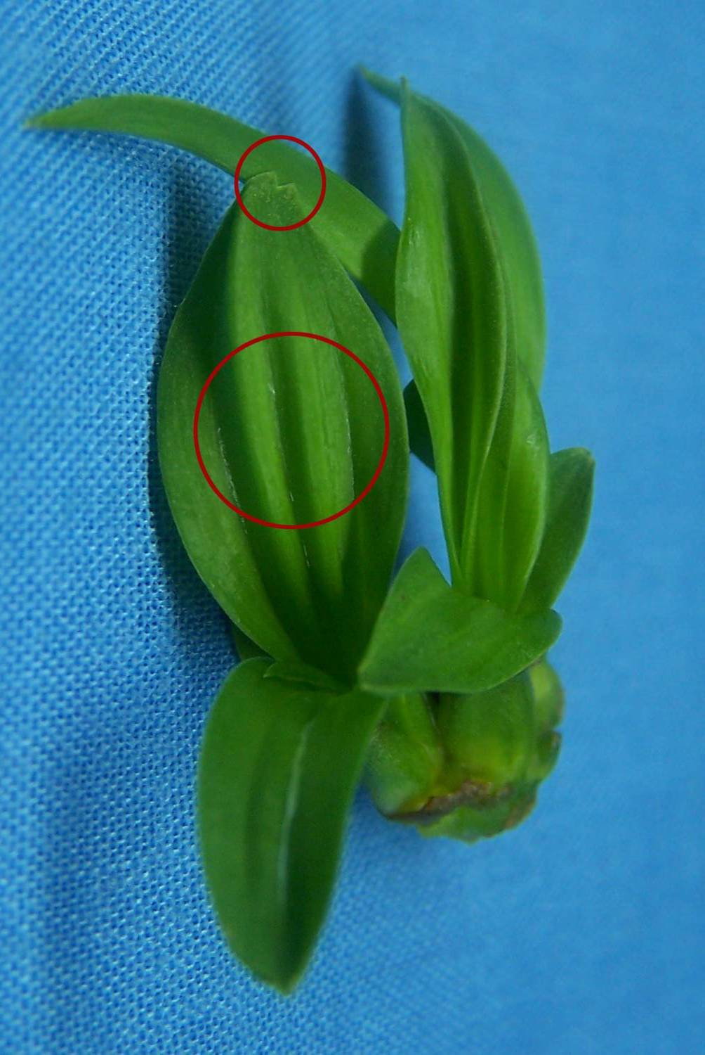
D
E
F
G
H
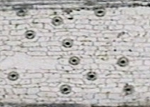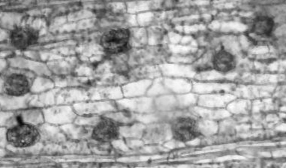
G
H

FIG. 2

