DEVELOPMENT OF POLLEN-MEDIATED ACTIVATION TAGGING SYSTEM FOR Phalaenopsis and Doritaenopsis
Emily Chin-Fun Chen¹, Hui-Min Ho¹, Sushim Kr. Gupta¹, Chang-Sheng Wang², Pei-Tsu Chen¹, Hsin-Sheng Tsay* ^{1,2}
- Institute of Biochemical Sciences and Technology, Chaoyang University of Technology, Wufong, Taichung 413, Taiwan.
- Department of Agronomy, National Chung-Hsing University Taichung 40227, Taiwan.
Dr. Emily Chin-Fun Chen, Institute of Biochemical Sciences and Technology, Chaoyang University of Technology, Wufong, Taichung 413, Taiwan, Tel: +886423303000 ext. 4578, Fax: +886423304921, Email: argentina@cyut.edu.tw.
Hui-Min Ho, Institute of Biochemical Sciences and Technology, Chaoyang University of Technology, Wufong, Taichung 413, Taiwan, Tel: +886423323000 ext. 7584, Fax: +886423304921, Email: jasminho@nhir.org.tw.
Dr. Sushim Kumar Gupta, Institute of Biochemical Sciences and Technology, Chaoyang University of Technology, Wufong, Taichung 413, Taiwan, Tel: +886423323000 ext. 7584, Fax: +886423304921, Email: sushimgupta@gmail.com.
Dr. Chang-Sheng Wang, Department of Agronomy, National Chung-Hsing University Taichung 40227, Taiwan. Tel: +886422840777 ext. 805, Fax: +886422877054, Email: wangchansen@nchu.edu.tw.
Pei-Tsu Chen, Institute of Biochemical Sciences and Technology, Chaoyang University of Technology, Wufong, Taichung 413, Taiwan, Tel: +886423303000 ext. 7584, Fax: +886423304921, Email: wing2418@yahoo.com.tw.
* Corresponding author
*Prof. Hsin-Sheng Tsay, Institute of Biochemical Sciences and Technology, Chaoyang University of Technology, Wufong, Taichung 413, Taiwan, Tel: +886423303000 ext. 7580, Fax: +886423304921, Email: hstsay@cyut.edu.tw.
Running Title: POLLEN-MEDIATED ACTIVATION TAGGING SYSTEM FOR ORCHIDS
Abstract
In the present study, a novel plant transformation system for Phalaenopsis and Doritaenopsis has been developed. The pollen-mediated activation tagging system was established by artificial pollination. The pollens, co-cultured with Agrobacterium tumefaciens strain EHA105 harboring an activation tagging vector (pTAG-8), were used for pollination. In order to optimize the transformation efficiency, several factors (concentration of A. tumefaciens, concentration of acetosyringone during co-cultivation and the duration of co-cultivation) known to influence Agrobacterium-mediated DNA transfer were examined. A concentration of 0.5-1 ×10⁸ CFU/ml for A. tumefaciens, 0.1 mM acetosyringone, and 6 h of co-culture period were found to be the optimal condition for high transformation efficiency. Integration of T-DNA into the genome of putative transgenic plants was confirmed by PCR and Southern blot analyses. Single copy of the transgene was observed in all transgenic plants analyzed. Most of the transgenic plants had a morphologically normal phenotype and the overall capsule formation efficiency was similar to control plant. Our results showed a new approach of genetic transformation for Phalaenopsis and Doritaenopsis and can be used for genetic improvement of the transgenic orchids.
Key words: Phalaenopsis amabilis, Doritaenopsis cultivars, activation tagging, Agrobacterium tumefaciens, transformation.
Introduction
Phalaenopsis and Doritaenopsis, an intergenetic hybrid between the orchid genera Doritis and Phalaenopsis, are grown throughout Asia and Pacific Ocean islands. Doritaenopsis often blooms longer and has more colors than the traditional Phalaenopsis. Both of them are cultivated for use as cut flowers or as blooming potted plants. Based on their economic value, genetic improvements with respect to the flower color, flower shape, disease resistance and flowering time are of considerable importance. However, progress in these respects has been very slow through sexual crossing techniques, due to the long growth and reproductive cycle of Phalaenopsis and Doritaenopsis. One effective alternative to this constraint is genetic transformation through Agrobacterium tumefaciens. Several studies have been reported on Agrobacterium-mediated transformation of Phalaenopsis (Anzai et al. 1996, Belarmino and Mii 2000, Chai et al. 2002) and other orchid species (Kuehnle and Sugii 1992, Chia et al. 1994, Nan et al.1998, Knapp et al. 2000, Yu et al. 2001, Liau et al. 2003). It is essential to optimize the transformation procedure, since plants exhibit wide variation in susceptibility to Agrobacterium. Since, tissue culture based methods require optimization of the plant regeneration system and often generate somaclonal variations, therefore, direct gene transfer method is an alternative for transformation. Direct transformation through pollen grains co-cultivated with A. tumefaciens has come up as an interesting alternative technique which has been used for transformation of Nicotiana langsdorffii (Sanford and Skubik 1986) and rice (Luo and Wu 1989).
The activation tagging system is normally used for generating gain-of function or loss-of function in mutants. By random insertion of a binary vector into the genome, it may enhance gene expression or knock-out the gene. This activation tagging approach has been successfully used in plants (Kardaisky et al. 1999, Van-Der Fits et al. 2001, Mathews et al. 2003, Hsing et al. 2007) and in fungi (Chen et al. 2009).
The purpose of the present study was to develop a pollen-mediated activation tagging system (PMATS) for Phalaenopsis and Doritaenopsis, and to analyze their effect on morphological changes. To date no study has been done on PMATS in orchids. To our knowledge, this is the first report on PMATS in orchids.
Materials and Methods
Plant materials
Potted plants of P. amabilis (45 cm in height) with white flowers (10-14 cm in diameter), Dpts. cultivars Sinica Sunday (55-62 cm in height) with pink flowers (10-12 cm), and Dtps. cultivars Taisuco Firebird (57-65 cm in height) with dark pink flowers (10-12 cm) (Fig 1A-C) were grown under greenhouse conditions in Chaoyang University of Technology, Taiwan.
Agrobacterium strain
A. tumefaciens strain EHA105, carrying a binary vector pTAG8 (Hsing et al. 2007, Chen et al. 2009) was used for the transformation. The T-DNA region of the binary vector contained a selectable marker coding for the hygromycin phosphotransferase (hptII) gene under CaMV 35S promoter was kindly provided by Dr. Yu (Academia Sinica). A. tumefaciens was cultured on LB medium containing 100 mg/l kanamycin, and 50 mg/l rifampicin at 28℃for 2 days.
Optimization of transformation conditions and pollination of flowers with pollen co-cultured with Agrobacterium
A. tumefaciens cells were harvested by centrifugation at 2500 x g for 10 min and their OD₆₀₀ was determined in resuspended liquid inoculation medium consisting of MS medium supplemented with 50 g/l sucrose, with or without acetosyringone (AS) at different concentrations (0, 0.1, 1, 10 mM). The cultures were then diluted to different concentrations (0.5×10⁸, 1×10⁸ , 5×10⁸, 50×10⁸cfu/ml) and used for the transformation. At full bloom, pollen from the flowers of recipient Phalaenopsis or Doritaenopsis plant to be pollinated was collected individually in 1.5 ml-centrifuge tubes. To each pollen sample, 100 μl A. tumefaciens in different concentrations was added without or with AS. The mixture of pollen grains and Agrobacterium was pasted either immediately (0 h) or after different co-culture periods (3, 6, 12, 24 or 48 h), onto the stigmas of the same recipient plant, thus facilitating self-pollination. Flowers without A. tumefaciens treated pollen served as control. Four months after the pollination, number of capsules formed under each treatment was recorded. The capsule ratio represents number of capsules divided by the number of flowers pollinated under each treatment.
Screening of orchid seedlings for hygromycin resistance
The optimum concentration of selection pressure for transformants was determined by using non-transformed orchid seeds. Capsules from both control and treatments were surface sterilized by immersion in 70% ethanol for 30-60 s, followed by soaking in 0.5% sodium hypochlorite for 20-30 min, and then rinsed with sterile water. After disinfected capsules were cut open in a sterile chamber, all seeds were scooped out and inoculated in Petri-dishes containing 1/2X MS basal medium (Murashige and Skoog 1962) supplemented with different concentrations of hygromycin (0, 0.125, 0.625, 1.25, 2.5, 5 and 10 mg/l). All transformants were selected on 1/2X MS basal medium with optimized concentration of hygromycin (5 mg/l, data not shown) 2 months after culture. The putative seedlings which survived on hygromycin were transferred to growth chamber for 3 weeks and later to green house for further growth.
Identification of activation-tagged Phalaenopsis and Doritaenopsis
To confirm the transformation, hygromycin-resistant transformants were randomly selected for genomic DNA extraction and PCR analysis. Total genomic DNA from the leaves of these putative transformants was extracted by CTAB method (Doyle and Doyle 1987). Integration of the foreign gene into the genome was confirmed by PCR using gus gene specific primers (GUSF: 5’GAAAGGTTGGGCAGGCCAGC3’ & GUSR: 5’TCGCCTGTAAGTGCGCTTGCT3’). The PCR was performed by using 50 ng of genomic DNA, 200 μM of each dNTP, 0.5 μM of each gus primer and one unit of Taq polymerase. Reactions were carried out with hot-started at 94ºC for 5 min and subjected to 35 cycles of denaturation at 94ºC for 30 s, annealing at 60ºC for 30 s, and elongation at 72ºC for 40 s. The final extension phase was prolonged for 10 min at 72ºC. The amplified 950 bp fragment from a control plant and different transgenic lines were electrophoresed on 1% agarose gel and visualized under UV after staining with ethidium bromide.
Southern hybridization analysis:
Six putative transformants were selected and their genomic DNA (15 μg) was digested with EcoRI and HindIII, the digested DNA was size-fractionated on 1% agarose gel. The gel was treated with dupurination, denaturation and neutralization buffers and DNA was transferred onto positively charged nylon membranes (Bio-Rad) as described by Sambrook et al (1989). A PCR-amplified fragment of the gus gene was labeled with digoxigenin-9-dUTP using Dig High Prime Labeling and Detection Starter Kit I (Roche, USA). This labeled probe was used for hybridization at 52ºC and later passed through series of stringency washes (high stringency at 56ºC) to eliminate unspecific binding. The hybridized probes were immuno-detected with anti-digoxigenin-AP, Fab fragments and visualized with the colorimetric substrates NBT/BCIP according to manufacturers instruction.
Results
Optimal conditions for high activation-tagged transformation efficiency in both Phalaenopsis and Doritaenopsis
In order to obtain the highest number of pollen-mediated activation-tagged transformants of P. amabilis and Doritaenopsis cultivars, a series of studies on Agrobacterium concentration, AS concentration, and co-culture period were carried out. Out of several Agrobacterium concentrations tested, 0.5x10⁸ cfu/ml to 1x10⁸ cfu/ml was the best for the co-culture. High concentration (50x10⁸ cfu/ml) of Agrobacterium produced no transformants, under different concentration of AS, an inducer of the vir gene expression of A. tumefaciens (Fig 2A). Higher concentration of AS had negative effect on the capsule ratio while lower concentrations promoted capsule ratio. Thus, capsule ratio was used as one of criteria to select transgenics and with lower concentration of AS (0.1 mM) and A. tumefaciens (0.5x10⁸ cfu/ml to 1x10⁸ cfu/ml), the capsule ratio increased significantly. Optimizing the co-cultivation time with A. tumefaciens to 6 h yielded the highest transformation frequency (Fig 2B). These experiments demonstrated that 0.5x10⁸ cfu/ml to 1x10⁸ cfu/ml of A. tumefaciens, 0.1 mM AS, and 6 h of co-culture period are the optimum conditions for the transformation of P. amabilis and Doritaenopsis cultivars. A total of 30 transformants of P. amabilis, 7 transformants of Dpts. cultivars Sinica Sunday, and 15 transformants of Dpts. cultivars Taisuco Firebird were obtained after selection in 5 mg/l hygromycin (Fig 1E and F).
Identification of T-DNA insertion by PCR
Although the most widely used method for the generation of transgenic plants is the Agrobacterium-mediated transformation which precisely delimited DNA sequences with a single integration (Lawrence and Koundal 2001), the structure of the inserted T-DNA varies widely to include single or multiple copies, at a unique or several loci in the plant genome. Total DNA isolated from the putative transformants was tested for the presence of the transgene. PCR amplification confirmed that the gus genes were present in plants grown in hygromycin selection medium. The PCR results of expected 950 bp fragments in four randomly selected (two from P. amabilis, one from Dpts. cultivars Sinica Sunday and one from Dpts. cultivars Taisuco Firebird) putative transgenic orchids are displayed in Figures 3. In this experiment, no PCR band was detected in the untransformed control (Fig 3).
Southern hybridization of activation-tagged transformants
Southern blot analysis were carried out to evaluate further the transfer and insertion of foreign gene lies between left and right border in the genome of the transformed Phalaenopsis and Dpts. cultivar. Hybridization of gus gene to EcoRI and HindIII digested genomic DNA from the transgenic plantlets is shown in Figure 4 A and B (transformant of Dpts. cultivars Sinica Sunday shown in lane:1, transformant of P. amabilis in lane 2, and transformants of Dtps. cultivars Taisuco Firebird in lane:3-6) respectively. The results confirmed that all six selected transgenic plantlets, contained bands with sizes larger than the gus gene fragment (950 bp) and were indicative of integration of the introduced plasmid part into the host plant genome. The results confirmed the transgenic nature and showed a uniform insertion pattern with only single insertion. No bands were detected in the wild type (Data not shown). The presence of calcium oxalate in the tissues of these species makes it difficult to isolate DNA. Thus, only few transgenic were analyzed through Southern blots.
Phenotypic characterization of dominant mutant in Phalaenopsis and Doritaenopsis
The selected T1 transformants of Phalaenopsis and Dpts cultivars were transferred to green house for acclimation to ex vivo conditions and their phenotypic characteristics were analyzed in two years of their growth. Most of transformants are morphologically similar to wild types. A small number of T1 transformants showed distinct phenotypic variations. Stunted growth was observed in the transformants of P. amabilis and of Dpts. cultivars (22 cm, one half of the wild type; Fig 5A, 5B and 5F) among the selected 30 transgenic P. amabilis (3%), 7 transformants of Dpts. cultivars Sinica Sunday (14%) and 15 transformants of Dpts. cultivars Taisuco Firebird (6%). Small size flowers were observed in two of the 15 transformants of Dpts. cultivars Taisuco Firebird (Fig 5C and 5E) and delayed flowering was observed in another selected transgenic Dpts. cultivars Taisuco Firebird (Fig 5D).
Discussion
Activation tagging has been used as a powerful tool to discover gene functions as well as to identify promoter regions. Many transgenic plants (Tani et al. 2004) or fungi (Chen et al. 2009) have been generated by this method. In the present study, a successful activation-tagged system was established in Phalaenopsis and Doritaenopsis via pollen-mediated Agrobacterium transformation. P. amabilis, Dpts. cultivars Sinica Sunday, and Dpts. cultivars Taisuco Firebird were used as the starting material for establishing PMATS because of their remarkable economic values.
Transformation efficiencies of orchids, like those of other plants or fungi, are correlated to the Agrobacterium and AS concentrations. Meyer et al (2003) reported that the excess of A. tumefaciens cause a decreased transformation efficiency. High Agrobacterium concentration (50x10⁸ cfu/ml) affected the capsule rate and the recovery of transgenic seedlings, resulting no transformants in this study. On the other hand, several studies have shown that co-culture periods may affect the transformation efficiency. A prolonged co-cultivation period (3d) has increased transformation efficiency in rice callus (Mohanty et al. 1999), while overnight co-culture has produced maximum transformants in Phalaenopsis callus (Belarmino and Mii 2000). Co-culture of pollen with A. tumefaciens and A. rhizogenes have been tested in tobacco (Sanford and Skubik 1986). However, no transformants have achieved in maize, when, pollens were mixed with plasmid DNA before pollination (Booy et al. 1989). No transformants have achieved in tobacco with mature pollens (Negrutiu et al. 1986). In case of Arabidopsis thaliana, transgenic plants have been generated by vaccum-infiltration of whole inflorescences with A. tumefacien in MS medium (Bechtold et al. 1993). Moreover, genetic transformations of Petunia hybrid have been generated by pollinating flowers through vacuum-infiltrated with A. tumefacien or by applying a drop of A. tumefacien to the stigma immediately or prior to pollination (Tjokrokusumo et al. 2000). Several reports have demonstrated that flavonoid compounds from pollen have activated the vir gene in A. tumefaciens (Zerback et al. 1989, Hess et al. 1990), while, ethylene has inactivated vir gene and ultimately effected transformation efficiency (Nonaka et al. 2008). The pollen grains were co-cultured with Agrobacterium for different time periods and maximum transformation efficiency were obtained 6 h after co-cultivation, the possible reason for maximum transformants after 6 h could be the counterfeit effect of flavonoids over ethylene which enhanced vir gene activation and ultimately total transformation efficiency. When co-culture period extended further the ethylene accumulation might have surpassed the flavonoid thus, reduced transformation efficiency. Flavonoids itself act as a chemical inducer and due to the presence of these flavonoid compounds in pollen required low levels of AS (0.1 mM) sufficient for good transformation efficiency in P. amabilis, and Dpts. cultivars. In the present study, a pollen-mediated transformation system with 0.1 mM AS, 0.5x10⁸ cfu/ml to 1x10⁸ cfu/ml of A. tumefaciens and co-culture for 6 h was established in P. amabilis, and Dpts. cultivars.
Integration of the T-DNA (from pTAG8) into the putative transgenic plant genomes was further confirmed by PCR and Southern blot analyses. Plants grew in selective media were randomly selected for molecular analysis. PCR analyses were conducted using the primer set for the gus gene and showed the expected size bands of 950 bp, in all randomly selected plants (Fig. 3). The amplified bands were not detected with gus primer set in untransformed plants. Southern blot analysis was carried out using the gus gene as probe. Genomic DNA from six putative transgenic plants was digested with EcoRI and HindIII, which only cut gus gene once and allowed to hybridize with the gus probe. Single copy insertion was observed in all six T1 transformants: one from Dpts. cultivars Sinica Sunday (Fig. 4A, lane1; Fig. 4B, lane 1), one from P. amabilis (Fig. 4A, lane 2; Fig. 4B, lane 2) and four from Dtps. cultivars Taisuco Firebird (Fig. 4A, lane 3-6; Fig. 4B, lane 3-6). Single or low-copy-number integration of transgenes through Agrobacterum have been observed in several plant species (Fransz et al. 1996, Ming et al. 2000). Although a single-copy insertion may facilitates the recovery of DNA sequences of the affected gene in most fungal genomes (Michielse et al. 2005), it is very difficult to isolate the flanking sequence of T-DNA in orchids by using TAIL-PCR or inverse PCR.
Without knowing the sequence of the affected gene, the PMATS developed in the present study is very useful in improving flower phenotypes or flowering time. Among 52 transformants (30 transformants of P. amabilis, 7 transformants of Dpts. cultivars Sinica Sunday and 15 transformants of Dpts. cultivars Taisuco Firebird) obtained, a small number of T1 transformants showed distinct phenotypic variations: stunted growth, small size flowers and delayed flowering. The occurrence of these changes might be caused by the integration of transgene or due to somaclonal variations. These variations frequently occur in in vitro culture of orchids (Ariffin and Basiran 2000). These variations are more frequent when culture goes through prolonged subculturing and longer duration of induction (Thorpe 1994).
An efficient, rapid and simple PMATS was developed in P. amabilis, Dpts. cultivars Sinica Sunday, and Dtps. cultivars Taisuco Firebird. This is the first report on PMATS in orchids and it can be used for genetic improvement in both Phalaenopsis and Doritaenopsis.
Acknowledgement
Research grants (NSC 93-2317-B324-001 and NSC 94-2317-B324-001) from the National Science Council, Taiwan are gratefully acknowledged.
Literature cited:
Anzai H., Ishii Y., Shichinohe M., Katsumata K., Nojiri C., Morikawa H., Tanaka M. (1996). Transformation of Phalaenopsis by particle bombardment. Plant Tissue Culture Letter, 13: 265-271.
Ariffin S., Basiran MN. (2000). Induced mutation of Dedrobium orchid. Seminar Research and Development MINT-2000., Malaysia.
Bechtold N., Ellis J., Pelletier G. (1993). In planta Agrobacterium-mediated gene transfer by infiltration of adult Arabidopsis thaliana plants. CR Academics of Science Paris Life Sciences, 316:1194-1199.
Belarmino MM., Mii M. (2000). Agrobacterium-mediated genetic transformation of a Phalaenopsis orchid. Plant Cell Reports, 19: 435-442.
Booy G., Krens FA., Huizing HJ. (1989). Attempted pollen-mediated transformation of maize. Journal of Plant Physiology, 135: 319-324.
Chai ML., Xu CJ., Senthil KK., Kim JY., Kim DH. (2002). Stable transformation of protocorm-like bodies in Phalaenopsis orchid mediated by Agrobacterium tumefaciens. Scientia Horticulturae, 96: 213-224.
Chen EC., Su Y., Selvaraju K., Agrawal DC., Tsay HS. (2009). Development of an activation tagging system for the basidiomycetous medicinal fungus Antrodia cinnamomea. Mycology Research, 113: 290-297.
Chia TF., ChanYS., Chua NH. (1994). The firefly luciferase gene as a non-invasive reporter for Dendrobium transformation. The Plant Journal, 6: 441-446.
Doyle JJ., Doyle JL. (1987). A rapid DNA isolation procedure for small quantities of fresh leaf tissue. Phytochemistry Bulletin, 19: 11-15.
Fransz PF., Stam M., Montijn B., Tenhoopen R., Wiegant J., Kooter JM., Oud O., Nanninga N. (1996). Detection of single-copy genes and chromosome rearrangements in Petunia hybrida by ﬂuorescence in situ hybridization. The Plant Journal, 9: 767–774.
Hess D., Dressler K., Nimmrichter R. (1990). Transformation experiments by pipetting Agrobacterium into the spikelets of wheat (Triticum aestivum L.). Plant Science, 72: 233-244.
Hsing YI., Chen CG., Fan MJ., Lu PC., Chen KT., Lo SF., Sun PK., Ho SL., Lee KW., Wang YC., Huang WL., Ko R., Chen S., Chen JL., Chung CI., Lin YC., Hour AL., Wang YW., Chang YC., Tsai MW., Lin YS., Chen YC., Yen HM., Li CP., Wey CK., Tseng CS., Lai MH., Huang SC., Chen LJ., Yu SM. (2007). A rice gene activation/knockout mutant resource for high throughput functional genomics. Plant Molecular Biology, 63: 351-364.
Kardailsky I., Shukla VK., Ahn JH., Dagenais N., Christensen SK., Nguyen JT., Chory J., Harrison MJ., Weigel D. (1999). Activation tagging of the floral inducer FT. Science, 286: 1962-1965.
Kuehnle AR., Sugii N. (1992). Transformation of Dendrobium orchid using particle gun bombardment of protocorms. Plant Cell Reports, 11: 484-488.
Knapp JE., Kausch AP., Chandlee JM. (2000). Transformation of three genera of orchid using the bar gene as a selectable marker. Plant Cell Reports, 19: 893-898.
Lawrence PK., Koundal KR. (2001). Agrobacterium tumefaciens-mediated transformation of pigeon pea [Cajanus cajan (L.) Mill sp.] and molecular analysis of regenerated plants. Current Science, 80:1428–1432.
Liau CH., You SJ., Prasad V., Hsiao HH., Lu JC., Yang NS., Chan MT. (2003). Agrobacterium tumefaciens-mediated transformation of an Oncidium orchid. Plant Cell Reports, 21: 993-998.
Luo ZX., Wu R. (1989). A simple method for the transformation of rice via the pollen-tube pathway. Plant Molecular Biology Reporter, 7: 69-77.
Mathews H., Clendennen SK., Caldwell CG., Liu XL., Connors K., Matheis N., Schuster DK., Menasco DJ., Wagoner W., Lightner J., Wagner DR. (2003). Activation tagging in tomato identifies a transcriptional regulator of anthocyanin biosynthesis., modification., and transport. Plant Cell, 15: 1689-1703.
Meyer V., Mueller D., Strowig T., Stahl U. (2003). Comparison of different transformation methods for Aspergillus giganteus. Current Genetics, 43: 371-377.

Ming X., Wang L., An C., Yuan H., Chen Z. (2000). Resistance to rice blast (Pyricularia oryzae) caused by the expression of trichosanthin gene in transgenic rice plants transferred through Agrobacterium method. Chinese Science Bulletin, 47: 1774-1778.
Mishelse CB., Hooykaas PJJ., Van der Hondel CA., Ram AF. (2005). Agrobacterium-mediated transformation as a tool for functional genomics in fungi. Current Genetics, 48: 1-17.
Mohanty A., Sharma NP., Tyagi AK. (1999). Agrobacterium-mediated higher frequency transformation of an elite indica rice variety Pusa Basmati1 and transmission of trangenes to R2 progeny. Plant Science, 147: 127-137.
Murashige T., Skoog F. (1962). A revised medium for rapid growth and bioassays with tobacco tissue culture. Physiologia Plantarum, 15:473-497.
Nan GL., Kuehnle AR., Kado CI. (1998). Transgenic Dendrobium orchid through Agrobacterium-mediated transformation. Malay Orchid Review, 32: 93-96.
Negrutiu I., Heberle-Bors E., Potrykus I. (1986). Attempts to transform for kanamycin-resistance in mature pollen of tobacco. In: Mulcahy DL., Bergamini-Mulcahy G., Ottaviano E. (Eds.) Biotechnology and Ecology of pollen. Springer, Berlin Heidelberg New York: 65-70.
Nonaka S., Yuhashi K., Takada K., Sugaware M., Minamisawa K., Ezura H. (2008). Ethylene production in plants during transformation suppresses vir gene expression in Agrobacterium tumefaciens. New Phytology, 178: 647-56.
Sambrook J., Frisch EF., Maniatis T. (1989). Molecular cloning: a laboratory manual (2 Eds.). Cold Spring Harbor Press, New York.
Sanford JC., Skubik KA. (1986). Attempted pollen-mediated transformation using Ti-plasmids. In: Mulcahy DL., Bergamini-Mulcahy G., Ottaviano E. (Eds.) Biotechnology and Ecology of pollen. Springer, Berlin Heidelberg, New York: 71-82.
Tani H., Chen X., Numberg P., Grant JJ., SantaMaria M., Chini A., Gilroy E., Birch PRJ., Loake GL. (2004). Activation tagging in plants: a tool for gene discovery. Functional and Integrative Genomics, 4: 258-266.
Thorpe TA. (1994). Morphogenesis and regeneration. In: Vasil IK., Thorpe TA. (Eds.) Plant Cell and Tissue Culture. Kluwer Academic Publishers: 17–36.
Tjokrokusumo D., Heinrich T., Wylie S., Potter R., McComb J. (2000). Vacuum infiltration of Petunia hybrida pollen with Agrobacterium tumefaciens to achieve plant transformation. Plant Cell Reports, 19: 792-797.
Van der Fits L., Hilliou F., Memelink J. (2001). T-DNA activation tagging as a tool to isolate regulators of a metabolic pathway from a genetically non-tractable plant species. Transgenic Research, 10: 513-521.
Yu H., Yang SH., Goh CJ. (2001). Agrobacterium-mediated transformation of a Dendrobium orchid with the class 1 knox gene DOH1. Plant Cell Reports, 20: 301-305.
Zerback R., Dressler K., Hess D. (1989). Flavonoid compounds from pollen and stigma of Petunia hybrida:inducers of the vir region of Agrobacterium tumefaciens Ti plasmid. Plant Science, 62: 83-91.

Figure legends
Fig.1 Potted plants of Dpts. cultivars Sinica Sunday (A), P. amabilis (B) and Dtps. cultivars Taisuco Firebird (C), and transgenic plantlets on selection pressure after co-cultivation (E and F). D is control.
Fig. 2. Effect of acetosyringone concentration (A) and co-culture period of pollen and Agrobacterium (B) on capsule ratio.
Fig. 3 Identification of randomly selected seedling of putative T1 transformants of Phalaenopsis and Doritaenopsis by PCR of GUS gene. M: DNA marker, P: pTAG-8 as template, D: WT Dpts. cultivars , Ph: WT P. amabilis, S1-4: putative transformants.
Fig. 4 Confirmation of T1 transformants of Phalaenopsis and Doritaenopsis by Southern blots. Six randomly selected T1 transformants were digested by EcoRI (A) or HindIII (B), and hybridized by GUS probe. 1: transformant of Dpts. cultivars Sinica Sunday, 2: transformant of P. amabilis, 3-6: transformants of Dtps. cultivars Taisuco Firebird.
Fig. 5 Phenotypic characterization of dominant mutants in Phalaenopsis and Doritaenopsis. A: transformant of Dpts. cultivars Sinica Sunday, B: transformant of P. amabilis, C-F: transformants of Dtps. cultivars Taisuco Firebird.
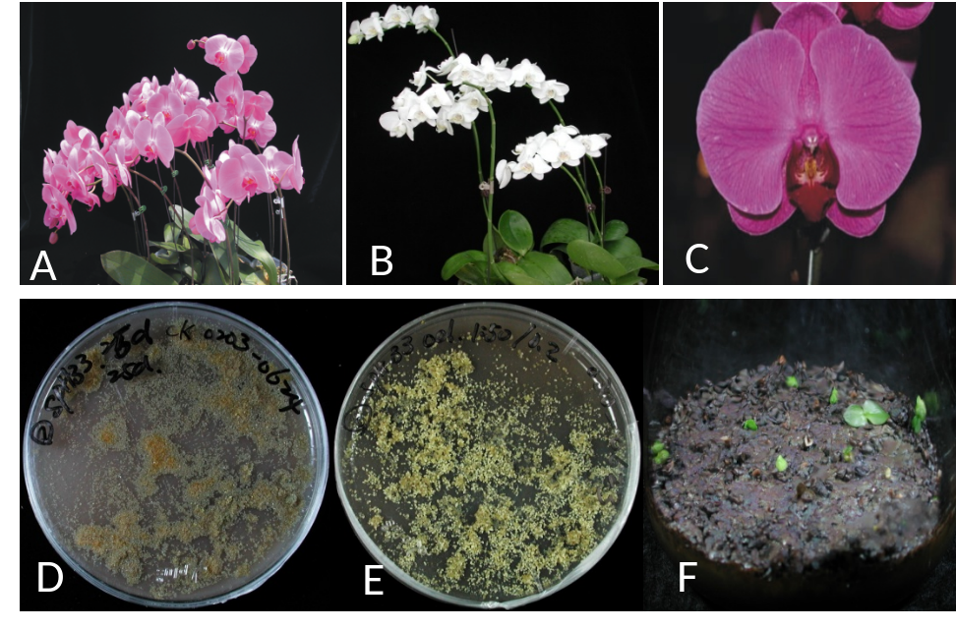

Fig. 1
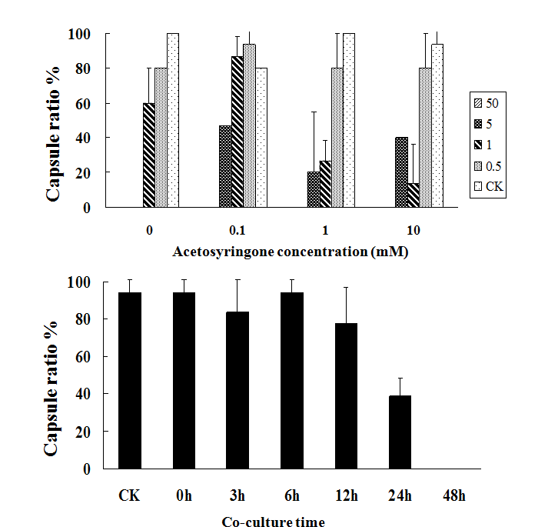
Fig. 2
A
BA

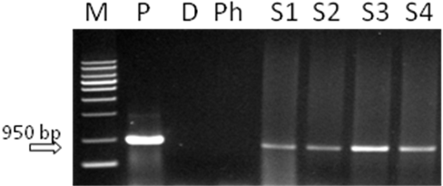

Fig. 3

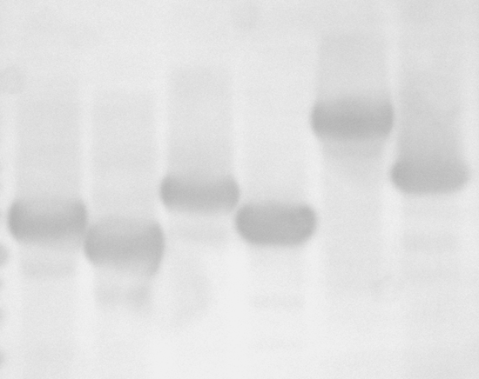
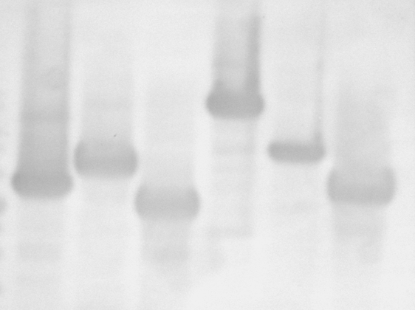
1 2 3 4 5 6
5.0 kb

3.5 kb
3.0 kb
A
1 2 3 4 5 6
5.0 kb

3.5 kb
3.0 kb
B

Fig. 4
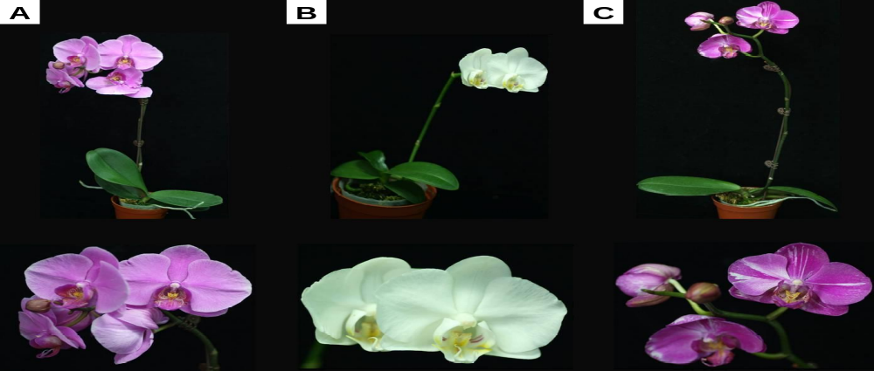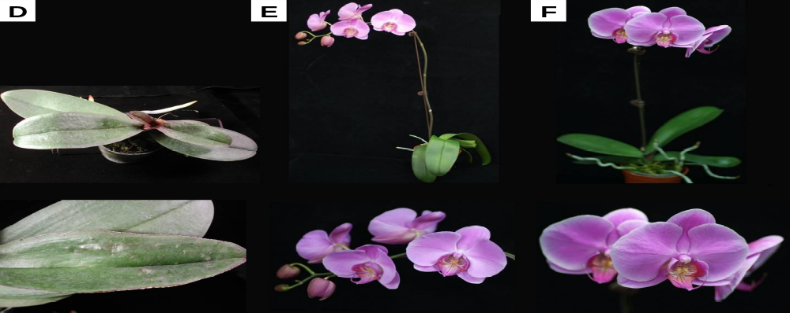
Fig. 5

