IN VITRO PROPAGATION OF SEDUM SPECTABILE BOREAU VIA LEAF CULTURE

Cui-Qin Yang^{1, 2}, Yao-Guo Qin³, Xin Sun², Shu Yuan¹ and Hong-Hui Lin^{1*}
¹ Key laboratory of Bio-resources and Eco-environment,College of Life Science, State Key Laboratory of Hydraulics and Mountain River Engineering,Sichuan University, Chengdu 610065 Sichuan, P. R. China
²College of Agriculture, Sichuan Agricultural University, Chengdu 611130, P. R. China.
³College of Horticulture, Sichuan Agricultural University, Ya'an 625014 Sichuan, P. R. China;
*E-mail: honghuilin@hotmail.com

Abstract
An efficient protocol for in vitro propagation of Sedum spectabile Boreau and an effective method for reversing hyperhydric plantlets were established in this study. In order to screen out the optimal explant, adventitious shoot regeneration and somatic embryoid induction were investigated with different parts of leaves, which were cultured on MS medium supplemented with different concentrations of BA or TDZ in combination with 0.1 mg l⁻¹ NAA. The results showed that compared with leaf middle and leaf tip, the leaf base was an optimal explant for in vitro shoot formation with the highest shoot induction rate of 88.9%, which was obtained from the culture medium supplemented with 0.4 mg l⁻¹ TDZ and 0.1 mg l⁻¹ NAA. Moreover, multiple shoot regeneration was preferable from leaves cultured on MS medium containing TDZ rather than BA. Shoots could root on plant growth regulator (PGR)-free MS medium. Furthermore, hyperhydric leaves could be observed in the initial culture, and then developed into somatic embryoids a month after inoculation, formed into hyperhydric plantlets. The hyperhydric plantlets could be reversed and became normal plantlets by removing PGRs from culture mediums. This is the first report on hyperhydricity in Sedum spectabile Boreau propagation. Our study provides a better understanding on the factors that influence hyperhydricity during in vitro regeneration.

Keywords: Sedum spectabile Boreau, leaf, tissue culture, hyperhydricity

INTRODUCTION
Sedum spectabile Boreau belongs to Crassulaceae family, the members of which are widely distributed throughout the warm and temperate zones. Sedum spectabile Boreau is an herbaceous perennial plant, which has strong tolerance to drought (Rabas and Martin 2003), low temperature (Iles et al. 1993; Iles and Agnew 1995), shade (Jiang et al. 2007), salt, barren soil, and etc. Many cultivars of Sedum spectabile Boreau have showy flowers with colors of white, pink or red. So it is used commonly in many countries as an ornamental plant. It also has a certain prospect to remedy the soil polluted slightly by Hg or Co (Wang et al. 2008). Meanwhile, Sedum spectabile Boreau is a facultative crassulacean acid metabolism (CAM) plant (Lin et al. 2003), which can be used as a good material for physiological studies.
Sedum spectabile Boreau is often propagated by cuttings or division of the roots. However, these conventional methods are slow and require a large numbers of parent propagules. In this case, in vitro culture is a candidate for overcoming these deficiencies. But there are few reports on tissue culture of Sedum spectabile Boreau. So, in this study, the leaves of Sedum spectabile Boreau were used as explants to investigate leaf morphogenesis in the process of culturing with the aim of establishing a regeneration system. It is wished to provide a reference for tissue culture and rapid propagation clone of Sedum spectabile Boreau as well. Also, we succeeded in overcoming the problem of hyperhydricity by removing PGRs. This result indicated the possibility to reduce or control hyperhydricity of in vitro grown plants, and thereby facilitating them for successful transfer to soil.

MATERIALS AND METHODS
Plant materials
Leaves of Sedum spectabile Boreau cultivar ‘Pink’ plants were used in this study.
Experimental design
Effects of cytokinin concentration on the morphogenesis of leaves
Leaves were washed in running tap water for 30 minutes, and sterilized by 70% ethanol for 10 seconds followed by 0.1% mercuric chloride for 8 minutes, and then washed five times in sterilized distilled water. These leaves were cut into three parts, namely, leaf top, leaf middle and leaf base (Fig.1A,B), which were cultured on Murashige and Skoog (1962) (MS) medium supplemented with different concentrations of BA ( 0.5, 1.0, 2.0 mg l⁻¹) or TDZ ( 0.2, 0.4, 0.6 mg l⁻¹) in combination with 0.1 mg l⁻¹ NAA. MS medium without PGRs was used as control.
Effects of PGRs on the morphogenesis of hyperhydric leaves
Hyperhydric leaves obtained from primary culture were inoculated on MS medium supplemented with 1.0 mg l⁻¹ BA or 0.4 mg l⁻¹ TDZ in combination with 0.1 mg l⁻¹ NAA. MS medium without PGRs was used as control.
Hyperhydric plantlets induced from hyperhydric leaves were cultured on PGR-free MS medium and MS medium containing 0.4 mg l⁻¹ TDZ and 0.1 mg l⁻¹ NAA.
Organogenesis of stem segments from plantlets in vitro
Regeneration of shoots
The stem of reversed normal plantlets was cut into about 2 cm segments with a node, and then inoculated on MS medium supplemented with different concentrations of TDZ (at 0.2,0.4,0.6 mg l⁻¹) in combination with 0.1 mg l⁻¹ NAA. MS medium without PGRs was used as control.
Induction of roots
The same stem segments were cultured on MS medium supplemented with NAA (0.1, 0.5, 2.5 mg l⁻¹) or IBA (at 0.1, 0.5, 2.5 mg l⁻¹) to induce roots.
Acclimatization
Rooted plantlets were washed with tap water to remove agar sticking to the roots and transferred to the sand then placed in the greenhouse at natural light/dark circle of sunlight with 24±2 ℃. The survival rate was investigated after a week.
Culture condition
All the above culture mediums contained 30.0 g l⁻¹ sugar and 6.0 g l⁻¹ agar. The pH of all the culture mediums was adjusted to 5.8 before autoclaving at a pressure of 105kPa for 20 minutes at 121℃. All cultures were incubated under 16 h photoperiod at 40 µmol m⁻²s⁻¹(cool white fluorescent light), at 23 ± 2 ℃ and 70~80% relative humidity.
Statistical analysis
Each treatment was inoculated with 40 explants and was repeated three times in the experiment of effects of PGRs on the morphogenesis of hyperhydric materials. Five replicates were used per treatment with 15 explants in other experiments. All data were recorded after 4 weeks of culture. The significance of differences among means was tested by Duncan's multiple range test (Duncan 1995).

RESULTS AND DISCUSSION
Effects of cytokinin concentration on the morphogenesis of leaves
All leaves expanded obviously a week after inoculation. Three types of organogenesis after swollenness were observed. Type I extended at twice to three times compared to its original volume and showed hyperhydric. Hyperhydric somatic embryoids regenerated from this type of leaves and then developed into hyperhydric plantlets (Fig.1E, G). Comparatively, type II was less swollen. And normal shoots were initiated from the cut surface of the morphological lower side of these leaves (Fig.1C, D). Although type III was also less swollen, there were not visible changes after a month.

Table 1. Morphogenesis of leaves 4 weeks after inoculation
Explant types | BA concentrations (mg l⁻¹) | TDZ concentrations (mg l⁻¹) | Embryoid induction rate (%) | Shoot induction rate (%) | Mean number of shoots
Leaf tip | 0 | 0 | 0 C | 0 E | 0 C
 | 0.5 | 0 | 0 C | 0 E | 0 C
 | 1.0 | 0 | 0 C | 0 E | 0 C
 | 2.0 | 0 | 14.3 A | 14.3 D | 0.1 C
 | 0 | 0.2 | 0 C | 33.3 B | 0.7 A
 | 0 | 0.4 | 0 C | 50 .0A | 0.3 B
 | 0 | 0.6 | 8.3 B | 25.0 C | 0.6 A
Leaf middle | 0 | 0 | 0 D | 0 D | 0 B
 | 0.5 | 0 | 11.1 B | 0 D | 0 B
 | 1.0 | 0 | 50.0 A | 0 D | 0 B
 | 2.0 | 0 | 12.5 B | 0 D | 0 B
 | 0 | 0.2 | 0 D | 60.0 A | 2.4 A
 | 0 | 0.4 | 8.3 C | 25 .0C | 0.4 B
 | 0 | 0.6 | 0 D | 50.0 B | 0.5 B
Leaf base | 0 | 0 | 0 B | 0 E | 0 C
 | 0.5 | 0 | 0 B | 0 E | 0 C
 | 1.0 | 0 | 11.1 A | 11.1 D | 0.1 C
 | 2.0 | 0 | 0 B | 0 E | 0 C
 | 0 | 0.2 | 0 B | 44.4 B | 0.6 B
 | 0 | 0.4 | 11.1 A | 22.2 C | 0.7 B
 | 0 | 0.6 | 11.1 A | 88.9 A | 1.7 A
Different letters within a column indicate difference at p≤0.01 according to Dunkan’s multiple range test.

Small particles emerged from the edge of hyperhydric leaves (Type I) 3 weeks after inoculation, which then became scattered and independent after 4 weeks, and finally developed into hyperhydric somatic embryoids (Fig.1F ). Embryoid induction of the leaf tip and the leaf middle reached the highest rate on the medium containing 2.0 mg l⁻¹ and 1.0 mg l⁻¹ BA, respectively. Meanwhile, the leaf base had the same high induction rate on the medium containing 1.0 mg l⁻¹ BA or 0.4 mg l⁻¹ TDZ or 0.6 mg l⁻¹ TDZ (Table 1). However, the enlarged leaves and induced embryoids were all hyperhydric (Fig.1E,F). Hyperhydricity was also known as 'vitrification'. Franck et al. (2004) concluded that hyperhydric materials were characterized by a translucent aspect due to a chlorophyll deficiency, a not very developed cell wall and a high water content. Rojas-Martínez et al. (2010) held that hyperhydricity was a physiological disorder in tissue-cultured plant material and considered this disorder as the result of the stressful conditions brought about by waterlogging of the apoplast. One hypothesised reason for hyperhydricity in this study might be different physiological status of the explants. The physiological state of leaves was different at various attachment region on the same plantlet. Leaves from different nodes showed different morphology on the same medium, and some of them were hyperhydric but others not. The other possible reason was the high concentration of PGRs. Kadota and Niimi (2003) found that TDZ and CPPU caused greater hyperhydricity in culturing of pear cultivar in vitro than BA. However, BA caused higher hyperhydricity of leaves than TDZ in our study.
Shoots were induced on type II leaves. The mediums containing 0.2~0.6 mg l⁻¹ TDZ and 0.1 mg l⁻¹ NAA were more effective than those containing 0.5~2 mg l⁻¹ BA and 0.1 mg l⁻¹ NAA in multiple shoots induction. The highest rates of shoot induction with the leaf tip, leaf middle and leaf base were detected on the medium containing 0.4 mg l⁻¹, 0.2 mg l⁻¹ and 0.6 mg l⁻¹ TDZ, respectively. The leaf base had a highest induction rate of 88.9% in comparison with other leaf parts. In addition, it was observed that all shoots grew from the morphologic bottom of the leaves (Fig.1C, D), indicating the existence of polarity in a leaf under induction.
Effects of PGRs on the morphogenesis of hyperhydric leaves
Since the embryoid induction rate of leaf middle and leaf base on the medium containing 1.0 mg l⁻¹ BA or 0.4 mg l⁻¹ TDZ in combination with 0.1 mg l⁻¹ NAA was high in primary culture, it was selected as control to subculture hyperhydric leaves. The first somatic embryogenesis was observed on the medium containing 1.0 mg l⁻¹ BA 10 days after subculture, and began to differentiate after 20 days. No significant difference of the embryoid induction and the differentiation rate was observed on mediums containing 0.4 mg l⁻¹ TDZ and 1.0 mg l⁻¹ BA, whereas they all had significant difference compared to the control on induction results (Table 2). Although hyperhydric somatic embryo could develope into plantlets after 20 days subculture, these plantlets had lower differentiation rate without root (Fig.1G). These monstrous plantlets should be reversed into normal plantlets before they could be applied.

Table 2. Subculture induction of hyperhydric leaves
Concentration combination of cytokinin and auxin (mg l⁻¹) | Embryoid induction rate (%) | Mean differentiation rate (%) | Growth state
0 | 0 B | 0 B | Hyperhydric leaves began to lose green, showed yellow, brown, and died after inoculation.
BA 1.0 + NAA 0.1 | 70.0 A | 66.7 A | Some remained green and no changes, and the others produced hyperhydric embryoids that soon differentiated into hyperhydric plantlets with slender fleshy leaves, thick fleshy stem and no root.
TDZ 0.2 + NAA 0.1 | 69.2 A | 65.5 A | Ditto
Different letters within a column indicate difference at p≤0.01 according Dunkan’s multiple range test

Effects of PGRs on the morphogenesis of hyperhydric plantlets
After inoculation on culture mediums with PGRs for a month, plantlets still remained at the state of hyperhydricity and did not take roots. However, hyperhydric plantlets began to reverse, and slender leaves turned to normal ovality and started to root on PGR-free medium after three weeks (Fig.1H, I). The reversal rate of hyperhydricity was 89.2% and rooting rate achieved 82.3%. It was shown that PGRs were the main factors affecting hyperhydricity of Sedum spectabile Boreau. It might be mainly concerned with the concentration of cytokinins. Kevers et al. (1984) reported that excess of cytokinins or NH₄⁺ ions indirectly led to deficiency of both cellulose and lignin, which would allow more water uptake due to reduced wall pressure and bring about the hyperhydric malformations. Recently, Yu et al. (2011) found that zeatin was the most important factor, followed by sucrose concentration, AgNO₃ and indoleacetic acid, for hyperhydricity. In addition, cytokinins also proved to caused hyperhydricity in vitro easily (Debergh et al. 1981; Debergh and Maene 1984; Pagues et al. 1987). In our study, hyperhydric phenomenon also occurrced on mostly all the culture mediums containing high concentration of cytokinin.
In addition to PGRs, the concentration of agar (6, 7 and 8 g l⁻¹) and pH value (5.8, 6.4 and 7.0) also influenced the differentiation degree of hyperhydric plantlets (data not shown). These two factors were shown to affect water content, chlorophyll and anthocyanin synthesis of hyperhydric plantlets, and could not make hyperhydric plantlets into normal plantlets (Fig.2A-F). Previous studies indicated that the increase of agarose concentration could reduce the rate of hyperhydricity (Borman et al. 1984; Debergh et al. 1983). However, we did not get the same result in this study. The difference among plant materials could be considered as a possible reason.
Besides, the factors such as humidity (Curtis et al. 1996), subculture times (Tsay et al. 1998) and infiltration of soft culture medium (Kevers et al. 2004) could also influence hyperhydricity. Saher et al. (2005) studied the mechanism of hyperhydricity and discovered that different pectin methyl esterases (PME) activities could regulate some of the structural changes related to hyperhydricity in micropropagated carnation plants. Hyperhydric leaves of carnation adapted to hypoxia stress conditions by the induction of oxidative pentose phosphate and fermentative pathways. However, it is still difficult to clarify the physiological causes of hyperhydricity. One of the most important reason is the multiplicity of the factors involved in this process.
In this experiment, the main reasons for hyperhydricity were suggested to be the physiological state of explants and the level of exogenous cytokinin. Indeed, the hyperhydric plantlets have been reversed by removing cytokinin and auxin.
Organogenesis of stem segments
Induction of adventitious shoots
The stems of reversed normal plantlets were cut into stem segments about 2 cm, which were then inoculated on culture mediums containing different combination of TDZ and NAA to induce adventitious shoots. The results showed that shoot regeneration rate on culture mediums with PGRs was obviously higher than on that without PGRs (Table 3). Moreover, the average number of shoots increased with the increase of TDZ concentration. But the induced shoots were all axillary buds (Fig.1J). In addition, embryonic callus was induced from the base of stem segments on culture mediums containing PGRs 3 weeks after inoculation (Fig.1J). So we also counted callus induction rate, and the highest rate was detected on the culture medium containing 0.4 mg l⁻¹ TDZ in combination with 0.1 mg l⁻¹ NAA. We also observed that the obtained callus had a strong regeneration ability (data not shown) and could be used as propagation material. Ren and Dong (2006) reported that single bud could developed into axillary buds on MS medium with 0.1 mg l⁻¹ BA and 0.1 mg l⁻¹ NAA, and formed into plexus buds finally. Callus was first shaped from the stem base, then differentiated into shoots, which was similar to our results.

Table 3. Effects of different PGRs on induction of shoots
TDZ concentrations (mg l⁻¹) | NAA concentrations (mg l⁻¹) | Shoot regeneration rate (%) | Mean number of shoots | Callus induction rate (%)
0 | 0 | 61.1 C | 1.9 A | 0 D
0.2 | 0.1 | 100.0A | 2.5 A | 27.8 B
0.4 | 0.1 | 91.7 B | 3.3 A | 58.3 A
0.6 | 0.1 | 100.0 A | 3.8 A | 22.2 C
Different letters within a column indicate difference at p≤0.01 according to Dunkan’s multiple range test.

Induction of roots and acclimatization
The stems of reversed normal plantlets were cut into stem segments about 2 cm, which were then inoculated on culture medium containing different concentrations of IBA or NAA to induce roots. The results showed that root induction rate, mean number of roots and the length of the longest root were all higher on auxin-free mediums than on mediums containing auxin. IBA was better than NAA for rooting among treatments supplemented with auxin (Table 4). Rooting plantlets were hardened after a week, and 100% survived. Healthy plants were obtained and flowers were normal in the next year. (Fig.1K, L)

Table 4. Effects of different PGRs on induction of roots
NAA concentrations (mg l⁻¹) | IBA concentrations (mg l⁻¹) | Root induction rate (%) | Mean number of root | Length of the longest root (cm)
0 | 0 | 100.0 A | 18.5 A | 2.5
0.1 | 0 | 55.6 C | 9.3 C | 1.5
0.5 | 0 | 94.4 B | 9.0 C | 0.5
2.5 | 0 | 94.4 B | 13.5 B | 0.2
0 | 0.1 | 100.0 A | 17 A | 2.5
0 | 0.5 | 100.0 A | 13.3 B | 1.5
0 | 2.5 | 100.0 A | 11.9 B | 1.0
Different letters within a column indicate difference at p≤0.01 according Dunkan’s multiple range test

CONCLUSIONS
In this study, we found that the combination of TDZ and NAA was better than BA and NAA to induce multiple shoots using leaf explants of Sedum spectabile Boreau. Lower concentration of TDZ was better than higher concentrations. In addition, hyperhydric plantlets could be reversed into normal plantlets on medium removed off PGRs. The combination of TDZ 0.4 mg l⁻¹ and NAA 0.1 mg l⁻¹could be selected to induce callus and then differentiate, or to induce axillary buds and then root if plantlets were used to propagate in vitro. Roots could be induced on PGR-free MS medium.

ACKNOWLEDGEMENTS
This work was supported by the National Nature Science Foundation of China (91017004, 31070210, and 30970214) and Sichuan Nature Science Foundation (2010JQ0080).

REFERENCES
Bornman C. H., Vogelmann T. C. (1984). Effect of rigidity of gel medium on benzyladenine-induced adventitious bud formation and vitrification in vitro in Picea abies. Physiologia Plantarum, 61: 505-512.
Curtis O. F., Shetty K. (1996). Growth medium effects of vitrification, total phenolics, chlorophyll, and water content of in vitro propa-gated oregano clones. Acta Horticulturae, 426: 489-497.
Debergh P., Harbaoui Y., Lemeur R. (1981). Mass propagation of globe artichoke (Cynara scolymus): evaluation of different hypotheses to overcome vitrification with special reference to water potential. Physiologia Plantarum, 53: 181-187.
Debergh, P. C. (1983). Effects of agar brand and concentration on the tissue culture medium. Physiologia Plantarum, 59: 270-276.
Debergh P. C., Maene L. J. (1984). Pathological and physiological problems related to the in vitro culture of plants. Parasitia, 40: 69-75.
Duncan D. B. (1995). Multiple range and multiple F test. Biometrics, 11: 1-42.
Franck T., Kevers C., Gaspar T., Dommes J., Deby C., Greimers R., Serteyn D., Deby-Dupont G. (2004). Hyperhydricity of Prunus avium shoots cultured on gelrite: a controlled stress response. Plant Physiology and Biochemistry, 42: 519-527.
Iles J. K., Agnew N. H. (1995). Seasonal cold-acclimation patterns of Sedum spectabile x telephium L. 'Autumn Joy' and Sedum spectabile Boreau. 'Brilliant'. HortScience, 30: 1221-1224.
Iles, J. K., Agnew N. H., Taber H. G., Christians N. E. (1993). Evaluation of structureless overwintering systems for container-grown herbaceous perennials. Journal of Environmental Horticulture, 11(2):48-55.
Jiang D., Xiao W., Ding P., Wu Y. H., Yang Y. H., Sun X. G. (2007). A Study on the adaptability of fourteen types of shade-tolerance plants in the special space in Lanzhou city. Journal of Northwest Forestry University, 22(2): 28-32.
Kadota M., Niimi Y. (2003). Effects of cytokinin types and their concentrations on shoot proliferation and hyperhydricity in in vitro pear cultivar shoots. Plant Cell Tissue and Organ Culture, 72: 261-265.
Kevers C., Coumans M., Coumans-Gillès M. F., Caspar T. (1984). Physiological and biochemical events leading to vitrification of plants cultured in vitro. Physiologia Plantarum, 61: 69-74.
Kevers C., Franck T., Strasser R. J., Dommes J., Gaspar T. (2004). Hyperhydricity of micropropagated shoots: a typically stress-induced change of physiological state. Plant Cell Tissue and Organ Culture, 77: 181-191.
Lin Z. F., Peng C. L., Lin G. Z. (2003). Photooxidation in leaves of facultative CAM plant Sedum Spectabile at C₃ and CAM mode. Acta Botanica Sinica, 45: 301-306.
Murashige T., Skoog F. (1962). A revised medium for rapid growth and bioassay with tabocoo tissues. Physiologia Plantarum, 15: 473-479.
Paques M., Boxus P. (1987). “Vitrification”: review of literature. Acta Horticulturae, 212: 156-166.
Rabas A. R., Martin C. E. (2003). Movement of water from old to young leaves in three species of succulents. Annals of Botany, 92:529-536.
Ren S. Y., Dong L. (2006). Tissue culture and rapid propagation of Sedum spectabile ‘Star Dust’. Plant Physiology Communications, 42: 246.
Rojas-Martinez L., Visser R.G.F., de Klerk, G.J. (2010). The hyperhydricity syndrome: waterlogging of plant tissues as a major cause. Propagation of Ornamental Plants, 10: 169-175
Saher S., Fernández-García N., Piqueras A. (2005). Reducing properties, energy efficiency and carbohydrate metabolism in hyperhydric and normal carnation shoots cultured in vitro: a hypoxia stress? Plant Physiology and Biochemistry, 43: 573-582.
Saher S., Piqueras A., Hellin E., Olmos E. (2005). Pectin methyl esterases and pectins in normal and hyperhydric shoots of carnation cultured in vitro. Plant Physiology and Biochemistry, 43: 155-159.
Tsay H. S. (1998). Effects of medium compositions at different recultures on vitrification of carnation (Dianthus caryophyllus) in vitro shoot proliferation. Acta Horticulturae, 461: 243-249.
Wang Y., Dai B. Q., Xin S. G., Kang Y. H., Li N. ( 2008). Physiological responses and absorption of heavy metals by Sedum spectabile Boreau under the stress of combined heavy metal pollution. Journal of Agro-Environment Science. 27: 1051-1056.
Yu U., Zhao Y. Q., Zhao B., Ren S. and Guo Y.D. (2011). Influencing factors and structural characterization of hyperhydricity of in vitro regeneration in Brassica oleracea var. italica. Canadian Journal of Plant Science, 91: 159-165.

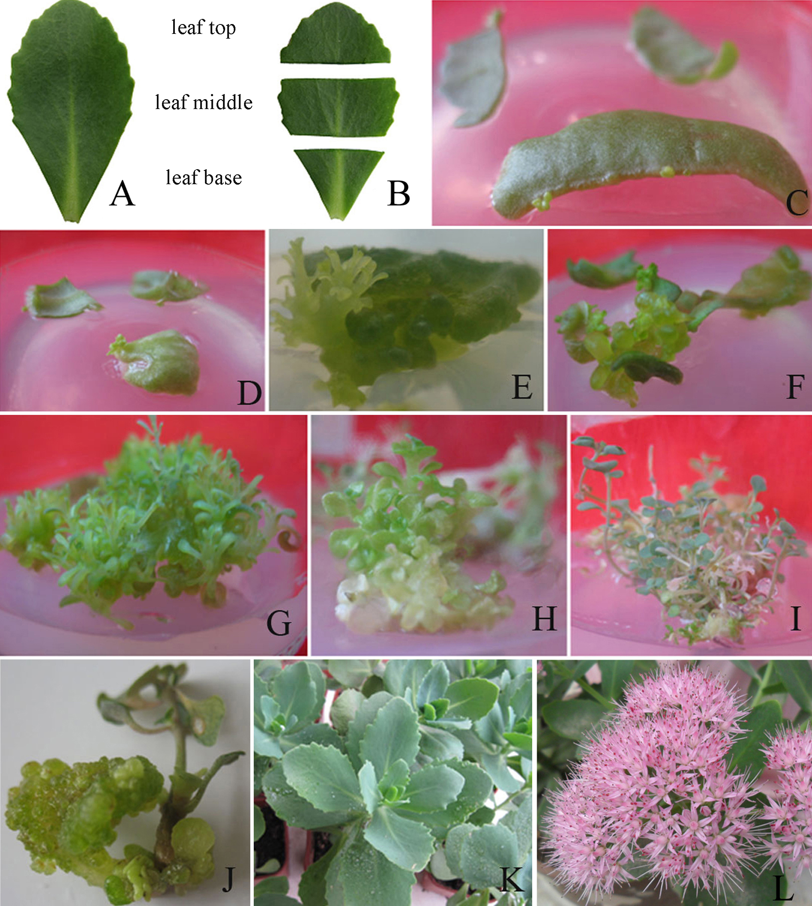
Fig.1. Leaf explant preparation, regeneration and micropropagation of Sedum spectabile Boreau. A),B) Leaf explant preparation, C), D) Organogenesis of leaf explants after 3 weeks of culture, E) Organogenesis of hyperhydric leaves after 2 weeks of subculture, F) Hyperhydric embryoids from leaf explants after 4 weeks of culture, G) Hyperhydric plantlets from hyperhydric embryoids, H) The intermediate type of hyperhydric and normal plantlets, I) Normal plantlets from hyperhydric plantlets after 4 weeks of culture on PGR-free MS, J) Organogenesis of stem segments on MS medium supplemented with 0.6 mg l⁻¹ TDZ and 0.1 mg l⁻¹ NAA, K) Acclimatization of leaf-derived plantlets, L) Flowering of leaf-derived plantlets.

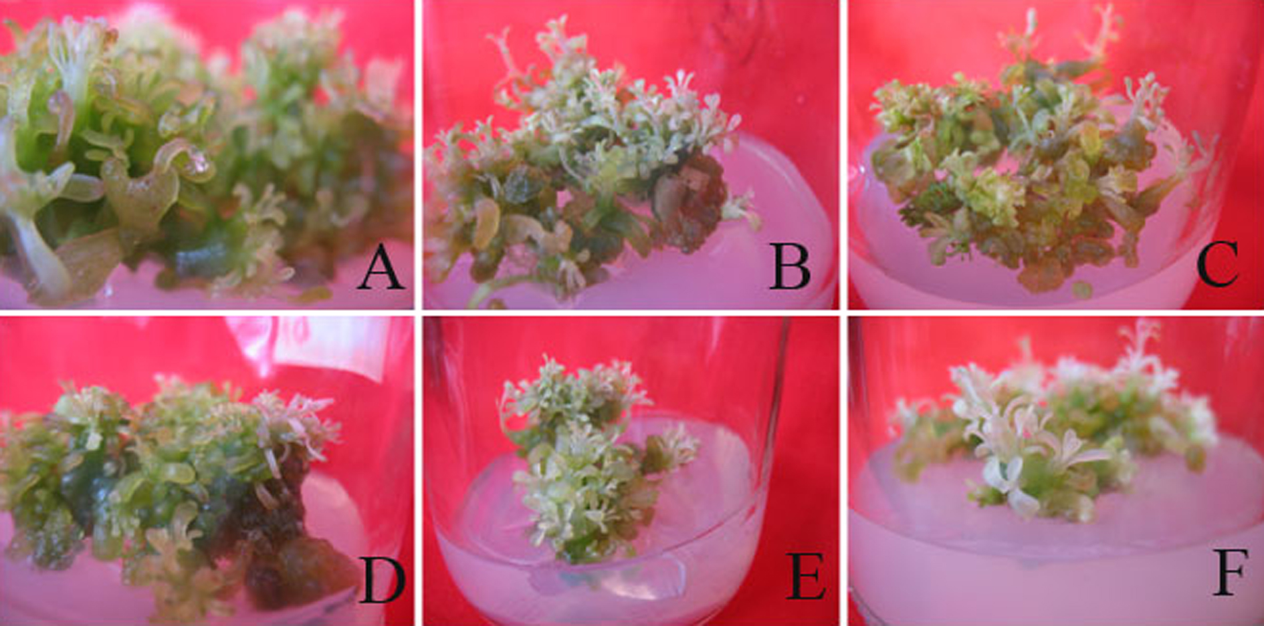
Fig.2. Effects of different agar concentration and different pH on differentiation degree of hyperhydric plantlets. A), B), C) Hyperhydric plantlets cultured on MS medium containing 6, 7 and 8g l⁻¹agar, D), E), F) Hyperhydric plantlets cultured on MS mediums (pH 5.8, 6.4 and 7.0).

