Clonal Propagation of Rhubarb from in vitro Cultured
Seedling Shoot-tips

Yan Zhou ¹，Zuguo Cai² and Yipeng Zhao ^{2*}
¹Department of Biotechnology，Henan Institute of Science and Technology, Xinxiang 453003, China
²Department of Horticulture, Henan Institute of Science and Technology, Xinxiang 453003, China (*E-mail: yzhao36@163.com)

Abstract
Rhubarb has been cultivated as a garden plant in Europe for more than a century. As a popular ornamental plant in the West it is less applied for gardening use in China. To extent its application in growing market of landscape and urban gardening an efficient protocol for rhubarb propagation using in vitro cultured seedling shoot-tips was developed. Plant regeneration was achieved by culturing shoot-tips on MS medium supplemented with BA or KT in different combinations with NAA or IBA at concentrations of 0-3 mg/L. The highest shoot number (9.1) regenerated from an explant was achieved on MS supplemented with 1.0 mg/L BA +1.0 mg/L NAA. Regenerated shoots rooted on 1/2 MS medium containing 0.5 mg/L NAA obtained the highest rooting percentage (92.6％). Rooted plantlets were successfully transferred in field with 90% of survival. This study reports a alternative method clonal propagation of rhubarb. It provides an efficient protocol for rapidly in vitro propagating planting materials for rhubarb cultivation.
Keywords: Rhubarb, in vitro propagation, seedling shoot tip, rooting

INTRODUCTION
Rhubarb (Rheum rhaponticum L.) is a species of Rheum genus in the family Polygonaceae. It is a tetraploid (2n = 4x = 44) herbaceous perennial plant (Zhao et al., 2005; 2008) and has been cultivated as a garden plant in the West for more than a century. Its petiole with unique taste and various nutrients is widely used as ingredient in pies, deserts marmalade, jam, syrup and wine (Foust and Marshall, 1991; Rumpunen and Henriksen, 1999). However, this rhubarb is little known in China.
Conventional propagation of rhubarb using crown division normally could not produce large quantity of young plants to meet the demand of field cultivation. In order to eliminate rhubarb virus plant tissue culture using shoot-tip or meristem-tip culture has been reported on rhubarb (Roggemans and Claes, 1979; Walkey and Matthews, 1979) and clonal propagation of rhubarb was also achieved (Roggemans and Boxus 1988). So far using seedling shoot-tip to establish a micropropagation system has not been well studied in rhubarb plants. This study reports an efficient protocol for rapid clonal propagation of rhubarb from explants of seedling shoot-tips followed by successful outdoor establishment of regenerated plants. This technique could also reduce the cost of stock plant management during micropropagation.

MATERIALS AND METHODS
Rhubarb cultivar Timeperly Early (TE) introduced from Europe was used for this investigation. Well-developed seeds were sterilized and germinated on Murashige and Skoog (1962) medium gelled with 0.6% (w/v) agar. Germination was carried out in a culture room at 22 ± 2ºC under a 12-h photoperiod at an intensity of 1000 Lx provided by cool white ﬂuorescent lamps. Shoot-tips of about 1cm length excised from 1-week old seedlings were used as explants for plant multiplication experiments.
MS medium containing 3% (w/v) sucrose was used in all the experiments. The pH of medium was adjusted to 5.8 before adding agar 0.6% (w/v). The media were sterilized by autoclaving at 121℃ for 30 min. All the cultures were maintained at 25±1℃ under a 12-h photoperiod at an intensity of 1000 Lx provided by cool white ﬂuorescent lamps.
MS basal medium supplemented with 0.1 to 3 mg/L 6-benzyladenine (BA) or kinetin (KT), in combination with 0.1 to 3 mg/L indole butyric acid (IBA) or naphthalene acetic acid (NAA) were used for shoot proliferation and multiplication (Table 1). MS medium lacking plant growth regulators was used as control. All the cultures were subcultured into fresh medium of the same composition every 3 weeks.
Well developed shoots were rooted on 1/2 MS medium supplemented with 3% (w/v) sucrose and 0.6% (w/v) agar containing 0.1 to 1.0 mg/L NAA or IBA (Table 2). The rooting culture was conducted in the same conditions as shoot multiplication. After 3 weeks of in vitro rooting, the effect of auxin on rooting was investigated. Rooted plantlets were then transplanted in to vermiculite pots for acclimatization under polyethylene tent for 2 weeks. Well acclimatized plants were transplanted to field condition.
All the experiments were repeated three times and 30 replications were tested for each treatment. The data were analyzed statistically using analysis of variance (ANOVA) and for means comparison Duncan’s multiple range test (DMRT) was applied at a 5% probability.

RESULTS AND DISSCUSSION
The present investigation aimed to examine the morphogenic potential of seedling shoot-tip in vitro culture. It was noticed that callus was developed from the base of shoot-tip explants after 7-12 days of culture on MS medium containing different growth regulators, but absent in the control. Shoot regeneration from in vitro cultured seedling shoot-tip was achieved on MS medium supplemented with different plant growth regulators, but not seen in the control. Regenerated shoots was noted in a week of culture and increased in number and length subsequently within 4 weeks of culture. Significant differences in the number of shoots and mean shoot length from an explant were detected among media containing different concentrations of BA and KT in combination with NAA or IBA (Table 1).
The result showed that BA had played more significant role than KT in shoot proliferation. The mean number of shoots (7.5) generated from an explant in BA treatments was significantly (P = 0.05) higher than that (5.3) in KT treatments, but KT had more effect on shoot elongation. The effect of KT on reduced number of shoots albeit with longer shoot was also reported in Ruta graveolens (Faisal et al., 2005). The result showed that MS media containing 1 mg/L BA was optimal for shoot regeneration, then shoot induction declined as increasing BA concentration. Such phenomenon has also been reported in other plants (Sen and Sharma, 1991; Faisal et al., 2005).
The effect of cytokinin and auxin combination was also evaluated on multiple shoot induction from seedling shoot tips (Table 1). The combinations of BA with NAA or IBA were founded more effectiveness for multiple shoot regeneration than those of KT in combination with NAA or IBA. Among various concentration of BA with NAA or IBA, the highest number (9.1) of regenerated shoots per explant was recorded on MS medium supplemented with 1mg/L BA and 1 mg/L NAA. A decrease in shoot multiplication was noted when NAA was replaced with IBA. This synergistic effect of BA and auxin on plantlet regeneration in this investigation has also been reported in other species (Casado et al., 2002; Martin, 2003; Faisal et al., 2005).
In accordance with these reports, the present study also exemplifies the positive effect of shoot induction efficacy by an auxin in combination with a cytokinin. Such finding is similar to the reports on other rhubarb cultivars (Roggemans and Boxus, 1988; Lassus and Viopio, 1994). So far KT has not been reported on colonal regeneration of rhubarb. Previous reports on rhubarb plant regeneration using shoot-tip or meristem-tip demonstrated a effective shoot induction on MS medium containing 1 mg/L BA and 1 mg/L IBA (Roggemeans and Claes,1979; Walkey and Matthews,1979), but this technique is laborious for explant collection from mature plants. In addition, at the same ratio of cytokinin/auxin, BA showed substantially more effective than KT on shoot regeneration (Fig. 1). Regenerated shoot number from an explant was maximized at 1.0 mg/L for both BA+NAA and BA+IBA.
Rooting was observed after 5 days of culture on rotting medium. The results showed that auxin (NAA or IBA) played significant roles in rooting rate (Table 2). The highest rooting percentage (92.6%) was founded at 0.5 mg/L NAA. Generally, NAA demonstrated a better effect on rooting than IBA, both in rooting percentage and root number. Hardening and acclimatization of all the in vitro raised plantlets was successfully achieved (Fig.2). The percentage survival of the plantlets after transfer to vermiculite was about 85%. Over 90% of the plants transferred to field soil survived and did not show any detectable variation in morphology or growth characteristics when compared with the donor plants.
In conclusion, this is the first study to demonstrate an efficient technique for mass propagation of rhubarb using seedling shoot tips. It provides an efficient protocol for rapidly propagating planting materials for rhubarb cultivation and facilitates our efforts in exploitation of commercially important cultivar of rhubarb.

Acknowledgements
The project was sponsored by the Scientific Creative Foundation of the Henan Department of Education (2007kycx016), the Excellent Youth Research Funding of Henan Department of Science and Technology (074100510019) and research project of Henan Institute of Science and Technology (2006).

REFERENCES
Casado J.P., Navarro M.C., Utrilla M.P., Martinez A., Jimenez J. (2002). Micropropagation of Santolina canescens Lagasca and in vitro volatiles production by shoot explants. Plant Cell Tiss. Org. Cult. 69:147-153.
Faisal M., Ahmad N., Anis M. (2005). In vitro regeneration and mass propagation of Ruta graveolens L. -- a multipurpose shrub. HortScience 40(5):1478-1480.
Faisal M., Anis M. (2003). Rapid mass propagation of Tylophora indica via leaf callus culture. Plant Cell Tiss. Org. Cult. 75:125-129.
Foust C.M., Marshall D.E. (1991). Culinary rhubarb production in North America: history and recent statistics. Horticultural Science 26: 1360-1363.
Lassus C., Voipio I. (1994). Micropropagation of rhubarb with special reference to weaning stage and subsequent growth. Agricultural Science in Finland 3: 189-194
Martin K.P. (2003). Rapid in vitro multiplication and ex vitro rooting of Rotula aquatica Lour., a rare rhoeophytic woody medicinal plant. Plant Cell Tiss. Org. Cult. 62:11-19.
Roggemans J., Claes M.C. (1979). Rapid clonal propagation of rhubarb by in vitro culture of shoot-tips. Scientia Horticulturae 11: 241-246.
Roggemans J., Boxus P. (1988). Rhubarb (Rheum rhaponticum L.). In: Bajaj， Y.P.S. (ed). Biotechnology in Agriculture and Forestry, Vol. 6, Crop-II. Springer-Verlag, Heidelberg. pp339-350.
Walkey D.G.A., Matthews K.A.M. (1979). Rapid clonal propagation of rhubarb (Rheum rhaponticum L.) from meristem-tips in tissue culture. Plant Science Letters 14: 287-290.
Rumpunen K., Henriksen K. (1999). Phytochemical and morphological characterization of seventy-one cultivars and selections of culinary rhubarb (Rheum spp.), Journal of Horticultural Science & Biotechnology 74:13-18.
Sen J., Sharma A.K. (1991). Micropropagation of Withania sonifera from germinating seeds and shoot tips. Plant Cell Tiss. Org. Cult. 26:71-73.
Zhao Y., Grout B.W.W., Crisp P. (2005). Abnormal chromosomes and DNA content in micropropagated rhubarb (Rheum rhaponticum L.) PC49.Plant Cell, Tiss. Org. Cult. (83): 335-338.
Zhao Y., Zhou Y., Grout B.W.W. (2008). Alterations in flower and seed morphologies and meiotic chromosome behaviors of micropropagated rhubarb (Rheum rhaponticum L.) ‘PC49’ . Scientia Horticulturae 116(2)：162 - 168.

Tables

Table 1: Effect of plant growth regulators on in vitro shoot induction from rhubarb
seedling shoot-tip after 3-week culture
Growth regulators (mg/L) Mean no of shoots Mean shoot
BA KT NAA IBA per explant length (cm)
0 0 0 1.1±0.2h 4.5d
0.1 0.1 5.2±1.6e 5.3c
0.5 0.5 5.9±1.9d 3.6e
1.0 1.0 9.1±2.6a 3.6e
2.0 2.0 8.6±2.8b 3.2f
3.0 3.0 8.5±2.3b 2.9f
0.1 0.1 4.9±2.2e 5.4c
0.5 0.5 6.2±1.8d 5.1c
1.0 1.0 7.6±2.8c 4.4d
2.0 2.0 8.7±2.7b 3.7e
3.0 3.0 8.5±2.9b 3.8e
Mean 7.5±2.3 4.1

0.1 0.1 5.3±2.9e 7.1b
0.5 0.5 5.1±1.6e 5.9c
1.0 1.0 5.1±1.6e 7.0b
2.0 2.0 5.8±1.8d 5.8c
3.0 3.0 6.1±1.8d 4.7d
0.1 0.1 5.2±1.6e 5.7c
0.5 0.5 3.5±1.1g 7.5a
1.0 1.0 4.4±1.4f 6.1b
2.0 2.0 4.6±1.5f 4.1d
3.0 3.0 4.5±1.4f 4.7d
Mean 5.3±1.3 5.9
Means followed by the same letter within columns are not significantly different.

Table 2. Effect of auxin on rooting of regenerated shoots from seedling
Shoot-tip explants of rhubarb in 1/2 MS medium after 3-week culture
Growth regulators(mg/L) Rooting Root /explant Mean root
NAA IBA (%) length (cm)

0 0 32.9e 7.0c 2.1a
0.1 81.5c 13.7b 1.3b
0.5 92.6a 24.5a 0.8c
1.0 81.5c 24.3a 0.7c
Mean 85.2 20.9 0.9

0.1 77.8d 6.2c 1.9a
0.5 88.9b 14.3b 1.2b
1.0 77.8d 13.8b 0.4d
Mean 81.5 11.4 1.1
Means followed by the same letter within columns are not significantly different.

Figures
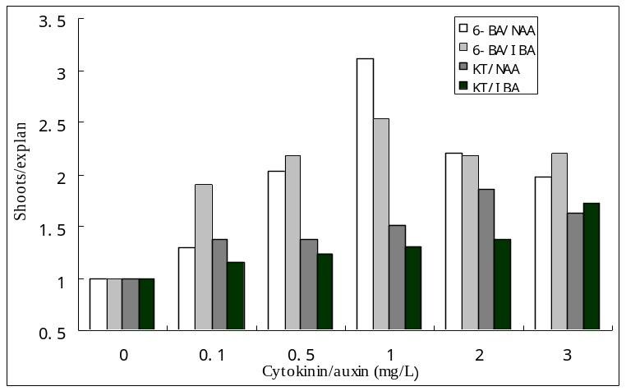
Fig.1. Effect of cytokinin/auxin ratio on shoot regeneration from seedling shoot-tip of rhubarb.

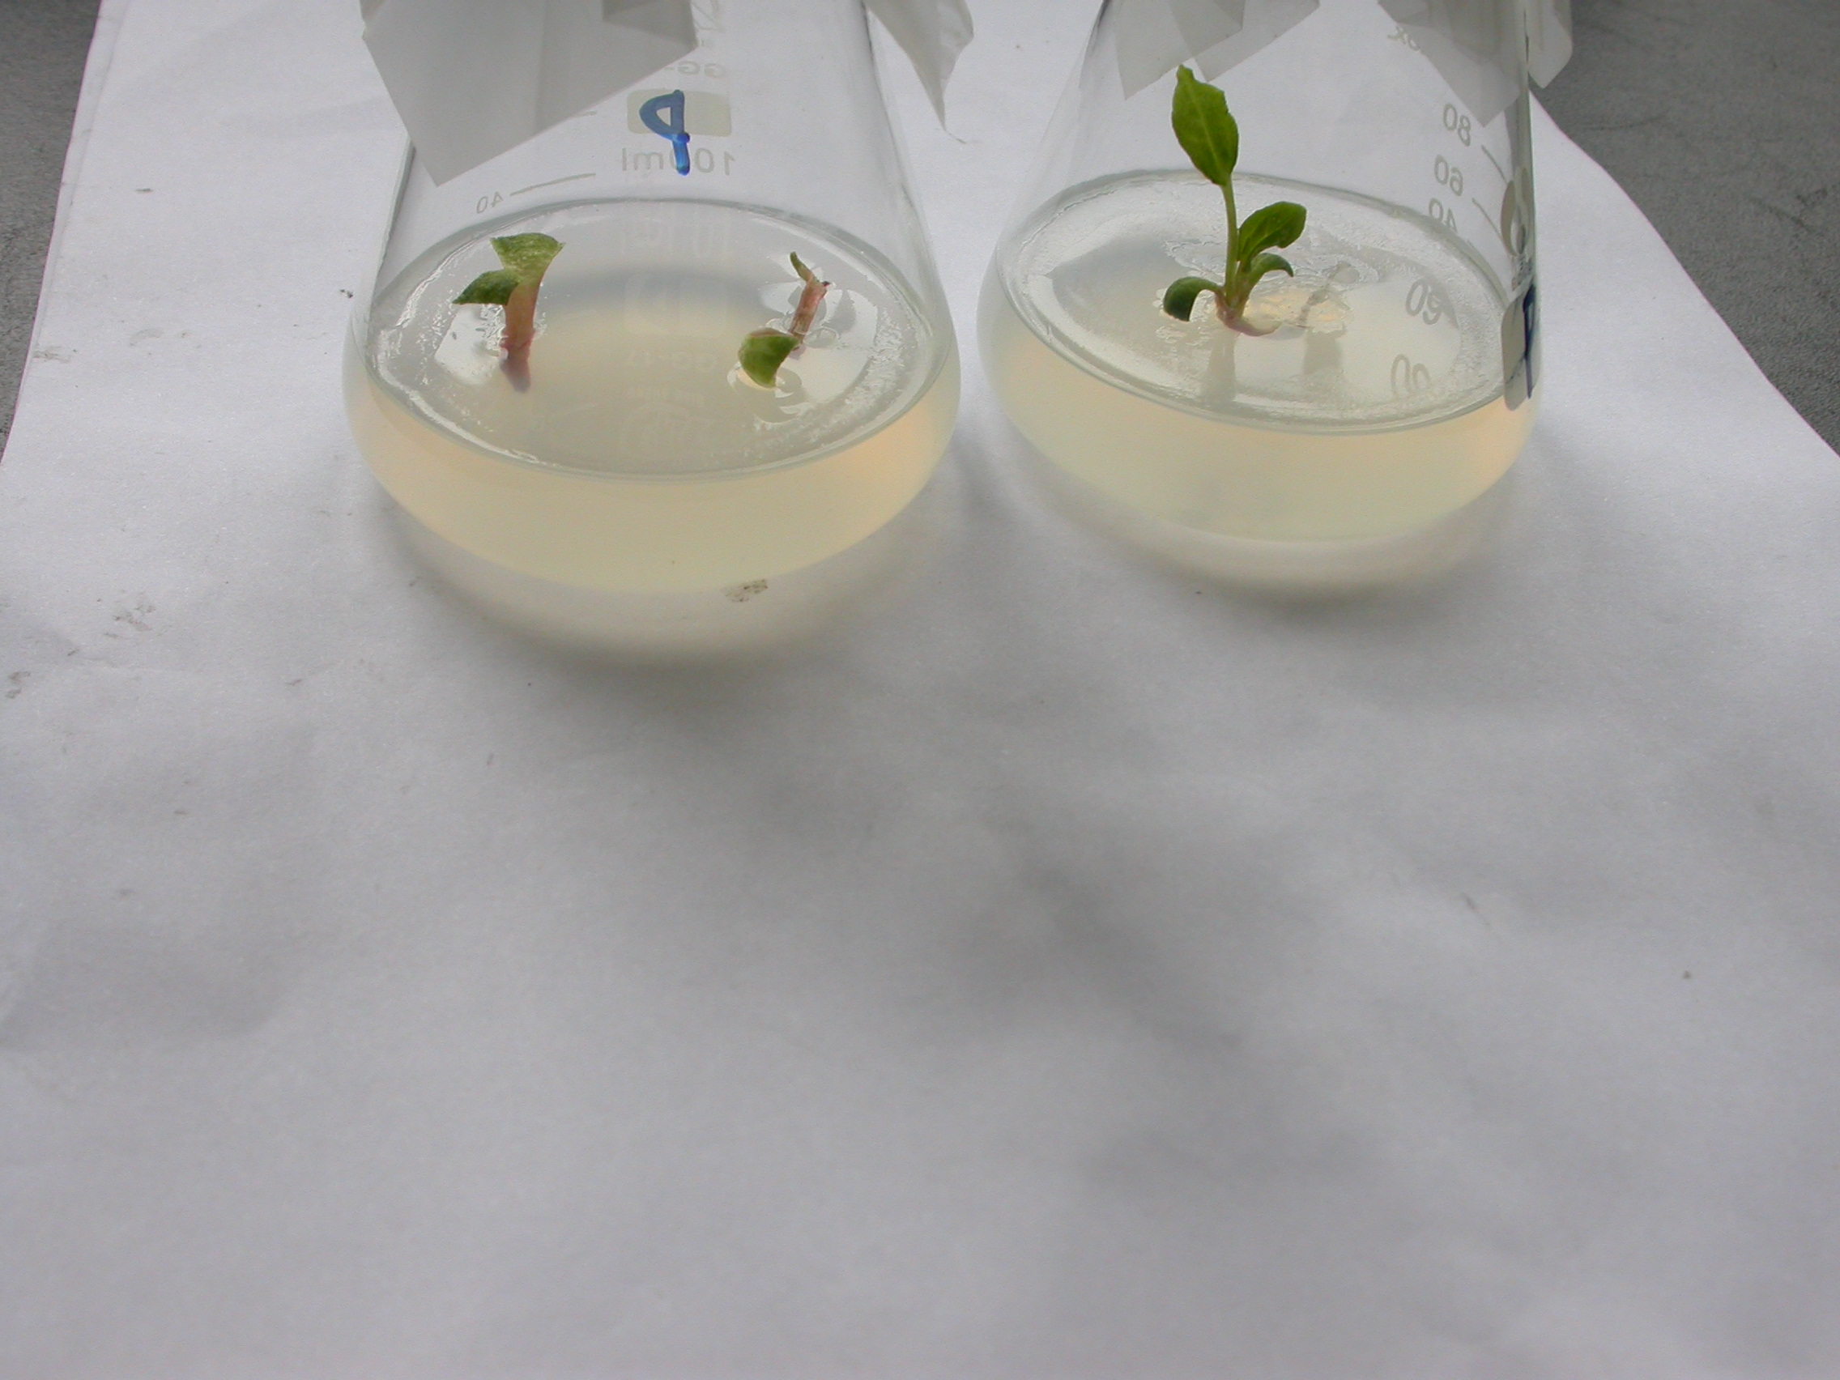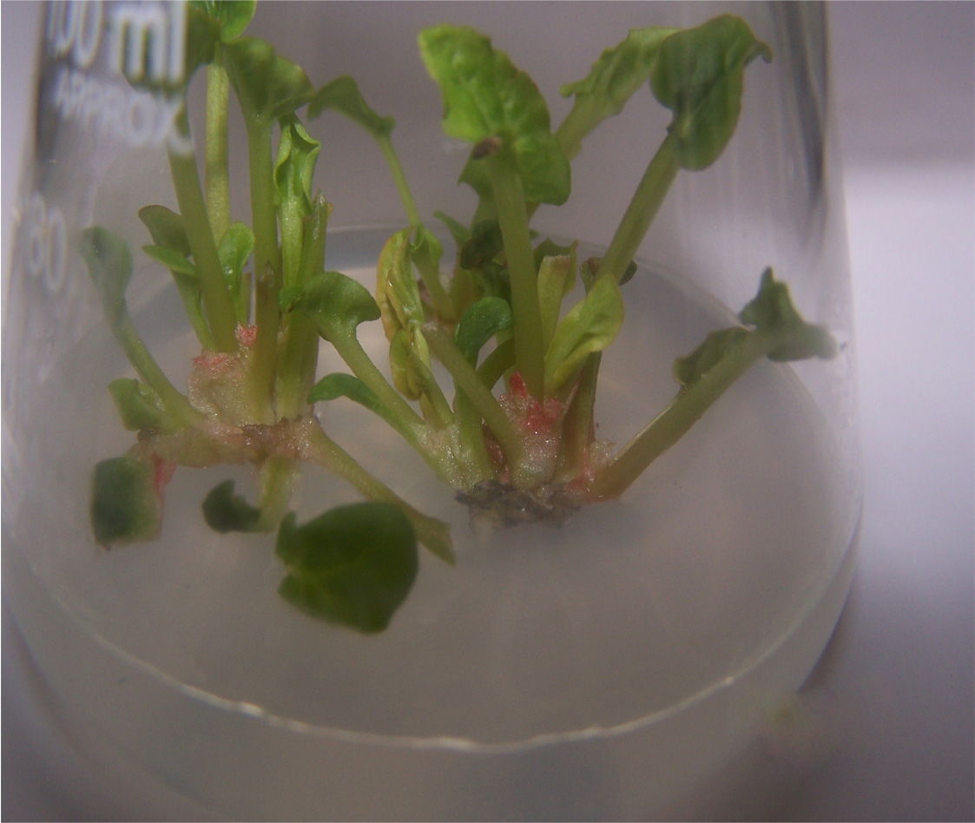
a
b
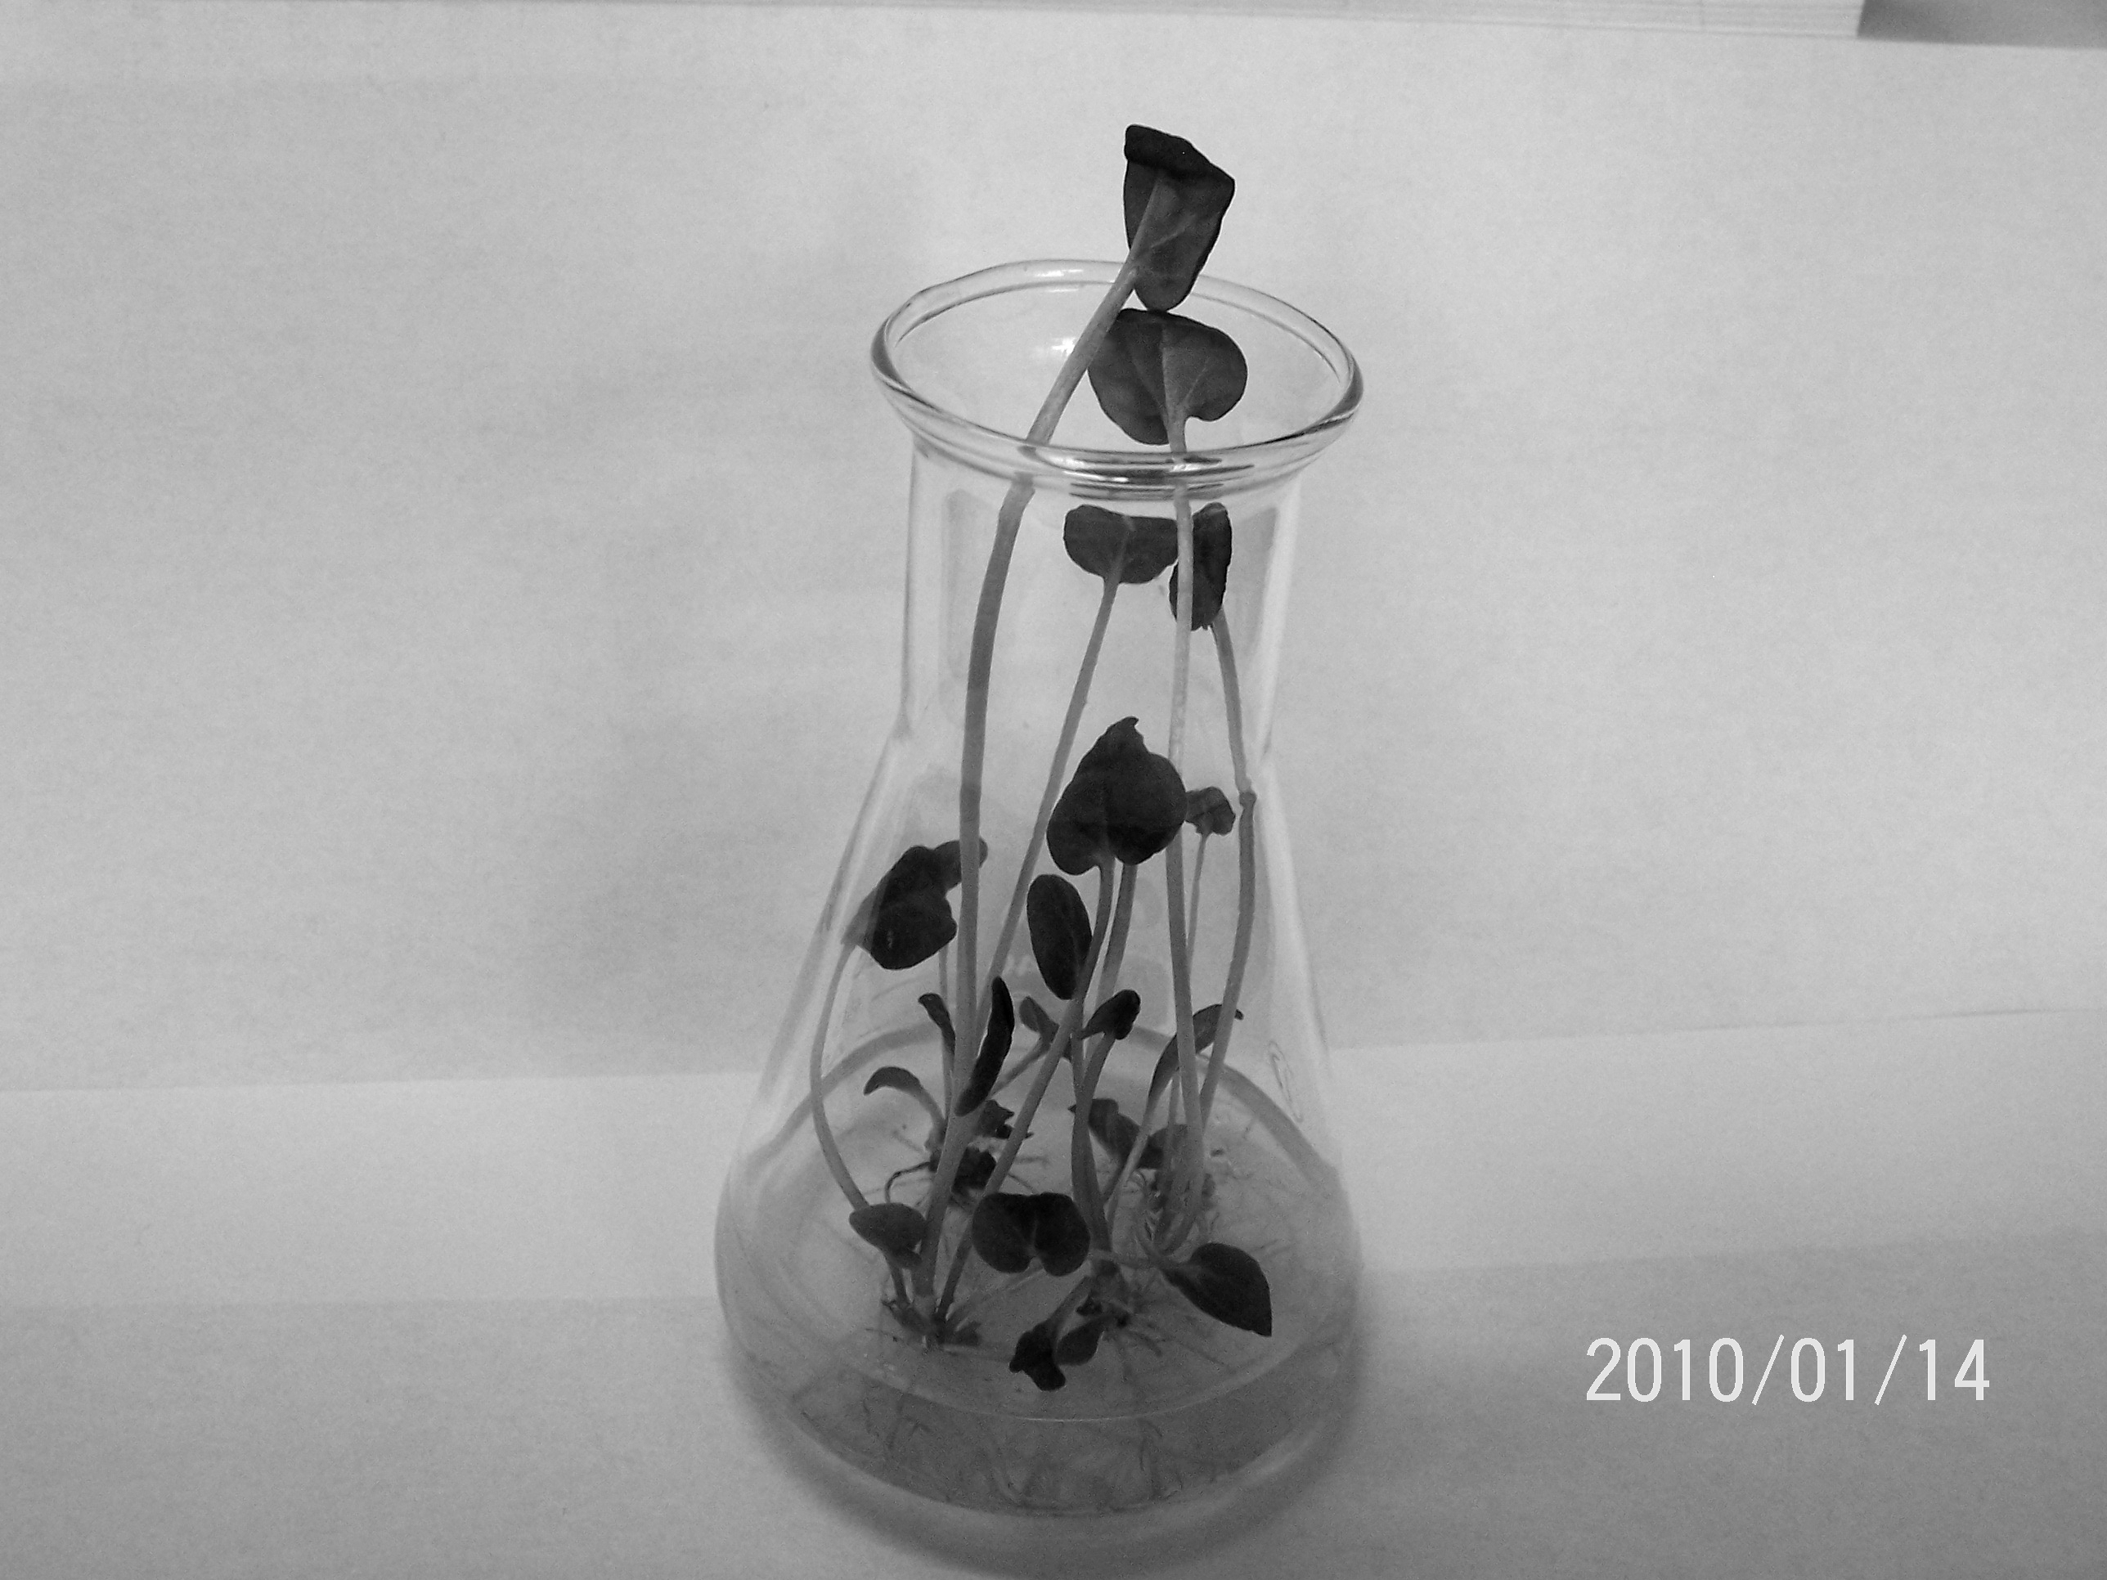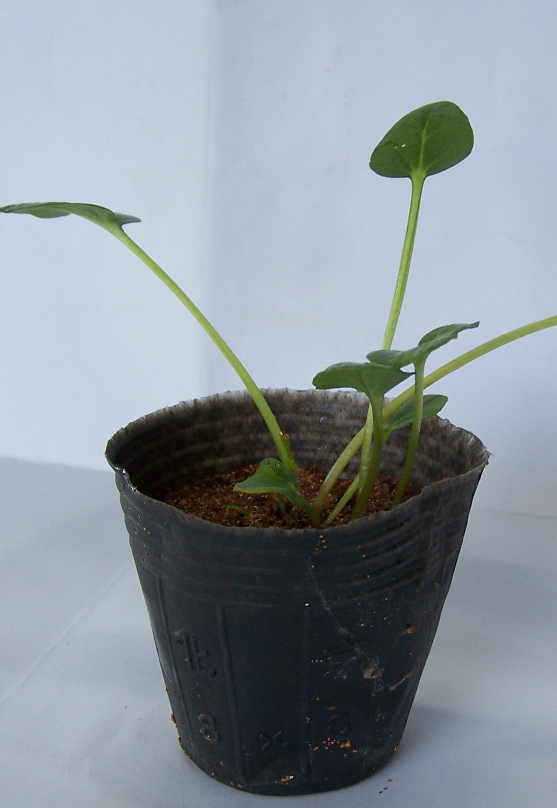
c
d
Fig. 2. Plant regeneration from in vitro cultured seedling shoot-tip of rhubarb：(a) seedling growing on MS medium, (b) shoot proliferation on MS + 1.0mg/L BA + 1.0 mg/L NAA, (c) rooting on 1/2MS + 0.5 mg/L NAA, (d) acclimatized plants.

