EFFICIENT IN VITRO SHOOT REGENERATION RESPONSES OF Buddelia globosa

Aboshama H. M. S.
Minufiya University - Genetic Engineering and Biotechnology Institute - Plant Biotechnology Department - Egypt.
abooshama@yahoo.com 01000447677

ABSTRACT
The data presented herein reports a rapid and efficient method for direct plant regeneration at high frequency without intervening callus formation from nodal segment and leaf segment. Single nodal explants isolated from greenhouse grown plants of Buddelia globosa, an important medicinal and ornamental plant, when cultured for 6 weeks on Murashige and Skoog's (MS) medium containing different concentrations of Benzyladenine (BA) or Kinetin (Kin) produced multiple shoots. (BA), was more effective in axillary buds promotion when compared to (Kin). A maximum of 14.4 shoots/node were produced in the presence of 2.0 mg/l BA.
The successful induction of adventitious shoot buds on Buddelia globosa leaves is reported. De novo shoots were induced directly on leaves without any callusing stage. Effects of several factors, including basal culture medium, growth regulators, silver nitrate and glutamine concentrations on regeneration response were examined based on three parameters, percentage of explants producing shoots, mean number of shoots per explant and shoot forming capacity (B.F.C.). Leaves were taken from in vitro clusters and cultured on MS or WPM basal medium supplemented with different growth regulators (2,4-D and TDZ). Prolific direct adventitious shoot regeneration occurred on most of the tested media which that contained either 2,4-D or TDZ. The best response in terms of frequency of shoot regeneration, number of shoots per explant (11.00) and bud forming capacity (3.66) were obtained from WPM medium supplemented with 1.0 mg/L 2,4-D. Bud formation occurred on both MS and WPM basal media, but, WPM basal medium was more than MS medium effective for direct organogenesis from leaf segments of Buddelia globosa..
The addition of silver nitrate (AgNO₃) to the induction medium of leaf segment culture also significantly improved the percentage of regeneration.
Regenerated shoots were excised and rooted; the highest number of root/shoot was obtained with half strength MS salt medium supplemented with 0.5 mg/L IBA. In vitro rooted plantlets were finally transferred to mixture of peatmoss and vermiculite at equal volume with survival rate 87% after 21 days. The protocol developed here will be very useful for the supply of Buddelia globosa all year.
Keywords: Buddelia globosa, organogenesis, leaf culture, direct regeneration, in vitro, tissue culture, adventitious shoots, single node, silver nitrate, L-glutamine.

INTRODUCTION
Buddleja globosa Hope (Buddlejaceae), is a shrub whose perennial leaves are traditionally used for healing wounds and ulcers (Mellado et al. 1996). They contain phenylpropanoids, iridoids, terpenes and flavonoids (Mensah et al. 2000). In recent pharmacological studies different medicinal properties were shown: antioxidant, antiinflammatory, cicatrizing and analgesic activities (Vargas 2001) as well as the regeneration of the mucous membrane in the case of ulcers (Yañez 2001). Buddleia is an attractive, long-flowering shrub known for its long panicles of scented flowers that attract butterflies. It is a genus comprising several species with more than one hundred cultivars and hybrids (Rose et al. 2000) and its tolerance of a wide range of landscape sites makes it an attractive plant (Buzzo 1993).
Buddelia can be propagated from nodal, inter-nodal, and shoot tip cuttings (Lamb et al., 1995), as well as from seed. Plants propagated by seed, are variable in form and do not have the desired horticultural characteristics. Therefore, it is essential to propagate selected cultivars through vegetative methods in order to retain the desirable horticultural characteristics in the daughter plant (Chu and Kurtz. 1990). Regeneration through in vitro culture has become now a viable alternative to the conventional propagation methods. Levin et al. (1988) utilized tissue culture technique for large scale production of chrysanthemum. The formation of healthy shoots and its higher rates of multiplication is one of the prerequisite of an economically viable micropropagation protocol. It is possible now to obtain a large number of plants from one explant through in vitro propagation (Bajaj et al.1992). The lack of publications about micropropagation of Buddelia may indicate difficulties in establishing or maintaining contaminant-free cultures in vitro (Phelan et al. 2005).
As an alternative, tissue culture techniques allow rapid mass propagation of elite genotypes independent from seasonal influences as well as the production of virus free plants. In addition, these in vitro culture techniques are a prerequisite for most transformation methods, which can complement conventional breeding programs
The development of protocols for direct shoot organogenesis from leaf not only has application in micropropagation but also in the introduction of novel traits via genetic transformation. In this application, direct shoot organogenesis from individual transformed cells is an indispensable step in the recovery of transgenic plantlets. Glutamine is frequently employed in the culture medium as an organic nitrogen source (Franklin and Dixon 1994). The use of exogenous glutamine can be beneficial for in vitro culture, increasing the regeneration rate and biomass of the explants (Vasudevan et al. 2004).
silver nitrate (AgNO₃) is one that has often proved to influence in vitro shoot development and multiplication of different herbaceous species, including Chicorium intybus (Bais et al. 2000), and Vanilla planifolia (Giridhar et al. 2001).
In this study, the glutamine effect on the promotion of shoot-bud organogenesis from leaf base explants in Buddelia cultivated on a shoot induction medium was evaluated.
The aim of the present study was to develop an efficient system to regenerate adventitious buds from in vitro leaf explants of Buddelia. at high frequencies by manipulating growth regulator requirements, silver nitrate (AgNO₃, Glutamine concentrations, explant tissue types and culture conditions.

MATERIALS AND METHODS

This study was carried out at Plant Biotechnology Department, Institute of Genetic Engineering and Biotechnology, Minufiya University, Egypt. During the years of 2009 and 2010.

PLANT MATERIALS AND EXPLANTS
Young Branches were excised from Buddleia globosa plants were obtained from the greenhouse of Al Shrook Nursery, Giza, Egypt. Nodal explants collected from young sprouts of plants were washed under running tap water with soap for 10 minutes. They were washed thrice with distilled water and kept in a laminar air flow chamber.
Surface sterilization of explants was performed by immersion in solution containing Clorox commercial for 10 minutes. That was followed by transferring the explants to solution of mercuric chloride HgCl₂ at 0.1% (w/v) for 3 min. Finally, the explants were rinsed three times in autoclaved distilled water to remove all traces of the disinfectant.
The external parts of explants were removed, then, The plant materials were cut into segments, each with one node and an axillary two buds (with leaves wiped off),the remained portions of a length 6-7mm with (single node) were cultured on nutrient medium. Murashige and Skoog basal medium (1962) was used at full strength.
Following preparation the medium and prior to addition of agar, the pH was adjusted to 5.8. The medium was poured into culture Jars (325 ml) where each jar contained 50 ml of the medium. The jars were capped with polypropylene closures and autoclaved at 121ºC and 1.2 Kg/cm² air pressure for 20 min.
This work was designed as follow:

(1) SINGLE NODE CULTURE
The aim of this experiment was to determine the optimal type and concentration of cytokinins for shoot proliferation from single node culture. Aseptic node explants (about 6-7mm) were placed vertically on MS medium containing 30 g/L sucrose and solidified with 7.0 g/L agar. For shoot regeneration, different concentrations of Benzyladenine (BA), Kinetin (Kin) were added at 0.0, 1.0, 2.0, 3.0 and 5.0 mg/L. The experimental design was a randomized complete block with five replications (the experiment was replicated two times). A replicate consisted of one jar containing three explants. After 6 weeks, number of shoots per explant were counted and analyzed by analysis of variance (ANOVA) according to Gomez and Gomez (1984).

(2) LEAF SEGMENT CULTURE
- Effects of basal medium, growth regulators, and concentrations on Direct shoot
regeneration from leaf explants.

Leaf explants were taken from stock cultures that were established from node culture. This born leaves required no sterilization. In vitro leaves were cut into two segments across the main vein, the terminal part was used as explant in this experiments.
For shoot regeneration from leaf explants Explants were transferred with their abaxial side down onto regeneration media that consisted of Lloyd and McCown (1980) medium (WPM) or Murashige and Skoog (MS) medium (1962) supplemented with 3% sucrose, 100 mg/l myo-inositol, and supplemented with 500 mg/L casein hydrolisate and different types and concentrations of plant growth regulators. The tested plant growth regulators included thidiazuron (TDZ) or 2,4-dichlorophenoxyacetic acid (2,4-D) were used in the concentrations of 0.0 0.5 1.0, 2.0 and 3.0 mg/l and evaluated for their effects on shoot regeneration.
The medium pH was adjusted to 5.8 prior to the addition of 0.7% (w/v) agar. Medium was distributed into culture jars (325 ml) where each jar contained 50 ml of the medium. The jars were capped with polypropene closures and autoclaved at 121ºC and 1,2 Kg/cm² air pressure for 20 min. All cultures were incubated at 25 ± 2 ºC under a 16-h ( 2000 Lux) photoperiod using cool, white fluorescent light. The results were collected four weeks after culture initiation. Explants forming bud percentage and number of buds per explant were counted.
For a more realistic determination of the efficiency of a given treatment, the Bud Forming Capacity (BFC) index was calculated according to (Martinez pulido et al. 1992).
-Effect glutamine on direct shoots regeneration from leaf explants.
For improvement of shoot regeneration, the medium was optimized by testing the effect of different concentrations of glutamine ( 0.0, 200 and 500 mg/L), on shoot formation on leaf Budellia. The best regeneration medium (WPM containing1.0 mg/l 2,4-D and 500 mg/L casein hydrolisate ) Was used In this experiment.
Cultures were maintained at 25±2°C in a growth chamber with a 16-h photoperiod under standard cool white fluorescent tubes for 4 weeks.

-Effect silver nitrate on direct shoots regeneration from leaf explants.
Effect of silver nitrate (AgNo₃) on regeneration Leaves of Budellia were prepared as previously described and placed on the best regeneration medium (WPM containing 1.0 mg/l 2,4-Dand 500mg/l glutamine) with silver nitrate (AgNo₃), at 0, 1.0, 2.0, or 3.0 mg/l.

The factorial experimental system in complete randomized block design with five replications was used. Each replicate consisted of one Jar containing three explants. Frequency of shoot formation was evaluated. The number of adventitious shoots per explant was counted and analyzed by analysis of variance (ANOVA).

(3) ROOT FORMATION AND ACCLIMATIZATION
For root induction, the shoots were individually transferred to rooting media. These media consist of half strength MS basal salts supplemented with 3.0 g/l activated charcoal (AC), 20 g/L sucrose and two types of auxins Indole-3-butyric acid (IBA) or Naphthalene acetic acid (NAA) each of which at different concentrations (0.0, 0.5 and 1.0 mg/L). The number of roots per shoot was evaluated 4 weeks later. The cultures were incubated at 25ºC day and night. Light was provided by white fluorescent tubes for 16-h per day. The well-developed plantlets were carefully washed in running tap water to remove the substrate, and then transferred to pots (6 cm) containing mixture of peatmoss and vermiculite at equal volume. These pots were covered with plastic bags to maintain high relative humidity around the plants in a greenhouse. A solution of quarter strength MS salt was added to the pots to enhance the development of plants. Data was recorded for percentage of survival after 21 days from transplanting.

RESULTS AND DISCUSSION

(1) SINGLE NODE CULTURE
Effect of cytokinins (BA,Kin) on shoot multiplication from single node culture .

The nodal explants(each having two axillary bud) cultured on MS basal medium showed signs of bud break in 2 weeks but did not produce multiple shoots even after 5 weeks. Media supplemented individually with BA and Kin induced bud break in 2 weeks followed by the formation of multiple shoots (Fig.1A). Among the two cytokinins, BA was found to be superior and more effective than Kin, in inducing shoot development as well as shoot multiplication from nodal explants (Table1). There was no sign of growth when nodal explants were cultured in media without cytokinin (Table 1). Shoot proliferation could be initiated from explants cultured on MS medium containing different cytokinins. In general, high-frequency shoot formation that occurred on medium with 0.5 to 2.0 mg /l cytokinin with the highest frequency appeared in the presence of 2.0 mg /l BA. However, the frequency declined when the BA concentration increased to 3.0 mg /l (Table 1). Several studies have shown that BA affects axillary shoot multiplication in willow species (Lyyra et al. 2006). BAP at high concentration was inhibitory to growth of axillary buds (Tiwari et al., 2002).

Table (1): Effect of BA and Kin at different concentrations on shoot proliferation from single
nods of Buddelia globosa after 6 weeks from culture.

Mean (B) | Number of shoot formation
Mean (B) | Kin | BA | cytokinin Types(A)  Con. (B) mg/l
0.00 | 0.00 | 0.00 | 0.0
3.10 | 2.60 | 3.60 | 0.5
7.40 | 5.20 | 9.60 | 1.0
10.50 | 6.60 | 14.40 | 2.0
8.70 | 9.40 | 8.00 | 3.0
 | 4.76 | 7.12 | Mean (A)
LSD at 5% A = 0.92 B = 1.45 AxB = 2.06
Among the various concentrations of BA, 2.0 mg/l proved to be optimum for culture initiation and multiplication. About 15 shoots/node were produced after 6 weeks in medium containing 2.0 mg/l BA, followed by 1.0 mg/l BA with 10 shoots (Table1). Higher concentration of BA (3.0mg/l) produced stunted shoots. Ramage and Williams (2004) reported that stunted plants were associated with increased exogenous BA concentration.
Of the various concentrations of Kin, 3.0 mg/l gave maximum number of shoots (9.4) after 6 weeks, followed by (6.6) shoots at 1.0mg/l (Table1).
With increasing BA concentrations in culture medium, a slight increase in the multiplication rate was observed up to 3.0mg/l (Table 1). Many node explants developed multiple shoots (Fig. 1A).
Shoot tip was also tested with all two cytokinin (BA , Kin) concentrations ranging from 0.0 to 3.0 mg/l but failed to induced multiple shoots and Hyperhydricity (waterlogging; syn. vitrification) was observed at all explants (data not shown). In this concern, Phelan et al., (2005) reported that In Buddelia, dieback occurs on most of the shoot tips and may be due to an accumulation of endogenous bacteria and/or viruses. Durkovic (2008) postulated on Cornus mas that, Later on, growth ceased, shoot tip necrosis appeared, and shoot cultures died gradually.

(2) LEAF SEGMENT CULTURE

1- Effect of growth regulators on direct regeneration from leaf explants.
In both Growth Regulators (2,4-D or TDZ) were tested direct shoot formation from leaf segments were observed. Presences of auxins either 2,4-D or NAA in culture media were essential for shoot-bud formation from leaves of calendula.(Aboshama 2005). The entire process could be completed without an intervening callus formation. This point is of major importance because plants produced by direct organogenesis may exhibit greater genetic stability than those produced from callus (Karam and Al-Majathoub, 2000).
Data in Table (2) show the effect of two types of growth regulators (2,4-D, TDZ) at various concentrations and culture media salts on the number of direct shoots per leaf segments explant and Bud Forming Capacity (B.F.C.) after 4 weeks from culture. Data clear that significant effect between MS and WPM media was observed on direct shoot induction from leaf segments.

Table 2: Effect of genotypes and growth regulator types and concentrations on the
number of shoot /explant of Buddelia globosa after 4 weeks in vitro
 |  | Number of direct shoots |  |  |  |  |  |  | Bud Forming Capacity (BFC)
 |  | concentrations (C) |  |  |  |  | Means (A x B) | Means of (A)
genotype (A) | Auxin  (B) | 0.0 | 0.5 | 1.0 | 2.0 | 3.0 | Means (A x B) | Means of (A)
 |  |  |  |  |  |  |  |  | 0.0 | 0.5 | 1.0 | 2.0 | 3.0
WPM | 2,4-D | 0.00 | 2.60 | 11.00 | 7.80 | 2.60 | 4.80 | 3.80 | 0.0 | 0.86 | 3.66 | 2.59 | 0.86
WPM | TDZ | 0.00 | 0.00 | 3.40 | 4.40 | 6.20 | 2.80 | 3.80 | 0.0 | 0.0 | 1.12 | 1.46 | 2.06
MS | 2,4-D | 0.00 | 1.00 | 6.40 | 3.80 | 0.40 | 2.32 | 1.92 | 0.0 | 0.33 | 2.13 | 1.26 | 0.13
MS | TDZ | 0.00 | 0.00 | 1.60 | 2.80 | 3.20 | 1.52 | 1.92 | 0.0 | 0.0 | 0.53 | 0.93 | 1.06
Means of (C) |  | 0.00 | 0.90 | 5.60 | 4.70 | 3.10 | Means of (B)
Means of  (B x C ) | 2,4-D | 0.00 | 1.80 | 8.70 | 5.80 | 1.50 | 3.56
Means of  (B x C ) | TDZ | 0.00 | 0.00 | 2.50 | 3.60 | 4.70 | 2.16
Means of  (A x C ) | WPM | 0.00 | 1.30 | 7.20 | 6.10 | 4.40
Means of  (A x C ) | MS | 0.00 | 0.50 | 4.00 | 3.30 | 1.80
LSD at 5% A = 0.35 B = 0.35 C = 0.56 A x B = 0.50 A x C = 0.79 B x C = 0.79 A x B x C = 1.12

The SFC index is a parameter that is effective in expressing the overall regenerative potential of explants, as it results from the combination of their regeneration frequencies with the number of shoots formed per explant. Data also clear that 2,4-D was more effective than TDZ in increasing direct shoots from leaf segments of Buddelia globosa. The highest shoot number per leaf segment and BFC (5.60, 3.66 respectively) was obtained by 1.0 mg/L Growth Regulators compared with control or other levels.
Concerning the interactions between culture media and GR (types or concentrations) significant effects on this parameter were observed. Data on the main effect of different used basal media showed that WPM was significantly more effective on direct shoot formation (3.80) when compared with MS basal medium (1.92). The MS and WPM media have similar ammonium nitrate rates but the total ionic strength of WPM is 45% of MS while WPM media has even lower total ionic strength and no nitrate or ammonium. In tissue culture studies with Cornus florida, WPM proved superior to Murashige and Skoog as well as Schenk and Hildebrandt basal media (Kaveriappa et al. 1997).
Regardless of PGR treatment, WPM basal medium was more than MS medium effective for direct organogenesis from leaf segments of Buddelia globosa. this is, perhaps due to high ammonia in MS basal medium. Similar results was found ( Dai and Castillo 2007) who found that, higher shoot regeneration rates with the WPM medium in this study indicated that buddleia may be sensitive to high ammonia and other salts during the in vitro regeneration. A low ammonium medium has performed better than high ammonium media for Prunus tissue culture (Dai et al., 2004).
However, a significant increase was obtained with increasing either 2,4-D or TDZ concentrations compared with the control. Regarding the interaction effect among GR type and concentration and culture media, data in the same Table reveal that no shoots were proliferated in the absence of GR in MS or WPM media. Also, the highest records were obtained with 2,4-D at 1.0 mg/L for both MS and WPM media (4.10and 7.30, respectively). However, the lowest records were obtained with TDZ at 0.5 mg/L for both MS and WPM media (0.60 and 1.40, respectively).

2-Effect of glutamine on direct regeneration from leaf explants.

The enhancement of growth rate by L-glutamine could be explained on the basis that L-glutamine provided a readily available source of nitrogen, the implication being that the formation of necessary carbon skeleton or the reduction of nitrate to ammonia is a limiting factor in the cells (Gamborg 1970). Addition of L-glutamine, which is relatively non-toxic (Gamborg et al. 1968) would enable the cells to maintain a high growth rate for a longer period.

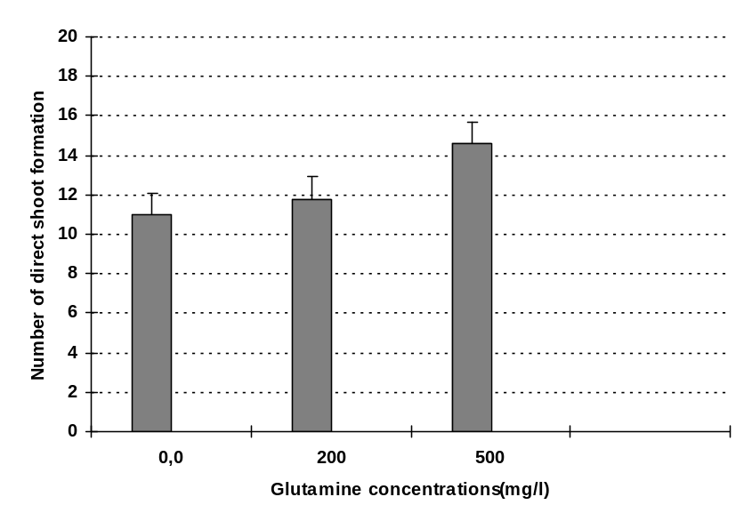

Fig. (1). The influence of Glutamine concentrations on Number of direct shoot formation of Budellia leaf segments culture.

As shown in Fig (1), the number of direct shoot formed on leaf segments according to the concentration of glutamine. it is obvious that glutamine at 500 mg/l resulted in the highest number of direct shoot formation (14.6). Medium supplemented with glutamine increases the number of embryos in Elaeis guineensis Jacq (Morcillo et al. 1999). Glutamine and glutamate are known to be the main endogenous amino acids involved in plant metabolism, providing nitrogen for the biosynthesis of amino acids, nucleic acids and other N-compounds (Coruzzi and Last, 2000).
Glutamine at the concentration of 150.0 mg/l proved to be the most effective in arresting leaf-fall in multiple shoots( Kaur and Kant 2000).In plants, glutamine is also involved in signaling of both plant nitrogen status and plant nitrogen:carbon ratio (Davenport 2002).

3-Effect of silver nitrate on regeneration from leaf explants.

This experiment was planned in order to test the effect of AgNO₃ on Budellia direct shoot formation from leaf segments.(Fig.2) shows that incorporation of AgNO₃ into the medium produced positive effects. Silver nitrate at 1.0 mg/l significantly enhanced shoot regeneration resulting in almost a twofold increase in comparison to the control (Fig. 2). Studies on sunflower cotyledons (Chraibi et al., 1991) have similarly shown that silver nitrate significantly improved shoot regeneration.

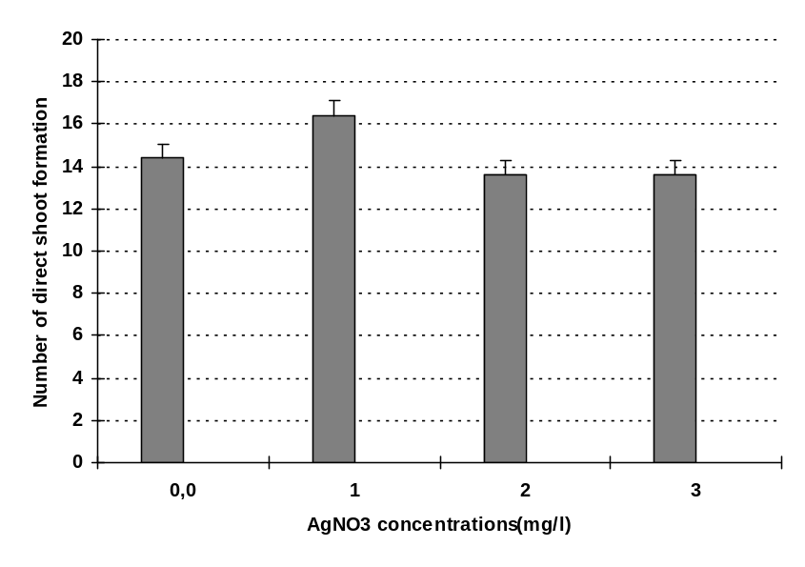

Fig. (2). The influence of ٍSilver nitrate AgNO₃ concentrations on Number of direct shoot formation of Budellia leaf segments culture.

In this study, increasing AgNO₃ from 1.0 to 3.0 mg/l significantly repressed regeneration, but the percentage remained higher than that of the control.
The best regenerative stimulation was obtained with the lowest AgNO₃ concentration (1.0mg/l). In contrast, the various concentrations of AgNO₃ did not produce significant differences in terms of direct shoot formation. The addition of silver nitrate to just the regeneration stage was effective in promoting cowpea regeneration (Brar et al 1999). Silver nitrate AgNO₃ inhibits ethylene action through the Ag‏ ions, by reducing the receptor capacity to bind ethylene (Beyer, 1976). The importance of adding AgNO₃ to the proliferation medium, together with a combination of cytokinins and NAA, produced good axillary shoot proliferation and elongation, as well as low callus proliferation ( Ozudogru et al., 2005).

Rooting of microshoots.
Effect of types of auxin and their concentrations on the number of roots:
Data in Table (3) clearly show the effect of different levels of IBA and NAA on the number of roots/shoot after 4 weeks from culture. Evidently, In vitro shoots of Buddelia globosa were easy to root in auxin-free medium. Similar results were obtained by (Dai and Castillo 2007) on microshoots of two Buddelia cultivars.

Table (3): Effect of Auxin at various Concentrations on root number of Buddelia globosa after 4 weeks in vitro.
Mean (B) | Number of root formation
Mean (B) | NAA | IBA | Auxin Types(A)  Con. (B) mg/l
0.60 | 1.0 | 1.10 | 0.0
3.30 | 2.90 | 3.70 | 0.5
2.30 | 2.10 | 2.50 | 1.0
 | 1.70 | 2.43 | Mean (A)
LSD at 5% A = 0.41 B = 0.50 AxB = 0.71
In Table (3) data on the main effect of types of growth regulators show that IBA was significantly more effective in root formation when compared with NAA. The same table represents the main effect of the different used concentrations of growth regulators, as it shows that the highest value of root numbers was significantly obtained with the low level (0.5 mg/l) compared to the 1 mg/L and control. The gradual increase of the concentration resulted in gradual decrease in the values of root numbers.
However, the addition of growth regulators to the medium at all concentrations was significantly effective in root formation when compared with the effect of hormone-free medium (control). The original data in Table (3) indicate that a high number of roots (3.70) was produced when the medium was supplemented with the low concentration 0.5 mg/L IBA.

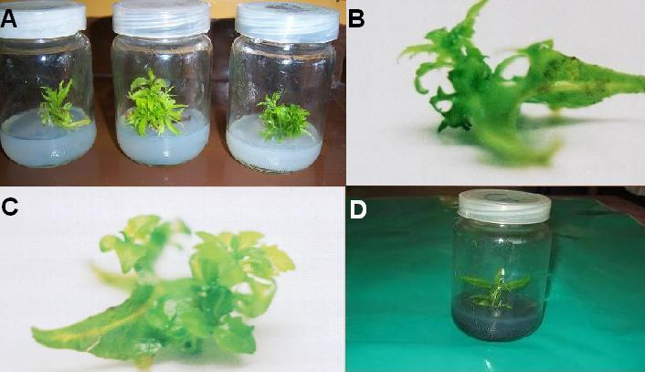
Fig.( 3). Shoot regeneration of Buddleia. A- Multiple shoot regeneration from single node culture. B and C- direct shoot regeneration on leaf segment. D- in vitro rooting of Buddleia shoots culturing on Rooting medium supplemented with 0.5 mg/l IBA and 3.0 g/l AC .
In vitro rooted plantlets were finally transferred to mixture of peatmoss and vermiculite at equal volume with survival rate 87% after 21 days.

Conclusions
The results show that a high frequency of shoot regeneration in Buddelia globosa could be achieved both from single node and leaf segments. The results on shoot multiplication show that BA was indispensable for the sprouting and multiplication of axillary buds of single node cuttings. This technology may provide a valuable tool in a shrubs improvement program. The leaf segments culture protocols described above will help to foster the studies on secondary metabolites and the establishment of regeneration and genetic transformation systems.

REFERENCES
Aboshama H. M. S. (2005) In Vitro Direct Plant Regeneration Of Calendula officinalis L. J. Agric. Sci. Mansoura Univ., 30 (12): 7955 – 7964.
Bais, H. P.; Sudha, G. S.; Ravishankar, G. A (2000). Putrescine and silver nitrate influences shoot multiplication, in vitro flowering and endogenous titers of polyamines in Chicorium intybus L. cv. Lucknow Local. J. Plant Growth Regul. 19:238–248;.

Bajaj, Y. P. S.; Sidhu M. M. S. and Gill P. S. (1992). Micropropagation of chrysanthemum Biotechnology in Agriculture and Forestry, 20: 69-80.

Beyer, E. (1976) Silver ion: a potent anti-ethylene agent in cucumber and tomato.HortScience 11:195–196.
.
Brar M. S., Moore M.J., AL-khayri J. M., Morelock T. E., and Anderson E. J. (1999). Ethylene Inhibitors Promote In Vitro Regeneration Of Cowpea (vigna unguiculata l.) In Vitro Cell. Dev. Biol.--Plant 35:222-225.

Buzzo R.J. (1993.). Field propagation of light sensitive species by seed.Combined Proceedings of International Plant Propagators Society, 43: 289-291.

Chraibi, B. K. M.; Latche A.,.; Roustan J., and Fallot J. (1991). Stimulation of shoot regeneration from cotyledons of Helianthus annuus by the ethylene inhibitors, silver and cobalt. Plant Cell Rep. 10:204-207.

CHU I. Y.E., Kurtz S.L.(1990). Commercialisation of plant micropropagation. In: Ammirato P.V., Evans D.A., Sharp W. R., Bajaj Y. P.S.(Eds). Handbook of Plant Cell Culture, 5: 126-164.

Coruzzi G. and Last R. (2000) Amino acids. In: Buchanan B, Groissem W, Jones R (eds), Biochemistry & Biology of Plants, pp. 358-410. American Society of Plant Physiologists, USA.
Dai, W., Jacques V., Walla J., and Cheng Z.M..(2004). Plant regeneration of chokecherry (Prunus virginiana L.) from in vitro leaf tissues. J. Environ. Hort. 22:225–228.

Dai W. and Castillo C. (2007) Factors Affecting Plant Regeneration from Leaf Tissues of Buddleia Species. HORTSCIENCE 42(7):1670–1673.

Davenport R. (2002) Glutamate receptors in plants. Ann Bot (Lond) 90:549–557.

Durkovic J. (2008). Micropropagation of mature Cornus mas ‘Macrocarpa’. Trees 22:597–602.

Franklin C.I. and Dixon R.A. (1994) Initiation and maintenance of callus and cell suspension cultures. In: Dixon RA & Gonzales RA (eds) Plant Cell Culture. A Practical Approach (2nd edn) (pp 1–25) Oxford University Press, New York

Gamborg, O.L., Miler, R.A. and Ojima, K (1968).Nutrient requirements of suspension cultures of soybean root cells. - Exp. Cell Res. 50: 151-158.

Gamborg, O. L.: (1970).The effects of amino acids and ammonium on the growth of plant cells in suspension culture. – Plant Physiol. 45: 372-375,.

Giridhar P.; Obul Reddy B. and Ravishankar, G. A. (2001). Silver nitrate influences in vitro shoot multiplication and root formation in Vanilla planifolia Andr. Curr. Sci. 81:1166–1170.

Gomez, K.A. and Gomez A. A. (1984). Statical Procedures For The Agricultural Researches. John wiley and Son, Inc. New York.

Karam, N.S., Al-Majathoub, M., (2000). Direct shoot regeneration and microtuberization in wild Cyclamen persicum Mill. using seedling tissue. Sci. Hortic. 86, 235–246.

Kaur K._ and Kant U. (2000) Clonal propagation of Acacia catechu Willd. by shoot tip culturePlant Growth Regulation 31: 143–145,

Kaveriappa K.M., Phillips L.M. and Trigiano R.N. (1997). Micropropagation of flowering dogwood (Cornus florida) from seedlings. Plant Cell Rep 16:485–489.

Lamb K., Kelly J. and Bowbrick P. (1995). Propagation and uses. Nursery Stock Manual, Grower Manual No. 1, Nexus Media Limited, 99 pp.

Levin, R.; Gaha V.; Tal B.; Hirsch S.; Denola D. and Vasil I. (1988). Automated plant tissue culture for mass propagation. Biotechnol, 6 : 1035-1040.

Lloyd, G. and McCown B.. (1980). Commerciallyfeasible micropropagation of mountain laurel, Kalmia latifolia, by use of shoot-tip culture. Proc. Intl. Plant Prop. Soc. 30:421–427.

Lyyra S, Lima A. and Merkle S.A. (2006) In vitro regeneration of Salix nigra from adventitious shoots. Tree Physiol 26:969–975.

Martinez-pulido C, Harry I.S. and Torpe T.A. (1992). Optimization of bud induction in cotyledonary explants of Pinus canariensis. Plant Cell Tiss. Org. Cult. 29:247-255.

Mellado V, Medina E. and San Martín C. (1996). Herbolaria Médica de Chile – Diagnóstico de su estado actual y perspectivas futuras para la Medicina Oficial Chilena; Ministerio de Salud, Santiago de Chile.

Mensah A.Y., Houghton P.J., Bloomfield S., Vlietinck A.. and Vanden Berghe D. (2000). Known and novel terpenes from Buddleja globosa displaying selective antifungal activity against dermatophytes. J Nat Prod 63(9):1210- 1213.

Morcillo F, Aberlenc-Bertossi F, Noirot M, Hamon S. and Duval Y. (1999). Differential effects of glutamine and arginine on 7S globulin accumulation during the maturation of oil palm somatic embryos. Plant Cell Rep 18:868–872.

Murashige, T. and Skoog F. (1962). A revised medium for rapid growth and bioassays with tobacco tissue culture. Physiol. Plant, 15: 473-497.

Ozudogru E. A., Ozden-Tokatli Y. and Akcin A. (2005). effect of silver nitrate on multiple shoot formation of virginia-type peanut through shoot tip culture. In Vitro Cell. Dev. Biol.—Plant 41:151–156.

Phelan S.,Hunter A. and Douglas G.(2005). Bacteria detection and micropropagation of ten Buddleia Cultivars. Propagation of Ornamental Plants 3: 164-169.

Ramage, C. M. and Williams, R. R. (2004). Cytokinin-induced abnormal shoot organogenesis is associated with elevated Knotted1-type homeobox gene expression in tobacco. Plant Cell Rep. 22: 919– 924.

Rose, J.B., Kubba J. and Tobutt K.R.. (2000).Induction of tetraploidy in Buddleia globosa Plant Cell Tissue Organ Cult. 63:121–125.

Tiwari S.K., Tiwari K.P. and Siril E.A. (2002). An improved micropropagation protocol for teak . Plant Cell, Tissue and Organ Culture 71: 1–6.

Vargas L. (2001). Evaluación de las actividades analgésica y antiinflamatoria de Buddleja globosa, Buddlejaceae. Formulación de un preparado dermatológico. Tesis Facultad Ciencias Químicas y Farmacéuticas, Universidad de Chile, Santiago, Chile.

Vasudevan A, Selvaraj N, Ganapathi A, Kasthurirengan S, Anbazhagan VR, Manickavasagam M (2004). Glutamine: a suitable nitrogen source for enhanced shoot multiplication in Cucumis sativus L. Biol Plant 48:125–128.
Yánez T. (2001). Matico, otro arbusto chileno con potencial exportador: Efecto de la infusión de hojas de matico en la úlcera gástrica. Memoria Instituto de Biología Vegetal y Biotecnología, Universidad de Talca.

