AN EFFICIENT PLANT REGENERATION SYSTEM FOR MANUKA (LEPTOSPERMUM SCOPARIUM) FROM SEEDLINGS IN CHINA
Tengfei Fan, Haigen Liu, Tiantian Wang, Min Du, and Lusheng Zhang*
College of Agriculture and Biotechnology, China Agricultural University, Beijing 100193, P.R. China, *Fax: + 86 10 51706892. *E-mail: lusheng@cau.edu.cn
Tengfei Fan: E-mail: tengfei.f@gmail.com
Haigen Liu: E-mail: liuhaigen19850101@163.com
Tiantian Wang: E-mail: WTTian@163.com
Min Du: E-mail: Dumin@yahoo.com
Lusheng Zhang: E-mail: lusheng@cau.edu.cn

* Corresponding author
AN EFFICIENT PLANT REGENERATION SYSTEM FOR MANUKA (LEPTOSPERMUM SCOPARIUM) FROM SEEDLINGS IN CHINA
Tengfei Fan, Haigen Liu, Tiantian Wang, Min Du, and Lusheng Zhang*
College of Agriculture and Biotechnology, China Agricultural University, Beijing 100193, P.R. China, *Fax: + 86 10 51706892. *E-mail: lusheng@cau.edu.cn
Abstract
Leptospermum scoparium, commonly known as manuka, is a widely distributed New Zealand shrub of the family Myrtaceae and an ornamental plant. The purpose of this research was to develop and establish an efficient micropropagation system for manuka introduction selections from seedlings in China. Shoot tips and nodal segments of manuka seedling were used as explants. Manuka seedling explants were cultured on Murashige and Skoog (MS) medium, supplemented with various concentrations of 6-benzyladenine (BA) (0.5, 1.0, 1.5, 2.0, 2.5 mg l⁻¹) or in combination with Gibberellin acid (GA₃) (0.1 mg l⁻¹). Shoot proliferation was most successful on MS medium supplemented with 2.0 mg l⁻¹ BA and 0.1 mg l⁻¹ GA₃ after 4 weeks of culture. Then the surviving explants were transferred to MS medium supplemented with 0.8 mg l⁻¹ BA and 0.2 mg l⁻¹ 1-naphthalene acetic acid (NAA) and 0.1 mg l⁻¹ GA₃ for regeneration. Regenerated shoots successfully produced roots on half-strength MS medium supplemented with 0.5 mg l⁻¹ NAA, resulting in a 96% root formation and a maximum root length of 2.26 cm after 3 weeks of culture. When the well-rooted explants induced by NAA were transferred to the mist system for acclimatization, 87.5% of them survived and continued to grow.
Keywords: Leptospermum scoparium; seedlings; shoot proliferation; shoot regeneration; root formation; acclimatization
Introduction
Leptospermum scoparium, a shrub of the family Myrtaceae, commonly known as manuka, is the member of New Zealand indigenous woody flora (Yin et al. 1984). Manuka has attractive white and pink to reddish coloured petals. Recently it has largely been used for garden and flowering pot plant use. The floriferous nature of manuka makes it good candidates for cut flower production (Seelye et al. 2001). Traditionally, manuka was known for various medicinal uses as outlined by Brooker et al. (1987). The leaves can be used for tea, which has antipyretic and diuretic effects. Essential oils from manuka showed moderate activity against F.circinatum (Lee et al. 2009). Manuka honey is derived from nectar collected by honeybees (Apis mellifera) foraging on the manuka tree in New Zealand, which has been reported to show a significant antimicrobial activity against a wide range of bacterial species (Henriques et al. 2010; Henriques et al. 2011).
Manuka is widespread and environmentally-tolerant plant in New Zealand islands (Yin et al. 1984). Variations of manuka plants were found in different geographic and climatic regions in New Zealand. The variation was mainly in the leaf size and shape. The introduction of manuka plants to China has not been reported before our work. We began to introduce manuka shoots from New Zealand in 2004, but the two-year-old clonal plants from tissue culture were dead when overwintering in Beijing. Considering if the cultivars selected from seedling variations would have more adaptability to the environmental conditions of Beijing, we introduced seeds of manuka later. Finally, some tissue cultured lines from germinated seedlings could be survived. Comparing the former tissue culture reports about Leptospermum (Shipton & Jackes 1986, Braun & Leung 1991, Seelye et al. 2001), here the regeneration system for manuka from seedlings had its speciality. As seed progenies are not uniform, no standard varieties are available (Khan et al. 1999). It could be applied for the selection and cloning of desired manuka plants. It was a necessary step in our introduction breeding of manuka to get more clones of seedling selections. This system could be also applied to the selection of manuka in other countries, especially in the Northern Hemisphere countries.
To date very few report has been published on micropropagation of maunka using seed-derived explants. We report here an efficient plant regeneration system for some seedling selection lines from our introduction breeding of manuka with a relatively simple procedure of acclimatizing rooted explants under mist with a high survival rate in Beijing of China.
Materials and methods
Plant material and preparation of explants
Seeds of manuka were washed under running tap water for at least 30 min. After thorough washing, they were immersed by 200 mg l⁻¹ GA₃ for 12 h. Before the seeds were cultured onto the MS basal medium for germination, they were surface sterilized with freshly prepared 10% (w/v) sodium hypochlorite (NaOCl) for 10 min followed by rinsing for three times with sterile distilled water. Then the seeds were inoculated onto MS (Murashige & Skoog 1962) basal medium for germination. Shoot tips and nodal segments, 1.0-1.5 cm long, were excised from 1-month old seedlings and used as explants. The leaves were separated from the nodal segments carrying dormant axillary buds.
Culture medium and culture condition
Shoot tips and nodal segments were cultured on basal MS supplemented with 3% (w/v) sucrose and 0.5% (w/v) agar. Rooting experiments were conducted on half-strength MS medium supplemented with 3% (w/v) sucrose and 0.5% (w/v) agar. At least 25 explants per treatment were used at each stage. Plant growth regulators and their combinations were added to the medium as specified below. The pH was adjusted to 5.8, prior to autoclaving at 121 °C for 20 min. When required, the appropriate auxins and cytokinins were incorporated into the media before sterilisation. GA₃ was filter sterilised using 0.2 μm Millipore filters and added to the media following sterilisation. Molten media (50 ml) were dispensed into 250 ml jars. All the cultures were incubated at 25 ± 2 °C and 70%-90% relative humidity under cool white fluorescent light with a photosynthetic photon flux density (PPFD) of 50 μmol m⁻² s⁻¹ for a photoperiod of 16 h.
Shoot proliferation and regeneration
At the first proliferation stage the basal medium was supplemented various concentrations of BA 0.5, 1.0, 1.5, 2.0, 2.5 mg l⁻¹ (Table 1). At the end of the fourth week, the number of explants forming shoots and shoot numbers were recorded. Then the surviving explants were transferred to 250 ml jars for regeneration, containing 50 ml of basal medium, supplemented with the 0.2 mg l⁻¹ NAA and 0.8 mg l⁻¹ BA and 0.1 mg l⁻¹ GA₃.
Rooting
The effect of auxins on root induction was studied by placing excised shoots measuring 1.5-2.0 cm into 250 ml jars, each containing 50 ml half-strength MS basal medium with various concentrations of NAA 0.2, 0.5, 1.0, 1.5 mg l⁻¹ (Table 2). A second experiment was supplemented with various concentrations of indole-3-acetic acid (IAA) 0.2, 0.5, 1.0, 1.5 mg l⁻¹ (Table 2). The control involved transferring the shoots to a medium lacking growth regulators. Three weeks later, rooting percentage, the number of explants forming roots and root lengths were recorded.
Acclimatization and transfer of plantlets to soil
Three weeks after incubation at the root forming stage, all jars with well-rooted explants from all treatments were transferred to the mist system equipped with an electronic leaf device, for hardening and acclimatization. Plantlets were washed thoroughly in running tap water to remove any agar medium from the roots and transferred to plastic pots (20 cm) containing sterile garden soil and vermiculite (2:1) under diffuse light (14/10 h photoperiod) conditions. Potted plantlets were covered with transparent plastic bags to ensure high humidity and watered every 3 days with half-strength MS salts solution for 2 weeks in order to acclimatize the plants to field condition. At the end of the second week all plastic bags were removed and the explants stayed there after uncovered. During this stage the shoots continued to grow as a sign of successful establishment. Three weeks after transplanting the explants into the pot mixture, the plantlets were transferred outdoors where they continued to grow.
Statistical analysis
All the experiments were conducted with a minimum of 25 replicates per treatment and were repeated three times. All data were analyzed using a one-way analysis of variance (ANOVA) and comparisons between the mean values of treatments were made by the least significant difference test at the 5% level of probability using the software SPSS 17.0.
Results and discussion
Shoot proliferation and regeneration
Only a few shoots developed in the absence of BA (Table 1). Explants demonstrated differential responses according to the concentrations and combinations of growth regulators in the culture media. In our study, the best shoot proliferation response was achieved on the medium supplemented with 0.1 mg l⁻¹ of GA₃ and 2.0 mg l⁻¹ of BA (Fig1. A). BA, at several concentrations, has been the most-commonly-used plant growth regulator for proliferation of Myrtaceae shoots (Yadav et al. 1990; Seelye et al. 2001; Khan et al. 1999; Speer 1993). So BA was considered to be one of the most effective cytokinins for the induction of shoot regeneration in our manuka research. For the various BA concentrations, the number of successful explants forming shoots increased with the increase in concentration of BA (Table. 1) and it was observed that the growth rate of shoots was slower when the concentration of BA was at 2.0 mg l⁻¹ or higher. Similar findings were found in Leptospermum scoparium (Braun & Leung 1991; Seelye et al. 2001) and other species of the Myrtaceae (Speer 1993). A high rate of shoot multiplication was obtained mainly due to BA in the medium, which stimulated the growth of multiple shoots during the shoot multiplication cycle from callus. In the previous study carried out by Braun & Leung (1991), the best BA concentration for Leptospermum scoparium proliferation was 1.0 mg l⁻¹ or 2.0 mg l⁻¹, but data on actual shoot numbers were not presented. In another study conducted by Seelye et al. (2001), the optimal BA concentration for Leptospermum hybrids proliferation was 0.05 mg l⁻¹, but it was not suitable in our research (data not shown).
The treatment with 0.1 mg l⁻¹ GA₃ had the effect of first promoting the multiplication of adventitious shoots (Table 1), and then stimulating their elongation. Similar results were also reported in Leptospermum (Braun & Leung 1991; Seelye et al. 2001) and other species of the Myrtaceae (De Fossard and Fossard 1988). This is not entirely surprising as GA₃ is known to promote internodal growth in many plants (Bidwell 1974). However, in most plants, the use of gibberellins in shoot culture media is detrimental, producing elongated shoots with narrow leaves. Sometimes, at the proliferation stage, GA₃ can enhance growth and/or increase the rate of shoot proliferation (Moshkov et al. 2008), so the addition of GA₃ with BA caused high-frequency bud breaks and shoot multiplication in apical shoot buds and nodal explants of Morus cathyana (Pattnaik and Chand 1997). Our results on shoot regeneration of manuka were similar. However, the growth rate of shoots was faster on the MS medium containing 2.0 mg l⁻¹ BA than 2.5 mg l⁻¹ BA with the addition of 0.1 mg l⁻¹ GA₃. Then the surviving explants were transferred to basal medium supplemented with 0.8 mg l⁻¹ BA and 0.2 mg l⁻¹ NAA and 0.1 mg l⁻¹ GA₃ for regeneration (Fig1. B).
Rooting
About 32% of shoots developed roots on half-strength MS medium without growth regulators. The best root forming response was achieved on half-strength MS medium supplemented with 0.5 mg l⁻¹ NAA (Table 2; Fig1. C). Of the various NAA or IAA concentrations, between 90 and 96% of individual shoots produced roots when the concentration of NAA or IAA was at 0.5 mg l⁻¹ or 1.0 mg l⁻¹. There was no significant difference in rooting number per shoot among the medium supplemented with 0.5 or 1.0 mg l⁻¹ NAA or IAA (Table 2). However, the roots had a faster growth rate and a longer length (2.26 ± 0.41) when the concentration of NAA or IAA was at 0.5 mg l⁻¹ (Table 2). Root production was suppressed with the higher concentration of NAA (1.5 mg l⁻¹) or lower concentration of NAA (0.2 mg l⁻¹) (Table 2). The results were in agreement with the study carried out by Speer (1993), where the root forming response in some Myrtaceae species was influenced by auxin concentration in the modified half-strength MS medium. Increasing the concentration of auxins resulted in a decrease in root length, an increase in number of roots formed (Speer 1993). In the previous studies carried out by Braun & Leung (1991) and Seelye et al. (2001), individual shoots developed roots on either a growth regulator-free medium or media with low concentrations (0.1 mg l⁻¹ or 0.2 mg l⁻¹) of IAA or NAA, but data on actual root numbers and length were not presented and Braun & Leung used one-tenth strength MS salts. Moreover, the roots induced by NAA were thick and white. But the roots induced by IAA were thin and brown. When transferred to soil, the plantlets from NAA had a 87.5% survival rate, by contrast, the plantlets from IAA had a 32% survival rate. This phenomenon maybe be attributed to the thick and white roots induced by NAA, which had a better absorbing ability than the thin and brown roots induced by IAA.
Acclimatization and transfer of plantlets to soil
Explants with roots were easy to transfer into the potting mixture without injury. The plantlets with fully expanded leaves and well-developed roots induced by NAA had a survival rate of 87.5% in the first 3 weeks and they continued to grow well, 5-month later, they grew to a height of 35 cm (Fig1. D). The environment in the mist system permits high humidity around the canopy of the explants. In many plant species, high mortality is observed upon the transfer of microshoots to ex vitro conditions, as the cultured plants have non-functional stomata, weak root systems and poorly developed cuticles (Mathur et al. 2008). The physiological and anatomical characteristics of micropropagated plantlets, therefore, necessitate gradual acclimatisation to the environment of the greenhouse or ﬁeld (Hazarika 2003).
Conclusions
The regeneration system for manuka from seedlings is an efficient technique. It may be a necessary step for the introducing breeding of manuka to get more clones of seedling selections, especially for the Northern Hemisphere countries. Shoot proliferation was most successful on MS medium supplemented with 2.0 mg l⁻¹ BA and 0.1 mg l⁻¹ GA₃. Then the surviving explants were basal medium supplemented with 0.8 mg l⁻¹ BA and 2.0 mg l⁻¹ NAA and 0.1 mg l⁻¹ GA₃ for regeneration. Regenerated shoots successfully produced roots on half-strength MS medium supplemented with 0.5 mg l⁻¹ NAA, resulting in a 96% root formation and a maximum root length. When the rooted explants were transferred to the mist system for acclimatization, 87.5% of them survived and continued to grow. In summary, this report communicates a replicable and complete micropropagation protocol for manuka from germinated seedlings (Fig. 2). The system appears to be highly effective and could be used as a means of propagation and multiplication of manuka.
ACKNOWLEDGMENTS
We are indebted to China Agricultural University for financial assistance. The plant materials are gratefully acknowledged from Massey University and AgrResearch of Palmerston North. We thank our New Zealand friend Steven Nichols and Mike Seawright, for their help to review the English in this manuscript.
REFERENCES
Bidwell R.G.S. (1974). Plant Physiology. Macmillan Publishers, New York, 321pp.
Braun R.H., Leung D.W.M. (1991). Establishment and clonal propagation of in vitro plantlets of Leptospermum scoparium. New Zealand Natural Sciences, 18: 39-43.
Brooker S.G., Cambie R.C., Cooper R.C. (1987). New Zealand Medicinal Plant. Heinemann publishers, Auckland, 170 pp.
De Fossard R.A., Fossard H. (1988). Micropropagation of some members of the Myrtaceae. Acta Hortic, 227: 346-351.
Mathur A., Mathur A.K., Verma P., Yadav S., Gupta M.L., Darokar M.P. (2008). Biological hardening and genetic ﬁdelity testing of micro-cloned progeny of Chlorophytum borivilianum Sant. et Fernand. African Journal of Biotechnology, 7: 1046-1053.
Moshkov I.E., Novikova G.V., Hall M.A., George E.F. (2008). Plant growth regulators III: gibberellins, ethylene, abscisic acid, their analogues and inhibitors; miscellaneous compounds. In: George E.F., Hall M.A., De Klerk G.J. (eds.) Plant propagation by tissue culture, vol.1, Springer, The Netherlands: 227-282.
Murashige T., Skoog F. (1962). A revised medium for rapid growth and bio assays with tobacco tissue cultures. Physiologia Plantarum, 15: 473-497.
Hazarika B.N. (2003). Acclimatization of tissue-cultured plants. Current Science, 85: 1704-1712.
Henriques A.F., Jenkins R.E., Burton N.F., Cooper R.A. (2010). The intracellular effects of manuka honey on Staphylococcus aureus. European Journal of Clinical Microbiology & Infectious Diseases, 29: 45-50.
Henriques A.F., Jenkins R.E., Burton N.F., Cooper R.A. (2011). The effect of Manuka honey on the structure of Pseudomonas aeruginosa. European Journal of Clinical Microbiology & Infectious Diseases, 30: 167-171.
Khan P.S.S.V., Hausman J.F., Rao K.R. (1999). In vitro morphogenesis and plantlet regeneration from seeds of Syzygium alternifolium. Biologia Plantarum, 42: 177-184.
Lee Y.S., Kim J., Lee S.G., Oh E., Shin S.C., Park I.K. (2009). Effects of plant essential oils and components from Oriental sweetgum (Liquidambar orientalis) on growth and morphogenesis of three phytopathogenic fungi. Pesticide Biochemistry and Physiology, 93: 138-143.
Pattnaik S.K., Chand P.K. (1997). Rapid clonal propagation of three mulberries, Morus cathayana Hemsl., M. ihou Koiz. and M. serrata Roxb., through in vitro culture of apical shoot buds and nodal explants from mature trees. Plant Cell Reports, 16: 503-508.
Shipton W.A., Jackes B.R. (1986). Clonal propagation of Leptospermum spp. by tissue culture. Plant Cell Reports, 5:5-8.
Seelye J.F., Hofmann B.L., Burge G.K., Morgan E.R. (2001). In vitro propagation of Leptospermum hybrids. New Zealand Journal of Crop and Horticultural Science, 29: 233-237.
Speer S.S.(1993). Micropropagation of some Myrtaceae species which show potential as 'new' ornamental plants. Australian Journal of Experimental Agriculture, 33: 385-391.
Yadav U., Lal M., Jaiswal V.S. (1990). In vitro micropropagation of the tropical fruit tree Syzygium cuminii L. Plant Cell, Tissue and Organ Culture, 21: 87-92.
Yin R.H., MARK A.F., WILSON J.B. (1984). Aspects of the ecology of the indigenous shrub Leptospermum scoparium (Myrtaceae) in New Zealand. New Zealand Journal of Botany, 22: 483-507.

Table 1. Effect of plant growth regulators on shoot proliferation from explants of Manuka seedling.
Plant growth regulators (mg l⁻¹) |  | Regeneration of shoots (%) | Number of shoots per explant
GA₃ | BA | Regeneration of shoots (%) | Number of shoots per explant
0 | 0 | 5.3 ± 1.3 a | 0.81 ± 0.05 a
 | 0.5 | 2.7 ± 1.3 a | 1.51 ± 0.11 b
 | 1.0 | 13.3 ± 3.5 b | 1.84 ± 0.06 c
 | 1.5 | 41.3 ± 2.7 d | 2.73 ± 0.03 d
 | 2.0 | 74.7 ± 2.7 f | 4.67 ± 0.02 e
 | 2.5 | 89.3 ± 1.3 g | 4.44 ± 0.05 e
0.1 | 0.5 | 6.7 ± 1.3 a | 1.58 ± 0.07 b
0.1 | 1.0 | 25.3 ± 1.3 c | 1.92 ± 0.11 c
0.1 | 1.5 | 64.0 ± 2.3 e | 2.90 ± 0.07 d
0.1 | 2.0 | 89.3 ± 1.3 g | 5.23 ± 0.06 f
0.1 | 2.5 | 90.1 ± 1.3 g | 5.16 ± 0.05 f
Each value represents the mean ± S.E. of three replications (25 cultures for each replication). Values
followed by different letters are significantly different (P=0.05).
Data were collected after 4 wk of culture grown on MS basal medium supplemented with different
growth regulators.
Abbreviations: GA₃ - Gibberellin acid; BA - 6-benzyladenine; S.E. - Standard Error of the Mean.

Table 2. Effect of plant growth regulators on root induction from shoots of Manuka.
Plant growth regulators (mg l⁻¹) |  | Percentage of shoots forming roots (%) | Number of roots per shoot | Root length (cm)
NAA | IAA | Percentage of shoots forming roots (%) | Number of roots per shoot | Root length (cm)
0 | 0 | 32.0 ± 4.6 b | 1.2 ± 0.08 a | 1.12 ± 0.32 c
0.2 |  | 30.7 ± 1.3 b | 1.6 ± 0.1 a | 0.76 ± 0.22 b
0.5 |  | 96.0 ± 2.3 d | 3.5 ± 0.2 b | 2.26 ± 0.41 e
1.0 |  | 90.7 ± 1.3 d | 3.7 ± 0.3 b | 1.25 ± 0.38 c
1.5 |  | 18.7 ± 2.7 a | 1.6 ± 0.2 a | 0.40 ± 0.10 a
 | 0.2 | 44.0 ± 2.3 c | 1.5 ± 0.1 a | 0.75 ± 0.25 b
 | 0.5 | 93.3 ± 1.3 d | 3.6 ± 0.2 b | 2.15 ± 0.32 e
 | 1.0 | 90.7 ± 2.7 d | 3.8 ± 0.2 b | 1.50 ± 0.43 d
 | 1.5 | 22.7 ± 1.3 a | 1.4 ± 0.1 a | 0.30 ± 0.08 a
Each value represents the mean ± S.E. of three replications (25 cultures for each replication). Values
followed by different letters are significantly different (P=0.05).
Data were collected after 3 wk of culture grown on half-strength MS basal medium supplemented with
different growth regulators.
Abbreviations: NAA - 1-naphthalene acetic acid; IAA - indole-3-acetic acid; S.E. - Standard Error of the Mean.

Figure 1. Regeneration of plantlets of Manuka (A) Proliferation of shoots on MS + BA (2.0 mg l⁻¹) + GA₃ (0.1 mg l⁻¹). (B) Regeneration of shoots on MS + BA (0.8 mg l⁻¹) + NAA (0.2 mg l⁻¹) + GA₃ (0.1 mg l⁻¹). (C) Rooted plantlet on 1/2 MS + NAA (0.5 mg l⁻¹). (D) 35 cm high plant after a 5-month in the outdoors.
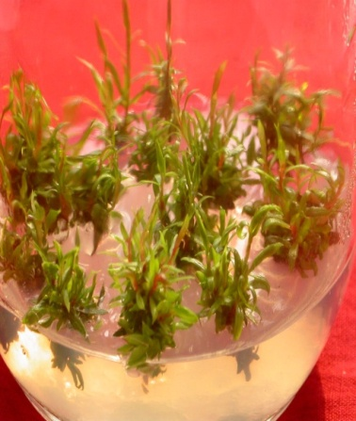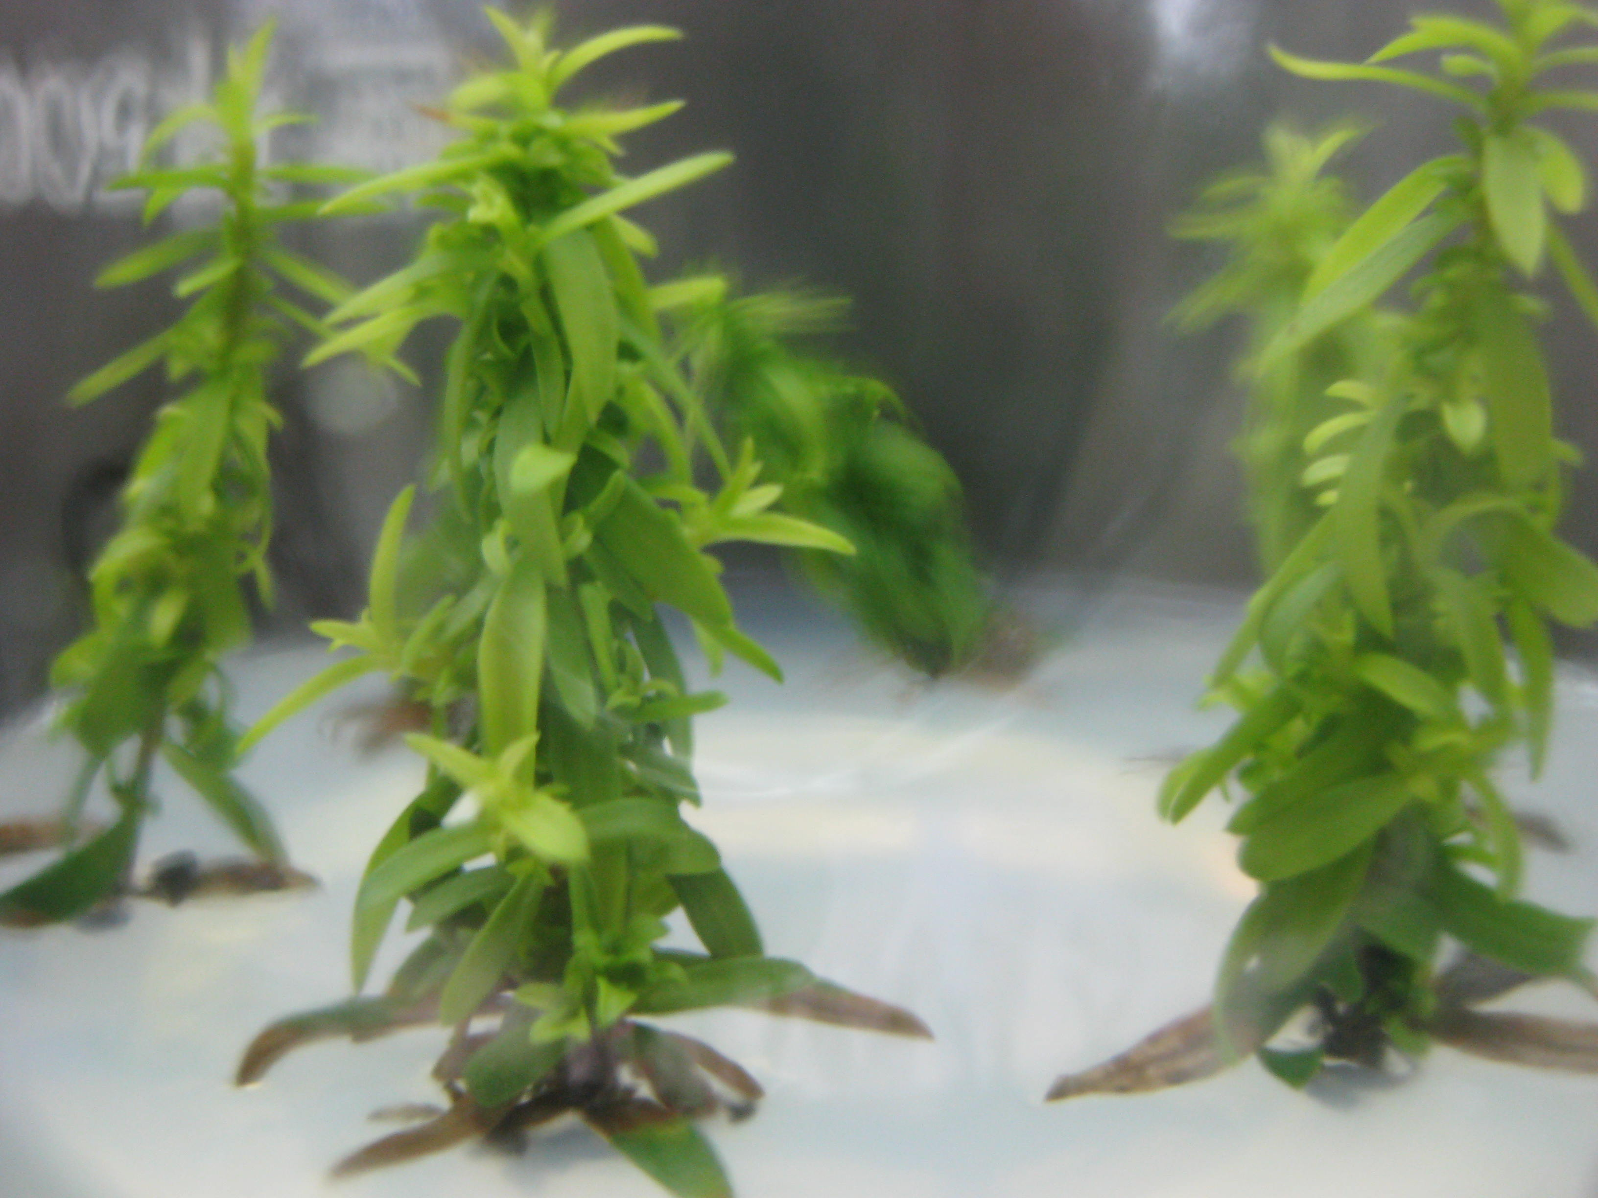
A
B

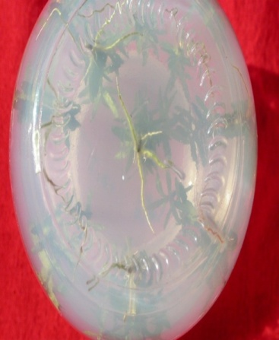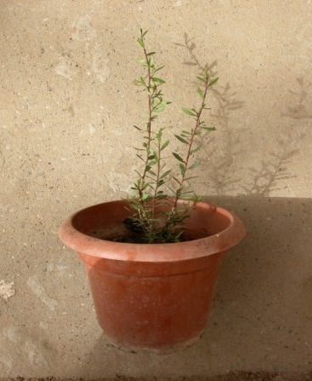
C
D

Figure 2. Schematic representation for successful in vitro propagation of Manuka
Seeds of Manuka

Washed for 30 min and immersed under 200 mg l⁻¹
of GA₃ for 12 h
Surface sterilization

10% NaOCl for 10 min followed by three washings
with sterile-distilled water
Germination

On MS medium for 1-month
Explants

Shoot tips and nodal segments, 1.0-1.5 cm long
Shoot proliferation and regeneration

Shoot proliferation was on MS medium supplemented with
2.0 mg l⁻¹ of BA and 0.1 mg l⁻¹ of GA₃, then the surviving explants
were transferred to MS medium supplemented with 0.8 mg l⁻¹ BA and 0.2 mg l⁻¹ NAA and 1.0 mg l⁻¹ GA₃ for regeneration
Rooting

On half-strength MS medium supplemented with 0.5 mg l⁻¹ NAA
Transferred to plastic pots covered with plastic bags

Containing sterile garden soil and vermiculite (2:1)
under diffuse light (14/10 h photoperiod) conditions
Acclimatization and transfer of plantlets to soil

Acclimatized in mist system for 3 WK,
then the plantlets were transferred outdoors
87.5% of them survived and continued to grow

