PROPAGATION AND GROWTH FROM CULTURED SINGLE NODE EXPLANTS OF ROSA (ROSA MINIATURE)
Farah Farahani ¹*, Soudeh Shaker ²,
¹Microbiology Department, Qom Branch, Islamic Azad University, Qom, Iran.
Fax: +98-21-66551802 , e-mail: farahfarahani2000@yahoo.com
²Plant Biotechnology Department, Karaj Center, Payame Noor university, Karaj, Iran
Fax: +98-251-7780002, e-mail: soudehshaker@yahoo.com
Corresponding Author:
Farah Farahani :
Microbiology Department, Qom Branch, Islamic Azad University, Qom, Iran.
e-mail: farahfarahni2000@yahoo.com
Tel: +989122778171
Fax: +982166551802

PROPAGATION AND GROWTH FROM CULTURED SINGLE NODE EXPLANTS OF ROSA (ROSA MINIATURE)
Farah Farahani ¹*, Soudeh Shaker ²,
¹Microbiology Department, Qom Branch, Islamic Azad University, Qom, Iran.
Fax: +98-21-66551802 , e-mail: farahfarahani2000@yahoo.com
²Plant Biotechnology Department, Karaj Center, Payame Noor university, Karaj, Iran
Fax: +98-251-7780002, e-mail: soudehshaker@yahoo.com
Abstract
Roses are one of the world's most important ornamentals for a long time and are most often used for ornamental medicinal and aromatic purposes. A method for the proliferation and growth of rose (Rosa miniature) was developed. First to seventh nodal explants from young healthy shoots were excised and cultured on basal medium of Murashige and Skoog (1962, MS) containing several concentrations of BAP and IBA. Multiple shoot formation of up to 4 shoots from a single node was obtained on MS medium supplemented with 2 mg/l BAP and 0.1 mg/l IBA. The mean length of shoots were 38 mm. The mean number of leaves 13 and color of leaves red-green were observed. The regenerated shoot readily rooted on as the same MS medium with growth regulators, mean length of root were 33 mm. In vitro flowering will observe on rose plants cultured.
Keyword: Proliferation, Rosa miniature, Single node, Rooting.
Introduction
Roses have been one of the world’s most popular ornamental plants for a long time. They belong to the Rosaceae and are grown worldwide as cut flowers and potted plants and in home gardens. The flowers vary greatly in size, shape and color. There are more than 20000 commercial cultivars of rose "the most important commercial crops" which collectively are based on only 80 of the approximately 200 wild species in Rosa (Razavizadeh and Ehsanpour 2008).
Roses can be propagated by seeds, cutting, layering and grafting. Seed propagation often results in variation while other methods of rose propagation are low and time consuming. So, there is need to introduce efficient methods for faster propagation of roses (Shabbir et al. 2009). Tissue culture system in roses has been established (Hsia and Korban 1996, Kintzios et al. 1999, Ibrahim and Debergh 2001, Kim et al. 2003, Rout et al. 2006, Hameed et al. 2006, Drefahl et al. 2007, Previati et al. 2008). Recently, in vitro flower induction in roses was demonstrated (Wang et al. 2002, Vu et al. 2006).
The flowering process is one of the critical events in the life of plant. This process involves the switch from vegetative stage to reproductive stage of growth and is believe to be regulated by both internal and external factors (Kanchanapoom et al. 2010).To establish an in vitro flowering research system, it is necessary to develop a reliable and rapid shoot organogenesis protocol. In this context, we describe an efficient tissue culture technique to yield large number of shoots from single node explants of rose. This study is part of a larger program designed to investigate in vitro flowering of Rosa species.
Materials and Methods
Plant materials
The single node explants containing lateral buds of actively field-grown ‘Miniature’ rose were used for multiplication experiments. They were cut in 5-6 cm length segments and surface-disinfested using 70% ethanol for 20 s and then immersed in laundry bleach (5.25% NaOCL) solution of commercial containing 2 drops of Tween-20 emulsifier to aid wetting for 20 min (Nak-Udom et al.). The sterilized explants were washed 2-3 times with sterile distilled water to remove disinfecting solution. They were trimmed down to 1 cm long prior to transferring to shoot multiplication medium.
Proliferation and Growth
The basal nutrient medium containing MS (Murashige and Skoog 1962) salts and vitamins was used with IBA and BAP. In the experiments, IBA at the concentrations of 0, 0.05 and 0.1 mg/l was combined with BAP at the concentrations of 0, 0.5, 1, 1.5 and 2 mg/l. Explants were subcultured to fresh medium every 6 weeks.
In vitro conditions
All media were supplemented with 3% sucrose and 7 g/l agar. The pH of all media was adjusted to 5.7 with 1 N NaOH or 1 N HCl prior to autoclaving at 1.05 kg/cm², 121ºC for 20 min. Cultures were maintained at 25±1 ºC air temperatures in a culture room with a 16-h photoperiod under an illumination of 20 mmol m-² s-¹ photosynthetic photon flux density provided by cool-white fluorescent light. Plant materials were stored in glass-capped culture jars (125 ml capacity) each containing 20 ml of medium.
Statistical analysis
Number of shoots and roots were evaluated after each culture period. A culture cycle was 6 weeks. Three explants were implanted per culture and 20 cultures were raised for each treatment unless otherwise stated. All of experiment were repeated for 3 times for each treatment used and morphological data were analyzed by analysis of variance test (ANOVA) followed by least significant difference test (LSD).
Results and Discussion
After approximately one week, most explants turned green and the node began to expand. Visible elongation of the node on shoot induction medium was observed within 10 days. New budding gradually occurred and reached climax at 4 to 6 weeks (Fig. 2a, b, c).
After 6 weeks of initial culture, nodal explants containing lateral buds cultured on MS medium in the experiments developed multiple shoots at a high frequency of 100% with 4 ± 0.66 shoots on 2 mg/l BAP and 0.1 mg/l IBA (Fig. 1a, b, c). There was no significant difference in shoot number per single node explants; however, regeneration frequency differed (Table 1). In the present study, multiplication occurred in all BAP containing media this may be attributed to the presence of IBA. Results revealed that highest level of BAP (2 mg/l) gave the highest number of 3.46 ± 0.6 shoots (p<0.05). Lower levels of IBA (0 or 0.05 mg/l) were significantly less effective (p<0.05) in shoot multiplication when compared to 1 mg/l (Table 2A). The length of shoot and number of leaves increased in different concentrations BAP (0, 0.5, 1, 1.5 and 2 mg/l) (Table 2B, D), the highest length of shoot and distance of internode were 38 mm and 5, the lowest observed 10 mm and 3 mm respectively. The highest number of shoot (3.46) showed on Ms medium culture with BAP (1.5 mg/l) and IBA (0.1 mg/l) and color of leaves were green completely.
Telgen et al. (1992) studied effects of different growth regulators and inhibitors on sprouting and outgrowth of isolated buds of different rose cultivars and reported bud growth stimulation by BAP.
At all concentrations of BAP and IBA tested, multiple shoots developed without the intervening callus stage. BAP or NAA have been used for most experiments on shoot multiplication of a number of rose species (Wang et al. 2002, Vu et al. 2006, Drefahl et al. 2007). Some other research obtained different results for other rose species with the combination of BA and IBA (Kumar et al. 2001, Khosh- Khui and Jabbarzadeh 2007). These multiple shoots with green expanded leaves and single main stem continued to proliferate after several subcultures with an average of 4 shoots per cycle. Clonal propagation of shoots was achieved by repeating subculture at 6 weeks intervals. Each nodal explant provided 16 shoots in 12 weeks, for a total production of 55 plantlets per six months.
During investigation, it was also observed that 2 mg/l BAP was best for shoot whereas lower (0.5 to 1.5 mg/l) and higher concentrations (> 2 mg/l) inhibited it. This is in accordance with the study conducted by Kim et al., (2003) in which they reported that lower concentration of BAP (0.5- 1.5 mg/l) stimulated the bud growth in six rose cultivars (Rosa hybrida L. cv. "Sequoia Ruby", "Play Boy") but higher concentration of BAP (2.5-4 mg/l) inhibited shoot proliferation (Hameed et al. 2006).
Roots that developed on this medium were thick, long and fibrous (Fig. 2d, e). In vitro-derived plants did not display any phenotypic variation during subsequent vegetative development (Fig. 1d). Up to 75% rooting was achieved on MS medium with growth regulators.
It is interesting to note that in vitro flowering was observed after transferring regenerated shoot cultured on MS medium containing 0.1 mg/l IBA and 2 mg/l BAP to rooting medium (Table 2C). BAP has been used for most experiments on in vitro flowering of a number of plants (Wang et al. 2002). In Rosa hybrida cultivar ‘Meirutral’ and cultivar ‘Fairy’ could flower in propagation medium containing BA (Dobres et al. 1998).
Xing et al. (2010) reported rooting of multiplied rose cultivar rugosa shoots was achieved on medium with IBA alone, but Razavizadeh and Ehsanpour (2008) comprised, rooting of Rose hybrida with IBA and NAA and they resulted NAA (0.1- 0.5 mg/l) were better.
In conclusion, a micropropagation system for Rosa miniature cultivar has been worked out utilizing single nodal explants. Micropropagated plants were rooted and established in vitro successfully. The preliminary result in this system enables in vitro flowering but requires further improvement.
Acknowledgement
This research was financially supported in parts by the Zarrineh Rooz Tissue Culture Company, Tehran, Iran. The authors wish to thank the Islamic Azad University of Qom Laboratory for the use of their equipments.
References
Dobres M., Williams L., Gail, R. (1998). Micropropagation of rose plants. United States patent 5,843,782.
Douglas G.C., Rutledge C.B., Casey A.D., Richardson D.H.S. (1989). Micropropagation of floribunda ground cover and miniature roses. Plant Tissue Culture, 19: 55-64.
Drefahl A., Quoirin M.G., Cuquel F.L. (2007). Micropropagation of Rosa × hybrida cv. Vegas via axillary buds. Acta Horticulturae, 751: 407-411.
Hameed N., Shabbir A., Ali A., Bajwa R. (2006). In vitro micropropagation of disease free rose (Rosa indica L.). Mycopath, 4: 35-38.
Hsia C.N., Korban S.S. (1996). Organogenesis and somatic embryogenesis in callus cultures of Rosa hybrida and Rosa chinensis minima. Plant Cell Tissue and Organ Culture, 44: 1-6.
Ibrahim R., Debergh P.C. (2001). Factors controlling high efficiency of adventitious bud formation and plant regeneration from in vitro leaf explants of roses (Rosa hybrida). Scientia Horticulturae, 88: 41-57.
Kanchanapoom K., Sakpeth P., Kanchanapoom K. (2010). In vitro flowering of shoots regenerated from cultured nodal explants of Rosa hybrida cv. 'Heirloom'. Science Asia, 36: 161-164.
Khosh-Khui M., Jabbarzadeh Z. (2007). Effects of several variables on in vitro culture of Damask Rose (Rosa damascena Mill.). Acta Horticulturae, 751: 389-393.
Kim S.W., Oh S.C., In D.S., Liu J.R. (2003). Plant regeneration of rose (Rosa hybrida) from embryogenic cell-derived protoplasts. Plant Cell Tissue and Organ Culture, 73: 15-19.
Kim C.K., Chung J.D., Jee S.O., Oh JY. (2003). Somatic embryogenesis from in vitro grown leaf explants of Rosa hybrida L. J. Plant Biotech., 5(3): 169-172.
Kintzios S., Manos C., Makri, O. (1999). Somatic embryogenesis from mature leaves of rose (Rosa sp.). Plant Cell Reports, 18: 467-472.
Kumar A., Sood A., Plani U.T., Gupta A.K., Plani, L.M.S. (2001). Micropropagation of Rosa damascene Mill. from mature bushes using thidiazuron. Journal of Horticultural Science and Biotechnology, 76: 30-34.
Murashige T., Skoog, F. (1962). A revised medium for rapid growth and bioassays with tobacco tissue cultures. Physiologia Plantarum, 15: 473-497.
Nak-Udom N., Kanchanapoom K., Kanchanapoom K. (2009). Micropropagation from cultured nodal explants of rose (Rosa hybrida L. cv. 'Perfume Delight'). Songkalnakarin J. Sci. Technol., 31(6): 583-586.
Previati A., Benelli C., Da Re F., Ozudogru A., Lambradi M. (2008). Micropropagation and in vitro conservation of virus-free rose germplasm. Propagation of Ornamental Plants, 8: 93-98.
Razavizadeh R., Ehsanpour A.A. (2008). Optimization of in vitro propagation of Rosa hybrida L. Cultivar Black Red. American- Eurasian J. Agric. & Environ. Sci., 3(1): 96-99.
Rout G.R., Mohapatra, A., Mohan Jain S. (2006). Tissue culture of ornamental pot plant: A critical review on present scenario and future prospect. Biotechnology Advances, 24: 531-560.
Shabbir A., Hameed N., Ali A., Bajwa R. (2009). Effect of different cultural conditions on micropropagation of rose (Rosa indica L.). Pak. J. Bot., 41(6): 2877-2882.
Telgen H., Elagoz V., Mil A., Paffen A., klerk G. (1992). Role of plant hormones in lateral bud growth of rose and apple in vitro. Acta Hort., 319: 137-142.
Vu N.H., Anh P.H., Nhut D.T. (2006). The role of sucrose and different cytokinins in the in vitro floral morphogenesis of rose (hybrid tea) cv. ‘First Prize’. Plant Cell Tissue and Organ Culture, 87: 315-320.
Xing W., Bao M., Qin H., Ning G. (2010). Micropropagation of Rosa rugosa through axillary shoot proliferation. Acta Biologica Cracoviensia Series Botanica, 52(2): 69-75.
Wang G.Y., Yuan M.F., Hong Y. (2002). In vitro flower induction in roses. In Vitro Cellular and Developmental Biology-Plant, 38: 513-518.

Table 1. Effect of different concentrations of BAP and IBA (Treatments) on adventitious shoot formation and rooting from single node culture of Rosa miniature
Color  of  Leaves | Number  of leaves | Length  of Root  (mm) | Number of  Shoot | Length  of Shoot  (mm) | IBA  (mg/l) | BAP (mg/l) | Treatment
_ | 0 ± 0 | 0 ± 0 | 0 ± 0 | 0 ± 0 | 0 | 0 | T1
Green | 5.2 ± 1.0 | 0 ± 0 | 3.4 ± 0.7 | 10 ± 0 | 0 | 0.5 | T2
Green | 8.5 ± 0.8 | 0 ± 0 | 3.6 ± 0.5 | 22.2 ± 2.6 | 0 | 1 | T3
Green | 10.5 ± 1.0 | 0 ± 0 | 3.6 ± 0.7 | 12.3 ± 5.3 | 0 | 1.5 | T4
Green | 21.8 ± 16.4 | 0 ± 0 | 5.6 ± 4.2 | 13.3 ± 10.8 | 0 | 2 | T5
Green | 11.1 ± 4.4 | 0 ± 0 | 2.7 ± 1.2 | 15 ± 6.6 | 0.05 | 0 | T6
Green | 6.6 ± 5.1 | 0 ± 0 | 1.6 ± 1.3 | 12.7 ± 10.0 | 0.05 | 0.5 | T7
Green | 6.1 ± 1.4 | 0 ± 0 | 2.3 ± 0.5 | 20.5 ± 3.9 | 0.05 | 1 | T8
Green | 10.2 ± 1.2 | 0 ± 0 | 2.6 ± 0.5 | 21.6 ± 4.3 | 0.05 | 1.5 | T9
Green | 10.0 ± 3.8 | 0 ± 0 | 2.2 ± 0.9 | 22.2 ± 9.7 | 0.05 | 2 | T10
Green | 7.6 ± 4.4 | 0 ± 0 | 2.3 ± 1.4 | 20 ± 11.9 | 0.1 | 0 | T11
Green | 12.3 ± 1.6 | 0 ± 0 | 2.7 ± 0.6 | 21.6 ± 5.5 | 0.1 | 0.5 | T12
Green | 17.2 ± 13.0 | 0 ± 0 | 1.7 ± 1.3 | 20.5 ± 15.7 | 0.1 | 1 | T13
Red-Green | 18.0 ± 7.3 | 21.6 ± 11.7 | 3.2 ±1.4 | 34.3 ± 14.4 | 0.1 | 1.5 | T14
Red-Green | 13.3 ± 1.7 | 33.07 ±11.4 | 3.4 ± 0.6 | 38.4 ± 4.2 | 0.1 | 2 | T15

Table 2A. Representative mean difference test (LSD) for Length of Shoot among Treatments.
(I) Treatment | (J) Treatment | Mean Difference (I-J) | Sig.
T1 | T3 | -22.2222 (*) | .000
T1 | T6 | -15.0000 (*) | .022
T1 | T8 | -20.5556 (*) | .000
T1 | T9 | -21.6667 (*) | .000
T1 | T10 | -22.2222 (*) | .000
T1 | T11 | -20.0000 (*) | .000
T1 | T12 | -21.6667 (*) | .000
T1 | T13 | -20.5556 (*) | .000
T1 | T14 | -34.3333 (*) | .000
T1 | T15 | -38.4615 (*) | .000
T2 | T3 | -21.2222 (*) | .000
T2 | T6 | -14.0000 (*) | .050
T2 | T8 | -19.5556 (*) | .000
T2 | T9 | -20.6667 (*) | .000
T2 | T10 | -21.2222 (*) | .000
T2 | T11 | -19.0000 (*) | .000
T2 | T12 | -20.6667 (*) | .000
T2 | T13 | -19.5556 (*) | .000
T2 | T14 | -33.3333 (*) | .000
T2 | T15 | -37.4615 (*) | .000
T3 | T1 | 22.2222 (*) | .000
T3 | T2 | 21.2222 (*) | .000
T3 | T15 | -16.2393 (*) | .002
T4 | T14 | -22.0000 (*) | .000
T4 | T15 | -26.1282 (*) | .000
T5 | T14 | -21.0000 (*) | .000
T5 | T15 | -25.1282 (*) | .000
T6 | T1 | 15.0000 (*) | .022
T6 | T2 | 14.0000 (*) | .050
T6 | T14 | -19.3333 (*) | .000
T6 | T15 | -23.4615 (*) | .000
T7 | T14 | -21.5556 (*) | .000
T7 | T15 | -25.6838 (*) | .000
T8 | 1.00 | 20.5556 (*) | .000
T8 | 2.00 | 19.5556 (*) | .000
T8 | 14.00 | -13.7778 (*) | .016
T8 | 15.00 | -17.9060 (*) | .000
T9 | 1.00 | 21.6667 (*) | .000
T9 | 2.00 | 20.6667 (*) | .000
T9 | 14.00 | -12.6667 (*) | .044
T9 | 15.00 | -16.7949 (*) | .001
T10 | 1.00 | 22.2222 (*) | .000
T10 | 2.00 | 21.2222 (*) | .000
T10 | 15.00 | -16.2393 (*) | .002
T11 | 1.00 | 20.0000 (*) | .000
T11 | 2.00 | 19.0000 (*) | .000
T11 | 14.00 | -14.3333 (*) | .009
T11 | 15.00 | -18.4615 (*) | .000
T12 | 1.00 | 21.6667 (*) | .000
T12 | 2.00 | 20.6667 (*) | .000
T12 | 14.00 | -12.6667 (*) | .044
T12 | 15.00 | -16.7949 (*) | .001
T13 | 1.00 | 20.5556 (*) | .000
T13 | 2.00 | 19.5556 (*) | .000
T13 | 14.00 | -13.7778 (*) | .016
T13 | 15.00 | -17.9060 (*) | .000
T14 | 1.00 | 34.3333 (*) | .000
T14 | 2.00 | 33.3333 (*) | .000
T14 | 4.00 | 22.0000 (*) | .000
T14 | 5.00 | 21.0000 (*) | .000
T14 | 6.00 | 19.3333 (*) | .000
T14 | 7.00 | 21.5556 (*) | .000
T14 | 8.00 | 13.7778 (*) | .016
T14 | 9.00 | 12.6667 (*) | .044
T14 | 11.00 | 14.3333 (*) | .009
 | 12.00 | 12.6667 (*) | .044
 | 13.00 | 13.7778 (*) | .016
T15 | 1.00 | 38.4615 (*) | .000
T15 | 2.00 | 37.4615 (*) | .000
T15 | 3.00 | 16.2393 (*) | .002
T15 | 4.00 | 26.1282 (*) | .000
T15 | 5.00 | 25.1282 (*) | .000
T15 | 6.00 | 23.4615 (*) | .000
T15 | 7.00 | 25.6838 (*) | .000
T15 | 8.00 | 17.9060 (*) | .000
T15 | 9.00 | 16.7949 (*) | .001
T15 | 10.00 | 16.2393 (*) | .002
T15 | 11.00 | 18.4615 (*) | .000
T15 | 12.00 | 16.7949 (*) | .001
T15 | 13.00 | 17.9060 (*) | .000

The mean differences are significant at the 0.05 level.

Table 2B. Representative mean difference test (LSD) for Number of Shoot among Treatments.
(I) Treatment | (J) Treatment | Mean Difference (I-J) | Sig.
T1 | T2 | -3.4444 (*) | .000
T1 | T3 | -3.6667 (*) | .000
T1 | T4 | -3.6667 (*) | .000
T1 | T5 | -5.6667 (*) | .000
T1 | T6 | -2.7778 (*) | .003
T1 | T8 | -2.3333 (*) | .037
T1 | T9 | -2.6667 (*) | .006
T1 | T11 | -2.3333 (*) | .037
T1 | T12 | -2.7778 (*) | .003
T1 | T14 | -3.2667 (*) | .000
T1 | T15 | -3.4615 (*) | .000
T2 | T1 | 3.4444 (*) | .000
T3 | T1 | 3.6667 (*) | .000
T4 | T1 | 3.6667 (*) | .000
T5 | T1 | 5.6667 (*) | .000
T5 | T6 | 2.8889 (*) | .002
T5 | T7 | 4.0000 (*) | .000
T5 | T8 | 3.3333 (*) | .000
T5 | T9 | 3.0000 (*) | .001
T5 | T10 | 3.4444 (*) | .000
T5 | T11 | 3.3333 (*) | .000
T5 | T12 | 2.8889 (*) | .002
T5 | T13 | 3.8889 (*) | .000
T5 | T14 | 2.4000 (*) | .006
T5 | T15 | 2.2051 (*) | .027
T6 | T1 | 2.7778 (*) | .003
T6 | T5 | -2.8889 (*) | .002
T7 | T5 | -4.0000 (*) | .000
T8 | T1 | 2.3333 (*) | .037
T8 | T5 | -3.3333 (*) | .000
T9 | T1 | 2.6667 (*) | .006
T9 | T5 | -3.0000 (*) | .001
T10 | T5 | -3.4444 (*) | .000
T11 | T1 | 2.3333 (*) | .037
T11 | T5 | -3.3333 (*) | .000
T12 | T1 | 2.7778 (*) | .003
T12 | T5 | -2.8889 (*) | .002
T13 | T5 | -3.8889 (*) | .000
T14 | T1 | 3.2667 (*) | .000
T14 | T5 | -2.4000 (*) | .006
T15 | T1 | 3.4615 (*) | .000
T15 | T5 | -2.2051 (*) | .027

The mean differences are significant at the 0.05 level.
Table 2C. Representative mean difference test (LSD) for Length of Root among Treatments.
(I) Treatment | (J) Treatment | Mean Difference (I-J) | Sig.
T1 | T14 | -21.6667 (*) | .000
T1 | T15 | -33.0769 (*) | .000
T2 | T14 | -21.6667 (*) | .000
T2 | T15 | -33.0769 (*) | .000
T3 | T14 | -21.6667 (*) | .000
T3 | T15 | -33.0769 (*) | .000
T4 | T14 | -21.6667 (*) | .000
T4 | T15 | -33.0769 (*) | .000
T5 | T14 | -21.6667 (*) | .000
T5 | T15 | -33.0769 (*) | .000
T6 | T14 | -21.6667 (*) | .000
T6 | T15 | -33.0769 (*) | .000
T7 | T14 | -21.6667 (*) | .000
T7 | T15 | -33.0769 (*) | .000
T8 | T14 | -21.6667 (*) | .000
T8 | T15 | -33.0769 (*) | .000
T9 | T14 | -21.6667 (*) | .000
T9 | T15 | -33.0769 (*) | .000
T10 | T14 | -21.6667 (*) | .000
T10 | T15 | -33.0769 (*) | .000
T11 | T14 | -21.6667 (*) | .000
T11 | T15 | -33.0769 (*) | .000
T12 | T14 | -21.6667 (*) | .000
T12 | T15 | -33.0769 (*) | .000
T13 | T14 | -21.6667 (*) | .000
T13 | T15 | -33.0769 (*) | .000
T14 | T1 | 21.6667 (*) | .000
T14 | T2 | 21.6667 (*) | .000
T14 | T3 | 21.6667 (*) | .000
T14 | T4 | 21.6667 (*) | .000
T14 | T5 | 21.6667 (*) | .000
T14 | T6 | 21.6667 (*) | .000
 | T7 | 21.6667 (*) | .000
 | T8 | 21.6667 (*) | .000
 | T9 | 21.6667 (*) | .000
 | T10 | 21.6667 (*) | .000
 | T11 | 21.6667 (*) | .000
 | T12 | 21.6667 (*) | .000
 | T13 | 21.6667 (*) | .000
 | T15 | -11.4103 (*) | .000
T15 | T1 | 33.0769 (*) | .000
T15 | T2 | 33.0769 (*) | .000
T15 | T3 | 33.0769 (*) | .000
T15 | T4 | 33.0769 (*) | .000
T15 | T5 | 33.0769 (*) | .000
T15 | T6 | 33.0769 (*) | .000
T15 | T7 | 33.0769 (*) | .000
T15 | T8 | 33.0769 (*) | .000
T15 | T9 | 33.0769 (*) | .000
T15 | T10 | 33.0769 (*) | .000
T15 | T11 | 33.0769 (*) | .000
T15 | T12 | 33.0769 (*) | .000
T15 | T13 | 33.0769 (*) | .000
T15 | T14 | 11.4103 (*) | .000

The mean differences are significant at the 0.05 level.

Table 2D. Representative mean difference test (LSD)for Number of Leaves among Treatments.
(I) Treatment | (J) Treatment | Mean Difference (I-J) | Sig.
T1 | T4 | -10.5556 (*) | .026
T1 | T5 | -21.8889 (*) | .000
T1 | T6 | -11.1111 (*) | .013
T1 | T9 | -10.2222 (*) | .038
T1 | T10 | -10.0000 (*) | .048
T1 | T12 | -12.3333 (*) | .003
T1 | T13 | -17.2222 (*) | .000
T1 | T14 | -18.0000 (*) | .000
T1 | T15 | -13.3846 (*) | .000
T2 | T5 | -16.6667 (*) | .000
T2 | T13 | -12.0000 (*) | .004
T2 | T14 | -12.7778 (*) | .000
T3 | T5 | -13.3333 (*) | .001
T3 | T14 | -9.4444 (*) | .026
T4 | T1 | 10.5556 (*) | .026
T4 | T5 | -11.3333 (*) | .010
T5 | T1 | 21.8889 (*) | .000
T5 | T2 | 16.6667 (*) | .000
T5 | T3 | 13.3333 (*) | .001
T5 | T4 | 11.3333 (*) | .010
T5 | T6 | 10.7778 (*) | .020
T5 | T7 | 15.2222 (*) | .000
T5 | T8 | 15.7778 (*) | .000
T5 | T9 | 11.6667 (*) | .006
T5 | T10 | 11.8889 (*) | .005
T5 | T11 | 14.2222 (*) | .000
T6 | T1 | 11.1111 (*) | .013
T6 | T5 | -10.7778 (*) | .020
T7 | T5 | -15.2222 (*) | .000
T7 | T13 | -10.5556 (*) | .026
T7 | T14 | -11.3333 (*) | .002
T8 | T5 | -15.7778 (*) | .000
 | T13 | -11.1111 (*) | .013
 | T14 | -11.8889 (*) | .001
T9 | T1 | 10.2222 (*) | .038
T9 | T5 | -11.6667 (*) | .006
T10 | T1 | 10.0000 (*) | .048
T10 | T5 | -11.8889 (*) | .005
T11 | T5 | -14.2222 (*) | .000
T11 | T14 | -10.3333 (*) | .007
T12 | T1 | 12.3333 (*) | .003
T13 | T1 | 17.2222 (*) | .000
T13 | T2 | 12.0000 (*) | .004
T13 | T7 | 10.5556 (*) | .026
T13 | T8 | 11.1111 (*) | .013
T14 | T1 | 18.0000 (*) | .000
T14 | T2 | 12.7778 (*) | .000
T14 | T3 | 9.4444 (*) | .026
T14 | T4 | 7.4444 (*) | .229
T14 | T7 | 11.3333 (*) | .002
T14 | T8 | 11.8889 (*) | .001
T14 | T11 | 10.3333 (*) | .007
T15 | T1 | 13.3846 (*) | .000

The mean differences are significant at the 0.05 level.

Figure 1. In vitro culture of Rosa miniature a) Mean length of shoot; b) mean of number of shoot; c) length of root; d) number of leaves in different treatments

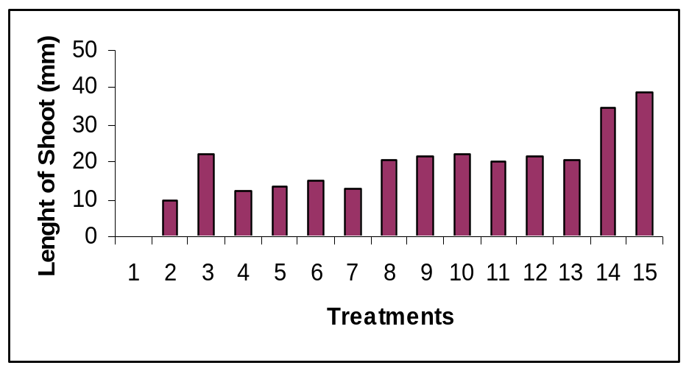
a

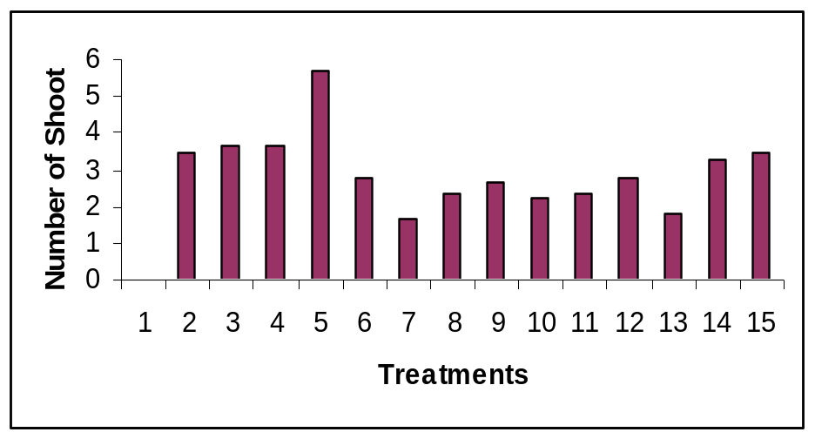
b

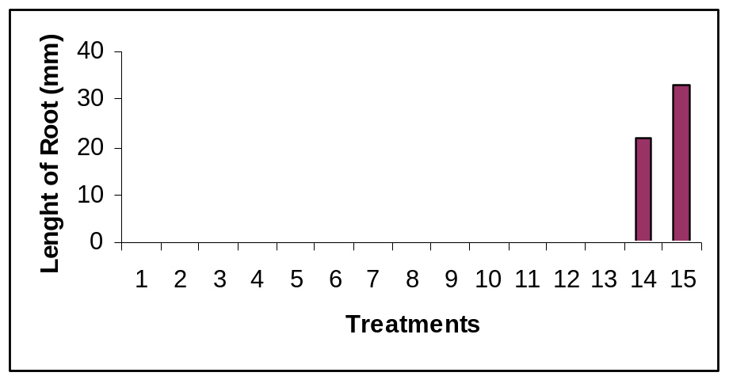
c

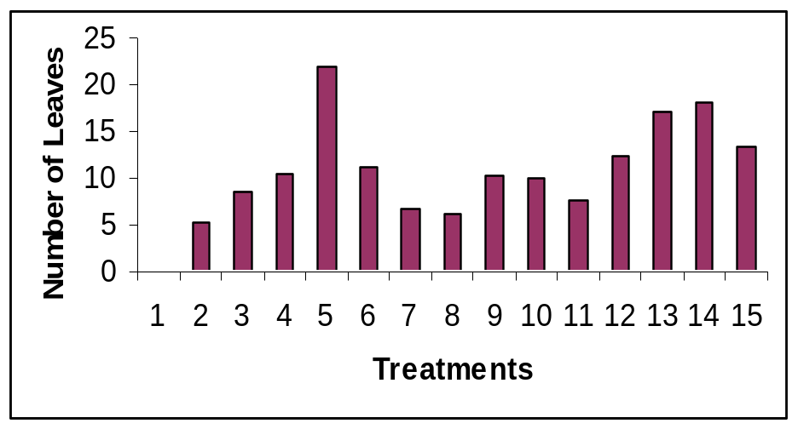
d

Figure 2. In vitro culture of Rosa miniature. a) Shoot initiation from single node explants b) shoot multiplication c) shoot elongation d) rooting, with long roots e) with large number of small roots
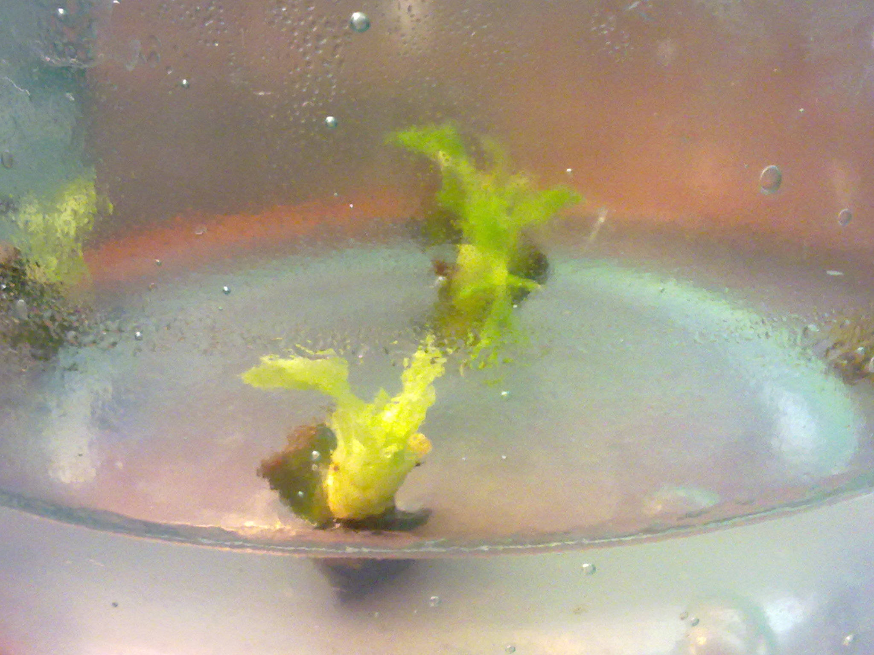

a
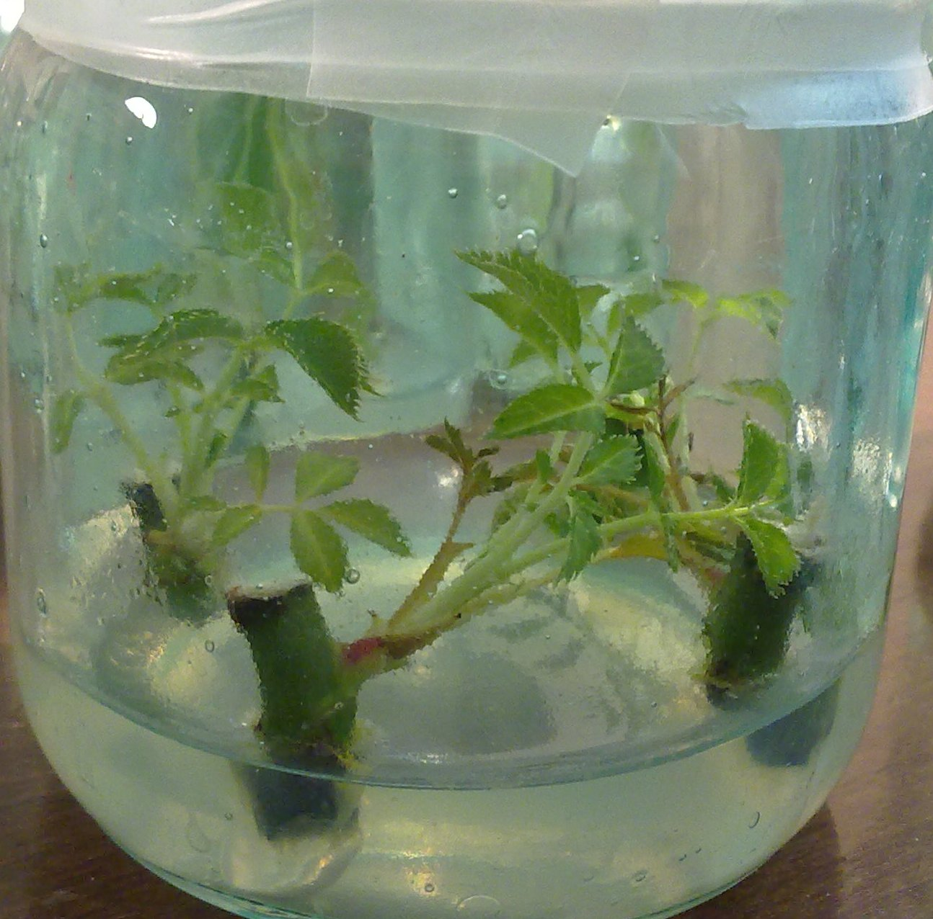

b

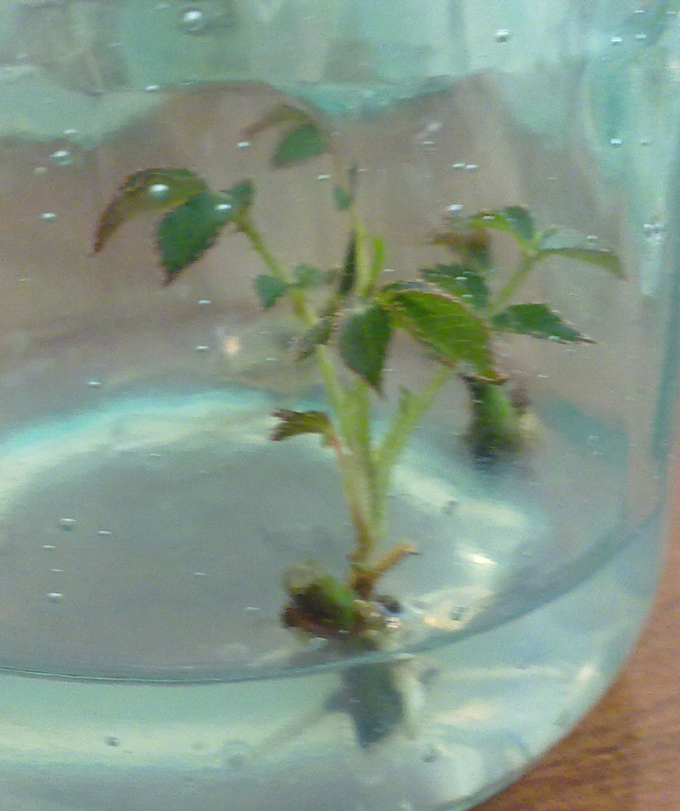
b

c

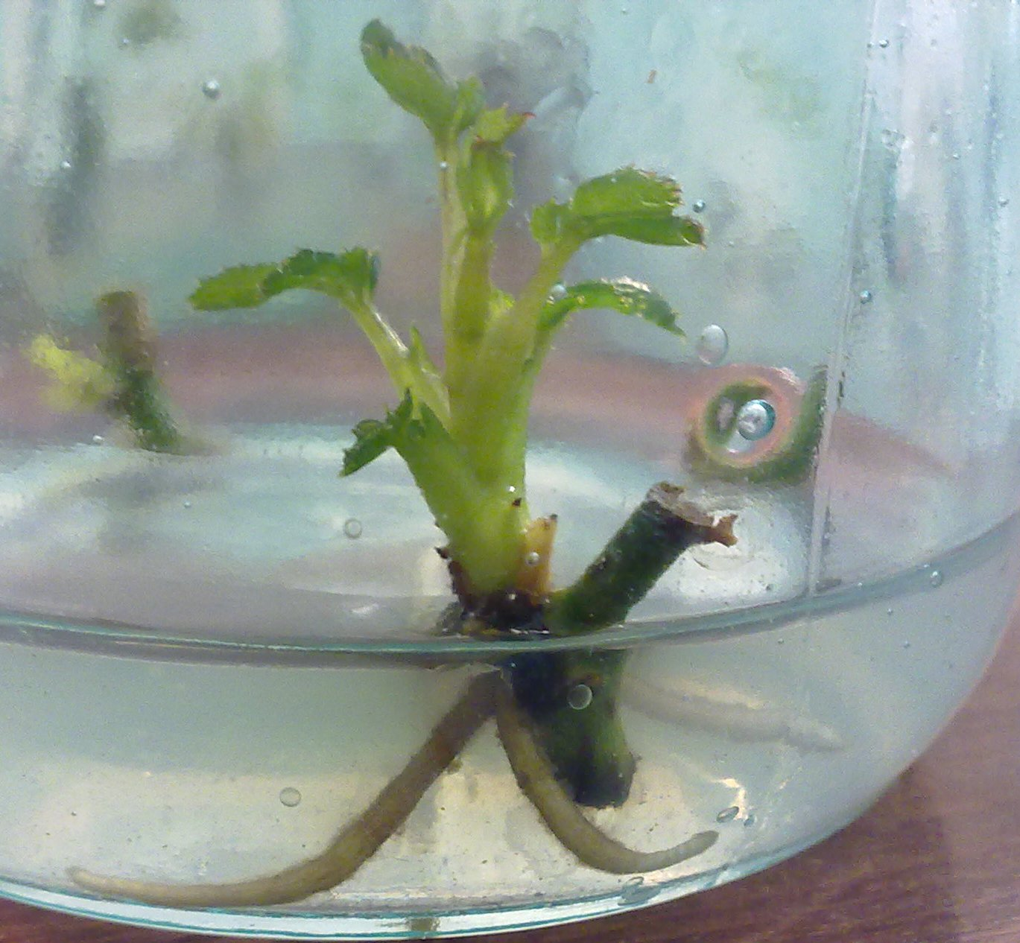

d

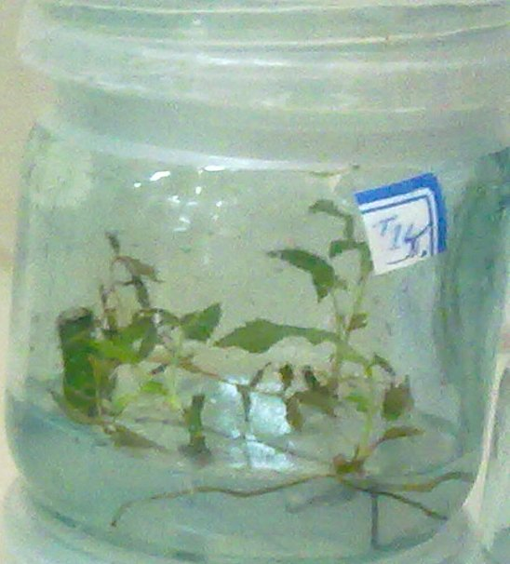

e

