Development and Validness of the Growth Model for
Tissue Culture Plantlets

Chiachung Chen
Chiachung Chen, Professor, Department of Bio-industrial Mechatronics Engineering, National ChungHsing University, 250 Kuokuang Road, Taichung, Taiwan.
Corresponding author is Chiachung Chen, Department of Bio-industrial Mechatronics Engineering, National ChungHsing University, 250 Kuokuang Road, Taichung, Taiwan; phone: 886-4-22857562; fax:886-4-22857135
e-mail:ccchen@dragon.nchu.edu.tw

Abstract
The effect of temperature and light intensity on the growth of in vitro cultures of Oncidium was studied. The increase of dry weights for plantlets was served as the growth index to valid the model. The Oncidium variety “Onc. Gower Ramsey” was selected to observe the growth conditions. The experimental design included the light intensity and temperature. The growth model of plantlets was developed and validated by the nonlinear regression technique and the growth parameters were further studied. The experiment result revealed the validness of this growth model. The dry weights of plantlets with the high temperature and high light intensity treatment had the highest value at the same culture days. The results of this study could provide useful information for the propagation of the Oncidium plantlets.

Key words: growth model, tissue culture, plantlets, Oncidium

INTRODUCTION
In 2010, 62 millions units of orchids were produced in Taiwan. The orchids industry has become the most important agricultural industry. All orchids are produced from the plantlets cultured by micropropagation. The quantity required to be stable and the quality needs to be enhanced for plantlets of orchids continuously.
Tissue culture plantlets in vitro are cultured in a small closed system of tissue culture vessels. In this technique, plantlets in vitro are cultured in small and aseptic culture vessels. The water and nutrition are supplied by the medium that had filled in the culture. The special environment within the culture vessel are pretty high relative humidity, low carbon dioxide (CO₂) concentrations in light period and high carbon dioxide concentrations in dark period (Kozai et al., 1995a). Because the growing conditions required maintaining in a low density of microorganisms, the gas exchange rates in tissue culture vessel was limited (Chen and Chen 2002). Vessels are placed on horizontal shelves arranged in the culture room. The growth of plantlets is influenced by the internal microclimate of vessels, such as light quality and quantity, air temperature, and air relative humidity. The optimum way to modify the internal microclimate of vessel is to adjust the outside environment of culture room indirectly. The measurement and model for the air temperature, relative humidity and light irradiance have been developed and validated (Chen 2003, 2004, 2005).
It is very useful to develop a growth model for plantlets in vitro to show the relationship between the microclimate and the growth conditions in the culture period. This growth model can be applied to compare the affecting factors and to optimize the production plan. There are many mathematical modes to describe the growth characteristics for agronomy and horticultural crops (Thornley and Johson 1990). However, only a few research papers exist for plantlets cultured in vitro.
The effects of the physical environment on the growth of plant tissue cultured have studied. Rahman and Blake (1988) developed the technique of the vegetative propagation of seedling jackfruit (Artocarpus heterophyllus Lam.) in vitro. Shoot proliferation was optimal at 30°C and hardly to obtain at 35℃ with a 12 h photoperiod. Hoer et al. (1988) studied the effect of temperature on the rate of shoot multiplication of Rosa hybrids with four conditions (12, 15, 18, 24℃), the best overall results were found at 18℃. Yamagishi (1988) studied the effect of the temperature on the enlargement of in vitro bulblets of Lilium japonicum Thunb. and found the culture temperature of 20℃ was better than that of 15℃ or 26℃.
Schripsema et al.(1990) assumed the lost weigh of medium content was transformed as the increase of dry weight for plant cell by suspension culture in a culture flask. The estimated CO₂ concentrations in the culture flask had the highly correlate with the assimilation of plant cells. Fujiwara and Kozai (1995 b) applied the mathematical simulation technique to evaluate the effects of air exchange rate of culture vessels and lighting cycle on the plantlet production. Fujiwara et al. (1995 c) developed a net photosynthesis model to estimate the effects of saccharine absorption rate and CO₂ concentration levels on the increase of dry weights of potato plantlets. Niu et al. (1996) show an hourly net photosynthetic rate model for Cymbidium plantlets in responses to the CO₂ concentrations and light compensation points. In the above literature, researchers claimed the validness of these models. However, no actual measuring data were collected to validate these models. The function of sugar absorption and transformed did not be considered.
Niu and Kozai (1997) proposed the growth model for potato plantlet cultured photo autotrophically in vitro. In the special case of sugar free, it is not necessary to consider the absorption of sugar. Their experiment design included three levels of vessel ventilation rate and two levels of light irradiance. The dry weight of plantlets measured at days 7 and 14 were used to validate the fitting-agree mat of model. The correspondence of measured data and predictive cures were observed by visual technique.
The plant growth models have been adopted to describe the relationship between the plant growth index and growth time. Karadavut et al. (2010) evaluated the fitting-agreement of several nonlinear models to describe the leaf growth for five maize cultivars. De Visser and van den Berg (1998) found the developed a two-parameter logistic model was the only adequate model to express the relationship between onion bulb weights and culture days. Willcutts et al. (1998) used the logistic equation to estimate the fertilizer N requirements of lettuce and recommended the best N concentration for lettuce growth. The fitting-agreement of several nonlinear models in analyzing the growth pattern of blueberry fruit diameter of different cultivars was compared by Godoy et al. (2008). Barker et al. (2010) measured the patterns of herbage mass and accumulation rate by time and found the Gompertz equation could best to describe the growth pattern.
In this study, the growth constant of growth model was assumed as the net grains of carbon source. Three growth models for plantlets were developed from a differential equation. The experiment design included two levels of temperature and irradiance. These models were evaluated with measured dry weights by using nonlinear regression analysis. The factors affecting the growth characteristics of plantlets were evaluated by the parameters of the best fit growth equation.

MATERIALS AND METHODS
Model development
The gain of carbon source for plantlets in vitro is assumed:
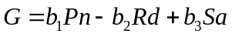 (1)
where G is the gain of carbon per plantlets of unit weight; Pn is the photosynthesis rate at light period; Rd is the respiration rate at dark period; Sa is the absorption rate of sugar from medium; and b_{1,} b₂ and b₃ are conversion factor.
Pn value could be calculated as (Fujiwara et al. 1995c),
(2)
where N is the air exchange rate of culture vessel; V is the volume of flask; Co(t) is the outside CO₂ concentration at time t; Ci(t) is the internal CO₂ concentration at time t; CO₂₋₁ is the CO₂ concentration at the end of light period; CO₂₋₂ is the CO₂ concentration at the start of light period; and K₁ is the conversion factors.
Rd value could be calculated as (Fujiwara et al. 1995c),
（3）
where C₂₋₃ is the CO₂ concentration at the end of dark period.
The N value is limited (Chen and Chen 2002), so the first term of equations (1) and (2) could be omitted. The values of CO₂₋₁, CO₂₋₂, and CO₂₋₃ at the fixed environment were constant (Chen 2007). The Pn and Rd values could be assumed as constants.
The growth of plantlets was assumed as a fist-order chemical reaction. The quantity of growth is work at a rate proportional to the substrate level. The growth model can be proposed as：
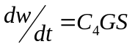 (4)
where C₄ is constant and S is the substrate level.
For the whole system, no gain or loss for the dry materials,
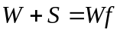 (5)
where Wf is the final value of W as time approach to infinite, combining (4) and (5),
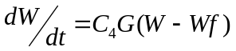 (6)
After integration equation (6),
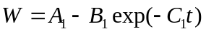 (7)
Equation (7) is the monomolecular equation.
If the growth mechanism is assumed as a rate proportion to the product of dry mass W and substrate S, the governing equation is:
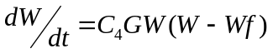 (8)
The new equation obtained by integrating equation (8):
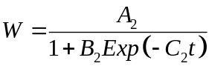 (9)
Equation (9) is called as the three-parameter logistic equation.
At the propagation stage, the young plantlets were transplanted into medium in the flash for further developing. Considering the initial weights of young plantlet, equation (9) was modified as:
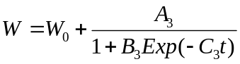 (10)
where W₀ is the initial weights of young plantlet.
This equation is called as the four-parameter equation.
Plantlet material
The usable shoots of Oncidium (Onc. Grower Ramsey) were transplanted on the same rooting medium for 10 days. There were 25 plantlets in a flask. A conical flask (F-1, I-Shin Co., Taiwan) was selected. The diameter of the glass vessels was 100 mm, the volume 550 ml and 105 ml medium filled into vessels. Vessels were sealed with black rubber stopper.
Experiment design
The culture conditions were 12 hours of light and 12 hours of dark. All culture vessels were placed on the horizontal shelves with different temperatures and light treatments in the different growth chambers. The experiment design was listed as follows:
1. High temperature and high light intensity, (HTHL): day temperature is 28℃, night temperature is 23℃, light irradiance is 60 μmolm⁻²s⁻¹
2. High temperature and low light intensity, (HTLL): day temperature is 28℃, night temperature is 23℃, light irradiance is 30 μmolm⁻²s⁻¹
3. Low temperature and high light intensity, (LTHL): day temperature is 23℃, night temperature is 18℃, light irradiance is 60μmolm⁻²s⁻¹
4. Low temperature and low light intensity, (LTLL): day temperature is 23℃, night temperature is 18℃, light irradiance is 30μmolm⁻²s⁻¹
Forty vessels were placed of the culture shelves in growth chamber for each treatment.
Measurement of plantlets growth conditions
The growth conditions were recorded firstly after 10 days transplanted. Culture vessels were taken out to measure the growth conditions of plantlets at day 10, 24, 35, 44, 51, 59, 66 and 73. Dry weights of oncidiums plantlets cultured in vitro were detected.
The dry weights were measured by electric balance (Mettler PM 400, HP, Palo Alto, CA, USA). To measure the dry weight of plantlets, samples were dried with hot air over for 24 hours at 80℃.
Statistical analysis
The relationship between dry weights and culture days was established by using nonlinear regression analysis. Data were analyzed by statistical software (Sigma plot, SPSS Inc., Chicago, IL.) to evaluate the fitting-agreement of the nonlinear model. Two quantitative standards, R-squared values (R²) and standard error of the estimated value (s) are used to compare the fitting ability of the growth models. The adequateness of the model was evaluated by residual plots. The residual was defined as the difference between the measured value and the predicted value calculated by the model. The distribution of the data points in the residual plots should tend to be a horizontal band centered around zero. If the data points of residual plots reveal a type of funnel shape, it indicated the variance of data points was not keep at constant. The data needs to be modified for further analysis.
Three growth models are adopted in this study, there are: the monomolecular model, three-parameter logistical model and four-parameter logistical model.
RESULTS AND DISCUSSION
The data distribution of dry weights
The data distribution, the relationship of dry weights and cultured days for four experiment designs, is presented in Figs.1-4.
The wide distribution of data point at each treatment showed the variation of biological characteristics. For the HTHL treatment, the dry weight of cultured plantlets was increase with the culture days. It indicated that the growth mechanism of plantlets was work in this experiment. For the HTLL treatment, the dry weights of plantlets begun to develop after 40 culture days. The growth mechanism seems to be stagnant at the initial period. The lower irradiance did not provide enough light intensity for the growth of plantlets.
For the LTHL and LTLL treatment, day/night temperature was set at 23/18℃. The plantlets began to develop after the 35 days culture period. However, treated with low irradiance seems had the higher dry weights at the same culture days.
The fitting model for plantlets
The estimated values of parameters and comparative criteria for three growth models with different experiments were listed in Table 1.
For the monomolecular model, only the data of HTHL treatment had the uniform distribution residual plants. The clean pattern of residual distribution could be found for others three models.
The monomolecular model for HTHL treatment is:
(11)
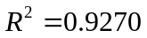, s = 0.0210
For the three-parameter model, two data sets of HTHL and LTLL treatment had the uniform distribution residual plots. The growth models for two treatments are:
1. HTHL treatment:
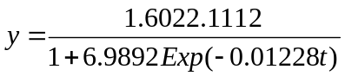 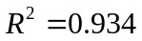, s = 0.0119 (12)
2. LTLL Treatment:
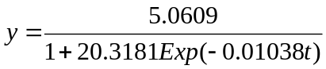 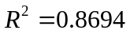, s = 0.0278 (13)
For the four-parameter model, all data sets had the uniform distribution of residual plots. This result indicated that this four-parameter model could serve as the adequate model of plantlets of Oncidium for four treatments. The growth models for two typical treatments are:
1. HTHL
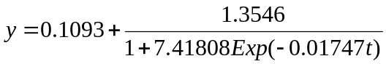 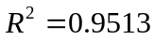, s = 0.0221 (14)
2. LTLL
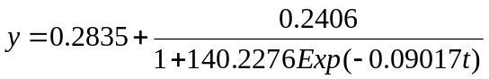 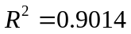, s = 0.0245 (15)
Compared with R² and s values, the four-parameter logistical model had the best fitting ability. The predictive curves from this equation were used for further analysis.
The effect of temperature and irradiance on the growth of plantlets
The predictive curves of four-parameter growth model for four treatments are plot as Fig. 5. The dry weights of plantlets with the HTHL treatment had the highest value at the same culture days. The growth condition of plantlets with LTLL treatment is better than that of others HTLL and LTHT treatments.
Because of the wide diversity of data sets, the effect of culture environment on these growth characteristic of plantlets is difficult to evaluate directly only by the data distribution of the plots. The predictive curves obtained from the growth model could provide a clear pattern to serve as the indication of the effects of factors on the growth conditions.
The parameter of the growth model could provide some biological the specific growth rate. The C₃ values of HTHL, HTLL, LTHL and LTLL are 0.01747, 0.06634, 0.01101 and 0.09017, respectively. The biological meaning of C₃ value indicated the growing rate. Because the negative sign of C₃ value in the model, the lower of the C₃ value, the higher growing rate of the plantlets. The C₃ values of four treatments showed the HTHL treatment had the highest growing rate. The results are the same as the distribution of predictive curves in Fig. 5.
The effects of the physical environment on the growth of plantlets have been reviewed in detail (George and Davies 2008). Most of the research works are focus on the photoenvironment. The study of the temperature effect was limit (Rahman and Blake 1988; Horn et al. 1988). In this study, the temperature had the significant effect on the growing rate and maximum dry weight of the “Onc. Gower Ramsey” plantlets. This information is very important for the propagation of plantlets and serves as the setting value of the culture environment.
The growing rate of the LTLL treatment effect was better than that of the HTLL and LTHL treatment. The effect of the interaction of the temperature and light intensity of the Oncidium plantlets need to be further studied. The technique developed in this study could be used to study the influence factors affecting the propagation of plantlets.
REFERENCE
Barker D., Ferraro F., Nave R., Sulc R., Lopes F., Albrecht K. (2010). Analysis of herbage mass and herbage accumulation rate using Gompertz equations. Agron J., 102, 849-857.
Chen C. (2003). Development of a heat transfer model for plant tissue culture vessels. Biosystems Engineering, 85: 67-77.
Chen C. (2004). Humidity in plant tissue culture vessels. Biosystems Engineering, 88: 231-241.
Chen C. (2005). Lighting distribution models of fluorescent for plant micropropagation. Biosystems Engineering, 90: 295-306.
Chen C., Chen J. (2002). Measurement of gas exchange rates for plant tissue culture vessels. Plant Cell, Tissue and Organ Culture, 71: 103-109.
Chen C. (2007). In situ measurement of microclimate for the plantlets cultured in vitro. Biosystem Engineering, 95:413-423.
Fujiwara K., Kozai T. (1995a). Physical microenvironment and its effects. In: Aitken-Chistie, J. et al. (Eds.) Automation and Environment Control in Plant Tissue Culture, Kluwer Acadmic Publisers:319-369.
Fujiwara K., Kozai T. (1995b.) Control of environment factors for plantlets productions-with some mathematical simulation. In: Proc. Ecophysiology and Photosynthetic in virto cultures. Derdrecht, Netherlands: Kluwer Academic publishers: 109-120.
Fujiwara K., Kira S., Kozai T. (1995c). Contribution of photosynthesis to dry weight increase of in vitro potato cultures under different CO₂ concentrations. Acta Horiculturae, 393: 654-661.
George E.F., Davies W. (2008). Effects of the physical environment. In: George E.F., Hall M.A., de Klerk G.. (eds.) Plant Propagation by Tissue Culture, vol.1, Springer: 423-464.
Godoy C, Monterubbianesi G., Tognetti T. (2008). Analysis of high bush blueberry (Vaccinium corymbosum L.) fruit growth with exponential mixed models. Scientia Horticulturae, 115:368-376.
Horn W., Schlegel G., John K. (1988). Micropropagation of roses (Rosa hybr.). Acta Horiculturae, 226:623-626.
Karadavut U., Palta C., Kokten K., Bakoglu A. (2010). Comparative study on some non-linear growth models for describing leaf growth of maize. International Journal Agriculture and Biology, 12: 227-230.
Niu G.., Kozai T., Kitaya Y. (1996). Simulation of the time course of CO₂ concentration in the culture vessel and net photosynthetic rates of Cymbidium plantlets. Transactions of the ASAE, 39:1567-1573.
Niu G., Kozai T. (1997). Simulation of the growth of potato plantlets cultured photoautotrophically in virto. Transactions of the ASAE, 40:253-260.
Rahamn M.A., Blake J. (1988). Factors affecting in vitro proliferation and rooting of shoots of jackfruit (Artocarpus heterophyllus Lam.). Plant Cell, Tissue and Organ Culture, 13:179-187.
Schripsema J., Mije A. H., van Iren F., ten Hoopen H.J.G.., Verpoorte, R. (1990). Dissimilation curves as a simple method for the characterization of growth of plant cell suspension cultures. Plant Cell, Tissue and Organ Culture, 22:55-64.
Thornley J.H.M., Joshson I. R. (1990). Plant and Crop Modelling: A mathematical Approach to plant and crop physiology. Clarendon Press. Oxford, Great Britain.
de Visser C., van den Berg W. (1998). A method to calculate the size distribution of onions and its use in an onion growth model. Scientia Horticulturae, 71:129-143.
Willcutts J., Overman A., Hochmuth G.., Cantiffe D., Soundy P. (1998). A comparison of three mathematical models of response to applied nitrogen: A case study using lettuce. Hortscience 33: 833-836.
Yamagishi M. (1988). Effects of culture temperature on the enlargement, sugar uptake, starch accumulation, and respiration of in virto bulblets of Lilium japonicum Thunb. Scientia Horticulturae, 73:239-247.

Table 1. The estimated values and comparative criteria of parameters of three growth models for four experiment designs.
Growth model | parameters  & criteria | HTHL | HTLL | LTHL | LTLL
Monomolecular model | A₁  B₁  C₁  R²  s  Residual plots | 4.996  4.7492  8.5190×10⁻⁴  0.9270  0.0220  CP | 4.1980  3.9513  5.4908×10⁻⁴  0.650  0.0326  CP | 5.7374  5.5207  5.3216×10⁻⁴  0.7472  0.0352  CP | 4.2940  4.0722  8.1896×10⁻⁴  0.8357  0.0312  CP
Three-parameter Logistic model | A₂  B₂  C₂  R²  s  Residual plots | 2.1112  6.9892  0.01228  0.9345  0.0199  UD | 3.2101  11.7914  0.007496  0.687  0.0308  CP | 7.1847  30.9464  0.009644  0.7988  0.0314  CP | 5.0609  20.3181  0.01038  0.869  0.0278  UD
Four-parameter Logistic model | W₀  A₃  B₃  C₃  R²  s  Residual Plots | 0.1093  1.3546  7.41808  0.01747  0.9513  0.0195  UD | 0.2926  0.6971  472.6685  0.06634  0.816  0.0239  UD | 0.2873  0.2570  1245.736  0.11007  0.9019  0.0223  UD | 0.2835  0.2406  140.2276  0.09017  0.9014  0.0245  UD
Note：UD：Uniform distribution
CP：Clear pattern

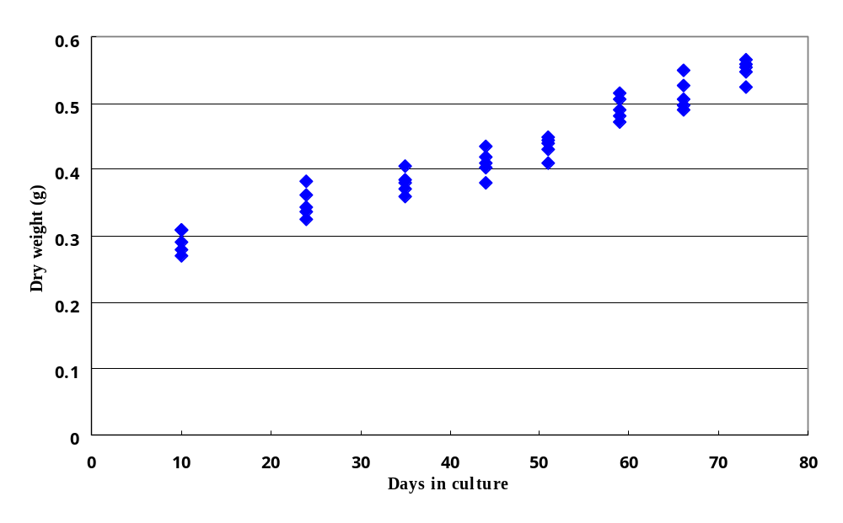
Fig. 1. The data distribution of dry weights and culture days for the
HTHL treatment.

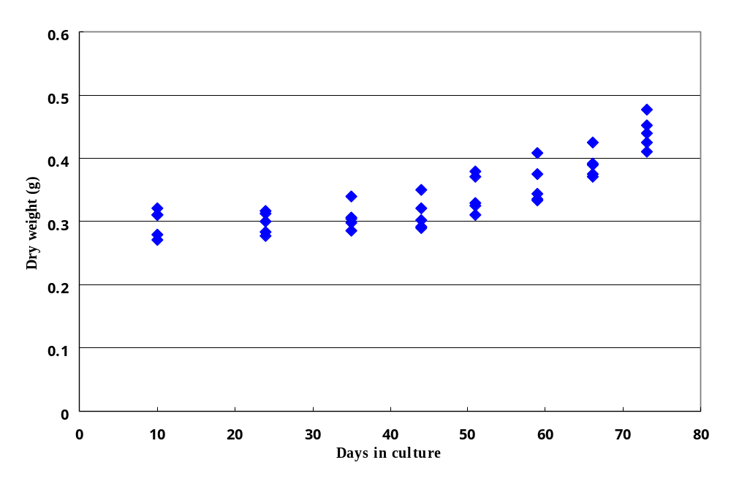Fig. 2. The data distribution of dry weights and culture days for the HTLL
treatment.

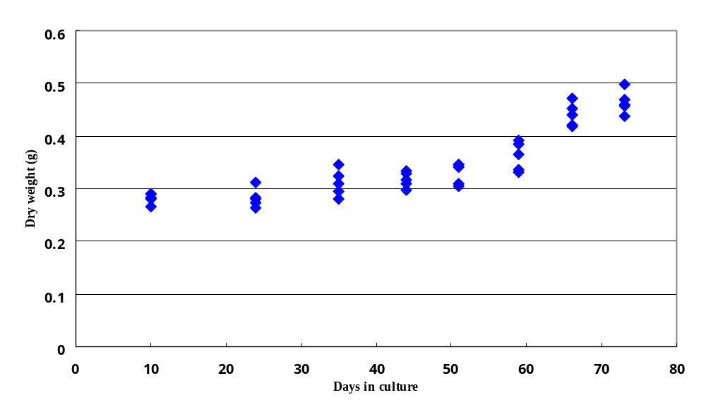
Fig. 3. The data distribution of dry weights and culture days for the LTHL treatment.

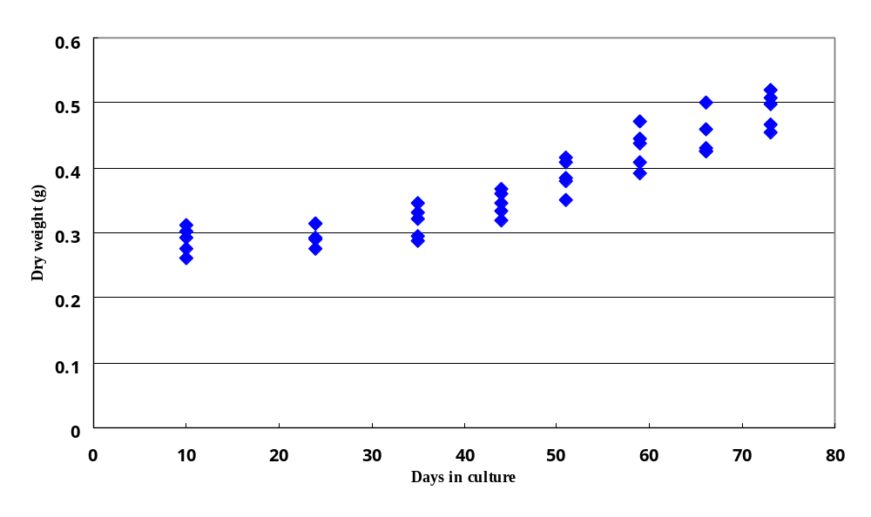Fig. 4. The data distribution of dry weights and culture days for the LTLL
treatment.

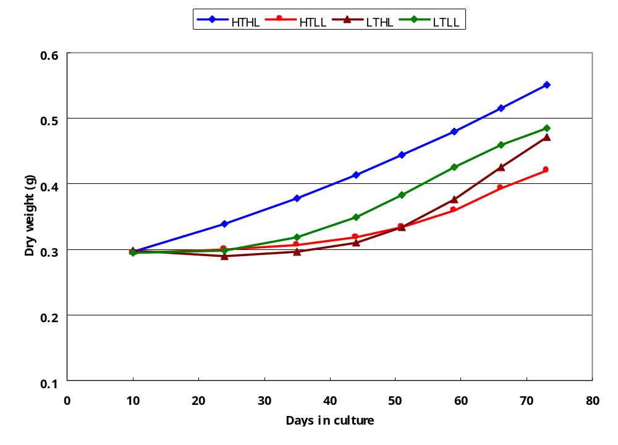

Fig. 5. The predictive curves of four-parameter growth model for four treatments

