CALLUS INDUCTION AND REGNERATION FROM SHOOT APEX AND LEAF DISC CULTURES OF THREE COMMERCIAL PETUNIAS

Maryam Jamshidnia^{1*},Badraldin Ebrahim Sayed Tabatabaei¹

¹ Deptment of Agricultural Biotechnology, Isfahan University of Technology, Isfahan 84156-83111, Iran, * E-mail: box_bio@yahoo.com

ABSTRACT

Optimizing regeneration for Iranian and foreign species of petunia plant via shoot apex and leaf disc was done in order to use in further Agrobacterium-mediated transformation studies. In the first experiment shoot apex were cultured on modified MS media (MS salts, B5 vitamins) with different concentrations from NAA (0, 0.2, 0.5 mg l⁻¹) and BAP (0, 0.1, 0.5, 1 mg l⁻¹). The frequency of callus induction of P. hybrida cv. Supercascaide was highest in medium containing 0.5 mg l⁻¹ BAP plus 0.5 mg l⁻¹ NAA. Using cytokinin alone at the tested concentration produced shoots without callus and auxin did not play any role in this respect. The data obtained revealed that the highest root formation was obtained from MS medium supplemented with 0.1 mg l⁻¹ BAP+0.5 mg l⁻¹ NAA. In the second experiment leaf disc explants of Iranian and foreign cultivars of petunia were cultured on 3 modified MS media: 2 mg l⁻¹ BAP+0.1 mg l⁻¹ NAA (MS₁), 1 mg l⁻¹ NAA (MS₂) and 2 mg l⁻¹ BAP+1 mg l⁻¹ Zea+0.1 mg l⁻¹ NAA (MS₃) in three replicates. The cultures were incubated at 25±2°C and in 16/8 hour photoperiod under cool-white fluorescent light at 40μmolm⁻²s⁻¹. The frequency of callus induction of P. hybrida cv. Supercascaide and Petunia hybrida cv. Opera were highest in medium containing 2 mg l⁻¹ BAP+0.1 mg l⁻¹ NAA (MS₁). Using auxin alone at the tested concentration produced callus without shoots. Although Petunia violacea did not produce callus in any culture media, obtained data revealed that the highest root formation was obtained in MS₂ medium supplemented with 0.1 mg l⁻¹ NAA by this species.

Key words: Petunia sp, Regeneration, Leaf disc, Shoot apex.

INTRODUCTION

Petunia is considered to be the first cultivated bedding plant and has remained one of the favorite genera for developing new varieties which are desirable in the bedding plant industry (Grates and Vandenbussche 2005). Petunia is grown for its showy flowers, making it a popular summer bedding plant (Dole and Wilkins, 2005). Recent modern techniques of propagation have been developed which could help growers to meet the demand of the horticultural industry in the next decades (Rout et al. 2006).
Different methods of tissue culture were used in petunia plant that can pointed embryogenesis, protoplast and petal culture (Kortessa et al. 1993, Qaoud et al. 2010, Razdan 2003). Shoot organogenesis in Petunia hybrida leaf discs is affected by explant size, configuration and duration of exposure to benzyladenine (BA) (Beck and Camper 1991). Also, studies on anatomical changes (Traas et al. 1990), effect of light (Reuveni and Evenor 2007), sugar and CO₂, nitrogen and calcium (Frett and Dirr 1986, Qu et al. 2007), and ethylene (Dimasi-Therion et al. 1993) on shoot and root regeneration in the petunia plant, were done. Researchers reported that increasing of shoot production in petunia by using NAA in culture medium. The discrepancy in NAA efficacy on shoot formation between two cultivars of petunia might be attributable to variation of endogenous cytokinin levels among petunia cultivars (Economou et al. 1982).
The shoot apex is the most preferred explant for plant regeneration and transformation because most herbaceous dicotyledonous and monocotyledon plants can be regenerated into intact plants using this explants source (Ulian et al. 1988). Also, somaclonal variation and mutation is very low in plants regenerated from shoot apex. Shoot apex regeneration is suitable method for production of eliminated virus plants and for this advantageous is noticeable in ornamental plant industry. The experiments of this study were done in order to investigate the behavior of the consecutive in vitro micropropagation stages of Petunia hybrida under the effect of different concentration of cytokinin (BAP) and auxin (NAA), and different types of culture substracts for callus induction. In this research, composition of culture medium as well as genotypes is effective on callus induction and regeneration of petunia. Especially in the first time, regeneration of petunia violacea an Iranian species that was introduced this region 100 years ago was studied. Also, in this paper we first report the comparison of callus induction and regeneration between Iranian and foreign cultivars of petunia.

MATERIALS AND METHODS

Seed germination

Seeds of the commercial petunia cultivars were surface sterilized in 20% (v/v) commercial bleach to which a wetting agent such as Tween 20 had been added, for ten minutes. The seed were then rinsed three times with sterile water. The sterilized seeds were then germinated on MS (Murashige and Skoog 1962) medium.

Callus induction and shoot regeneration using shoot apex

After one week of germination shoot apices of 0.3×0.6 mm in size were excised and in order to select the best shooting media, 180 shoot apices were transferred in a completely randomize design (CRD) with 12 shooting treatments: MS salts, B5 vitamins with different concentrations from NAA (0, 0.2, 0.5 mg l⁻¹) and BAP (0, 0.1, 0.5, 1 mg l⁻¹). Regeneration and production friable callus was analyzed. All the used culture media were adjusted to pH 5.7 with NaOH and autoclaved at 121°C and 1.2 Kg cm⁻² for 20 minutes before using. The cultures were incubated at 25°C, with a light to dark period of 16/8 hours. Regenerated shoots were transferred on the rooting medium containing MS salts, B5 vitamins, 2% sucrose, 1% glucose, 0.7% agar supplemented with 0.1 mg l⁻¹ NAA, adjusted to pH 5.7 with NaOH for developing roots.

Callus induction and shoot regeneration using leaf disc

In order to optimize regeneration via leaf disc, leaf discs from petunia in vitro culture were cut to 10×10 mm in size, and then were cultured on 3 modified MS media: 2 mg l⁻¹ BAP+0.1 mg l⁻¹ NAA (MS₁), 1 mg l⁻¹ NAA (MS₂) and 2 mg l⁻¹ BAP+1 mg l⁻¹ Zea+0.1 mg l⁻¹ NAA (MS₃) in three replicates. The cultures were incubated at 25°C, with a light to dark period of 16/8 hours. Production of friable callus and shoot regeneration was analyzed. Regenerated shoots were transferred on the rooting medium containing MS medium supplemented with 0.1 mg l⁻¹ NAA. All the used culture media were adjusted to pH 5.7 with NaOH for developing roots.

Statistical analysis

Experiments were conducted using a completely randomize design. Data were subjected to analysis of variance (ANOVA) and differences between treatment means were established with LSD test. Also, percentage of callus induction, percentage of explants with shoots and percentage of root regeneration were transformed with Arcsine to secure normal destruction. Statistical analysis was via SAS 9.1 program.

RESULTS AND DISCUSSION

Seed germination

After 2 weeks, all of the seeds germinated successfully on to the basal medium. In the first experiment, shoot apices were excised after one week of germination. In order to use in the second experiment, they continued to grow on this media for one month. All seedlings were clean without any contamination. This result was in agreement with a previous work of Dixon (1985) who reported that a high seed germination percentage of petunia was achieved on agar medium without growth regulators.

Callus induction and shoot regeneration using shoot apex

Data indicated that BAP, NAA and interaction between them were significant at p<0.0001. Data in Table 1 revealed that different concentrations of cytokinin (BAP) and auxin (NAA) tested in this trial had a significant effect on callus induction of explants. These results showed that the highest callus induction per explants was obtained after 30 days in modified MS-medium supplemeted with 0.5 mg l⁻¹NAA and 0.5 mg l⁻¹ BAP. Using the auxin only led to the production of callus and the BAP did not play any role in this respect. These results are in agreement with those reported by Edriss et al. (1996) who found that using high concentration of auxin (NAA) led to the production of callus only and the BA and Kinetin did not have any role in producing callus in potato meristem culture. On the other hand, the addition of BAP to the basal medium within concentrations ranging from 0-1 mg l⁻¹ significantly increased the caulogenesis efficiency in treatment of callus tissue. Using cytokinin alone at the tested concentration produced shoots without callus (Hatzilazarou et al. 2001). It was also noticed that using moderate concentration of auxin and moderate concentration of cytokinin produced high amount of callus. The treatment with 0.5 mg l⁻¹ NAA plus 0.5 mg l⁻¹ BAP was the most effective treatment for callus induction of Petunia hybrida. The callus which induced from shoot tip explants on MS basal medium containing 0.5 mg l⁻¹ NAA and 0.5 mg l⁻¹ BAP was yellow friable (Fig. 1 A). White friable callus induced on MS basal medium containing 0.2 mg l⁻¹ NAA and 0.1 mg l⁻¹ BAP or 0.5 mg l⁻¹ NAA and 0.1 mg l⁻¹ BAP (Fig. 1 B). The addition of BAP up to 1 mg l⁻¹ (w/v) to the medium containing different concentrations of NAA leads to the production of callus which is compact instead of friable (Fig. 1 C). Table 1 showed that cytokinin alone in the culture medium has not any effect on the callus induction but the addition of BAP increased the caulogenesis efficiency in treatment containing NAA. It means that BAP promote and proliferate the growth of callus tissue. The calluses which induced from shoot tip explants on MS basal medium containing different concentrations of NAA were friable.
Results on the rootlets induction of the in vitro plantlet derived from shoot tip explants cultured in the MS basal medium supplemented with 0.1 mg l⁻¹ BAP+0.2 mg l⁻¹ NAA, 0.5 mg l⁻¹ NAA or 0.1 mg l⁻¹ BAP+0.5 mg l⁻¹ NAA were shown in (Table 2, Fig. 2). The obtained data revealed that the highest root formation was obtained in MS medium supplemented with 0.1 mg l⁻¹ BAP+0.5 mg l⁻¹ NAA (Table 2).
The result revealed that 0.5 mg l⁻¹ NAA plus 0.1 mg l⁻¹ BAP was very significant for formation of rootlets obtain from in vitro plantlets. The findings are in agreement with those reported by other researchers (De Oliveiva et al. 1995). Some plants are known to produce high levels of auxin (Hubstenberger et al. 1992), and this was evident in the rooting ability of petunia cultures in the present study. Producing roots from callus caused problem in production of adventitious shoots. The more production of roots from callus, the less production of adventitious shoots. As a result, whenever, callus leds to regeneration, the culture medium is used that produces the least number of roots on callus (Jamshidnia et al. 2011).

Callus induction and shoot regeneration using leaf disc

Data indicated that culture medium, genotype and interaction between them were significant at p<0.0001. Data in Table 3 revealed that different media tested in this trial had a significant effect on callus induction of explants. These results showed that the highest callus induction per explants was obtained after 30 days in modified MS-medium supplemeted with 0.1 mg l⁻¹ NAA and 2 mg l⁻¹ BAP (MS₁). The addition of BAP significantly increased the caulogenesis efficiency in treatment of callus tissue. The callus which induced from leaf disc explants on MS basal medium containing 0.1 mg l⁻¹ NAA was friable (Fig. 3 A). BAP 2 mg l⁻¹ plus 0.1 mg l⁻¹ NAA (MS₁ medium) leads to the production of callus which is compact instead of friable (Fig. 3 B). The treatment with 2 mg l⁻¹ BAP plus 0.1 mg l⁻¹ NAA was the most effective treatment for callus induction of two cultivar of petunia. Table 3 showed that the addition of BAP increased the caulogenesis efficiency in treatment containing NAA. It means that BAP promote and proliferate the growth of callus tissue. Although auxin is capable to promote the growth of callus, according to Wernicke and Milkovits (1987), high concentration of 2,4-D may prevent cell division due to increase of internal auxin higher than critical threshold value(Behbahani et al. 2007).
Data in Table 3 revealed that different cultivars of petunia had a significant effect on callus induction of explants. Petunia violacea leaf discs produced root in MS₂ medium without callus induction (Fig. 3 C) although Petunia hybrida cv. Supercascaide produced yellow friable callus in this medium. NAA alone in MS₂ medium induced callus. As a result, cytokinin is not necessory in callus induction of petunia.
Regeneration via leaf disc exhibited significant responses to the medium, cultivar and interaction between them. Therefore, genotypes and medium composition can influence regeneration via leaf disc. Chen et al. (2004) indicated that the regeneration capacities of the explants vary with cultivar genotypes. It was also found that plant growth regulator treatments (2, 4-D, TDZ and their combinations) had different effects on the two hybrids of orchids (Chen et al. 2004). Economou et al. (1982) reported significant interaction occurred between plant growth regulators (BA and NAA) used in media, which increased shoot number of Suger Daddy. Also, their results demonstrated significant interaction in producing shoots by using two types of cultivars.
Leaf discs of three species showed shoot regeneration in MS₃ medium that percentage of this regeneration was the highest in Petunia violacea and the least in Petunia hybrida cv. Supercascaide (Table 4). Petunia violacea leaf discs regenerate directly in MS₁ and MS₃ medium but this regeneration in MS₁ medium was less percentage than MS₃ medium (Table 4) (Fig. 3 D). This result is in agreement with the findings of Beaujean et al. (1998), who reported the use of zeatin riboside in the regeneration media has allowed a considerable reduction of the callus phase, and accelerated transgenic bud formation. Our work shows that interaction between cultivar and media plays an important role in this respect.
Obtained results from cultured leaf discs of different cultivars showed that NAA alone caused callus induction in Petunia hybrida cv. Supercascaide, root in Petunia violacea and callus and root in Petunia hybrida cv. Opera. Other researchers reported different internal cytokinin levels of petunia cultivars caused varietes in NAA effect on shoot regeneration of two petunia cultivar (Read and Preece 2007). Also, Petunia violacea regenerate direct shoots in MS₁ and MS₃ media without callus induction. This results showed that regeneration via leaf discs is dependent on genotype (Rout et al. 2006).

REFERENCES

Beaujean A., Sangwan R.S., Lecardonnel A., Sangwan-Noreel B. S. (1998). Agrobacterium-mediated transformation of three economically important potato cultivars using cliced internodal explants: an efficient protocol of transformation. Journal of Experimental Botany, 49: 1589-1595.
Beck M. J., Camper N. D. (1991). Shoot regeneration from Petunia leaf discs as a function of explant size, configuration and benzyladenine exposure. Plant Cell, Tissue and Organ Culture, 26: 101-106.
Behbahani M., Ali A. M., Muse R., Mohd N. B. (2007). Anti-oxidant and anti-inflammatory activities of leaves of Barringtonia racemosa. Journal of Medicinal Plants Research, 5: 95-102.
Chen T. Y., Chen J. T., Chang W. C. (2004). Plant regeneration through direct shoot bud formation from leaf cultures of Paphiopedilum orchids. Plant Cell, Tissue and Organ Culture, 76: 11-15.
De Oliveiva S. A., Machado M. F. P. S., Prioli A. J., Mangolin C. A. (1995). In vitro propagation of Cereus peruvianus Mili (Cactaceae). In vitro Cellular and Developmental Biology, 94-98.
Dimasi-Therion K. E., Conomon A. S., Sfakiotakis E. M. (1993). Promotion of petunia (in petunia hybrida L.) regeneration in vitro by ethylene. Plant Cell, Tissue and Organ Culture, 32: 219-225.
Dixon R. A. (1985). Isolation and maintenance of callus and cell suspension culture. In: Dixon R. A. (Eds). Plant cell culture, a practical approach. Oxford: IRI, Press limited; 1-20.
Dole J. M., Wilkins H. F. (2005). Floriculture principles and species. pp.744-750.
Economou A. S., Read P. E. (1982). Effect of NAA on shoot production in vitro from BA-pretreated Petunia leaf explants. Journal of American Society Horticaltural Science. 107: 504-506.
Edriss M. H., Badawy M. A., Fathi S., El. Barkouki T. M. (1996). Propagation of potato using tissue culture technique. Acta Horticaltur. 434, 413-418.
Frett J. J., Dirr M. (1986). Effect of nitrogen and calcium stock plant nutrition on petunia hybrida leaf and anther explant growth in vitro. Science Horticaltur. 28: 289-298.
Gerats T., Vandenbussche M. (2005). A model system for comparative research: Petunia. Trends in Plant Science. 10(5): 251-256.
Hatzilazarou S., Economou A., Antoniou T., Ralli P. (2001). Propagation of Ebenus cretica L. by tissue culture. Propagation of Ornamental Plants, 1: 25-27.
Hubstenberger J. F., Clayton P. W., Philips G. C. (1992). Micropropagation of cacti (Cactaceae). In Baja YPS (Eds), Biotechnology in Agriculture and Forestry. High-tech and Micropropagation FJ, Springer, Berlin, Heidelberg, New York, vol. 20. pp. 49-68.
Jamshidnia M., Ghobadi C., Sayed Tabatabaei B. E., Yamchi A. (2012). Direct regeneration from leaf disc and shoot apex cultures of petunia. Iranian Journal of Horticaltural Science and Technology, 12 (3).
Kortessa D. T., Economou S., Sfakiotakis E. M. (1993). Promotion of petunia (Petunia hybrida L.) regeneration in vitro by ethylene. Plant Cell, Tissue and Organ Culture, 32: 219-225.
Murashige T., Skoog F. (1962). A revised medium for rapid growth and bioassays with tobacco tissue. Physiology Plantarum, 15: 474-497.
Qaoud H. A., Rayya A. A., Yaish S. (2010). Invitro regeneration and somaclonal variation of petunia hybrida. Journal of Fruit and Ornamental Plant Research, 18(1):71-81.
Qu Y. H., Lin C., Zhou W., Li Y., Chen B., Chen G. Q. (2007). Effect of CO2 cocentration and moisture content of sugar-Iree media on the tissue cultured plantlets in a large growth chamber. Comman Non-Linear Science. Number Simul. 10.1016/j.cnsns.-2007.05.032.
Razdan M. K. (2003). Introduction to plant tissue culture. Science. 170p.
Read P., Preece J. (2007). Micropropagatin of ornamentals: The wave of the future? Propagation of Ornamental Plants, 7(3):150-159.
Reuveni M., Evenor D. (2007). On the effect of light on shoot regeneration in petunia. Plant Cell, Tissue and Organ Culture, 89: 49-54,
Rout G. R., Mohapatra A., Jain S. M. (2006). Tissue culture of ornamental pot plant: A critical review on present scenario and future prospects. Biotechnology Advances. 24: 531-560.
Traas J. A., Renaudin J. P., Teyssendier De LaServe B. (1990). Canges in microtubular organization mark transition to organized growth during organogenesis in petunia hybrida. Plant Science. 68 (2): 249-256.
Ulian E. C., Smith R. H., Gould J., McKnight T. (1988). Transformation of plants via the shoot apex. ). In vitro Cellular and Developmental Biology, 24: 951-954.
Wernicke W., Milkovits L. (1987). Developmental gradients in wheat leaves- response of leaf segments in different genotypes cultured in vitro. Journal of Plant Physiology. 115: 49-58.

Table 1. Percentage of callus induction (CI) and Morphology of callus formed from Petunia hybrida shoot tip explants on MS basal medium supplemented with different levels of NAA and BAP supplied after 4 weeks of culture at 25°C under light condition.
No | Phytohormones supplied in MS basal medium (mg l⁻¹) | CI% | Morphology of callus formed from shoot tip explants
 | NAA BAP
1 | 0 0 | 0 g | -
2 | 0 0.1 | 0 g | -
3 | 0 0.5 | 0 g | -
4 | 0 1 | 0 g | -
5 | 0.2 0 | 10 f | PY, Friable
6 | 0.2 0.1 | 20 e | WY, Friable
7 | 0.2 0.5 | 40 d | PG, Compact
8 | 0.2 1 | 60 c | PG, Compact
9 | 0.5 0 | 15 f | PY, Friable
10 | 0.5 0.1 | 25 e | WY, Friable
11 | 0.5 0.5 | 90 a | PY, Friable
12 | 0.5 1 | 70 b | PG, Compact
Means with the same letter are not significantly different at LSD test (P<0.05). PG = pale green color, PY = pale yellow color, WY = white yellow color.

Table 2. Percentage of root regeneration from Petunia hybrida shoot tip explants on MS basal medium supplemented with different levels of NAA and BAP.
NO | PGR (mg l⁻¹) | Rootimg percentage
 | NAA BAP
1 | 0 0 | 0 d
2 | 0 0.1 | 0 d
3 | 0 0.5 | 0 d
4 | 0 1 | 0 d
5 | 0.2 0 | 0 d
6 | 0.2 0.1 | 30 b
7 | 0.2 0.5 | 0 d
8 | 0.2 1 | 0 d
9 | 0.5 0 | 20 c
10 | 0.5 0.1 | 40 a
11 | 0.5 0.5 | 0 d
12 | 0.5 1 | 0 d
Means with the same letter are not significantly different at LSD test (P<0.05).

Table 3. Callus formation and Morphology of callus formed from leaf explants of different cultivars.
cultivars | Percentage of explants with callus |  |  |  | Morphology of callus formed from leaf disc explants
 | MS₁ | MS₂ | MS₃ |  | MS₁ | MS₂ | MS₃
Opera | 100a | 40b | 30c |  | PG, Compact | PY, Friable | PG, Compact
Supercascaide | 100a | 100a | 5d |  | PG, Compact | WY, Friable | PG, Compact
Violacea | 0e | 0e | 0e |  | - | - | -
Means with the same letter are not significantly different at LSD test (P<0.05). PG = pale green color, PY = pale yellow color, WY = white yellow color.

Table 4. Direct shoot bud and Root formation from leaf explants of different cultivars.
cultivars | Percentage of explants with shoots |  |  |  | Percentage of explants with roots
 | MS₁ | MS₂ | MS₃ |  | MS₁ | MS₂ | MS₃
Opera | 20d | 0e | 70b |  | 0d | 40b | 0d
Supercascaide | 40c | 0e | 20d |  | 0d | 0d | 0d
Violacea | 20d | 0e | 100a |  | 20c | 100a | 0d
Means with the same letter are not significantly different at LSD test (P<0.05).

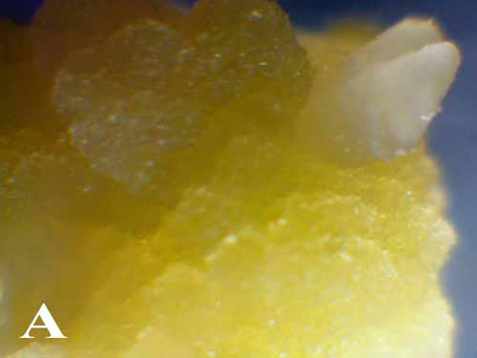
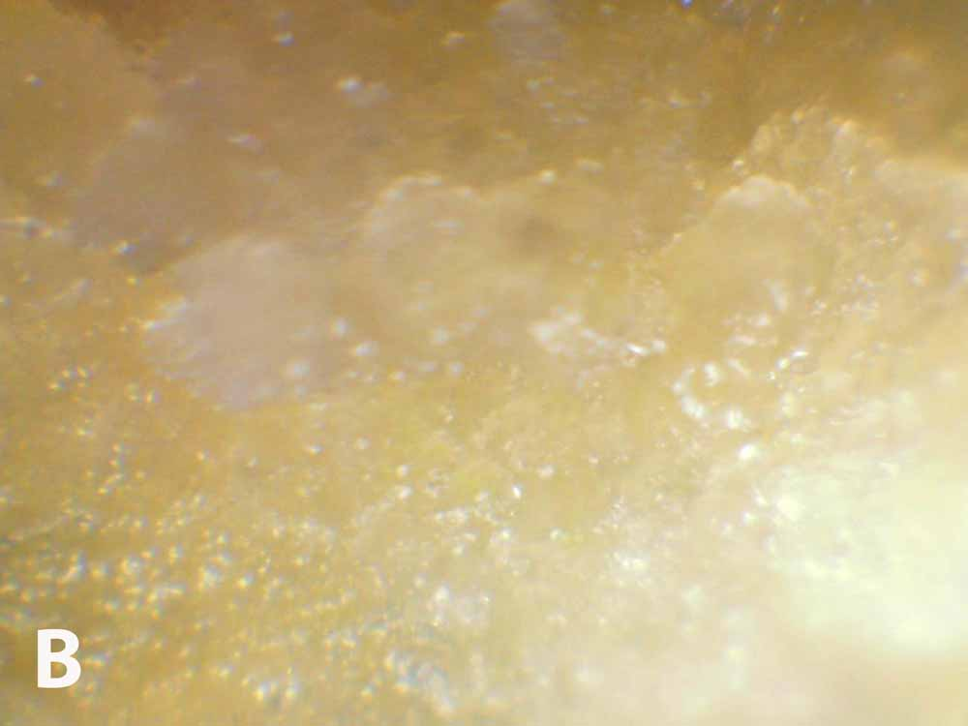
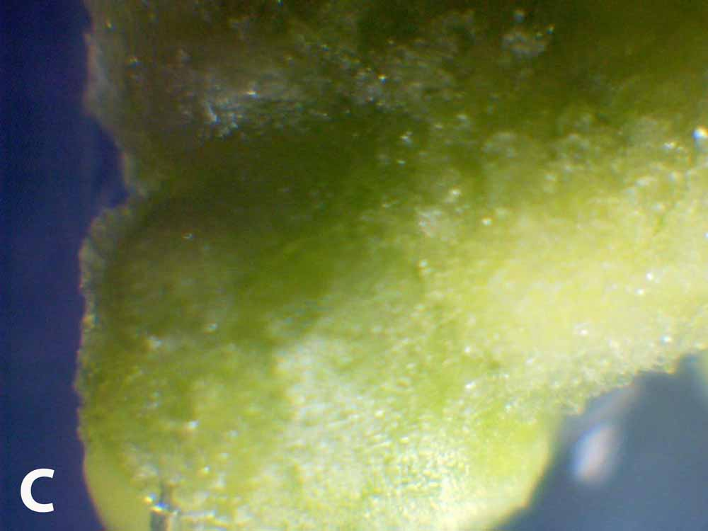
Fig. 1. A) yellow friable callus produced on 0.5 mg l⁻¹ NAA and 0.5 mg l⁻¹ BAP. B) White friable callus produced on 0.2 mg l⁻¹ NAA and 0.1 mg l⁻¹ BA. C) compact callus produced on 0.5 mg l⁻¹ NAA and 1 mg l⁻¹ BAP.
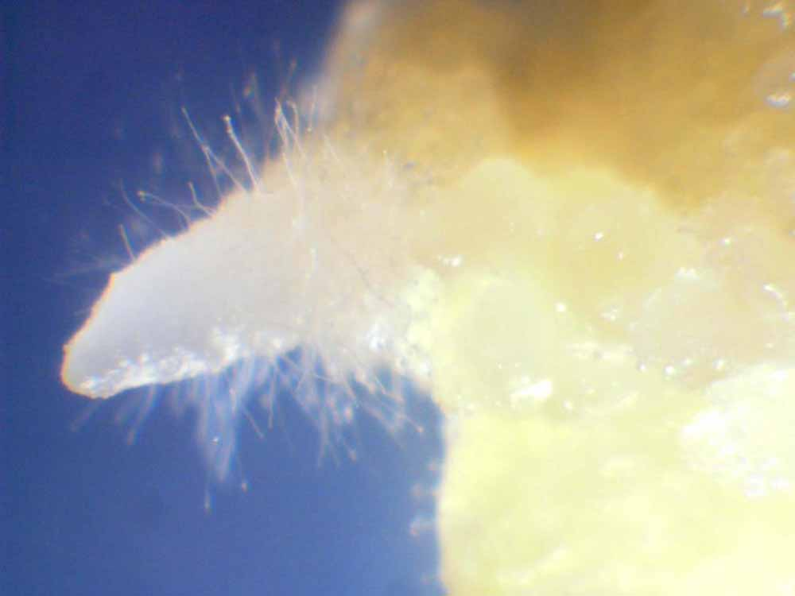

Fig. 2. rootlets induction of the in vitro plantlet derived from shoot tip explants cultured in the MS basal medium supplemented with 0.1 mg l⁻¹ BAP+0.2 mg l⁻¹ NAA.

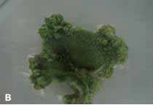
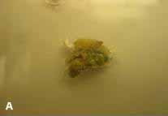

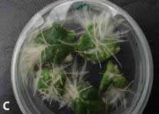
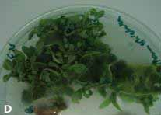

Fig. 3. A) friable callus produced on 0.1 mg l⁻¹ NAA. B) compact callus on 2 mg l⁻¹ BAP plus 0.1 mg l⁻¹ NAA. C) Petunia violacea leaf discs produced root in MS₂ medium without callus induction. D) Direct regeneration Petunia violacea.

