THE EFFECT OF ALGAMINOPLANT AND HUMIPLANT
ON RHIZOGENESIS IN STEM CUTTINGS OF PHYSOCARPUS OPULIFOLIUS ‘DART’S GOLD’ AND ‘RED BARON’

Andrzej Pacholczak,* Wiesław Szydło, Katarzyna Szulczyk
Department of Ornamental Plants, Warsaw University of Life Sciences (WULS)
Nowoursynowska 166, 02-787 Warszawa, Poland, *Tel./Fax: +48 (22) 5932268, *E-mail: kro@sggw.pl

Abstract
The UE-imposed restrictions on the manufacture and use of plant protection chemicals impose on the nurseryman the need to screen for new substances that are environmentally friendly and yet effective in the production of plant material. Biopreparations may constitute such a group as they contain substances that have little environmental impact. This study evaluated biopreparations AlgaminoPlant and HumiPlant for their effect on rooting of stem cuttings in Physocarpus opulifolius ‘Dart’s Gold’ and ‘Red Baron’. During rooting, cuttings were sprayed once, twice or three times with the water solutions of the biopreparations. To evaluate their effectiveness relative to the current treatments routinely used in the nursery production, some cuttings were treated with a rooting powder containing a synthetic auxin IBA or sprayed with water solution of IBA. The best results were obtained with the IBA solution, however, both biopreparations also positively affected rhizogenesis in ninebark. Biopreparations also affected the chlorophyll a+b, reducing sugars, free amino acids and polyphenolic acids contents in leaves but their effects varied depending on a cultivar and the preparation. This demonstrates that at least some bioprearations do have potential in commercial production but their effectiveness may be different in different species and their application regimes may have to be custom fitted to each target species.
Key words: ninebark, IBA, rooting, chlorophyll a+b, reducing sugars, free amino acids, polyphenolic acids.

INTRODUCTION
Demand for ornamental shrubs has been increasing lately, due to dynamic development of urban infrastucture. Gardens have become an inseparable element of modern settings. In response to this trend, the ornamental nursery production has been increasing to the point of becoming the most profitable branch of ornamental horticulture in Poland (Olewnicki 2011). The increasing demand for the ornamental plant material and strong competition among nurseries compels growers to deliver the best material in the shortest possible time, and in large quantities. As a consequence, new methods to intensify nursery production are constantly being tested. The UE-imposed restrictions on the manufacture and use of plant protection chemicals create a new production environment. It imposes on the nurseryman a need to screen for new substances that are environmentally friendly and yet effective in the production of plant material. Biopreparations may constitute such a group as they contain substance little affecting the environment. They are either single or multi-compound preparations, containing extracts from sea algae (Eclonia maxima, Laminaria digitata, Fucus vesiculosus or Durvillea potatorum) (Dobrzański et al. 2008). They induce, or are said to induce, plant resistance to different stresses and they can also positively affect rhizogenesis and the root system development (Pruszyński 2008). Some of these, such as AlgaminoPlant may contain low molecular weight polypeptides and amino acids, vitamins, enzymes, phytohormones, sugars, betains and antioxidants (Basak 2008). Some of these active compounds may stimulate rhizogenesis by inducing anatomical and morphological changes in plants (Cambri et al. 2008, Khan et al. 2009). Our previous study has shown that certain biopreparations not only enhance rhizogenesis in cuttings of ornamental shrubs but can even replace the rooting powders (Jacygrad and Pacholczak 2010; Pacholczak et al. 2010).
AlgaminoPlant is a liquid preparation produced on the base of a seaweed extract from Sargassum, Laminaria, Ascophyllum and Fuscus. It contains three groups of plant hormones: gibberellins, cytokinins and auxins. It is supplemented by potassium salts of amino acids at 10%. The preparation enhances uptake of macro- and microelements and their translocation within plants, increases the respiration rate and root growth, participates in photosynthesis and other metabolic processes. It positively affects plant resistance to stresses, accelerates flowering and fruit set (Bai et al. 2007). HumiPlant is a colloid suspension produced from leonardytes – intermediates between peat and brown coal. It contains a mixture of humic (12%) and fulvic (6%) acids and such elements as nitrogen, phosphorus, potassium, zinc and bor. Humic substances improve soil structure promoting the development of soil microflora and fauna which in turn activate soil compounds required by plants. They improve the soil water-holding capacity and maintain optimal soil pH (Matysiak et al. 2010). In plant, they enhance photosynthesis and respiration. As HumiPlant also enhances root development it was included in this study. The purpose of this study was to compare the two biological preparations, AlgaminoPlant and HumiPlant, with a commercial rooting powder containing synthetic auxin that is commonly used in nurseries. The tests were done on two cultivars of the popular ornamental shrub – ninebark – Physocarpus opulifolius. An attempt was also made to detect relationships between several different biochemical parameters of cuttings, as influenced by treatments, and the subsequent rhizogenesis.

MATERIALS AND METHODS
The experiment was carried out in 2010 in a commercial nursery of M.M. Kryt in Wola Prażmowska on two cultivars of Physocarpus opulifolius: ‘Dart’s Gold’ and ‘Red Baron’. Two biopreparations were used: AlgaminoPlant (0.2%) and HumiPlant (0.4%). The cuttings were sprayed with either solution once, twice or three times during the rooting period. To compare their effects with a commercial rooting powder, a synthetic auxin routinely used in nursery production - β-indolilobutyric acid (IBA) - was included. It was applied either directly to the bases of cuttings in the form of the commercially available rooting powder Rhizopon AA (2% IBA), or by spraying cuttings with the water solution of 200 mg·dm⁻³ IBA. The control cuttings were sprayed with distilled water. The experiment began on June 29, 2010. Semi lignified two nodal stem cuttings were prepared from shoots harvested from stock plants free from pathogens and diseases. Cuttings were rooted in styrofoam boxes. They were inserted to the depth of 2 cm into a mixture of peat, perlite and sand (2:1:1), pH 5.0. The mixture was thoroughly wetted and pressed, and covered with 0.5 cm layer of coarse sand.
Water and the solutions tested were applied with a hand pressure sprayer (volume 1 dm⁻³) on three dates: I date – beginning of the experiment (June 29), II date – a week later (July 6), III date – two weeks after the beginning of the experiment (July 13). Rooting took place in plastic tunnels equipped with automatic watering and mist systems as well as with shading devices. During the first two weeks the cuttings were protected against sun with a opaque foil and a shading cloth. Every two weeks, cuttings were sprayed against Botrytis with 0.2% Rovral or Sumilex.
The experiment consisted of nine treatments (Table 1), each in three replications, each replication containing 20 cuttings. Percentages of rooted cuttings and the degree of rooting were determined after 8 weeks from the start of the experiment. The degree of rooting was evaluated on a 5-point scale rating the development of the root ball (Table 2). The scores for the degree of rooting represent means of three independent observations by trained personnel.

Table 1. A list of treatments in the experiment
No. of treatment | Treatments
1 | Control (H₂O)
2 | Rhizopon AA (2% IBA) powder
3 | IBA 200 mg·dm⁻³ spraying
4 | single treatment, AlgaminoPlant 0.2%
5 | two treatments, AlgaminoPlant 0.2%
6 | three treatments, AlgaminoPlant 0.2%
7 | single treatment, HumiPlant 0.4%
8 | two treatments, HumiPlant 0.4%
9 | three treatments, HumiPlant 0.4%

Table 2. The evaluation scale of the root development
Root characteristics | Score
No visible roots on cuttings | 1
A few (1-3) short roots | 2
4-5 roots, some of them branched, no root ball formed | 3
Medium sized root system composed of 6-10 branched roots forming a root ball | 4
Well formed, branched root system forming a root ball (over 10 roots) | 5

Leaves from 20 cuttings per treatment were collected three weeks after the beginning of the experiment from treated and untreated cuttings. They were finely chopped, mixed and 0.5-1 g samples were taken for the measurements of dry matter and contents of chlorophyll a+b, reducing sugars, free amino acids and polyphenolic acids. Triplicate extracts were prepared for each analysis and three measurements were done for each extract producing nine readings for each data point.
For the dry matter content, 1 g samples were dried at 105ºC to constant weight (Strzelecka et al. 1982). Chlorophyll content (chlorophyll a + b) was analyzed according to Morgan and Porath (1980) with the modification of Inskeep and Bloom (1985). Reducing sugars were determined by the colorimetric method of Somogyi in the Nelson’s modification (Nelson 1944). Free amino acids were measured according to Rosen (1957), and polyphenolic acids by the colorimetric method with the Arnow’s reagent according to the Polish Norm PN-91/R-87019.
To compare the means, rooting percentages were transformed according to Bliss (Wójcik and Laudański 1989) while the degree of rooting by root transformation: y=x²+(x+1)² . The above data was subjected to ANOVA 1 and tested by the Duncan’s test at α=0.05. Results of biochemical analyses were subjected to the 2-factorial ANOVA and the means were compared by the Duncan’s test at α=0.05.

RESULTS
The untreated cuttings of the yellow-leaf ninebark cultivar rooted only in 32% (Fig. 1). The commercial rooting powder Rhrizopon AA increased this percentage to 40%. Significantly more effective was IBA applied as a water solution sprayed on cuttings (over 50% of rooting). HumiPlant – regardless the number of treatments - gave comparable results. The best results were obtained after triple treatment with Algaminoplant; it doubled the percentage of rooted cuttings relative to control (64%). A single application of AlgaminoPlant was ineffective while two sprayings gave results comparable to the auxin-based powder.

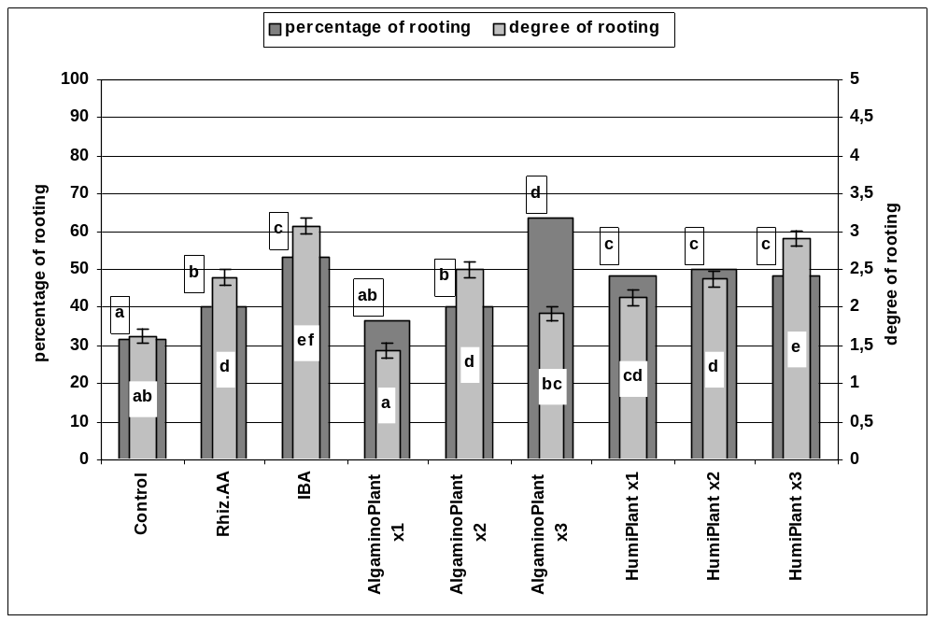
Fig. 1. The effect of biopreparations on the degree of rooting and on percentage of rooted cuttings in Physocarpus opulifolius ‘Dart’s Gold’. The means represented by bars indicated with the same letters do not differ significantly at α=0.05.

During eight weeks of the experiment, control (untreated) cuttings developed a few short roots (Fig. 1) and their degree of rooting was scored as 1.5. All treatments – except the single application of AlgaminoPlant – improved rhizogenesis. The best results were obtained following spraying with IBA, and after triple application of HumiPlant. Effects of other treatments were comparable to those obtained with Rhizopon AA.
In the red ninebark cultivar ‘Red Baron’ the percentage of rooted cuttings in control treatment was 50% and it did not change by treatments with IBA or with HumiPlant (Fig. 2). However, all treatments with AlgaminoPlant increased the rooting percentage up to 62-67%. Root developement proceeded similarly as in the yellow cultivar: a few short roots were formed in untreated cuttings during the eight weeks (a degree of rooting 1.5). The highest degree of rooting was in cuttings sprayed twice with HumiPlant or those treated with IBA in either form (Fig. 2). AlgaminoPlant was ineffective as compared to the control treatment.

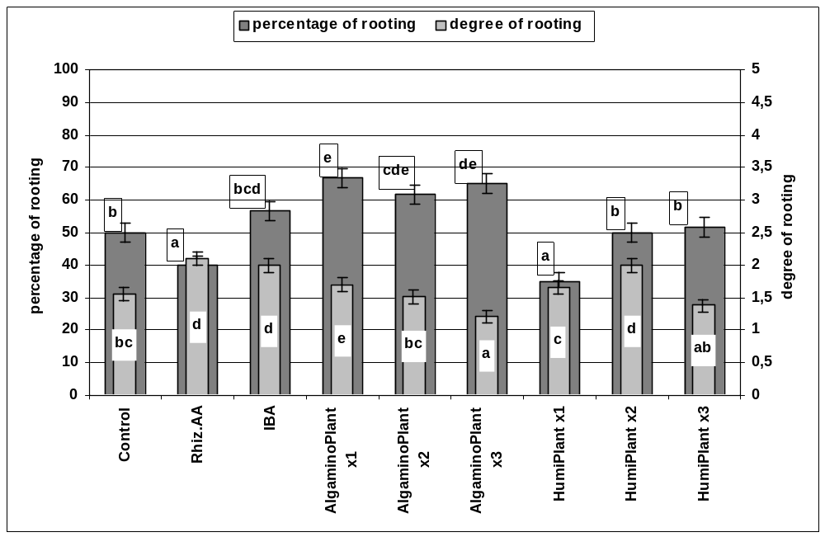
Fig. 2. The effect of biopreparations in Physocarpus opulifolius ‘Red Baron’ on the degree of rooting and on percentage of rooted cuttings. The means represented by bars indicated with the same letters do not differ significantly at α=0.05.

Biochemical analyses
Leaves of the stocks tested differed considerably in the chlorophyll a+b content: leaves of the control treatment in the yellow cultivar had less than 20% of the pigment content of the red leaved cultivar (Table 3). As compared to the control leaves, triple application of AlgaminoPlant and HumiPlant increased the chlorophyll content in ‘Dart’s Gold’ by 90% and 80%, respectively. On the contrary, in the red cultivar the above treatments reduced pigment contents by 7% and 20%, respectively.

Table 3. The effect of biostimulators AlgaminoPlant and HumiPlant on contents of chlorophyll a+b (mg·g⁻¹DW) determined in leaves of cuttings in two cultivars of Physocarpus opulifolius three weeks after inserting cuttings into the rooting medium
Cultivar | Control | AlagminoPlant | HumiPlant | Mean for  cultivar
'Dart's Gold' | 2,3 a | 4,4 b | 4,2 b | 3,64 a
'Red Baron' | 12,2 e | 11,4 d | 9,8 c | 11,11 b
Mean for treatment | 7,24 a | 7,91 b | 6,97 a

Both cultivars had similar amounts of reducing sugars in leaves of untreated cuttings and this did not change after the application of HumiPlant (Table 4). The effect of AlgaminoPlant varied in two cultivars: it decreased reducing sugar levels in ‘Dart’s Gold’ (30%) while increasing them in ‘Red Baron’ (12%).

Table 4. The effect of biostimulators AlgaminoPlant and HumiPlant on the reducing sugars contents (mg glucose·g⁻¹DW) in leaves of cuttings in two cultivars of Physocarpus opulifolius 3 weeks after inserting cuttings into the rooting medium
Cultivar | Control | AlagminoPlant | HumiPlant | Mean for  cultivar
'Dart's Gold' | 36,2 b | 25,0 a | 37,9 b | 33,04a
'Red Baron' | 37,5 b | 42,1 c | 37,2 b | 38,93b
Mean for treatment | 36,88 b | 33,55 a | 37,51 b

After treatments with both biopreparations, the polyphenolic acid contents dropped by 35-40% in the yellow cultivar (Table 5) but increased significantly, by 7 and 17%, in the red cultivar.
Table 5. The effect of biostimulators AlgaminoPlant and HumiPlant on the polyphenolic acid contents (mg·g⁻¹DW) in leaves of cuttings in two cultivars of Physocarpus opulifolius 3 weeks after inserting cuttings into the rooting medium
Cultivar | Control | AlagminoPlant | HumiPlant | Mean for cultivar
'Dart's Gold' | 8,3b | 5,4a | 5,0a | 6,26a
'Red Baron' | 12,2 c | 13,0 d | 14,3 e | 13,14b
Mean for treatment | 10,24b | 9,19a | 9,65a
The amino acid contents in control cuttings of the yellow cultivar was roughly half that of the red cultivar (Table 6). AlgaminoPlant increased the amino acid content in the yellow cultivar by 450% but only by 27% in the red one. The effect of HumiPlant was the opposite in both cultivars: it increased the free amino acid content in ‘Dart’s Gold’ (by 80%) and decreased it in ‘Red Baron’ (by 33%).

Table 6. The effect of biostimulators AlgaminoPlant and HumiPlant on the free amino acids contents(µmol leucin·g⁻¹DW) determined in leaves of cuttings in two cultivars of Physocarpus opulifolius 3 weeks after inserting cuttings into the rooting medium
Cultivar | Control | AlagminoPlant | HumiPlant | Mean for cultivar
'Dart's Gold' | 140,9 a | 643,9 f | 253,6 c | 346,14 b
. 'Red Baron' | 271,5 c | 344,5 d | 181,4 b | 265,76 a
Mean for treatment | 206,20 a | 494, 16c | 217,50 b

DISCUSSION
Two ninebark cultivars used in this experiment differed not only visually but also in their natural rooting capacity, which was higher in the red-leaved cultivar (50% versus 30%). Of course, there is not reason at this point to associate leaf color with rooting capacity. Positive effects of the treatments during this trial were twice as frequent in ‘Dart’s Gold’ as compared to ‘Red Baron’ (Table 7). The synthetic auxin IBA proved effective, serving as a reference point to evaluate the efficiency of two biopreparations AlgaminoPlant and HumiPlant.
Table 7. The effect of treatments on rhizogenesis and biochemical parameters in ninebark cultivars
 | Parameters | C | IBA | A1x | A2x | A3x | H1x | H2x | H3x
P.o. 'Dart's Gold' | percentage of rooting | + | + | = | + | + | + | + | +
P.o. 'Dart's Gold' | degree of rooting | + | + | = | + | = | + | + | +
P.o. 'Dart's Gold' | chlorophyll |  |  |  |  | + |  |  | +
P.o. 'Dart's Gold' | reducing sugars |  |  |  |  | - |  |  | =
P.o. 'Dart's Gold' | polyphenolic acids |  |  |  |  | - |  |  | -
P.o. 'Dart's Gold' | free amino acids |  |  |  |  | + |  |  | +
P.o. 'Red Baron' | percentage of rooting | - | = | + | + | + | - | = | =
P.o. 'Red Baron' | degree of rooting | + | + | = | = | - | = | + | -
P.o. 'Red Baron' | chlorophyll |  |  |  |  | - |  |  | -
P.o. 'Red Baron' | reducing sugars |  |  |  |  | + |  |  | =
P.o. 'Red Baron' | polyphenolic acids |  |  |  |  | + |  |  | +
P.o. 'Red Baron' | free amino acids |  |  |  |  | + |  |  | =
- dicrease; + increase, = no effect

There are reports that biopreparations obtained from algae increase chlorophyll content in crops (Sivasankari et al. 2005). In the yellow-leaved cultivar of Physocarpus with low chlorophyll content the pigment level increased after spraying with both biostimulators. Also, rhizogenesis was enhanced , more so than in ‘Red Baron’.
Rooting process depends on carbohydrate concentrations in plant tissue (Costa et al. 2007). There is little data on the effects of biopreparations on sugar levels in treated plants and even less so on the carbohydrate balance in cuttings after treatments with biopreparations. In Physocarpus opulifolius ‘Red Baron’ spray applications of AlgaminoPlant increased in the reducing sugar contents in cuttings and the percentage of rooting. In the yellow-leaved cultivar the reducing sugar level either decreased or remained unchanged relative to controls yet this did not impede their rooting. The relationship between carbohydrate levels and rhizogenesis following biopreparation applications needs further studies.
Phenolic compounds used together with auxins improve rooting of cuttings (Moore 1984). They act as auxin co-factors and are active in low concentrations (Jankiewicz 1997). Their mode of action is not entirely clear but the effects are recognized: they increase a percentage of rooted cuttings and improve root development. An increase in their content following bioprep treatments may be directly related to improved rhizogenesis. However, of the levels of polyphenolic acid in both cultivars tested did not appear related to rhizogenesis In the yellow-leaved cultivar, both biopreparations reduced polyphenolic acid levels relative to controls while enhancing rooting; in ‘Red Baron’ the positive effects of treatments on rhizogenesis were less pronounced while the levels of poliphenolic acids were elevated.
Amino acids play different roles in plant organisms, serving mainly as building material for synthesis of peptides and proteins. Some of them are storage forms of amine nitrogen, others serve as transportation forms between different plant parts (Kopcewicz and Lewak 2002). Lesuffleur et al. (2007) have shown that an elevated concentration of free amino acids in the rhizosphere positively affects rhizogenesis. This might have been the case for the yellow cultivar of Physocarpus with its lower natural rooting ability where both biopreparations increased the free amino acid contents and stimulated root development. In ‘Red Baron’, the percentage of rooting increased only treatment with AlgaminoPlant which also elevated the free amino acid content.
In easy-to-root plants the use of biopreparations may not be economically justified, however, in some case they may improve rhizogenesis. Generally, in nursery production, rooting powders such as Rhizopon AA, are recommended as effective and cheaper than biostimulators. The efficiency of Rhizopon AA and the water solution of IBA has been confirmed in this work, however, if a pressure to withdraw synthetic auxins grows, there is a chance that certain biopreparations are capable of replacing them, contributing to a more ecology-friendly production methods. In this sense, the results of this study are encouraging. However, varied response of different taxa to treatments with biopreparations indicate that detailed studies are needed to determine the best application regimes and to provide some understanding of their mode of action before any practical recommendations can be formulated.

CONCLUSIONS
1. The synthetic auxin IBA, both as an ingredient of the commercial rooting powder and as a water solution, positively affected rhizogenesis in ninebark, especially in cuttings of the yellow-leaved cultivar with low natural rooting capacity.
2. Three sprayings with biopreparations AlgaminoPlant and HumiPlant enhanced rhizogenesis in two ninebark cultivars, to the level of, or above the level of synthetic auxin IBA.
3. No clear relationship was found between values of selected biochemical parameters and the effects of treatments with biopreparations on rhizogenesis in ninebark.

REFERENCES
Bai N.R., Banu N.R.L. Prakash J.W., Goldi S.J. (2007). Effects of Asparagopsis taxiformis extract on the growth and yield of Phaseolus aureus. Journal of Basci and Applied Biology 1(1): 6-11.
Basak A. (2008). Klasyfikacja biostymulatorów na podstawie opinii badaczy oraz firm chemicznych krajowych i zagranicznych. [Classification of biopreparations based on opinions of researchers and the chemical companies from Poland and abroad] Wieś Jutra 5: 31-34.(in Polish)
Cambri D., Filippini L., Apone F., Arciello S., Colucci G., Portoso D. (2008). Effect of AminoPlant® on expression of selected genes in Arabidopsis thaliana L. plants. In: Biostimulators in modern agriculture. General Aspects. Wieś Jutra, Warszawa: 77-82.
Costa J.M., Heuvelink E., Pol P.A., Put H.M.C. (2007). Anatomy and morphology of rooting in leaf rose stem cuttings and starch dynamics following severance. Acta Horticulture 751: 495-502.
Dobrzański A., Anyszka, Z., Elkner K. (2008). Reakcja marchwi na ekstrakty pochodzenia naturalnego z alg z rodzaju Sargassum - AlgaminoPlant i z leonardytu - HumiPlant.[Carrot response to natural extracts from sea weeds Sargassum - AlgaminoPlant and from leonardit – HumiPlant] Journal of Research and Applications in Agricultural Engineering 53: 53-58. (in Polish)
Inskeep W.P., Bloom P.R. (1985). Extinction coefficients of chlorophyll a and b in N,N-dimethylformamide and 80% acetone. Plant Physiology 77: 483-485
Jacygrad E., Pacholczak A. (2010). Effect of biopreparations Amino Total and Biochikol 020 PC on rhizogenesis in stem cuttings of Physocarpus opulifolius ‘Dart’s Gold’ and ‘Diabolo’. Annals of Warsaw University of Life Scienses, Horticulture and Landscape Architecture 31: 19-27.
Jankiewicz L.S. (1997). Regulatory wzrostu i rozwoju roślin. [Plant growth regulators]. PWN, Warszawa (in Polish).
Khan W., Rayirath U.P., Subramanian S., Jithesh M.N., Rayorath P., Hodges D.M., Critchley A.T., Craigie J.S., Norrie J., Prithiviraj B. (2009). Seaweed extracts as biostimulants of plant growth and development. Journal Plant Growth Regulators 28: 386-399.
Kopcewicz J., Lewak S. (2002). Fizjologia roślin. [Plant Physiology]. PWN, Warszawa.
Lessufleur F., Paynel F., Bataillem P. (2007). Root amino acid exudation: measurement of high efflux rates of glycine and serine from six different plant species. Plant and Soil 294: 235-246.
Matysiak K., Kaczmarek S., Kierzek R., Kardasz P. (2010). Effect of seaweeds extracts and humic and fulvic acids on the germination and early growth of winter oilseed rape (Brassica napus L.). Journal of Research and Applications in Agricultural Engineering 55(4): 28-32.
Moore G.H. (1984). Mechanisms of hormone action in plants. Combined Proceedings International Plant Propagator’s Society 34: 79-90.
Morgan R., Porath D. (1980). Chlorophyll determination in intact tissues using N,N-Dimethylformamide. Plant Physiology 65: 478-479.
Nelson A. (1944). A photometric adaptation of the Somogyi method for determining glucose. Jurnal of Biological Chemistry 153: 375-380.
Olewnicki D. (2011). Przemiany w gospodarce ogrodniczej w Polsce w latach 1965-2008 oraz perspektywy jej rozwoju. [ Chnages in horticulture production in Poland in 1965-2008 and the perspectives for its development] PhD Thesis, Warsaw University of Life Sciences, 2011 (in Polish)
Pacholczak A, Szydło W., Jacygrad E. (2010). Wpływ preparatów AminoTotal i Biochikol 020 PC na ukorzenianie sadzonek pędowych Berberis thunbergii i Cornus alba. [Effect of Amino Total and Biochikol 020 PC on rooting of stem cuttings in Berberis thunbergii and Cornus alba.] Zeszyty Problemowe Postępów Nauk Rolniczych 551: 219-229.(in Polish)
Pacholczak A., Szydło W., Pijus J. (2010). Effect of preparation Asahi SL on rhizogenesis in stem cuttings of Physocarpus opulifolius ‘Dart’s Gold’ and ‘Diabolo’. Annals of Warsaw Agricultural University, Horticulture Landscape Architecture 31:11-18.
Pruszyński S. (2008). Miejsce biostymulatorów w ochronie roślin i nawożeniu. [ Perspectives of biopreparations in plant protection and fertilization] Wieś Jutra 5: 23-25.(in Polish)
Rosen H. (1957). A modified ninhydrin colorymetric analysis for amino acids. Archives of Biochemistry and Biophysics 67: 10-15.
Sivasankari S. Venkatesulu V., Anantharaj M. (2005). Transport properties of cuticular waxes of Fagus sylvatica and Picea abies. Estimation of size selectivity and tortusity from diffusion coefficients of aliphatic molecules. Plant 198: 104-109.
Strzelecka H., Kamińska M., Kowalski J. (1982). Chemiczne metody badań roślinnych surowców leczniczych. [Chemical methods to evaluate plant medicinal raw material]. PZWL, Warszawa: 56-57. (in Polish)
Wójcik A. R., Laudański Z. (1989). Planowanie i wnioskowanie statystyczne w doświadczalnictwie. [Statistical planning and concluding in experimental works]. PWN, Warszawa: 130 pp. (in Polish).

