IN VITRO PLANT REGENERATION VIA SOMATIC EMBRYOGENESIS IN AGAPANTHUS PRAECOS SPP. ORIENTALIS, BIG BLUE CULTIVAR
Wang Yue¹, Fan Xianli¹, Wang Gao² , Shen Xiaohui^{1＊}

Wang Yue
1: School of Agriculture and Biology, Shanghai Jiaotong University, No. 800 Dongchuan Road, 200240, Shanghai, China
Email: wangyue-0921@163.com, Tel: +86 (0)21 34205731, Fax: +86 (0)21 34205730
Fan Xianli
1: School of Agriculture and Biology, Shanghai Jiaotong University, No. 800 Dongchuan Road, 200240, Shanghai, China
Email: fanxianli@126.com, Tel: +86 13764113479, Fax: +86 (0)21 34205730
Wang Gao
2: Minhang Disvision of Shanghai Export & Import Bureau, Shanghai, China
Email: wanggao12345@163.com, Tel: +86 13764540415, Fax: +86 (0)21 34205730
Shen Xiaohui
1: School of Agriculture and Biology, Shanghai Jiaotong University, No. 800 Dongchuan Road, 200240, Shanghai, China
*The corresponding author: shenxh62@sjtu.edu.cn, Tel/Fax: +86 (0)21 34205730

Abstract
A protocol for in vitro plant regeneration via somatic embryogenesis was developed in Agapanthus praecox spp. orientalis L. ‘Big blue’. Three types of explants, i.e. caudexes, pedicels and young leaves were used to induce callus on Murashige and Skoog (MS) basal medium supplemented with plant growth regulators (PGRs). After two months of culture, yellowish callus was obtained from caudexes and pedicels with a highest frequency of 53.33% on MS medium containing 0.5 mg l⁻¹ and 3.0 mg l⁻¹ picloram (PIC, 4-amino-3,5,6-trichloropicolinic acid), respectively. Forty percent of young leaves produced callus on MS medium with 2.0 mg l⁻¹ PIC plus 0.4 mg l⁻¹ 6-benzylaminopurine (6-BA). These calli developed further into embryogenic callus (EC) on MS medium with 1.0 mg l⁻¹ PIC, and could be maintained by monthly subculture. When EC was transferred onto maturation media to induce somatic embryos, the highest number of embryo structures, up to 72.2 from 100 mg FW of calli, was achieved on MS medium with an addition of 0.1 mg l⁻¹ 6-BA plus 45 g.l⁻¹ sucrose. Seventy-nine percent of the heart-shape embryos germinated into plantlets, followed with 82.22% rooting. Regenerated plantlets grew well in greenhouse without phenotypic changes. Histological observation demonstrated that the development of plant regeneration was via somatic embryogenesis. Establishment of such an efficient protocol for ‘Big blue’ could be applied in the future research such as gene transformation.
Keywords: Agapanthus praecox; Embryogenic callus; Explants; Plant regeneration; Histological observation
Abbreviations: EC (embryogenic callus), 6-BA (6-benzylaminopurine), MS (Murashige and Skoog), FW (fresh weight), VC(vitamin C), IBA (indolebutyric acid), PGR (plant growth regulator), PIC (picloram, 4-amino-3,5,6-trichloropicolinic acid)
1. Introduction
Agapanthus praecox spp. orientalis L. is a perennial monocot belonging to the family Liliaceae. This species brought attention in floriculture because of its ornamental values as pot plants, cut flowers as well as garden plants (Mor et al. 1984). Agapanthus is primarily propagated by seeds or by the division of rhizomes. However, this limited the application of genetic transformation. Genetic modification techniques have offered a prominent alternative to introduce desirable traits in many ornamentals (Chandler and Brugliera 2011) and are also expected to be utilized in agapanthus breeding to improve its qualities.
To apply gene transfer in agapanthus breeding, it is necessary to develop an efficient protocol for in vitro plant regeneration. To date, there were limitedly reported studies on agapanthus plant regeneration through organogenesis or somatic embryogenesis (Supaibulwatana and Mii 1997, Suzuki et al. 2002) or callus-derived protoplasts (Nakano et al. 2003) and only one report about Agrobacterium-mediated transformation of A. praecox ssp. orientalis (Suzuki et al. 2002). The explants used in these studies, so far, have been focused on two types, i.e. young flower buds (Supaibulwatana and Mii 1997) and leaves (Suzuki et al. 2002). The potential of other putative explants has not yet been investigated.
The present study was aimed to establish an efficient regeneration system for an agapanthus cultivar ‘Big blue’ using three initial explants, i.e. caudexes, pedicels and young leaves. We studied the effect of different concentrations and combinations of PGRs on callus induction from these explants and the effect of PGRs and sucrose on somatic embryo formation from callus cultures. Histological observation illustrating somatic embryogenesis of plant regeneration was also described.
2. Materials and methods
2.1 Plant materials

A. praecox ssp. orientalis L. cultivar ‘Big blue’ was used in the present research. Plants propagated by dividing rhizomes were grown in greenhouse of Shanghai Jiao Tong University. At the same time, in vitro seedlings were also used to harvest caudexes for callus induction.
2.2 Culture medium and condition
The basal medium used in the present study was MS medium (Murashige and Skoog, 1962) with 30 g l⁻¹ sucrose and solidified by 2 g l⁻¹ gellan gum. All the media were adjusted to pH 5.8 before autoclaving at 121℃ for 20 min. Cultures of callus induction from explants, callus proliferation and embryo induction were in the dark at 25 + 2℃. Embryo germination and acclimation were under the light with a 16 h photoperiod at 50 μmol m⁻²s⁻¹ by white fluorescent lamps.
2.3 Embryogenic callus induction

Caudexes were excised from in vitro five-month-old seedlings and cultured on MS medium with or without PIC (Table 1).
Young inflorescences were collected from agapanthus plants in greenhouse before the green bracts of the inflorescences were opening. After washing for 30 min with running water, inflorescences were ready for sterilization. They were rinsed in 75% ethanol for 30 sec, then dipped in sodium hypochlorite solution containing 1% active chlorine for 10 min and followed by 5 rinses with sterile distilled water. After bracts and buds were removed, pedicels were harvested and cut into sections (0.5~1.0 cm in length ) and incubated on MS medium with PIC at five concentrations (1.0、2.0、3.0、4.0、5.0 mg l⁻¹) (Table 2).

Young leaves, about 10 cm in length, were harvested from plants of one-year old grown in greenhouse. After disinfection in the same way as the pedicels, they were transversely cut into pieces of 0.5 cm in length and cultured on callus induction medium with the abaxial surface upwards. Sixteen medium formulations were conducted according to the orthogonal experimentation of three factors (PIC, 6-BA and VC) and four levels to determine the optimal medium for callus induction (Table 3).

For each treatment, 45 explants (15 explants each replicate with three replicates) were performed on callus induction medium. After two months of culture, the number of callusing explants was recorded.

After separated from pedicels, young leaves and caudexes, yellowish calli were grown on MS medium containing 1.0 mg l⁻¹ PIC for proliferation (Suzuki et al. 2002). Newly produced creamy-white and friable calli on callus proliferation medium were selected and maintained by monthly subculture on the same medium (about 200 mg FW on each Petri dish).
2.4 Embryo induction

ECs on callus proliferation medium were transferred onto maturation media to induce somatic embryos. Nine maturation media were prepared according to the orthogonal experimentation of three factors (PIC, 6-BA and sucrose) and three levels (Table 4). 100 mg FW of calli were plated on Petri dish and five replicates were carried out for each treatment. The number of embryo structures resulting from ECs was recorded after one month of culture.
2.5 Embryo germination

Two types of embryo structures originating from maturation media were separately picked up from ECs and transferred onto 1/2 MS medium without PGRs for embryo germination. In order to promote rooting, the germinated embryos with cotyledon, shoot apex and radicle were transferred onto 1/2 MS medium with 0.15 mg l⁻¹ IBA. Well-rooted plantlets of about 5.0 cm in length were acclimated in the growth chamber for 1 week and then were transplanted to plastic pots containing mixture soil of perlite, vermiculite and peat (2:1:1 v/v/v). These regenerated plantlets were grown in greenhouse at 23~25℃ under 60~90% relative humidity.
2.6 Histological assay

The callus on proliferation medium and maturation medium was sampled every 10 days for three consecutives. After fixed in FAA (70% ethanol: formalin: acetic acid, 90:5:5 v/v/v), they were stained with Ehrlich’s hematoxylin, dehydrated with an ethanol series, infiltrated with xylene and embedded in paraffin wax according to Hu (2005). Samples were sectioned into a thickness of 10~12 mm using a rotary microtome and the prepared sections were observed under Olympus CX31 microscope (Olympus, Japan).
2.7 Statistical analysis

The data were analyzed using SPSS 17.0 and the statistically significant differences were analyzed by Duncan’s multiple range tests at a level of 0.05.
3 Results
3.1 Callus induction
In our study, three types of explants were used to initiate callus. The caudexes grown on the basal MS medium without PGR failed to produce any callus (Table 1). After about six weeks of culture on callus induction media containing PGRs, small yellowish granular callus was formed at the cut ends of explants. Callus clusters were produced in the next two weeks (Fig.1 A, B and C). The frequency of responsive explants varied with explant types as well as the concentrations of PGRs (Table 1, 2 and 3). The highest frequency of callus formation (53.33%) was achieved from both pedicels and caudexes on MS medium supplemented with 3.0 mg l⁻¹ and 0.5 mg l⁻¹ PIC respectively. Media containing PIC at other concentrations could result in a few calli on pedicels and caudexes, but did not grow as well as in these two concentrations (Table 1 and 2). For leaf explants, callusing was found with the highest frequency (33.33%) on MS medium with 1.5 mg l⁻¹ PIC plus 0.4 mg l⁻¹ 6-BA. Statistical analysis showed that PIC had a significant influence on callus induction from leaves while 6-BA and VC did not (Table 3). The optimized medium, i.e. MS medium with a combination of 2.0 mg l⁻¹ PIC and 0.4 mg l⁻¹ 6-BA slightly enhanced callus induction to 40% (Table 3).
Yellowish, compact calli (Fig.1 D) were transferred to MS medium with 1.0 mg l⁻¹ PIC and continued proliferating. A great number of creamy-white and friable callus were brought forth around previously produced calli, which indicated that they were embryogenic in nature (Fig.1 E). By monthly subculture onto the same medium, they could maintain vigorous proliferation and the embryogenic capacity for more than one year.
3.2 Embryo induction

In order to induce somatic embryos, the effect of various combinations of PIC, 6-BA and sucrose in maturation media was determined. After ECs were transferred onto the maturation media for a period of four weeks, a great member of embryos could be formed. However, the numbers produced on different media ranged greatly from on average 24.6 to 72.2 per 100 mg FW of calli (Table 4). The highest number was obtained on MS medium supplemented with 0.1 mg l⁻¹ 6-BA plus 45 g.l⁻¹ sucrose. Furthermore, the other two media also yielded as many as on average 69.6 and 68.6 embryos on MS basal medium without PGR or extra sucrose and on MS medium with 0.05 mg l⁻¹ PIC and 45 g.l⁻¹ sucrose, respectively. Results of statistical analysis showed that the concentration of PIC had a significant effect on embryo formation (Table 4). when PIC concentration was up to 0.5 mg l⁻¹, the number of embryos was low in three concentrations detected. Similarly, presence of 0.50 mg l⁻¹ 6-BA or 60 g l⁻¹ sucrose was found to lead to less embryo formation. Notably, increasing the concentration from 30 to 45 g l⁻¹ sucrose generally increased embryogenesis. These resulting somatic embryos showed two shapes, that is, heart-shape and globular embryos (Fig.1F).
3.3 Germination and acclimation
Produced globular and heart-shape embryos were separately transferred onto 1/2 MS medium without PGRs for further development under the light. After three weeks of culture, both types of embryos could gradually turn green and formed into individual complete plantlets with cotyledon, shoot apex and radicle. However, they exhibited differences in this conversion capacity. The percentage was much higher in the heart-shape embryos (79%) than in the globular ones (39%) (Fig. 2). Moreover, on 1/2 MS medium with 0.15 mg l-1 IBA, better rooting was observed in the plantlets derived from the heart-shape embryos (Fig. 2). Well-rooted plantlets were transplanted to the greenhouse (Fig. 1H), with the survival rate reaching to 98.5% (data not shown) and grew well without morphological variations compared with seedlings.
3.4 Histological observation
The sections showed a series of important characteristics belonging to the development of somatic embryogenesis, including embryogenic calli with small and compact cells, the dividing cells, single cells with two to three nuclei, proembryo structures consisting of 2-6 cells, oval-shaped structures and differentiated embryo (Fig. 3). Histological observation demonstrated that the callus derived from three explants was embryogenic and the process of plantlet regeneration from calli was via somatic embryogenesis, not organogenesis in our study.
4. Discussion
In the present study, three types of explants were used to successfully develop a regeneration protocol via somatic embryogenesis in an Agapanthus cultivar ‘Big blue’. Although plant regeneration of Agapanthus has previously been reported, the explant source was limited to leaves or flower buds (Supaibulwatana and Mii 1997, Suzuki et al. 2002). Here young leaves were also used and the frequency of callus induction was almost the same as the cultivar ‘Royal Purple Select’ (Suzuki et al. 2002). Besides, we examined two new types of explants, i.e. caudexes and pedicels, which exhibited a higher capacity to produce callus than leaves. The differences of explant origins have already been found in other plants (Fay 1994, Mori et al. 2005). The use of these three types of explants thus could broaden the callus origins for the future research.
PGRs play an important role in plant regeneration in vitro and PIC has been widely used for callus initiation in many monocotyledonous plants, such as lilies (Hoshi et al. 2004, Mori et al. 2005), tulip (Ptak and Bach 2007) and pineapple (Yapo et al. 2011). Our results suggested that the presence of PIC in medium be important to initiate callus from caudex explants. Together with pedicel and leave explants, our results confirmed the effectiveness of PIC in callusing. However, the appropriate concentration of PIC in callus induction medium was dependent on explant types. Despite the same frequency of callus formation achieved in both pedicels and caudexes, the required concentration of PIC in media was different. That could be due to the physiologically different variations of explants (Wang et al. 2005).
The induction of somatic embryo from EC is an important step in somatic embryogenesis. In our study, numerous embryos emerged on the ECs after 3-4 weeks of culture on the media either without PGRs or in the presence of PIC or 6-BA. When PGRs were present in media, their low concentrations were required. PGRs of high concentration inhibited the embryo development were also found in other plants (Kintzios et al. 2002).
The histological study proved the development process was through embryogenesis. The cells on callus proliferation medium were characteristic of dense cytoplasm and conspicuous nuclei, similar to Asparagus officinalis (Levi and Sink 1991), Lilium martagon (Kedra and Bach 2005) and Narcissus tazetta (Chen et al. 2005). Then on embryo induction medium, the series of observations showed the cell division, pre-embryo formation and mature embryo, which was typical of monocotyledon and could be a marker for somatic embryogenesis.
In conclusion, plant regeneration from three different explants in ‘Big blue’ was efficiently established via somatic embryogenesis. The protocol presented here can be useful for mass propagation, as well as for agapanthus breeding such as genetic transformation to improve resistances to stress.
Acknowledgements
This research work was granted by Shanghai Agriculture Committee (2006-4-9) and Natural Science Funding of China (NSFC, 30571475 and 31170655).

References
Chandler S. F., Brugliera F. (2011). Genetic modification in floriculture. Biotechnol Lett, 33: 207-214.
Chen L, Zhu X, Gu L., Wu J. (2005). Efficient callus induction and plant regeneration from anther of Chinese narcissus (Narcissus tazetta L. var. chinensis Roem). Plant Cell Rep. 24(7): 401-407.
Fay M. F. (1994). In what situations is in vitro culture appropriate to plant conservation? Biodivers Conserv 3: 176-183.
Hoshi Y., Kondo M., Mori S., Adachi Y., Nakano M., Kobayashi H. (2004). Production of transgenic lily plants by Agrobacterium-mediated transformation. Plant Cell Reports, 22: 359-364.
Hu S.Y. (2005). Reproductive Biology of Angiosperms. Beijing: China Higher Education Press.
Kintzios, S., Sereti, E., Bluchos, P., Drossopoulos, J.B., Kitsaki, C.K., Liopa-Tsakalidis, A. (2002). Growth regulator pretreatment improves somatic embryogenesis from leaves of squash (Cucurbita pepo l.) and melon (Cucumis melo l.). Plant Cell Reports, 21: 1-8.
Kedra M., Bach A. (2005). Morphogenesis of Lilium martagon L. explants in callus culture. Acta Biologica Cracoviensia / Botanica, 47: 65-73.
Levi A., Sink, K.C. (1991). Histology and morphology of Asparagus somatic embryos. Hort Science, 26(10): 1322–1324.
Luciani, G..F, Mary, A.K., Pellegrini, C., Curvetto, N.R. (2006). Effects of explants and growth regulators in garlic callus formation and plant regeneration. Plant Cell, Tissue and Organ Culture, 87: 139-143.
Mor, Y., Halevy, A.H., Kofranek, A.M., Reid, M.S. (1984). Postharvest handling of lily of the Nile flowers. Journal of the American Horticultural Science, 109: 494-497.
Mori, S., Adachi, Y., Horimoto, S., Suzuki, S., Nakano, M. (2005). Callus formation and plant regeneration in various Lilium species and cultivars. In Vitro Cell Dev-Pl. 41: 783-788.
Murashige T., Skoog F. (1962) A revised medium for rapid growth and bioassays with tobacco tissue cultures. Physiol Plant 15: 473-497.
Nakano, M., Tanaka, S., Oota M., Ookawa E., Suzuki, S.,, Saito, H. (2003). Regeneration of diploid and tetraploid plants from calluse-derived protoplast of Agapanthus praecox ssp. orientalis (Leighton) Leighton. Plant cell, Tissue and Organ Culture, 72: 63-69.
Ptak, A., Bach, A. (2007). Somatic embryogenesis in tulip (Tulipa gesneriana L.) flower stem cultures. In Vitro Cell Dev-Pl. 43: 35-39.
Supaibulwatana, K.,, Mii, M. (1997). Organogenesis and somatic embryogenesis from young flower buds of Agapanthus africanus Hoffmanns. Plant Biotechnology, 14(1): 23-28.
Suzuki, S., Oota, M.,, Nakano, M. (2002). Embryogenic callus induction from leaf explants of the Liliaceous ornamental plant, Agapanthus praecox ssp. orientalis (Leighton) Leighton histological study and response to selective agents. Scientia Horticulturae, 95: 123-132.
Suzuki, S., Nakano, M. (2002). Agrobacterium-mediated transformation in Liliaceous Ornamental plants. JARQ, 36(3): 119-127.
Wang, X.H., Shi, X.Y., Wu, X.J. (2005). Tissue Culture responses from different explants of Rice. Rice Science. 12(3): 229-232.
Yapo, E., Kouakou, T., Kone, M., Kouadio, J., Kouame, P.,, Merillon, J.-M. (2011). Regeneration of pineapple (Ananas comosus L.) plant through somatic embryogenesis. Journal of Plant Biochemistry and Biotechnology, 20(2): 196-204.

Figures
Fig.1
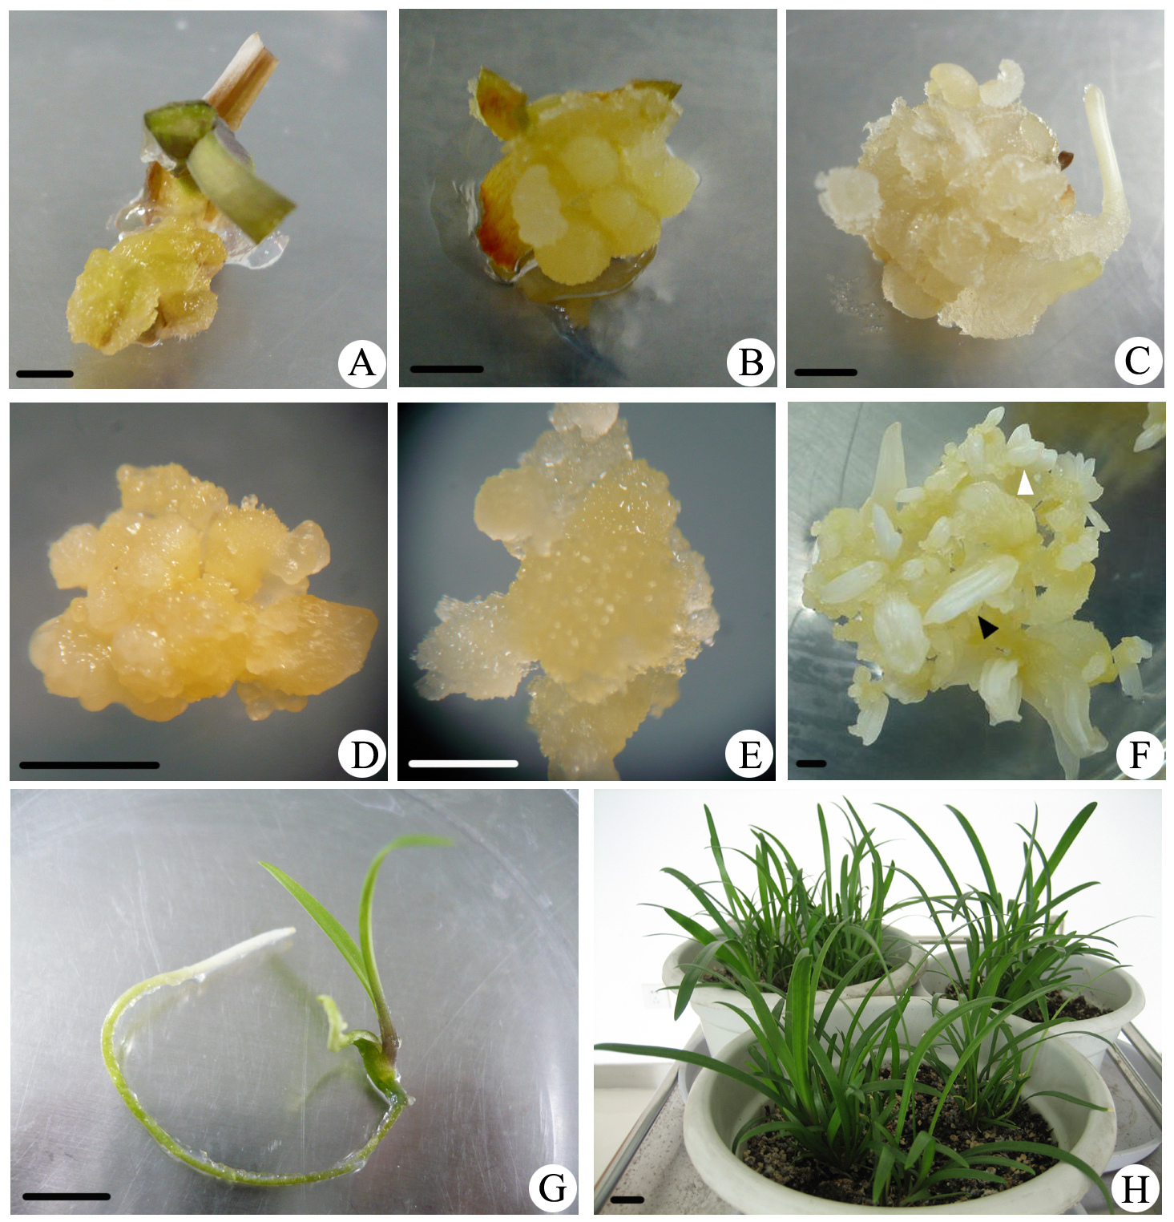
Fig.2
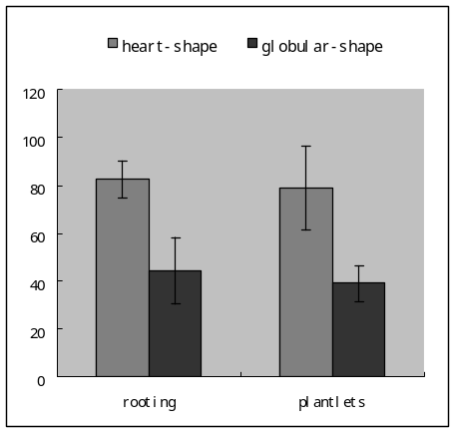
Fig.3
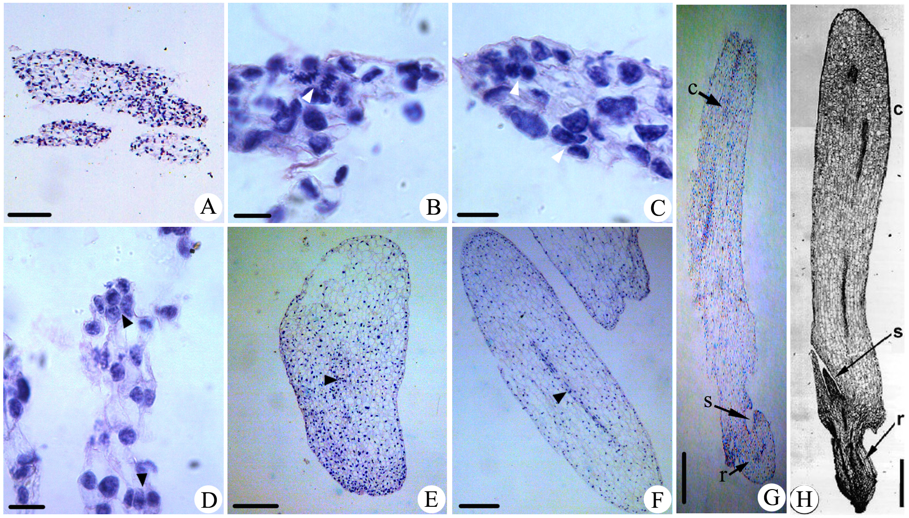
Legends:
Fig. 1 Formation of callus cultures and plant regeneration
A. Calli from the caudex on MS + 0.5 mg l⁻¹ PIC. Bar: 200 μm; B. Calli from young leaves on MS + 2.0 mg l⁻¹ PIC + 0.4 mg l⁻¹ 6-BA. Bar: 200 μm; C. Calli from the pedicel on MS + 3.0 mg l⁻¹ PIC. Bar: 200 μm; D. Yellowish calli. Bar: 500 μm; E. Embryogenic, creamy-white and friable calli. Bar: 500 μm; F. Heart-shape (open arrow) and globularr-shape (solid arrow) somatic embryos on embryo induction medium after 45 days. Bar: 500 μm; G. Germination of a somatic embryo on 1/2MS medium after 60 days. Bar: 2 cm; H. somtic seedlings in the greenhouse for 3 months. Bar: 2 cm.
Fig. 2 Regenerated plantlet and rooting from the globular and heart-shape embryos
Fig. 3 Histological observation from callus cultures in A. praecox ssp. orientalis
A. Calli. Bar: 200 μm; B. The dividing cell (arrowhead). Bar: 50 μm; C. The cell (arrowhead) consisting of 2-3 nucleus. Bar: 50 μm; D. Proembryos (arrowhead) consisting of 2–6 cells. Bar: 50 μm; E. A globular somatic embryo with a meristematic region (arrowhead). Bar: 200 μm; F. An oval somatic embryo with a procambium (arrowhead). Bar: 200 μm; G. A heart-shape somatic embryo with a cotyledon (c), shoot apex (s) and radicle (r). Bar: 500 μm.

Tables:
Table 1 Effects of PIC at different concentrations on callus induction from pedicels
PIC (mg l⁻¹) | Number of explants | Percentage of callus induction (%) | Status of callus growthª
1.0 | 45 | 3.33 | ++
2.0 | 45 | 3.33 | +++
3.0 | 45 | 53.33 | +++
4.0 | 45 | 6.67 | ++
5.0 | 45 | 3.33 | +
ª Status of callus growth was: -, no formation or growth; +, brown; ++, creamy white; +++, yellowish.
Table 2 Effects of PIC on callus induction from caudexes
PIC (mg l⁻¹) | Number of explants | Percentage of callus induction (%) | Status of callus growthª
0.0 | 45 | 0.00 | -
0.5 | 45 | 53.33 | +++
1.0 | 45 | 46.67 | +++
1.5 | 45 | 46.67 | ++
2.0 | 45 | 46.67 | ++

Table 3 Effects of PGR and VC on callus induction from leaves
Treatment | PIC  (mg l⁻¹) | 6-BA  (mg l⁻¹) | VC  (mg l⁻¹) | Percentage of EC induction (%) | Status of callus growthª
1 | 1(0.5) | 1(0.0) | 1(0) | 10.00 | ++
2 | 1(0.5) | 2(0.2) | 2(50) | 0.00 | -
3 | 1(0.5) | 3(0.4) | 3(100) | 0.00 | -
4 | 1(0.5) | 4(0.6) | 4(200) | 6.67 | +
5 | 2(1.0) | 1(0.0) | 2(50) | 3.33 | +
6 | 2(1.0) | 2(0.2) | 1(0) | 10.00 | ++
7 | 2(1.0) | 3(0.4) | 4(200) | 6.67 | +
8 | 2(1.0) | 4(0.6) | 3(100) | 3.33 | +
9 | 3(1.5) | 1(0.0) | 3(100) | 3.33 | +
10 | 3(1.5) | 2(0.2) | 4(200) | 13.33 | ++
11 | 3(1.5) | 3(0.4) | 1(0) | 33.33 | +++
12 | 3(1.5) | 4(0.6) | 2(50) | 26.67 | +++
13 | 4(2.0) | 1(0.0) | 4(200) | 20.00 | +++
14 | 4(2.0) | 2(0.2) | 3(100) | 16.67 | ++
15 | 4(2.0) | 3(0.4) | 2(50) | 30.00 | +++
16 | 4(2.0) | 4(0.6) | 1(0) | 20.00 | ++
optimizum | 2.0 | 0.4 | 0 | 40.00 | +++
k1 | 4.17 | 9.17 | 18.33
k2 | 5.83 | 10.00 | 15.00
k3 | 19.17 | 17.50 | 5.83
K4 | 21.67 | 14.17 | 11.67
R | 17.50 | 8.34 | 12.50
Variance Resource | Sum of  Squares | Degree of freedom | Mean Squares | F | Significant
PIC | 986.713 | 3 | 328.904 | 8.715 | *
6-BA | 179.918 | 3 | 59.973 | 1.589
Vc | 340.794 | 3 | 113.598 | 3.010
Errors | 226.450 | 6 | 37.742
Sum | 1733.875 | 15
* Significant difference at an alpha level of 0.05.

Table 4 Effects of PGRs and sucrose on the number of embryo induction
Treatment | PIC  (mg l⁻¹) | 6-BA  (mg l⁻¹) | Sucrose  (g.l⁻¹) | Numbers of embryos induced from 0.100 g of caullses
1 | 1(0.00) | 1(0.00) | 1(30.0) | 69.6+7.13
2 | 1(0.00) | 2(0.10) | 2(45.0) | 72.2+8.98
3 | 1(0.00) | 3(0.20) | 3(60.0) | 43.8+9.78
4 | 2(0.05) | 1(0.00) | 2(45.0) | 68.6+17.91
5 | 2(0.05) | 2(0.10) | 3(60.0) | 42.2+5.89
6 | 2(0.05) | 3(0.20) | 1(30.0) | 29.8+4.44
7 | 3(0.50) | 1(0.00) | 3(60.0) | 33.2+7.98
8 | 3(0.50) | 2(0.10) | 1(30.0) | 24.6+3.36
9 | 3(0.50) | 3(0.20) | 2(45.0) | 41.2+10.99
k1 | 61.87 | 57.20 | 41.33
k2 | 46.93 | 46.33 | 60.73
k3 | 33.00 | 38.27 | 39.73
R | 28.87 | 18.93 | 21.00
Variance Resource | Sum of squares | Degree of Freedom | Mean Squares | F | Significant
PIC | 1250.427 | 2 | 625.214 | 19.726 | *
6-BA | 541.627 | 2 | 270.814 | 8.544
Sucrose | 819.920 | 2 | 409.960 | 12.935
Errors | 63.390 | 2 | 31.695
Sum | 2675.364 | 8
* Significant difference at an alpha level of 0.05.

