Title: In vitro propagation of an outstanding autumn red-leaf individual of Liquidambar formosana Hance
Authors: Lin Xu¹², Kebing Du¹, Ranran Liu¹³, Chunmei Shi¹, Manzhu Bao^{1*} Weidong Chen¹²

Address:
1 Key Laboratory of Horticultural Plant Biology, Ministry of Education, College of Horticulture and Forestry Sciences, Huazhong Agricultural University, Wuhan, 430070, P.R. China
2 Research Institute of Forestry and Fruit Sciences of Wuhan City, Wuhan 430075, P.R. China
3 Forestry Planning and Design Institute of Chongqing City, Chongqing 400060, P.R. China

E-mail: Lin Xu: xulin.xulin@yahoo.com.cn Fax: 086 27 85718860

Kebing Du: kebingdu@mail.hzau.edu.cn Fax: 086 27 87282010

Ranran Liu: liuranran1120@yahoo.com.cn Fax: 086 27 87282010

Chunmei Shi: chunmeishi2008@yahoo.cn Fax: 086 27 87282010

Manzhu Bao: xulin20111120@yahoo.com.cn Fax: 086 27 87282010

Weidong Chen: roundface-825@webmail.hzau.edu.cn Fax: 086 27 85718860

*Corresponding author: Manzhu Bao

Co-first auther: Lin Xu, Kebing Du

In vitro propagation of an outstanding red-leaf individual
of Liquidambar formosana Hance
Abstract
Effective procedures for micropropagation in selected red-leaf individual of Liquidambar formosana Hance are described. When tender shoots cultured on woody plant medium (WPM) supplemented with 0.01 - 0.1 mg L⁻¹ NAA and 0.75 mg L⁻¹ BA, more than 90% explants sprouted out. The optimum proliferation medium was WPM contained 0.01 mg L⁻¹ NAA, 0.5 mg L⁻¹ BA and 0.3 mg L⁻¹ GA₃, which proliferation coefficients of 4.17 and shoot clump height of 2.90 cm were obtained. All the elongated shoots were rooted on WPM supplemented with2.0 mg L⁻¹ IBA, which superior to NAA in root length, root number and secondary roots. Plantlets were transplanted to soil successfully.
Keywords: Formosan sweetgum; Red-leaf individual; In vitro propagation; Rooting
Chemical names used:
BA: 6-Benzyladenine GA_{3:} Gibberellic acid IBA: Indole-3-butyric acid MS: Murashige and Skoog (1962) NAA: 1-Naphthalene acetic acid PGR: Plant growth regulator PPF: Photo-synthetic photon flux WPM: Woody plant medium (1980)

1 Introduction
Liquidambar formosana Hance, distributed in most of temperate and subtropical China, is popular in forestry and has been employed in urban landscaping in recent years for its excellent characteristics, such as fast growth, insect-resistance, autumn-color-leaf etc. To most formosan sweetgum trees, leaves would turn in yellow or yellow-red when autumn coming. While, the beauty of an outstanding autumn-red-leaf individual of L. formosana, located in the campus of Huazhong Agricultural University, Wuhan, China, attracted passerby’s attention in November-December. Therefore, it is valuable to propagate this individual tree as an excellent ornamental plant resource for landscape.
The conventional methods of vegetative propagation, such as cuttings, grafting etc, are often adopted. However, for L. formosana, it is difficult to root for cuttings, which resulted in survival rate was low. Moreover, both of cuttings and grafting require a great deal of cuttings. Therefore, in vitro propagation for rapid and large scale multiplication is an alternative method.
So far, in L. formosana, the reports on in vitro propagation were included: Durkovic et al. reported the micro-propagation of formosan sweetgum with a novel pattern of adventitious rooting (2005). Besides, in L. styraciflua grown in America, the counterpart to L. formosana, in vitro propagation of mature shoot tips was published (Sutter and Barker, 1985). Some data on plant regeneration of L. styraciflua were reported, such as via adventitious shoots from mature leaf and petiole segments (Brand and Lineberger, 1988) and hypocotyl segments (Kim et al., 1997), via somatic embryogenesis from hypocotyl-derived callus (Sommer and Brown, 1980), immature seeds (Merkle et al., 1998), and staminate and pistillate inﬂorescences (Merkle et al., 1998; Merkle and Battle, 2000).
Here, we studied the in-vitro shoot multiplication method, which could be applicable for the red-leaf elite tree. Therefore, the present investigation was undertaken to study the following aspects of in vitro propagation: (i) explanting season on contamination and sprouting; (ii) levels and combinations of plant growth regulators (PGRs) for shoot proliferation; (iii) effect of GA₃ on shoot length and proliferation; (iv) rooting medium for successful establishment of rooted plantlets.
2 Materials and methods
2.1Plant materials
An outstanding autumn-red-leaves individual of L. formosana with twenty-year-old, located in the campus of Huazhong Agricultural University, Wuhan, China, was taken as explants (Figure 1). Two kinds of explants were collected in two seasons: dormant buds with thick bud-scales in December and young tender shoot sprout out in April. After removed the dormant buds’ outermost bud-scale, as well as cut the tender shoots into 2-cm-length segment with an axillary bud, both kinds of explants were washed under running tap water for 30 min.
After surface-sterilized by immersion in 70% (v/v) ethanol for 30 sec, followed by a 6 -10 min immersion in 0.1% (w/v) mercuric chloride (HgCl₂) solution, and then by three rinses of 3 min each with sterile distilled water, explants were cultured on sprouting medium.
2.2 sprouting culture
Based on the above experiment results, we selected the tender shoots as explants. After basal cut into bevel edge, the shoot segments were inserted into woody plant medium (WPM, Lloyd and McCown. 1980) or MS (Murashige and Skoog, 1962) supplemented with different concentrations of BA (0.2, 0.75, 1.0 or 2.0 mg L⁻¹) combined with NAA at 0, 0.01 or 0.1 mg L⁻¹ (Table 1). A control WPM medium without PGRs was also used. Cultures were observed at weekly intervals, and the sprouting rate was recorded after 6 weeks.
2.3 Shoot proliferation
Sprouted axillary buds were excised and transferred to WPM basal media containing different concentrations of BA, NAA, and GA₃ (Table 2). The microshoots were further multiplied by subculturing in fresh medium at 6 weeks interval. Shoot proliferation rate and length of shoots were estimated from the means of three subcultures.
2.4. Rooting of microshoots and transplanting
To compare the effects of different auxins on rooting, elongated regenerated shoots (about 2-3 cm in length) were cut and transferred into WPM basal medium without PGRs or containing 5.4μM NAA, or three different concentrations of Indole-3-butyric acid (IBA) (0.5, 1.0 or 2.0 mg L⁻¹). Cultures were observed at weekly intervals, and the rooting rate, number of first-order lateral roots per plantlet and root length was recorded after 8 weeks.
After rooting culture for 8 weeks, the grown roots were cleaned of agar and the plantlets were transplanted into pots containing vermiculite and soil (1:2 v/v) (Xu et al., 2007).
2.5 Culture conditions
All the cultures were grown in a culture room at 25 ± 1℃, under a 14-h photoperiod of 50 μmol m⁻² s⁻¹ photosynthetic photon flux (PPF) provided by 40 W cool white fluorescent tubes. The vessels used in the experiments were 100 mm × 60 mm glass bottles each containing 40 ml of nutrient media and 3 explants per culture bottle was inoculated. The cultural media were adjusted to pH 5.8 and supplemented with 3% sucrose and 0.7% agar (Sigma A1296).
2.6 Statistical analysis
All the experiments were laid out 60 cultures per replication and each experiment was repeated twice. The means were evaluated by applying F-test and critical difference have been calculated at 5% level of significance. Data presented in percentages were subjected to arcsin transformation before analysis and then converted back to percentage for presentation.
3 Results
3.1 explants selection
After surface-sterilization using the method described above, almost all young tender shoots survived and germinated within 2 weeks. However, the dormancy buds often suffered from contamination or necrosis which resulted from much endophyte. The contamination was out of control even prolonged to 10-min immersion in HgCl₂ solution. Few survived dormancy buds could not sprout until one month later. Therefore, young tender shoots collected in spring were selected as the optimal explant materials.
3.2 sprouting culture
Tissue culture of L. formosana was significantly influenced by basal medium. MS basal medium was often used in plant in-vitro culture. However, browning and necrosis were often occurred seriously when cultured on MS medium. Cultured on WPM medium, the axillary buds could sprout out and grew vigorously, despite of light browning. Therefore, WPM was optimum basal medium in L. formosana in vitro culture.
Cytokinin played a critical role in inducing axillary buds germination. Meanwhile, germination rate and elongating growth of axillary buds were promoted greatly in the presence of NAA (Table 1). Only 13% explants germinated on WPM without PGR, accompanied by retarded growth and weak buds. Germination rate and elongating growth were advanced when supplemented BA. Results of No.4, 5 and 6 media showed that NAA positively affected germination rate of axillary buds proportionally to its concentration. High concentration of NAA（0.1 mg L⁻¹） induced big yellow-white callus occurred at basal, but disaffected germination of axillary buds. Under 0.1 mg L⁻¹ NAA, there was no difference observed in germination rate between BA at 0.75 mg L⁻¹ and 1.0 mg L⁻¹, except for the latter lightly suppressed bud elongation. When concentration of BA was up to 2.0 mg L⁻¹, germination rate decreased slightly, and shoot elongation was greatly inhibited, even formed tight and abnormal bud. In a word, new shoots were obtained when stem segments cultured on WPM contained 0.01 - 0.1 mg L⁻¹ NAA and 0.75 mg L⁻¹ BA for 4 weeks (Figure 2A).
3.3 Shoot proliferation
Shoots basal were swelled firstly after cultured on proliferation media for one week. Thereafter, massive callus would be obtained at plantlet basal cultured on most media. Around two weeks, some new buds would sprout from basal stem or axillary buds of the shoots.
BA was crucial to shoot proliferation of formosan sweetgum, and both amount and height of proliferating shoot increased with the concentration rise (Table 2). However, when sub-cultured on medium contained higher concentration BA (0.75 mg L⁻¹) for a long period, callus were promoted at basal shoot, which resulted in suppression of shoot elongation. NAA played a visible promoting role in shoot proliferation and growth (Table 2). When added 0.01 mg L⁻¹ NAA, both amount and height of proliferating shoot significantly higher than that of culture medium without NAA. A little callus was observed at the base of shoot which disaffected proliferation and growth at all. When the concentration of NAA was up to 0.1 mg L⁻¹ in medium, much callus grew and shoot growth were affected adversely by inhibiting absorb of water and nutrient. Besides, elongation of proliferated shoot was significantly promoted by 0.3 - 0.5 mg L⁻¹ GA₃. Whereas, sub-cultured on medium supplemented with 0.5 mg L⁻¹ GA₃, new obtained shoots always showed some characteristics such as slight stem, small leaves congregating at the top of stem etc, which went against subsequent rooting culture.
Based on the above results, for L. formosana, high proliferation coefficient and fast growth was obtained on WPM containing 0.01 mg L⁻¹ NAA and 0.5 mg L⁻¹ BA with or without 0.3 mg L⁻¹ GA₃ (Figure 2B). PGRs concentrations should be adjusted according to the growth response of shoot because of the adverse influence of PGRs accumulation during a long period of proliferation sub-culture. For instance, temperate reduction of PGRs concentration duly could efficiently solve the above problems and obtain elite shoots, including GA₃ leading to excessive elongation of internode, many buds in clusters sprouted induced by accumulation of BA, and adverse affection by excessive growth of callus.
3.4 rooting and transplanting
Effects of WPM medium containing different concentrations of NAA or IBA on in vitro rooting of formosan sweetgum were discussed in the present study. About 30 percent of the elongated shoots rooted and few adventitious roots were observed in WPM medium without auxin(data not shown). Root capability was greatly promoted in the presence of 0.5-2.0 mg/L IBA or NAA, both in rooting percentage and the number of adventitious roots (Table 3).
The morphological appearance had significant differences between adventitious root induced by NAA and IBA. Cultured on 1.0 mg L⁻¹ NAA, 1.0-cm callus were observed firstly. Subsequently, a multitude of thick, short roots were induced from the surrounding of callus radiantly. Secondary roots were not observed generally. The big callus negative influenced root growth and next transplanting plantlets to soil.
Adventitious roots induced by IBA began to differentiate after culture for 10 d, and 40 d later, about 2-cm length adventitious roots and secondary roots were developed. The adventitious roots were slender, less, and length and number of secondary root were advanced, which distinct differences with that by NAA. Growth of callus enhanced with the increase of IBA concentration, but still smaller than that induced by NAA, and disaffected adventitious root differentiation and growth.
Different effects were observed in rooting of formosan sweetgum among 0.5 - 2.0 mg L⁻¹ IBA. With the increase of IBA concentration, callus growth, root number, root length and the abundance of secondary root were enhanced. We observed 4.86 roots per plantlet on average, 2.48 cm in length, and good root system architecture induced by 2.0 mg L⁻¹ IBA（Figure 2C）. Abundant secondary roots played a positive role in nutrient absorbance either culturing in medium or transplanting to soil.
4 Discussions
4.1Selection of basal medium
WPM medium has been designed for tissue culture of woody species. In the present experiments, explants cultured on WPM and MS medium formulations displayed signiﬁcant differences in morphology. Cultured on WPM for 3 d, the shoot was swelled and 40% axillary buds began to sprout after 2 weeks. However, browning, necrotic tissue and dwarfed plant were often observed on MS. One possible explanation for this result is the differences of nutrition content between the MS and WPM media. The most of contents in MS medium was approximately two-fold higher than WPM. When we reduced the content to 1/2 MS, the ill states of browning, necrotic tissue and dwarfed plant were developed greatly to vigorous growth except to a little short inter-node. Based on the results, lower concentrations of nutrition content of WPM medium was adaptive to L. formosana. Our results were accordance with L. styraciflua (Brand and Lineberger, 1988) and Vitis thunbergii (Lu, 2005).
4.2 PGRs accumulation during sub-culture for a long time
When sub-cultures in the same proliferating medium for three years, we noticed large bud clusters produced and few buds developing into new shoots. Some earlier studies found BA was one of the most effective cytokinin for inducing shoot development in L. styraciflua (Sutter and Barker, 1985; Brand and Lineberger, 1988). In the presented studies on L. formosana, BA represented favorable multiplication exactly at first to second year. However, the subsequent sub-culture on the same medium containing 0.5 mg L⁻¹ BA resulted in unable-to-elongate buds, which couldn’t be improved by adding GA₃.When we removed or decreased BA, shoot growth was improved clearly. Base on the results, we considered that during long-term subculture, it’s possible that BA was accumulated and inhibited the adventitious buds elongation. Therefore, we speculated it was necessary to adjust the concentrations of PGRs according to the shoot growing status.

References
BRAND M. H. and LINEBERGER R. D. (1988). In vitro adventitious shoot formation on mature-phase leaves and petioles of Liquidambar styraciﬂua L. Plant Science, 57: 173–179.
DURKOVIC J., PICHLER V., LUX A. (2005). Micropropagation with a novel pattern of adventitious rooting in Formosan sweetgum. Can J For Res, 35: 2775–2780
LLOYD G. B., MCCOWN B.H. (1980). Commercially feasible micropropagation of mountain laurel, Kalmia latifolia, by use of shoot-tip culture. Proc Int Plant Prop Soc, 30: 421–427.
SOMMER H.E., BROWN C.L. (1980). Embryogenesis in tissue cultures of sweetgum. Forestry Science, 26: 257–260.
LU M.C. (2005). Micropropagation of Vitis thunbergii Sieb. et Zucc., a medicinal herb, through high-frequency shoot tip culture. Scientia Horticulturae. 107：64–69
SUTTER E.G. BARKER P.B. (1985). In vitro propagation of mature Liquidambar styraciflua. Plant Cell Tissue Organ Culture, 5: 13-21.
XU L., LIU G.F. BAO M.Z. (2007). Adventitious shoot regeneration from in vitro leaves of formosan sweetgum (Liquidambar formosana). Hortscience, 42(2): 721-723.
MERKLE S.A., NEU K.A., BATTLE P.J., BAILEY R.L. (1998). Somatic embryogenesis from immature and mature tissues of sweetgum (Liquidambar styraciflua). Plant Science, 132: 169–178.
MERKLE S.A., BATTLE P.J. (2000). Enhancement of embryogenic culture initiation from tissues of mature sweetgum trees. Plant Cell Reports, 19: 268–273
MURASHIGE T., SKOOG F. (1962). A revised medium for rapid growth and bioassays with tobacco tissue cultures. Physiol Plant, 15: 473–497.

Table 1 Effects of different media on in vitro germination of axillary buds of red-leaf individual Liquidambar formosana. Values represent the means; Means followed by different letters are significantly different at P﹤0.05, same as for below except for special statement.
No. | Medium | NAA  (mg L⁻¹) | BA  (mg L⁻¹) | Germination Rate (%) | Bud length  (cm) | Callus growth at  basal stem
1 | WPM |  |  | 13.0 g | _ |  | No callus
2 | MS |  | 0.2 | 65.2 f | _ |  | No callus and high necrosis
3 | WPM |  | 0.2 | 70.5 e | _ |  | No callus
4 | WPM |  | 0.75 | 83.3 d | 0.6 |  | No callus
5 | WPM | 0.01 | 0.75 | 90.2 c | 1.0 |  | No callus
6 | WPM | 0.1 | 0.75 | 100.0 a | 1.0 |  | Big callus
7 | WPM | 0.1 | 1.0 | 100.0 a | 0.8 |  | Big callus
8 | WPM | 0.1 | 2.0 | 92.3 b | _ |  | Big callus and  short, compact buds
Note: - represented data was less than 0.3 cm.

Table 2 Effects of different media on in vitro shoot multiplication of red-leaf L. fomosana.
PGR combinations (mg/L) |  |  | Proliferation coefficients | Average height  of shoot clumps（cm）
NAA BA GA₃ |  |  | Proliferation coefficients | Average height  of shoot clumps（cm）
 | 0.5 |  | 3.13±0.13c | 2.37±0.07ab
 | 0.75 |  | 4.06±0.19b | 2.55±0.03ab
0.01 | 0.5 |  | 5.25±0.25a | 2.57±0.19ab
0.01 | 0.5 | 0.3 | 4.17±0.17b | 2.90±0.32a
0.01 | 0.5 | 0.5 | 3.25±0.12c | 2.65±0.25ab
0.1 | 0.5 |  | 2.63±0.38c | 2.04±0.04b

Table 3 Effects of growth regulators on in vitro root formation of clonal shoots of red-leaf individual L. formosana.
Growth regulators (mg/L) | No. of first-order  lateral roots per plantlet | Root length（cm） | Secondary roots
NAA IBA | No. of first-order  lateral roots per plantlet | Root length（cm） | Secondary roots
0 0 | 3.10±0.10 b | 0.87±0.04 b | few
1.0 0 | 8.67±1.34 a | 0.97±0.04 b | few
0 0.5 | 3.50±0.25 b | 1.78±0.45 ab | less
0 1.0 | 3.69±0.98 b | 1.87±0.35 ab | medium
0 2.0 | 4.86±0.15 b | 2.48±0.56 a | abundant

Figure 1 Differences in color between the outstanding red-leaf and popular yellow-leaf trees of Liquidambar formosana. A. Representation of red-leaf tree in November; B. Representation of general yellow-leaf tree in November; C. Left red leaf was distinctly different from right yellow leaf.
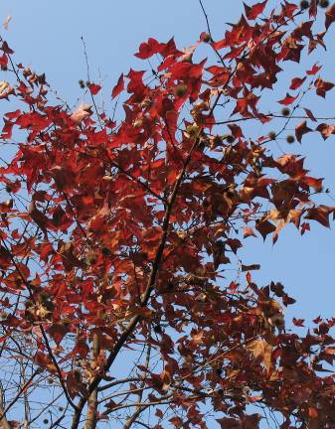
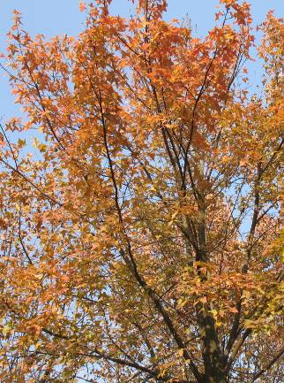
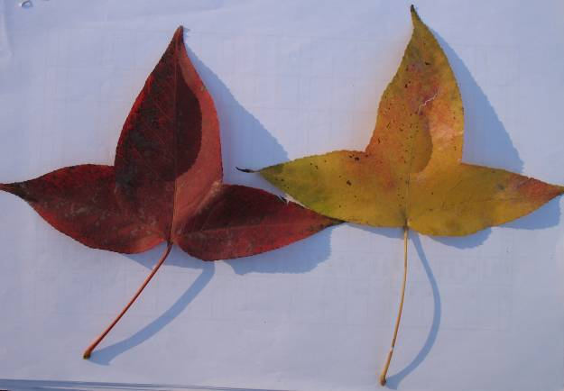
A
C
B

Figure 2 In vitro shoot multiplication, rooting and transplanting of L. formosana. A. In vitro germination of axillary buds (bar = 5 mm) ; B. Shoot multiplication culture on medium without GA₃ (bar = 5 mm) ; C. Shoot elongation on medium supplemented with 0.3 mg L⁻¹ GA₃ for 40 d (bar = 10 mm) ; D. In vitro root formation on WPM medium containing 2.0 mg L⁻¹ IBA for 40 d (bar = 5 mm) ; E. Plantlet after transplanting to soil (bar = 8 cm).
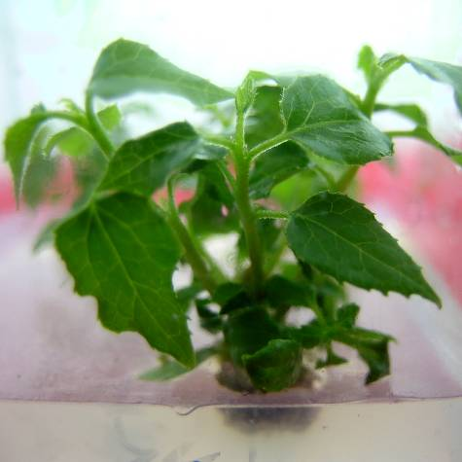
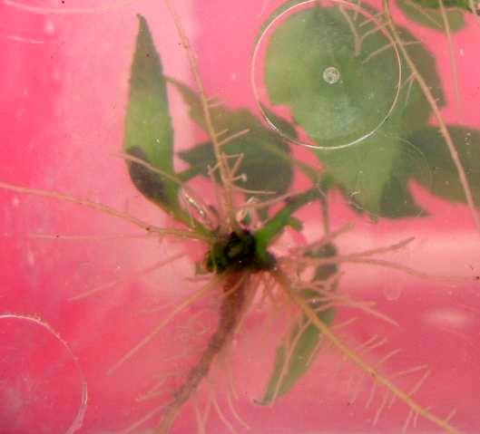
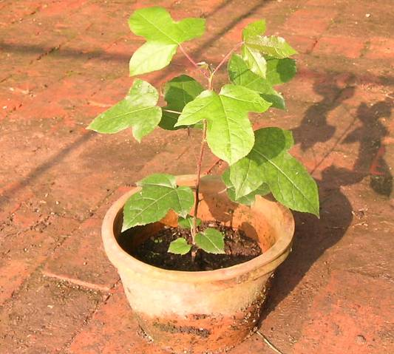
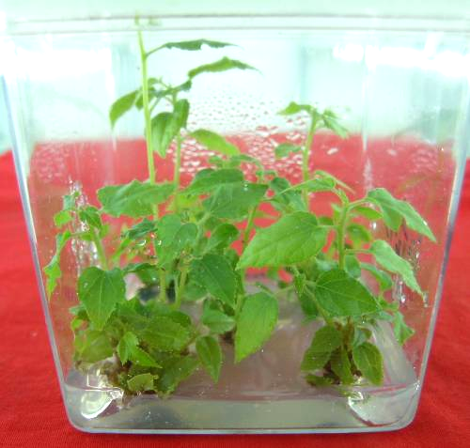
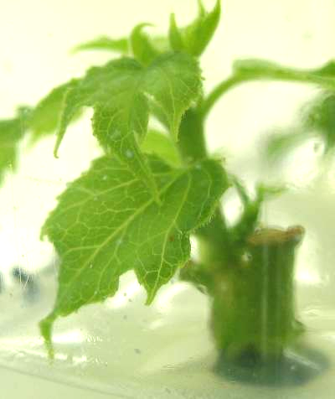
A
B
D
E
C

