MICROPROPAGATION OF ROSA CENTIFOLIA

GULZAR AKHTAR, MUHAMMAD ASLAM KHAN, JAFAR JASKANI, ADNAN YOUNIS, C.M. AYYUB, AHSAN AKRAM And ABDUL MANAN

Institute of Horticultural Sciences, University of Agriculture Faisalabad, Pakistan

ABSTRACT

A protocol for in vitro propagation of Rosa centifolia was developed by using nodal explants having an axillary bud. Nodal explants were cultured on MS medium supplemented with different concentrations of BAP (1.5 mg L⁻¹-3 mg L⁻¹) alone and with fixed concentration of NAA (0.5mg L⁻¹) for shoot formation. Different concentrations of NAA (1.5 mg L⁻¹-3 mg L⁻¹) alone and with fixed concentration of BAP (0.5 mg L⁻¹) were used for the root induction. Medium containing 3 mg L⁻¹ BAP along with 0.5 mg L⁻¹ NAA proves the best medium for in vitro shoot formation of Rosa centifolia from the axillary bud. At this concentration minimum days to initiate shoot were 9.2 with maximum number of laterals 1.6, number of leaves 2.6 and shoot length of 5.9 cm was observed. Medium containing 1.5 mg L⁻¹ NAA along with 0.5 mg L⁻¹ BAP was the best medium for root formation. At this treatment, minimum days to initiate root were 11.7, maximum number of roots 2.6 and maximum root length was 4.2 cm. After rooting formation plants were acclimatized and successfully transferred to the greenhouse.

Keywords: Rose, Rosa centifolia, micropropagation, BAP, NAA
Correspondence E Mail Gulzar_butt1849@yahoo.com

INTRODUCTION
Rose is very famous flower in the world. It consists of 200 species and 18000 cultivars (Gudin, 2000). From the ancient times, it has been associated with love, courtship, beauty and romance. Roses add beauty, charm and fragrance in nature. They used on different religious and traditional occasions, as cut flower and are a good source of rose oil and vitamins C (Marchant et al., 1996). Rose oil is one of the most expensive essential oils of the world (Baydar and Baydar, 2005) used in different products like creams, perfumes etc.
Rosa centifolia is an important landscape plant used in parks, gardens houses and is also very important among oil producing species of roses (Tucker and Maciarello, 1988). It produces flowers in hot summer conditions at about of 50⁰C. When other rose species are not able to produce flowers. Now its demand is increasing with the passage of time but its production is not sufficient to fulfill the growing needs in the country. As it is commercially propagated by asexual methods that are hard woodcutting, semi hard wood cutting, budding and grafting (Horn, 1992). But many problems associated with these propagation methods. As budding and grafting are very slow methods of propagation and can not fulfill the demand of market. In cutting rooting is a problem that decreases its production.
These problems can be solved by micropropagation. Micropropagation techniques can be used for mass propagation of healthy disease free plants round the year. Because in micropropagation any plant part can be used to regenerate into a new plant when it cultured on artificial nutrient medium under aseptic environmental condition.
This study was conducted to micropropagate the Rosa centifolia for mass propagation of disease free plants of Rosa centifolia.

MATERIALS AND METHODS
Experiments were conducted from March to June in Plant Tissue Culture Laboratory, Institute of Horticultural Sciences, University of Agriculture Faisalabad, Pakistan.
Plant material. Axillary buds were used as explant, taken from the soft young branch of Rosa centifolia grown in the rose project of Institute of Horticultural Sciences, University of Agriculture Faisalabad.
Preparation of explant. Leaves were removed from the explants by forceps and placed under the running water for half an hour to decrease browning.
Sterilization and culture of explant. For sterilization explants were first dipped in 70% ethanol for 6 minutes. Then washed three times with double distilled autoclaved water to remove traces of ethanol. Then dipped in 5% sodium hypochlorite for 5 minutes and again washed three times with double distilled autoclaved water to remove traces of sodium hypochlorite. Now the explants were ready for culture on MS medium (Murashige and Skoog 1962) made up of 30 g L⁻¹ sugar, 8 g L⁻¹ agar, MS salt, vitamin, iron and various concentrations of different growth regulators. pH of the medium was adjusted at 5.7 and then autoclaved for 20 minutes at 121⁰C and 15 Psi. After sterilization explants were cut at the lower and upper part by slanting cut to gave a proper shape. Then cultured on the medium in the test tube.
Culture conditions. After inoculation test tubes containing explants were placed in racks, which then placed in the growth room under 2500-lux light intensity and 25+2⁰C temperature (Thorpe, 1981).
Media for shoot formation. For shoot formation MS media was supplemented with different concentration of BAP (1.5 mg L⁻¹, 3 mg L⁻¹) alone and with fixed concentration of NAA (0.5 mg L⁻¹).
Media for root induction. For root formation MS media was supplemented with different concentrations of NAA (1.5 mg L⁻¹, 3 mg L⁻¹) with fixed amount of BAP (0.5 mg L⁻¹).
Statistics. The data was statistically analyzed by using analysis of variance and Duncan, s Multiple Range Test (Steel and Torrie, 1980) was used to check the level of significance among treatment means.
RESULTS AND DISCUSSION
Effect of different concentration of BAP and NAA on number of days to initiate shoots.
The data presented in the Table 1 showed that BA in combination with NAA presented variable results for shoot initiation. BA (3.0 mg L⁻¹) in combination with NAA (1.5 mg L⁻¹) took minimum days to initiate the shoots but control showed maximum days (17) to emergence shoots. BA alone and with low concentrations of NAA gave poor results. Explant that took minimum days to produce shoot produces more number of laterals shoots and leaves. These results were correlated with the findings of Carelli and Echeverrigaray, (2002) and Vajaya et al. (1991). They said that BA and NAA in combination gave good results for shoot initiation of the roses. Knox et al. (1991) also stated that BA and NAA in combination produced good results and increased the regeneration capacity of the explants for shooting in Limonium latifolia.

Fig. 1. Effect of different concentration of BAP and NAA on number of days to initiate shoots
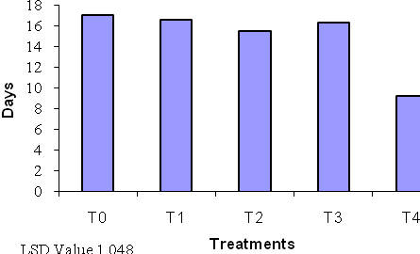

Effect of different concentration of BAP and NAA on number of lateral shoots
Table 1 showed that BA (3.0 mg L⁻¹) along with NAA (1.5 mg L⁻¹) resulted in maximum (1.6) number of laterals per explant. BA (1.5 mg L⁻¹) alone in the medium resulted in minimum (0.08) number of laterals. Higher concentration of BA gave better results as compared to low concentration and also in combination with NAA Vajaya et al. (1991). Explants, which had more number of laterals, showed good growth in the rooting and potting media. On the other hand shoots, which had no laterals shoots had maximum chance to die.

Fig. 2. Effect of different concentration of BAP and NAA on number of lateral shoots
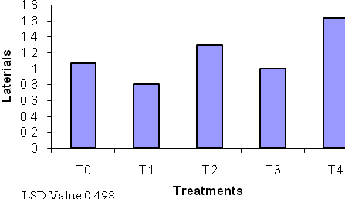

Effect of different concentration of BAP and NAA on number of leaves
The highest numbers of leaves (2.6) were obtained from the medium containing 3.0 mg L⁻¹ BAP along with 0.5 mg L⁻¹ NAA. On the other hand treatment BA 1.5 mg L⁻¹ alone shows the minimum number of leaves (1.8). Higher concentration of BA gives the good results as compared to low concentration alone and also in combination with NAA. The leaves that were remained in the shooting media for long period of time became dry and fall down on the media. This observation is similar with results of Chu et al. 1993 who said that plantlets began to exhibit some chlorosis in the 6th week of culture. Shoots, which have only one or two leaves, had maximum chance to die in the rooting media.
Fig. 3. Effect of different concentration of BAP and NAA on number of leaves
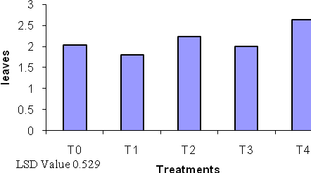

Effect of different concentration of BAP and NAA on shoot lenght
The highest shoot length (5.9cm) was recorded in the medium containing BA 3 mg L⁻¹ along with NAA 1.5 mg L⁻¹. According to the Table 1 control treatment shows the minimum shoot length (3.8cm). Shoots, which had more number of leaves and lateral, more shoot length, was observed. BA in combination with NAA gives good results as compared to the BA alone.

Fig. 4. Effect of different concentration of BAP and NAA on shoot length
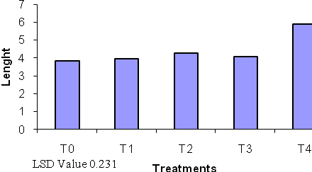
T0= Control
T1= MS+BA1.5 mg L⁻¹
T2= MS+BA 3 mg L⁻¹
T3= MS+BA 1.5 mg L⁻¹+NAA 0.5 mg L⁻¹
T4= MS+BA 3 mg L⁻¹+NAA 0.5 mg L⁻¹

Effect of different concentration of NAA and BAP on number of days to initiate roots
According to Table 2 medium containing NAA 1.5 mg L⁻¹ along with BA 0.5 mg L⁻¹ shows minimum days (11.7) to emerge root. Treatment (MS+NAA 1.5 mg L⁻¹) takes maximum days (17.0) to emerge roots. NAA in combination with BA gives better result than NAA alone with respect to root induction. These results are similar with Khosh-Khui and Sink (1982) who said that NAA and BA give good results for root induction.

Fig. 5. Effect of different concentration of NAA and BAP on number of days to initiate roots
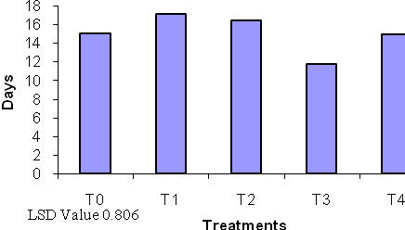

Effect of different concentration of NAA and BAP on number of roots
Table 2 shows that the highest numbers of roots (4.4) were obtained from the medium containing 3.0 mg L⁻¹ NAA with 0.5 mg L⁻¹ BA. On the other hand treatment T1 (MS + NAA 1.5 mg L⁻¹) produce minimum (2.0) number of root. NAA in combination with BA gives good results as compared to NAA alone in the MS medium. These results are different from Chu et al., (1993) who found that BA did not take part in rooting. Results are different because he used the liquid medium.
Explants that had more number of laterals produced more number of roots. Thus explants, which had more number of leaves gives good results as compared to shoots have less number of leaves.

Fig. 6. Effect of different concentration of NAA and BAP on number of roots
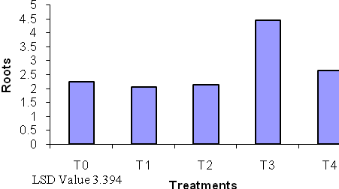

Effect of different concentration of NAA and BAP on root lenght
According to Table 2 treatment T3 (MS + NAA 1.5 mg L⁻¹+BA 0.5 mg L⁻¹) produces maximum (4.2) root length. On the other hand minimum root length (3.2) was measured in treatment T1 (MS + NAA 1.5 mg L⁻¹). NAA in combination with BA produces more root length as compared to NAA alone in the MS medium. Shoots, which had more number of laterals, produced more number of roots.

Fig. 7. Effect of different concentration of NAA and BAP on root length
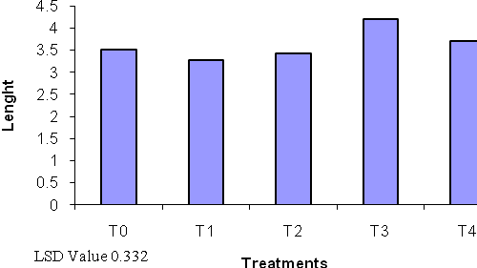
T1= MS+NAA 1.5 mg L⁻¹
T2= MS+NAA 3 mg L⁻¹
T3= MS+NAA 1.5 mg L⁻¹+BA 0.5 mg L⁻¹
T4= MS+NAA 3 mg L⁻¹+BA 0.5 mg L⁻¹

The rooted plants were transferred to small pots containing compost. The pots were covered with polythene bags to decrease the transpiration loses. First the plants were placed under controlled condition of temperature and humidity as these plants are very sensitive and hardening of is required before transferring them in the field. During acclimatization the plants don’t show any type of mortality. After acclimatization the plants were shifted to large pots containing sand, silt, soil and placed in lath house.
CONCLUSION
It is concluded that micropropagation is a very efficient and potential method for the production of disease free plants of Rosa centifolia. The optimization of different combinations of different plant growth regulators is very important for maximum shoot formation and root inductions in regenerated plantlets.
ACKNOWLEDGMENT
We are gratefully acknowledged the Higher Education Commission for financial assistance.

REFERENCES
Baydar, H., Baydar, N.G., 2005. The effects of harvest date, fermentation duration and Tween 20 treatment on essential oil content and composition of industrial oil rose (Rosa amascena Mill.). Ind. Crop. Prod. 21: 251-255.
Carelli, B.P. and S. Echeverrigaray. 2002. An improved system for the in vitro propagation of rose cultivars. Sci Hortic 92: 69-74.
Chu, Y.C., S.L. Knight and M.A.L. Smith. 1993. Effect of liquid culture on the growth and development of miniature rose (Rosa chinensis Jacq. ‘Minima’). Plant Cell, Tissue and Organ Culture. 23: 329-334
Gudin, S. 2000. Rose: Genetic and breeding. Plant Breeding 17: 159-189.
Horn, W.A.H., 1992. Micropropagation of roses. In: Bajaj, Y.P.S. (Ed.), Biotechnology in Agriculture and Foresty, 20. Springer-Verlag, Germany, pp. 320–342.
Khosh- Khui, M. and K.C. Sink. 1982. Micropropagation of new and old world rose species J. Hortic. Sci. 57: 315-319
Knox, G.W., A.R. Joshi and D. Zimet. 1991. Adventurous shoot regeneration in Limonium latifolia. PKV Research jour., 13: 166-167
Marchant, R., M.R. Davey, J.A. Lucas and B. Power. 1996. Somatic embryogenesis and plant regeneration in floribunda rose (Rosa hybrida L.) cvs Trumpeter and Glad Tiding. Plant Sci. 120: 95-105.
Murashige, T. and F. Skoog. 1962. A revised medium for rapid growth and bioassay with tobacoo tissue culture. Physiol. Plant. 15: 473-497.
Steel, R.G.D. and J.H. Torrie. 1980. Principles and Procedures of statistics. McGraw Hill Book Co., Inc., New York, USA.
Thorpe, T.A. 1981. Plant Tissue Culture: Methods and Applications in Agriculture. Academic Press, New York. Pp 74-81.
Tucker, A.O. and M. Maciarello. 1988. Nomenclature and chemistry of the Kazanlak Damask rose and some potential alternatives from the horticultural trade of North America and Europe. In: Flavors and Fragrances: A world Perspective. Elsevier, Amsterdam. 13: 99-114.
Vajaya, N., G. Satyanarayana J. Prakash and R.L.M. Pierik 1991. Effect of culture media and growth regulators on in vitro propagation of rose. In: Horticulture. 12: 209-214.

