SEED GERMINATION OF FERULA ASSA- FOETIDA L. RESPONSE TO SCARIFICATION, TEMPERATURE AND GA₃ TREATMENTS

Seyedeh Batool Hassani^{1*}, Azra Saboora², Tayebeh Radjabian³, and Hassan Fallah Husseini⁴

¹Department of Botany and Arboretum, Institute of Biology, Humboldt University Berlin, Invalidenstr. 42, D-10115 Berlin, Germany, *E-mail: hassanis@cms.hu-berlin.de, *Fax: (+4930) 2093 8725
²Department of Biology, Faculty of Sciences, Alzahra University, Tehran, Iran, E-mail: saboora@alzahra.ac.ir, Fax: (+9821) 88058912
³Department of Biology, Faculty of Sciences, Shahed University, Tehran, Iran, E-mail: radjabian@shahed.ac.ir, Fax (+9821) 55277639
⁴Department of Pharmacology, Institute of Medicinal Plants (ACECR), Karaj, Iran, huseinifallah@yahoo.com, Fax: (+98 261) 4764021

*Corresponding author: address, Department of Botany and Arboretum, Institute of Biology, Humboldt University Berlin, Invalidenstr. 42, D-10115 Berlin, Germany, Tel: (+4930) 2093 8624, Fax: (+4930) 2093 8725
E-mail: hassanis@cms.hu-berlin.de

Abstract
The seed germination of Ferula assa-foetida L. (Apiaceae), an endangered medicinal plant was studied. We analyzed treating seeds with GA₃, H₂SO₄, HNO₃, water soaking, freezing
(-20˚C), emery paper and cold stratification (4˚C). Cold stratification, soaking in water and lower concentrations of GA₃ were more effective in promoting seed germination. Cold stratification treatment had the most positive effect on elevating the seed germination percentage (73%) and index (2.5 germinated seeds per week). Combining freezing and cold stratification did not enhance germination to a level greater than control. For those seeds which were subsequently treated with 1000 mg l⁻¹ of GA₃ for 72 h or which were soaked in water for 72 h, the germination percentage reached 40 and 32%, respectively, after 12 weeks. The seeds which underwent acid scarification revealed less germination (27%, after treatment with HNO₃ 25% for 10 min) compared to cold stratification treatment. The results from seed coat disruption treatments indicated that the low germination rate of the seeds is not primarily due to physical dormancy and that low temperature played a critical role in breaking seed dormancy.

Key words: Ferula assa-foetida L., seed germination, temperature, scarification, GA₃ treatment

Running title: Seed germination of Ferula assa-foetida L.

1. Introduction
Ferula assa-foetida grows in Kashmir, Iran and Afghanistan. It has an unpleasant smell, is herbaceous and perennial, and grows up to 2 m high (Abd El-Razek 2007). This plant is one of the most important of the thirty species of Ferula which grows wild or has been recently cultivated in several areas of the country (Abd El-Razek et al. 2001, Sadraei et al. 2003).
The Ferula genus has been found to be a rich source of gum resin. The gum resins, which are obtained by incising the roots, are used as spices and drugs in many countries. F. assa-foetida has been reported in Iranian folk medicine to be analgesic, antispasmodic, anthelmintic, antiseptic, aphrodisiac, aromatic, carminative, digestive, expectorant, laxative, nervine and sedative properties (Sadraei et al. 2003, Khajeh et al. 2004).
Medicinal plants are threatened due to an increasing demand from international markets. Thus there is an urgent need to develop and implement regeneration/conservation strategies for over exploited medicinal plant species (Kandari et al. 2008). Among them, F. assa-foetida L. is one of the important high value species, which has huge economic potential, being used in pharmaceutical industries. Due to over exploitation, its natural population is threatened.
Although there have been some studies on the chemical composition and the medicinal effects of the resin found in F. assa-foetida (Abd El-Razek et al. 2001, Mallikarjuna et al. 2003, Sadraei et al. 2003, Khajeh et al. 2004, Abd El-Razek 2007), there have been few studies on seed germination. The seeds of many medicinal plants in Apiaceae such as F. assa-foetida have dormancy, they do not germinate unless specific environmental signals or events occur (Kaye 1997, Eyog-Matig et al. 2007).
Seed germination studies are key tools in conservation programs. Indeed, according to some researchers, their results can be used for management programs and species renewal (Ortega-Base and Rojas-Arechiga 2007). Germination represents a critical event in the plant life cycle, and seed dormancy is an innate seed property that defines the environmental conditions in which the seed is able to germinate (Finch-Savage and Leubner-Metzger 2006). Several researchers have reported using plant growth regulators (PGRs), chemical and physical factors to stimulate and to synchronize seed germination (Pandey et al. 2000, Ghimire et al. 2006, Kandari et al. 2008). Temperature as a physical factor is another crucial external cue that controls seed germination (Bewley and Black 1982). For example, dormancy may be broken by higher temperatures or lower temperatures, depending on the species. Temperature is the most important factor that drives changes in the depth of dormancy, although other factors may also be required to terminate dormancy and induce germination (Finch-Savage and Leubner-Metzger 2006).
The application of gibberellins to seeds can break seed dormancy, some scholars have proposed that GA controls primary dormancy by inducing germination (Greipsson 2001, Nadjafi et al. 2006). Washing and chilling are standard procedures which have been used to enhance the germination of dormant seeds (ISTA 1996). Chilling has been reported to induce an increase in GA₃ concentration (Bourgoin and Simpson 2004, Nadjafi et al. 2006).
The aim of this research was to evaluate treatments which are able to enhance the germination of F. assa-foetida.

2. Materials and methods
2.1. Seed collection
Mature seeds of F. assa-foetida were collected from the hillsides of the Shirkuh mountains in east Tabas (Yazd province, Iran) (Lat: 33˚ 35' N, Lon: 56˚ 55' E) during September 2007 and were stored in small cotton bags at ambient temperature.
The seeds were surface sterilized by prewashing with tap water for 1 h. Then, in a laminar flow cabinet, seeds were first soaked in 70 % alcohol for three minutes and then in 1% of sodium hypochlorite (NaOCl) + 2 drops of Tween 20 per 100 mL for 30 minutes, and washed with sterile distilled water 3 times for 5 minutes. In each trial, 20 seeds per Petri dish and five replicates were made for each treatment. Seeds were placed on filter paper (Whatmann No. 1) moistened with 5ml of distilled water in sterilized Petri dishes.
2.2. Chemical scarification
Seeds of F.assa-foetida were immersed in 75% aqueous solution of H₂SO₄ (v/v) in a conical flask for 5 and 10 min. Then the seeds were removed and properly washed with tap water, before the sterilization of seed surface. A similar procedure was repeated with 25% aqueous solution of HNO₃ (v/v) at the same periods of treatment. Then, sterilized seeds were subjected to germination on filter paper moistened with distilled water for 12 weeks.
2.3. Mechanical scarification
The seeds were scarified with emery paper (Matador P360, Germany) before sterilization. After the sterilization of treated seeds, they were incubated in Petri dishes on filter paper moistened with distilled water for 12 weeks.
2.4. Cold stratification and freezing
Sterilized seeds after moisturized with distilled water were maintained initially at -20°C for one or two weeks. They were then transferred to a temperature of 4°C till the end of the germination test period (12 weeks). In another treatment, similar numbers of sterilized seeds after being moisturized with distilled water were kept at 4°C for 12 weeks.
2.5. Soaking in water
The sterilized seeds were submerged and soaked in distilled water at room temperature (23±2°C) for 48 or 72 h. Then, seeds were incubated on moistened filter papers for 12 weeks.

2.6. Effect of GA₃
Sterilized seeds were submerged in aqueous solution of GA₃ (1000, 2000 and 3000 mg l⁻¹) for 48 or 72 h followed by incubation on filter papers moistened with distilled water for 12 weeks.
After the treatments, seeds were incubated at 23±2ºC in continuous darkness. These treatments were compared with a control treatment (untreated seeds and kept at 23±2°C).
During the following weeks, filter papers were humidified regularly with distilled water. The experiments lasted for 12 weeks and germinated seeds were counted every week. A seed was considered germinated when the tip of the radicle had grown free of the seed coat (Nadjafi et al. 2006).
The germination index (GI) was calculated as described in the Association of Official Seed Analysis (AOSA 1983) with the following formula:
GI = X₁/W₁+ (X₂-X₁)/W ₂ + … + (X _{n}-X_{n-1})/W_{n}
Where X_{n} is the germination percentage on the n^{th} week and W_{n} is the number of week from first week experiment.

2.7. Statistical analysis
The experimental design was completely randomized with six replications. Germination percentage data after 4, 8 and 12 weeks were subjected to one- way ANOVA by Duncan’s multiple range test (DMRT). For determination of the effects and interaction of GA₃ concentration and incubation length, the data were analyzed by General Linear Model (GLM) method (two- way ANOVA). Germination percentages and indexes were transformed to the scale √x + 0.5 for data normalization. All statistical analyses were done with the SPSS software version 9 (SPSS Inc. 1999).

3. Results
The effects of different chemical and physical factors on the germination of F. assa foetida seeds were studied. The results of one - way ANOVA analysis on seed germination data showed that there are significant differences among treatments (P <0.05) (Table 1). Incubation at 4˚C for 12 weeks resulted in maximum germination (73%) compared to control (untreated) and all other treatments (Table 1). However, the combination of freezing treatment (-20˚C) and cold treatment (4˚C) had the lowest germination indexes (0.1-0.2) and the germination percentage was decreased by 1.7-3% (Fig. 1 and 2b). Seed germination after freezing treatments (-20˚C) was reduced by 0.18-0.09-fold compared to the control treatment (Table 1).
Soaking seeds in HNO₃ (25% v/v) gave a higher percentage of germination than H₂SO₄ (75% v/v) (Table 1). Seeds scarified with H₂SO₄ (75% v/v) for five minutes started germination in the first week. This was before germination started in other treatments. Regarding the germination index, the highest performance (0.87 germinated seeds per week) was achieved by soaking seeds in acid for 10 minutes. The germination percentage at the end of 4th and 8th weeks was significantly higher with an increase in seed incubation in HNO₃ (25% v/v) (Table 1). The germination percentage under acid scarification treatment was highest (26.7%) when seeds were soaked in HNO₃ (25% v/v) for 5 min. However, the length of the acid scarification did not have a remarkable effect on the seed germination index and percentage at 12th week (Fig. 1 and 2a), but with increasing length of incubation the maximum germination percentage or index was achieved earlier (at 8th week). Germination percentages of 15% and 6.7% were recorded when seeds were treated with H₂SO₄ (75% v/v) for 5 and 10 min, respectively. This was considerably lower than the control (Fig. 2a). It was observed that seed germination decreased as the immersion time in sulphuric acid increased.
A germination percentage of 28% was obtained for seeds that were mechanically scratched with emery paper (Table 1). Although the seed germination percentage after emery paper treatment was higher than control for all weeks, the influence of this treatment was not significant when compared with the results of the acid treatment (Table 1). The same result was obtained for the germination index (Fig. 1).
The efficacy of GA₃ treatment in breaking dormancy depends on the concentration. The germination index and percentages at the 4th, 8th and 12th week were significantly affected by the concentration of GA₃. Inversely, two-way ANOVA results showed that incubation length effect and its interaction with GA₃ concentration effect had no significant influence on the seed germination index and percentage (P <0.05). The higher concentrations of GA₃ had a negative effect on seed germination at both soaking durations. When the incubation time was longer, the germination percentage was reduced significantly by an increase in GA₃ concentration (Fig. 3a and 3b). Also, at the 12th week the effects of 1000 and 2000 mg l⁻¹ GA₃ on the germination percentage were nearly the same. As the concentration of GA₃ increased from 1000 mg l⁻¹ to 3000 mg l⁻¹ at both soaking periods (48h and 72h), the germination index decreased from 0.8-1.25 to 0.2- 0.3 germinated seed per week (Fig. 4). Among the GA₃ treatments applied to overcome dormancy, soaking in 1000 mg l⁻¹ GA₃ for 72 h resulted in maximum germination percentage (40%) and germination index (1.25 germinated seeds per week) (Table 1, Fig. 3B and 4).
Water soaking treatments elevated germination up to 31%, when soaking time increased from 48h to 72h, as germination percentage and the index of seeds were enhanced 7% and 0.2 germinated seed per week, respectively (Table 1, Fig.3 and 4).

4. Discussion
Seeds of F. assa-foetida hardly germinated under control conditions (untreated) and the seed germination percentage did not reach 5% in the fourth week under laboratory conditions. Baskin and Baskin (1998) reported that seeds that could not germinate within 30 days are considered to be dormant. Thus, it seems that F. assa-foetida seeds have dormancy. Morphophysiological dormancy was described for some Apiaceae species such as Actinotus leucocephalus, Chaerophyllum temulum and Chaerophyllum tainturieri (Baker et al. 2005, Vandelook et al. 2007).
Plant growth regulators such as GA, chemicals scarification - for instance treatment of sulfuric acid or nitric acid (Nadjafi et al. 2006, Rahnama- Gahfarokhi and Tavakol-Afshar 2007) - and physical treatments such as chilling and freezing (Hermansen et al. 1999) have been recommended to break dormancy and enhance germination. The best results concerning total germination percentage and germination index were obtained with cold stratification (at 4˚C) or soaking in 1000 mg l⁻¹ GA₃ for 72h, respectively. In this trial, cold stratification turned out to be an excellent treatment to overcome seed dormancy. This corresponds to results from several authors for Apiaceae species such as Carum carvi Linn, Bunium persicum (Boiss.) and Heracleum sphondylium (Sharma et al. 2006, Vandelook et al. 2007). Temperature plays a major role in determining the periodicity of seed germination and also cold stratification is known to be effective in promoting and synchronizing seed germination (Yamauchi et al. 2004, Guan et al. 2009). Cold stratification is necessary for a period from a few days to several months, depending upon the species and the temperature, with one to three months being the most common (Bonner 1974). The physiological consequences of low temperatures in terminating dormancy may be: to promote a decline in the level of inhibitors, to increase the level of promotive hormones, or to increase their capacity for production. These events may occur in combination (Tipirdamaz and Gomurgen 2000).
Gibberellins take part in the regulation of seed germination (Sarihan et al. 2005). This study reveals that soaking seeds in 1000 mg l⁻¹ GA₃ for 72h increased the germination up to 40%. Similar results have been reported in some Apiaceae species such as Ferula gummosa (Nadjafi et al. 2006) and Carum carvi Linn. (Sharma et al. 2006). Gibberellic acid is used to release seeds from dormancy in many species by mobilizing nutrients, reducing inhibitor levels and increasing the plasticity of the cell wall (Aliero 2004, Bhatt et al. 2005, Sarihan et al. 2005). The efficacy of GA₃ treatment in breaking dormancy can depend on the concentration and length of incubation (Sivakumar et al. 2006). According to our results, GA₃ concentration was more effective than the length of incubation time on seed germination.
Contrary to many reports on the additional stimulatory effect of higher concentrations of GA₃ on seed germination, GA₃ in higher concentrations inhibited the seed germination of
F. assa-foetida. A similar result was obtained by da Silva et al (2005) on Coffea arabica cv. Rubi. Based on their results, seed germination was inhibited by GAs at physiological concentrations and the germination of coffee seeds depended on de novo synthesis of GAs. This has been shown for a large number of species, including Arnebia benthamii, Arabidopsis thaliana and tomato (Ganai and Nawchoo 2002).
Although cold stratification is required to break dormancy and some reports suggested that incubation at 4˚C regulates GA biosynthesis and catabolism (Yamauchi et al. 2004), our observations showed that gibberellic acid did not compeletely substitute for cold stratification. It is possible that reducing germination inhibitors is more effective than adding GA₃. Soaking seeds in distilled water for 48 h increased germination and longer soak time (72 h) additionally improved it. Water soaking might have leached out some of the water soluble inhibitors present in the testa resulting in germination improvement (Shanmugavalli et al. 2007). The results of the present study confirm those of Nadjafi et al (2006) in Teucrium polium and Bourgoin and Simpson (2004) in Acer pensylvanicum.
Acid treatments help to increase the permeability of seed coats. Further improving germination through acid scarification was tried, but was not a complete success. Seeds scarified with HNO₃ (25% v/v), especially for 5 min, showed a moderate increase in germination (nearly 27%). The same result was observed in Ferula gummosa (Nadjafi et al. 2006). With respect to H₂SO₄ treatment as a method for breaking seed dormancy, our results were inconsistent with other studies (Hermansen et al. 2000, Nadjafi et al. 2006, Rahnama- Gahfarokhi and Tavakol-Afshar 2007, Keshtkar et al. 2008). Our results demonstrated that the application of H₂SO₄ (75% v/v), especially for a longer time, harmed the seeds. Therefore, the germination of seeds treated with sulfuric acid was reduced considerably compared to the control. Prolonged soaking in H₂SO₄ may be injurious to the seeds as the acid may rupture vital parts of the embryo and cause a decline in germination (Aliero 2004, Cruz et al. 2007, Shanmugavalli et al. 2007). The results of mechanical scarification treatment by emery paper were the same as with acid scarification. As mechanical and chemical damages of the seed coat did not cause enhancement of the germination, it seems that the seed coat is not the main inhibitor of germination for F. assa- foetida.
The lowest seed germination percentages were found after freezing treatments. Incubation of seeds at -20°C for 1-2 weeks followed by cold stratification completely failed in improving germination. They achieved only 1-3% germination.
In conclusion, seed treatments involving freezing or sulfuric acid were inefficient in breaking the dormancy of F. assa- foetida seeds. This experiment suggests that the best method for seed germination is cold stratification at 4°C for 12 weeks.

Acknowledgements
We would like to thank Prof. Kurt Zoglauer for critical reading of the manuscript. This work has been financed by the Research Councils of Alzahra and Shahed Universities. The authors also thank the Institute of Medicinal Plants (ACECR, Iran) for collect the seeds.

References
Abd El-Razek M.H. (2007). A new ester isolated from Ferula assa- foetida L. Bioscience, Biotechnology, and Biochemistry, 71: 2300-2303.
Abd El-Razek M.H., Ohta S., Ahmed A.A., Hirata T. (2001). Sesquiterpene coumarins from the roots of Ferula assa-foetida L. Phytochemistry, 58: 1289-1295.
Aliero B.L. (2004). Effects of sulphuric acid, mechanical scarification and wet heat treatments on germination of seeds of African locust bean tree, Parkia biglobosa. African Journal of Biotechnology, 3: 179-181.
AOSA Association of Official Seed Analysts (AOSA). (1983). Seed Vigor Testing Handbook. In: Contribution No. 32 Handbook on seed testing. Lincoln, NE, USA, 88 pp.
Baker K.S., Steadman K.J., Plummer J.A., Merritt D.J., Dixon K.W. (2005). The Changing Window of Conditions that Promotes Germination of Two Fir Ephemerals, Actinotus leucocephalus (Apiaceae) and Tersonia cyathiflora (Gyrostemonaceae). Annals of Botany, 96: 1225-1236.
Baskin C.C., Baskin J.M. (1998). Seeds: ecology, biogeography, and evolution of dormancy and germination. Academic Press, San Diego, CA, 666 pp.
Bewley J.D. (1997). Breaking down the walls: a role for endo-β mannanase in release from seed dormancy. Trends in Plant Science, 2: 464-469.
Bewley J.D., Black M. (1982). Physiology and Biochemistry of Seeds: Vol. 2.Viability, Dormancy and Environmental Control, Springer-Verlag, Berlin.
Bhatt A., Rawal R. S., Dhar U. (2005). Germination improvement in Swertia angustifolia: a high value medicinal plant of Himalaya. Current Science, 89: 1008-1012.
Bonner F.T. (1974). Determining seed moisture in Quercus. Seed Science and Technology, 2: 399-405.
Bourgoin A., Simpson J.D. (2004). Soaking, moist-chilling, and temperature effects on germination of Acer pensylvanicum seeds. Canadian journal of forest research, 34: 2181-2185.
Cruz E. D., Carvalho J.E.U. de, Queiroz R.J. B. (2007). Scarification with sulphuric acid of Schizolobium amazonicum Huber ex Ducke seeds Fabaceae. Scientia Agricola, 64: 308-313.
Eyog-Matig O., Aoudji A.K.N., Linsoussi C. (2007). Garcinia kola Heckel seeds dormancy-breaking. Applied Ecology and Environmental Research, 5: 63-71.
Finch-Savage W.E., Leubner-Metzger G. (2006). Seed dormancy and the control of germination. New Phytologist, 171: 501-523.
Ganai K.A., Nawchoo I.A. (2002). In vitro seed germination studies on Arnebia benthamii. Indian Journal of Plant Physiology, 7: 252-255.
Ghimire B.K., Shin C.M., Li C.H., Ching I.M., Lee D.W., Kim H.Y., Kim N.Y., Lim J.D., Kim J.K., Kim M.J., Cho D.H., Lee S.J., Yu C.Y. (2006). Effect of Gibberellin and light on germination of seeds in Codonopsis lanceolata Benth. Korean Journal of Medicinal Crop Science, 14: 303-306.
Greipsson S. (2001). Effects of stratification and GA₃ on seed germination of a sand stabilising grass Leymus arenarius used in reclamation. Seed Science and Technology, 29: 1-10.
Guan B., Zhou D., Zhang H., Tian Y., Japhet W., Wang P. (2009). Germination responses of Medicago ruthenica seeds to salinity, alkalinity, and temperature. Journal of Arid Environments, 73: 135-138.
Hermansen A., Brodal G., Balvoll G. (1999). Hot water treatments of carrot seeds, effects on seed-borne fungi, germination, emergence and yield. Seed Science and Technology, 27: 599-613.
Hermansen L.A., Duryea M.L., White T.L. (2000). Viability in seed coat dormancy in Dimorphandra mollis. Seed Science and Technology, 28: 567-580.
ISTA. (1996). International rules for seed testing. Seed Science and Technology, 13: 299-513.
Kandari L.S., Rao K.S., Maikhuri R.K., Chauhan K. (2008). Effect of pre-sowing, temperature and light on the seed germination of Arnebia benthamii (Wall. ex G. Don): An endangered medicinal plant of Central Himalaya, India. African Journal of Plant Science, 2: 005-011.
Kaye T.N. (1997). Seed Dormancy in High Elevation Plants: Implications for Ecology and Restoration. In: Kaye T.N., Liston A., Love R.M., Luoma D., Meinke R.J., Wilson M.V., [eds]. Conservation and Management of Native Plants and Fungi. Native Plant Society of Oregon, Corvallis, Oregon, USA, 115-120.
Keshtkar A.R., Keshtkar H.R., Razavi S.M., Dalfardi S. (2008). Methods to break seed dormancy of Astragalus cyclophyllon. African Journal of Biotechnology, 7: 3874-3877.
Khajeh M., Yamini Y., Bahramifar N., Sefidkon F., Pirmoradei M.R. (2004). Comparison of essential oils compositions of Ferula assa-foetida L. obtained by supercritical carbon dioxide extraction and hydrodistillation methods. Food Chemistry, 91: 639-644.
Mallikarjuna G.U., Dhanalakshmi S., Raisuddin S., Ramesha Rao A. (2003). Chemomodulatory influence of Ferula assa-foetida L. on mammary epithelial differentiation, hepatic drug metabolizing enzymes, antioxidant profiles and N-methyl-N-nitrosourea-induced mammary carcinogenesis in rats. Breast Cancer Research and Treatment, 81: 1-10.
Nadjafi F., Bannayan M., Tabrizi L., Rastgoo M. (2006). Seed germination and dormancy breaking techniques for Ferula gummosa and Teucrium polium. Journal of Arid Environments, 64: 542-547.
Ortega-Baes P., Rojas-Arechiga M. (2007). Seed germination of Trichocereus terscheckii (Cactaceae): Light, temperature and gibberellic acid effects. Journal of Arid Environments, 69: 169-176.
Pandey H., Nandi S.K., Nadeem M., Palni L.M.S. (2000). Chemical stimulation of seed germination in Aconitum heterophyllum Wall. and A. balfouri Stapf, Important Himalayan species of medicinal value. Seed Science and Technology, 28: 39-48.
Rahnama-Ghahfarokhi A., Tavakol-Afshar R. (2007). Methods for dormancy breaking and germination of Galbanum seeds (Ferula gummosa). Asian Journal of Plant Sciences, 6: 611-616.
Sadraei H., Ghannadi A., Malekshahi K. (2003). Composition of the essential oil of Ferula assa-foetida L. and its spasmolytic action. Saudi Pharmaceutical Journal, 11: 136-140.
Sarihan E. O., Ipek A., Khawar K. M., Atak M., Gurbuz B. (2005). Role of GA₃ and KNO₃ in improving the frequency of seed germination in Plantago lanceolata L. Pakistan Journal of Botany, 37: 883-887.
Shanmugavalli M., Renganayaki P.R., Menaka C. (2007). Seed dormancy and germination improvement treatments in fodder sorghum. e-Journal of SAT agricultural research, An Open Access Journal published by ICRISAT, 3 (1).
Sharma R.K., Sharma S., Sharma S.S. (2006). Seed germination behavior of some medicinal plants of Lahaul and Spiti cold desert (Himachal Pradesh): implications for conservation and cultivation. Current Science, 90: 1113-1118.
Sivakumar V., Anandalakshmi R., Warrier R.R., Tigabu M., Oden P.C., Vijayachandran S.N., Geetha S., Singh B.G. (2006). Effects of presowing treatments, desiccation and storage conditions on germination of Strychnos nux-vomica seeds, a valuable medicinal plant. New Forests, 32: 121–131.
SPSS Inc, 1999. SPSS. Version 9.0 [computer program]. SPSS Inc., Chicago, Ill.
Tipirdamaz R., Gomurgen A.N. (2000). The Effects of Temperature and Gibberellic Acid on Germination of Eranthishyemalis (L.) Salisb. seeds. Turkish journal of botany, 24: 143-145.
Vandelook F., Bolle N., Van Assche J.A. (2007). Seed Dormancy and Germination of the European Chaerophyllum temulum (Apiaceae), a Member of a Trans-Atlantic Genus. Annals of Botany, 100: 233-239.
Yamauchi W.Y., Ogawa M., Kuwahara A., Hanada A., Kamiya Y., Yamaguchi S. (2004). Activation of Gibberellin Biosynthesis and Response Pathways by Low Temperature during Imbibition of Arabidopsis thaliana Seeds. The Plant Cell, 16: 367–378.

Table 1. Effect of different treatments on Seed germination percentage of F. assa- foetida at 4th, 8th and 12th weeks.
Number of treatment | Treatments | Seed germination percentage (%)
Number of treatment | Treatments | at 4th week | at 8th week | at 12th week
T₁ | Control (untreated) | 5 ± 1.67 cd | 13.3 ±2.7 bcd | 18.33±3.19 c-f
T₂ | HNO₃ (5 min) | 3.33 ± 1.93 cd | 10 ±3.33 bcd | 26.67±4.71 b-e
T₃ | HNO₃ (10 min) | 13.33 ± 2.7 b | 20 ±2.72 b | 23.34±3.34 b-e
T₄ | H₂SO₄ (5 min) | 10 ±1.92 bc | 11.67 ±5 bcd | 15±5 d-f
T₅ | H₂SO₄ (10 min) | 3.33 ±1.93 cd | 3.34 ±1.93 d | 6.67±2.72 f
T₆ | Cold stratification (4˚C, 12 weeks) | 45 ±3.19 a | 68.3 ±5.69 a | 73.33±6.67 a
T₇ | Freezing (-20˚C, 1 week) + (4˚C, 11 weeks) | 3.33 ±1.93 cd | 3.34 ±1.93 d | 3.34±1.93 f
T₈ | Freezing (-20˚C, 2 week) + (4˚C, 10 weeks) | 1.66 ±1.67 cd | 1.67 ±1.67 d | 1.67±1.67 f
T₉ | Emery paper | 8.3±4.1bcd | 20±2.7 b | 28.3±5.6 b-e
T₁₀ | Soaking water (48 h) | 1.67±1.6 cd | 11.67 ±3.19bcd | 25 ±6.87 b-e
T₁₁ | Soaking water (72 h) | 5 ±1.67cd | 18.34 ±6.87 bc | 31.67 ±7.39bcd
T₁₂ | GA₃ 1000 mg l⁻¹ (48 h) | 10 ±1.92bc | 20 ±5.44 b | 28.34 ±4.19b-e
T₁₃ | GA₃ 2000 mg l⁻¹ (48 h) | 10 ±5.77 bc | 18.34 ±5 bc | 33.33 ±7.24 bc
T₁₄ | GA₃ 3000 mg l⁻¹ (48 h) | 0 d | 5 ±3.19 d | 11.67 ±3.19 ef
T₁₅ | GA₃ 1000 mg l⁻¹ (72h) | 15 ±1.67 b | 20 ±2.72 b | 40 ±6.09 b
T₁₆ | GA₃ 2000 mg l⁻¹ (72h) | 3.34 ±1.93 cd | 21.67±5 b | 25 ±7.88 b-e
T₁₇ | GA₃ 3000 mg l⁻¹ (72h) | 0 d | 6.67 ±2.72cd | 18.34 ±4.19c-f

Note: Means followed by the same letter (s) in each column are not significantly different at p<0.05, according to Duncan’s Multiple Range Test (DMRT). ± indicates the standard error of mean.
Figure Legends
Figure 1. Mean seed germination index in F. assa-foetida L. using various chemical and physical treatments under laboratory condition after 12 weeks: T₁-Control, T₂- HNO₃ (25% v/v, 5 min), T₃- HNO₃ (25% v/v, 10 min), T₄- H₂SO₄ (75% v/v, 5 min), T₅- H₂SO₄ (75% v/v, 10 min), T₆- Cold stratification (4˚C, 12 weeks), T₇- Freezing (-20˚C, 1 week) + (4˚C, 11 weeks), T₈- Freezing (-20˚C, 2 week) + (4˚C, 10 weeks) and T₉- Emery paper. Bars with the same letters do not differ at 5% level of significance.
Figure 2. Mean germination percentage of F. assa-foetida L. seeds subjected to different treatments to break seed dormancy during 12 weeks. Error bars indicate standard error at 4th, 8th and 12th weeks.
Figure 3. Progress of germination (as percent) in response to pre-soaking of GA₃ at different concentrations, during 12 weeks. Error bars indicate standard error at 4th, 8th and 12th weeks.
Figure 4. Effect of GA₃ pre-soaking at different concentrations on mean germination index of F. assa-foetida L. seeds after 12 weeks. Error bars indicate standard error of mean, the same letter above the columns indicates no significant differences at P< 0.05.

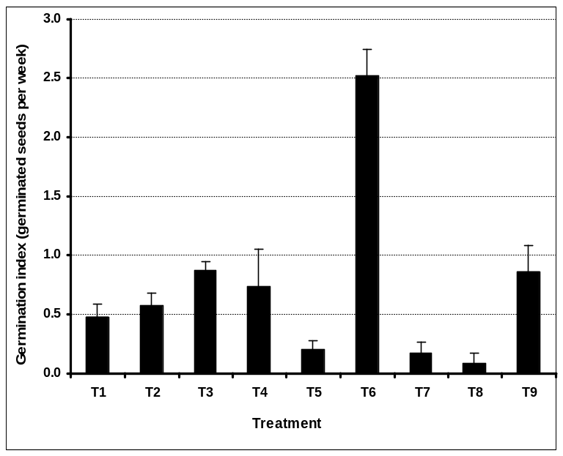
a

b
b
b
b
bc

cd
d
d

Figure 1

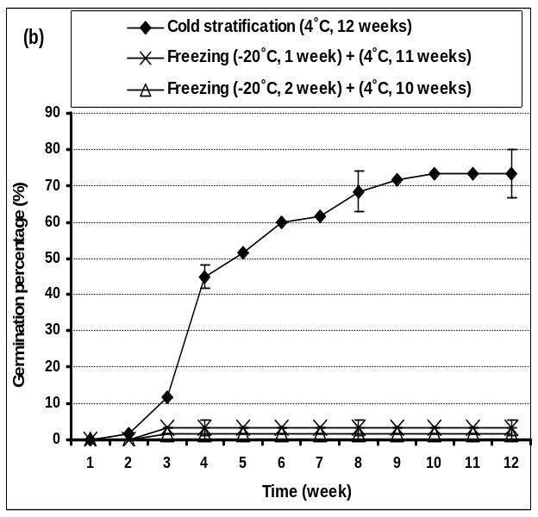
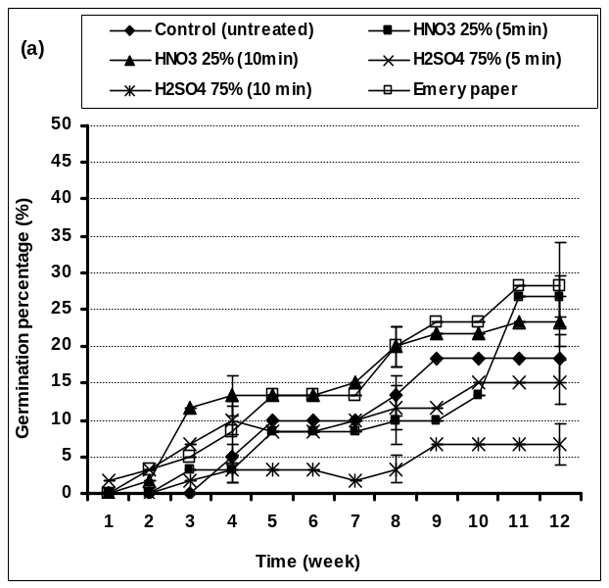

Figure 2

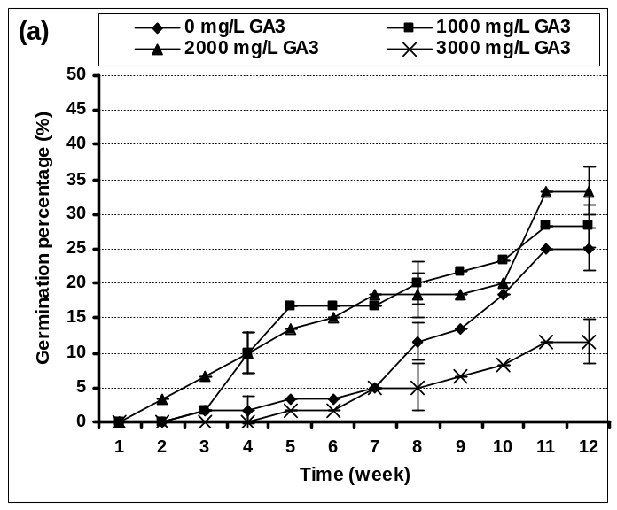
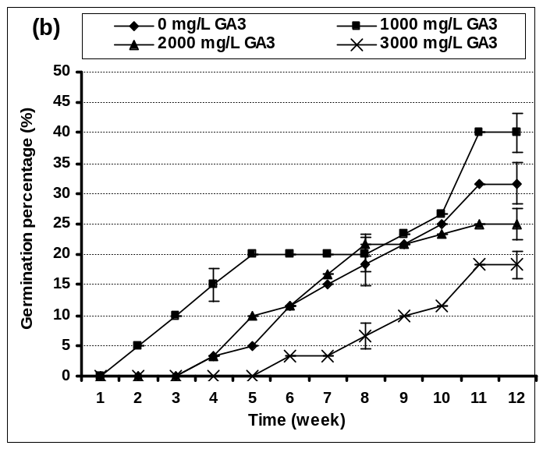

Figure 3

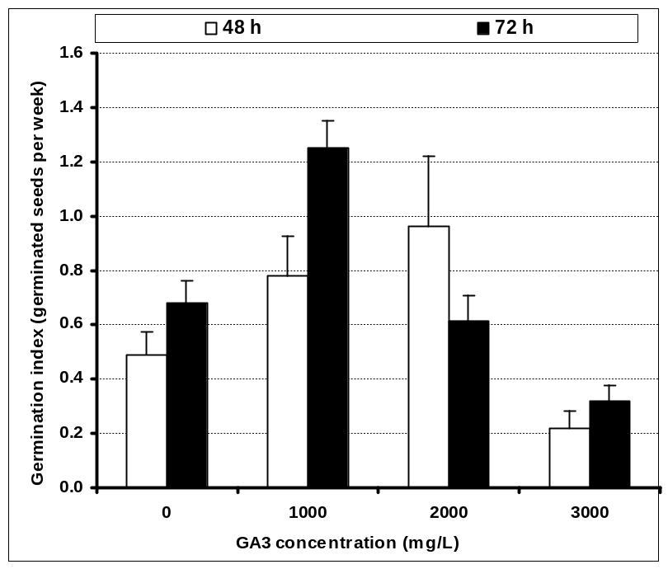

a
ab

abc
abc
bcd
bcd
cd

d

Figure 4

