CALLUS DEVELOPMENT IN TREE PEONIES (PAEONIA SECT. MOUTAN): INFLUENCE OF GENOTYPE, EXPLANT DEVELOPMENTAL STAGE AND POSITION, AND PLANT GROWTH REGULATORS
Lei Qin¹, Fangyun Cheng^{1*}, Yuan Zhong¹, Ping Gao¹, Haiping Yu¹
¹National Flower Engineering Research Center, Key Laboratory for the Genetics and Breeding of Forest Trees and Ornamental Plants, College of Landscape Architecture, Beijing Forestry University, Beijing 100083, China, *Fax: 086-010-62338027, *Email: chengfy8@263.net

Abstract Tree peonies (Paeonia sect. Moutan) are important ornamental plants, but their industrial exploitation is limited by the low yield of conventional propagation methods. Because rapid and efficient in vitro regeneration methods are critical for mass propagation, further studies on the induction of callus prior to regeneration are necessary. In the present study, callus formation and development were successfully achieved through the selection of genotypes, developmental stage and position of explants, and plant growth regulators (PGRs). Petiole layers collected during flowering as explants from seven different tree peony cultivars were cultured in SH media supplemented with 0-2 mg l⁻¹ 2,4-dichlorophenoxyacetic acid (2,4-D) and subcultured in the same basal media supplemented with 0.2-0.5 mg l⁻¹ 2,4-D and 2-6 mg l⁻¹ N⁶-benzyl adenine (BA). The best performing cultivar was ‘Golden era’, which produced a nodular structure within 90 days, while small calluses with low frequency were observed in ‘Luo Yang Hong’. Explants taken from the basal or top petioles between flowering and 1 week after blossom fall showed negligible browning. In contrast, considerable browning was observed in middle petiole explants or those collected later than 1 week after blossom fall. The optimum formulation for callus induction was SH media containing 1 mg l⁻¹ 2,4-D. Callus proliferated into nodule structures in SH media containing 0.2 mg l⁻¹ 2,4-D and 6 mg l⁻¹ BA for ‘Golden era’ and ‘Bartzella’ and 0.5 mg l⁻¹ 2,4-D and 2 mg l⁻¹ BA for ‘High noon’. Nodules were differentiated and maintained for more than 2 years in consecutive subcultures. The present induction conditions could be applied for the mass propagation of tree peonies, and the histological studies revealed the development of nodular structure.
Keywords Paeonia sect. Moutan , tree peonies, callus, organogenesis, nodule
Introduction
The tree peony belonging to the genus Paeonia of Paeoniaceae is a deciduous subshrub. Tree peonies are widely cultivated in temperate regions for their ornamental and medicinal value, and the global resource consists of 17 cultivar-groups (Cheng, 2007). However, the limited number produced by traditional propagation methods cannot meet the increasing demands of the market, especially for the mass production of a specific variety (Aoki and Inoue, 1992; James and Harris, 1996). Alternatively, the micropropagation of tree peony individuals is feasible through the cultivation of axillary buds (Buchheim and Meyer, 1992; Bouza et al., 1994; Beruto and Curir, 2007), although this method is limited by a low rate of in vitro proliferation (Beruto et al., 2004). Plant regeneration via indirect organogenesis and somatic embryogenesis is essential for plant multiplication in vitro (Edwin, 2008), and has been observed in a wide range of plant species including woody ornamental plants (McCown et al., 1988; Tian et al., 2008). However, the application of such techniques involves overcoming problems related to callus formation, the first step of indirect regeneration. In tree peonies, callus can be induced from various plant organs, such as the ovary, anther, petiole, leaf, stem and petal (Partanen, 1965; Sunderland et al., 1975; Gildow and Mitchell, 1977; Wang and Staden, 2001; Beruto et al., 2004). However, tree peony callus often shows poor growth and browning or vitrification, similar to other woody species, and the formation of compact callus with pro-meristematic centers is not easily achieved.
Genotype imposes one of the greatest constraints to in vitro plant regeneration, as realization of regeneration is dependent on the selection of the appropriate varieties (Kingdom et al., 2010). Developmental stage and the position of explants can also influence the capacity for callus formation, which may be related to the initial physiological and differentiation state of the explants (Gueye et al., 2009; Vered et al., 2011). Furthermore, the exogenous application of plant growth regulators (PGRs) to the media significantly affects callus induction and subsequent adventitious bud differentiation (Shen et al., 2008). Few histological studies of callus development in tree peonies have been published. A better understanding of this process may enable the development of applicable regeneration techniques for tree peonies via organogenesis or somatic embryogenesis.
In the present study, a vegetative organ, the petiole, was selected as the initial explant because it allows for the mass production of selected individuals with a reduced browning problem (Zhong, 2011). Callus induction can be easily achieved after the selection of genotypes, developmental stage and position of explants, and PGRs. The callus is then developed into nodules, which is an alternative morphogenic pathway for regeneration (McCown et al., 1988). Histological analysis was used to examine the development of nodules and determine their anatomical characteristics. The induction conditions were defined and can be used as a basis for further improvement of regeneration systems for the large-scale multiplication of tree peonies.
Materials and methods
Plant materials
Seven tree peony cultivars were investigated in the present study, three traditional cultivars from China (Paeonia suffruticosa ‘Luo Yang Hong’, ‘Wu Long Peng Sheng’ and P. ostii ‘Feng Dan’), one flare tree peony (P. rockii ‘Hong Lian’), two modern tree peonies (P.×lemoinei ‘High noon’ and ‘Golden era’) and one intersectional hybrid between herbaceous and tree peonies (P. Itoh ‘Barzella’). The cultivars were selected to represent the current genetic diversity in cultivated tree peonies grown in China.
Explant preparations and culture conditions
Petiole segments were cut from the upper part of the branches of field-grown plants during flowering (or other development stages, see “Experimental treatments” below). Surface dirt was brushed off and the segments were rinsed for 30 min under running water. After rough handling, the segments were soaked in 70% ethanol for 1 min, immersed in 10% commercial disinfectant with sodium hypochlorite for 15 min, and rinsed five times with sterile distilled water. Following sterilization, the petiole segments were cut into thin 1-2 mm layers. The layer explants were inoculated in SH media containing 30 g l⁻¹ sucrose and 8 g l⁻¹ agar supplemented with PGRs. Media were adjusted to a PH of 5.8 prior to autoclaving at 118℃ for 18 min. Petri dishes 90×15 mm were used as culture vessels and maintained at 25 ± 3℃ under dark conditions.
Callus induction
Experimental treatments: 2,4-D concentration. The layer explants of 7 cultivars were inoculated on SH media supplemented with various concentrations (0, 0.1, 0.5, 1 and 2 mg l⁻¹) of 2,4-D and 0 mg l⁻¹ as control. The frequency of callus formation was recorded after 45 days. The type of callus (compact, loose, vitrification or browning) was determined visually.
Experimental treatments: developmental stage and position of explants. Two trials were performed, and both experiments were conducted using the easy browning cultivar ‘Bartzella’ to obtain efficient callus formation with less browning. Five different developmental stages of layer explants were evaluated including leaflet extension, bell-like flower, flowering, 1-week after blossom fall and 1-month after blossom fall (sample collection times were described in Cheng, et al., 2001). In the second experiment, petioles collected during flowering were cut into thin layers, and the basal (B), middle (m) and top (t) segments were separated to determine the effect of explant position on callus formation. In both experiments, the media contained 1 mg l⁻¹ 2,4-D as determined in previous experiments. The frequency of callus formation and browning were evaluated after 45 days.
Callus proliferation
Calluses of ‘Wu Long Peng Sheng’, ‘Hong Lian’, ‘High noon’, ‘Golden era’ and ‘Bartzella’ were excised from layer explants, cut into approximately 5 mm³ pieces, and subcultured in SH medium supplemented with 0.2 or 0.5 mg l⁻¹ 2,4-D in combination with BA at concentrations of 2, 4 and 6 mg l⁻¹ for further growth. The explants were monitored for the location and frequency of nodule formation after 45 days.
Experimental design and data analysis
All experiments were carried out in a randomized design and replicated three times, each time containing 3 petri dishes. In each dish, 21 and 13 explants were inoculated for callus induction and callus proliferation, respectively. Mean differences were examined by Tukey’s (LSD) test with the ANOVA procedure using SPSS13.0.
Histological observations
Callus and nodule samples of ‘Golden era’ were fixed in FAA (40% formalin: glacial acetic acid: 50% ethanol = 5: 6: 89). The fixed samples were dehydrated in an ascending series of ethanol and xylene and embedded in paraffin wax. Serial sections (8-12 µm) were obtained using a rotary microtome (Reichert Histo Star 820) and stained with 1% safranin and 1% fast-green (Zheng, 1978). Relevant sections were identified and photographed using a Leica DFC 500 stereo-microscope.
Results
Callus induction
Callus formation rates differed in the layer explants from different cultivars (Table 1), with higher rates observed in ‘Hong Lian’ (89-93%) and ‘Golden era’ (83-94%) after 45 days of culture. Calluses derived from the peripheral zone of the petiole gradually covered the entire layer explant. The callus of ‘Hong Lian’ was loose in texture and showed signs of vitrification and slow growth (Fig. 1A), while ‘Golden era’ had a growth-promoting callus that was large in volume and compact in texture (Fig. 1B). ‘Bartzella’ callus was relatively compact but showed browning (Fig. 1C), which became worse with 2,4-D increasing. ‘Wu Long Peng Sheng’ and ‘High noon’ showed average callus formation rate, ‘Wu Long Peng Sheng’ with semi-vitrification callus (Fig. 1D) and ‘High noon’ with a relatively compact callus (Fig. 1E) that covered most of the cut surface. The recalcitrancy of ‘Feng Dan’ and ‘Luo Yang Hong’ confined callus formation to a few explants, and the callus was limited to the peripheral zones of explants (Fig. 1F and G).
Statistically significant differences in callus formation were observed in response to different 2,4-D concentrations (Table 1). The optimum 2,4-D concentrations were 0.5 mg l⁻¹ for ‘Wu Long Peng Sheng’, 1 mg l⁻¹ for ‘Luo Yang Hong’, ‘Feng Dan’, ‘Hong Liang’, ‘Golden era’, and ‘Bartzella’, and 2 mg l⁻¹ for ‘High noon’. In addition, control explants of ‘Hong Lian’, ‘High noon’, ‘Golden era’ and ‘Bartzella’ formed few calluses.
Callus development was limited by browning, especially in the cultivar ‘Bartzella’. A significant correlation was found between the developmental stage of the explants and their ability to produce callus (Table 2). Explants collected 1 month after blossom fall had the lowest callus formation rate due to a serious browning problem, while explants collected between the leaflet extension stage and 1 week after blossom fall showed a high callus formation rate (93.6-96.6%). Notably, explants obtained during the leaflet extension and bell-like flower stages showed relatively high rates of browning (8.5-14.1%). Explant position also influenced the callus induction rates (Table 3). Compared with B and T, the explants from C had the lowest callus formation rate and the callus was small in volume with a serious browning problem. In contrast, a high rate of formation and large calli were obtained from B and T explants.
Callus proliferation
The calli of ‘High noon’, ‘Golden era’ and ‘Bartzella’ were transferred to the proliferation media, where they developed into nodule clusters that were often found in contact with the culture medium. These nodule clusters were globular in form, yellowish in color and compact in texture (Fig. 3A). The highest nodule formation frequencies for ‘High noon’ (53.1%), ‘Golden era’ (71.1%) and ‘Bartzella’ (30.9%) were achieved in SH media containing 0.5 mg l⁻¹ 2,4-D and 2 mg l⁻¹ BA, 0.2 mg l⁻¹ 2,4-D and 6 mg l⁻¹ BA, 0.2 mg l⁻¹ 2,4-D and 6 mg l⁻¹ BA, respectively (Table 4). Nodule clusters were isolated and subcultured every 45 days to induce their multiplication. However, ‘Wu Long Peng Sheng’ and ‘Hong Lian’ calli were slow-growing and gradually died after transfer to proliferation media.
Histological study
Transverse sections of petiole explants at day 0 showed vascular bundles of different sizes arranged in a continuous ring (Fig. 2A). Five days after culture on SH medium with 2,4-D, cambium cells were characterized by a dense protoplasm, an increase in volume and a clear, centrally located nucleus (Fig. 2B). These activated cambial cells divided immediately, leading to the formation of incipient callus along the peripheral zones of explants after 10 d in culture. Certain parenchyma cells in the proximity of the cambium also produced callus, which grew together with the cambium callus (Fig. 2C). With increased time in culture, callus cells developed into active proliferating cells characterized by a dense cytoplasm, a clear nucleus in the center and a small cell size (Fig. 2D). Several neoformed tracheary elements differentiated from callus cells 15 days after the transfer of callus to proliferation media (Fig. 3B). Some of the tracheids organized as vascular centers were surrounded by layers of loosely arranged and plastid-dense cells, and this cortical-like area was surrounded by dense, elongated cells (Fig. 3C), with cell division taking place around the vascularized centers. This way, nodule structures were formed inside the callus. Another way nodules could form was when the central area of specialized parenchyma cells was surrounded by linear arrays of rapidly dividing cells (Fig. 3D). As a result, nodule structures arising from the callus tissue formed a cohesive unit capable of undifferentiated cell division (Fig. 3E).
Discussion
The present study examined different parameters that affect callus development in tree peonies using petiole layers as initial explants. Genotype selection, explant developmental stage and position, and PGR concentrations were optimized to induce the formation of a nodular callus with a pro-meristematic center.
Genotype plays a significant role in the in vitro behavior of explants in tree peonies. Callus forming ability, callus morphology and the subsequent callus development differed significantly among the 7 tree peony cultivars examined. Similar callus behaviors were reported for the in vitro regeneration of Dieffenbachia (Shen et al., 2008). Good performance in certain cultivars was correlated with the ability to heal from the wounding caused by excising (Kingdom et al., 2010). Our results supported the notion that callus texture may be an indicator of organogenic potential (Shen et al., 2008). In prior work, a compact callus made up of tightly packed cells was taken as evidence of the onset of organization (Grant and Fuller, 1968). This might partially explain why only the cultivars ‘Golden era’, ‘Bartzella’ and ‘High noon’ could produce nodular callus with pro-meristematic centers. Therefore, for the in vitro regeneration of tree peonies it is necessary to consider several cultivars with commercial value.
In tree peonies, in vitro browning is a very general phenomenon that has been reported in all types of explants. Browning is generally considered to be due to oxidation of phenolic compounds, which inhibits the growth of explants or even causes their death. Browning problem was substantially reduced for explants from a mother plant under shading treatment (Gildow and Mitchell, 1977) and associated with the addition of active carbon (AC) or polyvinylpyrrolidone (PVP) to the medium (Wang and Staden, 2001; Lang and Luo, 2007). To prevent browning and promote the growth and multiplication of microshoots in organ culture, our laboratory uses media with AC for the first four days of micro-shoot subculture followed by transfer to media without AC (Li et al., 2008). The present results also indicated that selection of the appropriate explant position and favorable developmental stage can diminish the browning problem without antibrowning agents. With regard to the developmental stage, layer explants collected at the beginning of the growing season showed a higher browning rate, and serious browning was observed in explants taken 1 month after blossom fall, which inhibited callus formation (Table 2) and could be attributed to changes in phenolic compounds during development stage. Furthermore, the position of the explant in the source plant had a significant effect on callus formation and browning. Prior studies have suggested that basal explants could produce a higher percentage of calluses because of the basipetal movement of endogenous auxin (Gueye et al., 2009; Vered et al., 2011). In the present study, both basal and top petiole sections performed better than middle sections. This could be due to differences in the number of vascular bundles, which play a major role in organogenesis (Pieron et al., 1998). The explants from the basal and top petiole sections were directly connected to the stem and leaflets in an area rich in vascular bundles, while the middle section, which does not have any organ connections, has few vascular bundles and therefore generated smaller calli with browning (data not shown).
In addition to these endogenous factors, PGRs are important for the induction and development of callus. In tree peonies, 2,4-D has been shown to be the most effective growth regulator for callus induction (Wang and Staden, 2001; Zhong, 2011). Our results with 7 cultivars suggested that 1 mg l⁻¹ 2,4-D was an effective concentration. In the cultivars ‘Golden era’ and ‘Bartzella’, the highest callus formation rates were 97.10% and 99.55%, respectively. However, higher concentrations of 2,4-D (2mg l⁻¹) inhibited callus growth, leading to serious browning in ‘Bartzella’. Low levels of 2,4-D combined with high levels of BA favored nodular callus formation. Our results indicate that media formulation should be optimized for each cultivar to achieve in vitro regeneration of tree peonies.
Cell division of cambial cells and the neighboring parenchyma cells resulted in callus formation (Ana et al., 2000; Vered et al., 2011). The similar observation was also noted in tree peonies. Callus transfer to proliferation media triggered the differentiation of tracheary elements, some of which acted as center, or some specialized cells could also organize as centers that were surrounded by a cortical-like area of highly plastid-dense cells. This way, nodule structure formed. Actually, the specialized-cell center structure is reported to be the first stage of nodule formation (McCown et al., 1988). The formation of a similar nodule structure was observed in Populus (McCown et al., 1988) and Humulus (Ana et al., 2000). McCown defined nodules as clusters of cells acting together as a meristematic center (McCown et al., 1988) that are able to undergo undifferentiated cell division and therefore of maintaining genetic stability. Successful nodule cultures with high regeneration potential were reported for Populus (McCown et al., 1988), Citrus (Chatwvedi and Mitra, 1975), Ananas (Teng, 1997) and a number of other woody species considered recalcitrant, suggesting that nodular callus induction could be a promising approach for the mass production of tree peonies. The nodular structures were maintained for more than 2 years in consecutive subculture in our laboratory and showed potential applications for the in vitro production of secondary metabolites such as paeonol and paeoniflorin (Zhong, 2011). Thidiazuron (TDZ) has been shown to be an important factor in shoot organogenesis in Populus (McCown et al., 1988) and its effect on nodule differentiation is currently being investigated by our group.

Acknowledgements
This study was supported by a grant from the National High Technology Research and Development Program of China (863 Program) [2011AA100207]. We thank J. Paul Stevens (University of Saskatchewan, Saskatoon, Canada) for his help in editing this paper.
REFERENCE
Ana M. Fortes and Maria S. Pais. (2000). Organogenesis from internode-derived nodules of Humulus Lupulus var. Nugget (Cannabinaceae): histological studies and changes in the starch content. American journal of botany, 87(7): 971-979.
Aoki N., Inoue I. (1992). Studies on production of nursery stock in tree peony, 1: Effects of bud position of scion, binding material, time, cultivar and temperature after grafting on graft-take of grafted tree peony. Bulletin of the Faculty of Agriculture Shimane University (Japan), 26: 83-89.
Beruto M., Lanteri L., Portogallo C. (2004). Micropropagation of tree peony (Paeonia suffruticosa). Plant Cell, Tissue and Organ Culture, 79: 249-255.
Beruto M., Curir P. (2007). In Vitro culture of tree peony through axillary budding. In: Jain S. Mand Haggman H. (Eds.) Protocols for Micropropagation of Woody Trees and Fruits, Springer publishers: 477-497.
Bouza L., Jacque M., Sotta B., Miginiac E. (1994). Relations between auxin and cytokinin contents and in vitro rooting of tree peony (Paeonia suffruticosa Andr.). Plant Growth Regulation, 15: 69-73.
Buchheim J. A. T., Meyer Jr. M. M. (1992). Micropropagation of Peony (Paeonia spp.). In: Y. P. S. Bajaj (Eds.) High-Tech and Micropropagation Ⅳ, Biotechnology in agriculture and forestry, Vol. 20, 269-284.
Chatwvedi H. C, Mitra G. C. (1975). A shift in morphogenetic pattern in Citrus callus tissue during prolonged culture. Ann Bot., 39: 683-687.
Cheng F. Y., Aoki N. and Liu Z. A. (2001). Development of forced tree peony and comparative study of pre-chilling effect on Chinese and Japanese cultivars. J. Japan Soc. Hort. Sci. 70: 46-53.
Cheng F. Y. (2007). Advances in the breeding of tree peonies and a cultivar system for the cultivar group. International Journal of Plant Breeding, 1: 89-104.
Edwin F.George (2008). Plant tissue culture procedure – background. In: Edwin F. George, Michael A. Hall, Geert-Jan De Klerk (Eds.) Plant propagation by tissue culture 3rd edition. Chapter 1, Springer publishers: 1-2.
Gildow F. E., Mitchell J. P. (1977). Initiation, growth and nuclear characteristics of tissue cultures of Paeonia suffruticosa. Physiologia Plantarum, 39: 295-298.
Grant, M. E. and Fuller K. W. (1968). Tissue culture of root cells of Vicia faba. J. exp. Bot., 19:667-680.
Gueye B, Morcillo F., Collin M., Gargani D., Overvoorde P., Aberlenc Bertossi F., Tranbarger T. J. Sane D., Tregear J. W., Borgel A., Verdeil J. L. (2009). Acquisition of callogenic capacity in date palm leaf tissues in response to 2,4-D treatment. Plant Cell Tissue Org. Cult., 99: 35-45.
James A. C., Harris R. A., Mantell S. H. (1996). Paeonia species (tree peonies). In: Bajaj Y. P. S. (Eds.) Biotechnology in Agriculture and forestry, Trees IV. vol. 35, Thomson Press, 244-270.
Kingdom Kwapata, Robab Sabzikar, Mariam B. Sticklen, James D. Kelly. (2010). In vitro regeneration and morphogenesis studies in common bean. Plant Cell Tiss. Organ Cult. 100: 97-105.
Lang Y. T., Luo X. F. (2007). The research on callus inducing and browning prevention of peony. Journal of Henan Forestry Science and Technology, 27: 4-6.
McCown B. H., Zeldin Eric. L., Pinkalla Hamilton. A., Dedolph Richard R. (1988). Nodule culture: a developmental pathway with high potential for regeneration automated micropropagation and plant metabolite production from woody plants. In: Hanover James W., Keathley Daniel E. (Eds.) Genetic Manipulation of Woody Plants, New York & London: Plenum Press, 149-166.
Partanen C. R. (1965). Cytological behaviour of plant tissues in vitro as a reflection of potentialities in vivo. In: White P. R., Grove A. R. (Eds.) Proceedings of an International Conference on Plant Tissue Culture. McCutchan Publishing Corporation, 1-9.
Pieron S., Boxus P. Dekegel D. (1998). Histological study of nodule morphogenesis from Cichorium intybus L. leaves cultivated in vitro. In Vitro Cell. Dev. Biol.-Plant, 34: 87-93.
Shen Xiuli, Michael E. Kane, Chen Jianjun. (2008). Effect of genotype, explant source, and plant growth regulators on indirect shoot organogenesis in Dieffenbachia cultivars. In Vitro Cell. Dev. Bio.-Plant, 44:282-288.
Sunderland N., Dunwell J. M., Robert M. (1975). Anther culture in the genus Paeonia. John Innes. Annu. Rep., 66: 57-60.
Teng W. L. (1997). An alternative propagation method of Ananas through nodule culture. Plant cell reports, 16:454-457.
Tian C. W., Chen Y., Zhao X. L., Zhao L. J. (2008). Plant regeneration through protocorm-like bodies induced from rhizoids using leaf explants of Rosa spp. Plant Cell Rep., 27: 823-831.
Vered Naor, Meira Ziv, Tirtza Zahavi. (2011). The effect of the orientation of stem segements of grapevine (Vitis vinfera) cv. Chardonnay on callus development in vitro. Plant Cell Tiss. Orgam Cult. 106:353-358.
Wang H., Staden Van J. (2001). Establishment of in vitro cultures of tree peonies. South African Journal of Botany, 67: 358-361.
Zheng Guo Cang. (1978). Technique of biological microscopy. People's Education Press, Beijing, 96-97, 147-148.
Zhong Yuan. (2011). Induction and culture of meristematic nodules in Paeonia rockii [PhD thesis]. Beijing: Beijing forestry university.

Table 1 Effect of 2,4-D concentration on induction of callus from the petiole of 7 tree peony genotypes
2,4-D | Callus formation (%)
(mg l⁻¹) | Luo Yang Hong | Wu Long Peng Sheng | Feng Dan | Hong Lian | High noon | Golden era | Bart-  zella
0 | 0c | 0c | 0d | 2.4b | 2.4d | 16.7c | 14.3c
0.1 | 24.6b | 76.3ab | 25.0c | 92.9a | 18.7c | 83.3b | 70.7b
0.5 | 41.1a | 80.6a | 48.0b | 90.1a | 58.3b | 87.7ab | 75.0b
1 | 48.4a | 73.1ab | 64.3a | 93.3a | 60.4b | 94.4a | 88.5a
2 | 37.7ab | 68.7b | 37.3bc | 88.9a | 95.6a | 88.9ab | 86.9a
Callus formation is expressed as the percentage of the explants producing callus. Data followed by different letters within the same column indicate a statistically significant difference at P≤0.05 according to the Tukey test.

Table 2 Effect of developmental stages on callus formation from the petiole of ‘Bartzella’
Explant developmental phase | Callus formation (%) | Browning (%)
leaflet extension | 98.7ab | 14.1b
bell-like flower | 99.6a | 8.5b
flowering | 93.6c | 2.5c
1 week after blossom fall | 95.4bc | 1.17c
1 month after blossom fall | 60.0d | 43.3a
Sample collection times are according to Cheng et al. (2001). Callus formation is expressed as the percentage of the explants producing callus. Browning is expressed as the percentage of the number of browning explants to the number of total explants. Data followed by different letters within the same column indicate statistically significant differences at P≤0.05 according to the Tukey test.

Table 3 Effect of explant position on callus formation from the petiole of Paeonia Itoh ‘Bartzella’
Explant position | Callus formation (%) | Browning (%)
Top petiole | 96.2a | 2.81 b
Middle petiole | 88.1b | 20.4 a
Basal petiole | 97.1a | 3.2 b
Callus formation is expressed as the percentage of explants producing callus. Browning is expressed as the percentage of the number of browning explants to the number of total explants. Data followed by different letters within the same column indicate statistically significant differences at P≤0.05 according to the Tukey test.

Table 4 Effect of different concentrations and combinations of PGRs on nodule formation of
five tree peonies genotypes
2,4-D | BA | Nodule formation (%)
(mg l⁻¹) | (mg l⁻¹) | Wu Long Peng Sheng | Hong Lian | High noon | Golden era | Bartzella
0.2 | 2 | 0 | 0 | 0.8b | 42.2b | 12.9bc
0.2 | 4 | 0 | 0 | 3.0b | 57.9ab | 13.0bc
0.2 | 6 | 0 | 0 | 7.7b | 71.7a | 30.9a
0.5 | 2 | 0 | 0 | 53.1a | 57.8ab | 7.4c
0.5 | 4 | 0 | 0 | 5.9b | 66.7a | 11.9bc
0.5 | 6 | 0 | 0 | 20.5ab | 68.9a | 14.3b
Nodule formation is expressed as the percentage of explants producing nodules. Data followed by different letters within the same column indicate statistically significant differences at P≤0.05 according to the Tukey test.

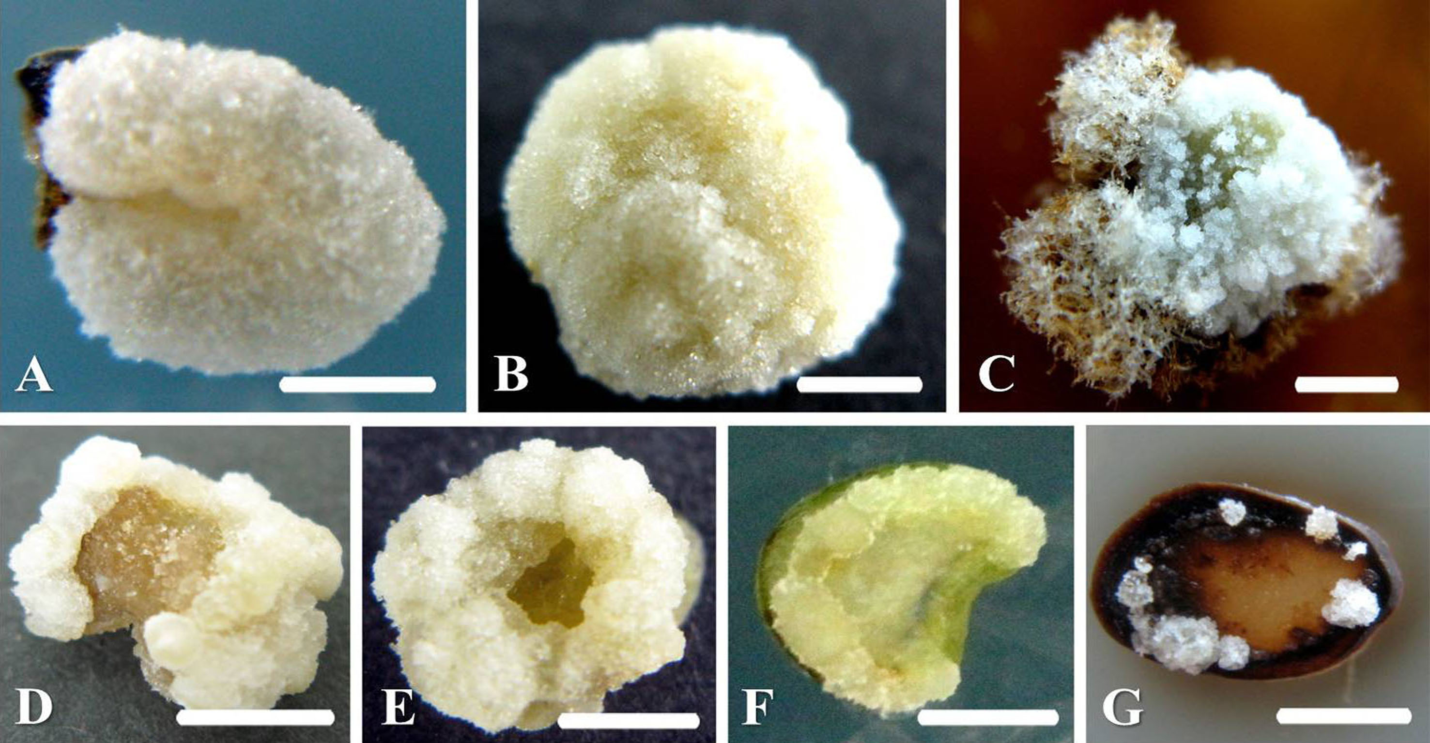
Fig.1 Characterization of callus induced on SH media supplemented with 1mg l⁻¹ 2,4-D after 45 days of culture in the dark for 7 tree peony cultivars. (A) Vitrification callus of P. suffruticosa ‘Hong Lian’. (B) Compact callus of P. ×lemoinei ‘Golden era’. (C) Browning callus of P. Itoh ‘Bartzella’. (D) Semi-vitrification callus of P. suffruticosa ‘Wu Long Peng Sheng’. (E) Relatively compact callus of P. ×lemoinei ‘High noon’. (F) A little callus of P. ostii ‘Feng Dan’. (G) A little callus of P. suffruticosa ‘Luo Yang Hong’. Bar=5mm

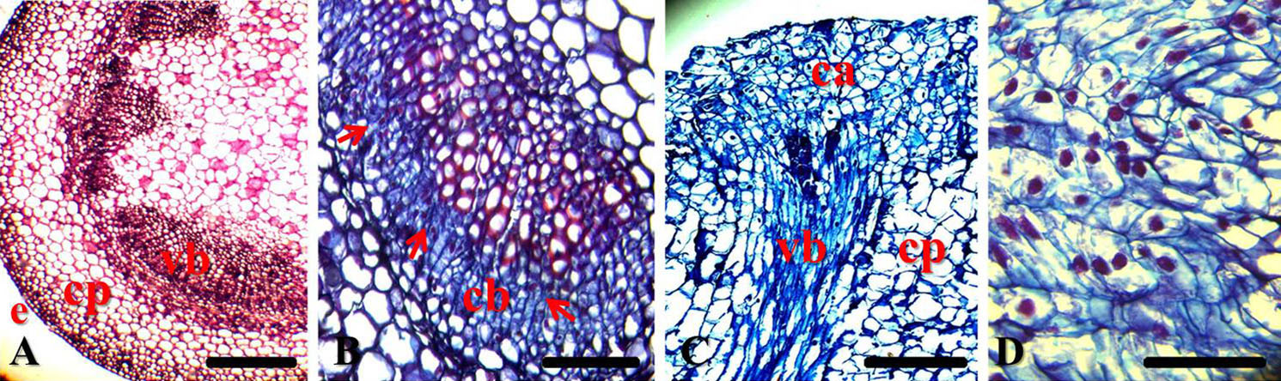
Fig.2 Callus induction of P.×lemoinei ‘Golden era’: the layer explants of basal petioles were cultured on SH medium with 1mg l⁻¹ 2,4-D. Sections were stained with 1% safranin and 1% fast-green. (A) Section of layer explants at the time of excision from the parent plant. (B) Section of layer explants performed after 5 d in culture medium. Cambial cells show a dense protoplasm, increased volume, and a clear and central nucleus, as indicated by the arrows. (C) Longitudinal section of an explant cultured for 15 d. Cortex parenchyma cells also produced callus, which grew together with the cambium callus. (D) Section obtained from callus tissue formed from a layer explant cultured for 45 d. Callus cells are characterized by dense cytoplasm, a clear nucleus in the center and small cell size. Bar in Fig.1 A and C = 50 µm; B and D = 10 µm. Figure abbreviations: e, epidermis; cp, cortex parenchyma; vb, vascular bundle; cb, cambium; ca, callus.
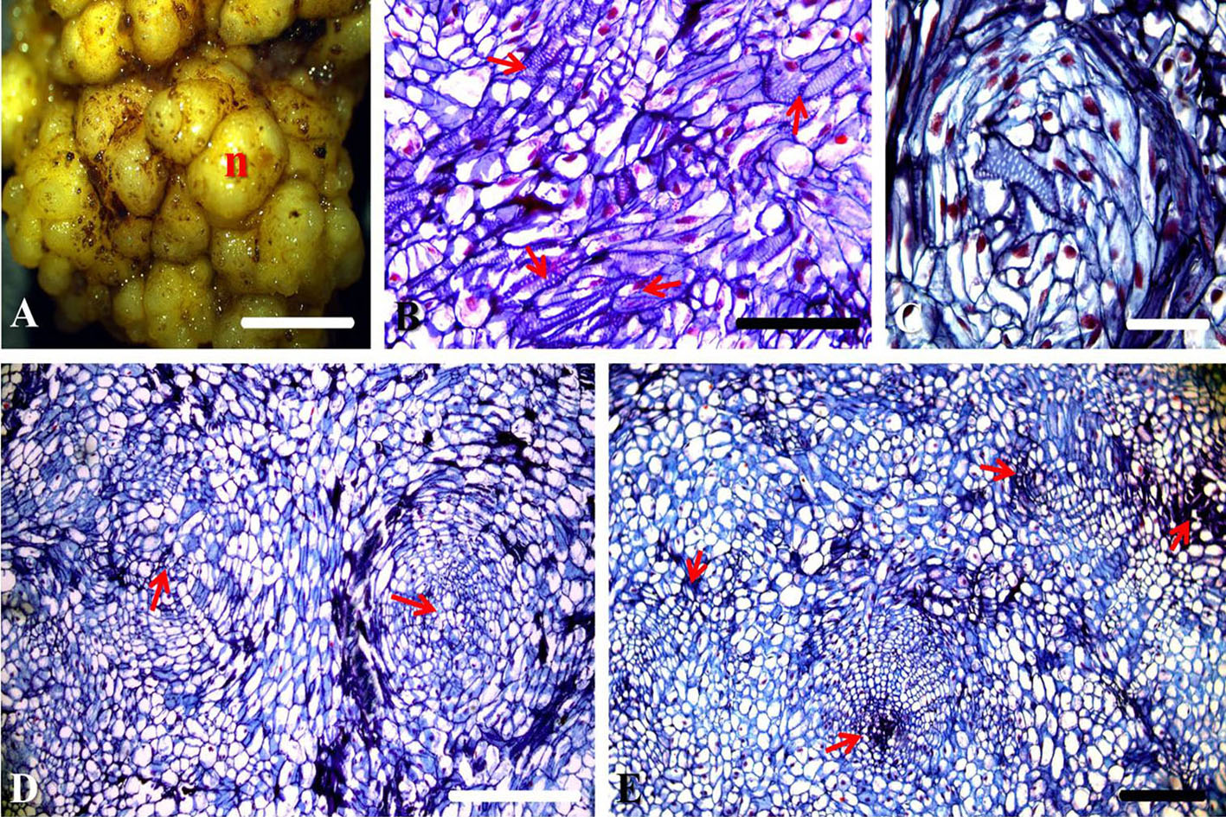
Fig.3 Nodule development of P.×lemoinei ‘Golden era’: nodular structures were achieved after transfer of the compact callus to SH medium supplemented with 0.2 mg l⁻¹ 2,4-D and 6 mg l⁻¹ BA in the dark. Figures B, C, D and E were stained with 1% safranin and 1% fast-green. (A) Nodule formed after 90 d of culture. The external features of the nodule are globular in form, yellowish in color and compact in texture. (B) Some callus cells differentiated into tracheary elements after 15 d of subculture, as shown by the arrows. (C) The nodule structure shows a central vascular area surrounded by plastid-dense cell layers and a cortical-like area surrounded by dense, elongated cells after 30 d of subculture. (D) Some specialized parenchyma cells also acted as centers surrounded by linear arrays of rapidly dividing cells after 30 d of subculture, as shown by the arrows. (E) Nodule structures formed cohesive units able to undergo undifferentiated cell division after 45 d of subculture; nodule centers are shown by the arrows. Bar in Fig.3 A = 5mm; B, D and E = 50 µm; C = 25µm. Figure abbreviations: N, nodule.

