Nitrogen use efficiency of Atractylodes lancea plantlets in vitro under different inorganic nitrogen levels
Yanyou Wu^{1, 2,}*, Kuan Zhao¹, Ying Chen¹, Jing Pang¹, Hongcheng Xu¹, Shan Lu¹
¹ Key Laboratory of Modern Agricultural Equipment and Technology, Ministry of Education , Institute of Agricultural Engineering, Jiangsu University, Zhenjiang, 212013, China
² State Key Laboratory of Environmental Geochemistry, Institute of Geochemistry, Chinese Academy of Sciences, Guiyang, 550002, China

Corresponding author: Dr. Yanyou Wu
Mailing Address: Key Laboratory of Modern Agricultural Equipment and Technology，Ministry of Education，Institute of Agricultural Engineering, Jiangsu University, Zhenjiang, Jiangsu 210213, P. R. China
Telephones: +86-511-88790558 (office)
Fax: ++86-511-88797338
E-mail: yanyouwu@ujs.edu.cn, yanyouwu@hotmail.com

Nitrogen use efficiency of Atractylodes lancea plantlets
Abstract:
To date, Atractylodes lancea had used for the collocation of compositae parterre to increase diversity of ornamental landscape. Tissue culture was most important means for the reproduction of Atractylodes lancea. Nitrogen in the medium was one of the most important factors, which cultured Atractylodes lancea plantlets in vitro. In order to determine the nitrogen use efficiency of Atractylodes lancea plantlets in vitro under different nitrogen levels, near infrared spectroscopy technique and image analysis technique with multi-references were used to obtain the successive information of nitrogen consumption. The Logistic and nonlinear hyperbolic equations were used for fitting the relationship of biomass of plantlet in vitro versus culture time, nitrogen utilization of plantlets versus culture time, and nitrogen utilization of plantlets versus biomass of plantlet in vitro. The models of growth prediction, nitrogen utilization and nitrogen use efficiency of plantlets in vitro were established. The nitrogen use efficiency of Atractylodes lancea plantlets in vitro sub-cultured in different combination of nitrogen source were measured, which decreased with the increase of culture time. Atractylodes lancea plantlets preferred nitrate. The combination of 0.555 g L⁻¹ nitrate with 0.091 g L⁻¹ ammonium was optimal for the propagation of Atractylodes lancea.
Keywords: Atractylodes lancea, image analysis, near infrared spectroscopy, nitrogen source, nitrogen use efficiency, plantlet in vitro

1. INTRODUCTION
Atractylodes lancea is a kind of medicinal plants; it was also used for the collocation of compositae parterre to increase diversity of ornamental landscape, to date. Atractylodes lancea seedlings can not stand the hot weather of summer; the survival rate of seedlings is very low, whereas the tuber propagation may bring out the degradation. Tissue culture was most important means for the reproduction of Atractylodes lancea (Hiraoka and Tomita 1990). However, the propagation efficiency of Atractylodes lancea via tissue culture was not ideal (Zhao et al. 2007). Therefore, the common medium, which cultured Atractylodes lancea plantlets in vitro, should be adjusted (Zhao et al. 2007).
Nitrogen is an essential nutrient element for plant growth, which is one of the major limiting factors, influenced plant growth in soils (Huang et al. 2010, Chio et al. 2001, Zhang et al. 2005). The inorganic nitrogen including ammonium and nitrate were the main forms utilized by plants. The ratio of ammonium and nitrate utilized by plants varied species. Some plants favor the use of nitrate, while some plants prefer the use of ammonium (Aerts and Chapin 1999, Cui and Song 2005, Liu et al. 2011).
Traditional methods of determining nitrogen in the medium, including Kjeldahl, dual-wavelength method and others, can pollute the medium, and not determine dynamically the nitrogen in the medium. Therefore, near-infrared spectroscopy (NIRS) was used to determine nitrogen in tissue culture medium. Near-infrared spectroscopy is an efficient modern analytical technique, which characteristics are rapid, nondestructive and sterile, called for the green analysis technology (Nicolai et al. 2007, Shiroma and Rodriguez-Saona 2009, Bobelyn et al. 2010).
With the recent development of new analytical procedures based on image analysis for nondestructive and non-contact measurement in biology and agriculture, it is used to estimate the growth of sterilized plantlets in vitro (Arvis et al. 2004, Ibaraki and Kenji 2001, Supalkova et al. 2007).
The paper determined nitrogen content of tissue culture medium by near-infrared spectroscopy, acquired biomass of plantlets in vitro by imaging processing technology. The influence of inorganic nitrogen on nitrogen use efficiency (NUE) in Atractylodes lancea plantlets in vitro was discussed. An optimal combination for the growth of Atractylodes lancea plantlets in vitro will be obtained.
2. MATERIALS AND METHODS
2.1 Materials and culture conditions
Three or four generations of sub-cultured plantlets from Atractylodes lancea were obtained from our laboratory. They were cultured in MS basal mediums supplemented with sucrose (3% W/V), agar (0.8 %), and additions of 2 mg∙L⁻¹ 6-benzyl aminopurine (6-BA) and 0.1 mg∙L⁻¹ naphthalene acetic (NAA). The culture was carried out in a chamber with a photoperiod of 16 h of light with intensity of about 100 μmol m⁻²s⁻¹ and 8 h of dark. The culture temperature was 25±2°C.
After 10 days, Atractylodes lancea plantlets were transferred in MS medium of different nitrogen source and level treatments. Ammonium nitrogen source was modified by NH₄Cl, nitrate nitrogen source modified by KNO₃. The treatments were shown in Table 1.
2.2 Measurement quotas and Methods
2.2.1 The model on biomass of Atractylodes lancea plantlets in vitro
The biomass of Atractylodes lancea plantlets in vitro was obtained by the image analysis technique with multi-references (Wu et al. 2009a). A CCD (charge coupled device) color camera (Model DSC-P43) with resolution of 2304 pixels×1728 pixels was used to record the images of A. lancea plantlets. To obtain constant lighting, a set of fluorescent lamps with 8×30 W fluorescent lamps source with a rated voltage of 220 V was used for acquiring the images. The background was a white board. A number of image processing steps were taken using the software of Adobe Photoshop (Photoshop CS2, Adobe Systems Incorporated, USA). Firstly, JPEG image was converted into grayscale image. Afterwards, brightness and contrast were adjusted, color reversed. Finally, the pixels of plantlets were counted.
Three images of each flask of the plantlets were acquired from each angle of 120˚. Conventional methods are used for obtaining the biomass of plantlets. The pixels of plantlets separately cultured in seven flasks including six references and one sample of unknown biomass were counted. The linear model of pixel vs. biomass was constructed according to six pairs of data. The model was used for the estimating biomass of the sample. Successive biomass information of the plantlets grown in the same bottle at various time were obtained, the curve of biomass vs. time was plotted. Finally, the dynamic growth of plantlets in vitro was estimated.
Four-parameters Logistic equation are used for fitting the model between the biomass of plantlets (M) and culture days (t), and then the instantaneous biomass of plantlets were calculated by the equation (1) (Wu et al. 2009b).
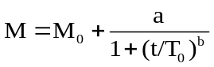 (1)
Where M₀ denotes the biomass of the original logarithmic growth stage, “a” denotes the upper limit of biomass changed with the days, T₀ defines the days reached to 50% the increment in the logarithmic growth stage. “b” denotes the fitting parameter.
2.2.2 The model on nitrogen use efficiency of Atractylodes lancea plantlets in vitro
The content of nitrogen in the medium sub-cultured plantlets was obtained by near-infrared spectroscopy method (Wu et al. 2011). Eighty standard samples containing 40 mL culture medium at various nitrogen concentrations were prepared. Those samples were placed in the refrigerator (0-4°C) to maintain the stability of status and performance. During the estimating the content of nitrogen in the culture medium sub-cultured the plantlets in vitro, eighty standard samples were divided into two types, 60 calibration samples and 20 prediction samples. The diffuse reflectance spectra of 80 standard samples and test samples with plantlets were collected using a portable spectrometer every certain time interval. The partial least squares method together with artificial neural networks (PLS + ANN), combined with differential, additional genetic algorithms optimization characteristic wavelengths were applied to establish a functional relationship, namely, a model between spectral information and the content of nitrogen in the medium by chemical metrology. When the models meet the prediction accuracy requirement, they were used to predict the content of nitrogen in test samples. The models were re-established with the same set of calibration and prediction samples every time.
The amount of nitrogen utilization by plantlets (ANU) was expressed into the difference of the absolute nitrogen amount in the medium between the after and previous culture periods at certain time interval.
Similarly, four-parameter Logistic equation is used for fitting the model between ANU and culture days (t) (Equation (2)).
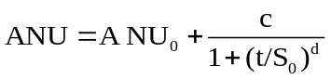 (2)
Where ANU₀ denotes the ANU during the original logarithmic growth stage, “c” denotes the upper limit of amount of nitrogen utilization changed with the days, S₀ defines the days reached to 50% the increment in the logarithmic growth stage. “d” denotes the fitting parameter.
Nonlinear hyperbolic equations were used for fitting the model between ANU and biomass of plantlets (M) (Equation (3).
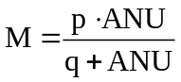 (3)
In the equation (3), “p” and “q” were fitting parameters.
First derivation of the equation (3) was calculated. The outcome (M′) was nitrogen use efficiency of plantlets in vitro (NUE) (Equation (4).
NUE=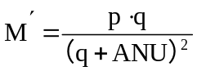 (4)
The equation (2) was brought into above equation (4), and then equation (5) was obtained which can calculate the instantaneous nitrogen use efficiency.
NUE=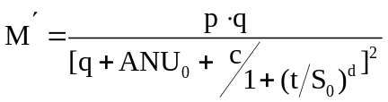 (5)
3. RESULT AND DISCUSSION
Table 2 showed the variation of biomass and ANU with sub-cultured days. From Table 2, we found that the biomass and ANU increased with the sub-cultured times. The ANU of A. lancea plantlets sub-cultured in the medium treated by high levels of nitrogen sources was significantly greater than those treated by low levels of nitrogen sources, regardless ammonium or nitrate treatments. It showed that the nitrogen sources had dose-effect on the nitrogen utilization of A. lancea plantlets, while the biomass of A. lancea plantlets sub-cultured in the medium was independent of nitrogen levels.
The models of nitrogen use efficiency of A. lancea plantlets were established (Table 3). The results showed that four-parameter Logistic equation can be fitting well the models between the biomass of plantlets and culture time (R²>0.99). The models between ANU and culture time can be well fitting by four-parameter Logistic equation (R²>0.99) for treatments 1,2,3,5,6 and 7, the plantlets of treatments 4 and 8 were in the logarithmic growth period, the linear equation can be used for fitting the models between ANU and culture time (Table 3). Nonlinear hyperbolic equations can be well fitting the model between ANU and biomass of plantlets (M) (Table 3).
The nitrogen use efficiency (NUE) at any one time after derivation of this equation (M=M(ANU)) was calculated (Table 4). From Table 4, we found that NUE decreased with the increase of culture time except for treatments 1 and 4. The NUE of A. lancea plantlets sub-cultured in the medium treated by low levels of nitrate nitrogen was also significant higher than these treated by higher levels, this phenomenon is the response of plant adaptability to low nutrient environment. Similarly, the NUE of A. lancea in ammonium nitrogen levels followed that treatment 5>6>7 >8, which revealed that low levels of ammonium nitrogen significantly increased the NUE of A. lancea plantlets. The treatment 5 had a highest NUE among all treatments, while nitrogen content in the medium of treatment 5 was only 0.651 g ∙L⁻¹. It suggested that the treatment 5 was the optimal combination for the growth of A. lancea plantlets in vitro and A. lancea plantlets in vitro preferred nitrate.
Acknowledgments: The authors gratefully acknowledge the financial support of A Project Funded by the Priority Academic Program Development of Jiangsu Higher Education Institutions, as well as the valuable comments and suggestions of the anonymous reviewers.
REFERENCES
Aerts R., Chapin III F. S. (1999). The mineral nutrition of wild plant revisited: a reevaluation of processes and patterns. Advances in Ecological Research, 30: 1- 67.
Arvis V., Michalet-Doreau B., Debain C. (2004). A new methodology to appraise the physical characteristics of maize silage by image processing: effect of the ensiling process. Journal of the Science of Food and Agriculture, 84: 1848-1854.
Bobelyn E., Serban A. S., Nicu M., Lammertyna J., Nicolai B. M., Saeys W. (2010). Postharvest quality of apple predicted by NIR-spectroscopy: study of the effect of biological variability on spectra and model performance. Postharvest Biology and Technology, 55(3): 133-143.
Chio J. M., Shin C. Y., Chung H. J. (2001). Effect of liming fertilization on changes of nutrient concentration in rice-hull based media, crop growth and uptake of chrysanthemum. Journal of the Korean Society for Horticultural Science, 42(5): 553- 556.
Cui X. Y., Song J. F. (2005). Soil NH₄⁺ /NO₃⁻ nitrogen characteristics in primary forests and the adaptability of some coniferous species. Acta Ecologica Sinica, 25(11): 3082- 3092.
Hiraoka N., Tomita Y. (1990). Botanical and chemical evaluation of Atractylodes lancea plants propagated in vitro and by division of the rhizome. Plant Cell Reports, 9: 332-334.
Huang C. B., Fang W. M., Yang Y., Cheng F., Xu Y. (2010). Effects of different nitrogen levels and forms on the appearance quality and photosynthesis characters of potted chrysanthemum with small inflorescences. Acta Agriculturae Zhejiangensis, 22(1): 45-50.
Ibaraki Y., Kenji K. (2001). Application of image analysis to plant cell suspension cultures. Computers and Electronics in Agriculture, 30: 193-203.
Liu C. N., Cui X. Y., Guo Y. F., Zheng H. (2011). Effects of different ratios of NH₄⁺-N /NO₃⁻-N on growth of Larix gmelinii seedings. Journal of Northeast Forestry University, 39(1): 28-30.
Nicolai B. M., Beullens K., Bobelyn E., Peirs A., Saeys W., Theron K. I., Lammertyna J. (2007) Nondestructive measurement of fruit and vegetable quality by means of NIR spectrscopy: a review. Postharvest Biology and Technology, 46(2): 99-118.
Shiroma C., Rodriguez-Saona L. (2009). Application of NIR and MIR spectroscopy in quality control of potato chips. Journal of Food Composition and Analysis, 22(6): 596-605.
Supalkova V., Petrek J., Baloun J. (2007). Multi-instrumental investigation of affecting of early somatic embryos of spruce by cadmium (II) and lead (II) ions. Sensors, 7: 743-759.
Wu Y. Y., Yang X. Y., Li P. P., Liang Z. (2009a). The technique of the acquiring dynamic information on the growth of plantlets in vitro. FBIE 2009 - Proceedings of 2009 International Conference on Future BioMedical Information Engineering, 13-16.
Wu Y. Y., Li P. P., Liang Z., Yang X. Y., Mao H. P., Huang D. K. (2009b). Acquiring the dynamic growth and development information on Atractylodes lancea. Proceedings of the 2nd International Conference on BioMedical Engineering and Informatics (BMEI'09), 1676-1679.
Wu Y.Y., Lu S., Zhu Y.L., Zhao K. (2011). Nondestructive measurement of nitrogen use efficiency of plantlets in vitro. Advanced Materials Research, 183-185: 287-290.
Zhang C. S., Oba S., Matsui S., Hara T. (2005). Effects of calcium and magnesium treatments on growth, nutrient contents, ethylene production, and gibberellin content in Chrysanthemum plants. Joumal of the Japanese Society for Horticultural Science, 74(2): 144-149.
Zhao Y. G., Wu Y. Y., Sang X. H. (2007). Embryo culture and propagation of Atractylodes lancea. Subtropical Plant Science, 36: 64, 67.
Tables
Table 1. Nitrogen source combinations of medium cultured in Atractlodes lancea plantlets in vitro (g ∙L⁻¹)
Table 2. The biomass and ANU of Atractlodes lancea plantlets in vitro at different culture days
Table 3. The various models among biomass (M, g), ANU of Atractlodes lancea plantlets in vitro (N, mg) and culture time (t, d)
Table 4. Nitrogen use efficiency (NUE) of Atractlodes lancea plantlets in vitro（g biomass g⁻¹ N）at different culture days

Table 1 Nitrogen source combinations of medium cultured in Atractlodes lancea plantlets in vitro (g ∙L⁻¹)
Treatment No. | 1 | 2 | 3 | 4 | 5 | 6 | 7 | 8
Nitrate | 0.185 | 0.370 | 0.555 | 0.740 | 0.555 | 0.555 | 0.555 | 0.555
Ammonium | 0.289 | 0.289 | 0.289 | 0.289 | 0.096 | 0.192 | 0. 289 | 0.385

Table 2. The biomass and ANU of Atractlodes lancea plantlets in vitro at different culture days.
Tretment No. | Culture time (D) | 5 | 10 | 15 | 20 | 25 | 30
1 | Biomass (g) | 0.24 | 0.30 | 0.40 | 0.56 | 0.66 | 0.70
1 | ANU (mg) | 0.06 | 1.12 | 5.26 | 8.76 | 10.38 | 12.03
2 | Biomass (g) | 0.28 | 0.36 | 0.61 | 0.66 | 0.70 | 0.75
2 | ANU (mg) | 5.51 | 6.16 | 9.99 | 13.64 | 20.74 | 24.32
3 | Biomass (g) | 0.29 | 0.32 | 0.44 | 0.52 | 0.60 | 0.68
3 | ANU (mg) | 10.93 | 20.26 | 28.44 | 31.02 | 34.96 | 38.23
4 | Biomass (g) | 0.30 | 0.37 | 0.44 | 0.49 | 0.64 | 0.78
4 | ANU (mg) | 9.17 | 24.92 | 29.49 | 35.63 | 39.50 | 44.27
5 | Biomass (g) | 0.30 | 0.36 | 0.44 | 0.60 | 0.76 | 0.82
5 | ANU (mg) | 1.63 | 1.86 | 3.02 | 4.02 | 6.32 | 7.98
6 | Biomass (g) | 0.34 | 0.43 | 0.69 | 0.82 | 0.99 | 1.24
6 | ANU (mg) | 5.44 | 6.01 | 8.48 | 14.41 | 20.32 | 24.28
7 | Biomass (g) | 0.31 | 0.37 | 0.49 | 0.57 | 0.66 | 0.74
7 | ANU (mg) | 16.40 | 18.38 | 24.62 | 32.17 | 36.24 | 38.74
8 | Biomass (g) | 0.33 | 0.43 | 0.49 | 0.54 | 0.62 | 0.66
8 | ANU (mg) | 25.13 | 30.75 | 36.62 | 38.08 | 47.35 | 51.65

Table 3. The various models among biomass (M, g), ANU of Atractlodes lancea plantlets in vitro (N, mg) and culture time (t, d).
No. | M=M(t) | ANU=ANU(t) | M=M(ANU)
1 | 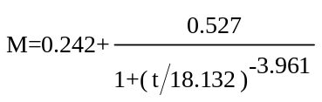  (R²=0.999, n=8) | 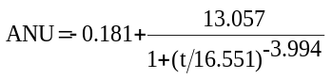  (R²=0.999, n=8) | 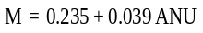  (R²=0.995, n=8)
2 | 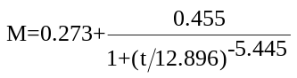  (R²=0.995, n=8) | 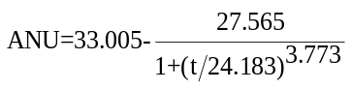  (R²=0.997, n=8) | 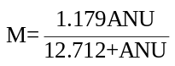  (R²=0.950, n=8)
3 | 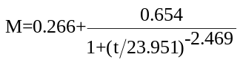  (R²=0.997, n=8) | 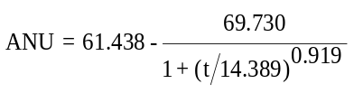(R²=0.998, n=8) | 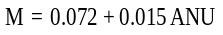  (R²=0.957, n=8)
4 | 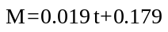  (R²=0.979, n=8) | 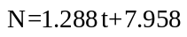  (R²=0.962, n=8) | 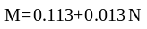  (R²=0.906, n=8)
5 | 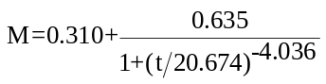  (R²=0.998, n=8) | 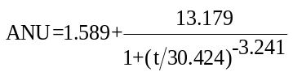  (R²=0.997, n=8) | 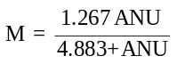  (R²=0.987, n=8)
6 | 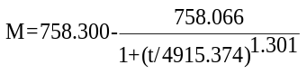  (R²=0.995, n=8) | 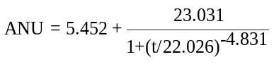(R²=0.999, n=8) | 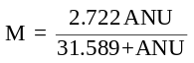  (R²=0.962, n=8)
7 | 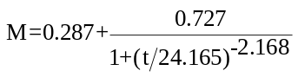  (R²=0.999, n=8) | 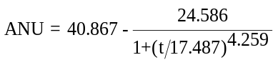(R²=0.999, n=8) | 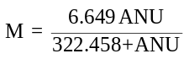  (R²=0.988, n=8)
8 | 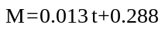  (R²=0.991, n=8) | 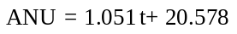  (R²=0.999, n=8) | 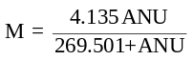  (R²=0.992, n=8)

Table 4. Nitrogen use efficiency (NUE) of Atractlodes lancea plantlets in vitro（g biomass g⁻¹ N）at different culture days.
No. | Culture time（d）
No. | 5 | 10 | 15 | 20 | 25 | 30
1 | 38.50 | 38.50 | 38.50 | 38.50 | 38.50 | 38.50
2 | 45.12 | 41.06 | 30.80 | 20.26 | 13.93 | 10.80
3 | 14.80 | 14.80 | 14.80 | 14.80 | 14.80 | 14.80
4 | 12.80 | 12.80 | 12.80 | 12.80 | 12.80 | 12.80
5 | 146.00 | 133.00 | 104.84 | 73.66 | 50.82 | 37.10
6 | 52.00 | 50.69 | 44.31 | 33.90 | 26.47 | 22.94
7 | 18.67 | 18.46 | 17.79 | 17.07 | 16.64 | 16.44
8 | 12.78 | 12.33 | 11.91 | 11.52 | 11.14 | 10.77

* Author to whom correspondence should be addressed.

