Assessment of Pollen Sterility in Tuberose (Polianthes tuberosa L.) Germplasm under Foothills of Himalayas

Ranjan Srivastava, G.C. Bajpai*, Babita Singh and Ved Byas
Department of Horticulture, Govind Ballab Pant University of Agriculture & Technology, Pantnagar, Uttarakhand, India. 263 145
Department of Genetics and Plant Breeding, G. B. Pant University of Agriculture & Technology, Pantnagar
e-mail: ranjansrivastava25@gmail.com

ABSTRACT
The present study on pollen sterility in tuberose was carried out at the Model Floriculture Centre, G. B. P. U. A. & T. Pantnagar during 2009-2010 and 2010-2011. The pollen sterility was estimated in 10 different varieties with the help of one per cent acetocarmine dye. Pollen grains were collected for pollen sterility test at tight bud stage. The pooled results showed that highest pollen sterility recorded in variety Shringar (51.60%), followed by Prajwal and Kalyani Double (16.91% and 15.94%) respectively. The flower of variety Swarna Rekha had no sterile pollen (0.00%) followed by Hyderabad Single and Suvasani (5.68% and 6.32%), respectively.
Key words: tuberose, pollen sterility, varieties
INTRODUCTION
Tuberose belongs to family Amaryllidaceae. It is a bulbous perennial perpetuating through bulbs. The aerial portion consists of a rosette of leaves, which are narrow, linear and light green. Inflorescence is known as spike which bears florets in pairs and release fragrance. It is extensively cultivated on a large scale in France, South Africa and USA. In India, it is under commercial cultivation in states of Karnataka, Maharashtra, Tamil Nadu and West Bengal. However, it is also adapted to North Indian climatic conditions and grows well in parts of Uttar Pradesh, Uttarakhand, Haryana and Punjab (Sadhu and Bose, 1973). Tuberose is popular by several vernacular names like Sughanda-Raja, Rajni-Ghanda, Gulcheri, Gulshabo, etc. The creation of novel form of plant is very fascinating. There is a tremendous scope of development of varieties through hybridization and selection in tuberose. Present variability for wide spectrum in colour, shape and size is very limited. Success in any crop breeding programme depends upon the knowledge of floral biology and breeding methodology (Nalawadi et al., 1978). Basic information on pollen sterility is important for planning of any hybridization programme. Genetic exploration of diverse germplasm is yet to be taken up in this flower.
MATERIAL AND METHODS
The present investigation on pollen sterility was carried out in 10 varieties of tuberose maintained at Model Floriculture Centre, G. B. P. U. A. & T. Pantnagar during 2009-2010and 2010-2011. Early buds were selected for pollen sterility test. These buds were first fixed in a fixative of acetic acid and alcohol in 3:1 ratio for 8-10 hours and after that they were preserved in 70 per cent alcohol and stored in refrigerator. Pollen grains from freshly dehisced anthers were placed on the slides and a drop of 1% acetocarmine solution was put on the slides and examined under 10X microscope. The pollen grains which did not stained were considered as sterile. The pollen counts were made at 10 microscale in every bud. Care was taken to include various fields laying both in peripheral and central regions of the cover slip as abortive pollen grains show a tendency to move towards the periphery and data were pooled and subjected to analysis of variance as per the method suggested by Gomez and Gomez, 1984.
RESULT AND DISCUSSION
Data on pollen sterility percentage is presented in Table 1/ Figure 1. The data reveled that the germplasm possessed significant variation in sterility level among different varieties of tuberose. The pooled result showed that highest pollen sterility recorded in variety Shringar (51.60 %) which was statistically higher than rest of the varieties and was followed by varieties Prajwal and Kalyani Double (16.91% and 15.94%) respectively. The higher rate of pollen sterility was due to failure of anthers to dehisce. The results of present level of study were in accordance with Pathak and Jaworski (1989). The flower of variety Swarna Rekha showed no pollen sterility (0.00%), whereas, it was of low level in Hyderabad Single and Suvasani (5.68% and 6.32%) respectively. In many flowering plants deficiency in carbohydrate metabolism in the anthers may lead to abnormal or sterile pollen development (Bhadola and Sawhnov, 1989).
REFERENCES
Bhadula, S.K. and Snwhnov, V.K. (1989). Amylolytic activity and carbohydride levels during the statment ontogeny of a male fertile and a “gibberellins-sensitivity” male sterile mutant of tomato (Lycopersicon esculentum). Journal of Experimental Botany, 40: 789-794.
Gomez, L. A. and Gomez, A. A. (1984). Statistical Procedure for Agricultural Research, John Wiley and Sons, 680p.
Nalawadi, U.G., Venkatarayappa, T., Venkatsubbiah, K. and Bojappa, K. (1978). Blossom biology in some varieties of Amaryllis belladonna (L). under Dharwad conditions. South Indian Hort., 26: 147-150.
Pathak, S.C. and Jaworski, C.A. (1989). UGA 1-MS male-sterile egg plant germplasm. HortScience. 24(6): 1050.
Sadhu, M.K. and Bose, T.K. (1973). Tuberose for most artistic garland. Indian Horticulture. 18(3) : 17-20.

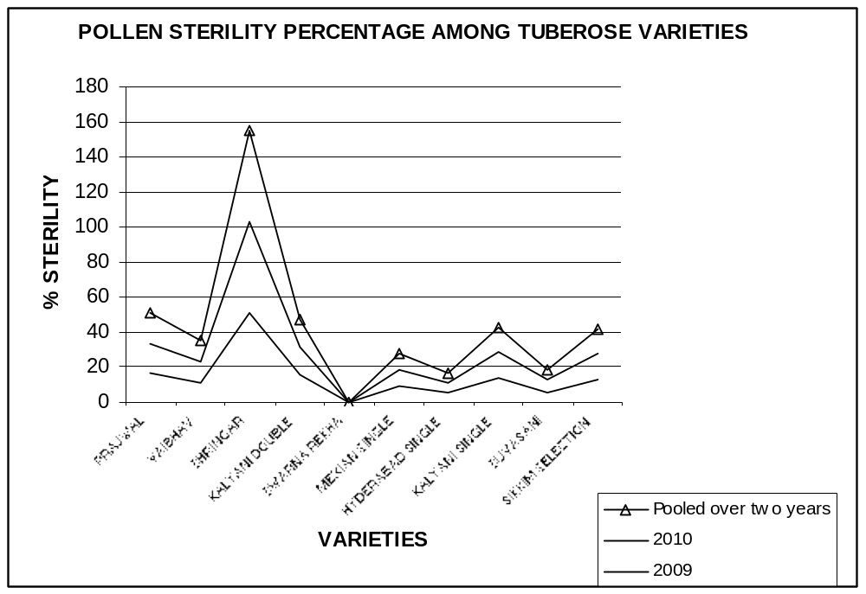

Table 1: POLLEN STERILITY PERCENTAGE
TREATMENTS | Sterility Percentage during
TREATMENTS | 2009 | 2010 | Pooled
PRAJWAL (T₁) | 16.58 | 17.25 | 16.91
VAIBHAV (T₂) | 11 | 12.24 | 11.70
SHRINGAR (T₃) | 50.58 | 52.62 | 51.60
KALYANI DOUBLE (T₄) | 15.43 | 16.40 | 15.94
SWARNA REKHA (T₅) | 0.00 | 0.00 | 0.00
MEXIAN SINGLE (T₆) | 9.17 | 9.56 | 9.36
HYDERABAD SINGLE (T₇) | 5.55 | 5.82 | 5.68
KALYANI SINGLE (T₈) | 13.78 | 14.93 | 14.35
SUVASANI (T₉) | 6.00 | 6.65 | 6.32
SIKKIM SELECTION (T₁₀) | 13.27 | 14.42 | 13.85
CD at 5% | 4.51 | 4.10 | 4.22

