Secondary Somatic Embryogenesis in Crocus vernus (L.) Hill
Iyyakkannu Sivanesan¹, Sonali Jana², and Byoung Ryong Jeong^{1,2,3*}
¹Institute of Agriculture and Life Science, Gyeongsang National University, Jinju, Korea 660-701
*Fax: + 82-55-757-7542, *E-mail: brjeong@gnu.ac.kr
²Research Institute of Life Science, Gyeongsang National University, Jinju, Korea 660-701
³Division of Applied Life Science (BK21 Program), Graduate School, Gyeongsang National University, Jinju, Korea 660-701
Abstract An efficient procedure for secondary somatic embryogenesis was developed in Crocus vernus. The primary somatic embryo (PSE) was induced from the corm explant of C. vernus on the Murashige and Skoog (MS) medium supplemented with 1.0 mg l⁻¹ 2,4- dichlorophenoxyacetic acid (2,4-D) and 0.5 mg l⁻¹ thidiazuron (TDZ) with a mean number of 52 somatic embryos per explant. The effects of medium type (Schenk and Hildebrandt (SH), Gamborg’s (B-5), Chu (N6), Anderson’s (AM), and MS) and light intensity (10 and 45 μmol·m⁻²·s⁻¹ photosynthetic photon flux density; PPFD) were studied for primary somatic embryo induction. The greatest number of somatic embryo induction was obtained on the SH medium amended with 1.0 mg l⁻¹ 2,4-D and 0.5 mg l⁻¹ TDZ under 10 μmol·m⁻²·s⁻¹ PPFD. The primary somatic embryos were inoculated on the SH medium amended with 2-isopentyl adenine or N⁶-benzyladenine (BA), in combination with α-naphthalene acetic acid (NAA) for secondary somatic embryo induction. After 45 days, the SH medium fortified with 2.0 mg l⁻¹ BA and 0.5 mg l⁻¹ NAA was found to be the best for secondary embryo induction, secondary embryos were induced on surface of globular (88.9%) and heart-shaped (95.2%) PSE’s. At 1.0 mg l⁻¹ gibberellic acid (GA₃) 92.3% embryo maturation and conversion were observed. Out of the various sucrose concentrations tried, 6% (w/v) sucrose was found to be the best with 100% embryo conversion. Finally it will be interesting to validate this protocol of reproducible direct somatic embryogenesis from the corm explants for other Crocus species as well.
Keywords: corm, Dutch crocus, light intensity, somatic embryogenesis, thidiazuron
Introduction
Crocus species belongs to the family Iridaceae which mainly embraces herbs with rhizomes, corms or bulbs. The genus Crocus includes about 80 species distributed from the south-western Europe, through central Europe to Turkey and south-western parts of Asia, as far as east and western China (Mathew 1982). This genus is mainly known for saffron (C. sativus), as one of the most important spices in the world, but other Crocus species are also economically important. Crocus vernus Hill is an ornamental species which acts as a temperate forest spring ephemeral (Badri et al. 2007). It is commonly known as the Dutch crocus, was originated in Russia and Eastern Europe, and is highly prized for its colorful flowers and thus used extensively in gardening.
It is propagated vegetatively by the daughter corms, which are annually formed at the top of mother corm. The rate of the natural propagation is very slow. The low rate of corm production limits the availability of propagation materials (Sivanesan et al. 2011a). Micropropagation is an alternative for large scale production of the disease-free, economically important plants. In recent years, there has been a growing interest to exploit tissue culture and genetic engineering techniques for improvement of the Crocus species.
Somatic embryogenesis can be the most promising technique for the in vitro propagation of the plants. An exceptional uniqueness of somatic embryogenesis is the continuation of growth and development of many embryos. Moreover, secondary somatic embryogenesis is a process whereby new somatic embryos are initiated from the originally-formed primary somatic embryos. It has certain advantages as compared to the primary somatic embryogenesis such as very high multiplication rate (Te-chato and Hilae 2007), independence of an explant source (Jariteh et al. 2011), and reproducibility (Karami et al. 2008). Additionally, embryogenicity can be maintained for a long period of time by repeated cycles of secondary embryogenesis.
The induction of somatic embryos in Crocus species has been reported earlier by manipulating adjustments such as decrease of plant growth regulator (PGR) concentrations and subsequent use of PGR-free medium (Plessner and Ziv 1999, Karamian and Ebrahimzadeh 2001, Karamian 2007), or changes of the auxin/cytokinin ratio. Somatic embryogenesis has been accomplished for a few Crocus species viz., C. cancellatus, C. caspius, and C. michelsonii (Karamian 2004), C. heuffelianus (Demeter et al. 2010), and C. sativus (Rajabpoor et al. 2007, Sheibani et al. 2007). However, till date, there is no report on the secondary somatic embryo induction on Crocus species. The callus and organ culture of C. vernus has been previously reported by Chub et al. (1994) and somatic embryogenesis by Sivanesan et al. (2011a). It is a well known fact that plant growth regulators influence somatic embryo formations. Other than this, culture conditions, medium, tissue or organ type, and its physiological status also have some pivotal role. Hence, the objectives of the present study were to assess the influence of medium, plant growth regulators (PGR), and culture conditions on somatic embryo induction, to assess the effects of plant growth regulators on the secondary somatic embryo formation, GA₃ and sucrose on embryo maturation and conversion.
Materials and Methods
Surface sterilization and culture conditions
The corms were collected from greenhouse-grown plants, washed thoroughly under running tap water for 30 min, and then washed with distilled water. The explants were decontaminated with 70% (v/v) ethanol (Yakuri Pure Chemicals, Japan) for 60 sec, 2.0% sodium hypochlorite (NaOCl) (Yakuri Pure Chemicals, Japan) for 10 min, and 0.01% (w/v) mercuric chloride for 15 min. Each treatment was followed by 3-4 washes with sterile distilled water.
The medium consisted of MS basal salts and vitamins (Murashige and Skoog 1962), supplemented with 3% (w/v) sucrose, and solidified with 0.8 % (w/v) agar. The pH of the medium was adjusted to 5.7 using 0.1 N NaOH or 0.1 N HCl before autoclaving at 15 psi and 121 °C for 15 min. Gibberellic acid (GA₃) and thidiazuron (TDZ) were filter sterilized and added to autoclaved medium. Other plant growth regulators were added to the basal medium prior to pH adjustment and sterilization.
The explants were cut into 0.5-1.0 cm long segments and cultured on 100mm Χ 40mm (diameter Χ depth) petridishes (SPL, Korea) containing MS medium supplemented with 0.25, 0.5, 1.0 or 2.0 mg l⁻¹ 2,4 dichlorophenoxy acetic acid (2,4-D) combined with 0.5 mg l⁻¹ thidiazuron (TDZ). The explants were maintained for 14 days at 25 ± 1ºC in darkness and then exposed to light of 45 µmol·m⁻²·s⁻¹ photosynthetic photon flux density (PPFD) provided by cool white fluorescent light (40 W tubes, Philips) with a daily light/dark cycle of 16/8 h.
Influence of media and light intensity on somatic embryogenesis
The decontaminated corm explants (0.5-1.0 cm) were cultured on Anderson’s (AM, 1984), Chu (N6, 1975), Gamborg’s (B-5, 1968), MS, or Schenk and Hildebrandt (SH, 1972) media amended with 1.0 mg l⁻¹ 2,4-D and 0.5 mg l⁻¹ TDZ. The two light intensities 10 and 45 μmol·m⁻²·s⁻¹ PPFD was also taken into account for SE induction.
Secondary somatic embryo induction
To obtain the secondary embryos, the primary embryos at different developmental stages were transferred to SH medium containing 1.0 or 2.0 mg l⁻¹ of either 2-isopentyl adenine (2-iP) or N⁶-benzyladenine (BA) combined with 0.1 or 0.5 mg l⁻¹ α-naphthalene acetic acid (NAA).
Somatic embryo maturation and conversion
Secondary somatic embryos were cultured on SH medium supplemented with activated charcoal (0.3%, w/v), and 0, 0.5, 1.0, 2.0 or 4.0 mg l⁻¹ GA₃ for maturation and conversion. The somatic embryos were subcultured at an interval of 3 weeks. The percentage embryo conversion was calculated as the percentage of the number of germinated somatic embryos divided by total number of somatic embryos.
Effect of concentration of sucrose on somatic embryo maturation and conversion
Secondary somatic embryos were cultured on SH medium supplemented with activated charcoal (0.3%, w/v), 1.0 mg l⁻¹ GA_{3,} and 0, 1.5, 3.0, 6.0 or 12.0% (w/v) sucrose for maturation and conversion. The percentage embryo conversion was calculated as the percentage of the number of germinated somatic embryos divided by total number of somatic embryos.
For each experiment, 50 explants were used and the experiment was repeated thrice. Data were statistically analyzed by analysis of variance (ANOVA) followed by Duncan multiple range test at a 5% probability level by using SAS computer package (SAS Institute Inc., NC, USA).
Results and Discussion
In our previous study high frequency of somatic embryogenesis was achieved when corm explants were cultured on MS medium with 0.5 mg l⁻¹ TDZ and 0.1 mg l⁻¹ NAA (Sivanesan et al. 2011a). However, the mean number of PSE per explant was less. Somatic embryogenesis is generally believed to be triggered by an auxin and for many plants, 2,4-D has been widely regarded to be effective (Brown et al. 1995, Balaraju et al. 2011). In Crocus species, a combination of 2,4-D and BA are reportedly being used for high frequency SE induction (Karamian 2004, Rajabpoor et al. 2007). Thus in this present endeavor, an optimal concentration of TDZ was combined with various concentrations of 2,4-D for somatic embryo induction. Direct PSE was observed on the surface of the explants when MS medium was supplemented with 2,4-D and TDZ. In contrast absence of PGR in the culture medium the explants turned brown, devoid of somatic embryos. When the cultures were kept under darkness for 14 days followed by expose to light, somatic embryos formed directly on the explants after 45 days at all concentrations tried (Table 1). Somatic embryos at globular, heart-shaped, and cotyledonary stages were observed throughout the incubation period on the same medium. Direct somatic embryogenesis requires plant growth regulators and favorable conditions to allow the pre-embryogenic determined cells to undergo cell divisions and expression of embryogenesis (Sharp et al. 1980). In the present endeavor, embryos were white or pale yellow in color, small and globular in shape appearing individually or in clusters. Morphologically, the early stage embryos appeared as shiny globular structures. None of the embryos were found to be abnormal. The direct induction of globular somatic embryos as well as the number of induced globular embryos was assessed.
On increasing concentrations of 2,4-D from 0.25 to 1.0 mg l⁻¹, SE induction frequency and number of SE’s induced per explant increased, but beyond 1.0 mg l⁻¹ they decreased (Table 1). In contrast to our results, high frequency of SE induction was reported in Crocus species when the culture medium supplemented with 2.0 or 4.0 mg l⁻¹ 2,4-D in combination with 1.0 mg l⁻¹ BA (Karamian 2004, Rajabpoor et al. 2007). The TDZ has a dual role in the induction of somatic embryogenesis; a cytokinin-like activity that promotes cell division and differentiation and an auxin-like activity that seems to be crucial for induction of embryogenic competence. Thus, the presence of TDZ in the culture medium may be the reason behind low concentrations of 2,4-D requirement for SE. Our findings are in agreement with Chen (2012) who reported that TDZ lower down the requirement of dicamba for callus induction. The SE induction was best (74.6%) at 1.0 mg l⁻¹ 2,4-D and 0.5 mg l⁻¹ TDZ on MS medium containing 3% sucrose with a mean number of 52 somatic embryos per explants. Similar results were reported in other plant species such as Cajanus cajan (Aboshama 2011), Pheonix dactylifera (Sidky and Zaid 2011) and Tricyrtis species (Nakano et al. 2004).
In this study, all stages of somatic embryos were observed, while in C. sativus monopolar embryos developed which later turned into bipolar structures during culture (Blazquea et al. 2009), and in C. heuffelianus bipolar embryos were directly differentiated from globular stage embryos (Demeter et al. 2010).
Influence of media and light intensity on somatic embryogenesis
On this optimal plant growth regulator concentration, the effect of culture medium and light intensity was studied for somatic embryo induction (Table 2). Among various media (AM, B5, MS, N6, and SH) studied, SH was found to be the most effective for SE induction. Thus, the frequency of SE varied considerably with the medium constitution. The requirement of SH salts for SE shows the low salt requirement for the growth of C. vernus. Out of two light intensities, SE induction was best achieved at 10 μmol m⁻² s⁻¹ PPFD as compared to 45 μmol m⁻² s⁻¹ PPFD (Fig. 1). When the cultures were maintained at 45 μmol m⁻² s⁻¹ PPFD, the mean number of SEs per explant developed on MS medium and SH medium was 52.0 and 73.4, respectively. The highest frequency of SE induction (100%) was achieved when the explants were cultured on SH medium with 1.0 mg l⁻¹ l 2,4-D and 0.5 mg l⁻¹ TDZ under 10 μmol·m⁻²·s⁻¹ PPFD (Table 2). Hence, the SH medium was found to be the best for SE induction and the mean number of SEs (124.7) induced per explant increased many folds than previous reports on Crocus species (Karamian 2004, Rajabpoor et al. 2007, Demeter et al. 2010, Sivanesan et al. 2011a).
The quality and intensity of light has been reported to affect somatic embryogenesis in terms of induction and growth of somatic embryos in Cydonia oblonga (Morini et al. 2000), Daucus carota (Takanori and Cuello 2005), and Coffea arabica (Gatica et al. 2008). In most of the reports, a dark period of few days has been necessary for induction of SE’s (Koleva-Gudeva et al. 2007, Sivanesan et al. 2011b). The results are in accordance to Konstas et al. (2003) that a minimum initial incubation was required for somatic embryogenesis to occur. The observed results indicate that lower light intensities were insignificantly associated with induction and proliferation of increased number of somatic embryos. In contrast to this, Rajabpoor et al. (2007) reported somatic embryo induction in C. sativus cultures when they were maintained completely under dark conditions for 70 days.
Effect of plant growth regulators (PGRs) on secondary somatic embryogenesis
Induction of secondary somatic embryos (SSE) on primary SE’s on the SH medium with different PGR’s was attempted. After 45 days of culture, when medium was fortified with 2-iP and NAA (0.1), SSE was not induced, but 2-iP with higher concentration of NAA (0.5 mg l⁻¹), SSE were induced (28.6 to 62.5 embryos per PSE). The best SSE induction was achieved with 2.0 mg l⁻¹ BA and 0.5 mg l⁻¹ NAA (Table 3, Fig. 2). When primary somatic embryo was transferred to this PGR combination, the highest SSE induction was achieved with heart-shaped (95.2) followed by globular PE’s (88.9). The percentage of torpedo-shaped PE’s conversion into SSE’s was very low. Similarly, the number of embryos induced by these PE stages (globular, heart, and torpedo) was also highest at 2.0 mg l⁻¹ BA and 0.5 mg l⁻¹ NAA (Table 3).
Effect of GA₃ on somatic embryo maturation and germination
For embryo maturation and germination, embryos were cultured on SH medium supplemented with 0.3% AC, GA₃ and 3% sucrose. In the present endeavor, embryo germination and maturation were achieved at all concentrations of GA₃, although it was highest (92.3%) at 1.0 mg l⁻¹ GA₃ (Table 4, Fig. 3). Thus, both the activated charcoal and GA₃ appeared to be necessary for the maturation and germination of SE’s.
The fact that GA₃ stimulates the formation and conversion of somatic embryos is well known. Embryo maturation and simultaneous conversion to obtain plantlets is one of the important steps in in vitro embryogenesis, which partially depends on the embryo quality also. In the present study conducted, addition of GA₃ at higher concentrations (>2.0 mg l⁻¹) resulted in green dormant embryos with no further elongation. Contrary to this, high concentrations of GA₃ (0.75-5.79 µM) have been reported to enhance germination in wheat somatic embryos (Miroshnichenko et al. 2009). In Crocus heffuelianus, conversion of somatic embryos was reported by addition of 0.5-2.0 mg l⁻¹ BA together with 2.5 mg l⁻¹ GA_{3,} 100 mg l⁻¹ ascorbic acid, and 1% sucrose (Demeter et al. 2010). In our study, activated charcoal was added to the medium so as to absorb the phenolics secreted by the cells. Aboshama (2011) suggested that there is an important role of activated charcoal in reducing the inhibitory effect of residual plant growth regulators and stimulating embryo conversion.
Effect of sucrose concentration on somatic embryo maturation and conversion
Influence of various sucrose concentrations was evaluated on embryo maturation and conversion on the SH medium with 1.0 mg l⁻¹ GA₃ and 0.3 % activated charcoal. The rate of conversion increased on increasing the concentration of the sucrose (Table 5). It was found that sucrose at 6% concentration resulted in 100% conversion. It has been reported by Corredoira et al. (2003) that carbon source and concentration had a marked influence on maturation and subsequent conversion ability of chestnut somatic embryos. The present findings are also in concomitance with Agarwal et al. (2004), who reported that best SSE was observed at 6% sucrose in the medium in Morus alba. It has been observed that increased concentrations of carbohydrates make them osmotically dynamic and they generate osmotic tension which helps in embryo formation and further conversion. However, sugars simply do not act as an osmoticum, but also provide energy and carbon source for somatic embryogenesis (Daigny et al. 1996). Contrary to these, Demeter et al. (2010) reported decrease in strength of culture medium (1/4th MS) and content of organic carbon source (1%) to be followed for C. heuffelianus.
To summarize a simple, reproducible, and efficient direct embryogenesis protocol which involved almost single step has been standardized. In the present study, the frequency of somatic embryogenic regeneration was found to be influenced by concentration of plant growth regulators, type of medium and light intensity. However, the results clearly indicate that low light intensity and the SH medium are best suited for this important species and highest number of somatic embryos can be induced. Based on the above observations, the SH basal medium was found to be the best for induction, maturation, and germination of SE. No intervening callus phase was noted during embryo germination; hence, direct secondary somatic embryo induction was achieved. This technique is important, since it could be used as a possible micropropagation system and for the regeneration of transgenic plants.

Acknowledgements: “This research was supported by Technology Development Program for Agriculture and Forestry, Ministry for Food, Agriculture, Forestry and Fisheries, Republic of Korea. Project No: 109096-5”.

References
Aboshama H.M.S. (2011). Somatic embryogenesis proliferation, maturation and germination in Cajanus cajan. World Journal of Agricultural Sciences, 7: 86-95.
Agarwal S., Kanwar K., Sharma D.R. (2004). Factors affecting secondary somatic embryogenesis and embryo maturation in Morus alba L. Scientia Horticulturae, 102: 359-368.
Anderson W.C. (1984). A revised tissue culture medium for shoot multiplication of rhododendron. Journal of American Society of Horticultural Sciences, 109: 343-347.
Badri M.A, Minchin P.E.H., Lapointe L. (2007). Effects of temperature on the growth of spring ephemerals: Crocus vernus. Physiologia Plantarum, 130: 67-76.
Balaraju K., Saravanan S., Agastian P., Ignacimuthu S. (2011). A rapid system for micropropagation of Swertia chirata Buch-Ham. ex Wall.: an endangered medicinal herb via direct somatic embryogenesis. Acta Physiologiae Plantarum, 33: 1123-1133.
Brown D.C., Finstad K.I., Watson E.M. (1995). Somatic embryogenesis in herbaceous dicots. In: T.A. Thorpe (ed.) In vitro Embryogenesis in Plants. Kluwer Academic, The Netherlands: 345-415.
Chen J.T. (2012). Induction of petal-bearing embryos from root-derived callus of Oncidium ‘Gower Ramsey’. Acta Physiologiae Plantarum, DOI 10.1007/s11738-012-0930-1.
Chu C.C., Wang C.S., Sun C.C., Hsu C., Yin K.C., Chu C.Y. (1975). Establishment of an efficient medium for anther culture of rice, through comparative experiments on the nitrogen sources. Scientia Sinica, 18: 659-668.
Chub V.V., Vlasova T.A., Butenko R.G. (1994). Callus development and morphogenesis in generative organ culture of spring-flowering Crocus L. species. Russian Journal of Plant Physiology, 41: 815-820.
Corredoira E, Ballester A., Vieitez A.M. (2003). Proliferation, maturation and germination of Castanea sativa Mill. Somatic embryos originated from leaf explants. Annals of Botany, 92:129-136.
Daigny G., Paul H., Sangwan R.S., Sangwan-Narreel B.S. (1996). Factors influencing secondary somatic embryogenesis in Malus x domestica Borkh. (cv. ‘Gloster 69’). Plant Cell Reports, 16: 153-157.
Demeter Z., Gyula Suranyi V., Molnar A., Sramko G., Beyer D., Konya Z. (2010). Somatic embryogenesis and regeneration from shoot primordia of Crocus heuffelianus. Plant Cell, Tissue and Organ Culture, 100: 349-353.
Gamborg O.L., Miller R.A., Ojima K. (1968). Nutrient requirements of suspension cultures of soybean root cells. Experimental Cell Research, 50: 148-151.
Gatica A.M., Arrieta G., Espinoza A.M. (2008). Direct somatic embryogenesis in Coffea arabica L. cvs. Caturra and Catuai: Effect of triacontanol, light condition, and medium consistency. Agronomia Costarricense, 32: 139-147.
Jariteh M., Ebrahimzadeh H., Niknam V., Vahdati K., Amiri R. (2011). Antioxidant enzymes activities during secondary somatic embryogenesis in Persian walnut (Juglans regia L.). African Journal of Biotechnology, 10: 4093-4099.
Karami O., Deljou A., Karimi G. (2008). Secondary somatic embryogenesis of carnation (Dianthus caryophyllus L.). Plant Cell, Tissue and Organ Culture, 92: 273-280.
Karamian R. (2004). Plantlet regeneration via somatic embryogenesis in four species of Crocus. Acta Horticulturae, 650: 253-259.
Karamian R. (2007). Somatic embryogenesis and plant regeneration from protoplast culture of Crocus pallasii subsp. hausknechtii. Pakistan Journal of Biological Sciences, 10: 659-663.
Karamian R., Ebrahimzadeh H. (2001). Plantlet regeneration from protoplast-derived embryogenic calli of Crocus cancellatus. Plant Cell, Tissue and Organ Culture, 65: 115-121.
Koleva-Gudeva L., Spasenoski M., Trajkova F. (2007). Somatic embryogenesis in pepper anther culture: The effect of incubation treatments and different media. Scientia Horticulturae, 111: 114-119.
Konstas J., Kintzios S., Drossopoulos J., Sarlis G. (2003). The effect of light intensity and relative exposure under light on the expression of direct and indirect somatic embryogenesis from common mallow (Malva sylvestris L.). Acta Horticulturae, 597: 315-319.
Mathew B. (1982). The Crocus. A revision of the genus Crocus (Iridaceae). B.T. Batsford Ltd. London.
Miroshnichenko D., Fillippov M., Dolgov S. (2009). Effects of daminozide on somatic embryogenesis from immature and mature embryos of wheat. Australian Journal of Crop Science, 3: 83-94.
Morini S., Onofrio C.D., Bellocchi G., Fisichella M. (2000). Effect of 2, 4-D and light quality on callus production and differentiation from in vitro cultured quince leaves. Plant Cell, Tissue and Organ Culture, 63: 47- 55.
Murashige T., Skoog F. (1962). A revised medium for rapid growth and bioassays with tobacco tissue cultures. Physiologia Plantarum, 15: 473-497.
Nakano M., Mizunashi K., Tanaka S., Godo T., Nakata M., Saito H. (2004). Somatic embryogenesis and plant regeneration from callus cultures of several species in the genus Tricyrtis. In Vitro Cellular and Development Biology Plant, 40: 274-278.
Plessner O., Ziv M. (1999). In vitro propagation and secondary metabolite production in Crocus sativus L. In: M. Negbi (ed). Saffron Crocus sativus L. Harwood Academic Publishers OPA (Overseas Publishers Association), NV 137-148.
Rajabpoor S., Azghandi A.V., Saboora A. (2007). Effects of different concentrations of 2,4-D and BAP on somatic embryogenesis induction in saffron (Crocus sativus L.). Pakistan Journal of Biological Sciences, 10: 3927-3930.
Schenk R.U., Hildebrandt A. (1972). Medium and techniques for induction and growth of monocotyledonous and dicotyledonous plant cell cultures. Canadian Journal of Botany, 50: 199-204.
Sharp W.R., Sondahl M.R., Caldas L.S., Maraffa S.B. (1980). The physiology of in vitro asexual embryogenesis. Horticultural Reviews, 2: 268-31.
Sidky R.A., Zaid Z. E. (2011). Direct production of somatic embryos and plant regeneration using TDZ and CPPU of date palm (Phoenix dactylifera L.). International Journal of Academic Research, 3: 792-796.
Sivanesan I., Lim M.Y., Jo E.H., Jeong B.R. (2011a). Somatic embryogenesis and plant regeneration in Crocus vernus. International Proceedings of Chemical Biology and Environmental Engineering, 4: 199-201.
Sivanesan I., Lim M.Y., Jeong B.R. (2011b). Somatic embryogenesis and plant regeneration from leaf and petiole explants of Campanula punctata Lam. var. rubriflora Makino. Plant Cell, Tissue and Organ Culture, 107: 365-369.
Takanori H., Cuello J. (2005). Regulating radiation quality and intensity using narrow-bands leds for optimization of somatic embryogenesis. Proceedings and Annual Meetings of American Society of Agricultural Engineers, 302-307.
Te-chato S., Hilae A. (2007). High-frequency plant regeneration through secondary somatic embryogenesis in oil palm (Elaeis guineensis Jacq. var. tenera). Journal of Agricultural Technology, 3: 345-357.

Abbreviations
SSE: Secondary somatic embryogenesis
2, 4-D: 2, 4-dichlorophenoxyacetic acid
TDZ: Thidiazuron
MS: Murashige and Skoog (1962)
SH: Schenk and Hildebrandt (1972)
B-5: Gamborg et al (1968)
N6: Chu et al (1975)
AM: Anderson’s medium
GA₃: Gibberellic acid
2iP: 2-isopentyl adenine
BA: N⁶-benzyladenine
NAA: α-naphthalene acetic acid
PPFD: Photosynthetic photon flux density
Table 1. Effect of concentration of 2,4-D plus 0.5 mg l⁻¹ TDZ on somatic embryogenesis from corm explants of Crocus vernus culture on the MS medium.
2,4-D (mg l⁻¹) | Somatic embryo induction (%) | No. of somatic embryos induced per explant
0.25 | 49.2±3.2d^{z} | 18.7±2.6c
0.50 | 60.8±2.5c | 30.4±3.0b
1.00 | 74.6±1.7a | 52.0±4.0a
2.00 | 69.4±1.2b | 10.2±1.6d
^{z}Means ± SD followed by same letters within a column are not significantly different (P≤ 0.05).
Table 2. Influence of medium and light intensity on somatic embryogenesis of Crocus vernus^{z}.
Culture medium | Somatic embryo induction (%) |  | No. of somatic embryos induced per explant
Culture medium | 10 μmol m⁻² s⁻¹ PPFD | 45 μmol m⁻² s⁻¹ PPFD | 10 μmol m⁻² s⁻¹ PPFD | 45 μmol m⁻² s⁻¹ PPFD
AM^{y} | 87.4±1.6c^{x} | 60.2±1.7c | 94.7±7.4b | 66.2±2.6b
B5 | 96.4±1.4a | 72.2±1.2ab | 75.3±8.1d | 41.4±1.0d
MS | 98.2±1.7a | 74.6±2.4a | 82.4±2.7c | 52.0±2.6c
N6 | 91.8±0.5 b | 59.6±1.0c | 86.0±5.0c | 63.7±1.4b
SH | 100a | 68.0±3.1b | 124.7±9.0a | 73.4±1.0a
^{z}Corm explants were cultured on the basal medium supplemented with 1.0 mg l⁻¹ 2,4-D and 0. 5 mg l⁻¹ TDZ.
^{y}AM, Anderson’s; B5, Gamborg’s; MS, Murashige and Skoog’s; N6, Chu’s; and SH, Schenk and Hilderbrandt medium.
^{x}Means ± SD followed by same letters within a column are not significantly different (P≤ 0.05).
Table 3. Effect of plant growth regulators (PGRs) on secondary somatic embryogenesis (SSE) on primary somatic embryo of C. vernus after 45 days of culture on the SH medium.
PGRs (mg l⁻¹) |  |  | SSE induction (%) |  |  | No. of SE’s induced per embryo
2-iP | BA | NAA | Globular | Heart | Torpedo | Globular | Heart | Torpedo
1.0 | 0 | 0.1 | 0.0g^{z} | 0.0f | 0.0e | 0.0f | 0.0e | 0.0e
2.0 | 0 | 0.1 | 0.0g | 0.0f | 0.0e | 0.0f | 0.0e | 0.0e
1.0 | 0 | 0.5 | 32.7±0.6f | 37.5±1.6e | 28.6±0.8d | 5.7±1.5e | 4.3±2.0d | 2.3±0.5c
2.0 | 0 | 0.5 | 40.4±1.6e | 62.5±1.7d | 42.9±1.2b | 9.7±1.3d | 7.0±0.6c | 3.6±0.5b
0 | 1.0 | 0.1 | 52.3±1.8d | 60.0±2.0d | 38.1±0.5c | 11.4±1.6c | 6.2±0.4c | 1.0±0.1d
0 | 2.0 | 0.1 | 70.4±2.6b | 81.2±0.8b | 43.8±1.5b | 11.0±2.0c | 9.0±1.5b | 1.2±0.3d
0 | 1.0 | 0.5 | 67.5±3.0c | 75.0±1.0c | 40.7±1.1bc | 18.4±2.4b | 12.4±1.2ab | 4.0±0.3b
0 | 2.0 | 0.5 | 88.9±1.0a | 95.2±1.0a | 55.6±1.7a | 28.0±3.0a | 14.6±0.6a | 7.2±0.6a
^{z}Means ± SD followed by same letters within a column are not significantly different (P≤ 0.05).
Table 4. Effect of concentration of GA₃ on embryo maturation and conversion.
GA₃ (mg l⁻¹) | Conversion (%)
0.0 | 47.1±1.2d^{z}
0.5 | 66.4±2.0c
1.0 | 92.3±1.6a
2.0 | 83.3±1.2b
4.0 | 21.0±1.0e
Secondary somatic embryos (globular) were cultured on SH medium supplemented with activated charcoal (0.3%, w/v).
^{z}Means ± SD followed by same letters within a column are not significantly different (P≤ 0.05).
Table 5. Effect of various concentrations of sucrose on embryo maturation and conversion.
Sucrose (g l⁻¹) | Conversion (%)
0 | 0.0e^{z}
15 | 70.5±2.3c
30 | 92.3±1.6b
60 | 100a
120 | 27.3±0.6d
Secondary somatic embryos (globular) were cultured on SH medium supplemented with activated charcoal (0.3%, w/v) and 1.0 mg l⁻¹ GA₃.
^{z}Means ± SD followed by same letters within a column are not significantly different (P≤ 0.05).

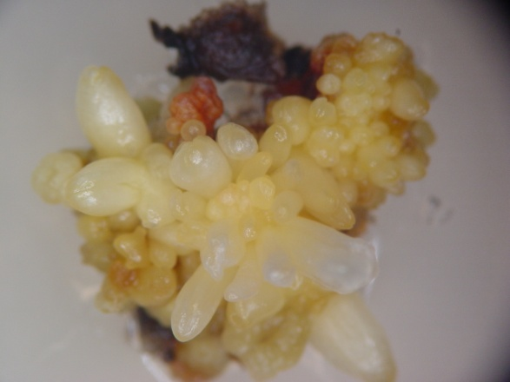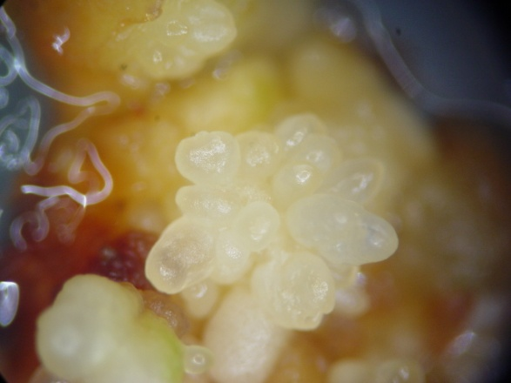
B
A
Fig. 1. Somatic embryos developed from the corm explants on the SH medium containing 1.0 mg l⁻¹ 2,4-D and 0.5 mg l⁻¹ TDZ after 45 days of culture under 10 μmol m⁻² s⁻¹ PPFD (A) and 45μmol m⁻² s⁻¹ PPFD (B).

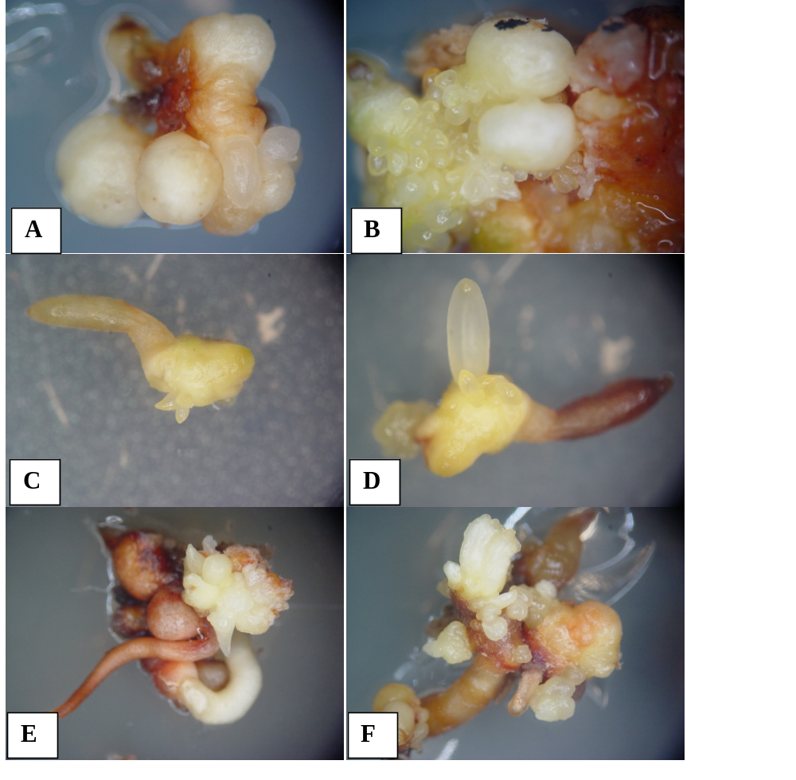
Fig. 2. Formation of secondary somatic embryos on the primary embryos were cultured on the SH medium supplemented with 2.0 mg l⁻¹ BA and 0.5 mg l⁻¹ NAA. A, Primary somatic embryos; B, secondary embryogenesis from the primary somatic embryos; C & D, induction and development of secondary embryos from torpedo stage embryos; and E & F, induction and development of secondary embryos from cotyledonary stage embryos.

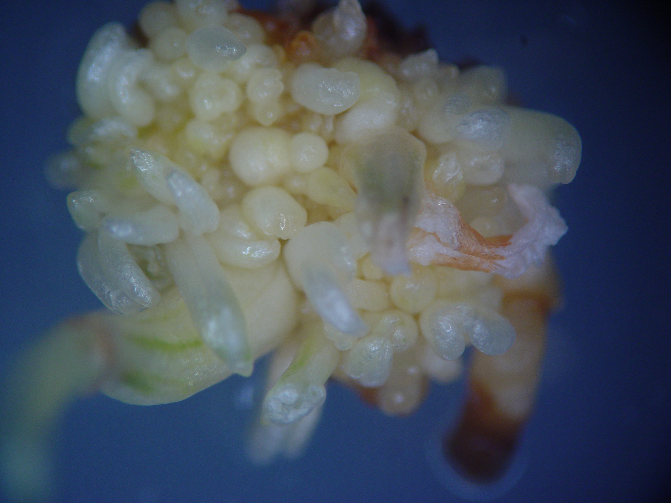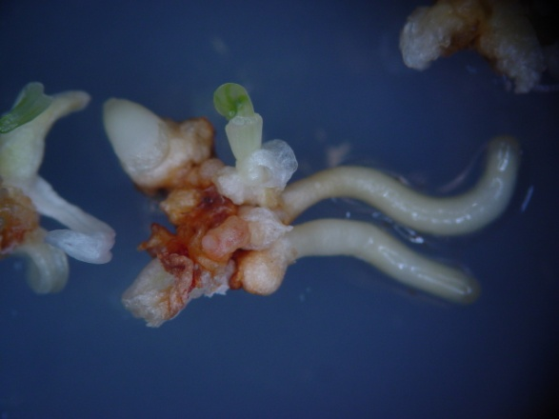
A
B

Fig.3. Maturation and conversion of somatic embryos on the SH medium supplemented with 6% (w/v) sucrose and 1.0 mg l⁻¹ GA₃. A, germination of somatic embryos after 4 weeks of culture and B, embryo derived plantlet

