In vitro propagation of Polygonatum odoratum Druce var. pluriflorum Ohwi for. variegatum Y.N. Lee
Iyyakkannu Sivanesan¹ and Byoung Ryong Jeong^{1,2,3*}
¹Institute of Agriculture and Life Science, Gyeongsang National University, Jinju, Korea 660-701
*Fax: + 82-55-757-7542, *E-mail: brjeong@gnu.ac.kr
²Division of Applied Life Science (BK21 Program), Graduate School, Gyeongsang National University, Jinju, Korea 660-701
³Research Institute of Life Science, Gyeongsang National University, Jinju, Korea 660-701
Abstract A protocol for in vitro propagation of variegated Solomon’s seal (Polygonatum odoratum Druce var. pluriflorum Ohwi for. variegatum Y.N. Lee) was developed. Rhizome explants were cultured on Anderson medium supplemented with different concentrations and combinations of plant growth regulators. Adventitious shoot buds were induced directly on the surface of the explants when the culture medium was supplemented with cytokinin alone. The highest frequency of shoot bud induction (100%) was obtained when the explants were cultured on Anderson medium supplemented with 1.0 mg l⁻¹ 2,4-D, 2.0 mg l⁻¹ 2-iP, and 0.5 mg l⁻¹ TDZ, with a mean number of 7.6 shoots per explant. The greatest frequency of rooting (100%), with maximum number of 5.2 roots per shoot were obtained on the half-strength Anderson medium supplemented with 1.0 mg l⁻¹ NAA. The survival rate of in vitro-regenerated plants transferred to the greenhouse was about 80%. The acclimatized plants grew normally without morphological abnormalities or variations.
Key words: Anderson medium, direct regeneration, plant growth regulators, rhizome explants, variegated Solomon’s seal
INTRODUCTION
The genus Polygonatum (Liliaceae) includes about 57 species, distributed in the temperate regions of the northern hemisphere. Polygonatum odoratum Druce var. pluriflorum Ohwi for. variegatum Y.N. Lee commonly known as variegated Solomon’s seal is a perennial herb, growing naturally in the highlands of Europe, Japan and Korea (Jeffrey 1980). It is commonly used for shady borders and woodland gardens. Recently, it has been used as cut foliage in Korea, because of its soft yellow patterned leaves (Yun et al. 2012). The plant is typically propagated by division of rhizomes but, the low multiplication ratio restricts a large-scale cultivation of this plant. Further, it requires two years to induce plant development through rhizomes, since the rhizomes were dormant after excision (Yoon and Choi 2002). Plant tissue culture techniques are considered as reliable methods for rapid propagation when the conventional propagation of plants is difficult. Although in vitro plant regeneration protocols have been developed for Polygonatum species using adventitious bud, leaf, rhizome, and stem explants (Yoon and Choi 2002, Zhao et al. 2003, 2009, Bisht et al. 2012), there have been no reports on plant regeneration from rhizome explants of P. odoratum var. pluriflorum for. variegatum. The objective of this study was to develop a simple and efficient in vitro plant regeneration protocol for variegated Solomon’s seal.
MATERIALS AND METHODS
The rhizomes were collected from the field, washed thoroughly under running tap water for 30 min, and then rinsed with distilled water. The explants were surface disinfested with 70% (v/v) ethanol (Yakuri Pure Chemicals, Japan) for 60 sec, 3.0% sodium hypochlorite (NaOCl) (Yakuri Pure Chemicals, Japan) for 15 min, and 0.01% (w/v) mercuric chloride for 20 min. Each treatment was followed by 3-4 rinses with sterile distilled water. The explants were blotted in a sterile filter paper to remove excess water and then cut into 0.5-1.0 cm segments. The medium consisted of Anderson (1984) nutrients and vitamins supplemented with 3% (w/v) sucrose, and solidified with 0.8 % (w/v) agar (Plant Agar, Duchefa Biochemie, The Netherlands). The pH of the medium was adjusted to 5.8 using 0.1 N NaOH or 0.1 N HCl prior to autoclaving at 15 psi and 121 °C for 15 min. All cultures were maintained at 25±1ºC under a 16 h photoperiod with 45 µmol·m⁻²·s⁻¹ photosynthetic photon flux density (PPFD) provided by cool white fluorescent light (40 W tubes, Philips).
For shoot induction, rhizome segments were cultured on Anderson medium supplemented with different concentrations and combinations of plant growth regulators (Table 1). The number of explants initiating shoot buds and the average number of shoot buds per explant were recorded after 8 weeks. In each treatment, 50 explants were used, and the experiment was repeated thrice. The regenerated shoot buds were transferred to half-strength Anderson medium supplemented with 0, 0.5, 1.0 or 2.0 mg l⁻¹ 2,4 dichlorophenoxyacetic acid (2,4-D) or α-naphthalene acetic acid (NAA) for shoot elongation and rooting. After 6 weeks, percentage of root induction and number of roots per shoot were recorded. In each treatment, 25 shoot buds were used, and the experiment was repeated three times.
For acclimatization, regenerated plantlets were transferred to acclimatization boxes containing a commercial growing substrate consisted of coir, peatmoss, perlite and vermiculite (Tosilee substrate, Shinan Grow, Jinju, Korea), irrigated every second day with quarter-strength nutrient solution (Sivanesan et al. 2010), and maintained in a greenhouse. After 4 weeks, acclimatized plants were transplanted into pots containing a Tosilee substrate. Plantlet survival was recorded after 4 weeks. For each experiment, about 25 plantlets were used and the experiment was repeated three times. All data were statistically processed by analysis of variance (ANOVA) followed by Duncan multiple range test at a 5% probability level by using SAS computer package (SAS Institute Inc., NC, USA).
RESULTS AND DISCUSSION
The disinfection procedure yielded about 72% aseptic explants. In plant growth regulator (PGR)-free medium, the explants became brownish and died within 3 weeks of culture. When the medium was supplemented with PGRs, the explants developed adventitious shoot buds (Table 1) within 4 weeks of culture. However, shoot induction was not observed in the presence of 0.5 mg l⁻¹ 2-isopentyl adenine (2-iP). With increasing 2-iP concentrations in the culture medium, direct adventitious shoot bud formation was observed. Among the different concentrations of 2-iP studied, the basal medium containing 2.0 mg l⁻¹ 2-iP was the most effective for shoot bud induction. On this medium, 59% of the explants responded, with a mean number of 2.0 shoot buds per explant. When the culture medium was supplemented with different concentrations of thidiazuron (TDZ) induced adventitious shoot buds within 3 weeks of culture, and root formation was observed at the base of the shoot bud another 2 weeks of culture (Fig. 1A). Most frequently, root formation is inhibited by the cytokinins used to induce shoot regeneration. The inhibitory effect of TDZ on root induction has been reported in Cotoneaster wilsonii (Sivanesan et al. 2011a), Eclipta alba (Ray and Bhattacharya 2008), and Kalanchoe pinnata (Jaiswal and Sawhney 2006). In the present study, both shoot and root induction was observed in the presence of TDZ. A similar result was also observed in Glycine max (Radhakrishnan et al. 2009). The highest frequency of shoot bud induction (71%), with a mean number of 3.8 shoots per explant, was obtained on Anderson medium supplemented with 1.0 mg l⁻¹ TDZ (Fig. 1B). However, at higher concentrations of TDZ, both the frequency of shoot bud induction and the average number of shoots per explant decreased. In the present study, 2-iP was less effective in adventitious shoot regeneration than TDZ. In several plant species, TDZ was proved as more effective than adenine-based compounds for inducing adventitious shoot regeneration (Huetteman and Preece 1993, Lata et al. 2009, Akram and Aftab 2011, Sivanesan et al. 2011b).
The synergistic effect of a range of PGR combinations on adventitious shoot regeneration was revealed in the present study. The combination of 2,4-D, 2-iP, and TDZ enhanced shoot induction frequency and the average number of shoots per explant. Similarly, the combinations of PGRs promoted adventitious shoot regeneration in Polygonatum cyrtonema (Zhao et al. 2003, 2009), P. odoratum (Yoon and Choi 2002), and P. verticillatum (Bisht et al. 2012). A nodular structures were formed directly on the surface of the explants within 3 weeks of culture, and these structures developed into shoot bud another 3 weeks of culture (Fig. 1C). Of the various combinations tested, Anderson medium supplemented with 1.0 mg l⁻¹ 2,4-D, 2.0 mg l⁻¹ 2-iP, and 0.5 mg l⁻¹ TDZ was optimum for adventitious shoot regeneration (Table 1). On this medium, 100% of the explants responded, with a mean number of 7.6 shoots per explants (Fig. 1D). Similarly, the combination of 2,4-D and BA has been used to induce adventitious shoots in P. cyrtonema (Zhao et al. 2003, 2009).
The shoots developed roots on the half-strength Anderson medium and the frequency of root induction was 34%. Reduced strength of basal medium is often used for rooting of adventitious shoots (Sediva 2012, Zhang et al. 2012). The addition of 2,4-D or NAA to the half-strength Anderson medium stimulated the rooting frequency (Table 2). The highest frequency of rooting (100%), with maximum number of 5.2 roots per shoot were obtained on the half-strength Anderson medium supplemented with 1.0 mg l⁻¹ NAA (Fig. 1E). The stimulating effect of NAA in root formation has also been reported in Polygonatum species (Zhao et al. 2003, 2009, Bisht et al. 2012). High concentration of NAA (2.0 mg l⁻¹) did not affect the root induction frequency, but reduced the average number of roots per shoot. The survival rate of in vitro-regenerated plants transferred to the greenhouse was about 80%. The acclimatized plants grew normally without morphological abnormalities or variations (Fig. 1F).
Acknowledgements: “This research was supported by Technology Development Program for Agriculture and Forestry, Ministry for Food, Agriculture, Forestry and Fisheries, Republic of Korea. Project No: 109096-5”.
REFERENCES
Akram, M., Aftab F. (2011). Adventitious shoot regeneration from cotyledons of Heterophragma adenophyllum (Wall. Ex G. Don) Seem. Ex Benth. & Hook. F. seedlings. Propagation of Ornamental Plants, 11: 197-203.
Anderson, W.C. (1984). A revised tissue culture medium for shoot multiplication of rhododendron. Journal of the American Society for Horticultural Science, 109: 343-347.
Bisht, S., Bisht N.S., Bhandari S. (2012). In vitro micropropagation in Polygonatum verticillatum (L.) All. an important threatened medicinal herb of Northern India. Physiology and Molecular Biology of Plants, 18: 89-93.
Huetteman, C.A., Preece J.E. (1993) Thidiazuron: a potent cytokinin for woody plant tissue culture. Plant Cell Tissue and Organ Culture, 33: 105-119.
Jaiswal, S., Sawhney S. (2006). Modulation of TDZ-induced morphogenetic responses by anti-auxin TIBA in bud-bearing foliar explants of Kalanchoe pinnata. Plant Cell, Tissue and Organ Culture, 86: 69-76.
Jeffrey, C. (1980). The genus Polygonatum (Liliaceae) in Eastern Asia. Kew Bulletin, 34: 435-471.
Lata H., Chandra S., Khan I., ElSohly M.A. (2009).Thidiazuron induced high frequency direct shoot organogenesis of Cannabis sativa L. In Vitro Cellular & Developmental Biology-Plant, 45: 12-19.
Radhakrishnan, R., Ramachandran A., Ranjitha Kumari B.D. (2009). Rooting and shooting: dual function of thidiazuron in in vitro regeneration of soybean (Glycine max. L). Acta Physiologiae Plantarum, 31: 1213-1217.
Ray, A., Bhattacharya S. (2008). An improved micropropagation of Eclipta alba by in vitro priming with chlorocholine chloride. Plant Cell, Tissue and Organ Culture, 92: 315-319.
Sediva, J. (2012). In vitro root formation in Pulstilla vernalis (L.) Mill. Propagation of Ornamental Plants, 12: 96-101.
Sivanesan, I., Son M.S., Lee J.P., Jeong B.R. (2010). Effects of silicon on growth of Tagetes patula L. ‘Boy Orange’ and ‘Yellow Boy’ seedlings cultured in an environment controlled chamber. Propagation of Ornamental Plants, 10: 136-140.
Sivanesan, I., Song J.Y., Hwang S.J., Jeong B.R. (2011a). Micropropagation of Cotoneaster wilsonii Nakai - a rare endemic ornamental plant. Plant Cell Tissue and Organ Culture, 105: 55-63.
Sivanesan, I, Ko C.H., Lee J.P., Jeong B.R. (2011b). Influence of cytokinins on adventitious shoot regeneration from leaf and petiole explants of Ajuga multiflora Bunge. Propagation of Ornamental Plants, 11: 156-158.
Yoon, E-S., Choi Y-E. (2002). Micropropagation and mass production of adventitious roots of Polygonatum odoratum via the culture of seedling explants. Journal of Plant Biotechnology, 4: 33-37.
Yun, N.Y., Rhie Y.H., Jung H.H., Kim K.S. (2011). Chilling Requirement for dormancy release of variegated Solomon’s seal. Horticulture, Environment, and Biotechnology, 52: 553-558.
Zhang, N., Guo J., Zhang Y., Han Y. (2012). Plant regeneration via direct organogenesis of Xanthoceras sorbifolia Bunge. Propagation of Ornamental Plants, 12: 63-71.
Zhao, D-L., Wang X-Y., Lu W., Zheng G-C. (2003). Plant regeneration via organogenesis from adventitious bud explants of a medicinal herb species, Polygonatum crytonema. In Vitro Cellular & Development Biology-Plant, 39: 24-27.
Zhao, Q., Wu C., Wang W., Yuan S., Bao J., Chen F. (2009). In vitro plantlet regeneration system from rhizomes and mannose-binding lectin analysis of Polygonatum cyrtonema Hua. Plant Cell, Tissue and Organ Culture, 99: 269-275.
Table 1. Effect of plant growth regulators (PGRs) on adventitious shoot induction from rhizome explants of Polygonatum odoratum var. pluriflorum for. variegatum.
Plant growth regulator (mg l⁻¹) |  |  | Shoot bud induction (%) | No. of shoot buds per explant
2-iP | TDZ | 2,4-D | Shoot bud induction (%) | No. of shoot buds per explant
0 | 0 | 0 | 0±0.0h | 0±0.0f
0.5 | 0 | 0 | 0±0.0h | 0±0.0f
1.0 | 0 | 0 | 32±1.0g | 1.2±0.3e
2.0 | 0 | 0 | 59±2.0ef | 2.0±0.5d
0 | 0.5 | 0 | 63±1.4e | 3.2±0.9c
0 | 1.0 | 0 | 71±3.0d | 3.8±0.7c
0 | 2.0 | 0 | 56±1.0f | 1.8±0.3de
2.0 | 0.5 | 0.5 | 87±3.0c | 2.7±0.1cd
2.0 | 0.5 | 1.0 | 100±0.0a | 7.6±1.3a
2.0 | 1.0 | 0.5 | 96±3.4b | 5.8±1.2b
2.0 | 1.0 | 1.0 | 98±2.0ab | 6.2±1.8ab
^{z}Means ± SD within a column followed by the same letters are not significantly different (P≤ 0.05).

Table 2. Effect of different concentrations of 2,4-D and NAA on root induction.
Conc. (mg L⁻¹) | Root induction (%) |  | No. of roots per shoot
Conc. (mg L⁻¹) | 2,4-D | NAA | 2,4-D | NAA
0 | 34±2.6d^{z} | 34±2.6c | 1.0±0.2d | 1.0±0.2c
0.5 | 61±3.7c | 80±1.0b | 1.8±0.4c | 4.1±0.8ab
1.0 | 94±5.2a | 100±0.0a | 3.2±0.6a | 5.2±0.5a
2.0 | 86±4.0b | 100±0.0a | 2.8±0.7b | 3.0±1.0b
^{z}Means ± SD within a column followed by the same letters are not significantly different (P≤ 0.05).
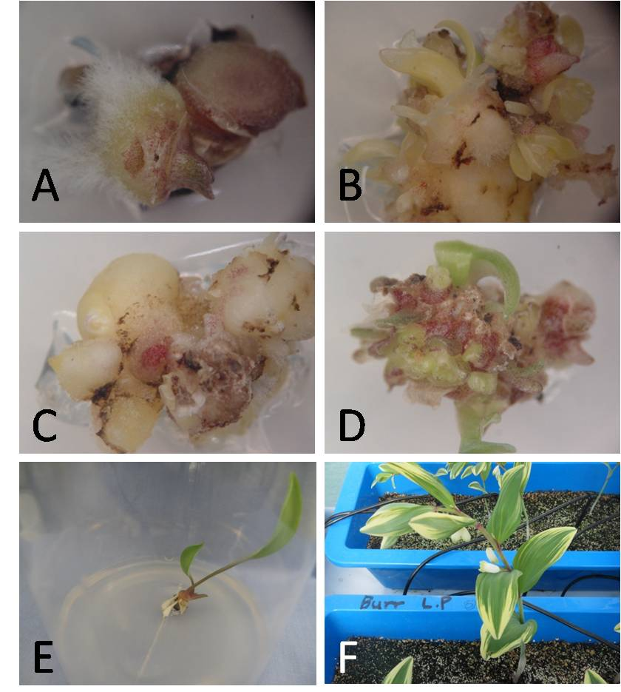
Fig. 1. In vitro propagation of Polygonatum odoratum var. pluriflorum for. variegatum. A) adventitious shoot bud with roots on Anderson medium with 0.5 mg l⁻¹ TDZ after 5 weeks of culture, B) adventitious shoot bud regeneration on Anderson medium with 1.0 mg l⁻¹ TDZ after 8 weeks of culture, C) shoot bud initiation on Anderson medium with 1.0 mg l⁻¹ 2,4-D, 2.0 mg l⁻¹ 2-iP, and 0.5 mg l⁻¹ TDZ, after 6 weeks of culture, D), shoot bud regeneration on Anderson medium with 1.0 mg l⁻¹ 2,4-D, 2.0 mg l⁻¹ 2-iP, and 0.5 mg l⁻¹ TDZ, after 8 weeks of culture, E) rooting of in vitro- regenerated shoot bud on half-strength Anderson medium with 1.0 mg l⁻¹ NAA after 6 weeks of culture, and F) acclimatized plants grown in the greenhouse.

