The influence of endogenous hormones on the formation of buds from Cotyledonary node of melon (Cucumis melo L.)
Huijun Zhang¹ xuezheng Wang¹ Peng Gao¹ Feishi Luan^{1＊} Meiling Gao²
( ¹Horticulture College, Northeast Agricultural University, Harbin, Heilongjiang Province, P.R. China, 150030²College of Life Science, Agriculture and Forest, Qiqihaer University, Qiqihaer，Heilongjiang province，P.R. China,161006)
Plant regeneration through organogenesis of shoot bud from callus cultures of melon was established and callus having different regeneration capacity were obtained, Cotyledonary node of melon (Cucumis melo L.) CM-23 was cultured on MS（Murashige and Skoog 1962）augmented with concentrations of benzyladenine (1.0mg/L) and IAA (0.1mg/L), The endogenous hormone concentrations indole-3-acetic acid (IAA), abscisic acid (ABA), gibberellins(GA), zeatin (ZT) of the calluses were determined, The endogenous ZT was higher in the cotyedonary node calluses that had formed buds, and there was a lower IAA/ZT ratio and IAA/GA ratio in the calluses having capacity for buds formation. The results showed addition of plant growth regulator influences endogenous hormone status，and it will be helpful for in vitro propagation of melon. This study therefore deduces that the various organogenic capabilities of cotyledonary node explants from melon are the result of their endogenous hormonal contents.
Key words: Endogenous phytohormones, in vitro culture, cotyledonary node melon (Cucumis melo L.).
Abbreviations: ABA, Abscisic acid; BA, benzyladenine; FW, fresh weight; GA₃, gibberellic acid ; IAA, indole-3-acetic acid; MS, Murashige and Skoog; ZT, zeatin.
Melon (Cucumis melo L.) is one of the oldest cultivated crops and an important horticultural crop grown in temperate, an annual tendril herbage plant belonging to family Cucurbitaceae. subtropical and tropical regions worldwide, being a significant component of fresh fruit traded internationally melon has a great potential for becoming a model plant for studying important traits in fruiting crops. In earlier studies on cucurbits via somatic embryogenesis, methods for plant regeneration from primary explants of cotyledons and leaves were established (Valentine et al, 2010; Muthu Thiruvengadam et al, 2010,). it was found that it was easy to induce callus and very difficult to differentiate buds (Tang et al, 1997; Tang et al, 1999; Sultana et al, 2003).
Plant hormones are chemicals occurring naturally within plant tissues, which are generally active at very low concentrations. They control the shape of the plant and mediate growth response on external factors such as light and temperature. It has been generally known that several factors influence organogenesis, the foremost of which include genotype, age and origin of the initial tissues, and composition of the medium (Josephina and van Staden 1990;Aneta et al.1994). Also, the original physiology status of explants and their hormonal contents are very important in directing in vitro response (Centeno et al.1996; Ana et al.2001 ). Up till now, five groups of plant hormone were found namely; auxins, cytokinins, gibberellins, ethylene and abscisic acid . Indole-3-acetic acid(IAA) is the major auxin involved in many of the physiological processes in plants (Wen Li Huang 2011). Gibberellic acid (GA₃),is the first gibberellin to be structurally characterized and it is not easily degraded to inactive conjugates by plant metabolism. Of the naturally occurring cytokinins, only zeatin have some use in plant tissue culture showing that both of them are active. The endogenous hormone levels have been regarded as critical for bud formation and even for plant regeneration in vitro culture for many plant species (Ansarali et al. 2009). To the best of our knowledge, there has been no report on endogenous hormones of Cotyledonary node calluses during in vitro culture in melon. A better understanding of the relationship between endogenous hormone concentrations in the calluses and the bud formation competence will be helpful for in vitro propagation of melon.
The purpose of this study the influence of endogenous hormones on the formation of buds from Cotyledonary node of melon . It should be noted, however, that just one cultivar was tested. Based on this premise, the correlation between the organogenic capacity of melon cotyledonary node explants, as a function of their developmental stages, and endogenous hormonal contents was confirmed.
Plant material and method
Seeds mature embryo were derived from viable seeds of melon inbred lines (CM-23). Seeds were supplied by the Watermelon & Melon Genetic Breeding Lab of Horticulture College at Northeast Agricultural University, Seeds were manually peeled and surface-sterilized with 70%(v/v) ethanol for 30s followed by 10 min sterilization with 0.1% mercuric chloride (HgCl₂) and then rinsed with sterile distilled (3 min) water. Ten seeds were placed in a 100mL triangle-bottle containing 25mL of basal medium MS (Murashige T, Skoog F 1962) supplemented with 30g/L sucrose and solidified with 8g/L agar (pH 5.8). All cultures were incubated in a growth chamber at 26±2°C with a 16h light/8h dark photoperiod (cool-white fluorescent lights at 60mol·m^{–2}·s^{–1}photon flux) for 5 days(Fig1A). Cotyledonary nodes were taken from 5 days old seedlings ( zhang et al 2011 ).
Shoot induction
Cotyledonary node explants of 5 days from seeding germination, (Fig 1B) containing 25 mL of basal MS medium solidified with 8g/L agar (pH 5.8, imported from Japanese agar), supplemented with 30g/L sucrose and different combinations of PGR: BA1.0mg/Land IAA 0.1mg/L. All cultures were incubated in a growth chamber at 25±2°C with 16h light/8h dark photoperiod (cool-white fluorescent lights at 60mol·m^{–2}·s^{–1}photon flux).
The explants were harvested at 0, 7, 14, 21, 28 day after the establishment of the culture. Samples of the stem calluses were surface dried and cleaned with a paper towel, immediately weighed and frozen in liquid nitrogen and stored at –80°C. Samples (approximately 0.5g fresh weight [FW]) were ground in liquid nitrogen the extraction, purification and determination of endogenous levels of IAA, GA, ABA and ZT by an indirect ELISA technique were performed as described by He(1993). The samples were homogenised in liquid nitrogen and extracted in cold 80%(v/v) methanol with butylated hydroxytoluene (1mmol·L¹)overnight at 4°C. The extracts were collected after centrifugation at 10000×g(4°C)for 20 min, the extracts were passed through a C₁₈Sep-Pakcatridge(Waters, Milford, MA) and dried in N₂. The residues were dissolved in PBS(0.01 mol·L⁻¹,PH7.4) in order to determine the levels of IAA,GA₃, ABA and ZT. Microtitration plates were coated with synthetic IAA,GA₃ or ABA, ZT. ovalbumin conjugates in NaHCO₃buffer (50mmol·L⁻¹,pH 9.6) and left overnight at 37°C.Oval-bumin solution (10 mg/mL) was added to each well in order to block nonspecific binding. After incubation for 30 min at 37°C,standard IAA,GA,ABA, ZT. samples and antibodies were added and incubated for a further 45 min at 37°C.The antibodies against IAA,GA, ABA were obtained as described by Weiler et al(1981). Then horseradish peroxidase-labelled goat antirabbit immunoglobulin was added to each well and incubated for 1 h at 37°C. Finally, the buffered enzyme substrate was added, and the enzyme reaction was carried out in the dark at 37°C for 15 min, then terminated using 3 mol·L⁻¹ H₂SO₄. The absorbance was recorded at 490 nm. Calculations of the enzyme-immunoassay data were performed as described by Weiler et al (1981). In this study, the percentage recovery of each hormone was calculated by adding known amounts of standard hormone to a split extract. Percentage recoveries were all above 90%, and all sample extract dilution curves paralleled the standard curves, indicating the absence of nonspecific inhibitors in the extracts.
Statistical analysis
a randomized complete block design was used for the experiments. For shoot induction, 6 explants per conical flask were inoculated in 100 mL flasks containing 30 mL of nutrient medium each, with 30 replicates per treatment. For differentiation, each treatment was applied to 30 calluses (5 calluses per conical flask and 6 replicates per treatment). Endogenous hormonal concentrations were determined in at least three biological replications. Significance between means was tested by Duncan's multiple range test
RESULT
Changes Indoleacetic Acid Concentration in Buds of during shoot initiation and development
Results showed significant differences in IAA concentrations in shoot of CM-23 olive at all sampling dates (Fig1A, Fig 2A, table1). IAA content of 0 day maximum. Then gradually declining. 28 days to have a minimum.
Results in Table (1) show significant differences in IAA concentration in all sampling date during shoots, These results suggest that IAA concentration in CM-23 buds play a significant role in the shooting of the cuttings and may be a limiting factor in this respect.
Changes in Endogenous zeatin Concentration in Buds of during shoot initiation and development
Results indicate that zeatin concentration in CM-23 shoots was significantly (fig 2B),
However, ZT higher oncentration shoots was significantly at 14 days (Table 1), The lowest zeatin concentration at 21days (Table 1, Fig1E). Based on these results, no consistent relationship can be established between zeatin concentration in shoots. ZT increases at 14 days may have a direct effect of the content of adventitious bud.
Changes in Endogenous Gibberellins Concentration in Buds of during shoot initiation and development
GA₃ concentration in buds was significantly the highest during 0 day (Table1, Fig1B ) and the lowest during (7.07±0.42 ng/g) 28 days compared to the other sampling dates. Table 1. There were significant differences in GA concentration during all sampling dates. A negative correlation was found concentration in CM-23 buds 0 day and 28 days .
Changes in Endogenous Abscisic Acid Concentration in Buds of during shoot initiation and development
ABA contents in shoot apex reached climax 0 day after etherhon application (Fig1B, Fig2 D, Table 1 ). After that, the ABA content in the shoot apex decreased continuously. In the mid and late stage of the shoot development, ABA content in the decreased slowly. ABA contents of shoot in the control plants did show any dramatic changes 0 day to 7 days (Fig 1D ). These results indicate that the application of ZT could cause increase in the contents of endogenous ABA, so high contents of endogenous ABA facilitated shoot initiation, but was not necessary to shoot development.
Changes in ratios between endogenous hormones during shoot initiation and development
This study analyzed changes in ratios between endogenous hormones during shoot initiation and development. The results show that in plants tissue, the ratio of IAA/ZT, IAA/GA all reached the climax at 0 day, and then dropped dramatically to the control level at 7 days(Fig 1E,F, ). Among them, the ratio of IAA/ABA, GA/ABA, ZT/ABA reached the climax at 7days and 14 days (Fig 2G,H,I ), and then dropped continuously to the control level .Obviously, IAA, GA played a more important role in shoot induction .
Discussion
In many plants, IAA has been shown to influence a wide variety of growth processes (Lincoln et al,1990). Evidence from physiological studies indicates that IAA affects such diverse processes as cell expansion during shoot elongation (Jacobs and Ray,1976), and apical dominance (Phillips,1975). Many mutants that appear to affect IAA levels cause morphological anomalies
In this report, The decrease in IAA concentration in shoots from 0 day to 28 days coincides with an increase shooting development of during culture (Table 1, Fig1C). Though the decrease levels of IAA may promote the internode elongation of melon, The increasing number of mutations or transgenes that affect IAA content, transport, or sensitivity, especially in Arabidopsis, provides a different approach to investigate the role of IAA in apical dominance, and in particular which stages of lateral shoot development it regulates in vitro (Stirnberg et al.,1999). Plants expressing the IAA biosynthetic genes from Agrobacterium tumefaciens have high endogenous IAA levels and increased apical dominance (Klee et al,1987;Romano et al,1993,1995). resulting in reduced levels of free IAA and reduced apical dominance(Romano et al,1991). Based on this point, it is hypothesized that apical dominance should not be the reason of the melon growth habit in C.moschata. A further study with a different application method and a different level of exogenous IAA is thereby needed to determine whether or not there is any relationship between IAA and vine elongation of melon plant.
ABA distributes ubiquitously in all organs and tissues of plants, and is abundant in the will be falling organs and tissues, especially in stress conditions (Yafeng Zhang, 2008). Endogenous ABA may nodulate the ratio or balance between hormones. in this study, ABA content increased shortly, then decreased during shoot formation, indicating that ABA played a cooperative role in shoot induction.
The role that GA₃ might play in the development of somatic embryogenesis in melon is not clear, low levels of GA₁-like substances and high levels of GA_{4/7} substances have been found in developing somatic embryos of carrot, while the opposite was found to be characteristic for proembryos. These authors postulated that the process of somatic embryogenesis in inhibited by endogenous GA₁ while it is less sensitive to endogenous GA_{4/7}. The immunological cross-reactions between GA₁, GA₃ and GA₂₀ in the present work do not allow us to exclude the possibility that the inactive GA₂₀ could be transformed into bioactive GA ₁ and GA₃; hence, it is not possible to make solid conclusions of the basis of existing data. Cytokinins could promote cell division and shoot initiation in many plants, Significantly higher ZT concentrations were found in the calluses that formed buds, and ZT in this study was consistent earier reports (Yoshimatsu and Shimomura,1994;Sarul et al.,1995)
There are many kinds of hormones that affect and control shoot differentiation of plants. The radar diagram (Fig 3) summarized and correlated normalized values of physiological parameters measured in this study after treatment with increasing concentrations of ABA and IAA. The main physiological parameters affected shoot bud, under our experimental conditions were ABA, IAA concentration might be the most notable response of melon callus to shoot.
In conclusion, higher concentrations of ZT were found in the calluses of cotyledonary node, while higher IAA/ZT and GA/ZT ratios were found in the callus. Significantly higher ZT concentrations were found in the calluses that formed buds, and inclusion of ZT in this study was consistent with earlier reports (Yoshimatsu and Shimomura, 1994; Sarul et al., 1995). In other studies, it was found that high concentrations of ABA were typical to adventitious bud-formation (Song and Gao, 2006; Guo and Gai, 1997; Liu et al, 2007). Our results differ from theirs, This may be because different genotypes were evaluated in the studies. lower levels of IAA/ ZT ratio in the cotyledonary node calluses seemed to be associated with the presence of bud formation, which is in agreement with the results of studies on other plants (Zaffari et al, 2000; Wang et al, 2005). With respect to the GA in control alluses, the high concentration may suppress adventitious bud formation. A similar result was also obtained in this study and lower GA/ZT ratio in cotyledonary node calluses was considered as an important factor for buds differentiation. To the best of our knowledge, this is the first work where endogenous hormone concentrations of cotyledonary node calluses in melon is analysed.

Table 1 Changes in endogenous levels of cotyledonary node during formation of buds in melon .
Measuremen(ng g⁻¹fw) | 0 | 7 | 14 | 21 | 28
ZT | 17.94±4.04a | 18.31±1.63a | 20.86±1.32a | 13.36±2.16a | 14.7±0.68a
GA | 13.45±3.27a | 7.28±0.53b | 7.44±0.15b | 8.44±1.57b | 7.07±0.42b
IAA | 96.35±1.27a | 44.20±5.14b | 36.26±5.14b | 37.51±1.46b | 36.69±5.91b
ABA | 130.96±6.82a | 42.11±5.84b | 58.61±5.84b | 38.24±4.2b | 36.69±5.64b
Note: The differences are presented in the same row, The values are means of three replicates± standard error (S.E.) D, days after medium A significant at P<0.01.
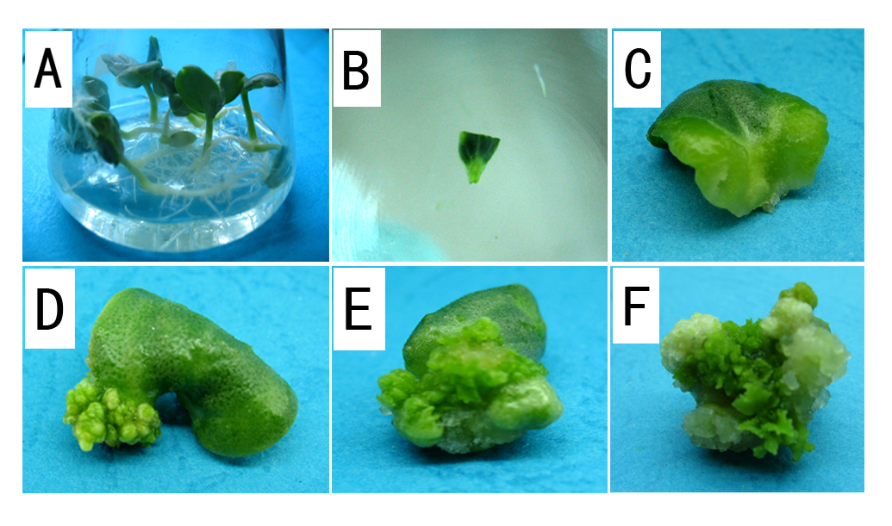
Figure 1
Several steps explants in plant regeneration form cotyledonary node explants of Cucumis melo L A. Embryogenesis of melon CM-23, Plants propagated by inbred line, after 5 days in propagation medium B. Embryogenesis of melon CM-23, Plants propagated by inbred line, after. cotyledonary node explants prepared for regeneration; C. cotyledonary node after 7 days in regeneration medium; D cotyledonary node after 14 days in regeneration medium; E cotyledonary node after 21day in regeneration medium;
F . cotyledonary node after 28day in regeneration medium;

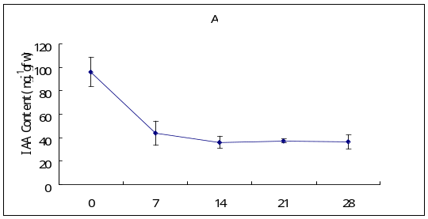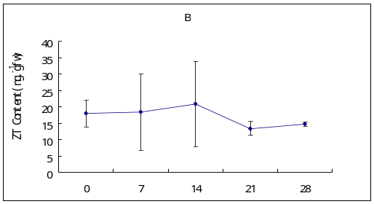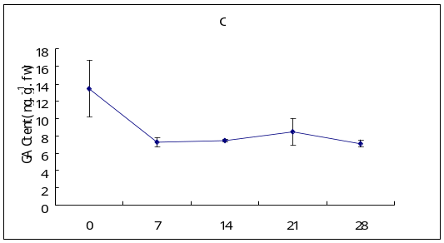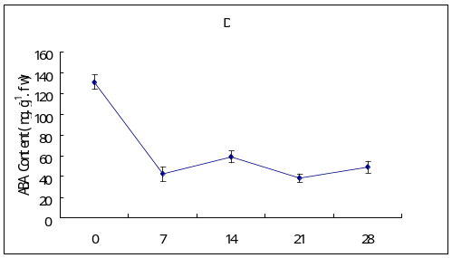
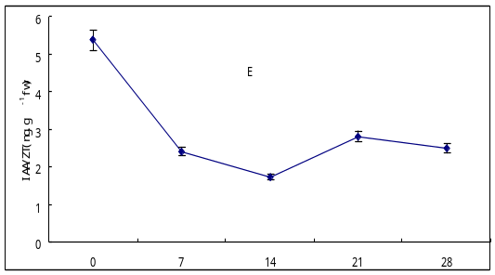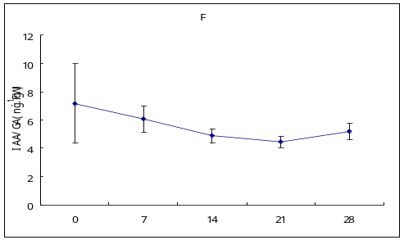

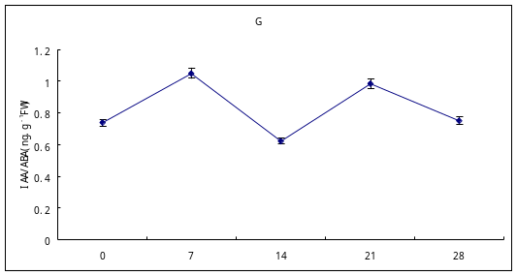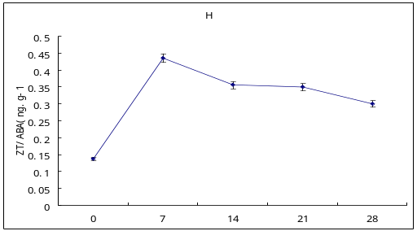

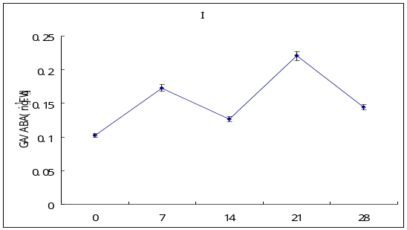
Days on regeneration measure
Fig.2 Changes in endogenous content during Shoot regeneration in melon callus. Vertical bars represent the standard Deviation for each measure (smaller than the symbol size in some data)
Fig.3 Radar diagram summarizing and correlating normalized values of physiological p arameters measured in this study after treatment with increasing concentrations of (0–28 day). The central point of the radar diagram represents the‘0%’value of each parameter (central blank polygon represents control values 50%) and the different line styles represent each parameter value under various physiological parameters.

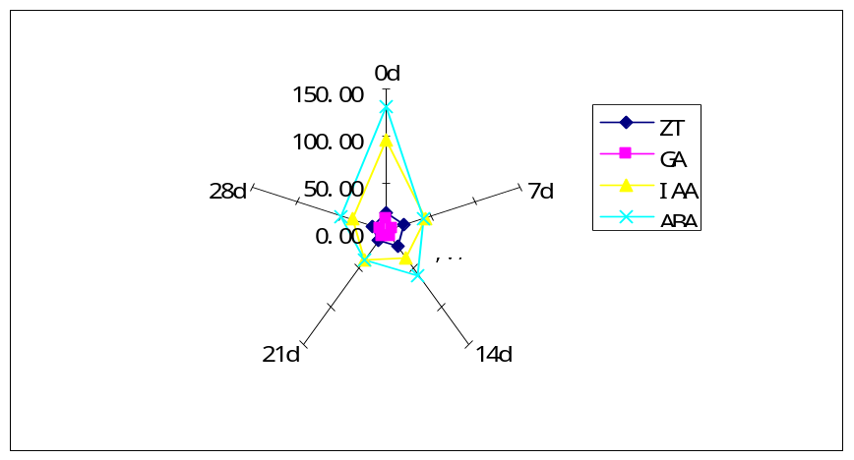

Acknowledgments
This work was supported by National Natural Science Foundation of China (31071812, 30871723); and China Agriculture Research System (CARS-26-02).
References
Ana EV,Ricardo JO,Bele′n F, Mar′a LC .(2001) .Relationships between hormonal contents and the organogenic response in Pinus pinea cotyledons. Plant Physiol .Bichem .39: 377 –384
Aneta I,Margarita V,Plamen D,Atanas A,Henri AVO.(1994).Endogenous hormone levels during direct somatic embryogenesis in Medicago falcata.Physiol Plant 92:85–89
ANSAR ALI, TOUQEER AHMAD, NADEEM AKHTAR ABBASI AND ISHFAQ AHMED HAFIZ. (2009). effect of different concentrentrations of auxins on in vitro rooting of olive cultivar “moralolo”, Pak. J. Bot., 41(3): 1223-1231,.
Centeno ML,Rodr′guez A,Feito I,Fern′andez B.(1996). Relationship between endogenous auxin and cytokinin levels and morphogenic responses in Actinidia deliciosa tissue . Plant Cell Rep 16:58–62
Edwin F. George, Michael A. Hall and Geert-Jan De Klerk.(2008). Plant Tissue Culture Procedure - Background Plant Propagation by Tissue Culture 978, 4020-5005
Effects of different combinations and concentrations of growth regulators and photoperiod on somatic embryogenesis of cucumis melo var.flexuosus. African Journal of Biotechnology. Vol.8(22) 6228-6232.
Guo ZB, Gai JY. (1997). Embryogenic callus inducing and differentiating regulated by endogenous IAA and ABA. Soybean Sci. 16(3): 194-198.
He Z.(1993).A Laboratory Guide to Chemical Control Technology on Field Crop. Beijing Agricultural University Press, Beijing China, pp. 60–68.
Jacobs,M.,Ray,P.(1976).Rapid auxin-induced decrease in free space pH and its relationship to auxin-induced growth in maize and pea.Plant Physiol.58, 203–209.
Josephina GN,van Staden J .(1990).The relationship betweengenotype, tissue age and endogenous cytokinin levels onadventitious bud formation on leaves of Lachenalia. Plant Cell Tissue Organ Cult 22:223–228
Klee,H.J.,Horsch,R.B.,Hinchee,M.A.,Hoffmann,N.L.(1987). The effects of overproduction of two Agrobacterium tumefaciens T-DNA auxin biosynthesis gene products in transgenic petunia plants. Genes Dev.1,86–96.
Liu Q, Zhu YH, Wu S, Shen GZ, Xiao LT .(2007). Studies on the content changes of endogenous phytohormones in rice calli for genetic transformation. Scientia Agricultura Sinica, 40(10): 2361-2367.
Lincoln,C.,Britton,J.H.,Estelle,M.(1990).Growth and development of the axr1 mutants of Arabidopsis.Plant Cell 2,1071–1080.
Muthu Thiruvengadam·K. T.Rekha·Chang-Hsien Yang·Narayanasamypillai Jayabalan·Ill – Min Chung .(2010). High-frequency shoot regeneration from leaf explants through organogenesis in bitter melon(Momordica charantia L.). Plant Biotechnol Rep. 4:321 – 328.
Murashige T, Skoog F .(1962). A revised medium for rapid growth and bioassays with tobacco tissue cultures. Physiol. Plant. 15:473-497.
Phillips, I. D.(1975).Apical dominance .Annu. Rev.Plant Physiol.26,341–367.
Romano,C.P.,Robson,P.R.H.,Smith,H.,Estelle,M.,Klee,H.(1995).Trans-gene-mediated auxin overproduction in Arabidopsis: hypocotyls elongation phenotype and interactions with the hy6-1 hypocotyl elongation and axr1 auxin-resistant mutants. Plant Mol. Biol. 27, 1071–1083.
Romano,C.P.,Cooper,M.L.,Klee,H.J.(1993). Uncoupling auxin and ethylene effects in transgenic tobacco and Arabidopsis plants. Plant Cell 5,181–189.
Romano,C.P.,Hein,M.B.,Klee,H.J.(1991).Inactivation of auxin in tobacco transformed with the indoleacetic acid–lysine synthetase gene of Pseudo-monas savastanoi.Genes Dev.5,438–446.
Sarul P, Vlahova M, Ivanova A, Atanassov A .(1995). Direct shoot formation in spontaneously occurring root pseudonodules of alfalfa (Medicago sativa L.). In Vitro Cell Dev. Biol. 31: 21-25.
Song LY, Gao F. (2006). Changes of endogenous hormones in Momordica charantia during in vitro culture. Chinese Bull. Bot. 23(2):192-196.
Stirnberg, P., Chatfield, S. P.,Ottoline Leyser,H.M.(1999).Axr1 acts after lateral bud formation to inhibit lateral bud growth in Arabidopsis. Plant Physiol. 121,839–847.
Sultana RS, Bari Miah MA. (2003). In vitro propagation of karalla (Momordica charantea Linn.) from nodal segment and shoot tip. J. Biol. Sci. 3(12): 1134-1139.
Tang L, Chen F, Jia YJ .(1997). In vitro propagation of Momordica charantia. Plant Physiol. Commun. 33: 126-127.
Tang L, Gou XP, Chen F .(1999). In vitro clonal propagation of balsam pear (Momordica charantia L.). J. Sichuan Univ. (Natural Science Edition), 36: 144-147.
Thomas T.D,Sreejesh KR. (2004). Callus induction and plant regeneration from cotyledon explants of ash gourd(Benincas ahispida L.). Scientia Horticulturae.100:359-367.
Valentine Otang Ntui.Raham Sher khan Dong Poh Chin.Ikuo Nakamura. Masahiro Mii.(2010). An efficient Agrobacterium tumefaciens-mediated genetic transformation of‘‘Egusi’’melon (Colocynthis citrullus L.). Plant Cell Tissue and Organ Culture. 103:15–22.
Wang XH, Shi XY, Wu XJ, Wang XD, Zhou KD .(2005). The influence of endogenous hormones on culture capability of different explants in rice. Agric. Sci. China, 4(5): 343-347.
Wen L iHuang • Chia-Huei Lee • Yi-Rung Chen.(2011). Levels of endogenous abscisic acid and indole-3-aceticacid inﬂuence shoot organogenesis in callus cultures of rice subjected to osmotic stress. 11240-011-0064 Plant Cell Tiss Organ Cult
Weiler E.W., Jourdan P.S.and Conrad W.(1981).Levels of indole3-acetic acid in intact and decapitated coleoptiles as determinedby a specific and highly sensitive solid-phase enzyme immunoassay. Planta 153:561–571.
Yafeng Zhang Jie hongZhou TaoWu Jiashu Cao Shoot regeneration and the relationship between Organogenic capacity and endogenous hormonal contents In pumpkin Plant Cell, Tissue Organ Cult. (2008). 93:323–331
Yoshimatsu K, Shimomura K. (1994). Plant regeneration on cultured roots segments of Cephalis ipecacuanha A. Richard. Plant Cell Rep. Plant Cell Rep. 14: 98-101.
Zaffari GR, Kerbauy GB, Kraus JE, Romano EC .(2000). Hormonal and histological studies related to in vitro banana bud formation. Plant Cell, Tissue Organ Cult. 63: 187-192.
Huijun Zhang,Gao Peng and Luan Feishi*African Journal of Biotechnology. (2011) . Efficient plant regeneration from cotyledonary node explants of Cucumis melo L. Vol .10(35), 6757-6761

 

