Leaf organogenesis in Anthurium andraeanum is affected by genotype, orientation and age of explants, and plant growth regulators

Jean C. Cardoso^{a*}, Gustavo Habermann^{b}

ª Lab de Biotecnologia Vegetal, Centro de Energia Nuclear na Agricultura - USP, Av. Centenário, 303, 13400-970, Piracicaba-SP, Brazil / jeancardosoctv@gmail.com (*corresponding author)
^{b} Departamento de Botânica, IB, Univ Estadual Paulista (UNESP), Rio Claro-SP, 13506-900, Brazil

ABSTRACT
Anthurium is one of the main pot-culture in the flower market, and micropropagation is the technique most used for clonal and large-scale propagation of this species. Callogenesis, organogenesis and plantlet regeneration were obtained from leaf segments of Anthurium andraeanum. The influence of genotypes, explant orientation, growth regulators and age of donor plants were tested. We obtained success in plant regeneration in three (‘Red One’, ‘Red Dark’, and ‘Snow White’) out of four cultivars that were tested. The ‘White Beauty’, however, was considered to be recalcitrant under these conditions. Therefore, in a second study conducted only with this cultivar, the use of juvenile rather than adult leaf explants enhanced plant regeneration from 0.3 to 2.8 plantlets per leaf lamina. In this study, using 1.0 mg L⁻¹ 6-benzylaminopurine (BAP) and no addition of 2,4-D in the culture medium induced plant regeneration of this valuable genotype. Plantlets obtained from ‘Red One’ and ‘White Beauty’ cultivars were successfully micropropagated and acclimatized. In the ex vitro phases, leaf-derived plants of these two genotypes were able to maintain their most important horticultural and ornamental characteristics.

Key-words: Direct and indirect organogenesis, recalcitrant cultivars, micropropagation, ex vitro cultivation, horticultural characteristics maintaining

Running Title: Leaf organogenesis in genotypes of Anthurium andraeanum

INTRODUCTION
The Anthurium genus is comprised of 1,500 species of tropical origin, and Anthurium andraeanum is of great ornamental value (Dufour and Guerin, 2003).
Despite of this important ornamental value, the use of seeds for propagating this species is prohibitive because seeds are available in small number and take too long to develop (Dufour and Guerin 2003). In addition, the high heterozygosity found in progenies obtained from crosses between hybrids (Bejoy et al. 2008) tends to result in high genetic segregation and uneven production. Vegetative propagation by traditional methods is difficult and time-consuming due to the slow growth behavior of this species. Therefore, the use of micropropagation is recognized as a successful alternative for anthurium propagation, as well as a rapid method for producing pathogen-free plants (D’Onghia et al. 2001, Martin et al. 2003).
Indirect organogenesis from leaf tissues are the most frequently used techniques for in vitro regeneration of this species (gantait and mandal 2010). Many explant types derived from different vegetative and reproductive organs have been successfully used (Atak and Çelik 2009). However, using leaf segments for indirect organogenesis has demonstrated to have wider applicability in attempts to micropropagate Anthurium because of enhanced regeneration potential and great genetic fidelity of regenerated plantlets (Gantait and Sinniah 2011). For this technique, callus induction and in vitro anthurium regeneration from leaf explants is highly dependent on genotypes (Silva et al. 2005, Gantait and Mandal 2010). However, for some anthurium cultivars, we have observed a conspicuous rate of unsuccessful regeneration.
Nevertheless, direct regeneration of anthurium plantlets from adult tissues is still a challenge.
The use of different explant orientation when inserting the explant into the regeneration medium has been reported to overcome unsuccessful results in ornamental species. Horizontal explant orientation, with adaxial-side-up was proved to have higher potential for induction of direct somatic embryogenesis in Phalaenopsis amabilis, P. ‘Nebula’ (Gow et al. 2009) and Oncidium cv. Gower Ramsey orchids (Chen and Chang 2002) than abaxial-side-up orientation.
Here we tested different genotypes and explants orientation on leaf-segmented organogenesis and plantlet regeneration of A. andraeanum. Additionally, we attempted to induce indirect and direct regeneration of plantlets using the same medium, i.e without transferring leaf explants or callus to another medium. The age of donor plants was tested as a potential factor controlling leaf organogenesis in recalcitrant cultivars. These goals provide practical information for micropropagation of anthurium cultivars.
We tested the hypothesis that (i) leaf organogenesis is affected by leaf explant orientation in the culture medium, and that (ii) using juvenile or adult phases strongly affect the in vitro organogenesis in recalcitrant cultivars of Anthurium andraeanum.

MATERIAL AND METHODS
Plant material
The leaves used for in vitro experiments were obtained from Anthurium andraeanum cv. ‘Red One’ and ‘Red Dark’ with red spathes, and ‘White Beauty’ with white spathes, all developed for potted plants, and cv. ‘Snow White’ with white spathes, which was originally developed to be cultivated as cut flowers.
The donor plants were derived from in vitro micropropagated plants, which were grown in plastic pots containing coconut fiber as organic substrate. These plants were maintained in greenhouse conditions, with an average irradiance of 300 μmol m⁻² s⁻¹ (11.5-h photoperiod), 25 ± 5°C and 60% as the minimum air relative humidity. Drip irrigation system and fertirrigation were used as recommended by horticultural standard procedures.

Study of explant orientation and genotypes on organogenesis of leaf segment
The four above-mentioned cultivars and three leaf-segmented explant orientations in the culture medium were tested. Explants orientation were horizontal, with the abaxial leaf surface in contact with the medium (ABA), horizontal, with the adaxial leaf surface in contact with the medium (ADA), and vertical, with 50% of the leaf segment inserted into the medium (VER).
The medium used for callus and shoot induction consisted of a ½ MS medium (Murashige and Skoog 1962) with a reduced concentration of NH₄NO₃ to 250 mg L⁻¹ (Geier 1986, Nhut et al. 2006, Atak and Çelik 2009), 30 g L⁻¹ of sucrose, 100 mg L⁻¹ of inositol, 1.0 mg L⁻¹ of thiamine, 1.0 mg L⁻¹ of 6-benzylaminopurine (BAP), and 0.1 mg L⁻¹ of 2,4-Diclorofenoxiacetic Acid (2,4-D). The medium pH was adjusted to 5.8 before solidification, which was achieved by adding 6.0 g L⁻¹ of Agar (Algagel, Type 900, Campinas-SP, Brazil). This medium was optimized for the conditions used in our lab, but it was also based on different protocols, as described above. Test tubes (13 cm x 2.1 cm) containing 10-mL of medium was used as culture vessels, which were autoclaved at 121°C under 1 kg cm⁻² for 20 min.
Leaves of donor plants were previously washed with tap water and detergent. Subsequently, these leaves were immersed in alcohol 75% (v/v) for one min, followed by immersion in a commercial bleach solution containing 1% (v/v) of active chlorine. Next, the leaves were washed three times in autoclaved distilled water.
Squares of one cm² were cut from leaf laminae using only distal and mid parts of young browned-green leaves (Martin et al. 2003). The midrib was cut and discarded.
Test tubes with leaf segments were maintained in dark conditions for 60 days, before being transferred to a 16-h photoperiod (35 µmol m⁻² s⁻¹ provided by white fluorescent lamps) for 30 days. The room temperature of both the dark and light conditions was 26 ± 1°C. The number of green and browned leaf segments, with callus, adventitious buds and shoots per leaf segment were measured after 90 days of incubation.
A two-way ANOVA was run to test the effects of the genotypes (4) and explant positions (3) and their interactions on the organogenesis of leaf segments. For each treatment, ten replications (test tubes containing one explant each) were used. The experiments were repeated twice.

Age of the donor plants on leaf organogenesis and shoot induction
A second experiment was conducted to study the influence of the age of donor plants and also to test different plant growth regulators (PGRs) in the culture medium. The ages of donor plants were: (D1) plants in the vegetative phase, with six months old after acclimatization, showing six completely expanded leaves, exhibiting no flowers; and (D2) plants in the reproductive phase, with 12 months old after acclimatization, displaying flowers and 12 to 15 completely expanded leaves.
Using the same previously described culture medium, we also tested the following PGRs types and combinations: (An1) 2,4-D at 0.1 mg L⁻¹ and BAP at 1.0 mg L⁻¹; (An2) BAP at 1.0 mg L⁻¹; (An3) 2,4-D at 0.1 mg L⁻¹ and kinetin at 1.0 mg L⁻¹; (An4) kinetin at 1.0 mg L⁻¹.
For this study, only the ‘White Beauty’ cultivar was used, because it showed a strong recalcitrant behavior regarding plantlet regeneration from in vitro organogenesis of leaf segment in the first study.
A two-way ANOVA was run to test the effects of the age of donor plants (2) and plant growth regulators in the medium (4) and their interactions on the organogenesis of leaf segments. For each treatment, ten test tubes containing one leaf segment (1 cm²) each were used as repetitions.
Growth conditions and period, as well as every evaluated parameter, were the same as those previously described in the first study.
For both experiments mean values were compared by the Tukey test (α = 0.05). The Assistat 7.6 (Silva 2011) statistical software was used. The second experiment also was repeated twice.

Micropropagation and growth of obtained plants
After shoot organogenesis obtained in both studies, the shoots were multiplied in the MS (Murashige and Skoog 1962) medium in which 25 g L⁻¹ of sucrose, 1.5 g L⁻¹ of activated charcoal, 0.1 mg L⁻¹ of inositol and 0.5 mg L⁻¹ of BAP were added. The medium used for stem elongation and rooting of anthurium shoots was the same as the medium previously described for the multiplication phase. However, BAP was replaced with indol-3-butyric acid at 0.1 mg L⁻¹. In both media, pH was adjusted to 5.8 ± 0.05 before solidification with 2.2 g L⁻¹ of Gelrite (Duchefa, Netherlands).
Growth conditions used in this phase were also the same as those used for the first and the second experiments previously described.
Two hundred plantlets of the ‘Red One’ and ‘White Beauty’ cultivars were acclimatized as follows: rooted plantlets were grown in plastic pots containing coconut fiber as organic substrate, and maintained in a greenhouse, where the air temperature oscillated between 20 (minimum) and 30°C (maximum) and an average irradiance of 150 μmol m⁻² s⁻¹ was used for the first three months, after which an average irradiance of 300 μmol m⁻² s⁻¹ was utilized.
The ex vitro plant development was observed for 18 months. During this phase, morphological alterations in plants obtained from leaf segment organogenesis were monitored, as well as the time for growth and flowering, and the color of leaves and flowers, which were closely observed.

RESULTS
Organogenesis from leaf explants
In both experiments, the rate of explant contamination varied from zero to 10%.
In the first study, three out of four cultivars responded to shoot organogenesis, with induction and regeneration of shoots from callus obtained from leaf segments. Only the 'White Beauty' cultivar showed a strong recalcitrant behavior to shoot organogenesis, presenting callus without shoot regeneration. For this cultivar, leaf segments, which were originally green, turned yellow after 60 days (dark conditions period), becoming darker and without shoot regeneration at the end of 90 days under (in vitro) incubation (Table 1).
The 'Red Dark' cultivar showed the highest rate of adventitious bud induction and shoot regeneration (8.13 shoots/leaf segment). Compared with ‘Red Dark’, the 'Red One' and 'Snow White' cultivars showed lower rates of adventitious bud induction and, consequently, shoot induction, although the rate of callus induction was high in these two cultivars (Table 1). We observed two types of callus formed from leaf segments: a cream-colored and usually small callus, and a green callus with intense growth. Both types showed shoot organogenesis.
Except for ‘White Beauty’, the other three cultivars showed shoot induction and regeneration by indirect organogenesis, with adventitious buds and plants obtained from the calluses (Table 1).
Leaf segments with adaxial surface in direct contact with the culture medium (ADA) showed callus induction and adventitious bud formation, with consequent shoot induction and regeneration (Table 1). When leaf segments with the abaxial surface was in contact with the culture medium (ABA), and when leaf segments were inserted in the vertical position into the culture medium (VER) they became yellow, then dark, and no callus induction or shoot induction was observed after 90 days of incubation (Table 1).
In the second study, the use of ‘White Beauty’ leaf explants obtained from juvenile donor plants demonstrated a higher potential for callus and shoot induction in comparison with leaf segment-derived from adult donor plants. This was especially evident when 1.0 mg L⁻¹ of BAP was added to the culture medium (An2), which produced 2.8 shoots per leaf segment (Table 2). However, when using this same PGR treatment (An2) for leaf segments obtained from adult donor plants, it was possible to observe shoot induction and regeneration, but at low number of shoots (0.3 shoots/leaf segment) (Table 2).
Leaf segments of 'White Beauty' adult donor plants inoculated in media with 2,4-D and BAP (An1) showed brown callus and tissues, but no shoot regeneration, after 90 days of incubation. Replacing BAP with another cytokinin (kinetin), with (An3) or without 2,4-D (An4) did not result in shoot induction in leaf explants obtained from adult plants (Table 2; Figure 1).
We also observed direct shoot organogenesis in leaf segments obtained from 'White Beauty' juvenile donor plants (0.8 shoots/leaf segment) and adult donor plants (0.3 shoots/ leaf segment) that were grown in 2,4-D-free media containing only BAP as cytokinin (Table 2). For juvenile tissues, adding 2,4-D, as well as replacing BAP with kinetin resulted in a drastic reduction in the number of shoots obtained through direct organogenesis (Table 2).

Micropropagation, acclimatization and ex vitro plant growth
Shoots obtained from leaf organogenesis of ‘Red Dark’ and ‘White Beauty’ cultivars were micropropagated, acclimatized and grown in greenhouse conditions. The multiplication rate of the 'Red Dark' cultivar was 5:1 (five shoots were obtained from each explant), requiring approximately 160 days for the production of 200 plants. Approximately 93% of these plants were successfully rooted and 89% of them were successfully acclimatized under greenhouse conditions. The multiplication rate of the 'White Beauty' cultivar was 3.5:1, which required approximately 200 days for the production of 200 plants. Approximately 98% of these plants were successfully rooted and 96% of them were successfully acclimatized under greenhouse conditions.
The plants obtained from these cultivars grew vigorously and showed no morphological variations, maintaining the main characteristics of their respective donor plants. For the 'White Beauty' cultivar, the time for plant development and for first flowering after ex vitro cultivation, as well as other horticultural characteristics of final obtained plants was similar between juvenile and adult leaf-derived plants. In addition, these flowers maintained the same morphological characteristics and color as donor plants, without apparent morphological variations (Figure 2).

DISCUSSION
Most protocols for induction and regeneration of anthurium shoots obtained from leaf segments (Joseph et al. 2003, Atak and Çelik 2009, Jahan et al. 2009) are usually performed in two phases: (1) production of callus and (2) induction and regeneration of shoots. As a novelty, we were able to obtain induction of callus and regeneration of anthurium shoots using the same medium, without transferring the calluses to another medium.
The results from the first experiment showed that leaf segments with the adaxial surface in direct contact with the culture medium (ADA) was the best leaf explant orientation for obtaining anthurium shoot induction, which corroborates our first hypothesis. Differently, adaxial-side-up (ABA-type) position was improved induction of direct somatic embryogenesis in Phalaenopsis amabilis and P. Nebula (Gow et al. 2009) and in Oncidium cv. 'Gower Ramsey' (Chen and Chang 2002) orchids. Therefore, the adaxial leaf surface might present some hormonal importance in the process of callus induction and plantlet regeneration in some species, such as A. andraeanum. Differences in the shoot induction when using the adaxial or abaxial leaf surfaces in contact with the culture medium might involve genetic, physiological and morphological reasons, starting with their different leaf polarity, which is ontogenetically established in the shoot meristem (Sessions and Yanofsky 1999, Xu et al. 2003). Such differences between leaf surfaces may also involve their distinct capacities for water and ion uptake (Schönherr 2006). Therefore, these findings in A. andraeanum are of great importance for further investigation.
The age of donor plant seems to be another critical factor that controls the shoot organogenesis in anthurium. For the 'White Beauty', we showed that the recalcitrance associated with this cultivar may be related to the developmental stage of donor plants. The reason why there is a reduction or loss of the in vitro regeneration capacity when anthurium plants become adults is unknown. In Prunus serotyna, 91.4% success performance in leaf shoot regeneration was reported when using juvenile explants, compared with 40% success performance of mature explants (Liu and Pijut 2008). Attempts to optimize regeneration protocols for adult-derived explants have been performed in tree species, which have long juvenile cycles; for this, genetic transformation to enhance cell competence for regeneration has been useful (Cervera et al. 2008, Peña-Ramírez et al. 2010). The juvenile-to-adult shift is little understood. However, science already knows that it does not only involve plant development shifts, including the silencing of many genes that can be reverted with the application of osmotic or temperature stress and/or with the use of PGRs (von Aderkas and Bonga 2000, Park et al. 2010).
Amongst PGRs, 2,4-D was pointed out by our results as a potential inhibitor of adventitious bud formation and shoot induction, especially for ‘White Beauty’. Therefore, our results, combined with those obtained from previous studies (Bejoy et al. 2008, Jahan et al. 2009) support the hypothesis that 2,4-D can serve as an inhibitor of leaf organogenesis in the regeneration of shoots from adult tissues for most anthurium cultivars. In addition, besides absence of 2,4-D, the presence of BAP is absolutely necessary for tissue regeneration (Table 2). This was also observed in Solanum tuberosum, in which 2,4-D was confirmed as an inhibitor whereas BAP was considered to be a promoter of adventitious bud formation (Shirin et al. 2007).
Our results indicated distinct shoot induction in leaf segments collected from four anthurium genotypes. Nhut et al. (2006) observed significant differences in the in vitro production of callus, organogenesis and regeneration of plantlets from leaf segments collected form ten anthurium cultivars. Two genotypes tested by these authors did not produce callus, and there was no plantlet regeneration from the callus observed in the other eight genotypes tested. A similar recalcitrance was observed in ‘Octopus’ cultivar of Dieffenbachia genus, which is related to Anthurium genus; in that cultivar, Shen et al. (2008) reported that no shoots or plantlet regeneration were obtained from leaf explants. Therefore, observations made by Nhut et al. (2006), Shen et al. (2008), as well as our results obtained with the recalcitrant ‘White Beauty’ cultivar largely exemplify strong factors involved in the recalcitrance to regenerate anthurium plantlets from leaf segments used as explants.
The current study allowed us to propose a protocol for direct regeneration of plantlets to be obtained from leaf segments of anthurium. The direct organogenesis has important advantages, such as presenting a faster start in the process of clonal propagation by using micropropagation, and resulting in a more genetically stable plant material for propagation, in comparison with plant material that is obtained from callus culture, because of the likely high somaclonal variation associated with the induction and cultivation of callus, as observed for Dieffenbachia (Shen et al. 2007), potato (Bordallo et al. 2004) and strawberry (Nehra et al. 1992).
The multiplication, rooting and acclimatization patterns of anthurium plantlets observed in the present study were similar to those observed for other anthurium cultivars (Atak and Çelik 2009, Martin et al. 2003). Every acclimatized plant that was subsequently cultivated in pots grew vigorously and showed no apparent morphological variations, maintaining the main characteristics of the original cultivars of donor plants. For ornamental species, monitoring horticultural traits in the field is important to detect any somaclonal variations that could have occurred in the in vitro phase. This horticultural watch in the field is important as the usage of molecular markers may fail to detect or may even be unable to reveal such variations, mainly because of the small number of markers available for these plants. Park et al. (2009) found fails in the use of RAPD markers to separate mutants of Doritaenopsis orchid obtained from tissue culture. In anthurium, SSR markers have also failed to detect genetic fidelity of micropropagated plants (Gantait and Sinniah 2011).
Systematic studies, like the present report, aiming to detect not only more responsive cultivars, but also to establish hypotheses for revealing the reasons associated with recalcitrance of valuable genotypes, are essential in plant micropropagation science. In addition, these studies show important improvements in the in vitro regeneration protocols.
In the present study, we showed that leaf segments with the adaxial surface in direct contact with the culture medium was the best leaf explant orientation for obtaining anthurium regeneration. Moreover, it became clear that callus and plantlet regeneration from leaf segments is genotype-dependent, and is best achieved when using juvenile donor plants, especially for the recalcitrant 'White Beauty' cultivar. Finally, BAP, and not 2,4-D, in the culture medium was demonstrated to be the best PGR to achieve the highest number of shoots and plantlets per leaf segment. As a novelty, we showed direct regeneration of shoots from adult tissues to be possible, but with fewer shoots and plantlets when BAP only was added to the media.

ACKNOWLEDGEMENTS
J. C. Cardoso acknowledges Vliet Flora Co. for the financial support and experimental conditions provided for the development of this study. G. Habermann acknowledges the Brazilian National Council for Scientific and Technological Development (CNPq) for the research productivity fellowship (CNPq Proc. 306119/2011-0).

REFERENCES
Atak Ç., Çelik O. (2009) Micropropagation of Anthurium andraeanum from leaf explants. Pakistan Journal of Botany, 41: 1155-1161.
Bejoy M., Sumitha VR., Anish MP. (2008). Foliar Regeneration in Anthurium andraeanum Hort. cv. Agnihothri Biotechnology, 7: 134-138.
Bordallo NP., Silva DH., Maria J., Cruz, C.D., Fontes, E.P. (2004). Somaclonal variation on in vitro callus culture potato cultivars. Horticultura Brasileira, 22: 300-304.

Cervera M., Navarro A., Navarro L., Peña L. (2008). Production of transgenic adult plants from clementine mandarin by enhancing cell competence for transformation and regeneration. Tree Physiology, 28: 55-66.

Chen JT., Chang WC. (2002). Effects of tissue culture conditions and explants characteristics on direct somatic embryogenesis in Oncidium ‘Gower Ramsey’. Plant Cell Tissue and Organ Culture, 69: 41-44.
D’Onghia AM., Carimi F, De Pasquale F., Djelouah K., Martelli GP. (2001). Elimination of citrus psorosis virus by somatic embryogenesis from stigma and style cultures. Plant Pathology, 50: 266–269.
Dufour L., Guerin V. (2003). Growth, developmental features and flower production of Anthurium andraeanum Lind. in tropical conditions. Scientia Horticulturae, 98: 25-35.
Gantait S., Mandal N. (2010). Tissue culture of Anthurium andraeanum: A significant review and future prospective. International Journal of Botany, 6: 207-219.
Gantait S., Sinniah UR. (2011). Morphology, flow cytometry and molecular assessment of ex-vitro grown micropropagated anthurium in comparison with seed germinated plants. African Journal of Biotechnology, 10: 13991-13998.
Geier T. (1986). Factors affecting plant regeneration from leaf segments of Anthurium scherzerianum Schott (Araceae) cultured in vitro. Plant Cell Tissue and Organ Culture, 6: 115-125.
Gow WP., Chen JT., Chang WC. (2009). Effects of genotype, light regime, explants position and orientation on direct somatic embryogenesis from leaf explants of Phalaenopsis orchids. Acta Physiologiae Plantarum, 31: 363-369.
Jahan MT., Islam MR., Khan R., Mamun ANK., Ahmed G., Hakim L. (2009). In vitro clonal propagation of Anthurium andraeanum L. using callus culture. Plant Tissue Culture & Biotechnology, 19: 61-69.
Joseph D., Martin KP., Madassery J., Philip VJ. (2003). In vitro propagation of three commercial cut flower cultivars of Anthurium andraeanum Hort. Indian Journal of Experimental Biology, 41: 154-159.
Liu X., Pijut PM. (2008) Plant regeneration from in vitro leaves of mature black cherry (Prunus serotina). Plant Cell Tissue and Organ Culture, 94: 113-123.
Maira O., Alexander M., Vargas TE. (2010). Micropropagation and organogenesis of Anthurium andraeanum Lind cv. Rubrum. Methods in Molecular Biology, 589: 3-14.
Martin KP., Joseph D., Madasser J., Philip VJ. (2003). Direct shoot regeneration from lamina explants of two commercial cut flower cultivars of Anthurium andraeanum Hort. In Vitro Cellular & Developmental Biology – Plant, 39: 500-504.
Murashige T., Skoog F. (1962). A revised medium for rapid growth and bioassay with tobacco tissue cultures. Physiologia Plantarum, 15: 473–497.
Nehra NS., Kartha KK., Stushnoff C., Giles KL. (1992). The influence of plant growth regulator concentrations and callus age on somaclonal variation in callus culture regenerants of strawberry. Plant Cell Tissue & Organ Culture, 29: 257-268.
Nhut DT., Duy N., Vy NNH., Kue CD., Khiem DV., Vinh DN. (2006). Impact of Anthurium spp. genotype on callus induction derived from leaf explants, and shoot and root regeneration capacity from callus. Journal of Applied Horticulture, 8: 135-137.
Park SY., Klimaszewska K., Park JY., Mansfield SD. (2010). Lodgepole Pine: The first evidence of seed-based somatic embryogenesis and the expression of embryogenesis marker genes in shoot bud culture of adult trees. Tree Physiology, 30: 1469-1478.

Park SY., Murthy HN., Chakrabarthy D., Paek KY. (2009). Detection of epigenetic variation in tissue-culture-derived plants of Doritaenopsis by methylation-sensitive amplification polymorphism (MSAP) analysis. In Vitro Cellular & Developmental Biology – Plant, 45: 104-108.
Peña-Ramírez YJ., Juárez-Gómez J., Gómez-López L., Jerónimo-Pérez JL., García-Sheseña I., González-Rodríguez JA., Robert ML. (2010). Multiple adventitious shoot formation in Spanish Red Cedar (Cedrela odorata L.) cultured in vitro using juvenile and mature tissues: an improved micropropagation protocol for a highly valuable tropical tree species. In Vitro Cellular & Developmental Biology – Plant, 46: 149-160.
Schönherr J. (2006). Characterization of aqueous pores in plant culticles and permeation of ionic solutes. Journal of Experimental Botany, 57: 2471-2491.
Sessions A., Yanofsky MF. (1999). Dorsoventral patterning in plants. Genes & Development, 13: 1051-1054.
Shen X., Chen J., Kane ME., Henny RJ. (2007). Assessment of somaclonal variation in Dieffenbachia plants regenerated through indirect shoot organogenesis. Plant Cell Tissue and Organ Culture, 91: 21-27.
Shen X., Kane ME., Chen J. (2008). Effects of genotype, explants source, and plant growth regulators on indirect shoot organogenesis in Dieffenbachia cultivars. In Vitro Cellular & Developmental Biolology – Plant, 44: 282-288.
Shirin F., Hossain M., Kabir MF., Roy M., Sarker RS. (2007). Callus induction and plant regeneration from internodal and leaf explants of four potato (Solanum tuberosum L.) cultivars. World Journal of Agricultural Sciences, 3: 1-6.
Silva FAS. (2011). Assistat Version 7.6 (Statistical Assistance). UFCG, Campina Grande, Brazil.
Silva JAT., Nagae S., Tanaka M. (2005). Effect of physical factors on micropropagation of Anthurium andraeanum. Plant Tissue Culture, 15: 1-6.
von Aderkas P., Bonga JM. (2000). Influencing micropropagation and somatic embryogenesis in mature trees by manipulation of phase change, stress and culture environment. Tree Physiolpgy, 20: 921–928.

Xu L., Xu Y., Dong A., Sun Y., Pi L., Xu Y., Huang H. (2003). Novel as1 and as2 defects in leaf adaxial-abaxial polarity reveal the requirement for ASYMMETRIC LEAVES1 and 2and ERECTA functions in specifying leaf adaxial identity. Development, 130: 4097-4107.

Table 1 – Effects of genotypes and explant orientation on organogenesis of leaf segments of Anthurium andraeanum (Efeitos de genótipos e orientação dos explants sobre a organogenese de segmentos foliares de Anthurium andraeanum)
Cultivar |  | Leaf Lamina |  |  |  | Number of
 | Explant Orientation | Green / Total | Browned / Total | with Callus / Total |  | Adventitious Bud /Leaf Segment | Shoots  / Leaf Segment
 | ABA | 0/10 aB | 10/10 aA | 0/10 bA |  | 0.0 aB | 0.0 aB
‘Red Dark' | ADA | 10/10 aA | 0/10 cB | 10/10 aA |  | 11.75 aA | 8.13 aA
 | VER | 0/10 aB | 10/10 aA | 0/10 bA |  | 0.0 aB | 0.0 aB
 | ABA | 0/10 aA | 10/10 aA | 0/10 bA |  | 0.0 aB | 0.0 aB
‘Red One' | ADA | 2/10 cA | 8/10 aA | 10/10 aA |  | 2.5 bA | 0.63 cA
 | VER | 0/10 aA | 10/10 aA | 0/10 bA |  | 0.0 aB | 0.0 aB
 | ABA | 0/10 aB | 10/10 aA | 0/10 bA |  | 0.0 aB | 0.0 aB
‘White Snow' | ADA | 6/10 bA | 10/10 aA | 10/10 aA |  | 2.0 bA | 1.25 bA
 | VER | 0/10 aB | 10/10 aA | 0/10 bA |  | 0.0 aB | 0.0 aB
 | ABA | 0/10 aA | 10/10 aA | 0/10 bA |  | 0.0 aA | 0.0 aA
‘White Beauty' | ADA | 0/10 cA | 6/10 bB | 10/10 aA |  | 0.0 cA | 0.0 dA
 | VER | 0/10 aA | 10/10 aA | 0/10 bA |  | 0.0 aA | 0.0 aA
Genotype |  | ** | ** | ns |  | ** | **
Explant position |  | ** | ** | ** |  | ** | **
Interaction |  | ** | ** | ns |  | ** | **
CV (%) |  | 21.5 | 21.72 | 0.0 |  | 35.29 | 20.59

Asterisks (**) and ‘ns’ represent, respectively, significant and non-significant difference between factors (genotypes, explant position and their interaction) by F test (P < 0.01). For each variable, the same lowercase letters in columns (between the same explant positions) are not significantly different by Tukey’s test (P < 0.01), and the same uppercase letters in columns (between the same genotypes) are not significantly different by Tukey’s test (P < 0.01). Mean values are comprised of 10 replications per treatment.
ABA – leaf lamina with the abaxial leaf surface in direct contact with the culture medium; ADA – leaf lamina with the adaxial leaf surface in direct contact with the culture medium; VER – vertical leaf segments inserted directly into the culture medium; CV(%) – Coefficient of variation

Table 2 – Effects of juvenile and adult explants of the ‘White Beauty’ cultivar on organogenesis of leaf explants of Anthurium andraeanum cultivated in culture media composed with different PGRs (An1, An2, An3, and An4) (Efeitos de explantes obtidos de plantas juvenis e adultas da cultivar ‘White Beauty’ sobre a organogênese de explantes foliares de Anthurium andraeanum cultivados in vitro em meio de cultura com diferentes reguladores vegetais).
Explant | Culture | Leaf Segment / Total |  |  |  | Number of Buds / Leaf Segment |  |  | Shoots / Leaf
age | Media | Green | Browned | with Callus |  | Direct Buds | Total of Buds |  | Segment
 | An1 | 0/10 bB | 10/10 aA | 10/10 aA |  | 0.2 aB | 0.2 aB |  | 0.2 aB
Juvenile leaf | An2 | 10/10 aA | 0/10 bC | 10/10 aA |  | 0.8 aA | 3.0 aA |  | 2.8 aA
 | An3 | 10/10 aA | 0/10 bC | 10/10 aA |  | 0.0 aB | 0.2 aB |  | 0.2 aB
 | An4 | 4/10 aA | 6/10 aB | 10/10 aA |  | 0.1 aB | 0.1 aB |  | 0.1 aB
 | An1 | 4/10 aA | 6/10 bC | 4/10 bC |  | 0.0 aA | 0.0 aA |  | 0.0 aA
Adult leaf | An2 | 8/10 aA | 1/10 aD | 9/10 bA |  | 0.3 bA | 0.3 bA |  | 0.3 bA
 | An3 | 0/10 bC | 10/10 aA | 4/10 bC |  | 0.0 aA | 0.0 aA |  | 0.0 aA
 | An4 | 1/10 bB | 8/10 aB | 6/10 bB |  | 0.0 aA | 0.0 aA |  | 0.0 aA
Explant age |  | ** | ** | ** |  | ** | ** |  | **
Culture media |  | ** | ** | ** |  | ** | ** |  | **
Interaction |  | ** | ** | ** |  | ** | ** |  | **
CV (%) |  | 17.58 | 2.64 | 5.59 |  | 22.69 | 30.45 |  | 32.51
Asterisks (**) and ‘ns’ represent, respectively, significant and non-significant difference between factors (explant age, plant growth regulator composition in the culture media and their interaction) by F test (P < 0.01). For each variable, the same lowercase letters in columns (between the same culture media) are not significantly different by Tukey’s test (P < 0.01), and the same uppercase letters in columns (between the same explant age) are not significantly different by Tukey’s test (P < 0.01). Mean values are comprised of 10 replications per treatment.
An1 - BA (1.0 mg L⁻¹) + 2,4-D (0.1 mg L⁻¹); An2 - BA (1.0 mg L⁻¹); An3 - Kinetin (1.0 mg L⁻¹) + 2,4-D (0.1 mg L⁻¹); An4 - Kin (1.0 mg L⁻¹)
CV(%) – Coefficient of variation

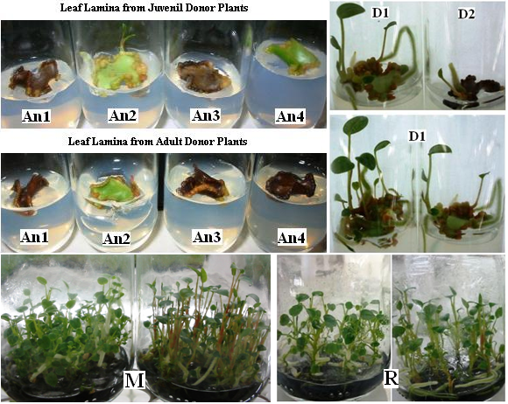
Figure 1 – Micropropagation and in vitro development of plantlets of Anthurium andraeanum obtained by organogenesis from leaf segments (Micropropagação e desenvolvimento in vitro de plântulas de Anthurium andraeanum obtidas por organogênese a partir de segmentos foliares): An1 - BA (1.0 mg L⁻¹) + 2,4-D (0.1 mg L⁻¹); An2 - BA (1.0 mg L⁻¹); An3 - Kin (1.0 mg L⁻¹) + 2,4-D (0.1 mg L⁻¹); An4 - Kinetin (1.0 mg L⁻¹); D1 – Juvenile explants; D2 – Adult explants; M – Multiplication phase and R – Rooting phase. On the left – Red One cultivar; On the right – White Beauty cultivar.
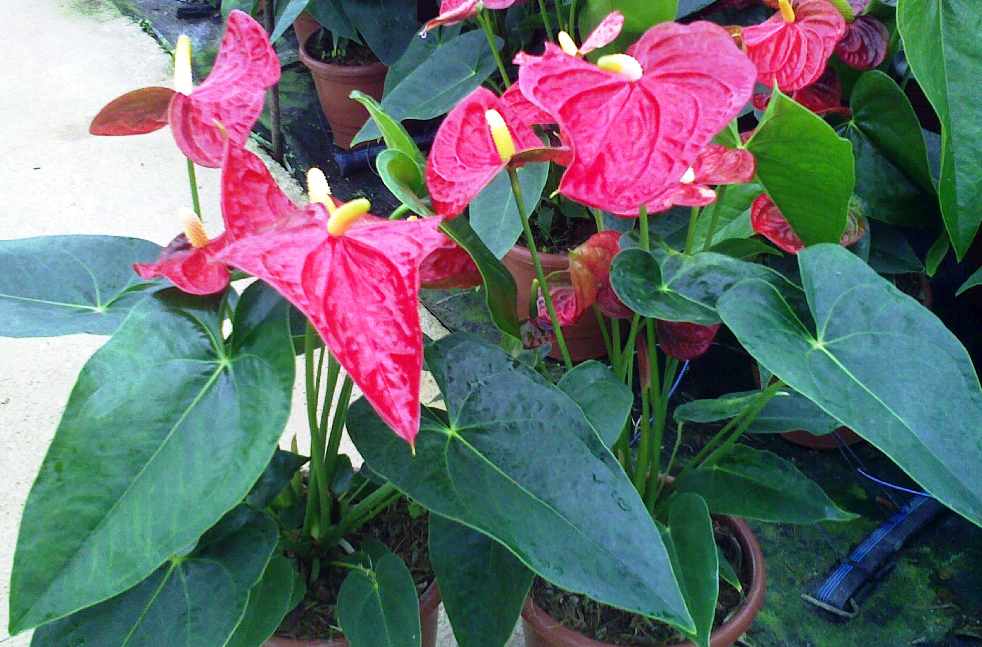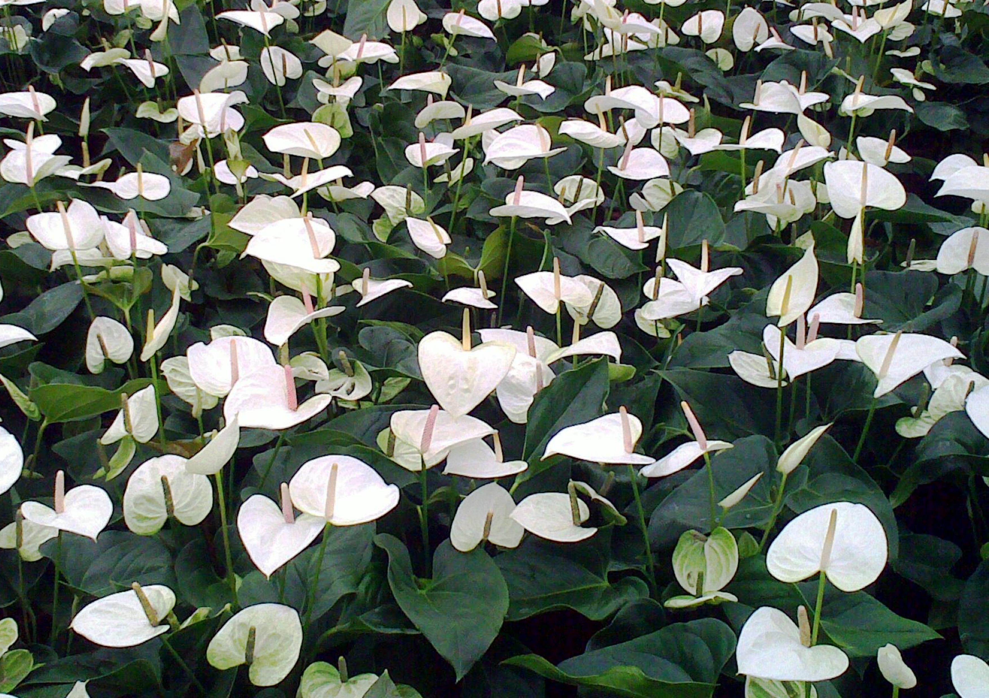
Figure 2 – Eighteen-month-old plants, grown in the greenhouse, obtained from organogenesis of leaf segment culture of Anthurium andraeanum. On the left: ‘Red One’ cultivar; on the right: ‘White Beauty’ cultivar. (Plantas com 18 meses de idade cultivadas em estufa, obtidas a partir da organogênese de segmentos foliares de Anthurium andraeanum)

