Osmopriming alleviates drought stress in soybean (Glaycine max L.) seeds during germination and early growth stages
Mahdi Ghiyasi¹ and Mehdi Tajbakhsh¹
¹Department of Agronomy, Faculty of Agriculture, Urmia University, Urmia, West Azarbaijan, Iran
Abstract:
Germination and seedling establishment are critical stages in the life cycle of plants especially under stress conditions. The objective of this study was to evaluate the effect of osmopriming on germination and seedling growth of Soybean (Glycine max L.) seeds under drought stress. Seeds were primed in aerated solutions of PEG 6000, KNO3 and KH2PO4 have -1.2 MPa osmotic potential. Drought levels were 0 (control), -3,-6,-9 bar. Stress condition was created by using PEG6000. Final germination percentage, time to get 50% germination (T50), seedling vigor index (SVI), germination index (GI), reduction percentage of germination (RPG), seedling dry weight and length were measured. The results indicated that inhibition of germination and seedling growth due to drought stress should be overcome by using osmopriming treatments in soybean. Among the materials used for osmopriming PEG 6000 has the greatest impact on mitigating the effects of drought stress on germination and early growth stages.
Key words: Germination, osmopriming, PEG 6000, drought, soybean,
Introduction:
Soybean (Glycine max L.) is one of the most important oil and protein crop throughout the world. Its oil is the largest component of the world’s edible oils. The world production of edible oils consists of 30% soybean. Poor germination and low seed viability are among the serious problems in the production of soybean (Arif et al., 2010).
Plant growth and productivity affected by nature’s wrath in the form of various abiotic stress factors. Plants are frequently exposed to the plethora of stress conditions such as salt, drought, Oxidative stress and others. All these stress factors are a means for plants and prevent them from reaching their full genetic potential and limit the crop productivity worldwide (Mahajan and Tuteja, 2005).
Lack of adequate soil moisture in the seedbed is a major obstacle to the establishment of the crop, because inadequate soil moisture can reduce germination, slow down seedling growth and decrease yield (Saglam et al., 2010).
There are many strategies to overcome the negative effects of drought. A good strategy is the selection of cultivars and species for drought condition (Pavlousek, 2011). However, an alternative strategy for the possibilities to overcome drought stress is by seed pre-sowing treatments (Ghiyasi et al., 2008). Seed priming was defined as pre-sowing treatments in water or in an osmotic solution that allows the seed to imbibe water to proceed to the first stage of germination, but prevents radical protrusion through the seed coat (Yari et al., 2012). Seed priming techniques such as hydropriming, hardening, osmopriming, osmohardening, hormonal priming and hydropriming have been used to accelerate emergence more vigorous plants and better drought tolerance in many field crop like what (Iqbal and Ashraf, 2007) , chickpea (Kaur et al., 2002), sunflower (Kaya et al., 2006), cotton ( casenve and Toselli, 2007) triticale ( Yagmur and Kaydan, 2008).
Primed seeds usually to exhibit an increased germination rate, greater germination uniformity and greater total germination percentage. Increased germination rate and uniformity have been attributed to metabolic repair during imbibitions build up of germination enhancing metabolites (Abbasdokht, 2012).
The objective of this study was to evaluate the effect of seed priming on soybean germination and vigor under drought stress.
Material and Methods:
This study was carried out at the Department of Agronomy, Faculty of Agriculture, Urmia University, West Azerbaijan, Iran. Seeds of soybean cv. Williams were used. Seed moisture content was determined by high-temperature oven method at 130±2º C for 4 hours (ISTA,2003). The mean moisture content of seed sample was about 10.30%.
The experimental design was tow factors factorial arranged in completely randomized design (CRD) with three replications. The first factor was osmopriming treatments consisted of soaking in -1.2 MPa solutions of KNO3, KH2PO4 and polyethylene glycol (PEG) 6000, and the second factor was drought levels (0, -0.3, -0.6 and -0.9 bar ). Drought stress was simulated by highly osmotic substance PEG of molecular weight (MW) 6000. Non-primed seeds were used as control. Before applying experimental treatments the seeds were sterilized by using 30% hypochlorite for five minutes and then washed three times with distilled water (Umair et al., 2012). The seeds were soaked in aerated solutions of all the osmopriming treatments for eight hours. After priming, seeds were given three surface washings with distilled water and re-dried, near to original weight under shade (Unair et al., 2011).
The standard germination test was performed by pacing 100 seeds between two women no. 1, filter paper in 120 mm Petri dishes (three Petri dishes were used in each replication). Petri dishes containing primed and control seeds were irrigated with solutions of drought stress levels. During the test filter papers in the Petri dishes were kept water saturated state. All Petri dishes moved to germinator with 25º C, temperature at dark condition (ISTA, 2003). Germinated deeds in each treatment were recorded every 24 hours for seven days. Seeds were considered as germinated when the radical length reached 2 mm long.
The time to get 50% germination (T50) was calculated according to the following formulae of Coobear et al. (1984) modified by Farooq et al. (2005) as below:
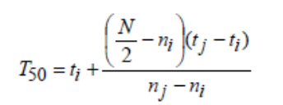
Where N is the final number of germination and ni , nj cumulative number of seeds germinated by adjacent counts at times ti and tj when ni < N/2 < nj.
Mean germination time (MGT) was calculated according to the equation of Ellis and Roberts (1981) as under:
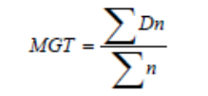
Where n is the number of seeds, which were germinated on day D, and D is the number of days counted from the beginning of germination.
Germination index (GI) was calculated as described in the Association of Official Seed Analysts (1983) as the following formulae:
Germination index = (Gt/Tt)
Where Gt is the number of seeds germinated on day t and Tt is the number of weekly germinated seeds at time Ti.
Seedling vigor index (SVI) was calculated following modified formula of Abdul-Baki and Anderson (1973):
The reduction percentage of germination (RPG) was calculated as quoted by Madidi et al. (2004):
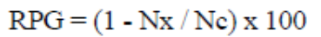
“Nx” is the number of germinated seedlings under drought treatments and “Nc” is the number of germinated seedlings under control.
For seedling growth test, 30 germinated seeds in each treatment were selected randomly and were transferred to plastic boxes (20×12×10) and were cultured on filter paper for ten days in three replications. Selected seedlings were weighted and then mean value was calculated to obtain seedling fresh weight (Jamal et al., 2011). Then these seedlings were dried in an oven at 80º C for 48 hours and again weighed after complete drying for recording seedling dry weight. Seedling length was measured with a ruler and accuracy of measurement was 1 mm. Data of germination and seedling growth tests were subjected to data transformation (arcsine) before the statistical analyzes in order to unify the variance of data. Analysis of variance (ANOVA) was used to compare treatment means. Differences between means were determined by Duncan’s multiple range tests (DMRT) at probability level 1 %. A computer software SAS was used to carry out the statistical analysis. Drawings were made using Excel software.
Results and Discussions:
The effect of osmopriming and drought on all studies treats were significant ( p <0.01). In addition to, the interaction among these factors was also significant (p <0.01). In osmopriming and control treatments with increasing stress intensity final germination percentage, MGT, T50, seedling dry weight, seedling length and SVI were affected by drought stress. However the negative effects of drought stress on treated seeds were significantly lower than control. (Fig 1 – Fig 7). RGP in drought levels (-3, -6 and -12 bar) of control treatment were 11.32, 21.37and 33.69 respectively (Fig 5). Although in osmopriming treatments with increasing drought stress RGP was increased, but reduced in germination percentage was significantly lower than the control (p <0.01). RGP in PEG 6000, KNO3 and KH2PO4 treatments in the drought levels (-3, -6 and -12 bar) were 5.57, 12.2, 21.47, 7.94, 15.35, 24.64, 5.61, 13.72 and 23.38 respectively (Fig 5). Despite germination and vigor of primed seeds with different materials under drought stress condition were better than control, but the results of the mean comparison indicated that the effects of various materials used for osmopriming in order to alleviation of this stress on germination of soybean seeds were statistically different (p <0.01) (Fig 1 – Fig 7). In this regard, PEG 6000 has the greatest impact on improving germination and seedling growth under drought stress condition.
The results of this study showed that drought stress affected germination and seedling growth of soybean seed adversely and osmopriming treatments indicated that enhanced performance under stress condition compared to control.
McDold (2000), stated that PEG 6000 large molecular size is not allowed to enter the cell embryo during the operation of osmopriming, while KNO3 and KH2PO4 can enter the seed embryo cells. It can be associated with some toxic effects (Noorbakhshin et al., 2011). Basra et al., (2006) reported that delayed and weak germination in seeds rice subjected to osmoconditioning for 24 and 48 h in KNO3 was probably due to toxicity. KNO3 toxicity results in injury to cellular organelles and membranes of wheat (Ghiyasi et al., 2008). The positive effect of inorganic salts such as KNO3 and KH2PO4 in some primed seeds of different crops related to the presence of the selectively permeable tissue layer surrounding the embryo, which allows the uptake of water but prevents the diffusion of solutes into the seeds (Tajbakhsh and Ghiyasi, 2009).
Osmopriming of seed prolongs phase II of germination process, where considerable metabolic activities take place that prepare germination seeds for radical emergence, such as DNA repair, DNA replication, β-tubulin accumulation and mobilization of seed storage (Chen et al., 2010). Thus primed seeds with a prolonged phase II are likely more prepared for germination and early growth than unprimed seeds. In addition to, osmopriming can contribute to improve germination rate and seedling emergence of seeds by increasing the expression of aquaporins, enhancement of ATP_{ase} activity, RNA and acid phosphatase synthesis (Gao et al., 1999).
Conclusions:
The results of this study demonstrate that osmopriming with PEG6000, KNO3 and KH2PO4 is effective for improvement of germination and seedling growth of soybean during germination and early growth stages especially under drought stress. Among these materials, primed seeds with PEG6000 recorded highest germination and vigor parameters under drought stress condition.
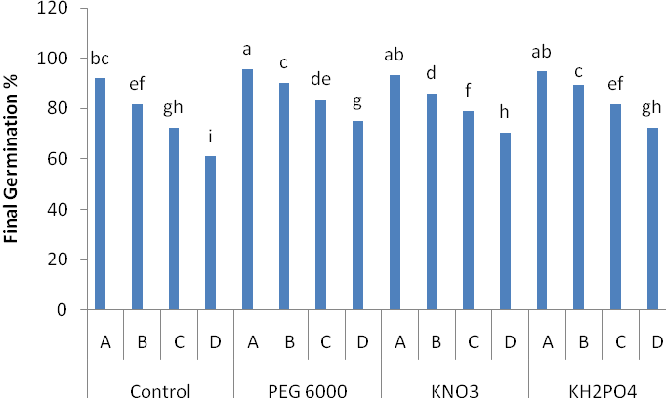
Fig 1. Effect of osmopriming treatments on final germination percentage of soybean seeds under different drought level. Different letters indicating significant differences at p≤0. 01. A= 0 bar, B= -0.3 bar, C= -0.6 bar , D= -0.9 bar.

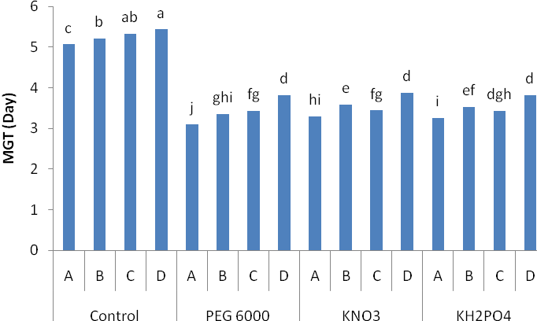
Fig 2. Effect of osmopriming treatments MGT of soybean seeds under different drought level. Different letters indicating significant differences at p≤0. 01. A= 0 bar, B= -0.3 bar, C= -0.6 bar , D= -0.9 bar.

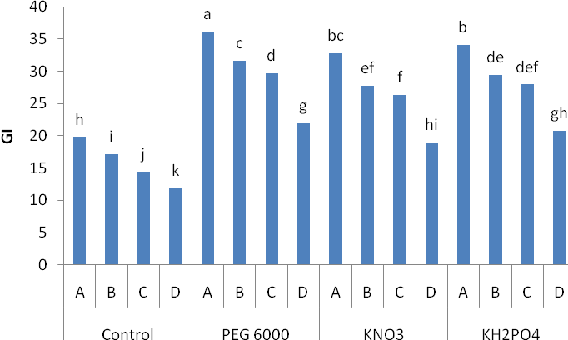
Fig 3. Effect of osmopriming treatments GI of soybean seeds under different drought level. Different letters indicating significant differences at p≤0. 01. A= 0 bar, B= -0.3 bar, C= -0.6 bar , D= -0.9 bar.

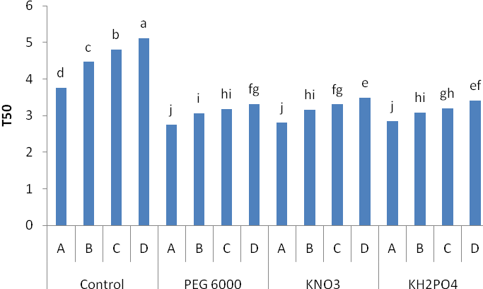
Fig 4. Effect of osmopriming treatments T50 of soybean seeds under different drought level. Different letters indicating significant differences at p≤0. 01. A= 0 bar, B= -0.3 bar, C= -0.6 bar , D= -0.9 bar.

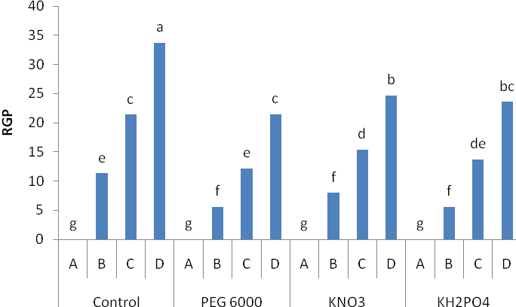
Fig 5. Effect of osmopriming treatments RGP of soybean seeds under different drought level. Different letters indicating significant differences at p≤0. 01. A= 0 bar, B= -0.3 bar, C= -0.6 bar , D= -0.9 bar.

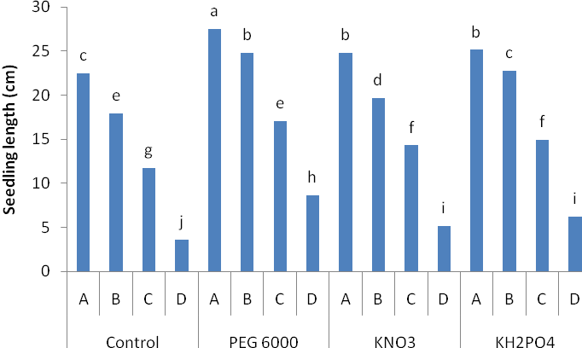
Fig 6. Effect of osmopriming treatments seedling length of soybean seeds under different drought level. Different letters indicating significant differences at p≤0. 01. A= 0 bar, B= -0.3 bar, C= -0.6 bar , D= -0.9 bar.

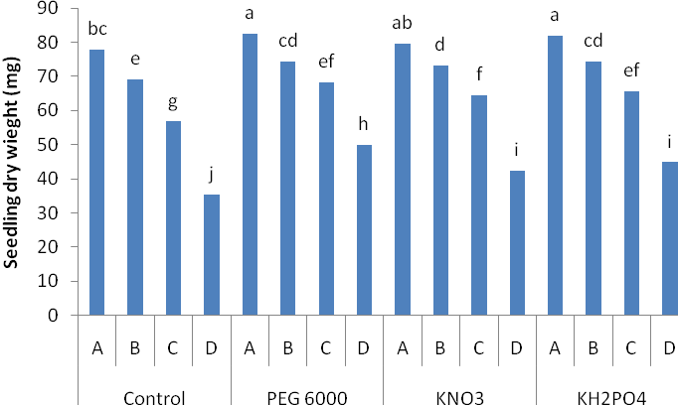
Fig 7. Effect of osmopriming treatments seedling dry wight of soybean seeds under different drought level. Different letters indicating significant differences at p≤0. 01. A= 0 bar, B= -0.3 bar, C= -0.6 bar , D= -0.9 bar.

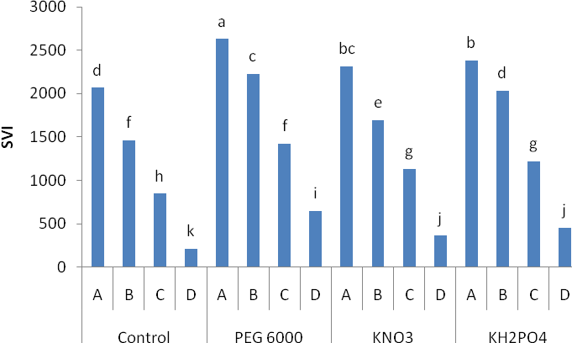
Fig 8: Effect of osmopriming treatments SVI of soybean seeds under different drought level. Different letters indicating significant differences at p≤0. 01. A= 0 bar, B= -0.3 bar, C= -0.6 bar , D= -0.9 bar.
References:
- Abbasdokht, H. 2001. The effect of hydropriming and halopriming on germination and early growth stage of wheat (Triticum aestivum L.). Desert, 16:61-68.
- Abdual-baki, A. A., Anderson J. D. 1973. Relationship between decarboxilation of glumatic acid and vigour in soybean seed, Crop Sci., 13: 222-226.
- Anonymous. 1983. Association of Official Seed Analysis (AOSA). seed vigor testing handbook. Contribution No. 32 to the handbook o seed testing. AOSA. Springfield, IL.
- Arif, M., Tariqjan M., Ullah khan N., Khan A., Khan M.J. , Munir I. 2010. Effect of seed priming on growth parameters of soybean. Pak. J. Bot. 42(4): 2803-2812.
- Basra, S. M. A., Farooq M., Tabassum R., Ahmad N. 2006. Evaluation of seed vigour enhancement techniques on physiological and biochemical basis in coare rice (Oryza Sativa L.). Seed Sci. Technol. 34:719-728.
- Casenave, E. C., Toselli M. E. 2007. Hydropriming as a pre- treatment for cotton germination under thermal and water stress conditions. Seed Sci. Technol. 35: 880-980.
- Chen, K., Arora R., Arora U. 2010. Osmopriming of spinach (spinaca oleracea) seeds and germination performance under temperature and water stress. Seed Sci. Technol., 38: 45-57
- Coolbear, P., Francis A., Grierson D. 1984. The effect of low temperature pre-sowing treatment on the germination performance and membrance integrity of artificially aged tomato seeds. J. Exp. Bot., 35: 1609-1617.
- Ellis, R. A., Roberts E. H. 1981. The quantification of ageing and survival in orthodox seeds. Seed Sci. Technol., 9: 373-409.
- Farooq, M., Basra S. M. A., Hafeez K.,Ahmad N. 2005. Thermal hardening: a new seed vigor enhancement tool in rice. J. Integ. PL. Biol., 47187-193.
- Gao, Y. P., Young L., Bonham P., Gusta L. V. 1999. Characterizationand experssion of plasma and tonoplast membrance aquaporins in primed seed of Brassica napus during germination under stress conditions. Plant Mol. Biol., 40, 635-444.
- Ghiyasi, M., Tajbakhsh M., Amirnia R., Salehzadeh H. 2008. Effect of osmopriming with polyethylene ghlycol 8000 on germination and seedling grwth of wheat (Triticum aestivum L.) seed under salt stess. Res. J. Biol. Sci. 3(10):12491251.
- hydropriming of chickpea seeds on seedling growth and carbohydrate metabolism under water deficit stress. Plant Growth Regul. 37: 17-22.
- Iqbal, M. , Ashraf M. 2007. Seed treatment with auxins modulates growth and ion partitioning in salt – stressed wheat plants. J. Integr . Plant Biol. 49:1003-1015.
- ISTA, 2003. International Seed Testing Assosiation. ISTA handbook on seedling evaluation, 3rd ed.
- Jamal, Y., Shafi M., Bakht J., Arif M. 2011. Seed priming imporoves salinity tolerance of wheat varieties. Pak. J. Bot., 2683-2686.
- Kaur, S., Gupta A. K. , Kaur N. 2002. Effect of osmo and
- Kaya, M. D, Okcu G., Atak M, Cikilli Y., Kolsarici O. 2006. Seed treatments to overcome salt and drought stress during germination in sunflower (Helianthus annuus L.). Ur. J. Agron. 24:291-295.
- Madidi, S. E., Baroudi B. E., Ameur F. B. 2004. Effects of sainity on germination and early gowth of barley (Hordeum Vulgare L. ) ultivars. Int. J. Agric. Biol.,6: 767-770.
- Mc Donald, M. B. 2000. Seed priming. Inseed technology and its biological basisi (eds. Blak , M. and bewly J. D.). pp: 287-325. Crc press LLc, Boca Raton, F. L. USA.
- Noorbakhsh, S. J., Nabipour M., Meskarbashee M., Amooaghaie R. 2011. Optimizaton of hydro and osmopriming in different seed size of sainfoin (onobrychis visiifolia scop). Aust. J. Basic and Appl. Sci. 5(11): 1236-1244.
- Pavlousek, P. 2011. Evaluation of drught tolerance of new grapevine rootstock hybrids. J. Environ. Biol., 32: 543-549.
- Tajbakhsh, M., Ghyasi M. 2009. Seed ecology. Jahad Daneshghahi press, Urmia Iran.
- Umair, A., Ali S., ayat R., nsar M., Tareen M. 2011. Evaluation of seed priming in mungbean (Vigna radiata) for yield , nodulation and biological ntrogen fixation undr rainfed conditions. Afr. J.. Biotechnol. 10 (79): 18122-18129.
- Umair, A., Ali S., Tareen M., Ljaz A., Tareen M. N. 2012. Effects od seed priming on antioxidant enzymes activiti of mungbean (Vigna radiata) seedlings. Pak. J. Nutr., 11(2):140-144.
- Yagmur, M., Kaydan D. 2008. Alleviation of osmotic stress of water and salt in germination and seedling growth of triticale with seed priming treatments. Afr. J. Biotechnol. 7(13): 2156-2162.
- Yari, L., Sheidale S., Sadeghi H., Khazaei F. 2012. Evaluation of temperature and seed priming duration on seed germination behavior of rice ( Oryza Sativa L.). Intl. J. Agric Res. Rev. 2(1): 7-12.

