Clonal Propagation of the nickel hyperaccumulator Glochidion lanceolarium (Roxb.) Dalz. through epicormic leafy shoot cuttings

Manikkannan Thirunavoukkarasu, Priyaranjan Behera, Gargibala Mishra, Subhashree Parida, Prasanna Kumar Panda

Bioresources Engineering Department, CSIR-Institute of Minerals & Materials Technology, Bhubaneswar 751 013, India.

* Corresponding author: E-mail: mtarasu@yahoo.com; Ph: +91 674 2379270; Fax: +91 674 2567637.

Abstract

Leafy shoot cuttings of Glochidion lancelarium exhibited highest percentage (83.3) of root formation when treated with 1000 ppm IBA. Maximum number of roots (4.8) attaining highest root length (3.7 cm) were also recorded in the same treatment. Shoot cuttings receiving 1000 ppm IAA responded with 53.3 % rooting, having mean root number of 3.0 and average root length of 2.8 cm. In both the treatments addition of BA exhibited inhibitory effect. Leaf shoot of 0.5-0.8 wide showed maximum response and presence of axillary buds proved beneficial for root initiation. The development of adventitious roots is directly correlated with the appearance of root initials.

Key words: Glochidion lanceolarium; epicormic leafy shoots; auxin; cytokinin; rooting

Running title: Propagation of the nickel hyperaccumulator Glochidion
Introduction

The growing concerns about environmental pollution and interest in phytoremediation have stimulated several recent studies on Ni hyperaccumulator plants, advocating their potential to survive and sequester high levels of Ni in tissues (up to 5% of dry biomass) without exhibiting phytotoxicity (Baker et al. 2000, Milner and Kochian 2008). Such metallophytes have immense potential for eco-restoration of areas following mining, remediation of metal contaminated soils and waters (Baker et al. 1994), or phyto-extraction of metals for economic returns (Nicks and Chambers 1995). Metallophytes colonizing such soils have limited geographic distribution and are considered to be vulnerable to extinction because of their limited occurrence. Therefore, there is an urgent need for not only identifying such potential species growing in mining areas, but also conserves such valuable biological resources (Whiting et al. 2003) before the mining activities deplete the biodiversity.

Glochidion lanceolarium (family: Euphorbiaceae) a medium sized tree found distributed on the Sukinda valley, Orissa (21°00′ to 21°05′ N latitude and 85°40′ to 85°53′ E longitude). It is a nickel hyperaccumulator and found to accumulate an average of 14070 mg/kg of Ni in the dry leaves (Pujari 2007). Due to its hyper accumulating nature, it is suitable for rehabilitation of nickel mine tailings and nickel overburden soils.. However, poor and erratic germination behavior of the species is a serious limitation for its large-scale exploitation for phytoremediation. Therefore, application of clonal propagation techniques is warranted to secure continuous supply of their planting stocks for reclamation or phytomining of Ni contaminated sites. Many plants are propagated by rooting of leafy shoots or stem cuttings because of simplicity and low cost. The type of shoots or cuttings and growth hormone play a very important role in securing satisfactory results. Although a considerable amount of literature is available on tree species which were successfully multiplied with the aid of hormone and mist chamber techniques in the past, work on G. lanceolarium appears to be lacking. The present set of experiments was carried out to assess the adventitious root forming ability of leafy shoot cuttings of G. lanceolarium for clonal propagation using auxin and cytokinin.

Materials and methods

Plant material

Epicormic leafy shoots (40–50 cm long) were harvested from 7-year-old trees of G. lanceolarium (Fig 1a) growing at Sukinda Valley. The shoots were carried to the experimental nursery in a polyethylene bag and were cut to create cuttings of approximately 8 – 10 cm long and 0.2 – 1.0 cm diameter with a pair of leaves intact. In all experiments, the leaves were cut in half transversely to minimize evapo-transpiration.

Plant growth regulators (PGR) and rooting media

Growth regulators such as Indole-3-butyric acid (IBA) and Indole-3-acetic acid (IAA) in the concentration of 1000 ppm along with or without 50 ppm concentration of 6-benzyladenine (BA 50 ppm) were used. The growth regulators were procured from E-Merk, India and were prepared by Dip Smear Method (DSM) as reported by Hartman and Kester (1972). The concentration and combination used in the study are shown in the Table 1. For the preparation of rooting media, sandy loam soil were taken from the plant material collection site and after 3-4 hours drying in Sun during the month of May, one part of well dried sandy soil was mixed thoroughly with the 2 parts of sandy loam soil. The prepared rooting media was filed in perforated polythene bags (20 cm height x 7.5 cm diameter).

Experiment 1: To identify influences of thickness of off shoots on rooting

In order to ascertain suitable thickness of the epicormic leafy shoots for induction of healthy root system, three category of thickness was used. The first category of shoots had 0.2 – 0.5 cm, the second category had 0.5 – 0.8 cm and the third category had 1.0 – 1.5 cm in diameter thickness. Ten off-shoots were taken from each category and auxin, IBA at 1000 ppm was used for root induction.

Experiment 2: To identify influences of active axillary buds on rooting

The effect of active axillary buds on rooting was determined by comparing off-shoot cuttings with or without axillary buds. Ten each of the shoot cuttings with or without bud were taken making a total of 20 cuttings per replication with single treatment of IBA 1000 ppm.

Experiment 3: Ontogenetic analysis of root development

For anatomical studies thirty off-shoots of 0.5 – 0.8 cm diameter were taken. The basal parts (1.0 – 1.5 cm) of off-shoots (treated with IBA1000 ppm), were cut into pieces and fixed in a formalin:ethanol:acetic acid (FAA) solution. Transverse sections were made by hand of the 1.0 – 1.5 cm long base of cuttings. Sections were stabilized, stained with safranin and mounted in 80 % Glycerol. The photomicrographs were taken with a Nikon photomicroscope to which a SONY Exwave HAD camera had been adapted. Samples were taken on 1, 7, 14, 21, and 28 days after immersed in rooting medium.

Results

Effect of PGR on root induction

Analyses of data of leafy shoot cuttings of G. lanceolarium taken for 7 weeks after planting showed that there was a significant difference between the rooting response of IBA and IAA either alone or in combination with BAP. Highest and healthy rooting was recorded with IBA 1000 ppm (Fig 1b) followed by IAA 1000 ppm treatments. Control treatment exhibited poor rooting response. Also we have tested synergic effect of BAP along with IBA or IAA, but addition of BAP resulted in reduction in rooting response (Table 1 & 2). Root initiation occurred between 3rd to 5th weeks after planting in the rooting medium. Leafy shoot cuttings which received IBA 1000 ppm treatment resulted in earliest root initiation where the root initiation started at 20th day after planting, while in case of cuttings treated with IAA 1000 ppm, root initiation formed after 24 day of planting. In the control sets the rooting process was noticed after 30 days.

Influences of thickness of off shoots on rooting

Thickness of the epicormic leafy cuttings had significant effect on root induction and root biomass in the present study. Leafy shoots with diameter range of 0.5 – 0.8 cm revealed highest rooting response (Fig 1c-i). It is clear from the experimental results that maximum of 83.3 % leafy shoots responded with mean root numbers of 4.8 and an average length of 3.7 cm when they were treated with IBA 1000 ppm concentration (Table 2). Combined treatment of IBA (1000 ppm) + BA (50 ppm) showed 56.7 % shoots responding to root formation but, with lesser number of roots (2.1) and reduced root length (3.16 cm). IAA 1000 ppm treated leafy shoots exerted 53.3 % response with the mean root numbers of 3.0 and a mean root length of 2.8 cm. Untreated control cuttings showed a mere of 16.7% with poor root number and root growth (Table 2). Cuttings of 0.2 – 0.5 cm diameter (Fig 1c-ii) showed a maximum response of 56.6 %, where the shoots received IBA 1000 ppm treatment. In this treatment root initiation occurred between 20 – 22 days after planting and recorded root numbers and root length was 21 and 2.04 cm respectively. Shoots with wider thickness (< 0.8 cm dia) showed very poor rooting response (Fig 1c-iii). Addition of cytokinin did not show any improvement in root numbers or root length, rather its presence resulted in reduction in root biomass (Table 2).

Influences of active axillary buds on rooting

Presence of active axillary bud had very significant influence on root formation on leafy shoot cuttings of G. lanceolarium. Leafy shoots without active axillary bud failed to form roots even after 8 weeks (Fig 1 d-i), whereas leafy shoots with active bud responded for rooting within 3-4 weeks time (Fig 1 d-ii).

Ontogenetic analysis of root primordial

Cross section of G. lanceolarium leafy shoot was studied at seven-day intervals. No distinct changes in the internal structure of the examined sections were notices up to two weeks from date of planting of the leafy shoots (Fig 2-a). However, changes were observed only after 3 weeks of planting which included cell division in the cambial zone and formation of root initials (Fig 2-b). The adventitious root arising from the cambial zone grew through the cortex towards the surface of the stem. When the internally growing root reached the surface of the stem, it ruptured the epidermis and passed through the opening (Fig 2-c).

Discussion

This is the first report on vegetative propagation of Glochideion lanceolarium. Our results conclusively indicate that the formation of adventitious roots in G. lanceolarium is strongly influenced by plant growth regulators and also the nature of leafy shoots. Requirement of an auxin is pre-requisite for successful induction of the roots on leafy shoots of G. lanceolarium. Out of the two auxin used in the present experiments, IAA and IBA, the later appears to be more effective in promoting rooting within a shorter period of time. The requirement of auxin to induce rooting in tree species even when the cuttings are favorably disposed to rooting have been reported earlier (Nanda et al. 1968). Auxins have been shown to stimulate cambial activity resulting in mobilizations of reserved food materials to the site of root initiation (Gurumurthi et al. 1984, Loach 1988, Thirunavoukkarasu and Gurumurthi 1998). It is believed that the principle role of IBA is to favour conjugation between endogenous IAA and amino acids which leads to the synthesis of the specific proteins necessary for the formation of root initials (Ryugo and Breen 1974). The beneficial role of IBA over other auxins, as observed in our present study, is in agreement with earlier reports in Enterolobium cylcocarpum (Thirunavoukkarasu and Brahmam 1999), Pongamia pinnata (Thirunavoukkarasu et al. 2002) and Camelia sinensis (Rout 2006).

Our study demonstrated that addition of cytokinin with auxin showed negative response on root induction. As it is evident from the experimental data when auxin was used alone, root formation as well as mean root number and root length were better than the combined treatment of auxin and cytokinin. Similar results were reported in previous studies where that exogenous applications of cytokinins inhibited lateral root initiation in other plant species (Li et al. 2006, Bottgor 1974, Wightman et al. 1980). Cytokinins were reported to inhibit cell division during early phase of organization of adventitious root primordia in pea stem cuttings (Bollmark et al. 1988). Contradictory to these, Laplaze et al. (2007) demonstrated that cytokinins also influence lateral root development. Eriksen (1974) reported that in pea, cytokinin at high concentrations may have an inhibitory effect on an early stage of rooting by blocking the activity of auxin.

Besides the auxin and cytokinin, thickness of the leafy shoot also exhibited significant variation in root formation. We observed a comparatively better rooting response of the shoots with 0.5 – 0.8 cm diameter in thickness than the shoots with lesser or higher thickness. In the previous studies on Pongamia pinnata a similar observation was reported where the root formation was found to be influenced by the thickness of leafy shoots (Thirunavoukkarasu et al. 2002). While poor rooting in thinner diameter off-shoot cuttings may be attributed to low level of reserved food materials at the time of samplings, in case of higher thickness off-shoots, such a phenomenon may be attributed to secondary growth and thickening of lignin layer which may create physical barrier to root initiation (Hartmann et al.1990, Aminah et al. 2006).

The purpose of using epicormic shoots for inducing rooting in G. lanceolarium is the fact that in many tree species the vegetative materials obtained from older trees fail to respond to rooting despite hormone treatment (Kozlowski 1971). In such plants attempts have been made to induce juvenile shoots in older trees by methods such as coppicing or hedging (Franclet 1988, Gurumurti and Bhandari 1988). However, when we work on a species which is endemic and occurs in isolation, coppicing of such tree will results in destruction, hence epicormic shoots were preferred. Epicormic shoots that originate at the base of a tree often have juvenile morphological and physiological characteristics compared with branches from other parts of the tree (Paton et al. 1970, Bonga 1982, Cameron and Sani 1994, Hartmann et al. 2011). Successful rooted cuttings using epicormic shoots have been reported in a number of tree species such as Betula pendula and B. pubescens (Kauppi et al. 1987, Rinne et al. 1987, Cameron and Sani 1994).

Histological analysis of leafy shoot cuttings revealed three distinct stages of development. The root development began with organized divisions in cells near the pericycle region, followed by numerous divisions in localized areas, and finally roots meristem organization. This pattern is very similar to the formation of lateral root meristems in root tissue of many plants. Adventitious root primordia originate de novo from cambium cells preserving meristematic character, whereas in other plants primordia can emerge from different tissues, like phloem, leaf traces, vascular rays, cortex and pith or other parenchymatous cells, e.g lenticels (Hartmann et al. 1990, Syros et al. 2004). Softwood cuttings obtained from very juvenile stock plants show easy rooting ability as anatomically these cuttings were yet to develop any form of mechanical barriers, such as thick layers of cork tissue outside the cortex, or a sclerenchymatic sheath peripheral to the primary phloem. This phenomenon is apparent in softwood cuttings of G. lanceolarium used in the present studies, which showed that the cell wall of the parenchymatous cells, especially the cortex, appeared relatively thin. The relationship between stem anatomy and adventitious rooting may have an important bearing on the capacity of these stems to form adventitious roots easily (Hasan and Dodd 1989). Thus, the observations in the present study help to exploit leafy cuttings of G. lanceolarium for rapid propagation for reclamation of Ni-overburden wastelands.

Acknowledgements

Authors are thankful to the Director, Institute of Minerals and Materials Technology (CSIR), Bhubaneswar for providing necessary facilities to carry out the work.

References

Aminah H., Hasnita R.M.N., Hamzah M. (2006). Effects of indole butyric acid concentrations and media on rooting of leafy stem cuttings of Shorea parvifolia and Shorea macroptera. Journal of Tropical Forest Science, 18(1): 1 – 7.
Baker A.J.M., Mcgrath S.P., Reeves R.D. (2000). Metal hyperaccumulater plants: a review of the ecology and physiology of biological resources for phytoremediation of metal polluted soil. In: Norman T., Bannelos G.S. (Eds.) Phytoremediation of contaminated soil and water CRC Press, LLC: 85 – 107.
Baker A.J.M., Mcgrath S.P., Sidoli C.M.D., Reeves R.D. (1994). The possibility of in situ heavy metal decontamination of polluted soils using crops of metal-accumulating plants. Resource Conservation Recycling, 11: 41–49.
Bollmark M., Kubat B., Eliasson L. (1988). Variations in endogenous cytokinin content during adventitious root formation in pea cuttings. Journal of Plant Physiology, 132: 262-265.
Bonga J.M. (1982). Vegetative propagation in relation to juvenility, maturity and rejuvenation. In: Bonga J.M., Durzan D.J. (Eds.) Tissue Culture in Forestry, Mattinus Nijhoff-Junk Publ. The Hague: 387-412.
Bottgor M. (1974). Apical dominance in roots of Pisum sativum L. Planta, 121: 253–261.
Cameron A.D., Sani H. (1994). Growth and branching habit of rooted cuttings collected from epicormic shoots of Betula pendula Roth. Tree Physiology, 14: 421-436.
Eriksen E.N. (1974). Root formation in pea cuttings: III. The influence of cytokinin content at different developmental stages. Physiologia Plantarum, 30:163–167
Franclet A. (1988). Clonal forestry: Its impact on tree improvement and our future forests. In: Zuffa et al. (Eds) Proceedings of Cannadian Tree Improvement Association, Ontario, Canada: 96.
Gurumurthi K., Bhandari H.C.S. (1988). Induction of rooting in cladode cuttings of Casuarina equisetifolia. Current Science, 57(17): 958-959.
Gurumurthi K., Gupta B.B., Kumar A. (1984). Hormonal regulation of root formation. In: Purohit S.S. (Ed.) Hormonal Regulation of Plant growth and development. Agrobotanical Publishers. India: 387-400
Hartmann H.T., Kester D.E. (1972). Plant Propagation: Principles and Practices, second ed. Prentice Hall of India Private Limited, New Delhi.
Hartmann H.T., Kester D.E., Davies F.T. (1990). Anatomical and Physiological basis of propagation by cuttings. Plant propagation, principles and practices. International Editions, London, 199-225 pp.
Hartmann H.T., Kester D.E., Davies F.T., Geneve R.L. (2011). Hartmann and Kester's Plant Propagation - Principles and Practices. 8th edition. (Prentice Hall). Upper Saddle River, New Jersey, 915 pp.
Hasan B.M., Dodd P.B. (1989). Histological study on adventitious root formation in stem cuttings of young Durian (Durio zibenthinus Murr.) seedlings. Pertanika, 12(3): 299-302.
Kauppi A., Rinne P., Ferm A. (1987). Initiation, structure and sprouting of dormant basal buds in Betula pubescens. Flora, 179: 55-83.
Kozlowski T.T. (1971). Growth and development of trees: Seed germination, ontogeny and shoot growth. Academic Press, New York.
Laplaze L., Benkova E., Casimiro I., Maes L., Vanneste S., Swarup R., Weijers D., Calvo V., Parizot B., Begon M., Rodriguez H., Offringa R., Graham N., Doumas P., Friml J., Bogusz D., Beeckman T., Bennette M. (2007). Cytokinins act directly on lateral root founder cells to inhibit root initiation. Plant Cell, 19: 3889–3900.
Li X., Mo X., Shou H., Wu P. (2006). Cytokinin-mediated cell cycling arrest of pericycle founder cells in lateral root initiation of Arabidopsis. Plant Cell Physiology, 47: 1112–1123.
Loach K. (1988). Hormone application and adventitious root formation in cuttings - a critical review. Acta Horticulturae, 227: 126-133.
Milner M.J., Kochian L.V. (2008). Investigating heavy-metal hyperaccumulation using Thlaspi caerulescens as a model system. Annals of Botany, 102: 3 – 13.
Nanda K.K., Purohit A.N., Bala A., Anand V.K. (1968). Seasonal rooting response of stem cutting of some forest tree species to auxin. Indian Forester, 94: 154-162.
Nicks L.J., Chambers M.F. (1995). Farming for metals. Mining Environmental Management Mining Journal Ltd., September 15–18. London.
Paton W., William D.M., Nichols R.R., Pryor L.D. (1970). Rooting of stem cuttings of Eucalyptus: a rooting inhibitor in adult tissue. Australian Journal of Botany, 18: 175-183.
Pujari G.N. (2007). Phytomining in India: with special reference to Ni deposits of Sukinda ultrasonic belt, Orissa. Indian Journal of Geochemistry, 22(1): 155-166.
Rinne P., Kauppi A., Ferm A. (1987). Induction of adventitious buds and sprouts on birch seedlings (Betula pendula Roth and B. pubescens Ehrh.). Canadian Journal of Forest Research, 17: 545-555.
Rout G.R. (2006). Effect of auxins on adventitious root development from single node cuttings of Camellia sinensis (L.) Kuntze and associated biochemical changes. Plant Growth Regulation, 48: 111–117.
Ryugo K., Breen P.J. (1974). Indole acetic acid metabolism in cuttings of plum (Prunus cerasifera x P. musoniana cv Martiana 2624). Proceeding of American Society of Horticulture Science, 99: 247.
Syros T., Yupsanis, T., Zafiriadis H., Economou A. (2004). Acticity and isoforms of peroxidases, lignin and anatomy, during adventitious rooting in cuttings of Ebenus cretica L. Journal of Plant Physiology, 161: 69–77.
Thirunavoukkarasu M., Brahmam M. (1999). Vegetative propagation of Enterolobium cyclocarpum (Jacq.) Griseb. through coppice shoot cuttings. Journal of Sustainable Forestry, 8(2): 127-134.
Thirunavoukkarasu M., Gurumurthi K. (1998). Vegetative propagation techniques - a potential tool for yield improvement in forestry. Journal of Sustainable Forestry, 7(3/4): 119-130.
Thirunavoukkarasu M., Brahmam M., Dhal N.K. (2002). Clonal propagation of Pongam [Pongamia pinnata (L.) Pierre] – An indigenous medicinal plant with multipurpose uses. Plant Science Research, 24 (1 & 2): 11-14.
Whiting S.N., Reeves R.D., Richards D., Johnson M.S., Cooke J.A., Malaisse F. (2003). Research priorities for conservation of metallophyte biodiversity and its sustainable uses in ecological restoration and site remediation. Restoration Ecology, 12: 107–117.
Wightman F., Schneider E.A., Thimann K.V. (1980). Hormonal factors controlling the initiation and development of lateral roots. II. Effects of exogenous factors on lateral root formation in pea roots. Physiologia Plantarum, 49: 304–314.

Table 1. Effect of growth hormones treatment on rooting response of leafy shoot cuttings of Glochidion lanceolarium (cutting thickness 0.2 – 0.5 cm dia)^{1, 2}

Treatment (ppm) | % Response | Days to root initiation | Mean root numbers | Mean root length (cm)
Control | 13.3 | 30 – 35 | 0.2^{c} | 0.25^{c}
IBA (1000) | 56.6 | 20 – 22 | 2.1ª | 2.04ª
IBA(1000) + BA (50) | 43.3 | 22 – 24 | 1.2^{b} | 1.21^{b}
IAA(1000) | 46.6 | 24 – 26 | 1.0^{bc} | 1.25^{b}
IAA(1000) + BA(50) | 43.3 | 26 – 28 | 1.0^{bc} | 1.01^{bc}

1.Data pooled from three independent experiments each with 10 replicates per treatment.
2.Data collected after 6 weeks in the rooting medium.
* Mean values within column followed by the same letter are not significantly different (p ≤ 0.05; Duncan’s New Multiple Range Test).

Table 2. Effect of growth hormones treatment on rooting response of leafy shoot cuttings of Glochidion lanceolarium (cutting thickness 0.5 – 0.8 cm dia)^{1, 2}

Treatment (ppm) | % Response | Days to root initiation | Mean root numbers | Mean root length (cm)
Control | 16.7 | 30 – 33 | 0.5^{d} | 0.36^{c}
IBA (1000) | 83.3 | 20 – 22 | 4.8ª | 3.70ª
IBA(1000) + BA (50) | 56.7 | 24 – 26 | 2.1^{bc} | 3.16ª
IAA(1000) | 53.3 | 24 – 26 | 3.0^{b} | 2.80^{ab}
IAA(1000) + BA(50) | 43.3 | 26 – 28 | 1.1^{cd} | 1.62^{bc}

1.Data pooled from three independent experiments each with 10 replicates per treatment.
2.Data collected after 6 weeks in the rooting medium.
* Mean values within column followed by the same letter are not significantly different (p ≤ 0.05; Duncan’s New Multiple Range Test).

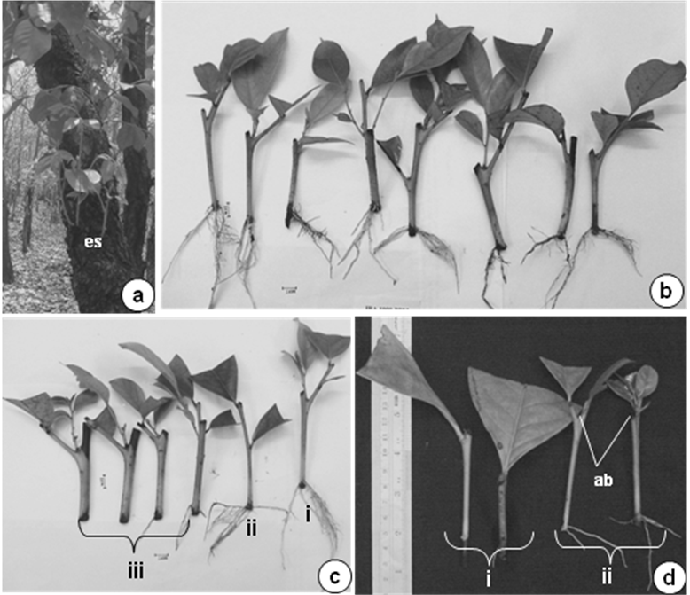
Figure 1

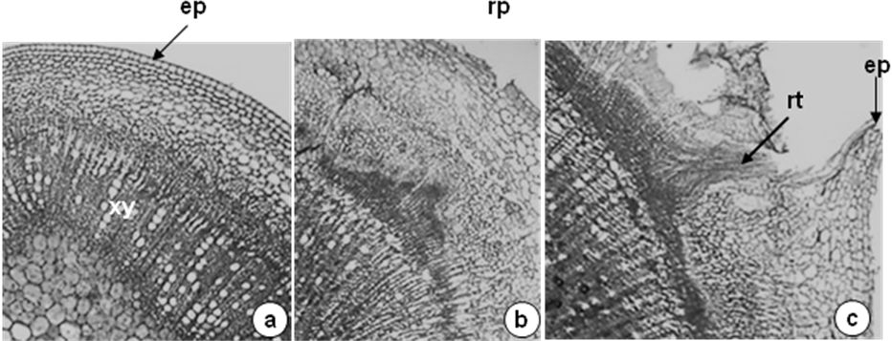
ca
Figure 2
CAPTION TO FIGURES

Figure 1. Root induction in epicormic leafy shoots of G. lanceolarium

(a) A seven year old tree showing epicormic shoot growth; (b) Leafy shoots rooted in IBA 1000 ppm treatment; (c) Rooting response of leafy shoots of varied thickness (i- Rooted leafy shoots of 0.5 – 0.8 cm dia thickness treated with IBA 1000 ppm treatment; ii- Rooted leafy shoots of 0.2 – 0.5 cm dia thickness treated with IBA 1000 ppm treatment; iii- Leafy shoots of 0.8 – 1.0 cm dia thickness treated with IBA 1000 ppm treatment); (d) Influence of axillary bud on root formation (i- Leafy shoots without axillary bud did not produce root; ii- Leafy shoots with axillary bud (arrow mark) showing rooting response (ab-axillary bud).

Figure 2. Transverse section of G. lanceolarium leafy shoot during root formation.

(a) Anatomy of leafy shoot at the end of 2 week time after planting; (b) Anatomy of leafy shoot at the end of 3 week time after planting showing cell division in the cambial zone and formation of root initials; (c) Anatomy of leafy shoot at the end of 4 week time after planting showing adventitious root growth and ruptured epidermis (ca-cambium; ep-epidermis; rp-root primordium; rt-root; xy-xylem).

