Study on Three Different Prunus mume Cultivar Groups in Vitro Rapid Propagation
Ran-Xin Li, Ying-Min Lv* , Cheng-Ke Li
- College of Landscape Architecture, Beijing Forestry University, Beijing 100083, China
Ran-Xin Li
Email:694910994@qq.com
Ying-Min Lv
Email:luyingmin@bjfu.edu.cn
Abstract
Three Prunus mume groups including ‘Wu Yuyu’ (Zhusha cultivar group), ‘Xiao Yudie’ (Yudie cultivar group) and ‘Xiao Lv’e’ (Lv’e cultivar group) are chosen as materials to be micro-propagated in vitro. Different hormone type and concentration，materials and disinfection time were used as factors, which influenced Prunus mume budded stems, to optimize the initiation culture of Prunus mume budded stems. Results showed that perfect explants of three Prunus mume groups are non-tender healthy part in the upper twigs. The best disinfection time is 10min by using Hgcl_{2.} The optimum in vitro shoot section explants growing medium for Prunus mume Yudie cultivar group was the WB medium supplemented with 0.2mg/L NAA and 0.5mg/L BA.The optimum proliferation medium for Lv’e cultivar group was improved WB medium supplemented with 0.1mg/LNAA and 0.5mg/LBA, while the optimum proliferation medium for Zhusha cultivar group was supplemented with 0.1 mg/ L NAA and 0.1 mg/L KT. On the basis of initiation culture, medium, hormone type and concentration was studied. The results show that the most suitable medium for multiplication culture of Zhusha cultivar group was WPM＋1.0mg/L BA＋1.0mg/L 2,4-D＋0.2mg/L TDZ＋100mg/L AHC,Yudie cultivar group was 1/2MS＋1.0mg/L BA＋1.0mg/L 2,4-D＋0.5mg/L NAA＋0.2mg/L TDZ＋100mg/L AHC,and Lv’e cultivar group was WPM＋1.0mg/L BA＋1.0mg/L 2,4-D＋0.2mg/L TDZ＋100mg/L AHC.
Keywords Prunus mume - Stem with axillary bud - In vitro rapid propagation.
Introduction
Prunus mume, Rosaceae, Prunus, is a deciduous tree and our unique traditional floral. It’s one of the ten famous traditional flowers with the decisive role position and influence in China’s garden and flower culture(Chen. 2010). Traditionally, the main breeding methods of Prunus mume is cutting and grafting, this way can maintain desirable qualities, but coefficient of reproduction gets a little(e.g., Chai et al.1988; Fu et al. 1991; Fu et al. 1995; Jiang et al. 2004; Liu et al. 1999).Tissue culture can solve the follow-up difficulty in question which is a reliable and fast way (Cao et al. 2005 ) .In vitro propagation of plum is the established premise of genetic transformation system. The establishment of Asexual System and Test tube can both provide the important test materials of the next step of transgenic breeding, and are a part of the next step of callus induction and differentiation of seedling (Cao and Lv. 2004). At present, by the tissue culture of stem segments to establish rapid propagation system has always been the important way of research and production of seedlings. But In vitro Rapid Propagation System of Prunus mume, the progressment is minimal, only a little variety can realize this technology (e.g.,Harada et al.1996; Olaya et al. 2000; Quoirin et al. 1977).
There are more than 300 varieties of Prunus mume. At present, the tissue culture of ‘Wu Yuyu’ (Zhusha cultivar group), ‘Xiao Yudie’ (Yudie cultivar group) and ‘Xiao Lv’e’ (Lv’e cultivar group) has not been reported. So, we conduct a research of this three cultivar group, in order to provide the theory and operation technology basis for the rapid propagation and industrial production of Prunus mume.
Primary culture
Materials and methods
The explants which are collected from Meiyuan of Jiufeng National Forest Park are ‘Wu Yuyu’ (Zhusha cultivar group), ‘Xiao Yudie’ (Yudie cultivar group) and ‘Xiao Lv’e’ (Lv’e cultivar group).

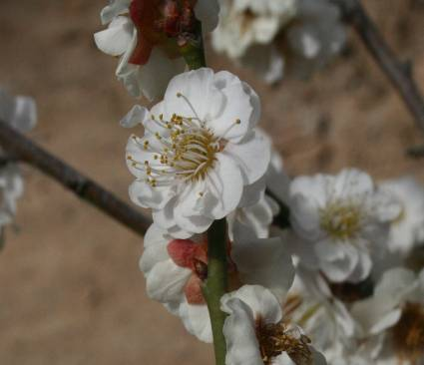 | 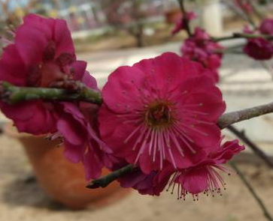 | 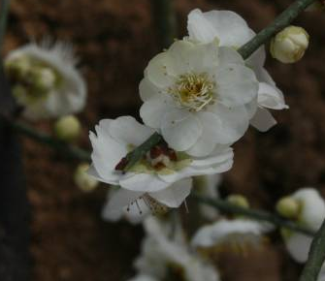
‘Xiao Yudie’ ‘Wu Yuyu’ ‘Xiao Lv’e’
The experiment is conducted in the tissue culture laboratory in October. We choose the tree with strong and fairly vigorous growth and without diseases and insect pests, shoots with the same length and width, and the peripheral branches which are distributed in the Crown Center as test materials.
Explants disinfection
Cutting away the leaves and petioles from the stem(in order to protect the bud ,we need to retain petiole about 0.1-0.2cm),then cut the treated stem into several parts which are about 1-2cm of each.Next,we soak the treated stem in the detergent about 30min,then rinse them 1h. Under aseptic conditions, the material will be soaked 30s in 75% alcohol, and disinfected by 0.1%Hgcl₂,the treatment are under 5、10、15min three conditions, then rinsed 5 times by sterile water. Finally, we vaccinate the treated material into medium, 20 bottles of each treatment and three stem segments of each bottle.
Medium
We choose WB medium as basic medium(Fu.1993) , sucrose 30 g/L and agar 6.5 g/L are added into the medium. The pH of medium is 6.0.
Hormone: KT, NAA and 6-BA.
Culture container and sterilization
The culture container of experiment is 100 mL glass bottle, each has 50 mL medium. The sterilization condition is 118℃ for 18 min.The Culture conditions is: Temperature 23 ± 2℃;Relative air humidity 60%;Light intensity 1500~2000lx;Lighting time 14h/d.We observe the growth of material once a week, record explants pollution and growth conditions.
Statistical analysis
Calculate the germination rate after 30d.
Germination rate＝(Bud number/Survival number)×100%.
Results and analysis
The relationship between different genotypes and germination rate
There are certain differences between the different species, cultivar groups and varieties. Add KT2.0mg/L and NAA 0.05mg/L to WB medium, 3 stems in each bottle, totally for 20 bottles, and then calculate the germination rate after 30d of each group. The germination rate of ‘Wu Yuyu’ is 69.81%, ‘Xiao Yudie’ is 85.71%,while ‘Xiao Lv’e’ is 80.39% . Results show that germination rate is: Yudie cultivar group＞Lv’e cultivar group＞Zhusha cultivar group. It can be concluded from the experiment that genotype has an important influence on the tissue culture of Prunus mume.
Different effect of material parts of germination rate
Choose the upper、central and lower stem with axillary bud as material，inoculate them into culture medium WB＋KT2.0mg/L＋NAA0.05mg/L. Calculate the germination rate after 30d.In general, the central part received a higher germination rate. For each 20 buds, repeat 3 times.
As we can see from table 1, the lower part has a low germination rate and grows slowly. The central parts of Yudie and Lv’e cultivar group reach the highest germination rate, but grow gently; while the upper parts of Zhusha cultivar group gets a higher germination rate, grow fast, with the obvious apical dominance. In this 3 cultivar groups, the highest germination rate group is Yudie cultivar group. The germination rate difference between the central and lower parts of Zhusha cultivar group is not significant. From this it follows that the most suitable material for Yudie and Lv’e cultivar group is the central part of stem, while for Zhusha cultivar group is the upper part.
Table1 The effect on germination rate of the different material parts which collected from same branch
Variety | Material parts | Germination rate (%)
‘Wu Yuyu’ -Zhusha cultivar group | Upper | 58.58a
‘Wu Yuyu’ -Zhusha cultivar group | Central | 51.11b
‘Wu Yuyu’ -Zhusha cultivar group | Lower | 45.95b
‘Xiao Yudie’ -Yudie cultivar group | Upper | 76.00b
‘Xiao Yudie’ -Yudie cultivar group | Central | 85.19a
‘Xiao Yudie’ -Yudie cultivar group | Lower | 57.89c
‘Xiao Lv’e’ -Lv’e cultivar group | Upper | 45.58b
‘Xiao Lv’e’ -Lv’e cultivar group | Central | 59.13a
‘Xiao Lv’e’ -Lv’e cultivar group | Lower | 34.29c

The most suitable time of explants disinfection
For the reason of material contaminated, the pollution always exists in vitro culture, so the inoculating material must through strict sterilization(e.g.,Chen and sun .2007; Chen .2003).
^{[13-14]}.This experiment conclude 3 gradient disinfection time, calculate the contamination and germination rate after 30d，in order to know the most suitable time of explants disinfection. For each 20 buds, repeat 3 times. The result is as shown in table 2.
Table2 The effect on germination rate of the different time of explants disinfection
Variety | Hgcl₂ disinfection time | Germination rate (%)
‘Wu Yuyu’ -Zhusha cultivar group | 5min | 22.59b
‘Wu Yuyu’ -Zhusha cultivar group | 10min | 39.53a
‘Wu Yuyu’ -Zhusha cultivar group | 15min | 12.77c
‘Xiao Yudie’ -Yudie cultivar group | 5min | 15.22b
‘Xiao Yudie’ -Yudie cultivar group | 10min | 39.13a
‘Xiao Yudie’ -Yudie cultivar group | 15min | 11.76c
‘Xiao Lv’e’ -Lv’e cultivar group | 5min | 31.03b
‘Xiao Lv’e’ -Lv’e cultivar group | 10min | 51.35a
‘Xiao Lv’e’ -Lv’e cultivar group | 15min | 22.58c

It can be concluded from table 2 that, the highest germination rate of three cultivar group is under the condition of Hgcl₂ 10min, and the highest germination rate group is Lv’e cultivar group. When the material is treated with Hgcl₂ 5min which gets the lowest germination rate of these 3 cultivar groups, has remarkable difference with the other two treatment. By contrast, the cultivar group which has the lowest germination rate is Yudie cultivar group. In conclude, the most suitable time of explants disinfection is 10min.
The impact of different hormones on primary culture
We choose WB medium as basic medium. In order to select the most suitable primary culture of 3 cultivar groups, we add hormone of different type and density into the basic medium.
The impact of different cytokinins on primary culture of three cultivar groups
In this experiment, we add 0.1mg/L NAA into the basic WB medium, so as to choose a suitable cytokinin. Respectively, add 0.5mg/L BA, 0.5mg/L KT and without any hormone into the medium to carry out the experiment. The results as shown in table 3.
Table3 The impact of different cytokinins on primary culture of three cultivar groups
Variety | Different hormone | Germination rate (%)
‘Wu Yuyu’ -Zhusha cultivar group | BA | 67.65b
‘Wu Yuyu’ -Zhusha cultivar group | KT | 75.68a
‘Wu Yuyu’ -Zhusha cultivar group | CK | 35.38c
‘Xiao Yudie’ -Yudie cultivar group | BA | 59.65a
‘Xiao Yudie’ -Yudie cultivar group | KT | 51.39b
‘Xiao Yudie’ -Yudie cultivar group | CK | 20.69c
‘Xiao Lv’e’ -Lv’e cultivar group | BA | 55.11a
‘Xiao Lv’e’ -Lv’e cultivar group | KT | 44.71b
‘Xiao Lv’e’ -Lv’e cultivar group | CK | 35.14c

As we can see from table 3,the highest germination rate of Zhusha cultivar group is the medium of WB＋KT0.5mg/L＋NAA0.1mg/L;while for Yudie and Lv’e cultivar group, the most suitable medium is WB＋BA0.5mg/L＋NAA0.1mg/L.With the addition of hormone, the germination rate is higher than CK. So, we divide 3 cultivar groups into two groups to conduct the next experiment.
The impact of different density on primary culture of three cultivar groups
(1) The impact of different density of KT and NAA on primary culture of Zhusha cultivar group
Treatment combination is as shown in table 4.
Table4 Different density of KT and NAA
KT  NAA |  | Concentration gradient(mg/L)
 |  | 0 | 0.5 | 1
Concentration gradient(mg/L) | 0 | 1 | 2 | 3
Concentration gradient(mg/L) | 0.1 | 4 | 5 | 6
Concentration gradient(mg/L) | 0.2 | 7 | 8 | 9

By the experiment of the above nine groups, the conclusion can be indicated in table 5.
Table5 The impact of different density of KT and NAA on primary culture of Zhusha cultivar group
Different treatment | Germination rate (%) | Different treatment | Germination rate (%)
1 | 71.11b | 6 | 86.67a
2 | 75.56b | 7 | 61.67c
3 | 63.33c | 8 | 82.35a
4 | 55.00d | 9 | 48.33e
5 | 65.00c

As can be seen from Table 5，for Zhusha cultivar group, the highest and lowest germination rate is medium 6 and 9. It has the nearly same germination rate in medium 3,5 and 7, so the difference was not significant. Therefore, the most suitable primary culture medium is WB＋NAA 0.1mg/L＋KT 1.0mg/L.
(2) The impact of different density of KT and NAA on primary culture of Yudie and Lv’e cultivar group
Result from the former experiment, the main hormone factor of germination rate of Yudie and Lv’e cultivar group is NAA and BA.So, we can set the concentration gradient as shown in table 6.
Table6 Different density of BA and NAA
BA  NAA |  | Concentration gradient(mg/L)
 |  | 0 | 0.5 | 1
Concentration gradient(mg/L) | 0 | 1 | 2 | 3
Concentration gradient(mg/L) | 0.1 | 4 | 5 | 6
Concentration gradient(mg/L) | 0.2 | 7 | 8 | 9

From the above nine groups combination, we can receive germination rate is derived in table 7 and table 8 below by using this two cultivar groups.
- ‘Xiao Yudie’ -Yudie cultivar group
Table7 The impact of different density of KT and NAA on primary culture of Yudie cultivar group
Different treatment | Germination rate (%) | Different treatment | Germination rate (%)
1 | 13.33f | 6 | 73.33b
2 | 26.67e | 7 | 80.00a
3 | 44.44d | 8 | 56.67c
4 | 18.33f | 9 | 25.00e
5 | 81.67a

It can be concluded from table7 that the most suitable medium is 5 and 7, which has significant difference with the other medium, while in medium 1 and 4, the germination rate is low. As we can see, in medium 5, three Yudie cultivar group's cotyledons can grow out nearly 10d, with strongly growth. In medium 6, Yudie cultivar group's germination rate is lower, but growing stronger than Lv’e cultivar group’s. Yudie cultivar group grow strongly in medium 7 ,the germinate exists after 7d.Three cotyledons can grow out after 14d,and there are the third round leaves after 21d,but the etiolating appeared in this medium at a later stage.
b. ‘Xiao Lv’e’ -Lv’e cultivar group
Table8 The impact of different density of KT and NAA on primary culture of Lv’e cultivar group
Different treatment | Germination rate (%) | Different treatment | Germination rate (%)
1 | 55.56c | 6 | 76.67b
2 | 60.00c | 7 | 60.00c
3 | 46.67d | 8 | 83.33a
4 | 38.33e | 9 | 50.00d
5 | 73.33b

As is shown in table8,medium8 is the most suitable medium, has significant difference with the other medium, which gets the highest germination rate.Germinate exists after 5d.In medium 9,although the germination rate only reaches 50.00%,the growing is better than any other treatment. The medium which reaches the lowest germination rate is medium 4.
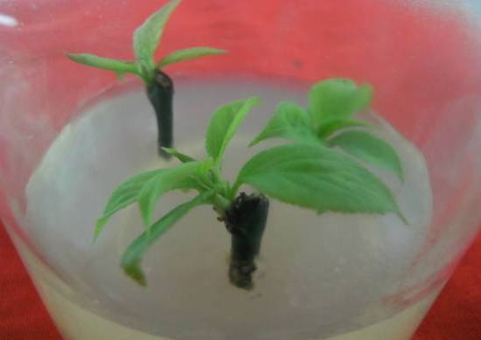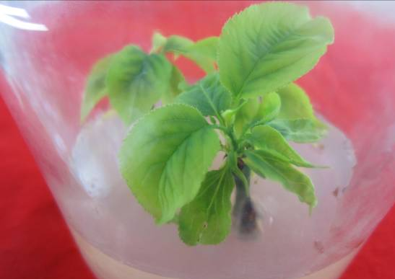
Primary culture of ‘Wu Yuyu’ Primary culture of ‘Xiao Yudie’
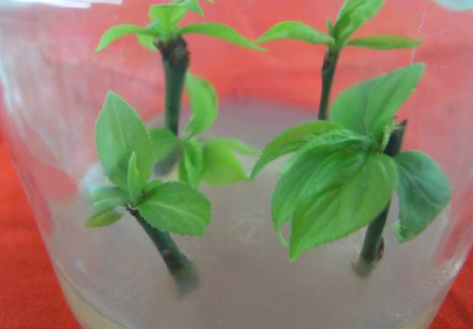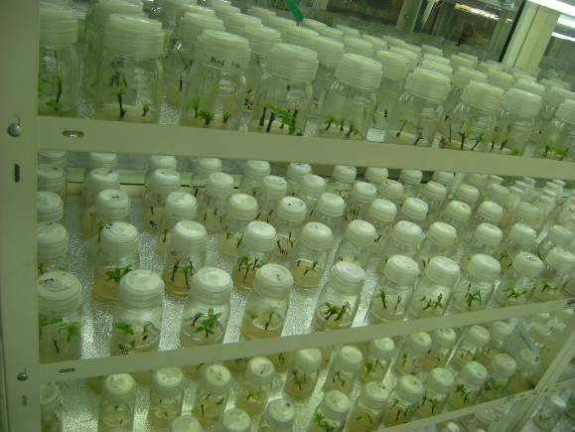
Primary culture of ‘Xiao Lv’e’ A large number of experimental materials
Secondary culture
Cutting the test tube leaves of primary culture from the base of the petiole, then inoculate them into secondary culture after cutting the leaves into 0.5cm×0.5cm pieces. After the formation of callus, we can get new plant from transformed callus by regulating hormone. All the materials are placed at 23 ± 2 ℃ for induction. Investigate growth of callus after 30d.Each combination 5 bottles×4 leaves, repeat 3 times. Use SPSS to carry out the significant difference analysis.
The impact of different medium on proliferation rate of three cultivar groups
Multiplication coefficient＝Buds which can be transferred out / Inoculated buds×100%
Most of the woody plant has a difficulty in tissue culture(Tan and Dai .1991), and because Prunus mume belongs to the typical recalcitrant plant, recovery capability is very weak, so tissue culture of Prunus mume is full of challenges. In order to establish the rapid propagation system of Prunus mume, we need try to find and summarize several issues and then provide solutions after the observation of its primary culture. Cut the bud which is got from primary culture from the former explants, and then transfer them into secondary culture, so as to carry out the next experiment.
We choose WB、WPM、MS、1/2MS and 1/2WPM as basic medium, then add 1.0mg/L BA and 0.5mg/L NAA into them. Each combination 20 bottles, with 3 calluses in it.The test results are shown in the following table.
Table9 The impact of different medium on proliferation rate of 3 cultivar groups
Medium | ‘Wu Yuyu’ -Zhusha cultivar group |  |  | ‘Xiao Yudie’ -Yudie cultivar group |  |  | ‘Xiao Lv’e’ -Lv’e cultivar group
Medium | Multiplication coefficient | Average bud length (cm) | Average bud height  (cm) | Multiplication coefficient | Average bud length (cm) | Average bud height  (cm) | Multiplication coefficient | Average bud length (cm) | Average bud height  (cm)
WB | 2.74bc | 1.48a | 2.39b | 2.72bc | 0.48bc | 0.93b | 1.45b | 0.68c | 0.33c
WPM | 3.37a | 1.67a | 3.23a | 3.13a | 0.73ab | 0.89b | 2.81a | 1.17b | 1.23a
MS | 2.41c | 1.01b | 1.87c | 2.71b | 0.87a | 0.72b | 1.58b | 0.63c | 0.69b
1/2WPM | 2.86b | 1.17b | 2.01c | 2.21c | 0.31c | 0.67b | 2.07b | 0.77c | 0.72b
1/2MS | 2.59bc | 1.13b | 2.16bc | 3.35a | 0.95a | 1.31a | 2.73a | 1.53a | 0.89b

As is shown in table9, the medium which has the greatest impact on Zhusha cultivar group is WPM, has a significant difference with the other 4 mediums. While to Yudie and Lv’e cultivar group, the greatest impact medium is 1/2MS. WPM also have greatly influences on Yudie cultivar group, while 1/2MS and WPM have a significant difference with the remaining two mediums. The basic medium which has the lowest impact on Zhusha , Yudie and Lv’e cultivar group, respectively are MS、1/2WPM and WB.To the average bud length ,the most suitable medium is WPM of Zhusha cultivar group, and 1/2MS of Yudie and Lv’e cultivar group .The basic medium which influence the average bud height most respectively are: WPM of Zhusha cultivar group , 1/2MS of Yudie cultivar group and WPM of Lv’e cultivar group. To sum up，the most suitable secondary culture medium for Zhusha , Yudie and Lv’e cultivar group is: WPM，1/2MS and WPM.
2.2 The impact of different combination of hormone on proliferation rate of three cultivar groups
According to the above test, we take WPM＋BA1.0mg/L＋2,4-D1.0mg/L as basic medium, add 3 different densities of NAA、TDZ and AHC.According to the orthogonal design to set up the experiment, each combination 20 bottles, with 3 callus in it. Orthogonal experiment design as shown in Table 10.
Table10 The combination of NAA、TDZ and AHC
Treatment number | NAA | TDZ | AHC | Treatment number | NAA | TDZ | AHC
1 | 1(0) | 1(0) | 1(0) | 6 | 2 | 3 | 1
2 | 1 | 2(0.2) | 2(100) | 7 | 3(1.0) | 1 | 3
3 | 1 | 3(0.4) | 3(200) | 8 | 3 | 2 | 1
4 | 2(0.5) | 1 | 2 | 9 | 3 | 3 | 2
5 | 2 | 2 | 3

After 30d of watching, we can receive the impact of different combination of NAA、TDZ and AHC on proliferation rate of 3 cultivar groups. The results are as shown in Table 11.
Table11 The impact of different combination of hormone on proliferation rate of three cultivar groups
Cultivar | NAA | TDZ | AHC(mg/L) | Average number of bud | Average bud length(cm) | Growth state of bud
‘Wu Yuyu’ -Zhusha cultivar group | 0 | 0 | 0 | 2.01f | 4.22e | Bushy stunt and with  small leaves
‘Wu Yuyu’ -Zhusha cultivar group | 0 | 0.2 | 100 | 4.02a | 7.31a | Vigorous
‘Wu Yuyu’ -Zhusha cultivar group | 0 | 0.4 | 200 | 3.13cd | 6.01b | Not weak enough
‘Wu Yuyu’ -Zhusha cultivar group | 0.5 | 0 | 100 | 3.43bc | 5.89bc | Not strong enough
‘Wu Yuyu’ -Zhusha cultivar group | 0.5 | 0.2 | 200 | 3.89ab | 6.12b | Not strong enough
‘Wu Yuyu’ -Zhusha cultivar group | 0.5 | 0.4 | 0 | 2.73de | 5.73bc | Not strong enough
‘Wu Yuyu’ -Zhusha cultivar group | 1.0 | 0 | 200 | 2.44ef | 4.98d | Bushy stunt and weak
‘Wu Yuyu’ -Zhusha cultivar group | 1.0 | 0.2 | 0 | 2.88cde | 5.53c | Not weak enough
‘Wu Yuyu’ -Zhusha cultivar group | 1.0 | 0.4 | 100 | 3.06cd | 5.82bc | Not strong enough
‘Xiao Yudie’ -Yudie cultivar group | 0 | 0 | 0 | 0.09e | 0.02f | Bushy stunt and with thin stems
‘Xiao Yudie’ -Yudie cultivar group | 0 | 0.2 | 100 | 1.95a | 1.69b | Weak
‘Xiao Yudie’ -Yudie cultivar group | 0 | 0.4 | 200 | 1.13b | 0.69c | Weak
‘Xiao Yudie’ -Yudie cultivar group | 0.5 | 0 | 100 | 0.52de | 0.27de | Not weak enough
‘Xiao Yudie’ -Yudie cultivar group | 0.5 | 0.2 | 200 | 2.01a | 2.23a | Vigorous
‘Xiao Yudie’ -Yudie cultivar group | 0.5 | 0.4 | 0 | 0.79cd | 0.47cd | Not strong enough
‘Xiao Yudie’ -Yudie cultivar group | 1.0 | 0 | 200 | 0.49de | 0.13e | Bushy stunt and with thin stems
‘Xiao Yudie’ -Yudie cultivar group | 1.0 | 0.2 | 0 | 1.01bc | 0.39cd | Weak
‘Xiao Yudie’ -Yudie cultivar group | 1.0 | 0.4 | 100 | 0.83cd | 0.43cd | Not strong enough
‘Xiao Lv’e’ -Lv’e cultivar group | 0 | 0 | 0 | 2.21e | 4.65f | Not strong enough
‘Xiao Lv’e’ -Lv’e cultivar group | 0 | 0.2 | 100 | 4.81a | 6.65b | Vigorous
‘Xiao Lv’e’ -Lv’e cultivar group | 0 | 0.4 | 200 | 3.56bc | 5.61cd | Not strong enough
‘Xiao Lv’e’ -Lv’e cultivar group | 0.5 | 0 | 100 | 2.87d | 4.87ef | Bushy stunt and with thin stems
‘Xiao Lv’e’ -Lv’e cultivar group | 0.5 | 0.2 | 200 | 5.03a | 7.02a | Vigorous
‘Xiao Lv’e’ -Lv’e cultivar group | 0.5 | 0.4 | 0 | 3.88b | 5.77c | Not strong enough
‘Xiao Lv’e’ -Lv’e cultivar group | 1.0 | 0 | 200 | 3.58bc | 5.42d | Vigorous
‘Xiao Lv’e’ -Lv’e cultivar group | 1.0 | 0.2 | 0 | 3.13d | 5.13e | Thin stems and weak
‘Xiao Lv’e’ -Lv’e cultivar group | 1.0 | 0.4 | 100 | 3.44c | 5.02e | Thin stems and weak

It can be concluded from table11 that in the secondary culture of Zhusha and Yudie cultivar group, the combination which has the greatest number of bud and the longest bud length is : TDZ0.2mg/L＋AHC100mg/L and NAA0.5mg/L＋TDZ0.2mg/L＋AHC100mg/L;While the suitable medium for Lv’e cultivar group is TDZ0.2mg/L＋AHC100mg/L and NAA0.5mg/L＋TDZ0.2mg/L＋AHC100mg/L,the difference between this two medium is not that significant. The worst medium of this three cultivar group is the basic medium without any added hormone.

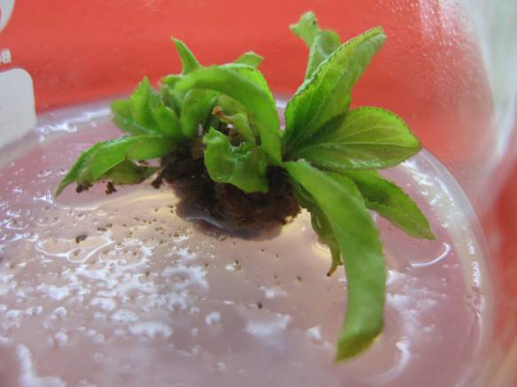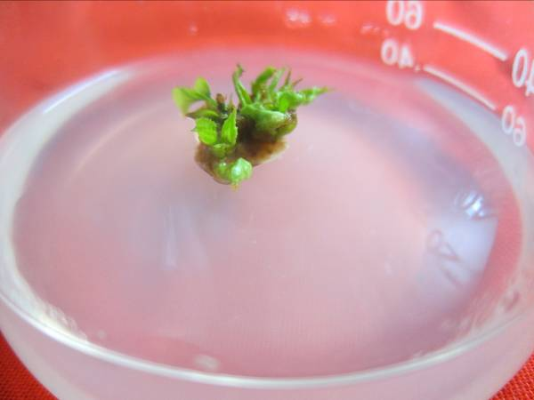
Secondary culture of ‘Wu Yuyu’ Secondary culture of ‘Xiao Yudie’

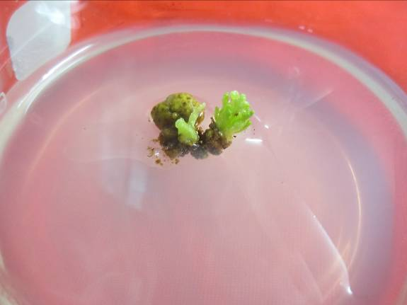 Secondary culture of ‘Xiao Lv’e’
Rooting culture
Inoculate the proliferation seedlings into the rooting medium, which is WPM＋0.3mg/L NAA. The proliferation seedlings are all dead after 30d, without any root. We need to find solutions to solve this problem.
Conclusions
It is very important for us to choose the appropriate explants. The reaction of different genotype, age even material parts of explants is different, may influence the reproductive effects and costs(Chen .1963). In the primary culture, the perfect explants of three Prunus mume groups is non-tender healthy part in the upper twigs and the best disinfection time is 10min by using Hgcl₂. Results show that germination rate of primary culture is: Yudie cultivar group＞Lv’e cultivar group＞Zhusha cultivar group. The optimum in vitro shoot section explants growing medium for Prunus mume Yudie cultivar group was the WB medium supplemented with 0.2mg/L NAA and 0.5mg/L BA. The optimum proliferation medium for Lv’e cultivar group was improved WB medium supplemented with 0.1mg/LNAA and 0.5mg/LBA,while the optimum proliferation medium for Zhusha cultivar group was supplemented with 0.1 mg/ L NAA and 0.1 mg/L KT. On the basis of initiation culture, medium, hormone type and concentration was studied. The results show that the most suitable medium for multiplication culture of Zhusha cultivar group was WPM＋1.0mg/L BA＋1.0mg/L 2,4-D＋0.2mg/L TDZ＋100mg/L AHC,Yudie cultivar group was 1/2MS＋1.0mg/L BA＋1.0mg/L 2,4-D＋0.5mg/L NAA＋0.2mg/L TDZ＋100mg/L AHC,and Lv’e cultivar group was WPM＋1.0mg/L BA＋1.0mg/L 2,4-D＋0.2mg/L TDZ＋100mg/L AHC.
References
Cao L , Lv YM (2004). Research status and prospect of tissue culture on Prunus mume. The progressing of China‘s ornamental horticulture, Chinese Forestry Press (Beijing):163-171.
Cao L , Lv YM ,Sun JP , Dong RB (2005). Research on primary culture of a few varieties of Prunus mume . The progressing of China‘s ornamental horticulture: 315-318.
Chai ML, Shen XD, Lin BN (1988) The embryo culture and shoot regeneration of Prunus mume, Plant Physiology Communications 3:53-54.
Chen, JY (2010) The district of Prunus mume cultivar, Chinese Forestry Press.
Chen RD (2003) Research on hybridization and embryo culture of Prunus mume . Beijing Forestry University (Doctoral dissertation) , Beijing Forestry University Library.
Chen RD, Sun WW (2007) Preliminary research of the opening primary culture on the variety of Prunus mume 'Dan Fenghou’. Journal of Beijing Forestry University ,29 (S l)：30-34.
Chen ZH (1963) Tissue culture and Application of Woody plant . Beijing: Higher Education Press: 13.
Fu EH (1993) In vitro rapid propagation method of Prunus mume. China Patent ZL90104477.6.
Fu EH, Xu HZ, Wang YL (1991) The study of micro-propagation of Prunus mume. Journal of Beijing Forestry University 9(3):275-280.
Fu EH , Xu HZ , Wang YL(1995) In vitro culture of the stem of Prunus mume ,Journal of Beijing Forestry University 17(S l)：76-78.
Harada H, Murai Y (1996) Micro-propagation of Prunus mume , Plant Cell, Tissue and Organ Culture, 36(4): 265-267.
Jiang ZP , Liang ZH , Liu GL , Zhu J (2004) The impaction of ZT and IAA on the proliferation and growth of Prunus mume. The progressing of China‘s ornamental horticulture 2:255-257.
Liu QL,Chen QH ,Chen JY (1999) Preliminary study on callus culture of Prunus mume .Journal of Beijing Forestry University , 21(2): 100-105.
Olaya P T, Lorenzo B (2000) Different media requirements for micro-propagation of apricot cultivars . Plant Cell, Tissue and Organ Culture, 63(2): 133-141.
Quoirin M , Lepoiver P (1977) Improved media for in vitro culture of Prunus spp. Acta Horti, 78(6): 437-442.
Tan WC ,Dai CG (1991) Tissue culture of ornamental plant technology . Chinese Forestry Press.

*Corresponding author. Email: luyingmin@bjfu.edu.cn.

