A preliminary study of tissue culture of the living fossil plant - Wollemi pine (Wollemia nobilis)
Y.L. Niu¹ J. Du ¹ Q.S. Zhang¹ X.H Zhan¹ X. Pei² X.B. Zhang¹
¹ Lushan Botanical Garden, Jiangxi Province and the Chinese Academy of Sciences, Lushan
Jiangxi 332909, China;
² Key Laboratory of Horticultural Plant Biology Affiliated to Ministry of Education Huazhong
Agricultural University, Wuhan 430070, China
Correspondence to: Xuanhuai Zhan
Fax: 0086-792-8282-223. E-mail: nyl0601@126.com
Abstract
The stem segments of Wollemi pine (Wollemia nobilis) were used as the explants to study the effects of pretreatment methods, media types, cytokinins and dark treatment on axillary shoots induction. The results showed that rapid freezing in liquid nitrogen was the most effective pretreatment method, dark treatment for the first 4-weeks of stem explants cultured in induction media could increase the frequency of axillary shoots induction significantly. The highest frequency of axillary shoot induction (63%) was obtained when stem were cultured in the 1/2GD medium with 6.8 μM TDZ combining 4-weeks dark treatment.
Key word: Wollemia nobilis; in vitro conservation; an endangered relict conifer

INTRODUCTION
Wollemi pine (Wollemia nobilis) was discovered in late 1994 as a small grove of trees in the Wollemi National Park, Australia (Jones et al. 1995). Its discovery is regarded as one of the most significant botanical finds of the twentieth century, akin to rediscoveries of other ancient species like the gingko tree (Gingko biloba) and the dawn redwood (Metasequoia glyptostroboides) (Woodford 2002, Offord and Meagher 2006). Wollemi pine belongs to the ancient Araucariaceae family, a whole new monotypic genus (Jones et al. 1995), Wollemi pine is as not only a curious Jurassic age relict, but also an exciting new horticultural species. Most importantly, it could be served as a model adopted for the reservation of many other endangered horticultural species. As such, it is a flagship species for plant science, ornamental horticulture, and biological conservation.
Wollemi Pine has high ornamental and scientific value (Hill 1996). However, only three populations with a total of less than 100 mature trees were uncovered after extensive searches (Woodford 2002). Collection of seed from the species’ natural populations would be very expensive, dangerous, and undesirable for conservation reasons (Stephen et al. 2007). furthermore,
The survival of this species is faced with serious threat, including the invasion of pathogens, illegal collection of plant material and catastrophic events (NSW 2006). So, conservation method for this species has relied heavily on vegetative propagation.
Firstly, studies have been done on cutting of Wollemi pine (Offord 1995, Pohio et al. 2005, Stephen and Rodger 2006), but actually there are many problems when the trees were propagated using vegetative material due to limited material source, which led to this species in “slow growth mode” essentially. The application of tissue culture technique is one approach to both the propagation of threatened species as well as a tool for the development of ex situ collections (Fay 1992, Pence 2011). However, micropropagation of gymnosperm have been more difficulties, especially for Araucariaceae species. They have been carried out the propagation of wollemia nobilis (Grace et al. 2005, Woodford 2005, Stephen et al. (2007), Agata et al. 2010). Trueman et al. (2007) have been achieved roots on ex-flasking, however the multiplication rate still remains relatively low. So, in the context of propagation for conservation of wollemia nobilis, this study optimized the conditions for shoot and root production in vitro and the acclimatization of plants to ex vitro conditions.
Materials and methods
Plant material
The stems of Wollemi pine were taken from 3-years-old potted plantlet grown in Exhibition Greenhouse of Lushan Botanical Garden. Health and plagiotropic branches which were cut to about 3cm long were used as experimental materials. Firstly, explants were soaked in tap water, and then immersed for 30min in water which was added with detergent, and gently scrubbed with a brush and rinsed under running water at least 1h.
Methods
Explants were pretreated in ice water mixture for 1d or in liquid nitrogen for 5min to freeze rapidly. They were then surface sterilized in 70% ethanol for 30s followed by immersion in 15% Clorox (0.6% sodium hypochlorite) containing 2 drops of tween-20 per 1000 ml solution for 8, 15 and 20min and rinsed three times in sterile distilled water, with a 3-min interval between each rinse. The explants were cultured on several media (GD, DCR, MS) with different concentration and type of cytokinin (BA, KT and TDZ), as well as dark treatment (0, 4 weeks) were employed. After that, the explants were kept under 16 h photoperiod and 1500lx luminance provided by cool white fluorescent at approximately 25℃. All experiments were randomized block design and performed under identical conditions unless otherwise noted.
Data analysis
Experiments were repeated three times with 6 explants per treatment were designed. Results are presented in mean percentages with their standard error. The induction rate was subjected to the analysis of variance (ANOVA), and treatment means were compared by least significant difference (LSD) (Zhang and Chen 2006). Percentage data were arcsin transformed prior to statistical analysis. (Yuan and Zhou 2000).
Results
Effects of pretreatment methods on the sterilization
The results showed that rapid freezing of liquid nitrogen was a superior pretreatment (Table1). The pretreatment time was very important for explants disinfecting. When the pretreated time is not enough long, the contamination rate is high. But explants would be killed if the pretreated time was too long. Of Among six treatments, that sterilized with 15% Clorox solution for 15 min is optimal and obtained the highest survival rate with 62.2%. The treatment with 15% Clorox solution for 20 min had obtained lower contamination, however its browning rate was very high.
Table 1 Effects of pretreatment methods on the sterilization
Pretreatments methods | Sterilization time(min) | Contamination rate (%) | Survival rate (%)
Ice water mixture for 1d | 8 | 65.9±0a | 19.8±10.39c
Ice water mixture for 1d | 15 | 38.5±3.27b | 38.5±3.27b
Ice water mixture for 1d | 20 | 41.7±3.27b | 27.8±3.7bc
Liquid nitrogen rapid freezing | 8 | 48.3±6.53b | 41.7±3.27b
Liquid nitrogen rapid freezing | 15 | 16.1±8.03c | 62.2±3.7a
Liquid nitrogen rapid freezing | 20 | 16.1±8.03c | 31.5±3.7bc
Note: (1) The data is mean ± standard error; (2) Means within columns followed by the same letter are not significantly different by least significant difference (LSD) test (P<0.05).
Effects of media types on axillary shoots inducation
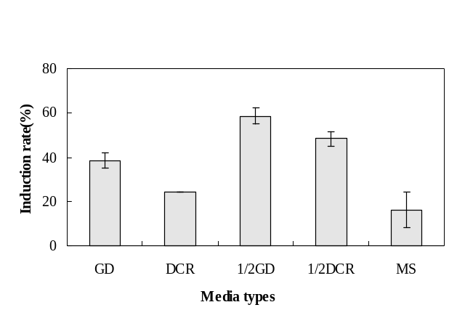
After 2-3 weeks, axillary shoots occurred in 1/2GD medium in succession. As shown Fig.1, The highest induction rates of axillary shoots were also occurred in 1/2GD medium. The induction rate of axillary shoots was higher in 1/2DCR medium, but browning appeared early and seriously. To a certain extent, high concentration NO₃⁻ might be inhibited induction and differentiation of stem explants.
Fig.1 Effects of media types on axillary shoots induction

Effects of cytokinin and dark treatment on axillary shoots induction
Different varieties and concentrations of cytokinins had different effects on the induction of axillary shoots. As shown in Fig. 2, with the concentration of cytokinins increasing, the induction rate also increased, but when the concentration extended 7μM the induction rates declined. Although high concentration cytokinins were prone to induce more shoots, but simultaneously, it would cause browning and abnormal swelling of some buds (Fig. 3). Fig. 4 showed that TDZ used as the cytokinin source was easier to be induced axillary shoots than BA and ZT. Dark treatment significantly enhanced axillary shoots induction except for TDZ 4.5μM. Comparing the response of explants to cytokinins, without dark treatment, only 16% of stem explants produces shoots in BA-containing medium, no axillary shoots were induced in ZT medium. The maximum frequency of axillary shoots induction (63%) was obtained when stem were cultured in the 1/2GD medium with 6.8μM TDZ combining 4-weeks dark treatment.
Discussion
Wollemi Pine remains only 100 adult trees in the wild, and the species is highly susceptible to Phytophthora cinnamomi (Bullock et al. 2000). Despite the relative ease of germination of seeds of this species (Offord and Meagher 2001), few seeds are produced, and they are difficult to harvest (Offord et al. 1999). These difficulties have stimulated efforts to explore in vitro approaches for propagation. Tissue culture technology is extensively used for the vegetative propagation of rare and endangerous species. However, limited amount of plant material available from rare species poses major challenges in the application of in vitro methods to endangered species (Sarasan et al. 2006).
A number of propagation strategies were considered as part of an integrated conservation programme (NSW Department of Environment and Conservation 2006). The authors (Luo 1997, Burrows et al. 1988, Sarmast et al. 2009) obtained limited success with rapid multiplication for Araucariaceae at this time. Stephen et al. (2007) have been raised in vitro using orthotropic shoots from Wollemi pine seedlings. They have been also researched the propagation of Wollemia nobilis through tissue culture, but multiplication rates were low or zero (Grace et al. 2005, Woodford 2005, Offord and Meagher 2006, Agata et al. 2010). Trueman et al.(2007) had obtained better multiplication rates as explants derived from orthotropic shoots of seedling-grown plants, while the number of these orthotropic shoots was limited comparing to plagiotropic shoots. In the study, plagiotropic shoots were used as explants which could have produced more trial materials than orthotropic shoots, and the plagiotropic shoots produce prostate plants of horticultural interest.
Numerous attempts to improve the induction rate of axillary shoot have been made. In the present study, we found that the pretreatment of liquid nitrogen deepfreezing was a superior pretreatment which could reduce the contamination rate. The authors think that liquid nitrogen perhaps killed quickly some pathogens and viruses.
It has been reported that the media composition played a significant role in the improvement of cell growth and development (Agata et al. 2010). Our results proved that, for buds induction of Wollemia nobilis, 1/2GD medium was preferable to MS and DCR as a basal medium. 1/2GD medium component might facilitated inducing phenotypically normal shoots of Wollemia nobilis. More heavy metal in MS and DCR medium could produce toxic on the explants or the induction of axillary shoots were inhibited.
The choice of TDZ as the cytokinins for buds initiation and shoot proliferation in wollemia nobilis was supported by its general extensive use in the culture of woody plant tissues (Yang et al. 2001). In the study, TDZ as a cytokinin was beneficial in comparison to BA, ZT for optimum shoot production with minimum callus induction. However, when the concentration of TDZ exceeded to a certain range, it failed to increase multiplication and, in most cases, were phytotoxic. A similar situation was reported by Aitken-Christie and Platt (1992). Dark treatment was generally effective in promoting the development of morphologically normal shoots, although dark treatment was not essential in exhibiting the most prolific shoot regeneration. In the present study, We found it was not suitable for the induction of root on Wollemi pine when there was not or only a kind of cytokinin existence. The similar results were also stated by Murch and Saxena (2008). These results were of valuable importance to propagate this species, however further studies are needed to increase our knowledge and prospect for applied propagation of this plant.
Trueman et al. (2007) development a propagation system and had few roots on ex-flasking. The percentage of plants of Wollemia nobilis that shoot regeneration and rooting remained low comparable to reports for micropropagated plants of other gymnosperm (Kalia et al. 2007). The main difficulty experienced in implementing this regeneration procedure is in the initial bud browning and root induction. In future experiments, it may be possible to increase the percentage of Wollemia nobilis surviving shoots by paying attention to such factors as the period of subculture, the ratio of hormone, the condition of culture, and the state of explants. Consequently, detailed analysis of the natural habitats of Wollemia nobilis could facilitate the propagation system.

Acknowledgments The authors thank Dr. Dalong Guo and Yanfang Zhang for proofreading of this manuscript. This work was supported by Scientific and Technological Project of Jiangxi Province (No 2009Dkp01000) and also Supported KIP Pilot Project of Chinese Academy of Science (KSCX2-YW-Z-1008, KSCX2-YW-Z-0928).

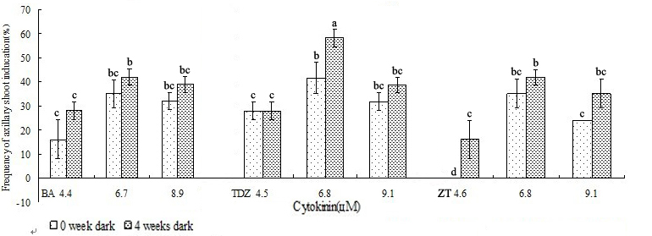
Fig.2 Axillary shoot inducation of Wollemi pine. The frequency of axillary shoot induction is expressed as the percentage of stem explants forming shoots in 8 weeks. Error bars with standard error. The same letter are not significantly different by least significant difference (LSD) test (P<0.05).

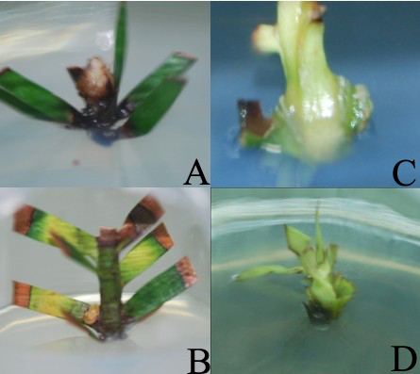
Fig.3 Browning and abnormal swelling of some buds in high concentration cytokinins.
(A) 10μM BA; (B) 12μM BA; (C) 12μM TDZ; (D) 10μMTDZ.

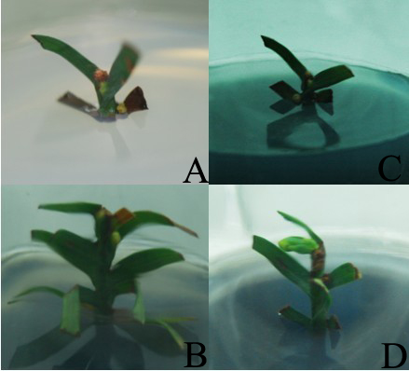
Fig.4 Inducted axillary shoots of Wollemi pine in the optimal treatment
shoots on 1/2GD medium after 10 weeks containing 6.8 μM TDZ; (B) shoot on 1/2 GD medium
after12 weeks containing 6.8 μM TDZ; (C) Abnormal shoot on 1/2DCR medium after 16 weeks
containing 10 μM TDZ; (D) prolonged shoot on 1/2GD medium after 20 weeks,

REFERENCES
- Agata S., Mateusz S., Herman J. Woerdenbag., Oliver Kayser. (2010). Wollemia nobilis in vitro cultivation attempts of the living fossil. Wollemia nobilis, pp: 75-87.
- Aitken-Christie J., Platt G.C. (1992). Agathis australis: a new era for Kauri production. Comb Proc Int Plant Propag Soc., 42: 321-326.
- Ashmore S.E., Hamilton K.N., Offord C.A. (2011). Conservation technologies for safeguarding and restoring threatened flora: case studies from Eastern Australia. In Vitro Cell Dev Biol-Plant., 47: 99-109.
- Burrows G.E., Doley D.D., Haines R.J., Nikles D.G. (1988). In vitro propagation of Araucaria cunninghamii and other species of the Araucariaceae via axillary meristems. Aust J Bot., 36: 665-676.
- Fay M. F. (1992). Conservation of rare and endangered plants using in vitro methods. In Vitro Cell. Dev. Biol., Plant., 28: 1-4.
- Fensom G., Offord C. (1998). Propagation of Wollemi pine (Wollemia nobilis). Comb. Proc. Intl.Plant Pro. Soc., 47: 66-67.
- Grace L., Cook J., Hargreaves C., Meagher P., Menzies M., Offord C., Trueman S. (2005). 16th Biennial Meeting of the New Zealand Branch of the International Association for Plant Tissue Culture and Biotechnology, Christchurch.
- Hall R.D. (1999). Plant cell culture protocols. In: Humana Press Inc., U.S.A. 421.
- Hill K.D. (1996). The Wollemi pine: discovering a living fossil. Nat Resour., 32: 20-25.
- Jones W.G., Hill K.D., Allen J.M. (1995). Wollemia nobilis, a new living Australian genus and species in the Araucariaceae. Telopea, 6:173-176.
- Kalia R. K., Arya S., Kalia S., Arya I.D. (2007). Plantlet regeneration from fascicular buds of seedling shoot apices of Pinus roxburghii Sarg. Bio. Plantarum., 51: 653-659.
- Luo J.X. (1997). Tissue culture and rapid propagation of Araucaria heterophylla. Acta Hort.Sin., 24: 100-102.
- Murch S.J., Saxena P.K. (2008). Wollmia nobilis : Modern Studies of an Ancient Plant. the 28th Symposium or Colloquium Presentation.
- NSW Department of Environment and Conservation. (2006) . Wollemia nobilis, Wollemi pine recovery plan. Department of Environment and Climate Change (NSW), Hurstville, NSW, Australia.http://www.environment.gov.au/biodiversity/threatened/publications/wollemia- nobilis.html. Viewed 23 Feb 2010.
- Offord C.A. (1995). Horticultural Research on the Wollemi Pine. The Gardens, 27: 9-10.
- Offord C.A., Meagher P.F. (2006). Wollemi pine: from the wild to the world. Chron Hortic., 46:10-13.
- Offord C.A., Porter C.L., Meagher P.F., Errington G. (1999). Sexual Reproduction and Early Plant Growth of the Wollemi Pine (Wollemia nobilis), a Rare and Threatened Australian conifer. Ann Bot., 84: 1-9.
- Pence V.C. (2011). Evaluating costs for the in vitro propagation and preservation of endangered plants. In Vitro Cell. Dev. Biol., Plant., 47: 176-187.
- Pohio K.E., Wallace H.M., Peters R.F., Smith T.E., Trueman S.J. (2005). Cuttings of Wollemi pine tolerate moderate photoinhibition and remain highly capable of root formation. Trees., 19: 587-595.
- Sarasan V., Cripps R., Ramsay M.M., Atherton C., McMichen M., Prendergast G., Rowntree J.K.(2006). Conservation in vitro of threatened plants-progress in the past decade. In Vitro Cell Dev Biol-Plant., 42: 206-214.
- Sarmast MK, Salehi H, Khosh-Khui M. (2009). Using plagiotropic shoot explants in tissue culture of Araucaria excelsa R. Br. var. glauca. Advances in Environmental Biol., 3: 191-194.
- Stephen J.T., Rodger F.P. (2006). Propagation of Wollemi Pine from tip cuttings and lower segment cuttings does not require rooting hormones. Sci Hort-Amsterdam., 109: 394-397.
- Trueman S.J., Pegg G.S., King J. (2007). Domestication for conservation of an endangered species: the case of the Wollemi pine. Tree For Sci., 1: 1-10.
- Woodford J. (2005). Prehistoric miracle:our dinosaur tree. Australian Geographic., 80: 50-57.
- Woodford J. (2002). The Wollemi Pine: The Incredible Discovery of a Living Fossil from the Age of Dinosaurs. Text Publishing Company, Melbourne, Australia.
- Yang J., Hu Z., Guo G.Q., Zheng G.C. (2001). In vitro plant regeneration from cotyledon explants of Swainsona salsula Taubert. Plant Cell Tissue Organ Cult., 66: 35-39.
- Yuan Z.F., Zhou J.Y. (2000). Design and Analysis of Experiments. Higher education press. China.
- Zhang W.B., Chen H.Y. (2006). Practical application of statistical analysis and SPSS 12.0. Posts & Telecom Press, Beijing, 1-339.

