Determination of the interval nutrient Solution in Eustoma hydroponically using hydrogel polymer

Ataei Jaliseh S.*
Corresponding author: Young Researchers and Elites club, North Tehran Branch, Islamic Azad University, Tehran, Iran.

Abstract
In recent years the use of soilless culture in greenhouse of decorative flowers and plants has been increased. A main problem which the hydroponic greenhouse managers face is to determine the internal nutrient solution. To assess the effect of the interval nutrient solution in Eustoma hydroponic culture, two studies performed randomized complete block design with 3 and 5 replications. In this two study, the effect of five interval nutrient solution (1, 3, 6, 9 and 30 days) which was treatment 30 day elected instance evidence. The results showed that the interval of 1 and 3 day nutrient solution with one percent weight super absorbent hydrogel the highest number of branches and diameter of flower has significantly in comparison with other treatments. On the other hand, the interval of 3 day nutrient solution with the decrease of consumption of water and chemical fertilizer can have a great role in increase of the efficiency of water and fertilizer in compared to the interval of one-day nutrient solution. In the experiment the highest point of durability of flowers was in 3-day treatment.

Keyword: Eustoma, Interval nutrient solution, Durability of flowers, Hydrogel.

Introduction
Eustoma (Gentianaceae) is one of the most common cut flowers and are of particular importance among cut flowers. Hydroponic cultivation of Eustoma in world is very common. Hydroponic culture and sustainable development of arid and semiarid regions depends on the water use efficiency and fertilizers. In recent decades, grown in greenhouses and controlled environments, the possibility of increasing production in various climatic conditions, soil and water provide, as an effective strategy for increasing yield and production, particularly in developed countries, have been considered. One of the main methods used in greenhouse cultivation, crop production system is. In the control cultures without soil being the main factors affecting production, possible to achieve high performance for water, fertilizer and other materials there. Cultivation methods in the context of crop production methods those are important throughout the word. Most parts of the plant available nutrient solution in each interval nutrient solution and lead to water pollution of underground and as a result, the cause for the water and fertilizer efficiency is reduced.

* Corresponding author: Young Researchers and Elites club, North Tehran Branch, Islamic Azad University, Tehran, Iran. E-mail: atayi.somayeh@yahoo.com Phone: 09111433511

In this regard, several studies have been conducted to increase the efficiency of water and fertilizers. It was shown in research, super absorbent or hydrogel, the hydrophilic polymer networks that are every bit of water absorption and swelling, while having mechanical consistency, maintains its shape and in time to plant, contracted and water and minerals are at the root. In case combination with a granular substrate without soil systems can improve the physical texture of the substrate, will increase water holding capacity, giving away the solution, facilitating the access of water and nutrients to plant roots and reduce drought stress. Thus, the rate per unit of water and fertilizer consumption increased performance and thereby improve water use efficiency and nutrient elements by plants.
On the basis of reports of (Bres et al., 1993); by adding 3 gr L⁻¹ hydrogel the culture medium Tomato, increase water-holding capacity and nutrient, and leaching rate of in the bed decreases. (Jehryng & Louise, 1980); in the one research, effect of hydrogel and flowerpot size on wilting and moisture stress of both Tagetes erecta and Zannia elegans plants were investigated. The results showed that both plants by increasing the amount of hydrogel time required to start wilting increases, so that the depth of the flowerpot with 5.1 cm of soil contained 16 kg of hydrogel on the cubis meter of soil, time required starting wilting in the parsley and starch, respectively, 45 and 37 percentage increase. Increase the flowerpot size increases the time required for the onset of wilting. The suction rate of internal moisture of plants grown in stress conditions was measured by the chamber pressure. The results showed that medium containing hydrogel moisture inside the plant will reduce the suction.
(Wang, 1992); in another study, effect of hydrogel at three levels: zero, 1.75 and 2.50 kg per m³ of soil, and several different culture media on growth and wilting of both Hibiscus chinensis and Codiaeum variegatum plants examined. Results showed that the hydrogel had no effect on plant growth, but the time required to begin to wilt in C. variegatum increased to 3 days.
Optimum use of water and nutrients, including important issues that need special attention. This study is an attempt to increase the efficiency of water and fertilizer use in without soil culture systems used in determine on the interval nutrient solution in Eustoma hydroponically could be investigated.

Materials and methods
This study was performed in 2009-2010 years. In this experiment, seedlings ready for planting beds of flowers in Eustoma grandiflorum species included black plastic pots (dimensions 20 x 16 x 20 cm) with a volume ratio of 1:1 and a mixture of perlite and cocobit wt% polymer hydrogel (Super water 1-200) were cultured. A plant was placed in each bed. Complete fertilizers were used in this study Omex Manufacturing Company (Tab. 1). Fertilizers or 7 gr L⁻¹ of water and the plants were collected. The values (Tab. 1); are the elements of a complete fertilizer. Solution pH in the range of 5.6 was set. EC and pH value of the solution was controlled during the study period. This study consists of five rounds of voting solutions (1, 3, 6, 9 and 30 days) were treated for 30 days were studied as a control experiment. Bed and all treatments with an interval of four days, was washed with water.
This study was a randomized complete block design with 5 replications was implemented. Eustoma flowers so good when fully grown and flags around the edge of the flower is to be seen on it, will be removed
Eustoma flowers are harvested when they came to the stage and size of the flowers and the number of branches in each plot was harvested. The amount of water (liters) and fertilizer Consumption (kg) and measuring the amount consumed in each treatment were measured relative to total consumption, consumption efficiency were studied.
In another experiment in a randomized complete block design with three replications of each treatment were harvested lasting flowers. Eustoma flowers harvested from the silver thiosulfate solution 190 mg ml, 5% sucrose were recorded for their survival.
Statistical analysis included analysis of variance and mean comparison using Duncan Two experiments using statistical software was Mstatc ver1-42.

Table 1: The amount of nutrients available in a complete fertilizer manufacturing company (Omex).
Basic solution | Symbol | Amount | Unit
Nitrogen azotes:  Calcium nitrate 5.8%  Ammonium 4.4%  Urea 9.8% | N | 20 | %
Phosphor | P₂O₅ | 20 | %
Potash | K₂O | 20 | %
Sulphur | S | 0.4 | %
Magnesium | Mg | 120 | mg/L
Copper | Cu | 16 | mg/L
Zinc | Zn | 14 | mg/L
Iron | Fe | 70 | mg/L
Bromine | Br | 22 | mg/L
Manganese | Mn | 42 | mg/L
Molybdenum | Mo | 14 | mg/L

Results and Discussion
The results of analysis of variance (Tab. 2); showed significant differences between the periodic solution given in 1% probability level, number of branches taken for properties, diameter, and there is a lasting flowers. Lack of nutrients causes the color bright green leaves and lower leaves are yellow. Gradually with the onset of drought conditions in the plant, the leaves were oriented toward the light brown, short and slender stems and under the deficiencies of nutrients, plant growth stage is delayed.
Water in the nutrient solution, for metabolic processes, dissolved nutrients in the plant (xylem and phloem); and for cooling by transpiration of plants is necessary and vital, with increasing water uptake by plants, usually the concentration of adsorbed ions increases with decreasing water absorption, thin stems, flowers and fruits are small. Comparison of the data (Fig. 1); showed that increasing the nutrient solution, a significant negative impact on the number of flowers and flower diameter. (Jandaghian, 2005); the effects of the solution, given the use of polyacrylamide (super absorbent) were incubated in Pelargonium zonale and Phylodendron sp., observed that the plant P. zonale, with increasing amounts of polymer from zero to 50% by volume (polymer before water is absorbed), a measure of growth (plant length, number of flowers, the number of leaf growth, leaf area, fresh and dry weight of shoot and root fresh and dry weight) and a maximum in 50% soil treated with 50% polymer can be seen.
Tallest plants in the treatment listed, giving 3 days was observed in the solution. P. zonale plant studies showed that treatment with 30% soil and 70% polymer solution, giving away 6 days of treatment is best. Results suggest that, taken Eustoma flowers lasting solution to reduce the image significantly increases the flowers will wilt. Quality of cut flowers is largely due to their leaves wilt and the leaves wilt and delay in flower senescence is due to longer shelf life. Freshness and shelf life of flowers may be due to chlorophyll degradation and destruction that will flower early aging and reduced carbohydrate and low water absorption and food plant is to follow.

Number of flowers
Eustoma flowers are harvested in the number of branches also strongly influenced by the solution is given. Comparison of the data (Fig. 1); shows that the solution given 1, 3 and 6 days respectively with 87, 86 and 47 days during the 12 month trial period the greatest number of flowers in the solution are given. Submit periodic solution of 1 and 3 days longer than the period given solution had significant differences, but differences are not significant. The lowest number of flowers in the solution, giving 9 days, with 27 flowers, respectively. Solution giving away 9 days, with a control sample that is fed every 30 days, showed no significant difference (Tab. 2). Ghasemi, and Khoshkhouy, in 2008; in their studies reported that use of the polymer on the flowering effect and values ​​of 0.8% and 1% polymer with the 0.4 percent and 0.6% of polymer with a significant difference there, also the highest number of goals related to the treatment polymer was 1%. Interactions showed that the rate of 0.8% polymer (8 gr polymer in kg soil) in the solution giving the highest average of 2 days (21.7) and having the lowest
average distance to the control solution was given 5 days.

Flower diameter
Comparison of the data (Fig. 1); shows that giving periodic solutions and periodic solutions of 1and 3 days, maximum flower diameter, and 6 and 9 day, flower diameter were lowest. Periodic solution of 1 and 3 days were not statistically different. Ghasemi and Khoshkhouy, 2008, declared that in their experiments, the solution was not significantly different between 2 and 3 days and maximum diameter of the flower, the giving away the solution was 4 days. Chrysanthemum morifolium flower diameter of less than 2 days to 4 days in the given solution may be due to more number of flowers in the solution giving away 2 days (15) compared with the solution given 4 days (5.7) is.

Flower durability
Mean data (Fig. 1); showed that soluble courses rated 1, 3 and 6 days compared to control, significant differences are observed in their survival. Solution away from the mean of the highest rated 3 days between periods is not the solution. Research on the use of stained glass (Estil, 1976); hydrogel (polyethylene oxide) in growth medium consisting of bark, the number of solution steps and stages of life and survival of age Ch. morifolium examined. The results showed that, with increasing hydrogel, blooming plants, requiring less soluble phases and their shelf-life of 11 to 23 percent increase.

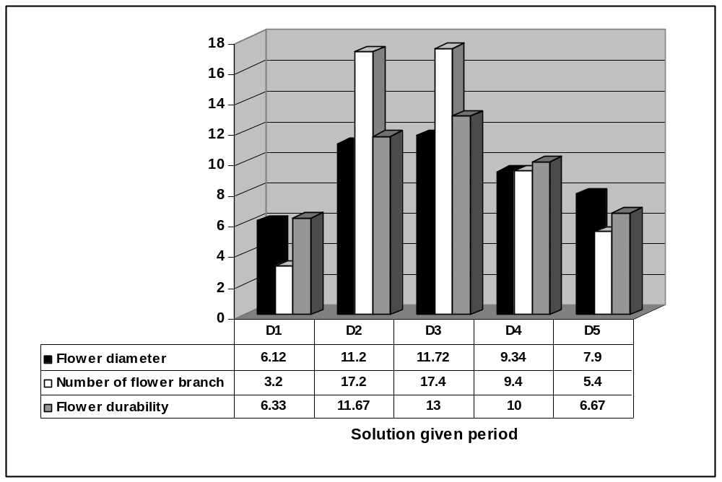
Figure 1: Comparison of the solution given period and its impact on branch diameter and durability of Eustoma flower.

Table 2: Analysis of variance of the number of branches, diameter and durability of Eustoma flower.
Changes in resources | Degrees of Freedom |  | Mean Squares
Changes in resources | Diameter and number of branch | Durability | Number of branch | Flower diameter | Flower durability
Replicate | 4 | 2 | 1.96 ^{ns} | 1.84 ** | 0.07 ^{ns}
Treatment | 4 | 4 | 216.26 ** | 26.91 ** | 26.43 **
Experimental error | 16 | 8 | 0.71 | 0.23 | 0.73
Coefficient of variation |  |  | 8.01 | 5.13 | 8.98
**: significant at 1% probability level.
ns: non-significant

Water and fertilizer use efficiency
In (Fig. 2); control can observe that the solution treated and given 30 days to 9 days, with the least amount of water and fertilizer consumption, the lowest level of the average show. Submit periodic solution of 1 and 3 days with the most water and fertilizer, the highest average level in the periodic solution are given, and the 3 days by reducing water and fertilizer, the solution giving away 1 day, significant differences in compared (Fig. 1); they can not be seen.

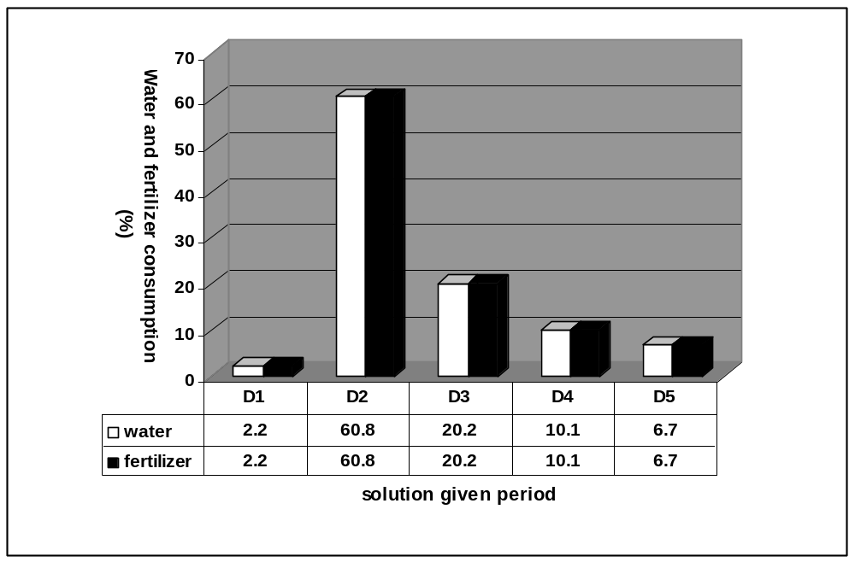
Figure 2: The total amount of water and fertilizer use in experiments.
D1 (in 30 days), D2, D3, D4 and D5, respectively, giving a periodic solution of (1, 3, 6 and 9 days).

Conclusion
The results show the periodic solution given 1, 3 and 6 days, compared with the control, the solution is given 30 days, the differences are significant. 3 days giving away the solution, the solution giving away 1 day, the periodic solution with the highest average week, compared to the average number of branches and flower diameter did not differ significantly in their views. The solution giving away 3 days decreased 40.6 percent less water and fertilizer solution than giving away 1 days, and with the highest average level of life, giving the best solution for the hydroponic cultivation of Eustoma mixed 1:1 with a bed volume cocobit and perlite and a weight percent hydrogel Polymer (Super water - 1-200) is known.

Acknowledgement
The author of Young Researchers and Elites club, North Tehran Branch and Islamic Azad University, Rasht branch, have been helpful in this study, is gratitude.

References
- Arbona, V., Iglesias, D.J., Jacas, J., Primo – Millo, E., Talon, M., Gomez – Cadenas, A., 2005. Hydrogel substrate amendement alleviates drought effects on young citrus plants. Plant and Soil. 270 (1), 73- 82.
- Arzani, A., 2007. Cultivation without soil (hydroponics) and domestic trade. Isfahan University Press.
- Biernhaum, A., Bosversluys, N., 1998. Water management. Horttechnology.
- Bres, W., Weston, L.A., 1993. Influenece of gel additives on nitrate, ammonium, and water retention and tomato growth in a soilless medium. Hortscience. 28 (10), 1005-1007.
- El-Hady, O.A., Wanas, Sh.A., 2006. Water and fertilizer use efficiency by cucumber grown under stress on sandy soil treated with acrylamid hydrogels. J.App.Sci.Res. 2(12), 1293- 1297.
- Entesari, M., Heidari, N., Kheirayi, J., Alayi, M., Farshi, A., Vaziri, Jh., 2007. Water use efficiency in greenhouse cultivation. Publications of the National Committee on Irrigation and Drainage.
- Ghasemi- Ghahsareh, M., Kafi, M., 2008. Scientific and practical potting. Galin Publications.
- Ghasemi, M., Khoshkhouy, M., 2008. Super absorbent polymer and effects on irrigation and growth of Chrysanthemum. Iranian Journal of Horticultural Science. 8 (2), 70-78.
- Gehring, J.M., Lewis, A.J., 1980. Effect of hydrogel on wilting and moisture stress of bedding plants. J. Am. Soc. Hort. Sci. 105, 511-513.
- Harbi, A.R., 1999. Efficacy of hydropohilic polymer declines with time in greenhouse experiments. Hortscience. 34(2), 233-244.
- Henderson, J.C., Hensley, D.L., 1986. Efficacy of a hydrophilic aid. Hortscience. 21(4), 991- 992.
- Jandaghian, M., 2005. Effect of polyacrylamide copolymer on rooting and growth of Phylodendron sp. and Pelargonium zonale. Master's thesis gardening. Islamic Azad University, Jahrom.
- Leperen, V., Nijsse, W.J., Keijzer, C.J., Meeteren, U., 2001. Induction of air embolism in xylem conduits of pre-diameter. J. Exp. Bot. 52, 981-991.
- Martyn, W., Szor, P., 2001. Influence of superabsorbents on the physical properties of horticultural substrates. Int. Agrophysics. 15, 87-94.
- Petridou, M., Voyiatzi, C., Voyiatzi, D., 2001. Methanol, ethanol and other compounds retard leaf senescence and improve the vase life and quality of cut chrysanthemum flowers. Postharvest boil.Tech. 23, 79-83.
- Still, S.M., 1976. Growth of ' Sunny Mandalay ' chrysanthemums in hardwood- bark- amended media as affected by insolubilized poly (ethylene oxide). HortScience. 11, 483-484.
- Toolayi, M., 2001. Guide to hydroponic cultivation of greenhouse plants in commercial levels. Dissemination of agricultural education.
- Verdonack, O., Demeyer, P., 2004. The influence of the physical properties of growing media. Acta hort. 664, 99-101.
- Wang, Y., Gregg, L.L., 1992. Hydrophilic polymers – Their response to soil amendments and effect on properties of a soilless potting mix. J. Am. Soc. Hort. Sci. 115, 943-948.

