GROWTH AND FLOWERING IN TWO HELLEBORE SPECIES GROWN IN POTS DEPENDING ON SUBSTRATE TYPE
Monika Henschke*, Piotr Czuchaj, Stanisława Szczepaniak
Department of Ornamental Plants, Poznań University of Life Sciences, ul. Dąbrowskiego 159, 60-594 Poznań, Poland, Fax: +48 618 487 999, E-mail*: mohen@up.poznan.pl

Abstract
An experiment was conducted on the effect of substrate type on growth of Corsican hellebore (Helleborus argutifolius Viviani) and new hybrids of lenten rose (Helleborus orientalis Lam). Plants were grown for two years in pots with substrates, which components included Klasmann highmoor peat, mineral soil, expanded clay and perlite at various volumetric ratios. Vegetative growth and flowering were observed in hellebores. It was shown that substrates exhibited a varied effect on plant growth. Corsican hellebore in a substrate with a considerable addition of mineral soil was lower, but more branched, and it did not form inflorescences. In contrast, lenten rose had the greatest number of leaves when grown in a mixture of peat, earth and expanded clay; however, these plants did not produce inflorescences. The type of applied substrate did not have a significant effect on the abundance or quality of flowering in either of the two hellebore species.

Kay words: growth, flowering, Helleborus argutifolius, Helleborus orientalis, cultivation, substrates

INTRODUCTION
In Europe in the production of ornamental plants to be used in interior decoration an increasing role is played by pot plants, particularly species with ornamental flowers. These plants are imported from countries with a warmer climate in much lower amounts than it is the case with cut flowers. Thus they do not constitute an equally significant competition for domestic production. Horticultural producers for cultivation select species with small thermal requirements and a short production cycle. For this reason the importance of hellebores has increased recently, as different studies, including cultivation trials, have been conducted on this species (Kraus and Warren 2002, Piskornik 2003a, Piskornik 2003b, Lubell et al. 2005, Szczepaniak et al. 2008, Henschke et al. 2009). Hellebores are herbaceous perennials, which flowering may be accelerated during a culture period of as little as 4 - 6 weeks in a greenhouse at a temperature of 12 - 16°C for a very attractive season, i.e. Christmas (Trier 2004, Klein 2008, Redler 2010). However, within the genus Helleborus there are several species, differing considerably in terms of their cultivation requirements, particularly the type of substrate. Commercially available substrates include those based on white Irish peat with clay, perlite, coir (coconut fibre) and sand (Springer 2005).
A standard growing medium in many pot cultures is the substrate. This medium exhibits several highly advantageous properties (Schmilewski 2007). However, natural resources of highmoor peat are slowly being depleted. Other substrates are being searched for to replace it, e.g. coir (Czajka and Szczepaniak 2005). There is a trend to re-introduce the application of those, which had been used for years before, such as perlite, expanded clay or hortisols. The type of the applied substrates, thanks to their physical properties, has a considerable effect on plant growth and flowering (Michalak and Hetman 2002, Hetman and Witek 2006, Riaz et al. 2008).
The aim of the study was to assess the effect of substrate type on growth and flowering of Corsican hellebore and new varieties of lenten rose in the first and second years of pot culture.

MATERIALS AND METHODS
An experiment was conducted at the Marcelin Experimental Station of the Poznań University of Life Sciences to determine the effect of substrate type on growth of Corsican hellebore (Helleborus argutifolius Viviani) and lenten rose (Helleborus orientalis Lam). Young plants for analyses in multitrays with 72 pots of 4 cm³ were supplied on 26 April 2006 by Syngenta Sp. z o.o. Seedlings of Corsican hellebore and lenten rose were uniform, at that time they developed 2.2 - 2.7 and 3.0 - 3.3 proper leaves, respectively. Plants were transplanted on 26 April 2006 and then again on 27 March 2007 to pots of 1.0 dm³ and 2.1 dm³, respectively. Young hellebores were grown in a greenhouse for 1 month, while older plants were grown in a hotbed with a shading mat and a mulching mat. For the winter period, from the beginning of November and March, plants were transferred to an unheated plastic tunnel. In the second year of culture flowering was accelerated in a greenhouse from the beginning of December. Plants were grown on five substrates, i.e. highmoor peat (H P), highmoor peat with mineral soil (H P + M S) at a 1:1 ratio (v:v), highmoor peat with mineral soil (H P + M S) at a 1:2 ratio (v:v), highmoor peat with mineral soil and with expanded clay (H P + M S +E C)) at a 1:1:1 ratio (v:v:v), and highmoor peat with mineral soil and perlite (H P + M S + P) at a 1:1:1 ratio (v:v:v). Highmoor peat produced by Klasmann with pH 3.91 was limed on the basis of the neutralization curve to pH 6.40 using CaCO₃ at a dose of 5.0 g.dm³ substrate. The applied expanded clay had grain size of 4 - 16 mm. The ready-to-use substrate mixtures were supplemented with 2.5 g.dm³ of a fertilizer Osmocote Plus 5-6 M (15:10:12). One month after transplanting top dressing with Peters Professional PL Special (15:11:29) was applied at a concentration of 0.15% (100 ml per pot), which was repeated every 2 weeks until the end of August.
Plant measurements consisted in the determinations of the number of leaves and plant height, repeated twice in the vegetation period. In 2006 plants were measured on 26 July and 26 September, while in 2007 it was on 13 August and 13 October. Flowering was observed only in 2007, since in 2006 very few specimens blossomed. At the beginning of flowering flower diameter and peduncle length were measured. At full blooming the number of inflorescences and the number of flowers and buds were determined. Results of measurements were subjected to a one-way analysis of variance using the Duncan test at the significance level of 0.05. One factor level (substrate type) comprised 10 replications.

RESULTS AND DISCUSSION
The effect of substrate type on plant growth varied in individual hellebore species. In the first year towards the end of vegetation in September both species had the greatest number of leaves when grown in pots in the highmoor peat substrate (Table 1). Reimaherr et al. (1998) reported that the most advantageous effect on growth in Christmas rose was found for well-aerated substrate, permeable and fertile, such as e.g. a peat and compost mixture (1:1, v:v) or a mixture of standard peat substrate P with a 15% fibrous peat addition. In the experiment conducted in the second year of this study Corsican hellebore formed many leaves when it was grown in a highmoor peat substrate, while lenten rose did so in a substrate mixture of highmoor peat + earth + expanded clay (1:1:1, v:v:v). The lowest plants in both years of the study were found in Corsican hellebore grown in a highmoor peat + earth substrate mixture (1:2, v:v) (Table 2). Also lenten rose in the first year culture in this substrate yielded the lowest plants, but the difference was significant only in comparison to those grown in the highmoor peat + earth + perlite substrate (1:1:1, v:v:v). In the second year substrate type did not have a significant effect on that characteristic. The large number of shoots formed by Corsican hellebore in the second year of culture in highmoor peat did not differ significantly from that recorded in the culture in a highmoor peat + earth mixture (1:2, v:v) (Table 3). In contrast, in an experiment by Szczepaniak and Kozik (2004) plants of Coreopsis grandiflora had a greater number of shorter lateral branchings when they were grown in a mixture of peat with mineral soil (1:1, v:v) than in peat alone.
Flowering in hellebores depended on the type of substrate. Plants of Corsican hellebore did not bloom in the substrate with the greatest compaction, i.e. highmoor peat + earth (1:2), while lenten rose in this substrate formed the greatest number of flowers and buds. In turn, lenten rose did not bloom when grown in the highmoor peat + earth + expanded clay substrate (1:1:1, v:v:v), in which it formed the greatest number of leaves. In the culture of plants in a mixture of highmoor peat with mineral soil, in comparison to culture in peat alone, more abundant flowering could be obtained also in other herbaceous perennials, such as e.g. Coreopsis grandiflora (Szczepaniak and Kozik 2004). Flowering of both hellebore species began in the last decade of December (Table 4). When grown in light substrates, i.e. highmoor peat or highmoor peat + earth + perlite (1:1:1, v:v:v), plants formed longer shoots, which was confirmed statistically only in Corsican hellebore (Table 5). The number of peduncles did not differ significantly, but it was greater in Corsican hellebore in the culture in highmoor peat, while in lenten rose in a mixture of highmoor peat + earth + perlite (1:1:1, v:v:v). Flowers in lenten rose were approx. by 2 cm bigger in diameter in relation to flowers of lenten rose, with the type of substrate having no significant effect on this characteristic in either species. The total number of flowers and buds was higher in Corsican hellebore grown in a light substrate, such as a peat + earth + perlite mixture (1:1:1, v:v:v), while in lenten rose it was for the substrate with the greatest compaction, i.e. highmoor peat + earth (1:2, v:v) (Figure 1,2). A positive effect of the peat substrate in comparison to the mixture of mineral earth and highmoor peat (2:1, v:v) on earliness and abundance of flowering was also obtained by Szczepaniak and Kupiec (2002) in forced pot culture of Doronicum orientale ‘Little Leo’, while Czuchaj and Szczepaniak (2005) reported the same trend in pot culture of Gaillardia aristata.

CONCLUSIONS
The present study has shown the effects of plants of Corsican hellebore grown in a highmoor peat + earth mixture (1:2, v:v) were lowest, with a large number of vegetative shoots and they did not bloom in the second year of pot culture. Lenten rose grown in pots in a mixture of highmoor peat + earth + expanded clay (1:1:1, v:v:v) formed the greatest number of leaves and it did not bloom. Formation of flowers and buds was most abundant in Corsican hellebore grown in a light substrate, such as a highmoor peat + earth + perlite mixture (1:1:1, v:v:v), while in lenten rose it was in a substrate with the greatest compaction, i.e. highmoor peat + earth (1:2, v:v). The type of applied substrate did not have a significant effect on the number of peduncles or flower diameter, while in lenten rose no effect was observed also for the length of peduncles. In Corsican hellebore longer peduncles were found in plants grown in a highmoor peat substrate or in a mixture of highmoor peat + earth + perlite (1:1:1, v:v:v).

REFERENCES
Czajka E, Szczepaniak S. (2005) Wpływ podłoża na wzrost młodych roślin trzech gatunków bylin o ozdobnych liściach. Zesz. Prob. Post. Nauk Roln. 504: 57-65
Czuchaj P, Szczepaniak S. (2005) Wzrost i kwitnienie gailardii ościstej (Gaillardia aristata Pursh) uprawianej w doniczkach w różnych podłożach. Zesz. Prob. Post. Nauk Roln. 504 cz I: 67-71
Dreßler H. (2010) Helmut Lörcks: Helleborus, Tontöpfe und die Farbe Blau. Gärtnerbörse 5: 10-12
Henschke M, Szczepaniak S Czuchaj P Kozik E. (2009) The effect of calcium carbonate and top dressing with Peters Professional Special on growth and flowering of Helleborus lividus Aiton. Folia Horticulturae Ann 21(1): 105-117
Hetman J, Witek M. (2006) Wpływ różnych podłoży na kwitnienie kohlerii (Kohleria amabilis Hook.). Acta Agrobotanica 59 (1): 405-412
Klein R. (2008) Zwischen Lampenfieber und Preisstürzen. De-Ga 17: 11-12
Lubell J. D., Thompson D. M., Brand M. H. 2005: Foliar sprays of benzyladenine increase bud and propagule production in Epimedium x rubrum Morren and Helleborus x hybridus L. Propagation of Ornamental Plants 5 (1): 19-22
Michalak B, Hetman J. (2002) Wpływ podłoża i nawożenia na jakość rozsad jednorocznych roślin kwietnikowych. Zesz. Prob. Post. Nauk Roln. 485: 205-216
Piskornik M. (2003a) Production of Christmas Rose young plants from seedlings during one vegetation season. EJPAU 6(1): http://www.ejpau.media.pl/volume6/issue1/ horticulture/art-05.html
Piskornik M. (2003b) Improving Christmas Rose (Helleborus niger L.) young plants production. Acta Sci. Pol. Hortorum Cultus 2(2): 69-74
Reimherr P. red. (1998) Helleborus niger (Ranunculaceae). Veitshöchheimer Kultur – Information zur Christrose. Gärtnerbörse 09: 27-29
Riaz A, Arshad M, Younis A, Raza A, Hameed M. (2008): Effects of different growing media on growth and flowering of Zinnia elegans cv. Blue Point. Pak. J. Bot., 40 (4): 1579-1585
Schmilewski G. (2007) Growing media and Quality – why peat? Mires and Peat Manuscript. Lamoura: 1-8
Springer P. (2005) Stabile Strukturen machen das Rennen. De-Ga 13: 17-19
Szczepaniak S, Kupiec A. (2002) Wzrost i kwitnienie omiega wschodniego (Doronicum orientalne Hoffm.) ‘Little Leo’ uprawianego w doniczkach pod osłonami. Zesz. Prob. Post. Nauk Roln. 483: 245-251
Szczepaniak S, Kozik E. (2004) Wpływ rodzaju i objętości podłoża oraz nawozów o spowolnionym działaniu na wzrost młodych roślin nachyłka wielkokwiatowego. Rocz. AR Pozn. CCCLX, Ogrodn. 38:157-161
Szczepaniak S, Henschke M, Czuchaj P, Kozik E. (2008) Growth and flowering of lenten rose (Helleborus orientalis Lam.) depending on the dose of calcium carbonate and top dressing with Peters Professional Special. Acta Sci. Pol. Hortorum Cultus 7(4): 13-22
Trier H. (2004) Helleborus. Fleur Kreativ 4:23-25

Table 1 The number of leaves in Helleborus argutifolius and Helleborus orientalis in the two years of pot cultivation depending on substrate type

Type of substrate | First year of pot cultivation |  |  |  |  |  | Second year of pot cultivation
Type of substrate | H. argutifolius |  |  | H. orientalis |  |  | H. argutifolius |  | H. orientalis
Type of substrate | Date of measurement
Type of substrate | 26.04 | 26.07 | 26.09 | 26.04 | 26.07 | 26.09 | 13.08 | 16.10 | 13.08 | 16.10
HP | 2.7 a* | 6.0 a | 14.6 b | 3.1 a | 5.3 a | 8.5 b | 24.3 b | 26.1 b | 10.5 ab | 9.7 ab
HP + MS  ( v:v 1:1) | 2.4 a | 5.9 a | 13.0 ab | 3.3 a | 4.0 a | 5.7 a | 18.3 a | 19.7 a | 8.0 a | 7.7 a
HP + MS  (v:v 1:2) | 2.4 a | 5.2 a | 12.0 a | 3.1 a | 4.0 a | 6.5 ab | 17.6 a | 20.5 ab | 10.9 ab | 10.9 ab
HP + MS+ EK  (v:v:v 1:1:1) | 2.7 a | 5.9 a | 11.4 a | 3.0 a | 4.8 a | 7.5 ab | 18. 1 a | 18.0 a | 13.5 b | 14.3 b
HP + MS + P  (v:v:v 1:1:1) | 2.2 a | 5.5 a | 12.4 a | 3.0 a | 5.0 a | 7.6 ab | 19.0 a | 20.4 ab | 8.0 a | 8.6 a
*Mean followed by the same letters within the columns are not significantly different at the level of α = 0.05

Table 2 Height of Helleborus argutifolius and Helleborus orientalis in the two years of pot cultivation depending on substrate type

Type of substrate | First year of pot cultivation |  |  |  | Second year of pot cultivation
Type of substrate | H. argutifolius |  | H. orientalis |  | H. argutifolius |  | H. orientalis
Type of substrate | Date of measurement
Type of substrate | 26.07 | 26.09 | 26.07 | 26.09 | 13.08 | 16.10 | 13.08 | 16.10
HP | 13.2 b* | 14.1 ab | 8.9 a | 15.4 ab | 19.5 b | 18.5 c | 19.4 a | 19.3 a
HP + MS  ( v:v 1:1) | 11.4 ab | 15.6 b | 8.9 a | 14.8 ab | 15.6 a | 15.6 ab | 19.9 a | 19.1 a
HP + MS  (v:v 1:2) | 9.8 a | 12.8 a | 7.0 a | 13.6 a | 15.1 a | 14.0 a | 19.9 a | 19.4 a
HP + MS+ EK  (v:v:v 1:1:1) | 11.2 ab | 15.8 b | 8.9 a | 15.8 ab | 16.1 a | 16.1 ab | 24.1 b | 21.0 a
HP + MS + P  (v:v:v 1:1:1) | 12.1 ab | 15.9 b | 9.0 a | 17.2 b | 16.8 a | 16.4 bc | 20.6 ab | 17.7 a
*For explanation, see table 1

Table 3 The number of shoots in Helleborus argutifolius in the second year of pot cultivation depending on type of substrate

Type of substrate | Date of measurement
Type of substrate | 13.08 | 16.10
H P | 3.0 b* | 3.4 c
H P + M S ( v:v 1:1) | 2.3 ab | 2.2 ab
H P + M S (v:v 1:2) | 2.6 ab | 2.8 bc
H P + M S+ E K (v:v:v 1:1:1) | 1.9 a | 1.7 a
H P + M S + P (v:v:v 1:1:1) | 2.2 ab | 2.2 ab
*For explanation, see table 1

Table 4 Phenology of flowering of Helleborus argutifolius and Helleborus orientalis in the second year of pot cultivation depending on substrate type

Type of substrate | H. argutifolius |  | H. orientalis
Type of substrate | Onset of flowering | Anthesis | Onset of flowering | Anthesis
H P | 30.12 | 09.01 | 23.12 | 29.12
H P + M S ( v:v 1:1) | 28.12 | 12.01 | 30.12 | 04.01
H P + M S (v:v 1:2) | - | - | 21.12 | 04.01
H P + M S+ E K (v:v:v 1:1:1) | 22.12 | 04.01 | - | -
H P + M S + P (v:v:v 1:1:1) | 01.01 | 17.01 | 28.12 | 29.12

Table 5 Evaluation of flowering of Helleborus argutifolius and Helleborus orientalis in the second year of pot cultivation depending on substrate type

Type of substrate | H. argutifolius |  |  | H. orientalis
Type of substrate | Onset of flowering |  | Anthesis | Onset of flowering |  | Anthesis
Type of substrate | Flower diameter | Length on peduncle  (cm) | Number of inflorescences | Flower diameter | Length on peduncle  (cm) | Number of inflorescences
HP | 5.6 a* | 20.4 b | 2.1 a | 7.6 a | 22.1 a | 1.9 a
HP + MS  ( v:v 1:1) | 5.1 a | 13.3 a | 1.6 a | 7.5 a | 18.6 a | 1.6 a
HP + MS  (v:v 1:2) | - | - | - | 7.5 a | 17.7 a | 1.9 a
HP + MS+ EK (v:v:v 1:1:1) | 5.6 a | 16.4 a | 1.7 a | - | - | -
HP + MS + P (v:v:v 1:1:1) | 5.4 a | 16.8 ab | 1.9 a | 7.1 a | 20.0 a | 2.0 ab
*For explanation, see table 1

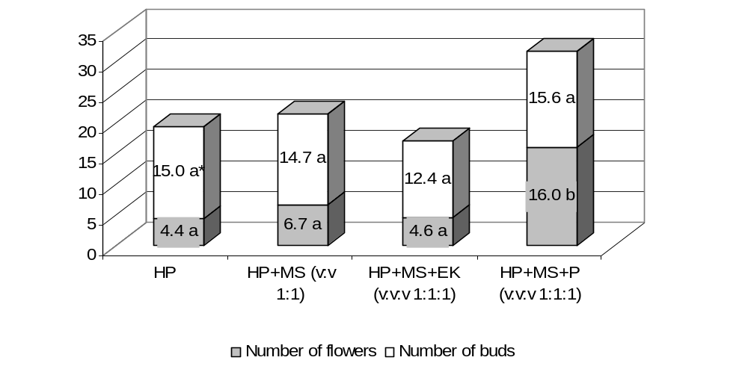
*Mean followed by the same letters within the feature are not significantly different at the level of α = 0.05

Fig. 1 Sum of flowers and buds Helleborus argutifolius in the second year of pot cultivation depending on substrate type

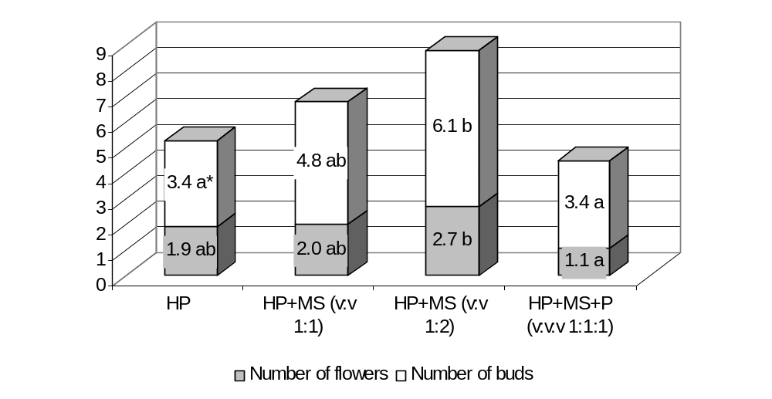
*For explanation, see figure 1

Fig. 2 Sum of flowers and buds Helleborus orientalis in the second year of pot cultivation depending on substrate type

