Adventitious shoots regeneration and organogenesis from leaf explants of Myrica rubra Seib & Zucc.

SYED ASGHAR^{1,2}, SAYED JAFFAR ABBAS², LIGENG CHEN¹, XINHUA HE¹, and YONGHUA QIN¹

¹Key Laboratory of Horticultural Plant Growth, Development and Biotechnology, Ministry of Agriculture, Zhejiang University, Hangzhou, 310029, P.R. China
² Biotechnology Center, Agricultural Research Institute, Tarnab, Peshawar, Pakistan

Abstract

Adventitious shoots were regenerated from leaf explants of M. rubra cultivar “Biji” on WPM medium supplemented with Thidiazuron (TDZ) alone or in combination with 2,4-D. TDZ concentrations of 0.1 and 0.2 mgL⁻¹ were found optimum for the adventitious shoot regeneration with maximum explants response (92.6% and 90.6%) and produced more adventitious shoots (3.4 and 4.4) without intervening callus phase. Combined effect of TDZ with 2,4-D on induction of adventitious shoots was recorded more prominent than TDZ alone. TDZ (0.2 mgL⁻¹ plus 2,4-D (0.05 mgL⁻¹) was the most effective combination with maximum number 5.24 of shoots per explant. Shoot elongation was achieved on the media supplemented with low BA concentration (0.05 mgL⁻¹) and NAA (0.6 mgL⁻¹). Full strength WPM media supplemented with IBA concentrations did not induced roots in M. rubra micro-shoots. Media supplemented with 0.3 mgL⁻¹ of IBA resulted in 81.4 % rooting efficiency and was found to be the best concentration. Rooted plants were successfully hardened and grown in the greenhouse.
Key words: Myrica rubra; Red bayberry; shoot regeneration; leaf explants; growth regulators; TDZ; Thidiazuran

Introductions

Myrica rubra is an endemic specie of the Far East Asia grown under warm and humid climates. It is grown in China, Japan, India, Thailand, Burma and Vietnam as fruit tree while in America and Europe as an ornamental tree (Wu 1995, Chen 2004). It is a stone fruit with a berry like edible part developed from the exocarp, consisting of capsule like cellules termed as flesh segments (He et al. 2004). This species is highly valued in Japan and China not only for fresh fruits but also for its medicinal properties (Jing et al. 2002). Fruits and leaves are used for treating congestion, coughs, digestive problems and diarrhea while bark is used for treatment of arsenic poisoning, skin diseases, wounds and ulcers (Wu 1995, Li 2002, He et al. 2002). Tannin, flavonoids, polyphenols and perfumery compounds have been extracted from its different parts (Gao 2001, Yang et al. 2003). Seed is used for the extraction of edible oils (Wu 1995). Each year, during the fruit season of Red bayberry, there is high competition among the local alcohol making industries (Xu and Lu 2003). Due to long lifespan, great economic value, low production costs and nitrogen-fixing activity, Red bayberry is regarded as an important economic source for the growers (Gao 2001, He et al. 2002). Breeding program for perennial fruit species by traditional methods require many years and several generations of backcrossing are required to eliminate undesirable characters (Caboni et al. 1999). In case of Red bayberry, the high level of heterozygosity and the long juvenile period makes genetic improvement through conventional breeding not only difficult but also year’s long process. In this context, In Vitro techniques and in particular those concerning regeneration of whole plants from adult tissues or application of gene transfer can accelerate the recovery of genotypes with superior traits.
There is no report on In Vitro adventitious shoot regeneration from leaf explants of M. ruba. The objective of this study was to establish an efficient shoot regeneration system of Red bayberry. To date, recalcitrant nature, difficulties in adventitious bud induction and their subsequent conversion into shoots have restricted work on genetic transformation of Myrica rubra. This regenerative protocol from leaf explants which is considered as best host for Agrobacterium would probably help in the genetic transformation of Myrica species.

Materials and methods

Plant material
The first five apical leaves from the six years old Myrica rubra cultivar “Biji” were excised and soaked in Tween-20 (2-3 drops/100 ml H₂O) for 10 min and thoroughly washed with tap water for 30 min. Surface disinfection was done with 60 % ethanol for about 1 min and sterilized with 0.05% (w/v) HgCl₂ for 6-7 min. Explants were rinsed 3-5 times with autoclaved and double distilled water by agitation method. Each leaf was transversely cuted into 4-5 explants and petioles were used as separate explants. Explants were then cultured in the regeneration media.
Media and Culture conditions
The basal media of WPM (Lloyd and McCown, 1980) was used with 30g sucrose and pH of the media was adjusted to 5.8 prior to adding the 8g agar. The media were autoclaved for 20 min at 121°C and then 30 ml media dispensed aseptically in each sterile vessel (5.0 cm diameter × 9 cm depth). All cultures were maintained at 26±1°C under fluorescent day light tubes in photon flux density of 50 μmol·m⁻²·s⁻¹ with 16 hours photoperiod.

Induction of adventitious shoots
The basal medium was supplemented with various concentrations of TDZ (0.025, 0.05, 0.1, 0.2, 0.4 and 0.8 mg L -1) alone for adventitious shoot regeneration. The optimum concentration of TDZ (0.2 mgL⁻¹) was also used in combination with different concentration of 2,4-D (0.025, 0.05 and 0.1 mg/l) for induction of multiple shoots. All the plant growth regulators (Sigma Chemicals, USA) were sterilized by filterand then added to the media in aseptic conditions. There were nine treatments and each treatment with 45 explants replicated for 5 times and theexperiment was repeated for three times. Data on number of shoots per explant was recorded after 8 weeks in culture.
Elongation of adventitious shoots
After 8 weeks of culture the adventitious multiple shoots were transferred to WPM medium fortified with already optimized concentration of BA (0.05 mg L⁻¹) in combination with NAA (0.4, 0.6, 0.8 and 1.0 mg L⁻¹). Shoots were counted and harvested after 5 weeks in culture. Microshoots that attained the size of 2-3 cm were harvested and transplanted to the media without growth regulators with the aim to eliminate the effects of cytokinins.
Rooting and hardening
Micro-shoots (2-3cm) were transferred to ¼ strength WPM medium containing various concentrations of IBA (0.05, 0.1, 0.3, 0.6 mgL ⁻¹). Effect of these IBA concentrations was observed on induction of roots from the shoots after 5 weeks in culture. Once roots were initiated then plantlets were transferred to full strength of WPM medium without the addition of growth regulators. After 6 weeks of culture the plantlets were removed from the vessels and washed with tap water for removing the media sticking to the roots. Plantlets were transplanted in pots containing 1:2 of perlite and sand medium. Plants were maintained under controlled conditions for 3-4 weeks covered with thin plastic sheets and then transferred to the green house. When plants were shifted to the green house conditions slits were made in the plastic to lower the humidity level in the plastic. After two weeks sheets were completely removed. Plants were maintained in the greenhouse for 6 months. All the plants were developed normal without showing any morphological abnormalities.
Statistical analysis
Data were analyzed using SAS statistical package (SAS Inst., Cary, N.C.) and differences between treatments means were compared by using LSD at p≤0.05. Standard Error (S.E) for the mean values was performed.

Results
Induction of adventitious shoots
The first change was observed within two weeks on shoot induction medium, it was the enlargement of explants to twice their original size. After 3 weeks, leaf explants were curled up and became thick and fragile. Most of the adventitious shoots were developed directly from explants away from the surface of media. The petiole explants were more responsive than the leaf and shoot. Growth on the petiole explants were vigorous than on the leaf explants. The first adventitious shoots were observed after 6 weeks of culture. Higher concentrations of TDZ induced profuse callus from the cut edges of the explants that exhibited rosetting of the regenerating shoots following prolonged culture of explants.
TDZ concentrations at 0.1 mgL⁻¹ and 0.2 mgL⁻¹ were found to be optimum for adventitious shoots regeneration with maximum number of explants responded (90.6 and 92.6%) to produce more adventitious shoots (3.4 and 4.4) without intervening callus phase (Table-1). The combination of TDZ (0.2 mg/L) and 2,4-D (0.05) was observed optimum for 100% shoot regeneration with maximum number of shoots growth per explant (4.4 mean shoots per explant). Higher concentrations of 2,4-D in combination with TDZ was resulted with the formation of white callus on the explants attached to the medium. In contrast, regeneration was slow for explants grown on medium containing high levels of TDZ alone. The callus observed with higher TDZ concentrations was hard in texture which exudes heavy phenolic compounds in the media. Callus produced in combination with 2,4-D was comparatively soft, white in nature with lesser amounts of phenolic compounds.

Shoot elongationShoots that were cultured on the adventitious bud induction media containing higher concentrations of TDZ took longer to elongate than the lower concentrations. Media supplemented with 0.05 mgL⁻¹ BA and 0.6 mgL⁻¹ NAA was observed optimum combination resulted in maximum shoot elongation 3.67 cm (Table-2). On shoot elongation media, higher concentrations of NAA were associated with callus. Shoots that attained the length of 1.5-2 cm were harvested and transferred to the rooting media.
Root induction and hardeningRoot induction started within 3-4 weeks in rooting medium containing various concentration of IBA (Table-3). Rooting proved to be mainly dependent on the medium strength. IBA concentration of 0.05mgL⁻¹ was not successful in root induction, while concentrations of 0.6mgL⁻¹ induced callus at the lower ends of the microshoots. Roots were induced with a high frequency of 92.0% in the medium supplemented with 0.3 mg L⁻¹ IBA followed by 81.4 % rooting efficiency with 0.6 mgL⁻¹ . Maximum numbers of roots (3.00) were obtained at 0.6 mgL⁻¹ (Figure B & D) as compared to the minimum numbers of roots (1.75) at 0.1 mgL⁻¹ of IBA. With longest root (3.43 cm) was recorded at 0.3 mgL⁻¹.

Discussion
Adventitious shoot formation from adult tissues is a reliable technique for clonal propagation as it prevents somaclonal variations in the cultures. The type of tissues used in the In Vtiro culture also influences the chances of genetic variation. Chances of somaclonal variation could be minimized if the regeneration of shoots occurs directly from the explants without intervention of callus phase. Asynchronous nature of callus tissues (Thorpe 1994) is frequently vulnerable for genetic mutations as compared to the other plants tissues.

Results of this study indicated that adventitious shoots were regenerated from leaf explants of M. rubra cultivar “Biji”. Although all concentrations of TDZ tested in this experiment induced adventitious shoots, however, higher concentrations were associated with callus and heavy exudation of phenolic compounds. Most of the adventitious shoots were developed directly on the leaf explants. Thidiazuron (TDZ) was effective in stimulating shoot regeneration from leaf explants of winter jujube (Gu and Zhang 2005). Thidiazuron was required for efficient regeneration of adventitious shoots, which is consistent with the results of many authors working with woody plants (Escalettes and Dosba 1993, Leblay et al. 1990, Korban et al. 1992, De-Bondt 1996). In this study, combined effect of TDZ with 2,4-D on induction of adventitious shoots was more prominent than TDZ alone. In Paphiopedilum orchids also, TDZ plus 2,4-D promoted shoot regeneration from leaf explants (Ting et al. 2004).
In this study callus observed with higher TDZ concentrations was hard in texture which exude heavy phenolic compounds in the media. Callus produced in combination with 2,4-D was comparatively soft, white in nature with lesser amounts of phenolic compounds. Describing this effect, Olaya et al. (2000) reported that secretionof phenolic substances was successfully eliminated by the addition of auxins in the media. They describe this effect might be due to the oxidation of phenols by auxin oxidase and therefore, the 2,4-D concentrations in the culture medium could compete for the active sites of the enzyme. In our case shoot elongation was achieved on the media supplemented with low BA concentration plus NAA. Many authors reported that adventitious shoots could not be elongated on the shoot induction media with high concentration of cytokinins, and shoot elongation was achieved on subsequent transfer of adventitious shoot clusters to the media with low or zero cytokinins (Antonelli and Druart 1990, Miguel et al. 1996), however the success depends on the species and genotypes. In this study root induction on micro-shoots proved to be mainly dependent on media strength. Roots were only initiated in the medium containing IBA with reduced medium strength (¼WPM). IBA with full strength WPM medium did not induce roots in M. rubra micro-shoots. These results are in agreement with the previous studies suggesting that low salt concentrations promote rooting of woody plants (Nemeth 1986). The protocol reported here for Myrica rubra is efficient, reproducible and could be used for genetic transformation experiments.

References
Antonelli M., Druart P. (1990) The use of a brief 2,4-D treatment to induce leaf regeneration on Prunus canescens Bois. Acta Horticulture, 280: 45–50.
Cabonil E., Tonelli M. G., Lauri1 P., Angeli S. D., Damiano C. (1999) In vitro shoot regeneration from leaves of wild pear. Plant Cell, Tissue and Organ Culture, 59: 1–7.
Chen K. S., Xu C. J., Zhang B., Ferguson I.B. (2004) Red bayberry: botany and horticulture. Horticulture. Reviews, 30:83-114.
De-Bondt A., Eggermont K., Penninckx I., Goderis I., Broekaert W.F. (1996) Agrobacterium-mediated transformation of apple (Malus x domestica Borkh): an assessment of factors affecting regeneration of transgenic plants. Plant Cell Reports, 15: 549–554.

Escalettes V., Dosba F. (1993) In vitro adventitious shoot regeneration from leaves of Prunus spp. Plant Science, 90 :201–209.
Gao J.Y., Tan D.F., Chen W.S. (2001) Extraction and characterization of water-soluble red pigment from Myrica rubra Sieb. & Zucc (in Chinese). Natural Product Research and Development, 13: 59-62.
Gu X. F., Zhang J. R. (2005) An efficient adventitious shoot regeneration system for Zhanhua winter jujube (Zizyphus jujuba Mill.) using leaf explants. Plant Cell Reports, 23:775–779.
He X. H., Chen L.G., Hu X.Q. (2002) Red bayberry-an excellent fruit and forestry tree for ecological restoration in Southern China (in Chinese). Fujian Tropical Crop Science and Technology, 27:42-43.
He X.H., Chen L.G., Asghar S., Chen Y. (2004) Red bayberry (Myrica rubra), a promising fruit and forest tree in China. Journal of the American Pomological Society, 58: 163-168.
Jing T. M., Toshio T., Iwao, A., Shin, Hisashi M., Masayuki Y. (2002) Inhibitors of nitric oxide production from the bark of Myrica rubra: structures of new biphenyl type diarylheptanoid glycosides and taraxerane type triterpene. Bioorganic and Medical Chemistry, 10: 401-405.
Korban S. S., O'Connor P. A., Elobeidy A. (1992) Effects of thidiazuron, naphthaleneacetic acid, dark incubation and genotype on shoot organogenesis from Malus leaves. Journal of Horticultural Sciences, 67: 341–349.
Leblay C., Chevreau E., Raboin L.M. (1990) Adventitious shoot regeneration from in vitro leaves of several pear cultivars (Pyrus communis L.). Plant Cell, Tissue and Organ Culture, 25: 99–105.
Li S.Y. (2002) Chinese bayberry (in Chinese) Agri. Sci. and Technol. Press of China, Beijing, 88.
Miguel C.M., Druart P., Oliveira M.M. (1996) Shoot regeneration from adventitious buds induced on juvenile and adult almond (Prunus dulcis Mill.) explants. In Vitro Cellular & Developmental Biology, 32: 148–153.
Nemeth G. (1986) Induction of rooting. In: Y.P.S. Bajaj Editor, Biotechnology in Agriculture and Forestry Springer, Berlin. pp. 49-86.
Olaya P.T., Jose E., Alicia V., Lorenzo B. (2000) Assessment of factors affecting adventitious shoot regeneration from in vitro cultured leaves of apricot. Plant Science, 158: 61-70.
Thorpe T.A. (1994) Morphogenesis and regeneration. In: Vasil, I.K., Thorpe, T.A. (Eds.), Plant Cell and Tissue Culture. Kluwer Academic Publishers, Dordrecht, pp. 17–36.
Ting Y.C., Jen T.C., , Wei C.C. (2004) Plant regeneration through direct shoot bud formation from leaf cultures of Paphiopedilum orchids. Plant Cell, Tissue and Organ Culture, 76: 11–15.
Wu G.M. (1995) Special fruits (Red bayberry, Loquat and Fig) in South of Yangze River. Zhejiang Agri. University Press, pp. 9-10.

Xu G.J. and Lu S.M. (2003) Brewing technique of the wine of Red bayberry. Food science and Technology, 1: 66-67.

Yang L.L., Chang L.G., Chen. (2003) Antitumor principle constituents of Myrica rubra var. acuminata . Journal of Agriculture and Food Chemistry, 51: 2974-2979.

Table 1. Effect of TDZ and 2, 4-D on shoot induction of adventitious shoots from leaf explants of Myrica rubra. Data was recorded after 8 weeks in culture.
TDZ | 2,4-D | Responding Explant (%) | No. of shoots per Explant
0.025 |  | 82.2±5.89c | 2.80±0.83c
0.05 |  | 84.5±5.49c | 3.40±0.89bc
0.1 |  | 90.6±3.13a | 3.40±0.54bc
0.2 |  | 92.6±2.07a | 4.50±0.54ab
0.4 |  | 85.2±3.83bc | 2.60±1.14c
0.8 |  | 71.4±2.96d | 2.00±0.70c
0.2 | 0.025 | 82.2±2.58c | 5.00±1.22a
0.2 | 0.05 | 85.7±4.03bc | 6.60±2.60a
0.2 | 0.1 | 89.6±2.96ab | 2.32±0.87bc
Means within each column followed by the same letter are not significantly different by LSD at p≤0.05. Values are means± standard deviation.

Table-2. Effect of Growth regulators on shoot elongation of Myrica rubra after 5 weeks in culture

BA (mg l⁻¹) | NAA (mg l⁻¹) | Shoot Length (cm)
0.05 | 0.4 | 2.62±0.41c
0.05 | 0.6 | 3.66±0.30a
0.05 | 0.8 | 3.22±0.33ab
0.05 | 1.0 | 3.04±0.35bc
Means within each row followed by the same letter are not significantly different by LSD at p≤0.05. Values are means± standard deviation.

Table-3. Effect of IBA on rooting of micro-shoots from Myrica rubra after 5 weeks in culture on ¼ strength WPM medium.
IBA | Rooting Efficiency (%) | Number of roots per explant | Root length (cm)
0.05 | 0.00 d | 0.00 c | 0.00 c
0.1 | 71.6±3.04c | 1.75±0.95b | 2.52±0.38b
0.3 | 92.0±3.08a | 2.75±0.95ab | 3.43±0.33a
0.6 | 81.4±2.70b | 3.00±0.81a | 2.45±0.20b
Means within each column followed by the same letter are not significantly different by LSD at p≤0.05. Values are means± standard deviation.
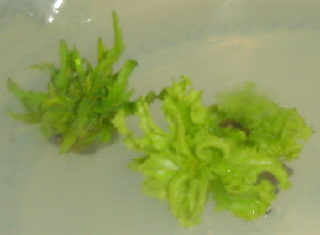  A | 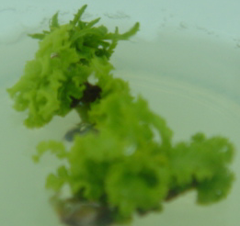  B
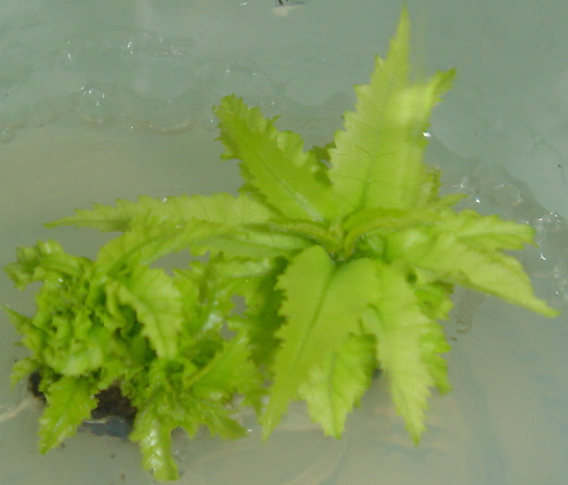  C | 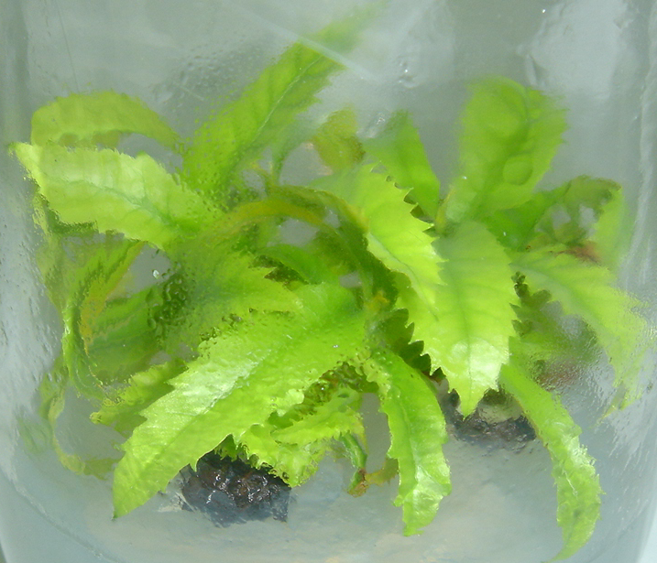  D
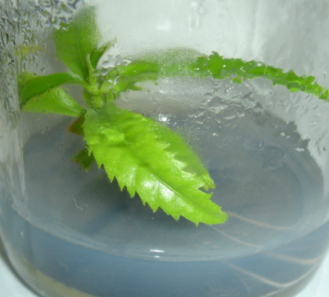  E | 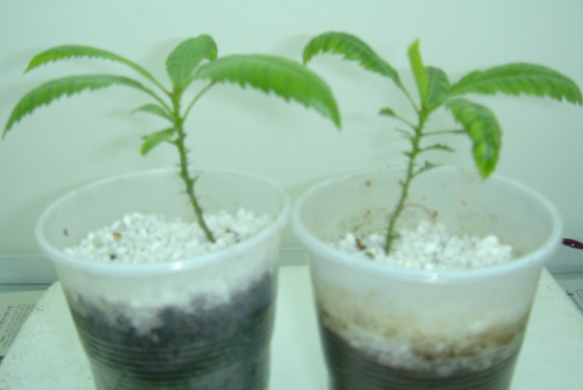  F
Figure: Different stages of adventitious micropropagation from shoot tips and nodal explants of M. rubra
A. Multiple shoots growing in BW medium containing 0.6 mg L⁻¹ TDZ after 6 weeks in culture
B. Well established root system on shoots from cultivar Biji in the media containing 0.3 mg L⁻¹
C. Roots developed on shoot after 4 weeks in culture from cultivar Dongkui.
D. Roots developed after 8 weeks in culture cv. Biji
E. Roots developed after 8 weeks in culture on rooting medium on shoots from cv. Dongkui

