MICROPROPAGATION OF MYRICA RUBRA. SIEB. & ZUCC. USING SHOOT TIPS AND NODAL EXPLANTS

SYED ASGHAR ^{1,2}, SAYED JAFFAR ABBAS² , LIGENG CHEN¹, XINHUA HE¹ , and YONGHUA QIN¹

¹Key Laboratory of Horticultural Plant Growth, Development and Biotechnology, Ministry of Agriculture, Zhejiang University, Hangzhou, 310029, P.R. China
²Biotechnology Center,Agricultural Research Institute, Tarnab, Peshawar, Pakistan

ABSTRACT
Myrica rubra is an important horticultural, forestry and ornamental tree. Its micropropagation was achieved by using shoot tip and nodal explants from two commercial cultivars “Biji and Dongkui” on BW medium supplemented with Thidiazuron (TDZ) and/2, 4D. TDZ induced multiple shoots but stunted growth . Maximum number of shoots (5.75) was recorded for both cultivars with 0.6 mg L ⁻¹ TDZ concentration. Shoot length was significantly improved with optimum concentration of TDZ (0.6 mg L ⁻¹) and with different concentrations of 2,4D. BW medium was found as suitable medium for micropropagation of both the cultivars of Myrica rubra with maximum number and longer shoots. WPM and MS medium ranked second in multiple shoot regeneration of both cultivars. Single microshoot cultured on plant growth regulator free medium for 3 wk. initiated roots on the medium containing IBA only with reduced (¼ and ½) medium strength. Roots were induced with a high frequency of 95% in Biji and 87% in Dongkui with 0.3 mg L⁻¹ IBA respectively. No callus was observed on shoots in rooting media. All concentrations of IAA either on reduced medium or full strength did not initiated any roots. Rooted plants were successfully acclimatized.

Key words: Myrica rubra; Chinese bay berry; micropropagation; plant growth regulators.

INTRODUCTION
Myrica rubra with a common name of red bayberry is an important member of Myricaceae family. It is one of the endemic plants species of Far East Asia grown under warm and humid climatic conditions. Myricaceae is also considered as first actinorhizal family emerged during the late cretaceous period (Maggia and Bousquet 1994). This plant can form a symbiosis with the actinomycetes Frankia and produce nitrogen fixing root nodules (Schweitzer and Lancelle 1983). It is a stone fruit with a berry like shape and edible portion developed from the exocarp. Also consisting of capsule like cellules termed flesh segments (He et al. 2004). This species is highly valued in Japan and China for its medicinal properties (Jing et al. 2002). Fruit, seed, bark, leaf and root of red bayberry are uses as medicines. Fruits and leafs are beneficial for treating congestion, cough, digestive problems, and diarrhea. The bark is used for the treatment of arsenic poisoning, skin diseases, wounds and ulcers (Chen et al. 2004, He et al. 2002, Li 2002). In recent years, a number of flavonoids and polyphenols have been extracted from its different parts (Yang et al. 2003, Chi et al. 2002, Gao et al. 2001).
It is domesticated in China, Japan, Thailand, South Korea and Philippines as fruit tree while in America and Europe as an ornamental tree (Chen et al. 2004). Due to long lifespan, great economic value, low production costs and nitrogen-fixing activity, red bayberry is considered as “green factory” while due to its high economic output it is called “money-making tree” (He et al. 2002, Li 2002).
Micropropagation used for faster multiplication of true-to-type genotypes in the minimum possible time (Vengadesan et al. 2002). Plants through micropropagation show greater genetic uniformity and clonal fidelity (Martin 2003). I In China Biji and Dongkui are the most promising cultivars of Myrica rubra with promising characteristics and are commercially planted throughout the country (Zhuang and Pan 2001). It is highly cross-pollinated and progeny is heterozygous (Horikawa 1972) and also itsvegetative propagation techniques such as air layering and grafting are not rapid to meet the need of elite varieties demand in time (He et al. 2002).
There is only one report that describes the micropropagation procedure from the seedling tissues of Myrica gale (Fernando et al., 1998). To our knowledge, protocol for In Vitro propagation of Myrica rubra has not yet developed.
The aim of this study, was to develop a micropropagation protocol for “Biji and Dongkui” cultivars of M. rubra. This technique would facilitate large-scale clonal production of these two commercially important cultivars.

MATERIALS AND METHODS
Plant material. Shoot tips and nodal explants were taken from 5 years old Myrica rubra plants of Biji and Dongkui cultivars grown in the green house of Horticulture Department, Zhejiang University. The excised explants were soaked in Tween-20 (1-2 drops/100 ml H₂O) for 15 min and the washed thoroughly with tap water for 30 min. Surface disinfection of shoot tips was done with 60 % (v/v) ethanol for 1-½ minute and sterilized with 0.05% (w/v) HgCl₂ for 7 min While the nodal explants was washed with 75% (v/v) ethanol for 1-2 min and sterilized with 0.1% (w/v) HgCl₂ for 8 min under laminar hood conditions. All the explants were rinsed for 3-5 times with autoclaved double distilled waterby agitator. Every explant size was about 0.4-0.6 cm also having one or two buds.
Media and Culture conditions. The basal medium of BW (Sugawara et al., 1994) with the addition of mineral salts, vitamins and 30 g sucrose was used. Medium pH was adjusted to 5.8 prior the addition of agar (8 g) and autoclaved at 121°C for 20 min. Shoot tips and nodal explants were placed separately in different jars containing 30 ml of medium and after 4 weeks (wk), all the cultures were transferred to fresh medium of the same composition. All cultures were maintained at 26±1°C under fluorescent day light tubes with a photon flux density of 50 μmol·m⁻²·s⁻¹ of 16 hours photo period.
Induction and elongation of multiple shoots. For induction of multiple shoots various concentrations (0.2, 0.4, 0.6, 0.8 and 1 mg L ⁻¹) of TDZ were used. Once the optimum level of TZD (Table 1) was known then all the shoot tips and nodal explants were cultured on the medium having a constant level of TDZ with different concentrations (0.025, 0.050, 0.075, 0.1 and 0.2 mg L ⁻¹) of 2,4-D (Table 2). The total period of culture was 9 weeks (wk) with an interval of 4 wk subculture.
Effect of media on induction of multiple shoots. The effects of five different media for example; BW medium (Sugawara et al. 1994), WPM (Lloyd and McCown 1980), MS medium (Murashige and Skoog 1962), NN medium (Nitsch and Nitsch 1969) and DKW medium (McGranahan et al. 1987) with the constant combination of 0.6 mg L⁻¹ TDZ and 0.075 mg L⁻¹ 2,4-D were compared on induction of multiple shoot. Cultures were evaluated for callus formation and shoot induction after 9 wk of culture.
Rooting. Before transferring microshoots for root induction, single shoot was transplanted into growth regulators free medium and cultured for 3 wk with the aim to eliminate the effect of growth regulators. Healthy shoots (3-4cm) were transferred to ¼, ½ and full strength BW medium containing various concentrations of IBA (0.05, 0.1, 0.3, 0.6 mg L ⁻¹) and IAA (0.3, 0.6 and 0.9 mg L ⁻¹). Effects of these auxins on were examined after in 8 wk culture. Once roots were initiated plantlets were transferred to full strength BW medium without the addition of growth regulators.
Plant acclimatization: Rooted plants were removed from the jars and the residues of the media were washed out. All the plants were individually planted in pots containing 1:2 of perlite and sand medium and covered with thin plastic sheet. After 7 days slits were made in the plastic to lower the humidity level and the sheets were completely removed on shifting them to the green house. Plants were maintained under this controlled condition for 2 wk and then transferred to the green house. Plants were maintained in the greenhouse for 2 months and all of them showed normal growth and development without any morphological abnormalities.
Statistical procedures and analysis: Per treatment was replicated twelve times in a completely randomized design. Each replica consisted of four explants and all the experiments were repeated three times. Data were analyzed using SAS statistical package (SAS Inst., Cary, N.C.) and treatments means were compared by using LSD at p≤0.05.

RESULTS
Effect of TDZ and/or2,4-D on shoot regeneration and elongation.
Data was recorded on the basis of viability of the explants. Nodal explants were medium tender having greenish axillary buds responded efficiently for bud sprouting and multiple shoot regeneration, while shoot tip explants were much tender turned brown after normal treatment of sterilization and disinfection. The survival percentage of explants and their subsequent development into shoots varied from 90-100% for variety Biji and 87-90% for Dongkui on BW medium supplemented with various levels of TDZ (Table 1). Number of shoots were significantly affected by different concentrations of TDZ. Both the cultivars responded almost similar in producing Maximum number of shoots (5.75) as compared to the Minimum number of shoots (2.75) by 0.6 mg L ⁻¹ TDZ and 0.2 mg L ⁻¹ TDZ respectively. A significant difference in shoot length was observed between two cultivars. Dongkui gave longer but fewer shoots than Biji. Maximum and minimum shoot length in Biji was 1.15 and 0.45 cm as compared to 2.18 and 1.00 cm in Dongkui respectively. Longer shoots were obtained with the lower concentrations of TDZ that subsequently decreased with the higher TDZ concentrations. With the addition of 0.075 and 0.05 mg L⁻¹ 2,4-D, maximum number (7.00) and longer shoots (4.92) were obtained in cultivars Biji and Dongkui respectively. Shoot length and number of shoots in both the cultivars were significantly improved with the addition of 2,4-D.
Effect of media on multiple shoot organogenesis. BW medium given good results for shoot organogenesis with highest shoot survival percentage, number of shoots per explant and shoot length. The effects of WPM and MS media on micropropagation of M. rubra were observed almost the same, while NN and DKW were given poor results. In this study, significant differences among the media were observed for shoots per explant and shoot length. Shoot regeneration response of both the cultivars to all media were observed similar. The highest survival percentage of explants was 100 and 91% for variety Biji and Dongkui respectively on BW medium supplemented with 0.6 mg L⁻¹ TDZ and 0.075 mg L⁻¹ 2,4-D (Table 3). Media significantly affected the number of shoots formation and shoot length elongation. Maximum number of shoots (6.80) and (5.60) was obtained for Biji and Dongkui respectively by BW medium as compared to the lowest (3.40 and 2.60) by NN media. Longer shoots were obtained in BW medium for both the cultivars as compared to the shortest in NN and DKW media.
Root induction: Root induction started within 3-5 wk in the rooting medium. Rooting proved to be mainly dependent on medium strength, since roots were observed on maximum shoots cultured on reduced strength medium (¼ and ½ BW) (Table-4 & 5). Medium strength greatly affected rooting efficiency, number of roots and root length. Roots did not occur with the addition of IAA in the ¼, ½ and full strength medium in both the cultivars. On ¼ strength medium, rooting efficiency and number of roots were observed higher in Biji than Dongkui, while longer roots were obtained in Dongkui by IBA concentrations. Roots were induced with a high frequency of 95% and 87% in the medium supplemented with 0.3 mg L ⁻¹ IBA in Biji and Dongkui respectively as compared to the lowest (34 and 24 %) with 0.05. Maximum roots (4.02) were obtained by 0.3 and 0.6 mg L ⁻¹ IBA in cultivar Biji as compared to the minimum (1.97) with 0.05 mg L ⁻¹ IBA in the same cultivar. With longest roots (7.25 cm) Dongkui ranked first as compared to 6.02 cm in Biji. After induction of roots under various concentrations of IBA in both ¼ and ½ strength media, subsequent root development and differentiation in adventitious roots was very slow. However, following transfer to full strength medium without growth regulators further elongation and differentiation into adventitious roots was easily achieved within 3 wk culture. No callus was observed during shoot rooting. On ½ strength medium, rooting efficiency, number of roots and root length were greatly reduced in both cultivars as compared to ¼ strength medium. On this medium also, micro shoots did not induce roots with all tested concentrations of IAA. Rooting efficiency was increased with an increase in IBA concentration and reached at peak (75 and 54 %) with the application of 0.6 mg L⁻¹ IBA. Maximum roots (3.60) were obtained by 0.3 in cultivar Biji as compared to the minimum (2.00) with 0.05 mg L ⁻¹ IBA in the same cultivar. On ½ strength medium Dongkui ranked first with longest roots (4.60 cm) as compared to 3.82 cm obtained with the same concentration in cultivar Biji.

DISCUSSION

Results of this study indicated that multiple shoots were regenerated from shoot tips and nodal explants from five years M. rubra plants with scion cultivars of Biji and Dongkui. TDZ induced multiple shoots formation but with stunted growth. Its lower concentrations produced fewer shoots while higher concentrations arrested shoot growth. TDZ in combination with 2,4-D induced better shoot regeneration with maximum number and longer shoots. Nemeth (1986) reported that multiple shoots regeneration depends on many endogenous and exogenous factors such as genetic background, physiological influences, age and the ontogenetic phase of the mother plant, environment and composition of the nutrient medium. Organogenesis is commonly induced by manipulation of exogenous phytohormone levels and occurs either directly from explant tissue or through callus (Vengadesan et al. 2002). Our results are in accordance with previous studies suggesting that TDZ is among the most active cytokinin-like growth substances for tissue culture of woody plant species and its low concentrations induces axillary shoot proliferation but may inhibit shoot elongation and high concentrations promotes formation of adventitious shoots (Heutteman and Preece 1993). Woody plants have responded to lower concentrations of TDZ in a similar manner to higher concentrations of other cytokinins (Donna et al. 2004). In the current study, all concentrations of TDZ stimulated callus formation on the lower ends of the explants and similar results were reported by Heutteman and Preece (1993) in Gymnema sylvestr.
In this study, BW medium was found as a suitable medium for the micropropagation of M. rubra followed by WPM and MS media. Several other studies suggest that type and composition of the nutrient medium play a basic role in In Vitro propagation system of plants (Arafeh 1999, Shimomura and Kitazawa 1991). Diverse media types evoked regeneration response in numerous plant species. In A. koa, MS medium produced maximum number of shoots (Skolmen and Mapes 1976; Xie and Hong 2001). In A. catechu, WPM and half strength WPM were successfully used in inducing shoot regeneration (Das et al. 1996). Adventitious shoot regeneration in A. mangium was obtained in Juglans on DKW medium by Douglas and McNamara (2000). In A. koa, successful shoot regeneration system was obtained on Schenk and Hildebrandt medium (Skolmen and Mapes, 1976).
Root induction on microshoots proved to be mainly dependent on medium strength and type of auxin used. Roots were only initiated in the medium containing IBA with reduced medium strength (¼ and ½ BW). Concentrations of IBA with full strength of BW medium did not induce roots in M. rubra in the stipulated period of 8 wk. All concentrations of IAA either on reduced medium or full strength did not initiate roots. These results are in accordance with previous studies suggesting that low salt concentrations promote rooting of woody plants (Nemeth 1986). According to Liu et al. (2000) IBA was shown to promote more and stronger root formation in S. sclarea than IAA. Sahoo et al. (1997) also reported that of the three auxins tested (IBA, IAA, and NAA) with O. basilicum, IBA was most effective in inducing rooting and obtaining the highest number and length of roots. For root initiation, IAA was reported as the least successful auxin in S. valentine (Cuenca and Amo-Marco 2000). Helior et al. (1997) have reported that IBA serves as a suitable auxin for in vitro rooting of V. vinifera cv. Pinot noir. Contrary to our results, microshoots of S. blancoana, S. valentina (Cuenca and Amo-Marco 2000) and S. miltiorrhiza (Morimoto et al. 1994) were able to form roots in the absence of auxin in the medium. Hosoki and Tahara (1993) also concluded that IBA was not necessary for rooting of S. leucantha since percent rooting and root number were high irrespective of IBA concentrations.

REFERENCES

Arafeh R.M. (1999) Factors affecting in vitro propagation, callusing, cell suspension culture and secondary metabolites production in sweet marjoram Origanum vulgare L. and Syrian marjoram Majorana syriaca L. Rafin (Origanum syriacum L.). M.Sc. Thesis. Jordan University of Science and Technology, Irbid, Jordan.
Chen K. S., Xu C. J., Zhang B., Ferguson I. B. (2004) Red bayberry, botany and horticulture. Horticulture Reviews, 30:83-114.
Chi W., Xu J., Tan W. (2002) Protective effect of bayberry polyphenol on platelet damages in mice and rats (in Chinese). China Pharmacy, 13:16-17.

Cuenca S., Amo-Marco J. B. (2000) In vitro propagation of two Spanish endemic species of Salvia through bud proliferation. In vitro cellular & developmental biology, 36: 225-229.
Das P., Samantaray S., Rout G.R. (1996) In vitro propagation of Acacia catechu, a xerophilous tree. Plant Tissue Culture, 62: 117-126.
Donna I., Ledbetter, Preece J. E. (2004) Thidiazuron stimulates adventitious shoot production from Hydrangea quercifolia Bartr. leaf explants. Scientia Horticulturae, 101(1-2): 121-126.
Douglas G. C., McNamara J. (2000) Shoot regeneration from seedling explants of Acacia mangium Willd. In vitro cellular & developmental biology, 365: 412-415.
Fernando T., Ilda A., Roberto. (1998) Regeneration of the actinorhizal plant Myrica gale L. from epicotyl explants. Plant Science, 135: 203-210.
Gao J.Y., Tan D. F., Chen W. S. (2001) Extraction and characterization of water-soluble red pigment from Myrica rubra Siet. et Zucc(in Chinese). Natural Product Research and Development, 13:59-62.
He X.H., Chen L.G., Hu X.Q. (2002) Red bayberry-an excellent fruit and forestry tree for ecological restoration in Southern China (in Chinese). Fujian Tropical Crop Science & Technology, 27:42-43.
He X.H., Chen L.G., Asghar S., Chen Y. (2004) Red bayberry (Myrica rubra), a promising fruit and forest tree in China. Journal of the American Pomological Society, 58: 163-168.
Helior M.C., Fournioux J. C., Oziol L., Bessis R. (1997) An improved procedure for the propagation in vitro of grapevine (Vitis vinifera cv. Pinot noir) using axillary bud cuttings. Plant Cell Tissue and Organ Culture, 49: 223-225.
Heutteman C. A., Preece J. E. (1993) Thidiazuron: a potent cytokinin for woody plant tissue culture. Plant Cell Tissue and Organ Culture, 33:105-119.
Horikawa Y. (1972) Atlas of Japanese floral. In “An introduction to plant sociology of East Asia”. Gakken. Tokyo, 30.
Hosoki T., Tahara Y. (1993) In vitro propagation of Salvia leucantha Cav. Horticulture Science, 283: 226.
Jing T., Toshio M., Iwao T., Shin A., Hisashi M., Masayuki Y. (2002) Inhibitors of nitric oxide production from the bark of Myrica rubra: structures of new biphenyl type diarylheptanoid glycosides and taraxerane type triterpene. Bioorganic and Medical Chemistry, 10(12): 401-405.
Li S.Y. (2002) Chinese bayberry (in Chinese). Journal of Agricultural Science and Technology, Press of China, Beijing, 88.
Lloyd, McCown. (1981) G. Lloyd and B.H. McCown, Commercially feasible micropropagation of mountain laurel, Kalmia latifolia by use of shoot tip culture. International Plant Propagators Society, 30 : 421–427.
Liu W., Chilcott C. E., Reich R. C, Hellmann G. M. (2000) Regeneration of Salvia sclarea via organogenesis. In Vitro Cellular & Developmental Biology 36: 201–206.
Maggia W., Bousquet J. (1994) Bacterial phylogeny of the actinorhizal Hamamelidae and relationships with host promiscuity towards Frankia. Molecular Ecology, 3:459-467.
Martin P. (2003) Plant regeneration through direct somatic embryogenesis on seed coat explants of cashew (Anacardium occidentale L.) Scientia Horticulturae, 98(3): 299-304.
McGranahan G.H., Driver A., Tulecke W. (1987) Tissue culture of Juglans. In: Bonga, G.M., Durzan, D.J. (Eds.), Cell and Tissue Culture in Forestry, Martinus Nijhoff, Dordrecht, 3:261-271.
Morimoto S., Goto Y., Shorama Y. (1994) Production of lithospermic acid B and rosmarinic acid in callus tissue and regenerated plantlets of Salvia miltiorrhiza. Journal of Natural Products, 576: 817-823.
Murashige T., Skoog F. (1962) A revised medium for rapid growth and bioassays with tobacco tissue culture, Plant Physiology, 15: 473-497.

Nemeth, G. (1986) Induction of rooting. In: Y.P.S. Bajaj Editor, Biotechnology in Agriculture and Forestry , Trees, Springer, Berlin, 49-86.
Nitsch J. P., Nitsch C. (1969) Haploid plants from pollen grains. Science, 163:85-87.
Sahoo Y., Pattnaik S. K., Chand P. K. (1997) In vitro clonal propagation of an aromatic medicinal herb Ocimum basilicum L. (sweet basil) by axillary shoot proliferation. In vitro cellular & developmental biology, Plant, 33:293–296.
Schweitzer C. R., Lancelle S.A. (1983) Effect of water-table depth on shoot growth, root growth, and nodulation of Myrica gale seedlings. Journal of Ecology, 71: 489-501.
Shimomura K., Kitazawa T. (1991) Tanshinone production in adventitious roots and regenerates of Salvia miltiorrhiza. Journal of Natural Products, 546:1583–1587.
Skolmen R.G., Mapes M.O. (1976) Acacia koa Gray plantlets from somatic callus tissue. Journal of Heredity, 67:114-115.
Sugawara F., Yamamoto N., Tanaka O. (1994) Plant regeneration in in vitro culture of leaf, stem and petiole segments of Actinidia polygama Miq. Plant Tissue Culture Letter, 11: 14-18.
Vengadesan G., Ganapathi A., Amutha S., Selvaraj N. (2002) In vitro propagation of Acacia species-a review. Plant Science,163 (4): 663-671.
Xie D., Hong Y. (2001) In vitro regeneration of Acacia mangium via organogenesis. Plant Cell Tissue and Organ Culture 66:167-173.
Yang L. L., Chang C. C., Chen L. G. (2003) Antitumor principle constituents of Myrica rubra var. acuminata . Journal of Agriculture Food and Chemistry, 51:2974-2979.
Zhuang W. D., Pan Y. S. (2001) The research progress of germplasm resources of Myrica in China (in Chinese). Journal of Fujian Forestry Science and Technology, 28:54-57; 2001.

Table-1: Effect Of Tdz On Multiple Shoot Regeneration From Myrica Rubra Shoot Tips And Nodal Explants After 9 Wk In Culture
TDZ |  | Explants | Survival (%) |  | Shoots per explant |  | Shoot Length (cm)
 |  | Explants | Biji | Dongkui | Biji | Dongkui | Biji | Dongkui
0.2 | 48 |  | 95 | 87 | 2.75±0.96c | 2.75±1.71b | 1.15±0.17a | 2.18±0.29a
0.4 | 48 |  | 98 | 89 | - ±1.29bc | 3.0±0.82b | 0.80±0.32b | 1.97±0.27a
0.6 | 48 |  | 100 | 90 | 5.75± 0.95a | 5.75±1.70a | 0.63±0.13bc | 1.38±0.29b
0.8 | 48 |  | 94 | 88 | 4.25 ±0.71abc | 4.50±1.29ab | 0.55±0.12bc | 1.15±0.20b
1 | 48 |  | 90 | 88 | 5.00±1.82ab | 4.50±1.29ab | 0.45±0.13c | 1.00±0.18b
Means within each row followed by the same letter are not significantly different by LSD at p≤0.05.

Table-2: Effect Of Tdz And 2,4-D On Shoot Regeneration And Elongation From Myrica Rubra Shoot Tips And Nodal Explants After 9 Wk In Culture
TDZ | 2,4-D | Survival (%) |  |  | Number of shoots per explant |  | Shoot Length (cm)
TDZ | 2,4-D | Explant | Biji | Dongkui | Biji | Dongkui | Biji | Dongkui
0.6 | 0.025 | 48 | 98 | 87 | 5.50±1.29abc | 5.25±1.26a | 3.62±0.28ab | 4.29±0.42a
0.6 | 0.05 | 48 | 97 | 91 | 6.25±1.50ab | 4.75±1.50a | 4.02±0.17a | 4.92±0.41a
0.6 | 0.075 | 48 | 100 | 86 | 7.00±1.83a | 5.00±1.41a | 3.80±0.32ab | 4.67±0.33ab
0.6 | 0.1 | 48 | 97 | 89 | 4.00±1.82bc | 4.25±1.70a | 3.45±0.34bc | 4.25±0.38bc
0.6 | 0.2 | 48 | 94 | 90 | 3.50±1.29c | 4.00±1.42a | 3.10±0.40c | 3.87±0.53c
Means within each row followed by the same letter are not significantly different by LSD at p≤0.05.

Table-3: Effect Of Media On Number Of Shoots And Shoot Length After 9 Wk In Culture.

Medium | Explant | Varieties |  | Number of shoots per explant |  | Shoot Length (cm)
Medium | Explant | Biji | Dongkui | Biji | Dongkui | Biji | Dongkui
BW | 48 | 100 | 91 | 6.80±1.48a | 5.60±1.14a | 5.00±0.50a | 5.02±0.46a
NN | 48 | 56 | 64 | 3.40±1.14b | 2.60±1.15b | 2.64±0.55c | 2.58±0.58b
WPM | 48 | 87 | 90 | 5.00±1.58ab | 5.80±0.83a | 3.98±0.53b | 4.56±0.67a
MS | 48 | 94 | 89 | 5.00±1.58ab | 5.20±1.48a | 4.18±0.59b | 4.32±0.63a
DKW | 48 | 69 | 87 | 3.80±1.48b | 2.80±1.49b | 2.04±0.63c | 2.20±0.58b
Means within each row followed by the same letter are not significantly different by LSD at p≤0.05.

Table-4: Effect Of Iba And Iaa On Microshoots Rooting From Myrica Rubra After 8 Wk, Cultured In ¼ Strength Of Bw Medium

 | Rooting (%) |  | Number of roots per shoot |  | Root length (cm)
IAA | Biji | Dongkui | Biji | Dongkui | Biji | Dongkui
0.3 | 0 | 0 | 0 | 0 | 0 | 0
0.6 | 0 | 0 | 0 | 0 | 0 | 0
0.9 | 0 | 0 | 0 | 0 | 0 | 0
IBA
0.05 | 34 | 24 | 1.97±0.49b | 1.27±0.27b | 5.12±0.56b | 5.40±0.45c
0.1 | 75 | 66 | 2.75±0.26b | 1.82±0.48b | 5.22±0.61b | 6.40±0.51b
0.3 | 95 | 87 | 4.02±0.75a | 2.65±0.38a | 5.80±0.28ab | 7.25±0.42a
0.6 | 88 | 84 | 4.02±0.40a | 2.95±0.42a | 6.02±0.26a | 7.10±0.53ab
Means within each row followed by the same letter are not significantly different by LSD at p≤0.05.

Table-5: Effect Of Iba And Iaa On Rooting From Myrica Rubra Microshoots After 8 Wk Cultured In ½ Strength Bw Medium

 | Rooting (%) |  | Number of roots per shoot |  | Root length (cm)
IAA | Biji | DongKui | Biji | Dongkui | Biji | Dongkui
0.3 | 0 | 0 | 0 | 0 | 0 | 0
0.6 | 0 | 0 | 0 | 0 | 0 | 0
0.9 | 0 | 0 | 0 | 0 | 0 | 0
IBA
0.05 | 21 | 26 | 2.00±0.66b | 1.20±0.761b | 3.50±0.25a | 3.92±0.37a
0.1 | 65 | 35 | 2.70±0.29b | 1.70±0.45b | 3.52±0.30a | 4.30±0.74a
0.3 | 74 | 45 | 3.60±0.80a | 2.62±0.43a | 3.82±0.33a | 4.60±0.50a
0.6 | 75 | 54 | 3.57±0.33a | 2.68±0.60a | 3.65±0.42a | 4.37±0.82a
Means within each row followed by the same letter are not significantly different by LSD at p≤0.05.

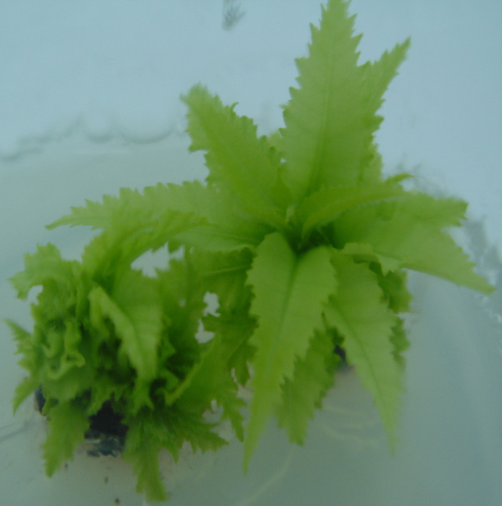  A | 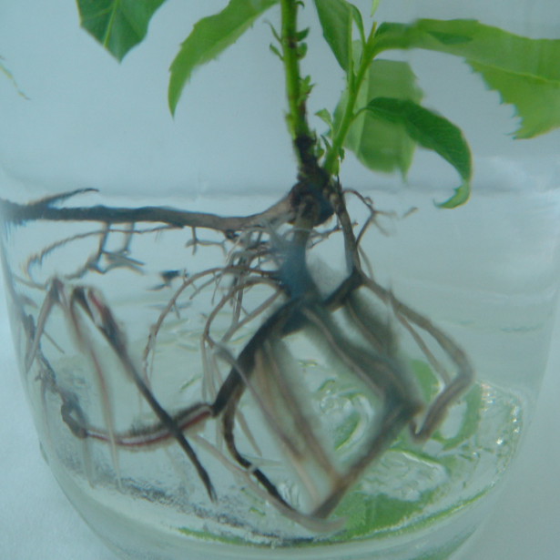  B
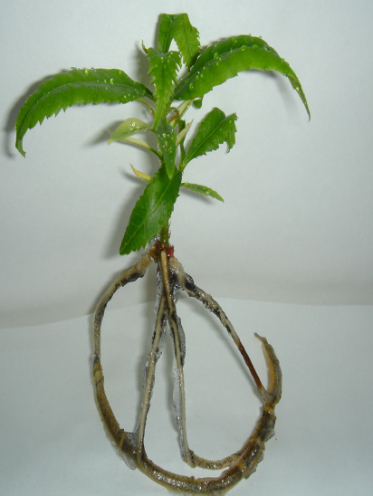  C | 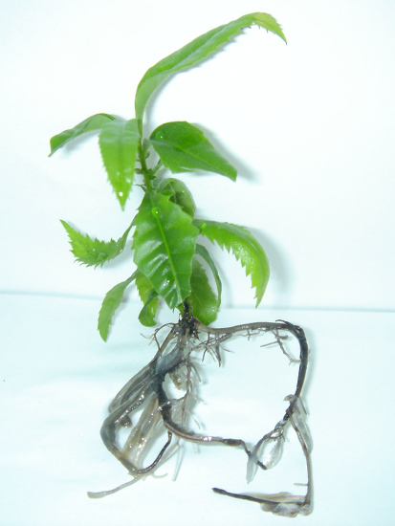  D
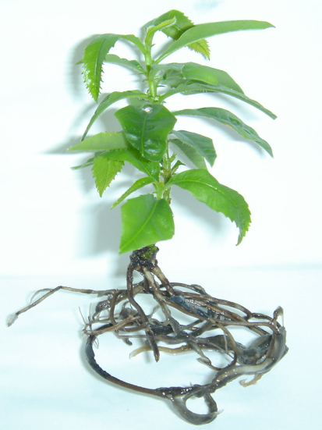
E

Figure-1: Different stages of micropropagation from shoot tips and nodal explants of M. rubra

A. Multiple shoots growing in BW medium containing 0.6 mg L⁻¹ TDZ after 6 wk in culture
B. Well established root system on shoots from cultivar Biji in the media containing 0.3 mg L⁻¹
C. Roots developed on shoot after 4 wk in culture from cultivar Dongkui.
D. Roots developed after 8 wk in culture cv. Biji
E. Roots developed after 8 wk in culture on rooting medium on shoots from cv. Dongkui

