The Effects of GA₃ on growth and flowering of Gladiolus hybrida cv.White prosperity

Mehrdad Azizi^{1*}, Mehrangiz Chehrazi¹ and Norolah Moalemi¹
¹Department of Horticulture, faculty of Agriculture, Shahid Chamran University of Ahvaz, Iran.
E. Mail: Mehrdad.918@gmail.com (Azizi), Chehrazi_m@yahoo.com, nmoallemi@yahoo.com.

Abstract

This study was carried out to determine the effects of gibberellin on growth and flowering of gladiolus during 2010 and 2011 in Ahvaz, Iran. Two methods applications were used of Gibberellins include drench and spray. Four Concentrations for two method applications GA₃ used Include: 0, 100, 200 and 300 PPM. In drench method corms before planting for one day in four concentrations drenched. Distilled water was used at a concentration of zero. In spray method, Gibberellin was sprayed when the planting was 50 days. In the present study, indices such as, fresh and dry weight, leaf area, flower diameter, number of leaves per plant, Chlorophyll a, b, Total Chlorophyll and plant height were measured. Number of leaves per plant, leaf area, fresh and dry weight and plant height increased significantly whit GA₃ treatment. This study also confirmed the higher potential and high quality flower of Gladiolus hybrida cv. White prosperity obtained when corms are sprayed in GA₃ solution of 200 PPM.

Key word: Gibberellic acid, drench, spray, Gladiolus cv.White prosperity

1. Introduction

Gladiolus is one of the important ornamental crops of the world. The magnificent inflorescence with a wide variety of color has enhanced its cultivation through-out the world. Gladiolus occupies a prominent position among the elite cut flowers owing to the elegant appearance of its spikes of different shapes and hues and excellent vase life (Anderton and Park, 1989; Bose et al., 2003). Gladiolus takes an important place in cut flower production for internal market in the Subtropical Region .Bulbous flowers (Gladiolus, Iris, Narcissus, Tulipa, etc.) make up a substantial proportion of the cut flower trade, gladiolus being prized by florists for their showy flowering stems and by growers for their relative ease of production (Serek et al., 1994). For planting-stock production, all over the world, the commercial growers use only large cormels. Regulation of growth and flowering is of particular concern for plants grown for cut flower production. Gibberellins are involved in several plant development processes and promote a number of desirable effects including stem elongation, uniform flowering, reduced time to flowering, and increased flower number and size (Hopkins, 1995). However, certain concentrations of GA₃ may cause excessive stem elongation and result in poor-quality plants (Neumaier et al., 1987). Gibberellins (GA₃) are generally involved in growth and development; they control seed germination, leaf expansion, stem elongation and flowering (Magome et al., 2004).The biosynthesis of GA₃ is regulated by both developmental and environmental stimuli (Yamaguchi and Kamiya, 2000; Olszewski et al., 2002). The beneficial effects of GA₃ on germination are well known (Angrish et al., 2001; Radi et al., 2001; Khan et al., 2002). When applied externally, gibberellins influence the organization of the internal chemistry of the plant cell and the interaction among cells, but the degree of interaction still depends mostly upon the plant species, the stage of plant development and the external environment (Arora et al., 1992). The gibberellins are involved in a number of processes including stem extension, flowering and fruit growth (Li et al., 1996; Szekers et al., 1996; Yang et al., 1996; Numura et al., 1997). Effectiveness of growth retardants depends on concentration and method of application among other factors. Excessive and undesirable reductions in growth may be caused by certain application rates of growth retardants (Cox and Keever, 1988; Latimer et al., 2001). The most common methods of application of growth regulators are foliar sprays and media drenches. Foliar sprays are used more often than drenches, presumably due to the higher labor costs involved in applying drenches in large scale production areas (Latimer et al., 2001). However, drenches have a longer period of activity than spray applications (Barrett, 1994). Moreover, drenches provide more uniform control of plant height and use less active material and lower concentrations of the growth regulator. The objectives of this study were to investigate the response of gladiolus cv. White prosperity to gibberellin treatment and to determine the effects of these treatments on growth and flowering gladiolus.

2. Materials and methods

In this experiment was conducted in shahid Chamran University Faculty of Agriculture Iran, Ahvaz (Ahvaz state: The latitude and longitude of Ahvaz is: 31° 19' 45" N / 48° 41' 28" E, also the city has an average elevation of 20 meters above sea level) at 2009-2010. The experimental soil was loamy and a PH of 7.4. Gladiolus corms cv. White prosperity was purchased from the Netherlands. Corms purchased diameter of 10-12 cm. The corms were sown in furrows of plant to plant distance of 10 cm, row to row distance of 30 cm and whit a plot to plot distance of 75 cm. A basal dose of P and K was applied at the rate of 65 kg P₂O₅ ha⁻¹ and 20 kg K₂O ha⁻¹, respectively. Nitrogen was applied in 2 equal doses, one at the time of final land preparation and the other two months after planting.
For Preparation of GA₃ solution, Gibberellins powder with small amount 70% ethanol solved and whit distilled water to reach the desired volume. Two methods applications were used of Gibberellins include drench and spray. Four Concentrations for two method applications GA₃ used Include: 0, 100, 200 and 300 PPM. In drench method corms before planting for one day in four concentrations drenched. Distilled water was used at a concentration of zero. Gibberellin was sprayed when the planting was 50 days. In this experiment 27 corms were planted per experimental.
The study was laid out by following a factorial design and replication four times. All data were subjected to one-way ANOVA using the SAS 10.0 soft-ware package. Difference at P < 0.05 was considered signiﬁcant between treatments. Difference at P < 0.05 was considered signiﬁcant between treatments.

3. Results and discussion
Vegetative growth parameters:
Stem Length (cm): The data in Table 1 showed that foliar application of Gladiolus cv.White prosperity with of GA₃ produced significant increases in stem length compared with the drench application and control plants. The highest values of stem length were obtained by spray application of 200 PPM GA₃ compared to the other treatments (figure 2). The increases may be due to effect of Gibberellic acid (GA₃) on stimulating the division and elongation of new growth cells formed on the gladiolus plants (Wasfy and Din, 1995). And increase in growth attributes may be subjected to the functional role of GA₃ in plant tissues (Yusef saleh, 2006). GA₃ is known to be involved in various processes of plant development (Hooley, 1994). In various plants, exogenous gibberellin promotes shoot elongation and vegetative growth (Rose et al., 1989; Sauter et al., 1993; Xu et al., 1997). Similar results were obtained by Kato and Takei (1991) on chrysanthemum.
Stem diameter: Data presented in experiment showed that the stem diameter of Gladiolus cv.White prosperity was significantly affected by the treatment of GA₃. The highest values of the stem diameter (11.72 cm) were obtained by using spray 300 PPM GA₃ (figure 3). The increases may be due to the role of GA₃ in the energetic metabolism and biosynthetic reactions. The results are in agreement whit El-Naggar (2004) on carnation plants.
Total fresh and dry weights (g): the obtained results indicated that application of 300 PPM GA₃ whit spray application (figure 4 and 5). These increases may be due to the favourable effects of GA₃ on vegetative growth, which lead to an increase in the photosynthesis efficiency and accumulation of dry matter in the stem. Similar results were obtained by El-Baky (1986) on carnation and Ateeque et al (1994) on sunflower plant.
Left number and left area: The largest leaf number and leaf area of found whit plants drench 300 PPM and sprayed whit 200 PPM respectively compared whit the other treatments (figure 6 and 7). The increase was mainly owing to the increase in the number of left/plant and area which might have increased the production of photosynthesis needed to enhance reproductive growth. The finding confirm the results of Groen and Slangen (1990), Nilimesh and Roychowdhury (1988) and Sidhu and Arora (1989).
Chlorophyll a, b and total: The results indicated that Chlorophyll a, b and total were significantly decreased as a result of spraying GA₃ to 300 PPM (figure 8, 9and 10). Chlorophyll content of left was decreased by increased GA₃ concentrations, it is shown that this is due to ‘dilution’ over a larger area of lefts (Monselise and Halevy. 2011).

Floral characteristics:
Daye to Flower (Day): The results indicated that flowering time from a planting date was significantly decreased as a result of spraying GA₃ to 300 PPM (figure 11). The same trend was reported by El-naggar (2009) on Dianthus caryophyllus.
Spike number/plant: Generally data in Table 1 showed the greatest number of spike/plant was obtained by application of 200 PPM with spray method (figure 12). The results were similar to those obtained by Kirilov et al (1989) on chrysanthemum plants.
Spike diameter (cm): The largest diameter of spike was found whit plants sprayed whit 300 PPM compared whit the other treatments (figure 13). The increased in the spike size may be due to the role of Gibberellic acid (GA₃) at suitable concentrations which lead to increases in the petals number, their expansion or both of them, consequently. The results are in agreement whit obtained by Ramesh et al (2002).
4. CONCLUSION

ACKNOWLEDGMENTS
We would like to thank the Experts and faculty members for support and assistance. Also the authors wish to thank Shahid Chamran University of Ahvaz for supporting this work.

REFERENCES
- Anderton E.W., Park R. (1989). Growing Gladioli, first ed. Timber Press, Portland, OR.
- Angrish R., Kumar B., Datta K.S. (2001). Effect of gibberellic acid and kinetin on nitrogen content and nitrate reductase activity in wheat under saline conditions. Indian J. Plant Physiol. 6, 172–177.
- Ateeque M., Malewar U., More M. 1994. Influence of phosphorus and born on yield and chemical composition of sunflower. Soils and Fert, Abst, 57: 10373.
- Barrett J.E. (1994). Growth regulators. In: Tips on Growing Marketing Hanging Baskets, Ohio Florists’ Association, Columbus, OH, pp. 43–46.
- Bose T.K., Yadav L.P., Pal P., Parthasarathy V.A., Das P. (2003). Commercial Flowers, vol. II. Naya Udyog, Kolkata, India.
- Cox D.A., Keever G.J. (1988). Paclobutrazol inhibits growth of zinnia and geranium. HortScience 23 (6), 1029–1030.
- El-Baky M.M. 1986. Physiological response of carnation to radiation and some other factions. M. Sc. Thesise. Fac. Agric, Minoufiiya Univ.
- El-Naggar A.H,. El-Naggar A.A.M. 2004. Physiological response of carnation plants to gibberellic acid and potassium fertilization under greenhouse conditions. J. Av. Agric. Res. (Fec. Ag. Saba. Basha), 9: 931-950.
- EL-Naggar A.H., EL-Naggar A.A.M., Naygloo, M. 2009. Effect of Phosphorus Application and Gibberlic acid (GA3) on the growth and flower quality of Dianthus coryophyllus L. American-Eurosian. Agric & Environ. Sci, vol. 6(4): 400-410.
- Groen N.P.A., Slangen J.H.G. 1990. Nitrogen fertilizer recommendations for gladiolus based on N-mineral soil analyses. Acta-Hort. 5th international symposium on flower bulbs, Seattle, Washington, USA.
- Hooley R. 1994. Gibberellins perception, transduction and responses. Plant Mol. Biol, 26: 1529-1555.
- Hopkins W.G. (1995). Introduction to Plant Physiology, 1st ed. JohnWiley and Sons Inc., New York, NY.
- Kato T., Takei. 1991. Studies on available soil phosphorus on growth and yield of chrysanthemum. Bulletin of the Aichi-kon Agric. Res center, 21: 230-238. (C.F. Soils and Fert. Abst. 54: 12361).
- Khan M.A., Gul B., Weber D.J. (2002). Improving seed germination of Salicornia Rubra (Chenopodiace) ynder saline conditions using germination- regulating chemicals. West. N. am. Net. 62, 101-105.
- Kirilov D., Groshkov I., Bchvarov P., Pavlova A. 1989. Floral nutrition of greenhouse carnations whit lactofol suspensions rastenieier. Dmi Nauki, 25: 56-59. (C.F. Hort. Abst, 59: 3127).
- Latimer J.G., Scoggins H.L., Banko T.J. (2001). Using Plant Growth Regulators on Containerized Herbaceous Perennials. Virginia Tech Publication No. 430-103, Blacksburg, VA.
- Li J., Nagpal P., Vitart V., Mcmorris T.C., Chory J. (1996). A role for branssinosteroids in light-dependent development of Arabidopsis. Science, 272: 398-401.
- Magome H., Yamaguchi S., Hanada A., Kamiya Y, Odadoi K. (2004). Dwarff and delayed flowering 1, a novel Arabidopsis mutant deficient in gibberellin biosynthesis because of over expression of a putative AP2 transcription factor. Plant J, 37: 720-729.
- Monselise S. P., Halevy A.H. 2011. Effects of gibberellin and amo-1618 on growth, dry-matter accumulation, chlorophyll content and peroxidase activity of citrus seedlings. American journal of botany, 49 (4): 405-412.
- Neumaier E.E., Blessington T.M., Price J.A. (1987). Effect of gibberellic acid on flowering and quality of double Persian violet. HortScience 22 (5), 908–911.
- Nilimesh R., Roychwdhury N. 1988. Effects of plant spacing and growth regulators on growth and flower yield of gladiolus grown under polythene tunnel. Acta-Hortic. International symposium on protected cultivation of ornamentals in Mild Winter Climates, Teneife, Canary Islands.
- Olszewski N., Sun T.P., Gubler F. (2002). Gibberellin signaling, biosynthesis, catabolism, and response pathways. Plant Cell 14, S61–S80.
- Radi A.F., Shaddad M.A.K., El-Enany A.E., Omran F.M. (2001). Interactive effects of plant hormones (GA3 or ABA) and salinity on growth and some metabolites of wheat seedling. Hannover, Germany, PP. 436-437.
- Ramesh k., Kartar S., Reddy B.S. 2002. Effects of planting time, photoperiod, GA₃ and pinching on carnation. J. Omam, Hortic, 5: 20-23.
- Ross J.J., Reid J.B., Gaskin P., Machillan J. 1989. Internode length in Pisum. Estimation of GA3 levels in genotypes Le, le and led. Physiol. Plant, 76: 173-176.
- Sauter m., Seagull R.W., Kende H. 1993. Internodal elongation and orientation of cellulose microfibrils and microtubules in deep water rice. Planta, 190:354-362.
- Serek M., Jones R.B., Reid M.S. (1994). Role of ethylene in opening and senescence of Gladiolus sp. flowers. J. Amer. Soc. Hort. Sci. 119, 1014±1019.
- Sidhu G.S., Arora J.S. 1989. Response of gladiolus varieties to nitrogen application. Lnd. J. Hortic, 46: 250-254.
- Szekeres M., Nemeth K., Z.K Nemeth., J. Mathur, M, Kauschmanm. (1996). Brassinosteriods resuce the deficiency of CYP90, a cytochrome P450, controlling cell elongation and de-etiolation in Arebidopsis. Cell, 85: 171-182.
- Warfy E., Din El. 1995. Growth regulators and flowering. Academic Bookshop, Modern Egyptain Press. Fax 2211073. (In Arabic).
- Xu Y.l., Gage D.A., Zeevaart J.A.D. 1997. Gibberellins and stem growth in Arabidopsis thliana. Plant Physiol, 114: 1471-1476.
- Yamaguchi S., Kamiya Y. (2000). Gibberellin biosynthesis, its regulation by endoge- nous and environmental signals. Plant Cell Physiol. 41, 251–257.
- Yang T., Davies P.J., Reid J.B. (1996). Genetic dissection of the relative roles of auxin and gibberellin in the regulation of stem elongation in intact light-grown peas. Plant Physiol, 110: 1029-1034.
- Yusef saleh S.A., Mahmoud S. 2006. Effects of GA₃ treatment and nitrogen on growth and development of gladiolus corms. Pakestan journal of Biological Science 9 (13): 2516-2519.
Table1. Influence of concentration and method application GA₃ on the Emergence and growth parameters in Gladiolus.

Treatment | Drench |  |  |  | Spray
Treatment | 0 PPM | 100 PPM | 200 PPM | 300 PPM | 0 PPM | 100 PPM | 200 PPM | 300 PPM
Days to flower | 104^{b} | 101.5^{c} | 101.5^{c} | 100.3^{c} | 105.5^{ab} | 104^{b} | 104.8^{ab} | 106.3ª
Plant height | 101.83^{d} | 105.03^{c} | 101.08^{d} | 101.29^{d} | 102.04^{d} | 107.79^{b} | 116.17ª | 108.33^{b}
Leaf number | 9.33^{ab} | 9.66^{ab} | 9.74^{ab} | 9.9ª | 9.2^{ab} | 9.13^{b} | 9.46^{ab} | 9^{b}
Inflorescence height | 104^{b} | 101.5^{c} | 101.5^{c} | 100.3^{c} | 105.5^{ab} | 104.8^{b} | 104.8^{ab} | 106.3ª
Spike number | 11.5^{ab} | 12.41ª | 11.58^{ab} | 10.9^{ab} | 9.79^{b} | 12.16^{ab} | 13.16ª | 12.95ª
Fresh weight | 108.4^{abc} | 114.4^{abc} | 106.5^{abc} | 91.15^{c} | 97.6^{bc} | 108.8^{abc} | 120^{ab} | 122.7ª
Dry weight | 15.13^{ab} | 14.9^{bc} | 14.72^{bc} | 12.29^{c} | 14.14^{bc} | 15.43^{ab} | 17.76ª | 16.07^{ab}
Description of Tables: Comparison of averages has been done by use of Duncan multiple range test (p < 0.05) has been done

Continue of Table1. Influence of concentration and method application GA₃ on the Emergence and growth parameters in Gladiolus.
Treatment | Drench |  |  |  | Spray
Treatment | 0 PPM | 100 PPM | 200 PPM | 300 PPM | 0 PPM | 100 PPM | 200 PPM | 300 PPM
Spike diameter | 10.03^{bc} | 9.96^{bc} | 9.98^{bc} | 9.54^{c} | 10.01^{bc} | 10.78^{abc} | 11.26^{ab} | 11.69ª
Stem diameter | 10.19^{abc} | 10.19^{abc} | 10.1 ^{abc} | 8.95^{c} | 9.82^{bc} | 10.36^{abc} | 11.26^{ab} | 11.72ª
Leaf area | 53440^{b} | 52110^{b} | 54070^{b} | 52110^{b} | 53100^{b} | 58480^{ab} | 64486ª | 56320^{ab}
Chlorophyll a | 0.84ª | 0.82ª | 0.78^{ab} | 0.78^{ab} | 0.77^{ab} | 0.67^{bc} | 0.63^{c} | 0.63^{c}
Chlorophyll b | 0.4ª | 0.35^{ab} | 0.34^{ab} | 0.3^{bc} | 0.3^{bc} | 0.24^{c} | 0.23^{c} | 0.14^{d}
Total chlorophyll | 1.1ª | 1.07^{ab} | 1.02^{abc} | 1.01^{abc} | 1^{abc} | 0.94^{bc} | 0.93^{c} | 0.78^{d}
Description of Tables: Comparison of averages has been done by use of Duncan multiple range test (p < 0.05) has been done

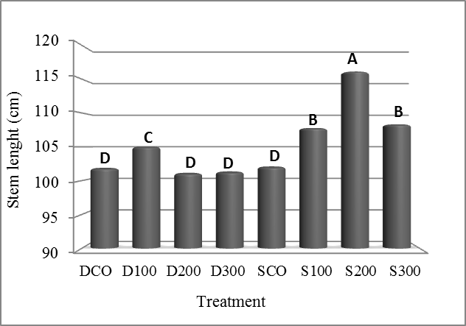
Fig.1. Effects of the concentrations and method of GA₃ on Stem length (cm).

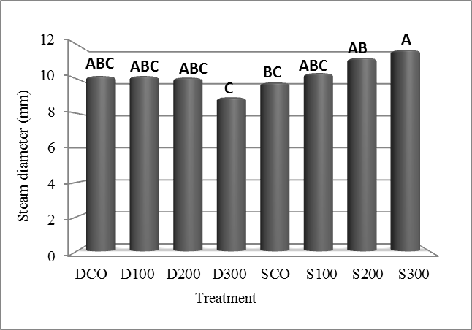
Fig.2. Effects of the concentrations and method of GA₃ on stem diameter (mm).

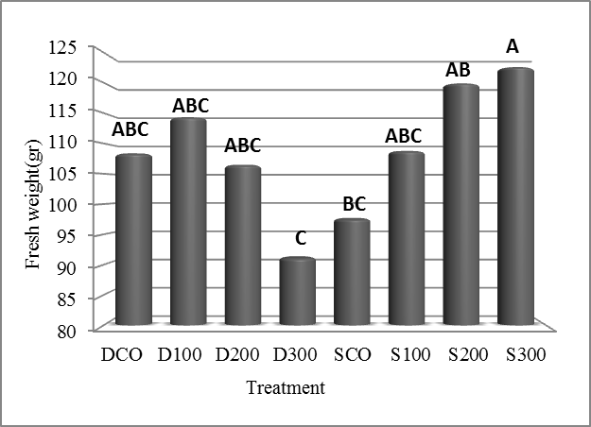
Fig.3. Effects of the concentrations and method of GA₃ on fresh weight (gr).

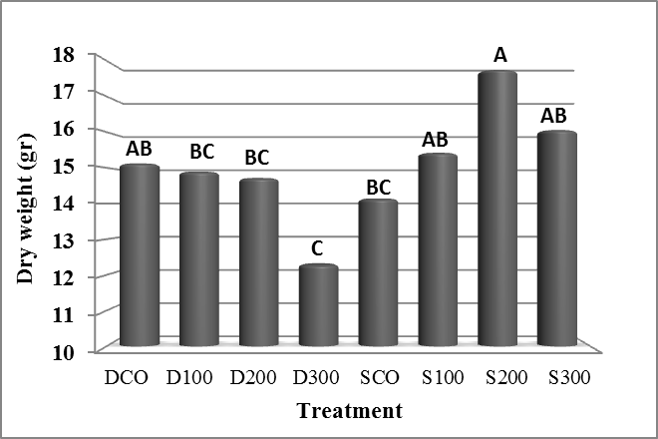
Fig.4. Effects of the concentrations and method of GA₃ on dry weight (gr).

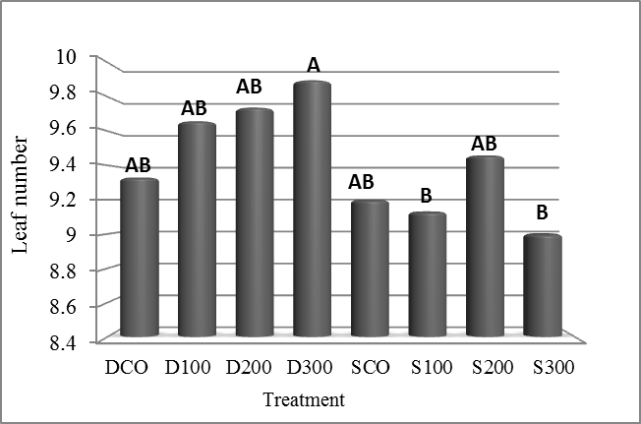
Fig.5. Effects of the concentrations and method of GA₃ on left number.

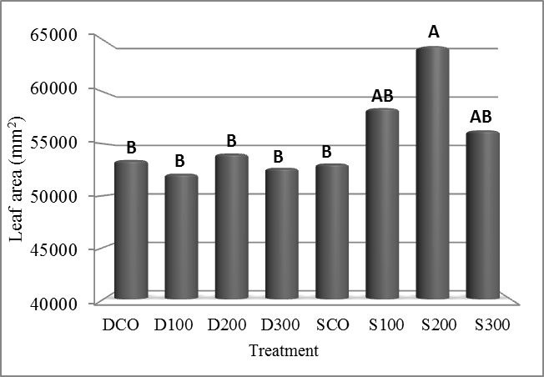
Fig.6. Effects of the concentrations and method of GA₃ on left area (mm²).

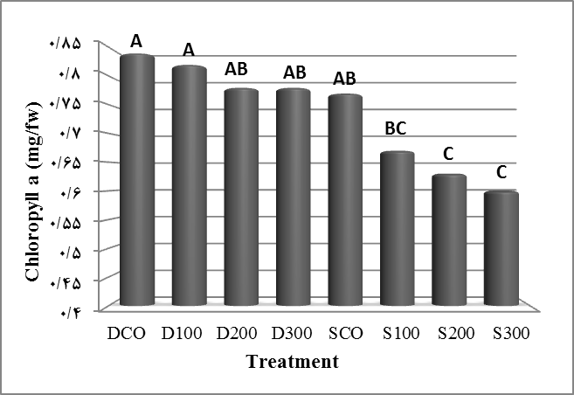
Fig.7. Effects of the concentrations and method of GA₃ on chlorophyll a.

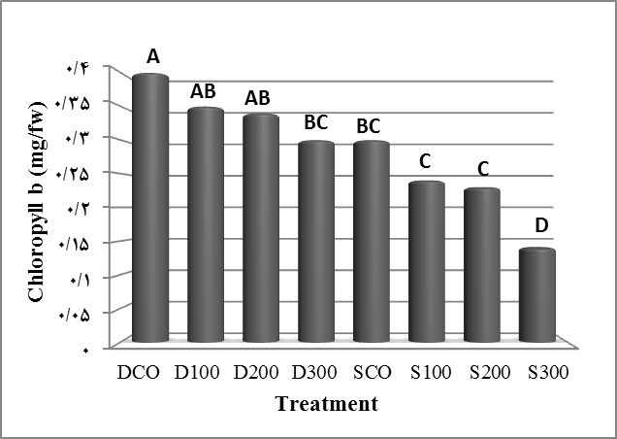
Fig.8. Effects of the concentrations and method of GA₃ on chlorophyll b (mg/fw).

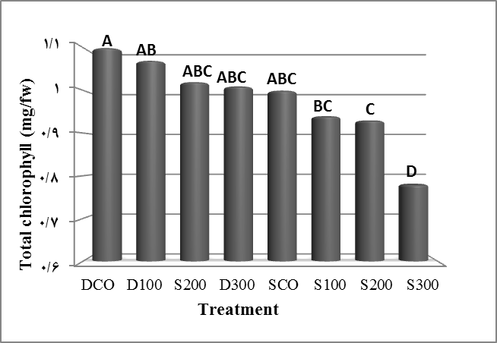

Fig.9. Effects of the concentrations and method of GA₃ on total chlorophyll (mg/fw).

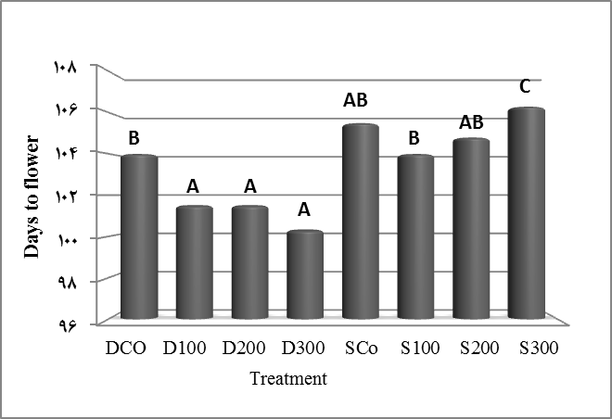
Fig.10. Effects of the concentrations and method of GA₃ on days to flower.

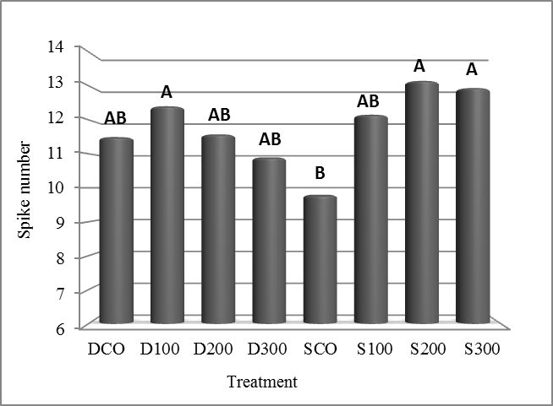
Fig.11. Effects of the concentrations and method of GA₃ on spike number.

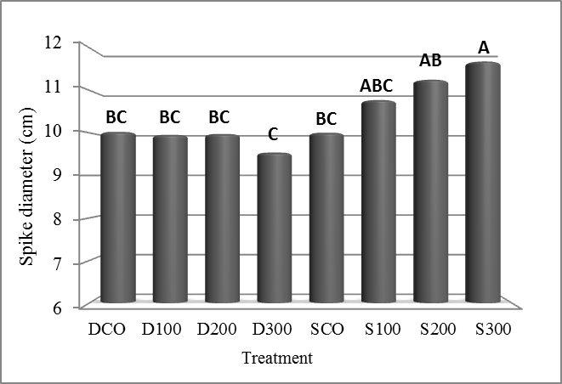
Fig.12. Effects of the concentrations and method of GA₃ on spike diameter (cm).

Table1. Influence of concentration and method application GA₃ on the Emergence and growth parameters in Gladiolus.
Fig.1. Effects of the concentrations and method of GA₃ on Stem length (cm).
Fig.2. Effects of the concentrations and method of GA₃ on stem diameter (mm).
Fig.3. Effects of the concentrations and method of GA₃ on fresh weight (gr).
Fig.4. Effects of the concentrations and method of GA₃ on dry weight (gr).
Fig.5. Effects of the concentrations and method of GA₃ on left number.
Fig.6. Effects of the concentrations and method of GA₃ on left area (mm²).
Fig.7. Effects of the concentrations and method of GA₃ on chlorophyll a.
Fig.8. Effects of the concentrations and method of GA₃ on chlorophyll b.
Fig.9. Effects of the concentrations and method of GA₃ on total chlorophyll.
Fig.10. Effects of the concentrations and method of GA₃ on days to flower.
Fig.11. Effects of the concentrations and method of GA₃ on spike number.
Fig.12. Effects of the concentrations and method of GA₃ on spike diameter (cm).

