Softwood cutting propagation and Landscape performance of three Polygonella wildflower species native to Florida

Mack Thetford^{1*}, Alison E. O’Donoughue², Sandra B. Wilson³, and Hector E. Pérez²

¹ West Florida Research Education Center, University of Florida, 5988 Highway 90, Building 4900, Milton, FL, 32583, *E-mail: thetford@ufl.edu
² Environmental Horticulture Department, Gainesville, FL
³ Indian River Research Education Center, University of Florida, Fort Pierce, FL
Abstract
Largeleaf jointweed (Polygonella macrophylla), October flower (Polygonella polygama), and sandhill wireweed (Polygonella robusta) are wildflowers that exhibit good form and showy flower displays within their natural growing environments. To broaden production and landscape use when seed is not available, asexual propagation has been explored as a potential alternative to seed produced transplants. Softwood cuttings of each Polygonella species, were collected from natural areas in Florida to (1) evaluate the effectiveness of various concentrations of indole-3-butyric Acid (K-IBA) on rooting, (2) determine the effect of propagation substrates on rooting success, and (3) evaluate the establishment, growth and flowering within three distinct growing regions. Terminal stem cuttings (8 cm) prepared from current season growth were treated with one of four concentrations (0, 1,000, 2,500, or 5,000 mgl⁻¹) of K-IBA using the quick-dip method prior to sticking in Fafard 3B or a mixture (50|50 by volume) of horticultural grade perlite and medium grade vermiculite and placed on greenhouse benches with intermittent mist. Approximately 7 weeks after sticking, cuttings were evaluated for: rooting, visual root quality, root number, and length of the longest root. Rooting percentages of 80% or greater were achieved with K-IBA at concentrations of 1000 to 5000 mgl⁻¹. Little or no difference in rooting percentage or root number was evident between the two propagation substrates. Plants of each species produced from cuttings rooted in Fafard 3B were evaluated in common garden landscape trials located in north (Milton), central (Gainesville) and south (Fort Pierce) Florida. All three Polygonella species transplanted successfully at each location and survival exceeded 80% within 28 weeks after planting. Flower impact, visual quality, and growth of each species varied by location and time, with peak performance occurring in November.

Key words: Wireweed, October flower, Jointweed, Polygonella macrophylla, Polygonella polygama, Polygonella robusta, asexual propagation
INTRODUCTION
There are an estimated 300-500 species of wildflowers commercially available in the US landscape trade, yet the majority have not been cultivated (Milstein 2005). Largeleaf jointweed (Polygonella macrophylla Small), October flower (Polygonella polygama (Vent.) Engelm. & A. Gray), and sandhill wireweed (Polygonella robusta (Small) G.L. Nesom & V.M. Bates) are Florida native wildflowers of Polygonaceae with excellent ornamental potential but of limited commercial availability due to the paucity of information regarding their propagation. Of the three species, P. macrophylla is endemic to north Florida occurring only in the panhandle region; P. polygama is present in all three regions of the state, and P. robusta occurs in central and south Florida (Fig. 1). Haehle and Brookwell (1999) noted the aesthetic appeal of the genus, stating that Polygonella spp. would make “a lovely addition to a wildflower garden”. These species have distinct morphological and floral characteristics that differentiate them from other commercially available species, making them excellent options for landscapers and gardening enthusiasts looking for unique native wildflowers.
Polygonella macrophylla is a suffrutescent perennial common to scrub and sandhills of northwestern Florida and the southern Alabama Gulf Coast. The broad sometimes fleshy, glabrous leaves, measuring 0.5 to 3 cm wide and 1 to 7 cm in length, and white, pink, or red flowers borne on racemes 1.5 to 6 cm long make this species stand out against the white sand of its habitat (Horton 1963). Though very attractive, P. macrophylla is classified as threatened, thus limiting its collection (Coile and Garland 2003). Morphological data suggest that P. macrophylla is most closely related to the more widespread P. polygama (Lewis and Crawford 1995). Within the Fort Pickens Aquatic Preserve (northwest Florida), it is found often in stable coastal dunes along with bitter panicum (Panicum amarum), Florida rosemary (Ceratiola ericoides Michx.), sea oats (Uniola paniculata L.), American searocket (Cakile edentula (Bigelow) Hook.), Cruise’s goldenaster (Chrysopsis gossypina (Michx.) Elliot ssp. cruiseana (Dress) Semple), and October flower (Polygonella polygama). It is also found in coastal scrub areas along with sand live oak (Quercus geminata Small), myrtle oak (Quercus myrtifolia Wild.), fetterbush (Lyonia lucida (Lam.) K. Koch), Florida rosemary, Cruise’s goldenaster, gopher apple (Licania michauxii Prance), saw palmetto (Serenoa repens (Bartram) Small), and October flower (FDEP, 2009).
Polygonella polygama var. polygama is an herbaceous perennial wildflower that is found in sandhills, flatwoods, and scrub, in full to partial sun within coastal plain regions of the southeastern United States (Wunderlin and Hansen 2009). The spatulate to linear light green leaves are approximately 0.5 to 2 cm long and 0.25 cm wide. The stem has some jointing visible every 5 to 10 cm. Its prolific, 0.9-1.8 mm, cream to yellow flowers usually appear in late fall on terminal racemes 2 to 5 cm long, thus garnering its common name, October flower. During these experiments it was observed that flowers of P. polygama had a light fragrance similar to jasmine. October flower is frequently found in open spaces with surrounding flora such as scrub oaks (Quercus spp.), gopher apple, saw palmetto, Florida rosemary, and pines (Pinus spp.) (Wunderlin and Hansen 2003, Osorio 2001, Taylor 1998). Although not used in this study, it should be noted that a second (though less common) variety exists by the name Polygonella polygama var. brachystachya (Meisn.). This variety is found mostly in flatwoods and can be distinguished from P. polygama var. polygama by its wider and longer leaves (Wunderlin and Hansen 2003).
Polygonella robusta is most commonly found in open sand, full sun environments along the coasts of Florida (Wunderlin and Hansen, 2009). This mounding herbaceous perennial has linear leaves 3 to 5 cm long and 0.25 wide. The stems have fibrous hairs at each node and appear to be jointed due to a sheathing petiole. Like P. polygama, it is also floriferous, but with terminal pink to cream 1.8-3.8 mm flowers that appear sporadically throughout the year on racemes 3 to10 cm long. While the species only naturally occurs in Florida, it is well distributed throughout the state. Accompanying flora include: saw palmetto, turkey oak (Quercus laevis), gopher apple, prairie clover (Dalea spp.), yucca (Yucca spp.), and some xerophytic grasses (Wunderlin and Hansen 2003, Osorio 2001, Taylor 1998). Neither P. polygama nor P. robusta is widespread in cultivation. Seed collection from natural populations can be restricted by varying seasonal conditions, management practices, or narrow harvest windows (Ingram and Yeager, 1990). While a few native nurseries produce both species from seed, germination often does not exceed 25% (N. Bissett, personal communication). Heather et al. (2010) attributed delayed, erratic, or reduced seed germination of P. polygama and P. robusta to physiological dormancy, collection site, and storage conditions.
The ornamental potential and limited knowledge regarding propagation of P. macrophylla, P. polygama and P. robusta warrants further investigation. Development of effective propagation methods may increase availability and use of Polygonella in coastal and urban landscapes and provide transplants for restoration projects. Vegetative propagation can often improve production efficiency, enhance product uniformity, and generate finished plants quicker and with greater reliability compared to seed propagation. Vegetative propagation has served as a reliable alternative for several other Florida native coastal or scrub species including Florida rosemary (Thetford et al. 2001), dune sunflower (Helianthus debilis) (Norcini and Aldrich 2000), and for the micropropagation of sea oats (Valero-Aracama et al. 2007).
Selection of an appropriate propagation substrate may depend on the species, cutting type, season, media availability, and propagation system (Thetford et al. 2001, Hartmann et al. 2011). Each of these factors may influence rooting percentages and the quality of roots produced. Additionally, water management within the propagation system is a critical factor in the selection of a propagation substrate. Delivery of sufficient water to maintain cutting turgor, while essential, may over-saturate the propagation substrate, thereby preventing adequate aeration. Prior propagation experiments with Florida rosemary (a beach plant), demonstrated successful rooting from softwood cuttings using either a pine bark or perlite|vermiculite substrate with cuttings yielding similar rooting percentages, root number and root length. However, an improvement of these rooting characteristics was evident with the use of perlite|vermiculite when cuttings were obtained from hurricane stressed stock plants (Thetford et al. 2001). To our knowledge, vegetative propagation protocols (including media type) have not been developed for Polygonella species. Evaluation of rooting responses in substrates of differing physical characteristics would assist in determining the importance of substrate characteristics on rooting percentages and the quality of roots produced for these sandhill species. Other herbaceous perennials native to coastal scrub communities of Florida such as dune sunflower (Norcini and Aldrich 2000), Florida rosemary (Thetford et al. 2001), and seacoast marshelder (Iva imbricata L.) (Raymer et al. 2008) have been propagated successfully by stem cuttings using the potassium salt of the rooting hormone indole-3-butyric Acid (K-IBA). Norcini and Aldrich (2000) found 2,000 mgl⁻¹ IBA was optimal to induce adventitious roots on dune sunflower; Thetford et al. (2001) recommend IBA concentrations below 5,000 mgl⁻¹ for rooting Florida rosemary and Raymer et al. (2008) successfully propagated stem cuttings of seacoast marshelder with 1000 mgl⁻¹ IBA.
While all three Polygonella species have visual characteristics that make them good candidates for wildflower landscape plantings, each has a different range within Florida. Little is known of the growth and flowering potential for these Polygonella species outside of their respective native ranges. A common garden approach to landscape performance evaluation has been used to investigate adaptability of wildflower species to differing regions of Florida and has demonstrated differences in performance for black-eyed susan (Rudbeckia hirta L.), tickseed (Coreopsis spp. L)., blanket flower (Gaillardia pulchella L.) and other species grown in areas outside their native region (Czarnecki et al. 2008; Hammond et al., 2007; Norcini et al. 2001a, Norcini et al. 2001b,).
The overall objective of this study was to determine if methods could be developed to root P. macrophylla, P. polygama, and P. robusta cuttings collected from natural areas in Florida. Specific objectives were to (1) evaluate the effectiveness of various concentrations of K-IBA on rooting, (2) determine the effect of propagation substrates on rooting success, and (3) evaluate the establishment, growth and flowering potential of vegetatively propagated Polygonella utilizing a common garden approach within three regions of Florida.

MATERIALS AND METHODS

Cutting source and auxin treatments
Cuttings of P. macrophylla, P. polygama and P. robusta were collected from natural populations occurring in north, central or south Florida during the summer of 2008 and 2009 (Table 1). Permit restrictions limited the number of cuttings available from a single location necessitating collection of cuttings for each experiment from a different site. Softwood (greenwood) cutting experiments were initiated for all species using approximately 8 cm terminal stem cuttings prepared from leafy stems of current season growth. The basal portion (1 cm) of each cutting was treated with one of four concentrations (0, 1,000, 2,500, or 5,000 mgl⁻¹) of K-IBA (Hortus IBA Water Soluble SaltsTM; Phytotronics, Inc., Earth City, MO) using the quick-dip method prior to sticking in Fafard 3B (45% Canadian sphagnum peat moss, 25% processed pine bark, 15% perlite, and 15% vermiculite; Conrad Fafard, Inc., Agawam, Mass.) or a mixture of horticultural grade perlite (Sun Gro Horticulture Canada Ltd. Seba Beach, AB) and medium grade vermiculite (Vergro container mix A; Verlite Co., Tampa, FL) each at 50% by volume. Cuttings were stuck 1 cm deep into media in 72-cell inserts and placed on greenhouse benches with mist for 8 seconds every 10 minutes for one week and then 6 seconds every 20 minutes thereafter. The mist ran from dawn until dusk, and was controlled with a sun sensor. Greenhouse temperatures recorded between May and Sept were 21°C min. and 32.5 °C max. Cuttings were maintained under a natural photoperiod.

Approximately 7 weeks after sticking, cuttings were evaluated for: rooting (0 or 1); visual root quality (1-5 scale, 1 = no roots, 2 = root initials little to no root elongation, 3 = few elongated roots; not enough for a contained root ball, 4 = many elongated roots; portion of root ball intact, 5 = large root system - many elongated roots filling the propagation cell); root number (number of roots originating from the base of the cutting); and length of the longest root (cm). Root balls were gently washed in water to remove substrate before determining root number and root length.

Landscape evaluation and performance
Each species was evaluated in landscape trials located in north (Milton), central (Gainesville) and south (Fort Pierce) Florida. At each site, raised beds were prepared with semi- permeable landscape fabric and drip irrigation. Initial soil samples were analyzed and characteristics are presented in Table 2. Softwood stem cuttings of each species rooted in Fafard 3B the summer of 2008 in Milton, FL (Table 1) were selected and finished plugs were transplanted into 3.7 L pots with soilless media (Fafard 3B) and top-dressed two weeks later with 15 ml of Osmocote Plus 18N 2.6P-10K (18-6-12) 9 month formulation (The Scotts Co., Marysville, OH). Plants were sensitive to over-watering during container production; hence individual plants were hand watered as needed based on the occurrence of minor wilting of stem tips. Finished plants were distributed to Gainesville and Fort Pierce and planted April 20, 2009 at all 3 sites. Initial plant height (cm) and width (cm) (mean of two perpendicular measurements) and visual quality were recorded at planting. Each month thereafter visual quality and flowering were recorded by the same individuals within each site throughout the evaluation period based on the following criteria. Visual quality was based on a scale of 1-5, where 1= Very poor quality - not acceptable, severe leaf necrosis or yellowing, not marketable, dead or almost dead; 2= Poor quality - not acceptable, sparse/uneven form, leaf yellowing, unhealthy appearance, not marketable; 3= Fair quality - marginally acceptable, somewhat desirable form and color, moderately healthy; 4= Good quality - very acceptable, minor flaws, nice color without yellowing, good form, healthy and vigorous, marketable; and 5= Excellent - perfect condition, premium color and form, extremely healthy and vigorous, very marketable. Flowering was based on a scale of 1-5, where 1= No flowers or flower buds; 2= Flower buds visible, no open flowers; 3= One to several open flowers; 4= Many open flowers, average to good flowering; and 5= Abundant flowering, possible peak bloom. Plant height (cm) and width (cm) (mean of two perpendicular measurements) were again recorded and a growth index calculated [(height +width1 + width2)/3] after 28 and 60 weeks. Monthly average temperature (°C) and monthly total rainfall (cm) for three planting sites in north (Milton), central (Gainesville), and south (Fort Pierce) were obtained from the Florida Automated Weather Network. All plants were pruned while still dormant on March 18, 2009 by shearing plants to a height and width that removed all dead floral stems.

Experiment Design and Data Analysis
Propagation experiments
For P. polygama and P. robusta our experimental design utilized a split plot arranged in a randomized complete block design with 6 replications. The main plots consisted of the propagation substrates and the subplots (each containing 6 cuttings) represented the 4 auxin treatments (a total of 8 substrate by auxin treatment combinations) for an experiment total of 144 cuttings. Limited cuttings were available for P. macrophylla, hence only one substrate was used (Fafard 3B) with 4 replications, each with 6 cuttings per IBA treatment for an experiment total of 96 cuttings. In 2008, the first rooting experiment with P. robusta was started 3 months later than the other experiments. Cuttings were not available until Aug from Jonathan Dickinson State Park and were shipped overnight to Milton, FL resulting in two day storage in sealed bags within a cooler prior to rooting in Fafard 3B. Significance of main effects of auxin concentration and rooting substrate and their interactions were determined using PROC GLM in SAS (version 8.01; SAS Institute, Cary, NC) and significant differences between means were determined with the lsmeans procedure using a Bonferroni correction. All differences were significant at an alpha level of 5%.

Landscape experiments
Landscape trials were planted in three locations; north (Milton), central (Gainesville), and south (Fort Pierce) Florida. At each location a randomized complete block design with 3 plants (subsamples) within each of the 3 blocks was installed. Significance of main effects of location and week of evaluation and their interactions were determined independently for each species using PROC MIXED in SAS (version 8.01; SAS Institute, Cary, NC) with a repeated statement included to account for the repeated measures data. Where significant differences among main effects or their interaction were present significant differences between means for an individual date were determined with the lsmeans procedure using a Bonferroni correction. Standard error bars demonstrate significant differences among locations within a given date. All differences were significant at an alpha level of 5%.

RESULTS
Propagation experiments
About 65 to 90% of P. macrophylla cuttings collected in May 2008 from Henderson Beach State Park rooted 47 days after sticking (Table 3). Application of K-IBA at 5000 mgl⁻¹ increased rooting percentages about 1.4-fold while at 2500 mgl⁻¹ rooting percentage increased 1.2-fold compared to cuttings treated with 0 or 1000 mgl⁻¹ K-IBA. Cuttings rooted with 2500 or 5000 mgl⁻¹ K-IBA produced twice the number of roots and had longer roots than cuttings rooted without K-IBA. The mean visual ratings indicated cuttings rooted with K-IBA at 2500 and 5000 mgl⁻¹ exceeded the minimum rating of 3 and would be considered a high quality rooted cutting with sufficient elongated roots present to keep at least a portion of the rootball intact.
Cuttings collected in May, 2009 from Big Lagoon State Park rooted between about 54 to 82% at 48 days after sticking (Table 3). While overall rooting percentages were lower in 2009, K-IBA applied at 2500 or 5000 mgl⁻¹ still increased rooting percentage by about 1.4 to 1.7 times compared to K-IBA at 0 or 1000 mgl⁻¹. Root number and root length did not differ with K-IBA application. The combined increase in root number and root length evident at the higher auxin concentrations, although not individually significant did impact root quality. Visual ratings increased as the rate of K-IBA increased, but only cuttings treated with K-IBA at 2500 or 5000 mgl⁻¹ were greater than 3 and both differed from cuttings treated with K-IBA at 1000 mgl⁻¹ and the non-treated control.
In May 2008, sufficient cuttings of P. polygama were available from Henderson Beach State Park to evaluate two propagation substrates in addition to the 4 rates of K-IBA. Cuttings rooted 35 days after sticking and overall rooting percentages exceeded 80% (Table 4). Rooting percentage, root number and visual ratings did not differ regardless of propagation substrate. Root length did not differ among cuttings propagated in Fafard 3B, but root length of cuttings propagated in perlite|vermiculite at 5000 mgl⁻¹ K-IBA were 0.5 to 1 cm shorter than roots of all other treatments. All visual ratings were 3 or greater with highest ratings occurring at K-IBA concentrations of 2500 or 5000 mgl⁻¹.
Polygonella polygama cuttings collected in May, 2009 from Big Lagoon State Park rooted between about 86 to 94% at 48 days after sticking in Fafard 3B. These softwood cuttings did not show a significant increase in rooting percentage, root number, root length or visual rating in response to auxin treatment (Table 5). The experiment-wise means were: percent rooting 88.9±2.6%, root number 6.4±0.3, root length 7.3±0.3 cm, and visual rating 4.3±0.1. This indicated that most cuttings had many elongated roots and a portion of the rootball remained intact, while additional cuttings had a large root system with many elongated roots filling the propagation cell.
Cuttings of P. robusta collected in 2008 rooted between about 85 to 94% at 42 days after sticking and rooting percentages did not differ among the auxin concentrations (Table 6). Cuttings rooted with K-IBA produced more roots than cuttings rooted without K-IBA, but root length did not differ among the 4 treatments. The mean visual ratings were all above 3 indicating most cuttings had many elongated roots and a portion of the rootball remained intact.
In May 2009, sufficient cuttings of P. robusta were available from Savannah Preserve State Park to evaluate two propagation substrates in addition to the 4 rates of K-IBA. The spring softwood cuttings did not show a significant increase in rooting percentage in response to auxin treatment or propagation substrate when evaluated 34 days after sticking (Table 7). The experiment-wise mean rooting percentage was 92±1.6%. There was no difference in root number among cuttings in response to auxin concentration or propagation substrate. Cuttings from this experiment only produced 2 roots per cutting in comparison to the 12 to 18 roots per cutting for cuttings from Jonathan Dickinson State Park propagated in Aug. Root length did not differ among K-IBA and nontreated cuttings, but cuttings rooted in Fafard 3B had significantly longer roots than cuttings rooted in perlite|vermiculite. Overall, visual ratings for P. robusta cuttings were similar among all rates of K-IBA. However, visual ratings of cuttings rooted in Fafard 3B were significantly higher than visual ratings of cuttings rooted in perlite|vermiculite. Unlike all other Polygonella propagation studies described here, visual ratings for P. robusta cuttings rooted in May did not exceed 3 regardless of auxin or propagation substrate treatments. Visual ratings were closer to 3 for cuttings rooted in Fafard 3B indicating most of these cuttings had few elongated roots, but there were not sufficient roots to contain the propagation substrate around the rootball. Perlite|vermiculite resulted in shorter roots which reduced the visual ratings compared to cuttings rooted in Fafard 3B. It is difficult to say if the lower root numbers are a reflection of the shorter rooting period (i.e. 34 vs. 42 days after sticking) or the storage of the cuttings during shipping (4 days vs. 2 days). In spite of these factors, the cuttings collected in May rooted at very high percentages and roots were similar in length to cuttings rooted Aug 2008.

Landscape trials
All three Polygonella species transplanted successfully at each of the three Florida locations and survival exceeded 80% for all species at all locations by Nov 2008, which was 28 weeks after planting (Fig. 2). All three species had achieved their maximum size (Fig. 3) and were expressing or just past peak flowering or peak quality ratings (Fig. 4) by week 28. However, while all three species expressed similar peak periods of flowering and quality ratings, there were differences in performance between the species as well as differences in species performance among the three planting sites (Table 8). Most notable was the lack of persistence for P. robusta at all three sites beyond winter dormancy (Fig. 2).
Quality ratings for P. macrophylla were initially greater in north FL and remained higher than other sites between Aug and Nov 2008, resulting in a significant interaction between the main effects of planting location and week of evaluation (Table 8; Fig. 4A). However, following winter dormancy, plant quality ratings did not differ among the sites in 2009 and quality ratings showed a general pattern of increase from Jan through Jul. Flowering followed a similar pattern with first flowers appearing between Jul and Aug and peak flowering occurring between Oct and Nov for all sites. Flower ratings for north FL exceeded ratings for other sites from Oct to Nov and flowers were present in north FL only May 2008 and in north and central FL Jan 2009. Growth index did increase over time but did not differ among locations with a growth index of 16 at planting, 49 at the peak of flowering and 32 just prior to flower initiation.
Quality ratings for P. polygama were initially greater in north and south FL until Jul 2008 when ratings for plants in north FL remained higher than other sites until Feb 2009, resulting in a significant interaction between the main effects of planting location and week of evaluation (Table 8; Fig. 4B). However, following winter dormancy plant quality ratings did not differ among the sites in 2009 and quality ratings showed a general pattern of increase from Jan through Jul. Flowering followed a similar pattern with first flowers appearing between Jul and Aug 2008 in the north and between Aug and Sep for central and south FL. Peak flowering occurred in Oct for all sites, but flowering in the north exceeded flowering at both central and south FL in Nov. Flowers were present on plants in north and central FL while no flowers were present on plants in south FL in Jan 2009 and no plants flowered from Feb to July of 2009. Growth index did increase over time but did not differ among locations with a growth index of 22 at planting, 52 at the peak of flowering and 42 just prior to flower initiation.
Quality ratings for P. robusta were initially greater in the north until Jan 2009, resulting in a significant interaction between the main effects of planting location and week of evaluation (Table 8; Fig. 4C). Following winter dormancy plant quality ratings remained low for central and south FL reflecting the 100% mortality at those two sites. A single plant survived in north FL and began to show signs of improved quality by July 2009. Flowering began early for P. robusta with first flowers appearing between Apr and May and reaching peak flowering from Nov and Dec. Flowering was most similar for plants in north and central FL with the exception of a slight delay in flowering for plants in central FL in Sep. Flowering for plants in south FL was similar to other sites through Nov, but a considerable decline in flower ratings began in Dec while flowering had stopped at all sites March to July of 2009. Growth index did increase over time but did not differ among locations with a growth index of 18 at planting, 67 at the peak of flowering and 40 just prior to flower initiation. In a similar common garden trial of the same species produced from seed, P. robusta performed as well as P. macrophylla and P. polygama (S. Wilson, personal communication).

DISCUSSION
Propagation experiments
Results of propagation experiments demonstrate Polygonella can be successfully rooted from softwood cuttings and that an external application of auxin was not necessary to achieve rooting success at ranges of 54 to 65% for P. macrophylla, 83 to 86% for P. polygonella, and 85 to 93% for P. robusta. However, rooting percentages for all three species were improved with the addition of K-IBA. Advantages typically associated with the application of auxins, such as an increase in the number of cuttings that form roots and an increase in the number of roots per cutting (Hitchcock and Zimmerman 1936, Hartmann et al. 2011), were evident when propagating Polygonella with the addition of K-IBA.
It was also evident that a favorable rooting environment resulted from the use of either a commercial mix such as Fafard 3B or a mix of perlite|vermiculite. Little or no difference in rooting percentage or root number was evident between the two propagation substrates. Only slight differences in root length were evident with P. robusta rooted in Fafard 3B showing less than a 2 cm increase in root length over cuttings rooted in a mix of perlite|vermiculite.
Overall, auxin application or an increase in auxin concentration resulted in an improvement of rooting percentage, root number or root length for Polygonella, a result which contrasts with previous work with the coastal scrub species Ceratiola. With Ceratiola, cuttings rooted well without application of an external application of auxin and no auxin treatment resulted in an increased root length or root numbers compared to the nontreated cuttings. Nursery professionals should expect rooting percentages of 80% or greater for these Polygonella with the application of K-IBA at concentrations of 1000 to 5000 mgl⁻¹ as these treatments generally had no negative effects on rooting percentage or measures of root quality (root number or length). While our experiments yielded many cuttings with low visual ratings, higher concentrations of K-IBA did result in higher visual ratings for rooted cuttings. These lower ratings are likely an artifact of our experimental approach. While an early harvesting of cuttings (35 to 48 days after sticking) provided ideal conditions to evaluate root number and root length, visual ratings were reduced overall because of the minimal root growth available to maintain rootball integrity. The visual ratings for all cuttings would most likely be higher if cuttings were allowed to continue to produce new roots and expand root elongation beyond 35 to 48 days after sticking. For experiments harvested at 48 days after sticking, visual ratings did show an increase in rootball integrity with an increase in auxin concentration.
These results suggest nursery professionals may achieve an improvement of rootball integrity and root quality by increasing root number and root length with the application of a synthetic auxin containing K-IBA at concentrations up to 5,000 mgl⁻¹. Early research has demonstrated that efficacy of auxins varies with the compound, the chemical form of the compound, and the formulation in which the auxin preparation actually resides (Blazich 1988) so preliminary on-site trials should be conducted prior to initiating a propagation program with K-IBA concentrations above 5000 mgl⁻¹ or prior to using other auxin compounds or formulations.

Landscape trials
Results of the field experiment demonstrated the potential to successfully transplant container grown Polygonella produced from wild collected cuttings within all three regions of Florida. Plant quality ratings also indicated that the plants maintained a fair quality, would be marginally acceptable with a somewhat desirable form and color, and appear moderately healthy for a majority of the growing season within all three regions of Florida. Quality ratings also demonstrated a decrease in quality during the dormant season (Dec through Apr) where plants would be considered poor and not acceptable because of sparse/uneven form, leaf yellowing or an unhealthy appearance and would not be considered marketable.

Planting location did have an effect on quality ratings for all three species, particularly during peak flowering. The consistently higher quality ratings for plants in north FL and the occasional higher quality ratings for plants in central FL suggest north and central Florida would be more suitable locations for the landscape use of all three Polygonella. Milton (north) did experience the greatest rainfall and Fort Peirce (south) frequently experienced greater rainfall than Gainesville (central) (Fig. 5), however, all trials were irrigated providing a similar minimal irrigation throughout the growing season. Effects of provenance selection have been noted with other Florida wildflower species (Czarnecki et al. 2008, Hammond 2007, Norcini et al. 1998, 2001a). Lewis (1991) investigated detectable allozyme diversity of P. macrophylla and determined that most of the diversity of this species is among populations. This suggests that several populations must be protected in order to preserve the genetic resources of P. macrophylla and provenance origin should be considered in additional work where these plants would be used for ecological restoration projects. Further development of horticultural selections or comparison of plants from a variety of provenances may also result in varied or improved performance of these plants across the three regions of the state (Czarnecki et al. 2008, Norcini et al. 2001b).

ACKNOWLEDGEMENTS
The authors are grateful for the help of Keona Muller, Pat Frey, Fé Almira, Darlene Bonelli and Tim Baxley for their field and research assistance. We would also like to thank Steve Woodmansee for his assistance in permitting and collection. Gratitude is extended to the Florida Wildflower Foundation for funding this research.

REFERENCES
Blazich F.O. (1988). Chemicals and formulations used to promote adventitious rooting. In: Davis T.D., Haissig B.E., Sankhla N. (Eds.). Adventitious Root Formation in Cuttings, Advances in Plant Sciences Series, vol. 2, Dioscorides Press, Portland, OR: l32-147.
Coile N.C., Garland M.A. (2003). Notes on Florida’s endangered and threatened plants. Botany Contribution No. 38, 4th ed. (PDF version). Florida Department of Agriculture & Consumer Services, Division of Plant Industry, Florida: 122 pp.
Czarnecki D.M., Rao M.N., Norcini J.G., Gmitte F.G. and Deng Z. (2008). Genetic diversity and differentiation among natural, production, and introduced populations of the narrowly endemic species Coreopsis leavenworthii (Asteraceae). Journal of the American Society of Horticultural Science, 133: 234-241.
Hammond H.E., Norcini J.G., Wilson S.B., Schoellhorn R.K., Miller D.L. (2007). Growth, flowering, and survival of fire wheel (Gaillardia pulchella Foug.) based on seed source and growing location. Native Plants Journal, 8:25-39.
Florida Department of Environmental Protection (FDEP) (2009). Fort Pickens Aquatic preserve Information Page, last updated: Feb. 23, 2009. http://www.dep.state.fl.us/coastal/sites/ftpickens/info.htm
Hartmann H.T., Kester D.E., Davies F.T., Geneve R. (2011). Hartmann and Kester's Plant Propagation: Principles and Practices. Prentice Hall, NJ: 928 pp.
Haehle, R.G., Brookwell J. (1999). Native Florida plants: Low maintenance landscaping and gardening. Gulf Publishing Company, Houston, TX: 400 pp.
Heather A., Pérez H., Wilson S. (2010). Non-deep physiological dormancy in seeds of two Polygonella species with horticultural potential. HortScience, 45:1854–1858.
Hitchcock A.E., Zimmerman P.W. (1936). Effect of growth substances on the rooting response of cuttings. Contributions from Boyce Thompson Institute, 8:63-79.
Horton J.H. (1963). A taxonomic revision of Polygonella (Polygonaceae). Brittonia, 15:177-203.
Ingram D., Yeager T. (1990). Propagation of landscape plants. 10 June 2009. http://edis.ifas.ufl.edu/MG108.
Lewis P.O. (1991). Allozyme variation in the rare gulf coast endemic Polygonella macrophylla Small (Polygonaceae). Plant Species Biology, 6:1-10.
Lewis P.O., Crawford D. J. (1995). Pleistocene refugium endemics exhibit greater allozymic diversity than widespread congeners in the genus Polygonella (Polygonaceae). American Journal of Botany, 82:141-149.
Milstein G.P. (2005). The uses and potential of wildflower seed and landscaping. In: McDonald M.B., Kwang FY. (Eds.). Flower Seeds: Biology and Technology. CABI Publishing, Columbus, OH: 39-51.
Norcini J.G., Aldrich J.H., Halsey L.A., and Lilly J.G. (1998). Seed source affects performance of six wildflower species. Proceedings of the Florida State Horticultural Society, 111:4-9.
Norcini J.G., Aldrich J.H., Martin F.G. (2001a). Seed source effects on growth and flowering of Coreopsis lanceolata and Salvia lyrata. Journal of Environmental Horticulture, 19:212-215.
Norcini J.G., Thetford M., Klock-Moore K.A., Bell M.L., Harbaugh B.K., Aldrich J.H. (2001b). Growth, flowering, and survival of black-eyed susan from different regional seed sources. HortTechnology, 11:26-30.
Norcini J., Aldrich J. (2000). Cutting propagation and container production of ‘Flora Sun' beach sunflower. Journal of Environmental Horticulture, 18:185-187.
Osorio R. (2001). A gardener’s guide to Florida’s native plants. University of Florida Press, Gainesville, FL: 345 pp.
Raymer J., Thetford M., Miller D.L. (2008). Fertility rate of seacoast marshelder stock plants influences cutting production and rooting characteristics of stem cuttings. HortTechnology, 18:372-378.
Taylor W.K. (1998). Florida wildflowers in their natural communities. University Press of Florida, Gainesville, FL: 370 pp.
Thetford M., Miller D., Penniman P. (2001). Vegetative propagation and production of Ceratiola ericoides Michx. for use in restoration. Native Plants Journal, 2:116-125.
Valero-Aracama C., Wilson S.B., Kane M.E., Philman N.L. (2007). Influence of in vitro growth conditions on in vitro and ex vitro photosynthetic rates of easy- and difficult-to-acclimatize sea oats (Uniola paniculata L.) genotypes. In Vitro Cellular and Developmental Biology, 43:237-246.
Wunderlin RP, Hansen B.F. (2003). Guide to the Vascular Plants of Florida, 2nd edition. University Press of Florida, Gainesville, FL: 787 pp.
Wunderlin R.P., Hansen B.F. (2009). Atlas of Florida Vascular Plants. Landry S.M. and Campbell K.N. (application development), Florida Center for Community Design and Research. Institute for Systematic Botany, Univ. of South Florida, Tampa. Retrieved 24 Aug. 2009. www.florida.plantatlas.usf.edu.

Table 1. Summary of Polygonella rooting experiments indicating collection location and date, number of cuttings collected, substrates tested and date of cutting evaluation.

Species name | Common habitat | Florida location | Collection/sticking date | Cutting  number | Substrates  tested^{Z} | Evaluation date
P. macrophylla; large-leaved jointweed | Coastal dunes and scrub | Henderson Beach State Park; Okaloosa Co. | May 21, 2008 | 96 | Fafard 3B | July 7, 2008
P. macrophylla; large-leaved jointweed | Coastal dunes and scrub | Big Lagoon State Park; Escambia Co. | May 13, 2009 | 96 | Fafard 3B | June 30, 2009
P. polygama; october flower | Coastal dunes and scrub | Henderson Beach State Park; Okaloosa Co. | May 21, 2008 | 288 | Fafard 3B  Perlite|Vermiculite | June 26, 2008
P. polygama; october flower | Coastal dunes and scrub | Big Lagoon State Park; Escambia Co. | May 13, 2009 | 144 | Fafard 3B | June 30, 2009
P. robusta; sandhill wireweed | Sandhills and scrub | Jonathan Dickinson State Park; Martin Co. | Aug 14/15, 2008 | 144 | Fafard 3B | Sept 26, 2008
P. robusta; sandhill wireweed | Sandhills and scrub | Savannas Preserve State Park; Martin Co. | May 17-20, 2009 | 288 | Fafard 3B  Perlite|Vermiculite | June 23, 2009
^{Z}Substrates tested = Fafard 3B (45% Canadian sphagnum peat moss, 25% processed pine bark, 15% perlite, and 15% vermiculite; Conrad Fafard, Inc., Agawam, MA) or Perlite|Vermiculite (50% each by volume; Sun Gro Horticulture Canada Ltd. Seba Beach, AB and Vergro container mix A; Verlite Co., Tampa, FL).

Table 2. Initial chemical and nutrient analysis of soils in north (Milton), central (Gainesville), and south (Fort Pierce) Florida where Polygonella were trialed.
Florida Organic Est. N EC CEC
Planting matter release P K Mg Ca (mmhos/ (meq.
Site (%) (kg∙ha⁻¹) (mgl⁻¹) (mgl⁻¹) (mgl⁻¹) (mgl⁻¹) pH cm) 100g⁻¹)
North 1.3 78 20 17 7 110 5.3 0.01 1.1
Central 2.9 114 133 71 49 499 6.4 0.11 3.4
South 2.8 112 56 79 102 1132 5.9 0.08 8.6
Table 3. Rooting in response to auxin concentration of softwood stem cuttings of Polygonella macrophylla collected from Henderson Beach State Park, FL (May 21, 2008) and Big Lagoon State Park, FL (May13, 2009) and stuck in Fafard 3B.
Henderson Beach State Park Big Lagoon State Park
K-IBA Conc. Rooting Roots/cutting Root length Visual rating Rooting Roots/cutting Root length Visual rating
(mgl⁻¹) (%) (no.) (cm) (%) (no.) (cm)
0 65±6 b 2.6±1 b 4.4±0.6 b 2.5±0.2 b 54±10 b 5±1 4.4±1 2.9±0.4 ab
1000 65±6 b 3.8±1 b 4.9±0.5 b 2.6±0.2 b 48±11 b 6±2 4.0±1 2.6±0.4 b
2500 80±5 ab 6.1±1 a 7.3±0.3 a 3.7±0.2 a 76±10 a 7±1 6.7±1 3.7±0.4 a
5000 90±4 a 5.9±1 a 6.5±0.4 a 3.7±0.2 a 82±8 a 9±1 6.2±1 3.9±0.3 a
Significance
Concentration 0.0019 <0.0001 <0.0001 <0.0001 0.0381 ns ns 0.0334
For each location means within a column followed by the same letter do not differ (Bonferonni, alpha = 0.05). Visual root quality (1-5 scale, 1 = no roots, 2 = initials little to no root elongation, 3 = few elongated root; not enough for a contained root ball, 4 = many elongated roots; portion of root ball intact, 5 = large root system - many elongated roots filling the propagation cell), root number (number of roots originating from the base of the cutting), and length of longest root (cm).
Table 4. Rooting in response to propagation substrate and auxin concentration of softwood stem cutting of Polygonella polygama collected from Henderson Beach State Park (May 21, 2008).
K-IBA Conc. Rooting Roots/cutting Root length (cm) Visual rating
(mgl⁻¹) (%) (no.) Fafard 3B Perlite|Vermiculite
0 83±5 b 6±1 b 5.9±0.4 a 5.7±0.4 a 3.0±0.2 b
1000 90±4 a 6±1 b 5.7±0.3 a 5.8±0.3 a 3.3±0.1 ab
2500 96±3 a 8±1 a 6.2±0.2 a 5.8±0.3 a 3.6±0.1 a
5000 95±2 a 7±1 ab 5.8±0.3 a 5.2±0.2 b 3.5±0.1 a
Significance
Concentration 0.0004 <0.0001 <0.0001 <0.0001
Substrate ns ns ns ns
Conc. × Substrate ns ns <0.0001 ns
visual root quality (1-5 scale, 1 = no roots, 2 = initials little to no root elongation, 3 = few elongated root; not enough for a contained root ball, 4 = many elongated roots; portion of root ball intact, 5 = large root system - many elongated roots filling the propagation cell), root number (number of roots originating from the base of the cutting), and length of longest root (cm) .

Table 5. Rooting in response to auxin concentration of softwood stem cutting of Polygonella polygama collected from Big Lagoon State Park (May 13, 2009) in Fafard 3B.
K-IBA Conc. Rooting Roots/cutting Root length Visual rating
(mgl⁻¹) (%) (no.) (cm)
0 86±6 a 6±1 a 6.4±0.6 a 4.1±0.2 a
1000 89±5 a 7±1 a 7.7±0.6 a 4.4±0.2 a
2500 94±4 a 7±1 a 7.7±0.6 a 4.3±0.2 a
5000 86±6 a 6±1 a 7.6±0.6 a 4.3±0.2 a
Significance
Concentration ns ns ns ns
Means within a column followed by the same letter do not differ (Bonferonni, alpha = 0.05).
visual root quality (1-5 scale, 1 = no roots, 2 = initials little to no root elongation, 3 = few elongated root; not enough for a contained root ball, 4 = many elongated roots; portion of root ball intact, 5 = large root system - many elongated roots filling the propagation cell), root number (number of roots originating from the base of the cutting), and length of longest root (cm) .
Table 6. Rooting of softwood stem cutting of Polygonella robusta collected from Jonathan Dickinson State Park, FL (August14-15, 2008) in Fafard 3B in response auxin concentration.
K-IBA Conc. Rooting Roots/cutting Root length Visual rating
(mgl⁻¹) (%) (no.) (cm)
0 85±6 a 12±1 b 6.6±0.5 a 3.4±0.2 a
1000 85±5 a 17±1 a 7.6±0.3 a 3.7±0.2 a
2500 85±4 a 18±1 a 6.8±0.4 a 3.7±0.2 a
5000 94±3 a 18±2 a 6.7±0.6 a 3.9±0.2 a
Significance
Concentration ns 0.0009 ns ns
Means within a column followed by the same letter do not differ (Bonferonni, alpha = 0.05).
visual root quality (1-5 scale, 1 = no roots, 2 = initials little to no root elongation, 3 = few elongated root; not enough for a contained root ball, 4 = many elongated roots; portion of root ball intact, 5 = large root system - many elongated roots filling the propagation cell), root number (number of roots originating from the base of the cutting), and length of longest root (cm) .
Table 7. Rooting of softwood stem cutting of Polygonella robusta collected from Savannas Preserve State Park, FL (May 17-20, 2009) in response to propagation substrate and auxin concentration.
Rooting Roots/cutting Root length Visual rating
Variable (%) (no.) (cm)
K-IBA Conc. (mgl⁻¹)
0 93±3 a 2±0.1 a 6.5±0.3 2.5±0.1
1000 93±3 a 2±0.1 a 6.8±0.4 2.7±0.1
2500 90±4 a 2±0.1 a 6.4±0.4 2.6±0.1
5000 93±3 a 3±0.1 a 6.3±0.3 2.7±0.1
Substrate
Fafard 90±3 2±0.1 7.1±0.3 a 2.9±0.1 a
Perlite|Vermiculite 94±2 2±0.1 5.9±0.2 b 2.3±0.1 b
Significance
Concentration ns ns ns ns
Substrate ns ns 0.0003 <0.0001
Conc. × Substrate ns ns ns ns
Means within a column followed by the same letter do not differ (Bonferonni, alpha = 0.05).
visual root quality (1-5 scale, 1 = no roots, 2 = initials little to no root elongation, 3 = few elongated root; not enough for a contained root ball, 4 = many elongated roots; portion of root ball intact, 5 = large root system - many elongated roots filling the propagation cell), root number (number of roots originating from the base of the cutting), and length of longest root (cm) .
Table 8. Type 3 tests of fixed effects of growth index, flowering and plant quality for 3 species of Polygonella produced from wild collected cuttings planted at 3 locations and evaluated over 60 weeks.
Degrees of freedom
Source Numerator Denominator Type 3 F Pr > F
Polygonella macrophylla
Growth Index
Location 2 4 2.38 0.2084
Week 2 4 63.75 <0.0009
Location×Week 4 8 1.56 <0.2742
Flower rating
Location 2 4 7.49 0.0444
Week 15 30 53.65 <0.0001
Location×Week 28 56 4.01 <0.0001
Quality rating
Location 2 4 11.56 0.0218
Week 15 30 11.53 <0.0001
Location×Week 28 56 1.88 0.0226
Polygonella polygama
Growth Index
Location 2 4 1.18 0.3951
Week 2 4 36.33 <0.0027
Location×Week 4 8 2.07 <0.1767
Flower rating
Location 2 4 2.45 0.2018
Week 15 30 51.10 <0.0001
Location×Week 28 56 4.09 <0.0001
Quality rating
Location 2 4 12.09 0.0201
Week 15 30 11.70 <.0001
Location×Week 28 56 2.18 0.0066
Polygonella robusta
Growth Index
Location 2 4 4.95 0.0828
Week 2 2 131.17 0.0076
Location×Week 2 3 6.01 0.0893
Flower rating
Location 2 4 3.03 0.1582
Week 15 30 13.20 <0.0001
Location×Week 28 56 1.52 0.0916
Quality rating
Location 2 4 27.73 0.0045
Week 15 30 25.46 <.0001
Location×Week 28 56 1.87 0.0235

Fig. 1. Distribution of largeleaf jointweed (Polygonella macrophylla), October flower (P. polygama) and sandhill wireweed (P. robusta) in Florida based on vouchered specimines reported in the Atlas of Florida Vascular Plants (www.florida.plantatlas.usf.edu).
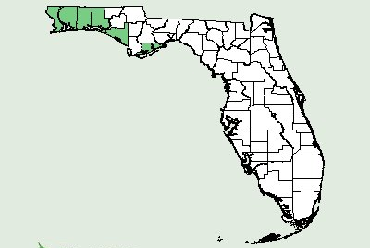 | 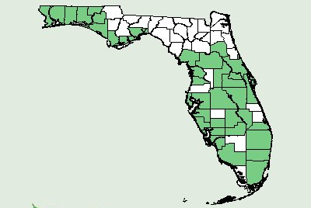 | 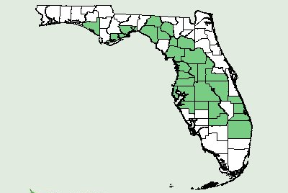
P. macrophylla | P. polygama | P. robusta

Fig. 2. Mean survival (%) for three Polygonella species 0, 28 and 60 weeks after planting (Apr 2008, Nov 2009 and Jul 2009 respectively) in north (Milton), central (Gainesville), and south (Fort Pierce) Florida. Error bars denote standard error of mean survival, n=9.
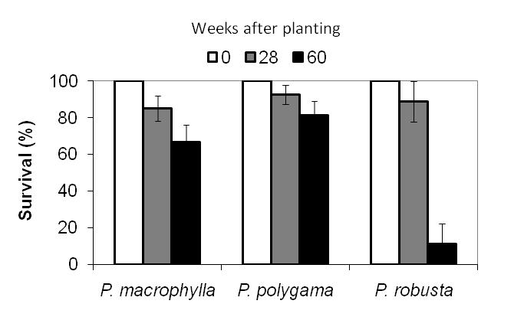

Fig. 3. Mean growth index for three Polygonella species 0, 28 and 60 weeks after planting (Apr 2008, Nov 2009 and Jul 2009 respectively) in north (Milton), Central (Gainesville), and south (Fort Pierce) Florida. Error bars denote standard error of mean growth index, n=9. 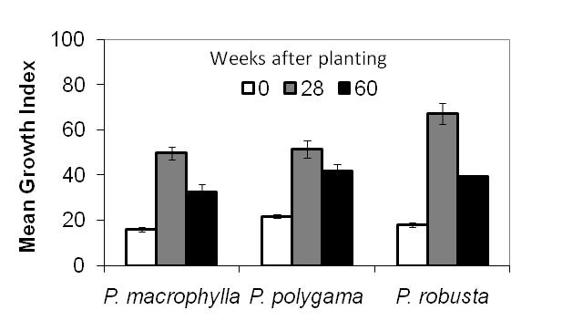
Fig. 4. Monthly plant quality and flower ratings of Polygonella macrophylla (A), Polygonella polygama (B), and Polygonella robusta (C) planted in northwest (Milton), central (Gainesville), and south (Fort Pierce) Florida. The study was initiated on April 20, 2009. Visual quality was based on a scale of 1-5, where 1= Very poor quality; 2= Poor quality; 3= Fair quality; 4= Good quality; and 5= Excellent. Flowering was based on a scale of 1-5, where 1= No flowers or flower buds; 2= Flower buds visible, no open flowers; 3= One to several open flowers; 4= Many open flowers; and 5= Abundant flowering, possible peak bloom. Error bars denote standard error of mean plant quality or flower rating, n=9.
Species | Plant quality | Flower rating
(A)  Polygonella macrophylla | 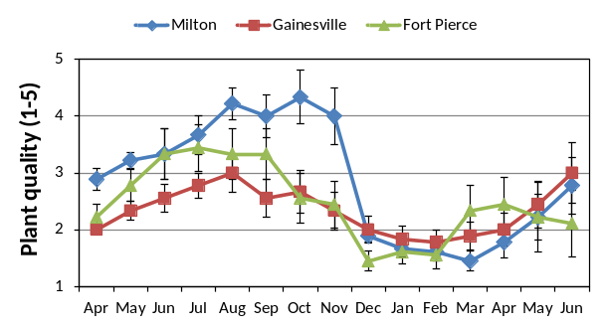 | 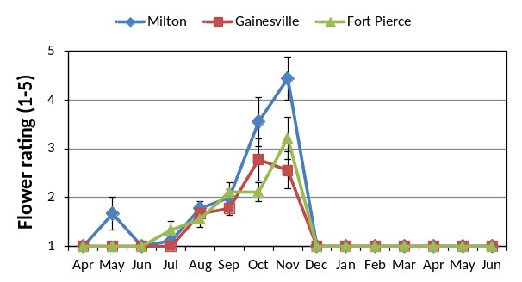
(B)  Polygonella polygama | 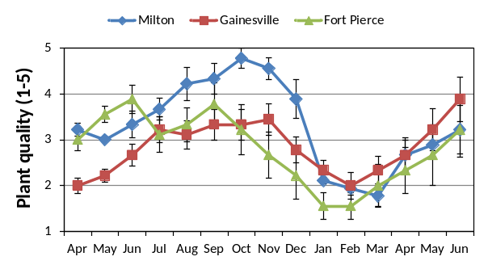 | 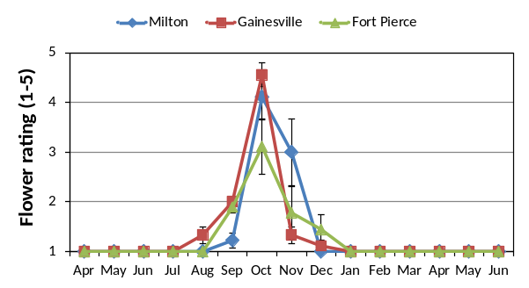
(C)  Polygonella robusta | 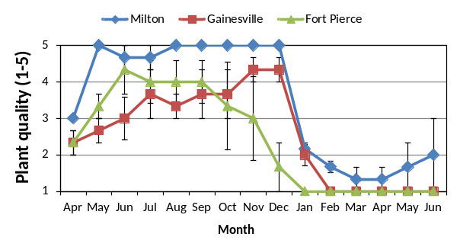 | 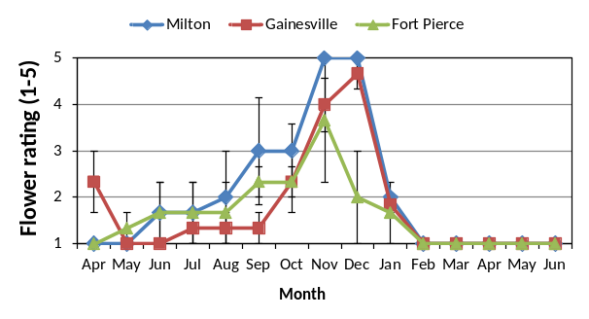

5. Monthly average temperature (°C) and monthly total rainfall (cm) for three planting sites in north (Milton), central (Gainesville), and south (Fort Pierce) Florida. The study was initiated on April 20, 2009 and terminated in January 2010.
