Improvement of somatic embryogenesis and plantlet conversion of Oplopanax elatus, an endangered woody species

Heung-Kyu Moon¹, Yong-Wook Kim¹, Yong-Pyo Hong², So-Young Park^{3*}
¹ Division of Forest Biotechnology, Korea Forest Research Institute, Suwon 441-847, Republic of Korea

² Division of Forest Genetic Resources, Korea Forest Research Institute, Suwon 441-847, Republic of Korea

³ Department of Horticultural Science, Chungbuk National University, Cheongju 361-763, Republic of Korea

* Corresponding author:

So-Young Park, Ph. D
E-mail: soypark7@cbnu.ac.kr
Tel: +82-43-261-2531
Fax: +82-43-271-0414
ABSTRACT
Oplopanax elatus is a medicinal plant on the verge of extinction because of overexploitation. In the present study, the effects of various factors in enhancing somatic embryogenesis (SE) and plantlet conversion were studied. Mature seeds were collected from a total of 13 plants from 4 mountains in South Korea, and the genetic distances were calculated to analyze the effect of genotype on SE. Results of cluster analysis and the unweighted-pair-group method with arithmetic mean of 13 genotypes indicated the presence of 3 main groups. Both genotype and explant type affected SE induction. Sorak 2 and root were found to be the most suitable genotype and explant, respectively, for SE induction in Oplopanax. Among the different types of carbon sources tested, 5% sucrose induced the maximum number of somatic embryos. The formation and development of somatic embryos were significantly influenced by culture density; thus, 0.2–0.5 g of embryonic callus was found to be the most suitable for SE induction. The highest rates of germination and somatic embryo conversions were obtained in a germination medium containing 8 g·l⁻¹ agar. In addition, 80% of the plantlets transplanted into artificial soil acclimatized successfully. Thus, our results showed that the percentage survival of O. elatus during in vitro proliferation could be increased through improvements to the SE system.

Key words: Oplopanax elatus, genotype, plantlet formation, somatic embryogenesis.

INTRODUCTIONOplopanax elatus is a valuable medicinal plant and one of the first Far-Eastern plants to be recommended for research as a source of herbal preparations, similar to ginseng. Because of its highly valued medicinal properties against conditions such as asthenia, depressive states, and hypertension, this rare and endangered species has been historically over-exploited throughout Asia, and its demand has increased (Zhuravlev and Kolyada 1996; Lee et al. 2002; Park et al. 2011a).
The distribution of O. elatus in South Korea is considerably limited, and it only occurs in restricted areas on high mountains (Lee et al. 2002). Conventional methods for the vegetative propagation of O. elatus, such as plant division, layering, and cutting, have not been effective (Fu and Jin 1992; Zhuravlev and Kolyada 1996). Moreover, the distribution of weak, less viable embryos of this species is restricted to high elevations (Lee et al. 2002). Therefore, alternative methods for the rapid multiplication of this plant must be developed for its conservation as well as for medicinal purposes.
In vitro culture has always been a preferred, alternative approach for replicating genetically identical plantlets of rare and endangered species (Kowalski and von Staden, 2001; Negash 2002; Rai 2002; Gomes et al. 2003; Martin 2003a, b; Park et al. 2011a, b). Although callus induction and somatic embryogenesis (SE) have been widely explored options for Araliaceae genera (Park et al. 2011b), studies on SE for O. elatus are comparatively rare (Moon and Youn 1999; Moon et al. 2006). For this species, callus induction and SE have been reported by only Cho et al. (1991); however, these authors could not regenerate plantlets. In 2006, plantlets of this species could be successfully regenerated by SE in our laboratory (Moon et al. 2006; Park et al. 2011a). However, because of the low ratio of SE induction and plantlet conversion, this method could not be established for the mass propagation of O. elatus. Another limitation was that viable seeds of this species cannot be easily collected from natural habitats. Consequently, embryogenesis is dependent on other somatic tissues, such as leaves, stems, and roots. In this paper, we report an improved SE production system for O. elatus by investigating the effects of various factors on plantlet conversion.

MATERIALS AND METHODS
Plant material and EC induction
Mature seeds were collected from total 13 trees at 4 mountains (Mts. Sorak, Jili, Bantae and Taebaek), South Korea, in September of 2006, and transported in an icebox to the laboratory. They were surface sterilized with 70% ethanol for 3 min, 2% NaOCl for 30 min, and 0.2% (w/v) HgCl₂ (Aldrich, USA) following the method of Moon et al., 2006. The seeds were carefully de-husked with a scalpel, and the naked seeds were inoculated on MS medium (Murashige and Skoog, 1962) containing l g L⁻¹ glutamine, 3% sucrose, and 0.3% gelrite (Aidrich, USA), and which was supplemented with 1.0 mg L⁻¹ of 2,4-D for embryogenic callus (EC) induction.
DNA isolation, Simple sequence repeat (SSR) analysis and cluster analysis
Genomic DNA was isolated from embryogenic callus of each genotype following CTAB method. DNA was amplified in a PTC-200 PCR (MJ Research, USA) containing 50 ng template DNA, 1X buffer (75 mM Tris.HCl (pH 9.0), 50 mM KCl, 20 mM (NH₄)₂SO₄), 2 mM MgCl₂, 200 μM of each dNTP, 5 pmol SSR primers, and 1 unit Taq DNA polymerase (ABgene, UK). Initial denaturation was at 94°C for 5 min, followed by 94°C, 30 sec, 52°C, 30 sec and 72°C, 30 sec. Cycle was repeated 45 times, followed by 60 sec extension at 72°C. The amplified products were separated on 2% agarose gel and detected by EtBr staining. For cluster analysis, the bands appearing without ambiguity were scored as 1 (present) and 0 (absent) for each primer. Genetic relationship of individuals was analyzed by UPGMA method (Phylip v3.5c; Felsenstein 1993).
Induction of somatic embryos (SEs)
For induction of somatic embryos from EC, MS medium was supplemented with ABA 0.1 mg L⁻¹, 0.02% activated charcoal, 5% sucrose and 0.5% gelrite. ECs were plated on filter paper (diameter 70mm) following method of Moon et al. (2008). Cultures were maintained in darkness and examined after 4 weeks of culture.
For investigation of various factors on SE induction viz. genotype effect, explant origin, carbon source, inoculation density and gelling agent the experiments were done as follows:
Genotype effect
For studying the effect of genotype, EC were induced from the 13 different genotypes from the four different mountains as follows: Two from Sorak, one from Bangtae, two from Taebaek and eight genotypes from Mt. Jiri.
Explant origin
EC were induced from leaf, petiole and root from somatic plantlets which were grown for 4 weeks in MS medium. Size of explants was leaf 0.5 x 0.5cm, 1~2mm petiole and 1cm root segments. Ten explants were cultured on EC induction medium on a petri-dish with five replications.
Histological observation
Callus obtained from different explants were fixed in a solution containing 2.5% glutaralde hyde and 1.6% paraformaldehyde buffered with 0.05 M phosphate buffer, pH 6.8, for 24 h at 4°C. Samples were dehydrated in an alcohol series and then embedded in Technovit 7100 (Kulzer, Germany) according to Yeung (1999). Serial 3-µm-thick sections were cut on a Reichert-Jung 2040 Autocut rotary microtome. and stained with toluidine blue O (Yeung 1984).
Effects of carbohydrate sources and concentrations, inoculation density
Mt. Sorak zyotic embryo-derived EC were used for experiment as plant materials. For studying the effect of carbohydrate source, glucose, fructose, maltose, sorbitol and mannitol were added at concentrations of 1%, 3% and 5% to the medium.
For studying the effect of inoculation density embryogenic cells were plated following method of Moon et al. (2008). Ten to fifty mg of embryogenic calli were plated per plate in 90mm-diameter petri-dishes.

Germination and plantlet conversion
Somatic embryos in the early cotyledonary stages were selected and used for these experiments. To improve conversion rate of plantlets from somatic embryos, gelling agents were tested. Half concentration of MS medium containing 20 gL-1 sucrose was solidified with five different combinations of gelling agent ; 0.3 and 0.5% gelrite, 0.8 and 1.0% agar, 0.18% gelrite+0.32% agar mixture. For the experiment, around 20 SEs were cultured onto 1.5x9-cm petri-dish, which contained 25 mL of germination medium (GM) completed with different concentrations of gelling agents and GA₃. The cultures were maintained under light condition (16/8h, day/night), and after 4 weeks, the number of plantlets converted into plantlets were counted.

Soil transfer and acclimatization
Two hundred normally converted young plantlets (about 7 to 10 cm long) were selected from the culture dishes and the agar was carefully removed from the roots with tap water. These plantlets were then transferred to an artificial soil mixture (1:2 = PKS2 : pelrite, by volume) and cultured in a high-humidity greenhouse to determine their survival after two months.

Statistical analysis
Experiments were carried out in a randomized design and repeated twice with each treatment having five replicates. The results were subjected to analysis of variance (ANOVA) using the SAS program (SAS Institute, Inc., Cary, NC). Mean values were presented with SE values or separated according to Duncan’s multiple range test at P≤0.05 level.

RESULTS
Cluster analysis and genotype effect
The results of the cluster analysis indicated that the genotypes of the studied O. elatus specimens may be divided into 3 main clusters (Fig. 1A). The Bangtae genotype is related to the 2 Taebaek genotypes, whereas the 2 Sorak genotypes and the 8 Jiri genotypes form separate clusters.
Maximum SE formation was observed in Sorak 2, followed by Jiri F. However, the rate of SE formation was low in all the other genotypes from Mt. Jiri (Fig. 1B). This result indicates that even the closely related Oplopanax genotypes belonging to the same locality vary widely in the ability for SE formation.
SE induction
The type of explant selected also influenced SE induction in Oplopanax (Fig. 2A). The maximum number of somatic embryos was induced when the root was used as an explant, followed by the petiole and the leaf. The histological study indicated that the calli formed from the leaves and stems consisted of vacuolated cells or cell aggregates (Fig. 2B-a,b), whereas the calli initiated from the roots consisted of small cytoplasmically rich cells that occurred in compact cell clumps (Fig. 2B-c).
The type of carbohydrate used as the carbon source was found to influence the number of somatic embryos formed. Sorbitol and mannitol were detrimental to SE induction (data not shown), whereas glucose, fructose, and sucrose favored SE induction when added to the medium (Fig. 3). Among these compounds, sucrose was found to be the most suitable carbon source, and the maximum number of somatic embryos was formed when 5% sucrose was used.
Ten milligrams of the embryogenic calli was suitable for SE induction. However, 50 mg of embryogenic calli caused a decline in SE induction (Fig. 4) and an increase in EC proliferation instead (data not shown).
Among the gelling agents that were used separately, 0.8% agar led to the highest percentage of plantlet conversion. However, a high percentage of conversion was also observed when a combination of gelling agents was used, i.e., with 0.18% Gelrite + 0.32% agar mixture (Fig. 5).

DISCUSSION
For many rare and endangered plant species, in vitro regeneration has been accomplished through organogenesis by using axillary bud and callus cultures (Negash 2002; Rai 2002; Gomes et al. 2003; Martin 2003); however, SE is not a commonly used method for such species (Augustine and D’ Souza, 1997; Beena and Martin, 2003). In the present study, 200 normally converted young plantlets of Oplopanax elatus (about 7 to 10 cm in length) were selected and then transferred to an artificial soil mixture (Fig. 6a–f). Eighty percent of the plantlets survived; this led to better survival rates than observed using our previous protocol (Moon et al, 2006).
Both the genotype of the plant tissue and the choice of explant type are usually the most important factors in determining the regenerability of the plantlets of woody species (Merkle et al. 1997, 1998; Chalupa 2000; Bonga 2004). In the present study, a wide variation in SE formation was observed among different genotypes. Similarly, Meurer et al. (2001) observed that in soybean, the genotype had an effect on SE formation during tissue culture. Genetic variability among genotypes may be considered as a factor influencing the regeneration capacity during tissue culture. However, in O. elatus, since closely related genotypes show wide variation in SE induction, further studies at the gene level are required to better understand this variation.
In this study, the explant type strongly influenced SE induction in O. elatus. Differential responses of different explants from the same source may be achieved by isolating and culturing tissues that are in a more juvenile, potentially regenerative state than most other tissues of a plant (von Aderkas and Bonga 2000). Further, the callus initiated from the root of O. elatus was compact and contained small, cytoplasmically rich embryogenic cells; thus, it formed the so-called “proembryonal complex,” which is commonly observed during indirect somatic embryogenesis via callus formation or in “State 1” cell clusters (Zimmerman 1993).
In the present investigation, SE induction was enhanced when the cell density was within a particular range. SE is the process in which somatic cells in a culture redifferentiate and give rise to cells that can form somatic embryos, with cell–cell interactions also occurring (McCabe et al. 1997). Cells cultured at low cell densities cannot form somatic embryos; however, cells cultured at a high density, or at a low density in the presence of a cell-free growth medium preconditioned by a high-density suspension culture, can undergo SE (Smith and Sung 1985; de Vries et al. 1988). However, in this study, higher cell densities of O. elatus were unfavorable for SE, which may be due to competition for nutrients, release of an inhibitor molecule, or non-release of a signal molecule. Further, this discrepancy between our result and those of previous studies may be attributable to fact that the previous studies were conducted using suspension cultures, whereas we used calli.
The exogenous sugar source has been recognized as a major component influencing SE induction (Jain et al. 1995). Ladyman and Girard (1992) observed that among glucose, fructose, sucrose, and maltose, sucrose was the best sugar source for inducing the germination of somatic embryos in cucumber. The effect of sucrose on SE induction and maturation has been thoroughly investigated (Tremblay and Tremblay 1995). Further, the positive effect of sucrose cannot be replaced, even by supplying its monomers, viz., glucose and fructose, to the SE maturation medium in spruce (Iraqi and Tremblay 2001). In our study as well, sucrose resulted in good SE induction at all concentrations, but sugar alcohols could not induce somatic embryo formation in O. elatus. However, Walker and Parrott (2001) observed that addition of 3% sorbitol increased germination and the conversion frequency of somatic embryos in soybean. Plasmolyzing osmotica, such as sugar alcohols, are known to readily pass through the cell walls and cause temporary plasmolysis, until their movement into the cytosol leads to osmotic recovery (Attree and Fowke 1993). This information indicates that in O. elatus, sugar alcohols are not suitable for use in SE induction media because of their plasmolyzing nature and, thus, cannot serve as a sugar source.
An important phase in somatic embryo development is the process of maturation. During this phase, embryos undergo various morphological and biochemical changes, which are evident from the deposition of storage materials, repression of germination, and acquisition of desiccation tolerance (the latter aspect is mainly observed in species with orthodox seeds) (Blackman et al. 1992, Kermode 1995, Thomas 1993, McKersie and Brown 1996). In the present study, the effect of gelling agents on somatic embryo maturation was investigated. It was observed that both the type and concentration of the gelling agent influenced SE conversion in O. elatus, with 0.8% agar producing the best results. Similar results were obtained in a previous study in which SE was induced in cucumber (Ladyman and Girard 1992); in this study, agar used separately was found to be better than Gelrite. The authors also observed that an increase in agar concentration caused a reduction in the number of somatic embryos. Owens and Wozniac (1991) investigated the formation of morphogenetic calli from the leaf disc of sugar beet and observed that both gel type and concentration influenced the water availability to tissues because of differences in gel matric potential. Further, Pullman et al. (2005) found that during somatic embryo development in spruce, the gelling agent strongly influenced ABA adsorption, with agar decreasing the adsorption of ABA to a greater extent than gellan gum (i.e., Gelrite and Phytagel).
The maturation, germination, and conversion of somatic embryos into plants are difficult to attain during SE (Sutton and Polonenko 1999). For woody species in particular, the efficiency of conversion is relatively low, which restricts the application of SE systems for commercialization purposes (Merkle et al. 1998).
In conclusion, we have developed an improved regeneration system based on SE for O. elatus. We expect that by incorporating the changes tested in this study, higher numbers of plantlets of this valuable medicinal woody species will be obtained; this will potentially address the issue of overexploitation of this endangered plant.

ACKNOWLEDGEMENTS
This work was supported in part by grant No. FG 0701-1996-01 from the Korea Forest Research Institute.

References

ATTREE S. M., FOWKE L. C. (1993). Embryogeny of gymnosperms: advances in synthetic seed technology of conifers. Plant Cell Tiss Organ Cult 35:1-35.
AUGUSTINE A. C., D’ SOUZA L. (1997). Somatic embryogenesis in Gnetum ula Brongn. (Gnetum edule) (Willd) Blume. Plant Cell Rep 16:354-357.
Beena M. R., Martin K. P. (2003). In vitro propagation of the rare medicinal plant Ceropegia candelabrum L. through somatic embryogenesis. In Vitro Cellular and Development Biology-Plant, 39:510-513.
Blackman S. A., Obendorf R. L., Leopold A. C. (1992). Maturation proteins and sugars in desiccation tolerance of developing soybean seeds. Plant Physiol 100:225-230.
Bonga J. M. (2004). The effect of various culture media on the formation of embryo-like structures in cultures derived from explants taken from mature Larix decidua. Plant Cell Tissue and Organ Culture, 77:43-48.
Chalupa V. (2000). In vitro propagation of mature trees of pedunculate oak (Quercus robur L.). Journal of Forest Science, 46:537-542.
Cho H. J., Yang W. Y., Yun D. W., Kim Y. H., Soh W. Y., Chung T. Y. (1991) Somatic embryogenesis from inflorescence derived callus of Oplopanax elatus Nakai. Research Report RDA Korea, 33:1-6.
De Vries S. C., Booij H., Meyerink P., Huisman G., Wilde H. D., Thomas T. L., Van Kammen A. (1988). Acquisition of embryogenic potential in carrot cell-suspension cultures. Planta, 176:196-204.
Fu L. K., Jin J. (1992). China Plant Red Data Book: Rare and Endangered Plants. Science Press, Beijing, pp 741.
Gomes G. A. C., Paiva R., Paiva P. D. D. O., Santiago E. J. A. D. (2003). Plant regeneration from callus cultures of Maclura tinctoria, an endangered woody species. In Vitro Cellular and Development Biology-Plant,-Plant 39:293-295.
Halperin W. (1964). Morphogenetic studies with partially synchronized cultures of wild carrot. Science, 146:408-410.
Iraqi D., Tremblay F. M. (2001). The role of sucrose during maturation of black spruce [Picea mariana (Mill.) BSP) and white spruce [Picea glauca (Moench) Voss] somatic embryos. Physiologia Plantarum, 111:381-388.
Jimenez V. M. (2005). Involvement of plant hormones and plant growth regulators on in vitro somatic embryogenesis. Plant Growth Regulation, 47:91-110.
Jain S. M., Gupta P. K., Newton R. J. (1995). Somatic embryogenesis in woody plants. Vol 3. Gymnosperms. Dordrecht, Kluwer Academic Publishers.
Kermode A. (1995). Regulatory mechanisms in the transition from seed development to germination: interactions between the embryo and the seed environment. In: Kigel J, Galili. (ed.) Seed Development and Germination. Marcel Dekker Inc. New York. pp 273-332.
Kowalski B., von Staden J. (2001). In vitro culture of two threatened South African medicinal trees –Ocotea bullata and Warburgia salutaris. Plant Growth Regulation, 34:223-228.
Ladyman J. A. R., Girard B. (1992). Cucumber somatic embryo development on various gelling agents and carbohydrate sources. HortScience, 27:164-165.
Lee S. W., Kim Y. M., Kim W. W., Chung J. M. (2002). Genetic variation of I-SSR markers in the natural populations of a rare and endangered tree species, Oplopanax elatus in Korea. Journal of Korean Forest Socciety, 91:565-573.
Martin K. P. (2003). Rapid in vitro multiplication and ex vitro rooting of Rotula aquatica Lour., a rare rhoeophytic woody medicinal plant. Plant Cell Reports, 21:415-420.
Martin, K.P. (2003b). Plant regeneration through somatic embryogenesis on Holostemma ada-kodien, a rare medicinal plant. Plant Cell Tissue and Organ Culture, 72:79-82.
McKersie B. D., Brown D. C. W. (1996). Somatic embryo genesis and artiﬁcial seeds in forage legumes. Seed Science and Research, 6:109-126.
Merkle S. A., Bailey R. L., Pauley B. A., Neu K. A., Kim M. K., Rugu C. L., Montello P. M. (1997). Somatic embryogenesis from tissues of mature sweetgum trees. Canadian Journal of Forest Research, 27:959-964.
Merkle S. A., Neu K. A., Battle P. J., Bailey R. L. (1998). Somatic embryogenesis and plantlet regeneration from immature and mature tissues of sweetgum (Liquidambar styraciflua). Plant Science, 132:169-178.
Meurer C. A., Dinkins R. D., Redmond C. T., McAllister K. P., Tucker D. T., Walker D. R., Parrott W. A., Trick H. N., Essig J. S., Frantz H. M. (2001). Embryogenic response of multiple soybean. In Vitro Cellular and Development Biology-Plant,-Plant 37:62-67.
McCabe P. F., Levine A., Meijer P. J., Tapon N. A., Pennell R. I. (1997). A programmed cell death pathway activated in carrot cells cultured at low cell density. The Plant Journal, 12:267-280.
Moon H. K., Park S. Y., Kim Y. W., Kim S. H. (2008). Somatic embryogenesis and plantlet production using rejuvenated tissues from serial grafting of a mature Kalopanax septemlobus tree. In Vitro Cellular and Development Biology-Plant,-Plant 44:119-127.
Moon H. K., Kim J. A., Park S. Y., Kim Y. W., Kang H. D. (2006). Somatic embryogenesis and plantlet formation from a rare and endangered tree species, Oplopanax elatus. Journal of Plant Biology, 49:320-325.
Murashige T., Skoog F. (1962). A revised medium for rapid growth and bioassays with tobacco tissue. Physiologia Plantarum, 15:473-479.
Negash L. (2002). Successful vegetative propagation techniques for the threatened African pencil cedar (Juniperus procera Hoechst. Ex Endl.). Forest Ecology Management, 161: 53-64.
Noma M., Huber J., Ernst D., Pharis R. P. (2002). Quantitation of gibberellins and the metabolism of [3H] gibberellin A1 during somatic embryogenesis in carrot and anise cell cultures. Planta, 155:369-376.
Owens L. D., Wozniak C. A. (1991). Measurement and effects of gel matric potential and expressibility on production of morphogenic callus by cultured sugarbeet leaf discs Plant Cell Tissue and Organ Culture, 26:127-133.
Park S. Y., Moon H. K., Murthy H. N., Kim Y. W. (2011a). Improved growth and acclimatization of somatic embryo-derived Oplopanax elatus plantlets by ventilated photoautotrophic culture. Biologia Plantarum, 55: 559-562.
Park S. Y., Cho H. M., Moon H. K., Kim Y. W., Paek K. Y. (2011b). Genotypic variation and aging effects on the embryogenic capability of Kalopanax septemlobus. Plant Cell Tissue and Organ Culture, 105:265–270.
Pullman G. S., Gupta P. K., Timmis R., Carpenter C., Kreitinger M., Welty E. (2005). Improved Norway spruce somatic embryo development through the use of abscisic acid combined with activated carbon. Plant Cell Reports, 24:271-279.
Rai V. R. (1985). Rapid clonal propagation of Nothapodytes foetida (Wight) Sleumer–a threatened medicinal tree. In Vitro Cellular and Development Biology-Plant,-Plant 38:347-351.
Smith J. A., Sung Z. R. (1985). Increase in regeneration of plant cells by cross feeding with regenerating Daucus carota cells. In: Terzi M, Pitto L, Sung ZR (ed.) Somatic Embryogenesis. Incremento Produttivita Risorse Agricole, Rome pp. 133-136.
Steward F. C., Mapes M. O., Mears K. (1958). Growth and organized development of cultured cells. II. Organization in cultures grown from freely suspended cells. American Journal of Botany, 45:705-708.
Sutton B. S. C., Polonenko D. R. (1999). Commercialization of plant somatic embryogenesis. In: Jain SM, Gupta PK, Newton RJ (ed.) Somatic embryogenesis in woody plants, Vol. 4. Kluwer, Dordrecht, Germany pp. 263-291.
Takeno K., Koshioka M., Pharis R. P., Rajasekaran K., Mullins M. G. (1983). Endogenous gibberellin-like substances in somatic embryos of grape (Vitis vinifera × Vitis rupestris) in relation to embryogenesis and the chilling requirement for subsequent development of mature embryos. Plant Physiology, 73:803-808.
Thomas T. L. (1993). Gene expression during plant embryogenesis and germination: an overview. The Plant Cell, 5:1401-1410.
Tremblay L., Tremblay F. M. (1995). Maturation of black spruce somatic embryos: sucrose hydrolysis and resulting osmotic pressure of the medium. Plant Cell Tissue and Organ Culture, 42:39-46.
von Aderkas P. V., Bonga J. M. (2000) Influencing micropropagation and somatic embryogenesis in mature trees by manipulation of phase change, stress and culture environment. Tree Physiology, 20:921-928.
Walker D. R., Parrot W. A. (2001). Effect of polyethylene glycol and sugar alcohols on soybean somatic embryo germination and conversion. Plant Cell Tissue and Organ Culture, 64:55-62.
Yeung E. C. (1984). Histological and histochemical staining procedures. In: Vasil IK (ed) Cell culture and somatic cell genetics of plants, Laboratory procedures and their applications vol 1. Academic, Orlando, pp 689–697.
Yeung E. C. (1999). The use of histology in the study of plant tissue culture systems-some practical comments. In Vitro Cellular and Development Biology-Plant,-Plant 35:137-143.
Zhuravlev Yu N., Kolyada A. S. (2003). Araliaceae: Ginseng and other Aralia of the Russian Far East. Vladivostok (Russia) [in Russian]: Dalnauka; 1996. English summary available at http://www.burkemuseum.org/ Accessed September 25, 2003.
Zimmerman J. L. (1993). Somatic embryogenesis: A model for early development in higher plants. The Plant Cell, 5:1411-1423.

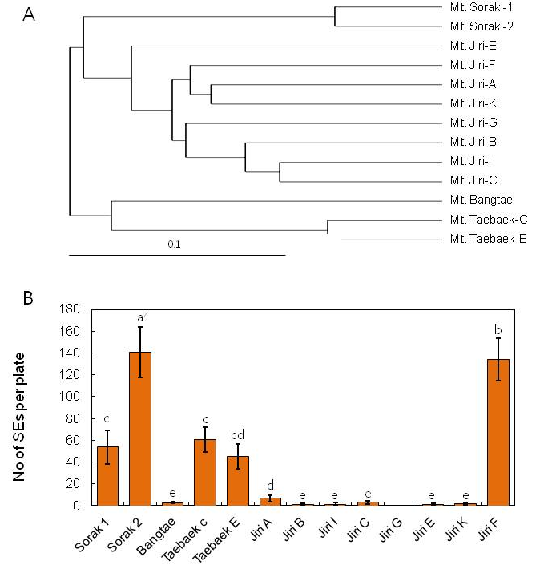
Fig. 1. Genetic distances by UPGMA Cluster analysis (A) and genotype effect on somatic embryo (SE) induction (B) in O. elatus.

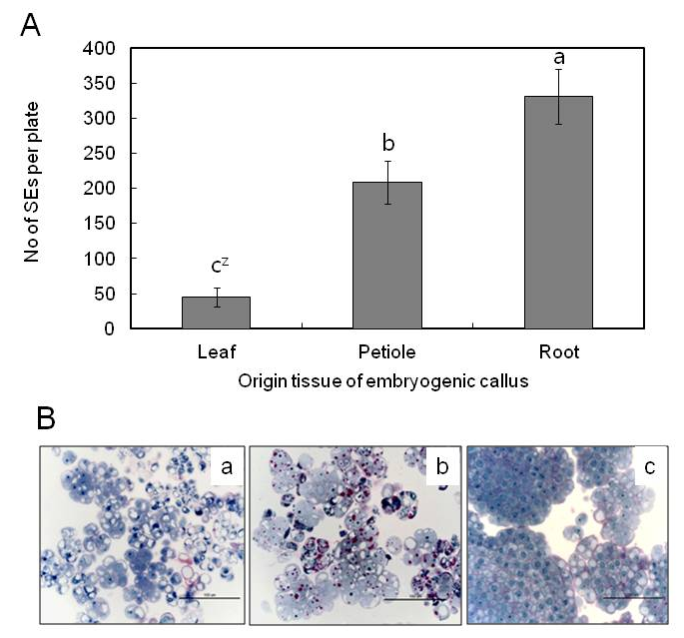
Fig. 2. Effect of origin explants on SEs induction from embryogenic calluses (ECs). A. Number of SEs induced from different explant-derived ECs, B. Histological differences of different explant-derived ECs, a. leaf-derived EC, b. petiole-derived EC, c. root-derived EC.

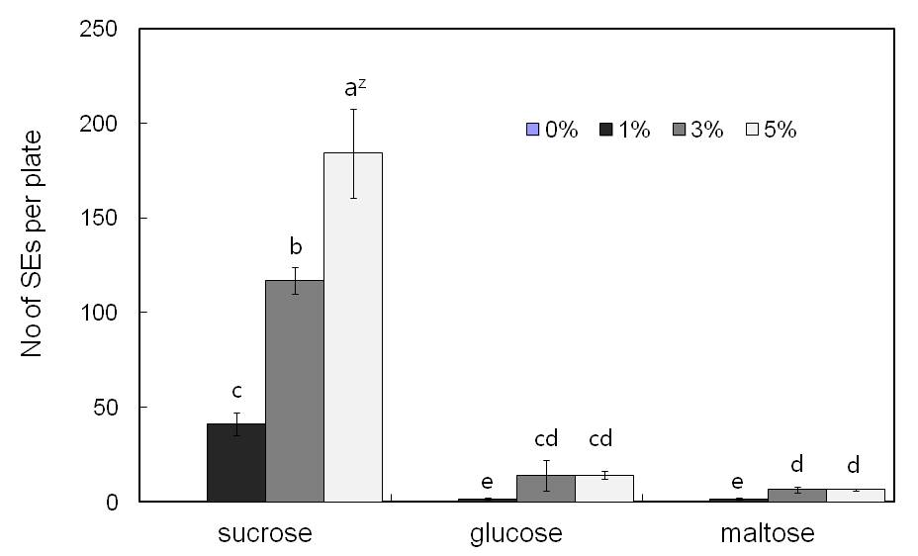
Fig. 3. Effect of carbon sources and concentrations on SE induction in O. elatus.

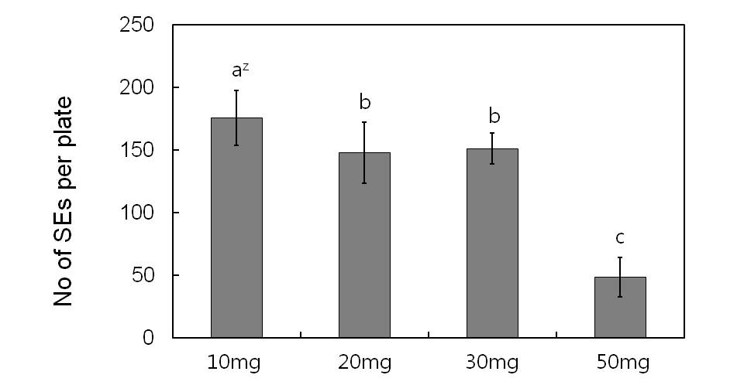
Fig. 4. Effect of cell density on somatic embryo induction from embryogenic callus in O.
elatus.

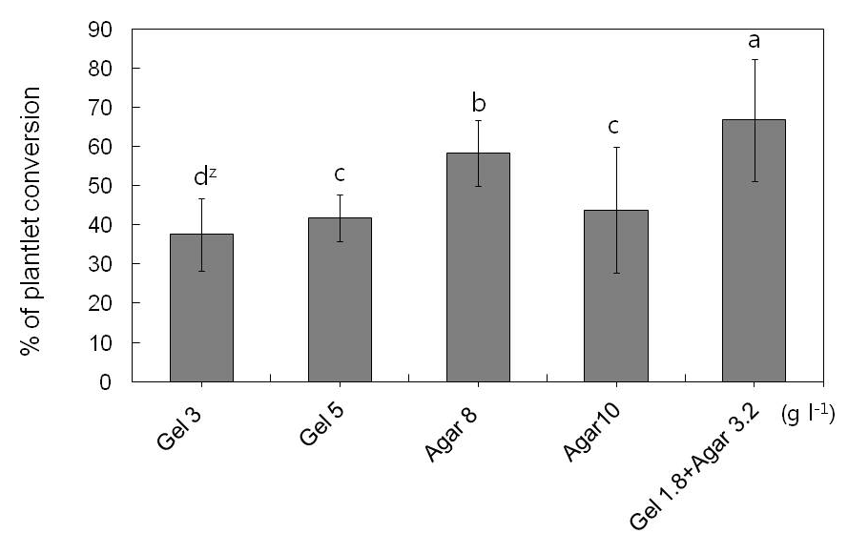
Fig. 5. Effect of gelling agents on SE conversion into plantlets in O. elatus.

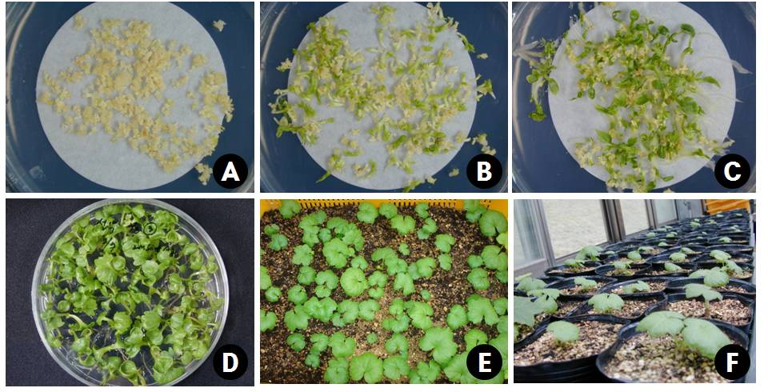
Fig. 6. Plantlets regeneration of O. elatus via somatic embryogenesis. A. Various stages of somatic embryos (SEs) induced on EC induction medium, B and C. SE maturation and germination on half strength MS medium with 5% sucrose and 0.8% agar, D. Converted plantlets on half strength MS medium, E and F. Acclimatized plantlets in an artificial soil mixture for 5 weeks (E) and 2 months (F) in greenhouse.

