EFFECT OF CULTURE MEDIA, AUXIN AND CYTOKININ ON IN VITRO PROPAGATION OF ROBINIA PSEUDOACASIA L. USING EMBRYONIC AXES

Behzad Kaviani^{1*}, Naser Negahdar², Davood Hashemabadi¹, Ali Mohammadi Torkashvand¹ and Mohammad Reza Safarimotlagh¹

¹Department of Horticultural Science, Rasht Branch, Islamic Azad University, Rasht, Iran
E-mail: b.kaviani@yahoo.com, Tel: 00989111777482
²Master Science, Department of Horticultural Science, Rasht Branch, Islamic Azad University, Rasht, Iran

Abstract
Clonal multiplication of Robinia pseudoacasia L. was obtained using embryonic axes as explants. Factors affecting shoot and root production of Robinia pseudoacasia L. were investigated by comparing various growth regulators [ɑ-naphthaleneacetic acid (NAA) and 6-benzylaminopurine (BA)] and culture media [Murashige and Skoog (MS) and WPM (woody plant medium)]. Both of BA and NAA were used at concentrations of 0, 0.5, 1 and 1.5 mg l⁻¹. The optimum plant growth regulator (PGR) combination for maximal plant height (6.51 cm), shoot number (4.86), node number (8.00), root number (12.33), root length (6.30 cm), leaf number (7.40), fresh (4.86 g) and dry weight (2.23 g) was 1 mg l⁻¹ NAA and 1 mg l⁻¹ BA in MS medium. Minimum of all traits was obtained in plantlets grown on media without plant growth regulators (control). About 90% of the micropropagated plantlets were established successfully in acclimatization medium. Regenerated plantlets were morphologically identical with mother plants.

Keywords: Fabaceae, tissue culture, black locust, plant multiplication, embryonic axes.

INTRODUCTION

Black locust (Robinia pseudoacasia L.) belongs to the Fabaceae family is a papilionaceous tree and valuable due to its ornamental and commercial values. Robinia pseudoacasia L. is an important landscape plant for fall, winter and spring gardens and parks. Robinia genus has about 10 species, native to the south-eastern USA (Zhang et al. 2007), of which Robinia pseudoacasia is the only economic tree and the most widely planted in the worldwide (Kanwar et al. 2009). This species has hard wood, and is able to good growth on poor and nitrogen-deficient soils and is proper for afforestation (Boine et al. 2008). The wood of black locust is valued for durability high fuel value (Zhang et al. 2007). Robinia pseudoacasia L. is being cultivated to control erosion and establishment of energy (Zhang et al. 2007). This species is able to fix molecular (atmospheric) nitrogen and rich the soil fertility (Zhang et al. 2007, Boine et al. 2008).
The conventional plant propagation by cutting, grafting and root sucker is too slow to meet the needs of large-scale plantations (Zhang et al. 2007). Also, Robinia pseudoacasia L. has external dormancy and its seed coat is relatively impermeable to the water (Cox and Klett 1984). Micropropagation, as an alternative to the conventional methods for vegetative propagation attracts much attention, because of its advantages (Chang et al. 2000). Some protocols for micropropagation of Robinia pseudoacasia L. was presented (Kanwar et al. 2007, 2008). It is well known that several factors such as plant growth regulators, plant and explants type, culture media type and environmental conditions can affect in vitro micropropagation (Jain and Ochatt 2010). Most important of these parameters are the plant growth regulators content in the culture media (Gomes and Canhoto 2003). Some studies showed the positive effect of BAP and BA as the source of cytokinins in Robinia pseudoacasia L. culture medium (Zhang et al. 2007, Kanwar et al. 2007). Also, several studies revealed the role of NAA, IBA and 2,4-D as the source of auxins in tissue culture of Robinia pseudoacasia L. (Zhang et al. 2007, Kanwar et al. 2009). Micropropagation from embryonic axes, seeds and apical and axillary buds is a simpler and reliable technique compared to other, because it allows greater genetic stability, less somaclonal variation and also avoids using high concentrations of cytokinins for the development of axillary buds (Jain and Ochatt 2010). Thus, the objectives of the present study were to determine the efficiency of NAA and BA, and culture media (MS and WPM) on improvement of in vitro micropropagation of Robinia pseudoacasia L.

MATERIALS AND METHODS

Seed explants were collected from 15-year-old Robinia pseudoacasia L. plants grown in a greenhouse at the suburb of Amol city, Mazandaran province, Iran. Following removing of the coats, seeds were disinfested in 20% (v/v) sodium hypochlorite with 0.1% Tween 20 for 15 min. A spreader-sticker surfactant, e.g. Tween 20 (1 to 2 drops/100 ml), is normally used due to enhance the tissue penetration capability of the chlorine based solutions and to improve the contact of the latter with the tissues. After sterilization, the seeds are washed three to five times with distilled autoclaved water. The embryonic axes (0.5-1 cm long) were excised from the cotyledons, and as explants were cultured on induction medium.
To determine the effect of culture medium type, the explants were cultured on MS (Murashige and Skoog 1962) and WPM (Lloyd and McCown 1980, 1981) media supplemented with 30 g l⁻¹ sucrose and 0.8% powder agar. To compare the effect of plant growth regulators and their concentrations, the explants were cultured on MS and WPM media containing BA and NAA, both with concentrations of 0, 0.5, 1 and 1.5 mg l⁻¹. The medium pH was adjusted to 5.7 before autoclaving at 121°C, 1.2 kg cm⁻² for 15 min. The cultures were maintained at 20±2°C under a 12/12 h (light/dark) photoperiod with light provided by cool-white fluorescent tube with an intensity of 80 µmol m⁻²s⁻¹.
In vitro characters including plant height, shoot number, node number, root number, root length, leaf number, fresh and dry weight were calculated after 30 days. For determination of plants fresh weight, the plants were weighted by a digital balance. Following obtaining of fresh weight, plants were dried in Oven at 103°C for 24 h, and their dry weight was obtained by a digital balance.
A complete randomized block (CRD) design was used for the experiments and was repeated three times. Five explants were inoculated per glass vessel (containing 25 ml of culture medium), and each treatment involved seven vessels. After 30 days from the start of the experiments, the data were recorded and analyzed. Analysis of variance (ANOVA) was done using SPSS and MSTAT-C statistical software and means were compared using LSD test at 0.05 level of probability.

RESULTS

We studied the effect of different concentrations of BA and NAA, also type of culture media (MS and WPM) on improvement of micropropagation of black locust (Robinia pseudoacasia L.), an ornamental plant. Studied characteristics were plant height, shoot number, node number, leaf number, root length, root number, fresh weight and dry weight. Our data revealed that there are differences in the effect of the different concentrations of BA, NAA and interaction between these two growth regulators on these characters (Tables 1 and 2). Embryonic axes were excised from the seeds and transferred on MS and WPM media containing BA (0-1.5 mg 1⁻¹) and NAA (0-1.5 mg 1⁻¹). Subsequently within the next 4 weeks, differences were observed.
MS medium induced higher plant height (3.47 cm) than that of WPM medium (2.72 cm). The medium supplemented with 1 mg l⁻¹ BA and 1 mg l⁻¹ NAA resulted in the highest plant height (6.51 cm) (Table 1). MS medium containing 1 mg 1⁻¹ BA with 5.87 cm plant height was a proper medium. This result was comparatively better than plant height (0.93 cm) of the control (Table 1). The lowest plant height (0.93 and 1.16 cm) was obtained from plantlets grown in medium without any plant growth regulators (Table 1). Comparison between different concentrations of BA and NAA showed that 1 mg l⁻¹ BA with 5.03 cm and 1 mg l⁻¹ NAA with 3.59 cm had maximum and minimum effects on plant height, respectively (Table 1). Data analysis showed that the effect of different concentrations of BA, NAA, culture media, and reciprocal effects of culture media and BA, culture media and NAA, and BA and NAA were significant on plant height (p≤0.01) (Table 2).
Data analysis showed that the effect of different concentrations of BA, NAA, culture media, and reciprocal effects of culture media and BA, culture media and NAA, and BA and NAA were significant on shoot number (p≤0.01) (Table 2). Explants cultured on MS medium produced longer shoot number (2.33 shoots per plant) than that of WPM medium (1.99 shoots per plant). Mean comparison of the effect of different concentrations of BA and NAA also MS and WPM media showed that the MS medium supplemented with 1 mg l⁻¹ BA and 1 mg l⁻¹ NAA with 4.86 shoots per plant, and WPM medium containing 1 mg l⁻¹ BA and 0.5 mg l⁻¹ NAA with 4.33 shoots per plant were obviously better than the control with 0.60 shoots per plant (Table 1). MS medium containing 1 mg 1⁻¹ BA with 3.88 shoots per plant, also 1 mg l⁻¹ BA and 0.5 mg l⁻¹ NAA with 3.73 shoots per plant were suitable medium. This result was comparatively better than shoot number per plant (0.76 and 0.80) of the control (Table 1).
Our data revealed that there are differences in the effect of the different concentrations of BA, NAA and MS and WPM Media on node number of black locust. MS medium supplemented with 1 mg l⁻¹ BA and 1 mg l⁻¹ NAA resulted in the largest number of node per plant (8.00) (Table 1). This obtained node number was apparently better than node number of the control (1.67 node per plant) (Table 1). MS medium containing 1 mg 1⁻¹ BA with 7.30 nodes per plant was proper medium. Explants cultured on MS medium produced larger number of nodes per plant (4.90) than that of WPM medium (3.80 nodes per plant). Data analysis showed that the effect of different concentrations of BA, NAA, culture media, and reciprocal effects of culture media and BA, culture media and NAA, and BA and NAA were significant on node number at 1% probably level (Table 2).
MS medium induced larger leaf number per plant (4.20) than that of WPM medium (3.40 per plant). The medium supplemented with 1 mg l⁻¹ BA and 1 mg l⁻¹ NAA resulted in the maximum leaf number (7.40) (Table 1). MS medium containing 1 mg 1⁻¹ BA with 6.60 leaves per plant was a proper medium. This result was comparatively better than leaf number per plant (2.80 and 2.20) in the control plant (Table 1). Data analysis showed that the effect of different concentrations of BA, culture media, and reciprocal effects of culture media and BA, culture media and NAA, and BA and NAA were significant on leaf number at 1% of probability level. But, the effect of different concentrations of NAA was significant on leaf number at 5% of probability level (Table 2).
Root length in MS medium was better than that of WPM medium. Root length was greatest (6.30 cm per plant) in medium containing 1 mg l⁻¹ BA and 1 mg l⁻¹ NAA (Table 1). This amount is much better than that of the control (1.83 cm per plant). Root response in MS medium containing 1 mg l⁻¹ BA (5.66 cm per plant) was good (Table 1). Root length in MS medium containing 1 mg l⁻¹ NAA (4.48 cm per plant) was relatively proper. Statistical analysis showed that the effect of culture medium and reciprocal effect of culture medium and NAA were significant at 5%. Also, the effect of BA, NAA, reciprocal effect of culture medium and BA and reciprocal effect BA and NAA were significant at 1% (Table 1).
Root number in MS medium was better than that of WPM medium. The best treatment for root development in term of number of roots was exposure of explants to 1 mg l⁻¹ BA and 1 mg l⁻¹ NAA (12.33 roots per plant) (Table 1). Also, high numbers of roots were obtained in MS medium containing 1 mg l⁻¹ BA (10.25 roots per plant) and 1 mg l⁻¹ BA and 0.5 mg l⁻¹ NAA (9.66 roots per plant) (Table 1). Least number of roots (3.66) was obtained in control plants. Statistical analysis showed that the effect of different concentrations of BA, NAA, culture media, and reciprocal effects of culture media and BA, culture media and NAA, and BA and NAA were significant on shoot number (p≤0.01) (Table 2).
The data presented in Table 2 indicated that, the effect of different concentrations of BA, NAA, culture media, and reciprocal effects of culture media and BA, culture media and NAA, and BA and NAA were significant on fresh and dry weight (p≤0.01). MS medium induced more fresh and dry weight (2.33 and 1.83 g per plant, relatively) than WPM medium (1.99 and 0.92 g per plant, relatively). Both, the most fresh and dry weight (4.86 and 2.23 g) were achieved in MS medium incorporated with 1 mg l⁻¹ BA and 1 mg l⁻¹ NAA (Table 1). These amounts were apparently greater than those of control with 0.60 and 0.30 g for fresh and dry weight, relatively (Table 1).

DISCUSSION

Attention has been devoted to Robinia pseudoacasia L. as a suitable species for landscape. The first step in such studies was to rapidly produce true-to-type and safe plants within a short span of time. Current study successfully established a high frequency, mass propagation system for Robinia pseudoacasia L. In this work, we observed significant differences between various treatments including MS and WPM media, cultivation beds, different concentrations of BA, NAA and extract of Ascophyllum nodosum. The most adequate and effective culture medium for in vitro cultivation of woody plants depends on the explant type, cultivar and cultivation stage (Pasqual and Ferreira 2007). For in vitro cultivation of Robinia pseudoacasia L., the MS and the WPM media are being used. The MS culture medium is widely used for plant tissue culture. Its high salt concentrations are responsible for significant gains in tissue and cell growth. The WPM is the second most used medium for in vitro cultivation (Lloyd and McCown 1981). It was developed for culturing shoots of woody plants and has found widespread use in the propagation of bushes and trees (Pasqual and Ferrera 2007). In the present experiments, explants cultured on two media and displayed significant differences in all measured characters. Explants cultured on MS medium had more plant height, shoot number, node number, leaf number, root length, root number, fresh weight and dry weight than those of cultured on WPM medium. Nitrogen and potassium content of the MS medium was approximately two- to four folds higher than that of the WPM medium (Lu 2005). Probably Robinia pseudoacasia L. needs more nitrogen and potassium for successful micropropagation and acclimatization process. Another explanation for the results is the difference in microelement compositions among MS and WPM media, which might cause differences in micropropagation rate and other traits. Similar to current study, findings of Rathore et al. (2004) on several woody plants showed that the MS medium is a suitable medium for micropropagation. Contrary to our findings, some studies showed superiority of WPM than MS in several species such as Citrus, Vitis, Ulmus and Ficus (Kobayashi et al. 2003, Fráguas et al. 2004, Lu 2005, Pasqual and Ferrera 2007, Thankur and Karnosky 2007). The results of Pasqual and Ferreira (2007) study on micropropagation of Ficus carica L. (a woody tree) indicated a high number of shoots and excellent growth of roots and aerial parts for the WPM medium supplemented with 1 mg l⁻¹ BA and 1 mg l⁻¹ NAA. However, Hepaksoy and Aksoy (2006) showed that rooting is successful on MS medium amended with 1.2 and 2.5 μM NAA. Borthakur et al. (1999), Cheong and Pooler (2003) and many other researchers (Prakash et al. 2006, Phulwaria et al. 2011) recommended MS medium for micropropagation of Alpinia, Cercis and Albizia (three woody plants) and many other woody plants.
High levels of spontaneous shooting and rooting were observed in MS medium containing 1 mg l⁻¹ BA and 1 mg l⁻¹ NAA. This medium induced the highest plant height, shoot number, node number, leaf number, root length, root number, fresh weight and dry weigh. Most studies found BA to be the most effective cytokinin for inducing shoot development in many species (Lu 2005, Jain and Ochatt 2010, Ahmadi Hesar et al. 2011, Kaviani et al. 2011, Ghaffari Esizad et al. 2012). Probably, the endogenous cytokinin and auxin level was relatively low in Robinia pseudoacasia L. However, this subject requires further examination. Brum (2001) and Fráguas et al. (2004) for example revealed that for root induction and growth of some Ficus carica L. cultivars, the addition of auxins to the culture medium is not necessary. Some researchers reported that NAA provided a suitable auxin for in vitro rooting (Lu 2005, Jain and Ochatt 2010, Kaviani et al. 2011). Heloir et al. (1997) reported that IBA provided a suitable auxin for in vitro rooting of Vitis vinifera (a woody plant) than NAA. NAA does not yield more roots, but produces callus formation (Heloir et al. 1997). Lu (2005) showed numerous roots induced in the presence of 0.5 mg l⁻¹ NAA in Vitis. In another study on Pyrus syrica (a woody plant), successful shoot proliferation was obtained on MS medium supplemented with 1.5-2.0 mg l⁻¹ BA (Shibli et al. 1997). The use of BA and NAA (especially, both at 1 mg l⁻¹) was recommended for successful micropropagation by some workers for woody plants (Kumar et al. 1998, Gunver et al. 1998, Brum 2001, Thakur and Karnosky 2007, Ďurkovič 2008).

Table 1. Mean comparison for the effect of different culture media, different concentrations of BA and NAA on the shoot number, fresh weight, dry weight, leaf number, node number, plant height, root number and root length of Robinia pseudoacasia L.
Treatments |  |  |  | Characters
 | Shoot number | Dry weight (g) | Fresh weight (g) | Leaf number | Node number | Plant height (cm) | Root number | Root length (cm)
WPM (M₁) | 1.99b | 0.92b | 1.99b | 3.40b | 3.80b | 2.72b | 5.54b | 3.58b
MS (M₂) | 2.33a | 1.18a | 2.33a | 4.20a | 4.90a | 3.47a | 6.31a | 3.79a
Control (B₁) | 0.98d | 0.40d | 0.98d | 2.30d | 2.30d | 1.23d | 3.66c | 2.32d
0.5 mg l⁻¹ BA (B₂) | 1.63c | 0.92c | 1.63c | 3.20c | 4.00c | 2.70c | 9.08b | 3.42c
1 mg l⁻¹ BA (B₃) | 3.53a | 1.73a | 3.53a | 5.70a | 6.30a | 5.03a | 5.62a | 5.17a
1.5 mg l⁻¹ BA (B₄) | 2.50b | 1.16b | 2.50b | 4.00b | 4.60b | 3.42b | 5.33b | 3.83b
Control (N₁) | 2.03a | 0.91c | 2.03b | 3.60b | 3.80c | 2.64c | 5.08c | 3.17c
0.5 mg l⁻¹ NAA (N₂) | 2.20a | 1.01b | 2.20ab | 3.60b | 4.10c | 2.99b | 5.91b | 3.61b
1 mg l⁻¹ NAA (N₃) | 2.13a | 1.22a | 2.13ab | 4.30a | 4.90a | 3.59a | 7.04a | 4.17a
1.5 mg l⁻¹ NAA (N₄) | 2.28a | 1.08b | 2.28a | 3.80b | 4.50b | 3.15b | 5.66b | 3.80b
M₁ × B₁ | 0.76h | 0.38h | 0.76h | 2.30g | 1.80h | 1.16h | 3.83g | 2.45g
M₁ × B₂ | 1.55f | 0.90f | 1.55f | 3.10f | 3.80f | 2.60f | 5.41e | 3.39f
M₁ × M₃ | 3.18b | 1.43b | 3.18b | 4.70b | 5.30b | 4.20b | 7.91b | 4.68b
M₁ × B₄ | 2.48d | 0.98d | 2.48d | 3.50d | 4.10e | 2.92d | 5.00f | 3.83d
M₂ × B₁ | 1.20g | 0.43g | 1.20g | 2.20h | 2.70g | 1.31g | 3.50h | 2.20h
M₂ × B₂ | 1.71e | 0.94e | 1.71e | 3.40e | 4.30d | 2.80e | 5.83c | 3.46e
M₂ × B₃ | 3.88a | 2.02a | 3.88a | 6.60a | 7.30a | 5.87a | 10.25a | 5.66a
M₂ × B₄ | 2.53c | 1.35c | 2.53ab | 4.50c | 5.20c | 3.92c | 5.66d | 3.84c
M₁ × N₁ | 1.83g | 0.75h | 1.83g | 3.30 | 3.20h | 2.21h | 4.83h | 3.14h
M₁ × N₂ | 2.28c | 0.82g | 2.28c | 2.90 | 3.40g | 2.43g | 5.16g | 3.47f
M₁ × N₃ | 1.71h | 1.07d | 1.71h | 3.80 | 4.30e | 3.17d | 6.25c | 3.86c
M₁ × N₄ | 2.15e | 1.05f | 2.15e | 3.60 | 4.20f | 3.05f | 5.91d | 3.87b
M₂ × N₁ | 2.23d | 1.06e | 2.23d | 3.90 | 4.50d | 3.08e | 5.33f | 3.21g
M₂ × N₂ | 2.13f | 1.20b | 2.13f | 4.30 | 4.80b | 3.56b | 6.66b | 3.75d
M₂ × N₃ | 2.55a | 1.36a | 2.55a | 4.80 | 5.40a | 4.02a | 7.83a | 4.48a
M₂ × N₄ | 2.41b | 1.11c | 2.41b | 3.90 | 4.80c | 3.24c | 5.41e | 3.73e
B₁ × N₁ | 0.80n | 0.30p | 0.80n | 2.80l | 1.67p | 0.93p | 3.33m | 1.83o
B₁ × N₂ | 0.93m | 0.39o | 0.93m | 1.80p | 2.10o | 1.14o | 3.33m | 2.01n
B₁ × N₃ | 1.10l | 0.40n | 1.10l | 2.20o | 2.50n | 1.29n | 4.16k | 2.73l
B₁ × N₄ | 1.10l | 0.54m | 1.10l | 2.38n | 2.90m | 1.58m | 3.83l | 2.73l
B₂ × N₁ | 1.43k | 0.71l | 1.43k | 2.80m | 3.60l | 2.03l | 4.66j | 2.63m
B₂ × N₂ | 1.63j | 0.87k | 1.63j | 3.10k | 3.80k | 2.61k | 5.66f | 3.51k
B₂ × N₃ | 1.43k | 1.05j | 1.43k | 3.40j | 4.20j | 3.06j | 6.00e | 3.70b
B₂ × N₄ | 2.03b | 1.05b | 2.03b | 3.70b | 4.60g | 3.09b | 6.16d | 3.86g
B₃ × N₁ | 3.30d | 1.51c | 3.30d | 5.10c | 5.70c | 4.40c | 7.16c | 4.48d
B₃ × N₂ | 3.73b | 1.67b | 3.73b | 5.50b | 6.10b | 4.93b | 9.66b | 5.28b
B₃ × N₃ | 3.76a | 2.23a | 3.77a | 7.40a | 8.00a | 6.51a | 12.33a | 6.30a
B₃ × N₄ | 3.33c | 1.48d | 3.33c | 4.80d | 5.60d | 4.29d | 7.16c | 4.63c
B₄ × N₁ | 2.60f | 1.10h | 2.60f | 3.70h | 4.40b | 3.22h | 5.16h | 3.76h
B₄ × N₂ | 2.53g | 1.13g | 2.53g | 3.90g | 4.40h | 3.31g | 5.00b | 3.63j
B₄ × N₃ | 2.23h | 1.18f | 2.23h | 4.10f | 4.80f | 3.52f | 5.66f | 3.96f
B₄ × N₄ | 2.66e | 1.24e | 2.66e | 4.30e | 5.00e | 3.63e | 5.50g | 3.98e
M₁ × B₁ × N₁ | 0.60y | 0.22 | 0.60y | 3.60 | 1.10 | 0.74 | 3.33 | 1.73
M₁ × B₁ × N₂ | 0.73x | 0.35 | 0.73x | 1.60 | 1.60 | 1.08 | 3.66 | 2.36
M₁ × B₁ × N₃ | 0.80w | 0.40 | 0.80w | 1.90 | 2.00 | 1.18 | 4.00 | 2.60
M₁ × B₁ × N₄ | 0.93v | 0.55 | 0.93v | 2.20 | 2.50 | 1.62 | 4.33 | 3.10
M₁ × B₂ × N₁ | 1.26s | 0.65 | 1.26s | 2.40 | 3.40 | 1.82 | 4.66 | 2.76
M₁ × B₂ × N₂ | 1.40r | 0.78 | 1.40r | 2.70 | 3.20 | 2.29 | 5.33 | 3.50
M₁ × B₂ × N₃ | 1.26s | 1.02 | 1.26s | 3.20 | 4.00 | 2.96 | 5.33 | 3.60
M₁ × B₂ × N₄ | 2.26m | 1.14 | 2.26m | 3.90 | 4.73 | 3.32 | 6.33 | 3.70
M₁ × B₃ × N₁ | 3.06f | 1.14 | 3.06f | 3.80 | 4.20 | 3.38 | 6.33 | 4.06
M₁ × B₃ × N₂ | 4.33b | 1.27 | 4.33b | 4.20 | 4.90 | 3.74 | 7.33 | 4.50
M₁ × B₃ × N₃ | 2.66b | 1.96 | 2.66b | 6.60 | 7.20 | 5.71 | 11.00 | 5.53
M₁ × B₃ × N₄ | 2.66b | 1.36 | 2.66b | 4.40 | 5.00 | 3.96 | 7.00 | 4.63
M₁ × B₄ × N₁ | 2.40b | 0.97 | 2.40k | 3.40 | 4.00 | 2.90 | 5.00 | 4.00
M₁ × B₄ × N₂ | 2.66k | 0.89 | 2.66b | 3.10 | 3.80 | 2.62 | 4.33 | 3.53
M₁ × B₄ × N₃ | 2.13b | 0.93 | 2.13n | 3.40 | 4.20 | 2.85 | 4.66 | 3.73
M₁ × B₄ × N₄ | 2.73n | 1.14 | 2.73h | 4.00 | 4.60 | 3.30 | 6.00 | 4.06
M₂ × B₁ × N₁ | 1.00h | 0.37 | 1.00u | 2.00 | 2.20 | 1.11 | 3.33 | 1.93
M₂ × B₁ × N₂ | 1.13u | 0.38 | 1.13m | 2.00 | 2.60 | 1.19 | 3.00 | 1.66
M₂ × B₁ × N₃ | 1.40m | 0.41 | 1.40r | 2.40 | 2.90 | 1.39 | 4.33 | 2.86
M₂ × B₁ × N₄ | 1.26r | 0.53 | 1.26s | 2.50 | 3.20 | 1.54 | 3.33 | 2.36
M₂ × B₂ × N₁ | 1.60s | 0.76 | 1.60q | 3.10 | 3.90 | 2.25 | 4.66 | 2.50
M₂ × B₂ × N₂ | 1.86q | 0.95 | 1.86o | 3.50 | 4.30 | 2.92 | 6.00 | 3.53
M₂ × B₂ × N₃ | 1.60o | 1.07 | 1.60q | 3.50 | 4.40 | 3.16 | 6.66 | 3.80
M₂ × B₂ × N₄ | 1.80q | 0.96 | 1.80p | 3.50 | 4.40 | 2.86 | 6.00 | 4.03
M₂ × B₃ × N₁ | 3.53p | 1.89 | 3.53d | 6.40 | 7.20 | 5.42 | 8.00 | 4.90
M₂ × B₃ × N₂ | 3.13d | 2.07 | 3.13e | 6.80 | 7.40 | 6.12 | 12.00 | 6.06
M₂ × B₃ × N₃ | 4.86a | 2.52 | 4.86a | 8.30 | 8.80 | 7.32 | 13.66 | 7.06
M₂ × B₃ × N₄ | 4.00a | 1.60 | 4.00c | 5.13 | 6.10 | 4.61 | 7.33 | 4.63
M₂ × B₄ × N₁ | 2.80c | 1.22 | 2.80g | 4.10 | 4.70 | 3.55 | 5.33 | 3.53
M₂ × B₄ × N₂ | 2.40g | 1.38 | 2.40k | 4.70 | 5.00 | 3.99 | 5.66 | 3.73
M₂ × B₄ × N₃ | 2.33k | 1.43 | 2.33l | 4.80 | 5.50 | 4.20 | 6.66 | 4.20
M₂ × B₄ × N₄ | 2.60l | 1.35 | 2.60j | 4.50 | 5.40 | 3.96 | 5.00 | 3.90
In each column, means with the similar letters are not significantly different at 5% level of probability using LSD test

Table 2. Analysis of variance (ANOVA) for the effect of different culture media, different concentrations of BA and NAA on the shoot number, fresh weight, dry weight, leaf number, node number, plant height, root number and root length of Robinia pseudoacasia L.
Source of variations | df |  |  |  | MS
 |  | Shoot No. | Fresh weight | Dry weight | Leaf No. | Node No. | Plant height | Root No. | Root length
Culture beds (M) | 1 | 2.733** | 1.614** | 2.733** | 1.500** | 29.040** | 13.800** | 14.260** | 10.200*
BA (B) | 3 | 29.353** | 7.241** | 29.353** | 15.296** | 68.230** | 59.907** | 124.121** | 33.174**
NAA (N) | 3 | 0.272^{ns} | 0.410** | 0.273^{ns} | 50.320* | 4.973** | 3.722** | 16.177** | 4.121**
M × B | 3 | 0.504** | 0.417** | 0.504** | 2.536** | 2.534** | 3.140** | 7.593** | 1.721**
M × N | 3 | 0.984** | 0.108** | 0.984** | 4.564^{ns} | 0.830* | 0.944** | 5.760** | 0.622*
B × N | 9 | 0.310** | 0.193** | 0.310** | 1.439** | 1.982** | 1.580** | 8.195** | 1.100**
M × B × N | 9 | 0.868** | 0.021^{ns} | 0.868** | 2.777^{ns} | 0.296^{ns} | 0.180^{ns} | 1.056^{ns} | 0.332^{ns}
Error | 62 | 0.106 | 0.014 | 0.106 | 0.652 | 0.268 | 0.113 | 0.620 | 0.224
CV (%) | - | 15.074 | 11.456 | 15.074 | 21.045 | 11.880 | 10.877 | 13.291 | 12.828
**: Significant at α = 1%, *: Significant at α = 5%, ^{ns}=Not significant

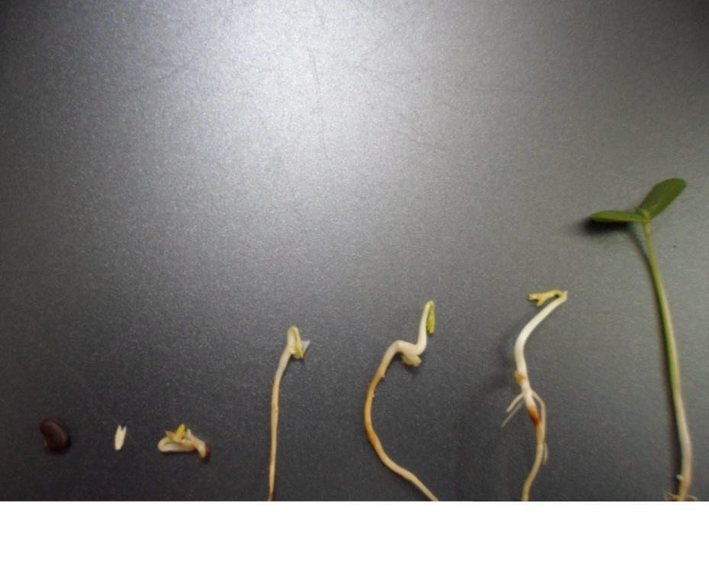
Fig. 1. The process of seed germination in Robinia pseudoacasia L. Embryonic axes were used as explants.

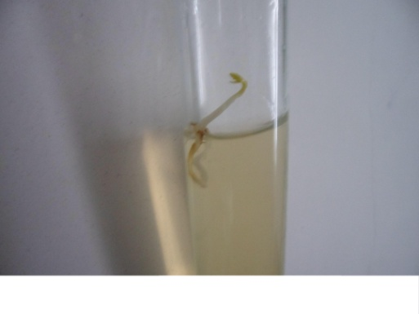 | 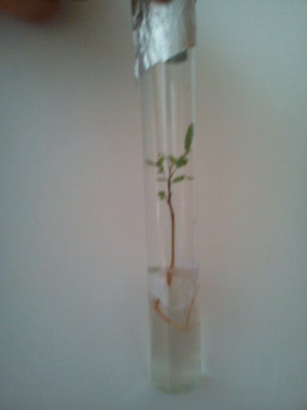 | 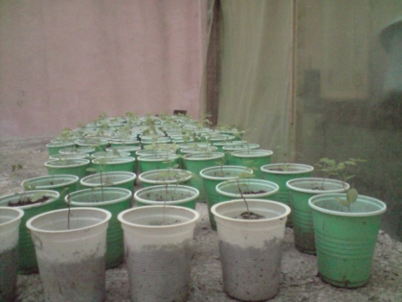
Fig 2. The process of micropropagation in Robinia pseudoacasia L. Embryonic axes were cultured as explants on MS medium (Left). Plantlets formed on MS medium containing 1 mg l⁻¹ BA and 1 mg l⁻¹ NAA (Medium). Hardening of plantlets in a greenhouse (Right).

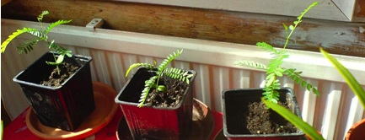
Fig 3. Acclimated Plantlets were transformed into the pots containing normal soil of Robinia pseudoacasia L. grown on it.

REFERENCES
AHMADI HESAR A., KAVIANI B., TARANG A.R., BOHLOOLI ZANJANI S. (2011). Effect of different concentrations of kinetin on regeneration of ten weeks (Matthiola incana). Plant Omics Journal, 4: 236-238.
BOINE B., NAUJOKS G., STAUBER T. (2008). Investigations on influencing plant-associated bacteria in tissue culture of black locust (Robinia pseudoacacia L.). Plant Cell, Tissue and Organ Culture, 94: 219-223.
BORTHAKUR M., HAZARIKA J., SINGH R.S. (1999). A protocol for micropropagation of Alpinia galangal. Plant Cell, Tissue and Organ Culture, 55: 231-233.
BRUM G.R. (2001). Micropropagação da figueira (Ficus carica L.) ‘Roxo de Valinhos’ Dissertação (Mestrado em Fitotecnia)-Universidade Federal de Lavras, Lavras, MG, 41.
CHEONG E., POOLER M.R. (2003). Micropropagation of Chinese redbud (Cercis yunnanensis) through axillary bud breaking and induction of adventitious shoots from leaf pieces. In Vitro Cellular and Dev.-Biology Plant, 39: 455-458.
CHANG C., CHEN C.T., TSAI Y.C., CHANG W.C. (2000). A tissue culture protocol for propagation of a rare plant, Lilium speciosum Thunb. var. gloriosoides Baker. Botany Bulletin of Academic Science, 41: 139-142.
COX R.A., KLETT J.E. (1984). Seed germination requirements of native Colorado plants for use in the landscape. Plant Propagation, 30: 6-10.
ĎURKOVIČ J. (2008). Micropropagation of mature Cornus mas ‘Macrocarpa’. Trees, 22: 597-602.
FRÁGUAS C.B., PASQUAL M., DUTRA L.F., CAZZETA O. (2004). Micropropagation of fig (Ficus carica L.) ‘Roxo de Valinhos’ plants. In Vitro Cellular and Dev.-Biology Plant, 40: 471-474.
GHAFFARI ESIZAD S., KAVIANI B., TARANG A.R., BOHLOOLI ZANJANI S. (2012). Micropropagation of lisianthus (Eustoma grandiflorum), an ornamental plant. Plant Omics Journal, 5: 314-319.
GOMES F., CANHOTO J.M. (2003). Micropropagation of Eucalyptus nitens Maiden (Shining gum). In Vitro Cellular and Dev.-Biology Plant, 39: 316-321.
GUNVER G., ERTAN E., AKSOY U., FERGUSON L., HEPAKSOY S. (1998). A study on the propagation of figs by the tissue culture techniques. Acta Horticulture, 480: 169-172.
HELOIR M.C., FOURNIOUX J.C., OZIOL L., BESSIS R. (1997). An improved procedure for the propagation in vitro of grapevine (Vitis vinifera cv. Pinot noir) using axillary bud microcuttings. Plant Cell, Tissue and Organ Culture, 49: 223-225.
HEPAKSOY S., AKSOY U. (2006). Propagation of Ficus carica L. clones by in vitro culture. Biologia Plantarum, 50: 433-436.
JAIN S.M., OCHATT S.J. (2010). Protocols for in vitro propagation of ornamental plants, Springer Protocols, Humana Press.
KANWAR K., BHARDWAJ A., DEEPIKA R. (2009). Efficient regeneration of plantlets from callus and mesophyll derived protoplasts of Robinia pseudoacacia L. Plant Cell, Tissue and Organ Culture, 96: 95-103.
KANWAR K., BHARADWAJ A., DEEPIKA R., SHARMA D.R. (2007). Robinia pseudoacasia Linn. Tree Forestry Science and Biotechnology, 1: 74-80.
KANWAR K., KAUSHAL B., ABROL S., DEEPIKA R. (2008). In vitro regeneration from cell suspension culture in Robinia pseudoacasia L. Biology Plant, 52: 187-190.
KAVIANI B., AHMADI HESAR A., KHARABIAN MASOULEH A. (2011). In vitro propagation of Matthiola incana (Brassicaceae)-an ornamental plant. Plant Omics Journal, 4: 435-440.
KOBAYASHI A.K., BESPALHOK J.C., PIREIRA L.F.P., VIEIRA L.G.E. (2003). Plant regeneration of sweet range (Citrus sinensis) from thin sections of mature stem segments. Plant Cell, Tissue and Organ Culture, 74: 99-102.
KUMAR V., RADHA A., GOH C.J. (1998). In vitro plant regeneration of fig (Ficus carica L. cv. Gular) using apical buds from mature trees. Plant Cell Report, 17: 717-720.
LIOYD G.B., MCCOWN B.H. (1980). Commercially feasible micropropagation of mountain laurel (Kalmia latifolia) by use of shoot tip culture. Proceeding of International of Plant Propagators Society, 30: 421-437.
LIOYD G.B., MCCOWN B.H. (1981) Use of microculture for production and improvement of Rhododendron spp. HortScience, 15: 416-417.
LU M. (2005). Micropropagation of Vitis thunbergii Sieb. et Zucc., a medicinal herb, through high-frequency shoot tip culture. Scientia Horticulture, 107: 64-69.
MURASHIGE T., SKOOG F. (1962). A revised medium for rapid growth and bioassays with tobacco tissue culture. Physiology Plant, 15: 473-479.
PASQUAL M., FERREIRA E.A. (2007). Micropropagation of fig tree (Ficus carica L.), In: Jain S.M. Häggman H. (eds.), Protocols for Micropropagation of Woody Trees and Fruits. 409-416.
PHULWARIA M., KHETA R., GAHLOT P., SHEKHAWAT N.S. (2011). Micropropagation of Salvadora persica-a tree of arid horticulture and forestry, New Forests.
PRAKASH E., SHA VALLI KHAN P.S., VIVEK T.J., RAO S., MERU E.S. (2006). Micropropagation of red sanders (Pterocarpus santalinus L.) using mature nodal explants. Journal of Forestry Research, 11: 329-335.
RATHORE J.S., VINOD RATHORE N.S., SHEKHAWAT R.P., SINGH LILER G., PHULWARIA M., DAGLA H.R. (2004). Micropropagation of Woody Plants, Plant Biotechnology and Molecular Markers, Anamaya Publishers, New Delhi, India.
SHIBLI R.A., AJLOUNI M.M., JARADAT A., ALJANABI S., SHATNAWI M. (1997). Micropropagation in wild pear (Pyrus syrica). Scientia Horticulture, 68: 237-242.
THAKUR R.C., KARNOSKY D.F. (2007). Micropropagation and germplasm conservation of Central Park Splendor Chinese elm (Ulmus parvifolia Jacq. ‘A/Ross Central Park’) trees. Plant Cell Report, 26: 1171-1177.
ZHANG J., LIU Y., WANG H. (2007). Micropropagation of black locust (Robinia pseudoacacia L.), Book Chapter, 193-199.

