Depulping of fruits and soaking the seeds enhances the germination and seedling growth attributes of Terminalia belerica Roxb in nursery condition

Md. Aktar Hossain^{1,2*}, Mohammad Salah Uddin², Nor Aini Ab Shukor^{1,3}

¹ Faculty of Forestry, Universiti Putra Malaysia, 43400 UPM, Serdang, Selangor D.E., Malaysia
² Institute of Forestry and Environmental Sciences, Chittagong University, Chittagong -4331, Bangladesh
³ Institute of Tropical Forestry and Forest Products, Universiti Putra Malaysia, 43400 UPM, Serdang, Selangor D.E., Malaysia
*Corresponding Author’s Email: aktar _forestry@hotmail.com

Abstract

The study describes the effects of depulping the fruits and soaking the seeds of Terminalia belerica Roxb on seed germination and seedling growth attributes in nursery condition. Around half of the freshly collected fruits of T. belerica were depulped by rotting the fleshy pulp in water and dried following storage in airtight container. The effects of depulping and soaking period were explored by soaking the dry intact fruits or depulped seeds in cold water for 0, 24, 48 and 72 h and sowed in polybags filled with soil and cow dung at a ratio of 3:1. The study reveals that depulping the fruits and soaking the seeds significantly enhanced the seed germination and seedling growth performance in nursery condition. The fastest seed germination was observed in depulped seeds soaked in cold water for 72 h (DT3) and slowest germination was in intact fruits without treatment (IT0). The highest germination percentage (93) was observed in depulped seeds soaked in cold water for 48 h (DT2) followed by 85.6% in depulped seeds soaked in water for 24 h (DT1), which was significantly higher than the other treatments including the control (36.7). Although growth parameters such as shoot length, root length, total height, leaf number, leaf area and collar diameter of the seedlings were maximum in the seedlings developed through DT3, the vigor index was maximum in DT2 and minimum in IT0. Total dry mass per seedling was also maximum in the seedlings developed from the treatment DT3. Considering the imbibition period, germination percentage, growth performance including vigor index and total biomass produced per seedling, depulping the fruits and soaking the dry seeds in cold water for 48 h may be recommended for obtaining maximum germination and seedling growth performance.

Additional Keywords: Terminalia belerica, medicinal plants, pre-sowing treatment, depulping, germination capacity, growth performance

Running Title: Effects of depulping and soaking of seed on germination and seedling growth
Introduction
Medicinal plants are playing enormous roles in treating various diseases throughout the world since time immemorial. Plant based drugs are now being increasingly used in traditional medicines because of their efficacy, cheap and lower side effects. World health organization (WHO) has estimated 80% of the total populations in developing countries rely on traditional medicines, mostly plant derived for their primary health care. Rests of the people are also dependent substantially on plant based medicines or on chemicals derived from plants (Sharma and Govind, 2009). They utilize these plant resources for their existence by developing their own knowledge passing it from one generation to others. People are reverting back to herbal preparations since the data provided on herbal products, exhibit high level of satisfactions (Kaur and Jaggi, 2010). Medicinal plants are now being used by Unani and Ayurvedic practitioners as well as household remedies by the common people. Plants with medicinal properties are also being used as raw materials for the downstream processing operations in the pharmaceutical industries (FAO, 1995).

Terminalia belerica (Bohera) is an important medicinal tree species under Combretaceae family used for various purposes in the Indian sub continent. Fruit of the species is one of the three ingredients of ‘Triphala’, which is a popular Ayurvedic formulation extensively used traditionally to recover from fever, cough, diarrhea, skin diseases, oral thrush (Elizabeth, 2005), hypertension, to reduce cardiac depression and the risk factors associated with the heart (Chaudhary et al., 2012), remove toxins and other undesirable accumulations from the body, improve digestion and assimilation and acts as antioxidant. The fruits of T. belerica contain very high level of total phenolic compounds (TPC) (164.5 mg g⁻¹) (Bajpai et al., 2005) including Glucoside (bellericanin) (Singh, 2006), Gallo-tannic acid, resins, oil (Nadkarni, 2002), Ellargic acid, gallic acid, lignans7-hydroxy 3’4’ flavone and anolignan B (Annon, 2001), tannins, ethyl gallate, , phenyllemblin, β-sitosterol, mannitol, glucose, fructose and rhamnose (Annon, 2001; Saroya, 2011). Off these, Glucoside, Tannins, Gallicacid, Ellagicacid, Ethylgalate, Gallylglucose are mainly believed to be responsible for its wide spectrum therapeutic actions. Therefore, the fruits are being used as an antioxidant, antimicrobial (Alam, 2011), antidiarrheal, anticancer, antidiabetic, antihypertensive and hepatoprotective agent (Mottamari et al., 2012)

Fruits of T. bellerica are reported to have antibiotic activities against a wide variety of microorganisms and extensively used in Ayurveda (an ancient form of Indian medicine), to treat piles, dropsy, diarrhea, fever, cough, skin diseases and oral thrush (Mukherji 1953; Elizabeth 2005; Kumar et al., 2010a). The starndard extract of fruit enhances the angiotensin converting enzyme (ACE) inhibitory activitites (Chaudhary et al., 2012). Kernel of fruit is edible but contains narcotic properties. The oil extracted from the seeds is useful as a hair tonic. T. bellerica extract/fractions is suitable for functional food for pharmaceutical purpose can be used against hypertension and other related diseases (Chaudhary et al., 2012). Seventy percent extract of T. belerica increased resistance to necrotizing agents, providing a direct protective effect on the gastric mucosa and exhibited antiulcer effect (Jawanjal et al, 2012). The aqueous and ethanolic extracts of T. belerica have been reported to possess antidiabetic and antioxidant (Latha et al., 2010; Sabu and Kuttan, 2009), anthelmintic (Kumar et al., 2010b), anticancer (Kumudhavalli et al., 2010) and antimicrobial (Elizabeth, 2005; Alam, 2011) activities. T. bellirica can be used for economic upliftment of the local inhabitants as fruits of the tree are sold at high premium in the market for preparing Triphala churan.

However, due to overexploitation (because of its multipurpose uses), tremendous population pressure, rural poverty, absence of appropriate government policy, accelerated growth of synthetic drugs and inappropriate utilization of forest products, these vital plat resources are being declined rapidly. Besides these, natural regeneration through seeds is very poor, uncertain (Luna, 2005) and required long time to germinate which ifluences forest department not including the species in the afforestation and/or reforestation programs. This delay and irregularity in germination of seeds is believed to be due to the hard seed coat and thick fleshy pericarp of the fruits of the species (Shivanna et al. 2007). The pericarp of the fruit contains very high level of phenolic compound (Bajpai et al., 2005) which is also reported to inhibit seed germination in many plant species. For examples, Yukiko et al. (2001) repoted 60-100 % inhibition of shirakamba birch, Betula platyphylla Sukatchev var. japonica Hara seed germination in nine phenolic compounds; salicylic acid , p-hydroxybenzaldehyde , p-hydroxybenzoic acid , vanillic acid, p-coumaric acid , 3,4,5-trimethoxybenzoic acid, chlorogenic acid, 3,4-dimethoxybenzoic acid and ferulic acid. Li et al. (1993) postulated that phenolic compounds along with ABA had additive inhibitory effects, both on seedling growth and seed germination. Therefore removing the thick pericarp of the fruit having high level of phenolic compounds may be one of the ettective pre-sowing treatment of the species for enhanced germination of seeds.
There are some studies which examined the germination potentials of T. chebula and T. belerica through different pre-sowing treatments like depulping the fruits, shoaking the seeds in hot or cold water for hours, scarifications, H₂SO₄ treatment etc. For example, Ara et al. (1997) and Hossain et al. (2005 a,b) found a positive correlation between T. chebula and T. belerica seed germination and depulping of dry fruits by knife and soaking the seeds in cold water for various time periods. However, depulping the dry fruits of the species by knife is very difficult and laborious tasks. Depulping of the T. belerica fruits by rotting fleshy pulp in water would be one of the important options for depulping the dry fruits with knife or other mechanical scarifications but the technique and its subsequent effect on seed germination have not been sufficiently investigated. Therefore, the present study has been designed to explore the enhanced seed germination as well as seedling growth performance of T. belerica under different easily applicable pre-sowing treatments avoiding the laborious process of depulping the dry fruits of the species.

Materials and Methods
Study area
The study was conducted in the nursery of Institute of Forestry and Environmental Sciences, Chittagong University, Bangladesh located at the intersection of the 22°30′ N latitude and 91°50′ E longitude. The area enjoys typically tropical climate, characterized by hot humid summer and cool dry winter (BBS 2010). Mean monthly temperature varied between 28.3°C to 31.9°C maximum and between 15.2° C to25.2° C minimum. Relative humidity is generally maximum (86%) in July to September and minimum (72%) in February. Mean annual rainfall of the area is about 3000 mm (Banglapedia 2012) which mostly taken place between June and September. Mean monthly day lengths variation is from 10h 35 min in December to 13h 20 min in June.

Seed collection and pre-sowing treatments
Ripe fruits of T. belerica were collected in January from the pre-selected plus trees of the Seed Orchard Division of Bangladesh Forest Research Institute (BFRI) situated in Chittagong. Uniform fruits were sorted out and used for the treatments to avoid the non-treatment variations since germination percentage and seedling vigor was reported to be influenced by the seed size (Indira et al. 1999; Gunaga et al. 2007; Gunaga et al. 2011). Half of the freshly collected fruits were placed in water for a week which allowed the fleshy pulp rotting. Seeds were extracted from the rotten pulp and dried in sun followed by storing in airtight container until treatments were applied. Rest of the fruits were also dried in sun directly without depulping and stored in airtight container (Figure 1).

The intact fruits or depulped seeds were soaked in cold water for four different periods of time, 0, 24, 48 and 72 h. Therefore the presowing treatments applied to the T. belerica seeds were intact fruits without any pre-sowing treatment considered as control (IT0), intact fruits soaked in cold water for 24 h (IT1), 48 h (IT2), and 72 h (IT3), depulped seeds without any other treatments (DT0), depulped seeds soaked in cold water for 24 h (DT1), 48 h (DT2) and 72 h (DT3).

Growing media and experimental design
The treated fruits or seeds were sown in the polybags (12.5cm × 15.25cm in size) filled with soil collected from the forest area of Chittagong University and decomposed cow-dung at a ratio of 3:1. The soil was moderately coarse to fine textured sandy loams with p^{H} 4.5. Before filling with the prepared soil mixture, few holes were made in the polybag by punching to facilitate aeration and proper drainage. Randomized complete block design was adopted for the study with three replications (50 seeds per replication) for each treatment. Thus each treatment consisted of 150 seeds and a total of 1200 seeds were subjected to 8 different pre-sowing treatments.

Seed sowing and aftercare
Only one seed was sown in each polybag filled with growing media directly. Seeds were dibbed to 0.5 cm beneath the soil surface by pressing them with thumb and covered with thin layer of soil. After sowing the seeds, protective measures were adopted against the hot sun, intensive rains, birds, rodents and pests. Insecticides (BHC) and fungicides (Diathene M-45) were applied in the soil to protect the seeds and young seedlings from ants, termites and fungal attack respectively. Proper care was taken since the sowing of seeds till the harvesting of seedlings for assessment. Watering and weeding were done regularly to obtain maximum growth of seedlings. Loosening of topsoil was also done whenever necessary to prevent the growth of green mold on the soil surface.
Data recording and statistical analysis
The effects of pre-sowing treatments were explored periodically through counting germinated seeds and assessing initial growth performance of seedlings. Cumulative germination was recorded in every third day from the day of sowing and continued till ending of the germination (72 days after sowing the seeds). Mean daily germination was determined by dividing the cumulative number of seeds germinated with respective number of days. Germination phase like imbibition period was determined by counting the number of days required for the commencement of germination from the day of sowing and germination period was the number of days required for completion of germination from sowing the seeds.
For the growth performance study, all seedlings were measured for total length, number of leaf and collar diameter. Ten seedlings from each replication treatment (30 from each treatment) were randomly uprooted and measured for total length (root length, shoot length), number of leaf, leaf area and collar diameter. The seedlings were then separated into root, shoot and leaf components and dried in electric oven at 70° C for 48 h. Dry weight of root, shoot and leaves were also recorded to assess the growth performance of the seedlings. Seedling vigor index (VI) was also calculated according to Abdul-Baki and Anderson (1973) as the germination percent multiplied by total length of seedling (i.e. sum of shoot and root length).

All of the recorded data related to seed germination and seedling growth performance were analyzed statistically by using computer software IBM SPSS ver.21.0. The analysis of variance (ANOVA) and Duncan’s multiple range test (DMRT) was performed to explore the possible treatment variations.

Results and Discussion
Seed Germination
Germination period: Seeds of T. belerica started to germinate 25 days after sowing and continued up to 72 days. Different pre-sowing treatments significantly (p≤0.05) affected the germination period for the species. The fastest germination (least imbibition period; 25 days) was observed in DT3 (depulped seeds, soaked in cold water for 72 h) followed by DT0 and delayed (highest imbibitions period) was observed in IT0 (intact fruits without any treatment) (Table 1). However, the fastest completion of seed germination (54.7 days) was noticed in DT0 followed by DT1 and slowest completion (72 days) was in IT0. Germination of depulped seeds was much faster than the intact fruits through out the treatments (Figure 4). Seed germination period in the present study was supported by Hossain et al. (2005 a,b), who mentioned that the seed germination started 29 days after sowing the T. chebula seeds and continued up to 86 days when the fruits were depulped and soaked in cold water for 48 h while the seed of T. belerica started to germinate 31 days after sowing and continued up to 79 days. Conversely, Ara et al. (1997) mentioned that the germination of T. belerica seeds was started from 20-25 days after sowing and continued up to 55-60 days when depulped and soaked in cold water for 48h. In a recent report Hossain et al. (2013) mentioned that the T. chebula seeds started to germinate 23 days after sowing and continue until 84 days for completion.
Seed germination pattern: Mean daily germination percent varied in different days in different treatments for T. belerica seeds. Depulping of fruits and soaking of seeds remarkably affected the mean germination among the treatments. The highest mean daily germination percentage was observed at 55 days after sowing in DT2 (1.64) followed by DT1 (1.56) after 51 days, DT0 (1.32) after 58 days, DT3 (1.26) after 58 days. Among the intact fruits, IT3 produced the highest mean daily germination percentage (0.69) after 72 days, followed by IT1 (0.71) after 66 days, IT0 (0.59) after 62 days and IT2 (0.57) after 58 days (Figure 2). Seed germination started 25 days after sowing and continued up to 72 days. After 72 days of sowing no germination was observed (Figure 3). The cumulative germination percent in treatment DT1 and DT2 mounted sharply from 31 days and 34 days after sowing (respectively) to 49 and 58 days after sowing respectively and remained constant till ending the germination test (72 days). In most of the cases, the cumulative germination percentage of depulped seeds was observed to move up warded after starting the germination. However the progress of the cumulative germination in the intact fruit was comparatively slow and gradual. The daily germination percentage and cumulative germination percentage was significantly higher in depulped seeds than that of the intact fruits throughout the treatments.

Germination percentage: Germination percentage varied from 36.7 to 93 in T. belerica seeds among the treatments. The highest germination percentage (93) was obtained from the treatment DT2 (depulped fruits, soaked in cold water for 48 h) followed by DT1 (85.6), which were significantly higher than the other treatments including control (36.7) (Figure 5 and figure 6). Germination percentage was higher in depulped seeds than the intact fruits in all soaking period (Figure 5). The result of the present study were in the line of the findings of many other authors who mentioned that depulping of fruits and soaking in cold water enhanced the seed germination of T. belerica (Hossain et al. 2005b; Ara et al. 1997; Rashid et al. 1990;), T. chebula (Nainar et al. 1999; Hossain et al. 2005a; 2013) and Grevillea robusta (Anon 2000; Murugesh 2011). Germination percentage of the species in the present study was comparatively better than the findings of other authors. For example, the maximum germination percentage (88.9.) was observed by Hossain et al. (2005b) in depulped fruit soaked in cold water for 48 h for T. belerica. Ara et al. (1997) reported 70-75 % germination in T. belerica seeds after soaking in cold water for 48 h and depulping the fruits thereafter. Rashid et al. (1990) reported up to 70 % germination from whole fruits of T. chebula treated by soaking in water for 48 h with successive treatment by 10 % sulfuric acid for 20 min. Nainar et al. (1999) had shown that seed pre-treatments including mechanical scarification offered the highest germination percentage (60) in T. chebula seeds.

Growth performance
Seedling growth morphology including the length of shoot, root and total length, number of leaf per seedling was significantly (p≤0.05) affected by the pre-sowing treatments of the seeds (Table 2). The utmost shoot length, root length and the total length of the seedling was obtained from DT3 (38.2 cm, 56.9cm and 95.1 cm respectively) followed by DT2 (34.6 cm, 54.0 cm and 88.6 cm respectively) and DT1 and lowest (21.7 cm, 32.0 cm and 55.4 cm respectively) was in IT0 four months after sowing the seeds in the polybags. The results of the present study were in the line of those reported by Hossain et al. (2005a; 2013) and mentioned that the seedling growth including root, shoot and total length of T. chebula was highly influenced by the pre-sowing treatment specially depulping the fruits and soaking the seeds in water. They observed maximum
shoot length of seedlings (38.67 cm) when fruits were depulped and soaked in cold water for 48 h. Since the root length and shoot length of the seedlings in the present study was significantly higher in DT3, total length of the seedlings was also considerably higher in DT3 (95.1cm) than the other treatments and lowest was in IT0. The average length of T. belerica seedling in the present study was comparatively higher than that of (Table 2 and figure 7) other researchers.

Average number of leaf of seedlings was also found maximum in the treatment DT3 (21.33 leaves after four months of sowing the seeds) followed by DT2 and lowest (15.8) in IT1 (Table 2). However, Hossain et al. (2005b) differed in this regard and mentioned that average number of leaf per seedling of T. belerica was not affected significantly due to the treatment but the leaf number of T. chebula seedlings was considerably higher (53.66) when depulped and soaked in cold water for 48 h (Hossain et al. 2005 a). However there was no significant difference in leaf area produced per seedling developed under various treatments (Table 2) although average leaf area of seedlings was found maximum in DT3 (619.9 sq.cm) and lowest in IT2 (312.9 sq.cm). The mean collar diameter of T. belerica seedlings varied from 3.8 to 4.9 among the treatments. Although the collar diameter of seedlings was not found to vary significantly due to different treatments, maximum diameter was recorded in DT3 and minimum in IT0 (Table 2).

Vigor index: The vigor index of the seedlings was dramatically varied from 2029 to 7586 among the pre-sowing treatments. The vigor index for the species was highest (7586) in DT2 (Depulped seeds soaked in cold water for 48 h) and lowest (2029) was in IT0 (Table 2). Hossain et al. (2005 a,b) also reported similar result for the T. chebula and T. belerica that the highest vigor index (5291) was in depulped seeds treated with cold water for 48h. Again, in a separate study Hossain et al. (2013) reported the maximum vigor index for T. chebula (4105 four months after sowing the seeds) in depulped seeds soaking with water for 48h.

Biomass production: The dry mass of seedlings including the leaf, root, shoot and total dry weight in different treatments was significantly (p≤0.05) influenced by depulping and soaking period. The highest leaf dry weight of T. belerica seedling (3.20 g per seedling) was recorded in DT3 and the lowest (2.16 g) was in IT1 treatment (Table 3). However, the result of the present study differed with those reported by Hossain et al. (2005b) who mentioned that the leaf dry weight of T. belerica seedlings was not significantly varied due to the treatments but leaf dry mass of T. chebula seedlings was remarkably enhanced by the pre-sowing treatment and found maximum (2.26 g) in depulped fruits soaked in cold water for 48 h. Shoot dry weight of seedlings was also significantly higher in depulped seeds than those from the other treatments. Maximum shoot dry weight (2.91g) was observed in seedlings developed from treatment DT3 and lowest (0.77g) in IT0 (Table 3). Similar result was reported by Hossain et al. (2005 a,b) in case of the shoot dry weight of T. chebula and mentioned that significantly higher shoot dry weight (1.53 g) was observed in depulped fruits soaked in cold water for 48 h. Average root dry weight of T. belerica seedlings ranged from 0.76g to 1.36g among the treatments. The highest root dry weight of T. belerica seedlings (1.32g) was noticed in DT2 treatment, which was remarkably higher than those of other treatments (Table 3). However, Hossain et al. (2005b) reported no significant effect of pre-sowing treatments on root dry weight of T. belerica seedlings in their study.
Total dry weight per seedlings of T. belerica, was found to vary from 7.43 g to 3.81g among the treatments. The total dry weight per seedling was significantly enhanced by the depulping the fruits of the species in the present study. The maximum dry matter of the seedling (7.43 g) was recorded from the treatment DT3 followed by DT0 and the minimum was in IT1 (Table 3). However, Hossain et al. (2005a, b) mentioned that total bio-mass per seedling of T. belerica was not significantly (p≤0.05) varied due to the pre-sowing treatment but highly influenced the T. chebula seedlings. They recorded maximum dry mass of T. belerica and T. chebula seedling (8.38 g and 4.61g respectively) in depulped seeds soaked in cold water for 48 h.

Generally the seeds with hard seed coat or thick pericarp are reported to enhance germination with pre-sowing treatments (Alamgir and Hossain 2005a,b; Hossain et al. 2005 a,b; Agboola et al. 2004; Shivanna et al. 2007; Ajiboye et al. 2009, Azad et al. 2010, 2011, Anand et al. 2012). However, untreated seeds germinate slowly and irregularly (Jackson, 1994). As expected the presowing treatment specially depupling the fruits and soaking the seeds significantly enhanced the germination performance of T. belerica in the present study. Depulping the fruits increased the germination speed, germination percentage and seedling growth which were considerably higher than the intact fruits or control treatments. Jackson (1994) explained that seed soaking in water for 48 h improved germination capacity of the seeds. Luna (2005) reported that fermentation of seed for three weeks by removing fruits’ pulp and placing the seeds in between layers of straw in a tray having perforations at the bottom gives about 60% germination of T. chebula seed. Again, clipping the seeds at its broad end in such a way that the embryo was not damaged, and such seeds were soaked in cold water for about 36 h and sown in nursery beds under shade, provide about 80% germination. The results of the present study were also consistent with the findings of other authors. For instance, Rashid et al. (1990) showed that, whole fruits of T. chebula, and T. belerica pre-treated by soaking in water for 48 h with successive treatment by 10% sulfuric acid for 20 min produced up to 70 % germination. Shivanna et al. (2007) reported 51-60% germination of T. belerica seeds when the mesocarp was depleting. A germination success of up to 50% was obtained when clean seeds (removing the dry pulp) were sown at BFRI (Ara et al. 1997). The result of the present study was also supported by the findings of Hossain et al. (2005 a,b) and mentioned that depupled seeds soaked in the cold water for 48 h gave the maximum germination and seedling growth for both the species T. belerica and T. chebula. Usually depulping the fruits allows seed coat for water penetration which makes the seed soft and suitable for germination.

Conclusion
Due to the hard seed coat with thick pericarp having high content of phenolic compounds T. belerica seeds germinate irregularly taking longer time for nursery establishment. Pre-sowing treatments are therefore essential to soften and break down the seed coat and fleshy pericarp for making the conditions for the embryo coming out. In the present study, among the treatments applied for T. belerica depulped seeds soaking in cold water for 48 h were found more effective in respect to maximum germination. Although, initial growth performance and maximum dry mass was observed in the treatment DT3 due to the faster germination and plants growth (Table-1), the vigor index was found highest in the treatment DT2 which was consistent with the maximum seed germination of the species in the treatment. Therefore, depulping and soaking in cold water for 48 h may be one of the efficient pre-sowing treatments for T. belerica for obtaining maximum seed germination and seedling growth performance in the nursery for large scale plantation programs.

Reference

Abdul-Baki A., Anderson J.D. (1973). Vigor determination in Soybean seed by multiple criteria. Crop Sci., 13: 630-633.
Agboola D.A., Ebofin A.O., Aduradola A.M., Ajiboye A.A. (2004). Effect of presowing treatments on seed germination of two savanna tree legumes. J. Trop For., 20 (I & II): 17‐24

Ajiboye AA., Atayese M.O., Agboola D.A. (2009). Effect of Presowing Treatments on Seed Germination and Percentage Starch Content Levels in Tamarindus indica, Prosopis africana, Parkia biglobossa and Albizia lebbeck. J. Appl. Sci. Res., 5(10):1515-1519

Alam B. (2011). Antioxidant,Antimicrobial and Toxicity studies of the Different Fractions of Fruits of Terminalia belerica Roxb. Global Journal of Pharmacology. 5(1):07-17.
Alamgir M., Hossain M.K. (2005a). Effect of pre-sowing treatments on Albizia procera (Roxb.) Benth seeds and initials development of seedlings in the nursery. J. Forest. Environ., 3:53-60
Alamgir M., Hossain M.K. (2005b). Effect of pre-sowing treatments on germination and initials seedling development of Albizia saman in the nursery. J. For. Res., 16(3):200-204

Anand B., Devagiri G.M., Gurav M., Vasudev H.S., Khaple A.K. (2012). Effects of Pre-sowing Seed Treatments on Germination and Seedling Growth Performance of Melia dubia CAV: An Important Multipurpose Tree. Int. J. Life Sci., 1(3): 59-63
Anonymous (2000). Grevillea robusta seed leaflet No. 14, September, prepared by Danida Forest Seed Centre.

Anonymous (2001). The Ayurvedic Pharmacopoiea of India,1stedition,Published by The controller of Publications,Civil Lines, New Delhi. Part-1,01: 252.

Ara R., Mohiuddin M., Alam M.J., Rashid M.H. (1990). Flowering and Fruiting Period of Medicinal Plants of Bangladesh. Bulletin 3, Minor Forest Products Series, Bangladesh Forest Research Institute, Chittagong. (in Bangla) 10 pp.
Ara R., Merry S. R., Siddiqi N.A. (1997). Cultivation and Uses of Twelve Medicinal Plants of Bangladesh. Bulletin 7, Minor Forest Products Series, Bangladesh Forest Research Institute, Chittagong. 27-31 pp
Azad M.S., Zedan-al-Musa M., Matin M.A. (2010). Effects of pre-sowing treatments on seed germination of Melia azedarach. J. For. Res., 21(2):193-196
Azad M.S., Manik M.R. Hasan M.S., Matin M.A. (2011). Effect of different pre-sowing treatments on seed germination percentage and growth performance of Acacia auriculiformis. J. For. Res., 22(2):183-188
Bajpai M., Pande A., Tewari S. K., Prakash D. (2005). Phenolic contents and antioxidant activity of some food and medicinal plants. International Journal of Food Sciences and Nutrition, 56(4): 287-291
Bangladesh Bureau of Statistics (BBS) (2010). Statistical yearbook of Bangladesh, Statistics Division, Ministry of Planning, Government of the People’s Republic of Bangladesh. p. xxii.

Banglapedia 2012. http://www.banglapedia.org. Accessed 10 January 2012.

Chaudhary S.K., Mukherjee P.K., Nema N.K., Bhadra S., Saha B.P. (2012). ACE inhibiton activity of standardized extract and fractions of Terminalia bellerica. Orient Pharm Exp Med, 12:273-277
Elizabeth K.M. (2005). Antimicrobial activity of Terminalia bellerica. Indian J Clin Biochem 20(2):150-153
FAO (1995). Non wood forest products for rural income and sustainable forestry. Non Wood Forest Products 7. FAO, Rome.

Gunaga R.P., Hareesh T.S., Vasudeva R. (2007). Effect of fruit size on early seedling vigour and Biomass in White Dammer (Vateria indica): a vulnerable and economically important tree species of the Western Ghats. J. NTFPs, 14: 197-200
Gunaga R.P., Doddabasava, Vasudeva R. (2011). Influence of seed size on germination and seedling growth in Mammea suriga. Karnataka J. Agric. Sci., 24 (3):415-416

Hossain M.A., Arefin M.K., Khan B.M., Rahman M.A. (2005a). Effects of Seed Treatments on Germination and Seedling Growth Attributes of Horitaki (Terminalia chebula Retz.) in the nursery. Res. J. Agric. Biol. Sci., 1(2):135-141
Hossain M.A., Arefin M.K., Khan B.M., Rahman M.A. (2005b). Effects of Different Seed Treatments on Germination and Seedling Growth Attributes of a Medicinal Plant Bohera (Terminalia belerica Roxb.) in Nursery. Int. J. For. Usuf. Mgt., 6:28-37

Hossain M.A., Uddin M.S., Rahman M.M., Shukor, N.A.A. (2013). Enhancing seed germination and seedling growth attributes of a tropical medicinal tree species Terminalia chebula through depulping of fruits and soaking the seeds in water. Journal of Food, agriculture and Environment, 11(3&4), In press.
Indira E. P., Basha S. C. (1999). Effects of seeds from different sources on germination and growth in Teak (Tectona grandis L. f.) in the nursery. Ann. For. 7(1):39-44.
Jackson J. K. (1994). Manual of Afforestation in Nepal. Forest Research and Survey Centre Kathmandu. 2nd edition. 608-724 pp
Jawanjal H., Rajput MS., Agrawal P., and Dange V. (2012) Pharmacological Evaluation of Fruits of Terminalia belerica Roxb. for Antiulcer Activity. Journal of Complementary and Integrative Medicine, 9(1):1-12
Kaur S., Jaggi R.K. (2010). Antinociceptive activity of chronic administration of different extracts of Terminalia belerica Roxb. and Terminalia chebula Retz. fruits. Indian Journal of Experimental Biology, 48:925-930
Kumar B., Divakar K., Tiwari P., Salhan M., Goli D. (2010a). Evalution of Anti-Diarrhoeal Effect of Aqueous And Ethanolic Extracts of Fruits Pulp of Terminalia belerica In Rats. International Journal of Drug Development and Reasearch. 2(4):769-779.

Kumar B., Kalyani D., Hawal L.M., Singh S. (2010b). In vitro anthelmintic activity of ethanolic and aqueous fruit extract of Terminalia belerica. J Pharm Res, 3:1061-62.

Kumudhavalli M.V., Mohit V., Jayakar B. (2010). Phytochemical and pharmacological evaluation of the plant fruit of Terminalia belerica Roxb. Int J Pharm Life Sci, 1:1-11

Latha P.C.R., Daisy P. (2010). Influence of Terminalia belerica Roxb. Fruits Extract on Biochemical Parameters In Streptozotocin Diabetic Rats, International Journal of Pharmacology. 6:89-96
Li H.H., Inoue M., Nishimura H., Hasegawa K., Mizutani J., Tsuzuki, E. (1993). Interactions of trans-cinnamic acid, its related phenolic allelochemicals, and abscisic acid in seedling growth and seed germination of lettuce. J. Chern. Ecol., 19:1775-1787

Luna R.K. (2005). Plantation Trees. International Book Distributors, Dehra Dun. 975pp

Motamarri N.S., Karthikeyan M., Kannan M., Rajasekar S. (2012). Terminalia belerica Roxb.-A Phytopharmacological Review. International Journal of Research in Pharmaceutical and Biomedical Sciences, 3(1):96 -99
Mukherjee P.K., Rai S., Bhattacharya S., Wahile A., Saha B.P. (2008). Marker analysis of polyherbal formulation, Triphala-Awell known Indian traditional medicine. Indian J Trad Knowl 7:379-383
Murugesh M. (2011). Effect of seed pre-treatment on germination and seedling attributes of Grevillea robusta (Silver oak). My. Forest, 47(1):53-62
Nadkarni K.M. (2002). Indian Meteria Medica, Published by Ramdas Bhatkal for Popular Prakashan Pvt.Ltd.Mumbai, 01:202-1205.
Nainar P., Sundharaiya K., Ponnuswamy V. (1999). Germination studies in kadukkai (Terminalia chebula). South Indian Horticulture, 47:1-6.
Rashid, M. H., Mohiuddin, M., Ara, R. and Alam, M.J. (1990). Medicinal Plant and Its Cultivation. Bulletin 4, Minor Forest Products Series, Bangladesh Forest Research Institute, Chittagong. 17 pp. (in Bangla).
Sabu M.C., Kuttan R. (2009). Antidibetic and antioxidant activity of Terminalia belerica Roxb. Ind J Experimental Bio, 47:270-75
Saroya A.S. (2011). Herbalism phytochemistry and Ethanopharmacology. Science Publishers. 357-361
Sharma M., Govind P. (2009). Ethanomedicinal Plants for Prevention and treatment of tumors, International Journal of Green pharmacy, 3:2-5

Shivanna H., Balachandra H.C., Suresh N.L. (2007). Effect of Pre-Sowing Treatment on Germination of Terminalia bellerica (Ber). Karnataka Journal of Agricultural Sciences, 20 (2):442-443
Singh A. (2006). Medicinal Plants of the World, Published by Mohan Primlani for Oxford and IBH Co. Pvt,New Delhi. 26
Singh U., Wadhwani A.M., Johir B.M. (1965). Dictionary of Economic Plants In India. Indian Council of Agricultural Research, New Delhi. 288 pp

Yukiko I., Yasuo K., Minoru T. (2001). Effects of Phenolic Compounds on Seed Germination of Shirakamba Birch, Betula platyphylla var.japonica. Eurasian J. For. Res. 2:17-25
Tables

Table1: Effect of pre-sowing treatments on germination period of T. belerica seeds in the nursery.
Vari-ables | Treatments |  |  |  |  |  |  |  |  | Probability
Vari-ables | Intact fruits |  |  |  | Depulped seeds
 | IT0 | IT1 | IT2 | IT3 | DT0 | DT1 | DT2 |  | DT3 | Depulping | Soak ing
Germination starting  (days) | 36.0 ±  0.58a | 33.0±  1.0ab | 35.3±  1.85a | 33.0±1.1ab | 27.0± 1.0cd | 29.7±  0.8bc | 32.0±  0.5ab | 25.7±  1.7d |  | .000 | .002
Germination ending  (days) | 72.0±  0.57a | 66.0±  1.15b | 62.0±  1.15bc | 72.0±1.73a | 54.7±  1.45d | 59.3±.0.88c | 69.3± 1.20a | 66.0±  1.73b |  | .000 | .000

Note: Means followed by the same letter (s) are not significantly different at p≤0.05, according to Duncan’s Multiple Range Test (DMRT). ± indicates the standard error of mean

Table 2: Effect of pre-sowing treatment on shoots length (SL), root length (RL), total length (TL), leaf number (LN), leaf area (LA), collar diameter (CD) and vigor index (VI) of T. belerica seedlings four months after sowing the seeds.

Vari-  ables | Treatments |  |  |  |  |  |  |  |  |  | Probability
Vari-  ables | Intact fruits |  |  |  | Depulped seeds |  |  |  | Depulping |  |  | soak  ing
Vari-  ables | IT0 | IT1 | IT2 | IT3 | DT0 | DT1 | DT2 | DT3 |  |  |  | soak  ing
SL  (cm) | 21.7 ±  0.7c | 24.7 ±  1.5c | 26.6 ±  0.5bc | 28.7 ± 5.3bc | 28.1 ±  4.8bc | 34.5 ±  1.1ab | 34.6 ±  2. 6ab | 38.2 ±  0.9a |  | 0.001 |  | 0.049
RL  (cm) | 32.0 ±  6.1b | 45.6 ±  3.9ab | 36.3 ± 4.4b | 48.3 ± 7.6ab | 48.9 ±  7.2ab | 33.7 ±  3.8b | 54.0 ±  3.6a | 56.9 ±  2.9a |  | 0.007 |  | 0.083
TL  (cm) | 55.4 ±  3.4c | 70.3 ±  2.5bc | 63.0 ± 4.8c | 77.1 ±  12.6abc | 76.9 ±  10.2abc | 66.5 ±  7.1bc | 88.6 ±  6.2ab | 95.1 ±  3.7a |  | 0.008 |  | 0.053
LN | 16.3 ±  0.3b | 15.8 ±  0.4b | 15.8 ±  0.7b | 16.7 ± 2.1b | 16.3 ±  1.1b | 17.0 ±  1.0b | 18.3 ±  0.7ab | 21.3 ±  1.5a |  | 0.021 |  | 0.116
LA (cm²) | 378.1 ± 75.3a | 401.4 ± 40.5a | 312.9 ± 92.2b | 415.5 ± 72.0a | 457.7 ± 198.7a | 436.4 ±  103.2a | 455.3 ±  86.9a | 619.9 ± 220.7a |  | 0.051 |  | 0.480
CD  (mm) | 4.9 ±  0.3a | 3.8 ±  0.2a | 3.9 ±  0.3a | 3.9 ±  0.8a | 4.2 ±  3.8a | 3.9 ±  0.2a | 4.8 ±  0.4a | 5.0 ±  0.20a |  | 0.106 |  | 0.398
VI | 2029 ±  3.3c | 3278 ±  2.3b | 2520 ±  5.5c | 3856 ±  14.5b | 6156 ±  17.7ab | 6184 ±  8.1ab | 7586 ±  2.1a | 7227 ±  4.3a |  | 0.039 |  | 0.154

Note: Means followed by the same letter (s) are not significantly different at p≤0.05, according to Duncan’s Multiple Range Test (DMRT). ± indicates the standard error of the mean

Table 3: Leaf dry weight (LDW), shoot dry weight (SDW), root dry weight (RDW) and total dry weight (TDW) of T. belerica seedlings developed under various pre-sowing treatments four months after sowing the seeds.

Variables | Treatments |  |  |  |  |  |  |  | p
Variables | Intact fruits |  |  |  | Depulped seeds |  |  |  | Depulping | soak  ing
Variables | IT0 | IT1 | IT2 | IT3 | DT0 | DT1 | DT2 | DT3 | Depulping | soak  ing
LDW (g) | 2.57 ±  0.311ab | 2.16 ±  0.32b | 2.17 ±  0.32b | 2.54 ± 0.34ab | 3.19 ± 0.35a | 2.67 ± 0.32ab | 3.05±0.33a | 3.20±0.45a | 0.010 | 0.481
SDW (g) | 0.77 ±  0.10b | 0.79 ±  0.10b | 0.74 ±  0.11b | 0.84 ± 0.12b | 1.55 ± 0.29b | 1.10 ± 0.12b | 1.16±0.15b | 2.91±0.58a | 0.000 | 0.003
RDW (g) | 1.02 ±  0.19abc | 0.85 ±  0.11bc | 1.06 ±  0.13abc | 1.11 ±  0.1abc | 1.19 ± 0.13ab | 0.76 ±  0.09c | 1.36± 0.11a | 1.32± 0.13a | 0.108 | 0.009
TDW (g) | 4.36 ±  0.55bc | 3.81 ±  0.44c | 3.97 ±  0.47c | 4.51 ± 0.52bc | 5.93 ± 1.12b | 4.52 ± 0.49bc | 5.57± 0.51b | 7.43±0.53a | 0.000 | 0.059

Note: Means followed by the same letter (s) are not significantly different at p≤0.05, according to Duncan’s Multiple Range Test (DMRT). ± indicates the standard error of mean

Figures

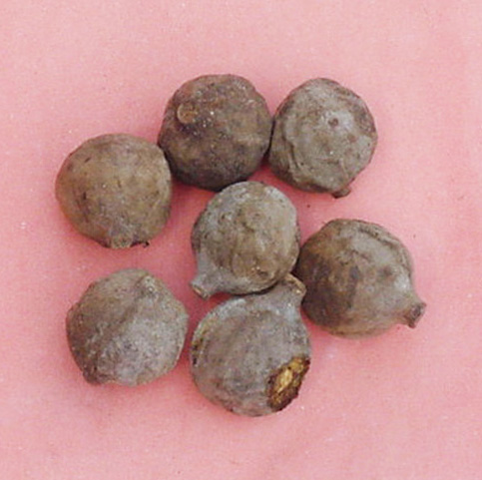 | 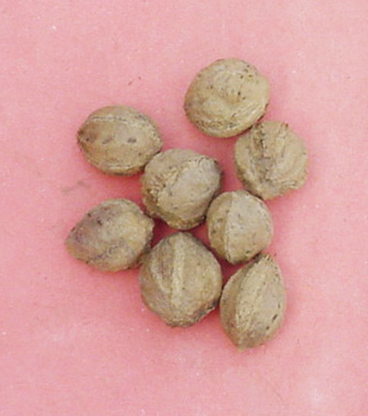

Figure 1: Intact fruits and depulped seeds T. belerica after drying.

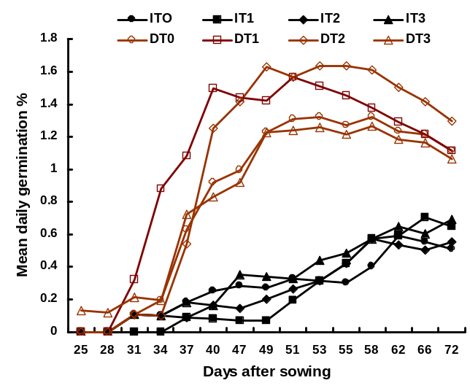
Figure 2: Mean daily germination percentage of T. belerica seeds under various presowing treatments.

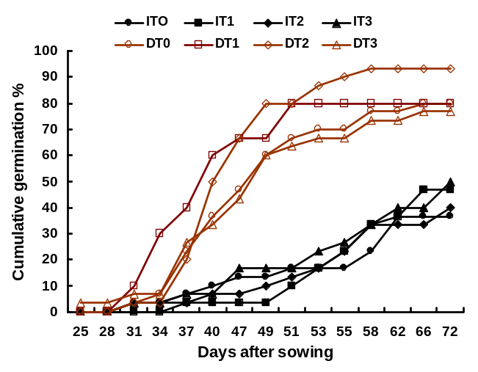
Figure 3: Effects of depulping the fruits and soaking the seeds on cumulative germination percentage of T. belerica seeds.

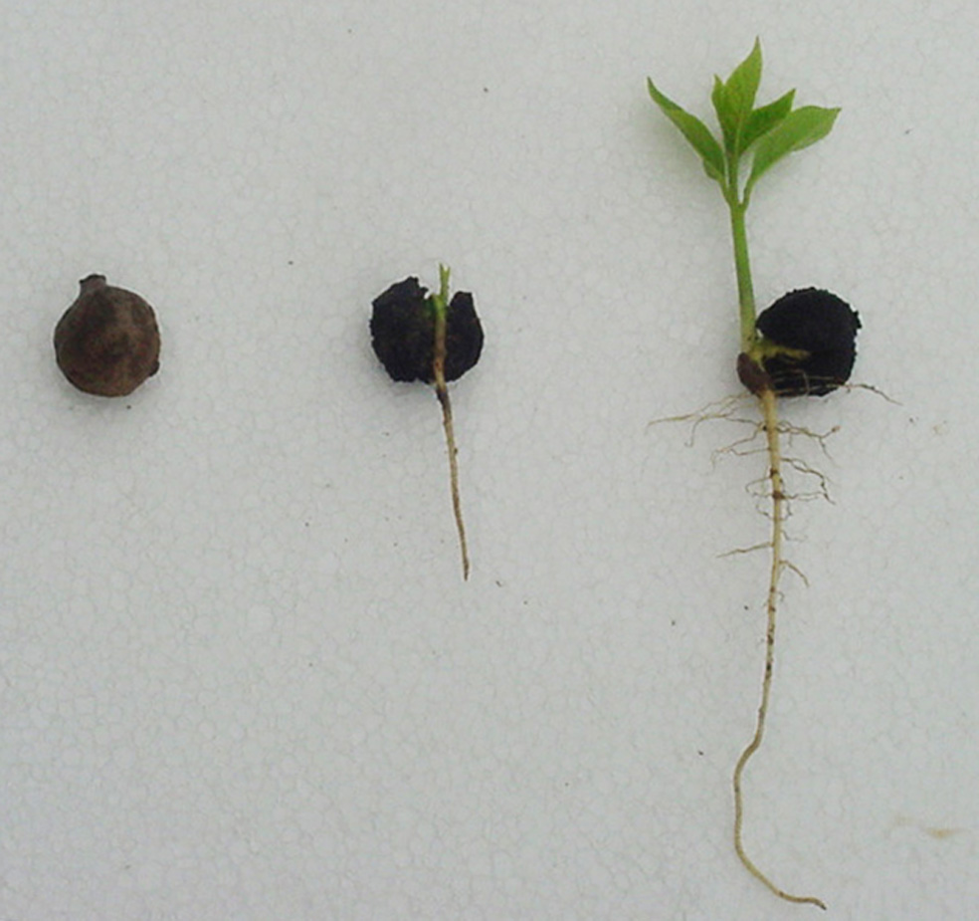 | 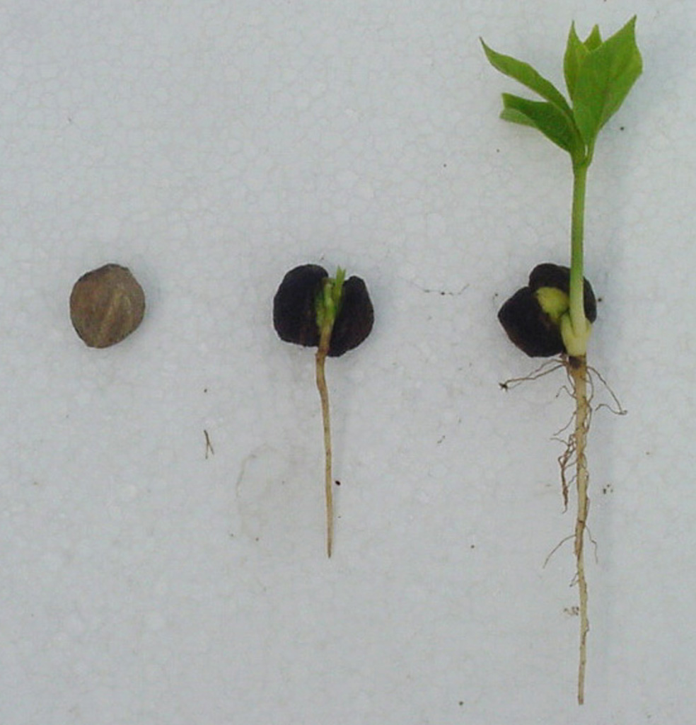

Figure 4: Germination pattern of intact fruits (left) and depupled seeds (right) of T. belerica.

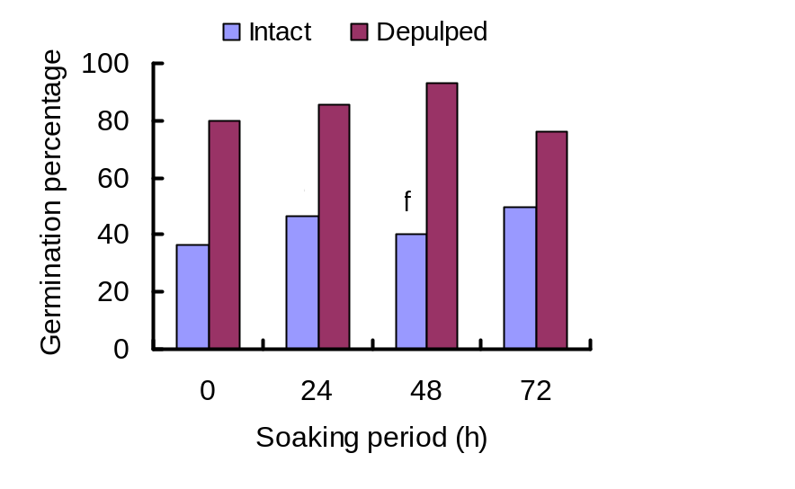
Figure 5: Germination percentage of intact fruits and depulped seeds of T. belerica various soaking periods.

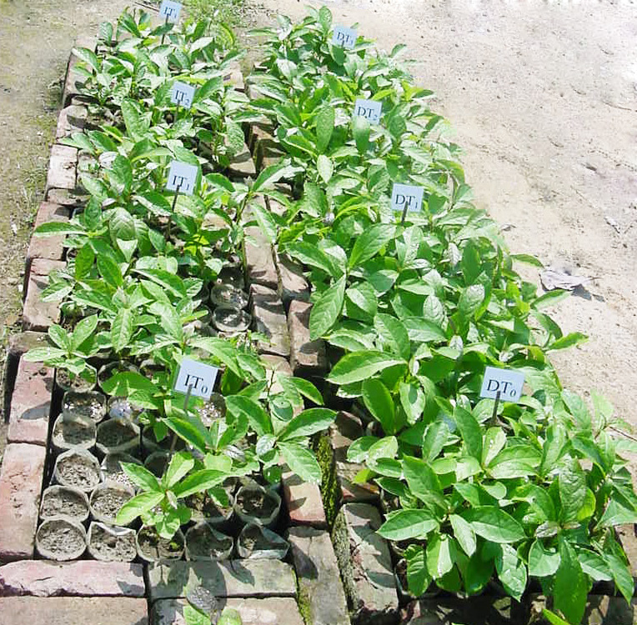

Figure 6: Germination of intact fruits and depulped seeds of T. belerica under different soaking periods

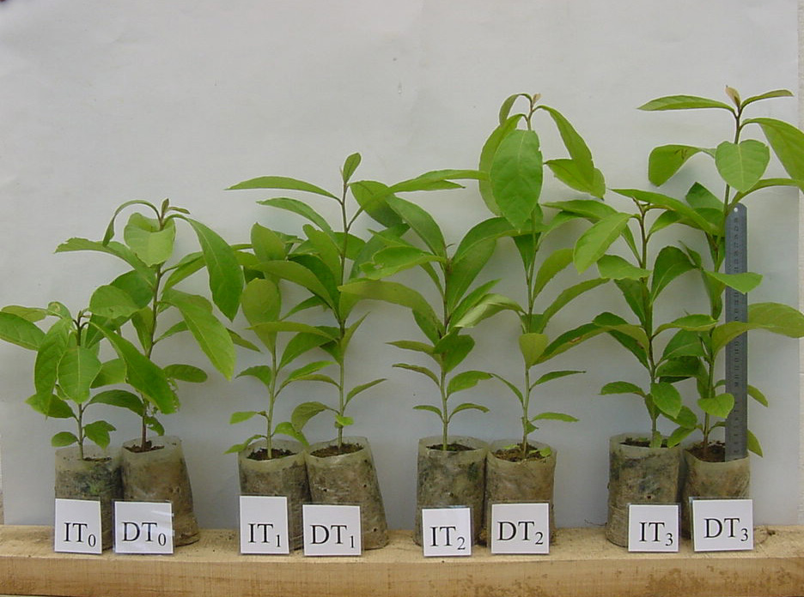

Figure 7: Growth performances of T. belerica seedlings germinated under different seed treatments four months after sowing the seeds.

