Expression of Anthocyanin Biosynthesis Genes in Relation to Anthocyanins and Flavonoids Levels during
Leaf Development of Malus Crabapples
Tingting Song· Jie Zhang· Ji Tian· Yuncong Yao

College of Plant Science and Technology, Beijing University of Agricultural,
Agricultural Road 7 Changping District, Huilongguan town，Changping district，Beijing, China, *Fax: +86-10-80799004, *E-mail: Yaoyc_20@126.com
Abstract
Anthocyanin plays a determinant role in the color of many plants. The expression of structure genes involved in anthocyanin biosynthesis is closely associated with anthocyanins levels. In Malus crabapple, we used a homology-based cloning approach to obtain the five genes of cDNA full-length, which encoded five enzymes, chalcone synthase (CHS), chalcone isomerase (CHI), flavanone 3-hydroxylase (F3H), dihydroflavonol 4-reductase (DFR) and anthocyanidin synthase (ANS) in anthocyanin pathway. The BLAST results showed that the amino acids sequence of the five genes had a high homology with the known species. Through real-time quantitative PCR and spectrophotometer we found that there were positive relationships between McCHS, McDFR and McANS expression levels and anthocyanins content in different leaf color cultivars (from green to mauve). The trends in McCHS and McDFR expression in young leaf were higher than that in mature leaf of green-leaf and ever-mauve-leaf cultivars, while the McANS expression was same situation in all three cultivars. Significant positive correlation with the anthocyanins content existed in which in young leaf was higher than that of mature leaf except in green-leaf cultivar, in which in ‘red and mauve leaf’ was higher than that in ‘green leaf’ with the decreasing of leaf hue. However, the McCHI expression was negatively correlated with anthocyanins content. So it is speculated anthocyanins are important pigment for coloring of leaf and expression of structural genes is involved in the accumulation of anthocyanins and is correlated with the leaf color formation in M. crabapples leaves.
Keywords: Structural genes, Anthocyanin, Malus crabapple, Leaf color
Introduction
M. crabapples are of the important ornamental plants due to their manifold posture of canopy and the rich color of leaves, fruits and flowers. Centuries of natural hybridizing and breeding have produced numerous varieties in which levels of anthocyanins pigment vary widely and change in response to environmental and developmental stimuli, and their cultivation is continuously rising worldwide and drastically expanding in Asia ( Zhang N et al.,2007). Despite all that, few have been investigated at the molecular level in M. crabapple yet.
Anthocyanin are water-soluble flavonoid pigments found in most of higher plants and are responsible for red, blue, mauve and purple color of leaves, flowers, fruits and seeds. Flavonoid are believed to have a variety of functions including pathogen defense, protection against light stress, regulation of polar auxin transport and signaling, establishment of microbial symbioses and pollen fertility (Bohm et al., 1998; Harborne and Williams, 2000), and also contribute to or even determine additional features that are of special relevance in ornamental plants (Schijlen et al. 2004).
Anthocyanin biosynthesis involves a common branch of the flavonoid pathway and has been intensively investigated in many plants such as Arabidopsis, Petunia, tomato, grape and apple (Devic et al., 1999; Napoli et al., 1999; Helena Mathews et al., 2003; Kobayashi etal., 2002). In apple the considerable effect has been invested in improving the coloration of fruit skin and in clarifying the mechanism underlying the red coloration. Based on these effects, major factors affecting red coloration have been proposed in which the formation of anthocyanin is genetically determined. The structural genes encoding enzymes in the anthocyanin biosynthetic pathway have therefore been isolated from apple and their expression during fruit development have been analyzed. The results indicated that most of the genes in the anthocyanin biosynthetic pathway, and particularly those for chalcone synthase (CHS), chalcone isomerase (CHI), flavanone3-hydroxylase (F3H), dihydroflavonol 4-reductase (DFR) and anthocyanin synthase (ANS) (Fig.1), are closely related to the accumulation of anthocyanins in apple skin (Honda et al. 2002). However, there are different expression patterns in various organs, in different stages, as well as in various species. Similar report showed that among different various sweet potato cultivars, the color and/or color intensity of the ﬂesh seems to be not related to those of other tissues, such as the tuber skins, ﬂowers, leaves, and stems (Mano et al,. 2007) .
In M. crabapple, there are three kinds of leaf-color genotypes typically including the green-leaf cultivar, the spring-red-leaf cultivar and the ever-mauve-leaf cultivar. The characteristic of leaf colors is the most important factor in ornamental consideration. So we compared M. crabapple cultivars ‘Flame’, ‘Radiant’ and ‘Royalty’ representing respectively above three genotypes, in which ‘Royalty’ is highly pigmented throughout all tissues including fruit, cortex and leaves. We isolated the cDNA of five structure genes from ‘Royalty’ and compared the expression of these genes in different leaf development stages of three types of leaf-color cultivars by quantitative RT-PCR (qPCR). In expression analysis studies, the behavor of structure genes suggests that it is responsible for leaf red color variation.
Fig 1. Diagrammatic representation of the flavonoids biosynthetic pathway in apple. Enzymes for each step are shown in bold. Flavonoid intermediates are boxed and principle flavonoid end products are in gray boxes. The Phe ammonia lyase (PAL) enzyme is at a key branch point of the phenylpropanoid pathway that can lead to many classes of compounds. Enzymes required for flavonoid synthesis: CHS, Chalcone synthase; CHI, chalcone isomerase; F3H, flavanone-3 -hydroxylase; DFR, dihydroflavonol 4- eductase; ANS, anthocyanin synthase. Enzymes specific for various flavonoid compounds: UFGT, UDP-glycose: flavonoid-3-O-glycosyl transferase for anthocyanin synthesis. The unidentified enzyme encoding a glycosyl transferase for flavonol glycone synthesis is referred to as GT. The flavononoid-3’-hydroxylase enzyme has been omitted for clarity but it may hydroxylate several of the intermediates from the CHI step onwards. (Adam M., 2006)
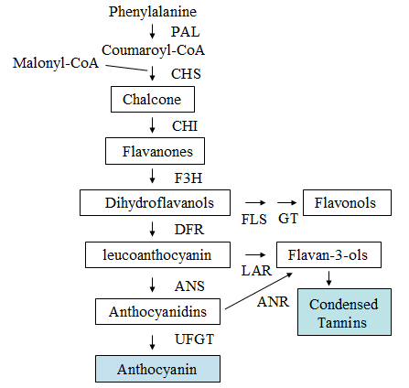

Materials and methods
Plant materials
The leaves of cultivars including Malus crabapple cv. ‘Flame’, Malus crabapple cv. ‘Radiant’, and M. crabapple cv. ‘Royalty’ were collected from shoots of 6 years old trees in BUA Crabapple Germplasm Resource Garden (Beijing University of Agriculture, Beijing, China ) in 2008. ‘Flame’ is a typical green-leaf cultivar. ‘Radiant’ is a spring-red-leaf cultivar that the leaf color varies from red in spring to green in fall with leaf development. And ‘Royalty’ is an ever-mauve-leaf cultivar that high pigmented tissues throughout plant present in leaves, cortex, fruit skin and flesh (Fig.2). Two times in leaf sampling were chosen with development process in which one was the 7d and the other was 50d after bud germination according to criteria including similar size, section and growth status. All samples were frozen in liquid nitrogen upon collection in the field and stored at -80℃ until analyzed.
‘Flame’ ‘Radiant’ ‘Royalty’
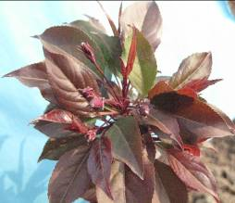
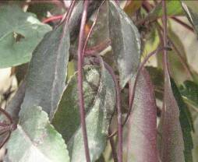
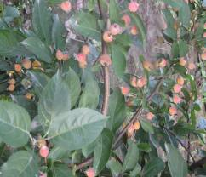
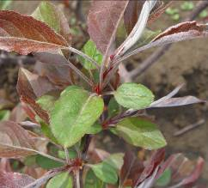
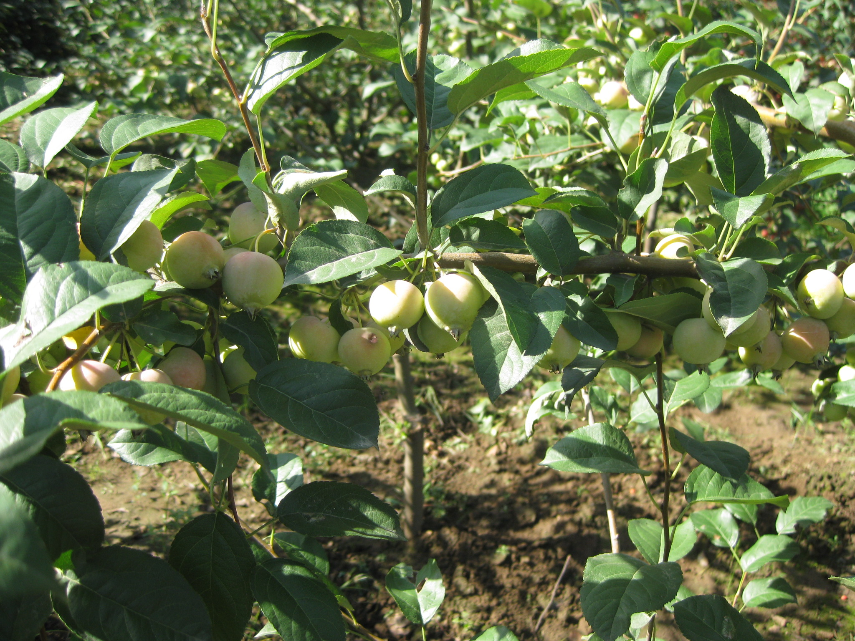
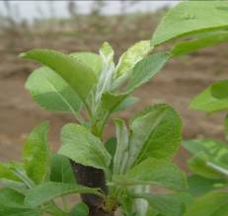
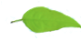
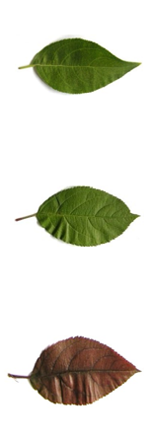
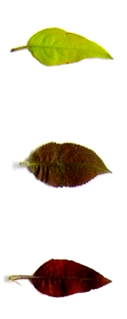

Young leaf

Mature leaf

Fig. 2 Three types of leaf color cultivars and its two leaf development stages
Cloning of Malus crabapple anthocyanin cDNAs
For cloning of the M. crabapple anthocyanin cDNA of CHS, CHI, F3H, DFR, and ANS, total RNA was isolated from young leaves of the M. crabapple cv. ‘Royalty’ using the guanidine thiocyanate solution (Chomczynski and Sacchi, 1987). cDNA was prepared from 1 ug total RNA using the SMARTTM RACE cDNA Amplification Kit (Clontech, USA). PCR conditions were 1.5 mM MgCl₂, 200uM dNTPs, 500 nM each primer, with 10 ng cDNA and 1 U LA Taq DNA polymerase in 1×buffer (Takara, Ohtsu, Japan). Cycling conditions were: 94℃ for 1.5 min, 30 × (94℃ for 30 s, 50-64℃ for 1 min, 72℃ for 2 min), 72℃ for 7 min. For each cloning approach, primers sequences were listed in Table 1, where the primers combinations and annealing temperatures which were finally used for the cloning process are presented. All 5’ and 3’ primer combinations were tested for PCR amplification of the expected DNA fragments at three to five different annealing temperatures in the range of 55-64℃. The PCR products were directly cloned into the pMD-19 vector (akara, Ohtsu, Japan) for sequencing.
Table 1 Primers in this study
Gene | 5’ Primer | 3’ Primer | Tm (℃)
CHS  CHI  F3H  DFR  ANS | 5’-CGGGAAGAATGGTTTGTGCTGCT-3’  5’-GGCGGAAACAATACATAAACGAAGC-3’  5’-CATTTACACCCGTTCAATAGTTG -3’  5'–CCTCGCGGCCAAACTT–3'  5’- GGCTTGTCTGGCCACCTCG -3’  5'–CCCGGTGACGAATCGGATATG–3'  5’- GCTTGATGATGCCATAATGTG -3’  5'–CATTTCTTAAGATCGGCGAAAGTC–3'  5’-GGAACCATGTTGTGGAGGATG-3’  5'–GGCGAGTGCACTCACGTCAG–3' | 5’-GGACATCTCCGTGAAGTAGGG-3’  5’-CAAGCCTATTGGGATTTCGG-3’  5’- CACCGGGYGCCTCTATTCT -3’  -  5’- GGCTGGCTTCATCGTGTC -3’  -  5’-CACATCCTCAGCAGGAACTG-3’  -  5’- GGGAGGACTACTTCTTCCAC -3’  - | 64  63  64  55  64  58  60  58  62  62

Sequence analysis
Comparison and analysis of the sequences were performed with the advanced basic local alignment search tool (BLAST) at the National Center for Biotechnological Information (http://www.ncbi.nlm.nih.gov/). The full-length sequences of DNA and protein were aligned using DANMAN. (Lynnon Biosoft, USA) Phylogenetic and molecular evolutionary analyses were conducted using MEGA version 4 (Kumar et al. 2004) using a minimum evolution phylogeny test and 1,000 bootstrap replicates.
Total anthocyanins and flavonoids content and color measurement
The leaf tissue was extracted using methanol–HCl (Piccaglia et al. 2002). One gram of sample was homogenized with 10 mL of methanol:HCl (99:1 v/v) then immersed for 20 h at room temperature. The clear supernatant was transferred to a new tube then the absorbance value at 530 nm and 325nm measured using a UNICO UV-2100 spectrophoto meter (Shimadzu, Kyoto, Japan). The concentration of anthocyanins and flavonoids was calculated according to the papers published before (Siegelman and Hendriks 1958; Pirie and Mullins 1976). All measurements were done in triplicate. The color were measured using a Minolta CR-300 chromometer (calibrated to D65 light) (Konica Minolta, Mahwah, NJ, USA) by the L*a*b* system (CIE, 1986).
Real-time PCR expression analysis
Table 2 Primers in qPCR
Anthocyanin gene | Forward primer | Reverse primer | Tm
McCHS | 5’-GGGCTTACATTTCACCTTCT-3’ | 5’- GGCCAACTTGGACTCT ACTT -3’ | 55℃
McCHI | 5’-CCGTTCAATAGTTGGGATAA-3’ | 5’-TCCTAAAGGATCACTCACG-3’ | 50℃
McF3H | 5’-CACAATTACCCTTCTGCTTC-3’ | 5’- AGATGACCATGATCTCCAAG -3’ | 52℃
McDFR | 5’-GGTTGGATGTACTTCGTCTC-3’ | 5’- TGATGAGGCT TGGTGGCAT -3’ | 55℃
McANS | 5’-AAGGAGAAGTATGCCAATGA-3’ | 5’-TTGAGGCCAAATAGACAAGT-3’ | 52℃
18srRNA | 5’-ACACGGGGAGGTAGTGACAA-3’ | 5’-TTGAGGCCAAATAGACAAGT-3’ | 52℃
Partial cDNA fragments of the McCHS，McCHI，McF3H，McDFR and McANS genes were all amplified by RT–PCR. Total RNA was isolated from ‘Flame’, ‘Radiant’ and ‘Royalty’ using the with guanidine thiocyanate solution (Chomczynski and Sacchi, 1987). For real-time PCR, cDNA was diluted 1, 1/10, 1/100, 1/1000, 1/10000 with water to draw a standard curve. Primers and Tm for real-time PCR were listed in Table 2, and reaction conditions were amplified 40cycle under the following standard conditions: denaturizing at 94℃ for 20 s, annealing at 50-55℃ for 30 s, and extension at 72℃ for 30s. Fluorescence collected in the third step of every cycle, and finally denaturizing at 95℃ for 1min, annealing at 55℃ (ascend 0.15℃ interval 10s), keep for 1min to draw a melting curve. Malus domestica 18S ribosomal RNA (accession number: DQ341382) was carried out the same reaction as a control. Real-time PCR reaction system follows Real Master Mix SYBR Green protocols (QIAGEN).The PCR reactions were carried out in a Bio-Rad iQ5 real-time PCR instrument (Bio-Rad). The relative gene copy number was calculated follow the formula 2^{-△△Ct}.
Results
Cloning of anthocyanin cDNAs in Malus crabapple
The cloning of key structure genes was performed by deriving for each target sequence 5’ primers and 3’ primers from the non-coding 5’ and 3’ regions of available corresponding Malus anthocyanin cDNA sequences. Full size coding sequences of five structure genes (Table 3) were successfully amplified with the primers designed in table 1, which they were named as McCHS, McCHI, McF3H, McDFR, McANS. All sequences have been submitted to GenBank (Table 3). The cDNA of five genes could be obtained from the M. crabapple cv. ‘Royalty’ by this approach.

Table 3 Information of isolated structural genes from M. crabapple
Gene | Length of gene  segment /bp | GenBank accession No. | Gene | Length of gene  segment /bp | GenBank  accessionNo.
McCHS  McCHI  McF3H | 1529  660  1406 | FJ599763  FJ817485  FJ817487 | McDFR McANS | 1265  1350 | FJ817487  FJ817488
a 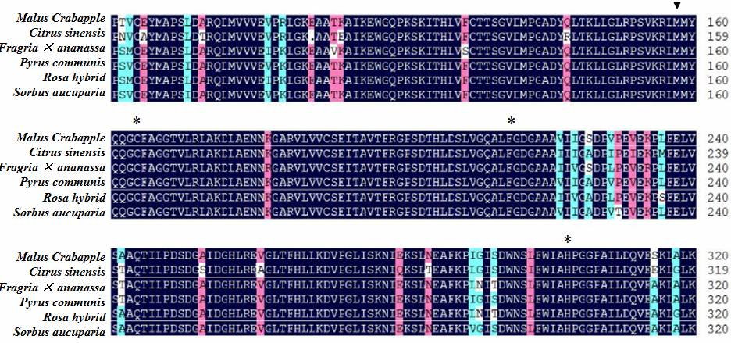
b
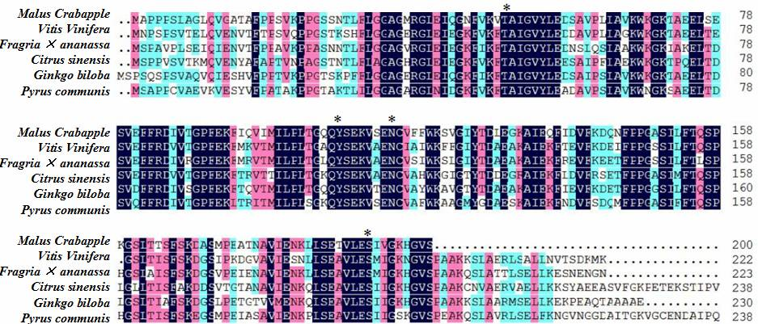
c
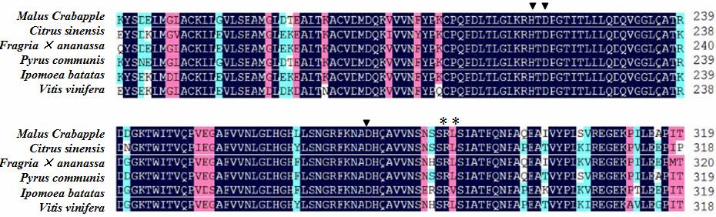
d
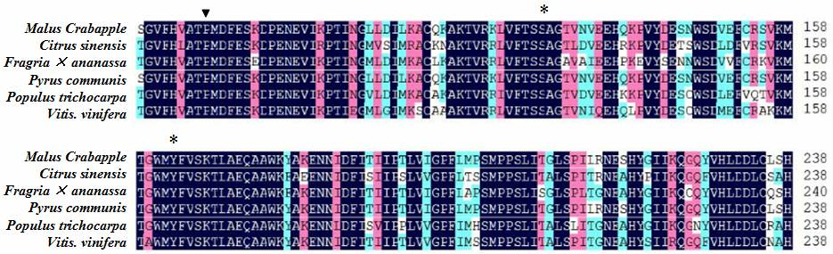
e
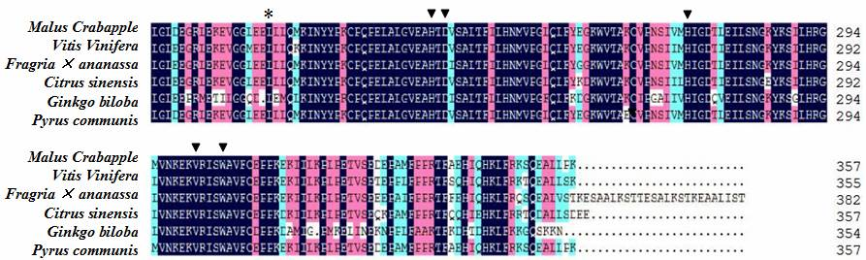

Fig.3 Amino acid sequences alignment of key structural genes from different species
Comparison of the deduced amino acid sequence of anthocyanin structure genes with known genes from other plant species. a-e: Sequences alignment of McCHS, McCHI, McF3H, McDFR and McANS. Asterisk(*) indicates the active sites; inverse triangle(▼)indicates the strictly conserved amino acid residue.
There were four active sites which take effect in McCHS (Fig. 3 a): Cys(C), Phe (F), His (H) and Asn (N). In these sites, Cys is a binding site of Coumaroyl-CoA and is essential for McCHS enzyme activity. (Fig.3 a) (Jez& Noe,l 2000); Thr(T), Tyr (Y), Asn (N) and Ser (S) are necessary for the activity of the amino acids sequence of McCHI as well as Thr can catalyze the polarity of flavonol. (Fig. 3 b) (Li et a.l, 2006). In the sequence of McF3H and McANS in M. crabapple(Fig. 3 c e), they had the same His (H) , Asp (D) residues which is Fe binding site, and Arg (R), Ser (S) can combine with 2-oxogutarate, and these sites were highly conserved in different species. The amino acids sequence of McDFR had a highly conserved region and two totally conserved residues: Ser (S) and Tyr (Y), furthermore there was an important site Asn (N) which can catalyze DHK (Dihydrokainate) to product pelargonidin (Fig. 3 d).

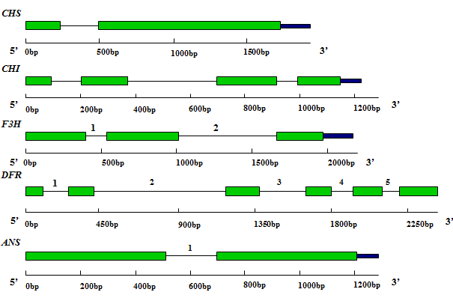
: exon;
: intron;
: UTR;
Legend:
1 2 3 4 5 : intron phase respectively
Fig. 4 DNA sequence structure of five genes from M. crabapple in anthocyanin biosynthesis

Using the M. crabapple cv. ‘Royalty’ DNA as the template, we amplified the genome full-length of five structure genes (Fig. 4). After sequencing the PCR product, the all five sequences were obtained. With the position of the translation start codon designated as +1, the full length of McCHS DNA sequence was 2022 bp, exist 1 intron in it and located in + 190bp- + 819bp (intron 1), the full-length of McCHI DNA sequence was 1180bp, exist 3 introns in it and located in + 107bp- + 210bp (intron 1),+ 376bp-+704bp (intron 2),+ 929bp-+1009bp(intron 3); the full-length of McF3H DNA sequence was 1983bp, exist 2 introns in it and located in + 364bp- + 540bp (intron 1), + 970bp-+1678bp (intron 2); the full-length of McDFR DNA sequence was 2396bp, exist 5 introns in it and located in +119bp-+ 238bp (intron 1), + 409bp-+1167bp (intron 2), + 1363bp-+1620bp (intron 3), + 1785bp-+1887bp(intron 4) ,+ 2081bp-+2200bp(intron 5); the full-length of McANS DNA sequence was 1268bp, exist 1 intron in it and located in + 508bp- + 699bp (intron 1). These results were consisted with previously research in other species and all the cleave sites obeyed with the GT-AG rule. These introns had a high specificity by BLAST except the third intron in McCHI gene which had a high homology with soybean.
Phylogenetic analysis for anthocyanin structure genes from M.crabapple
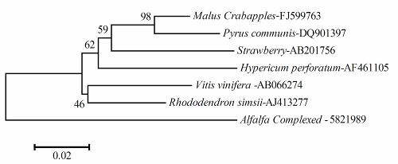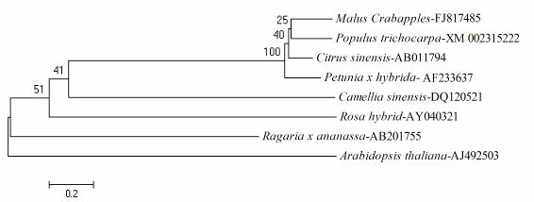
a b
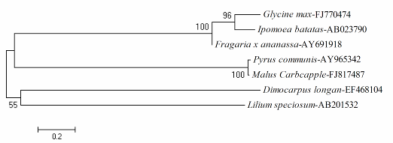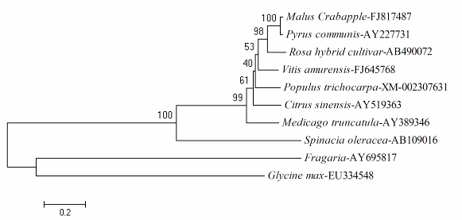
c d
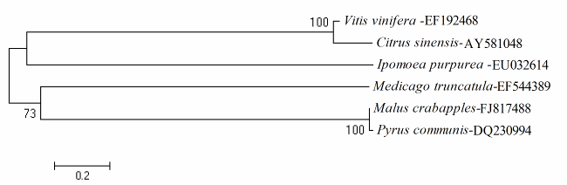
e
Fig. 5 Phylogenetic tree of amino acid sequences of key enzymes in M. crabapple
A-E: Phylogenetic tree of CHS, CHI, F3H, DFR and ANS; GenBank accession number showed after horizontal.
A phylogenetic tree for the five anthocyanin biosynthesis enzymes that we isolated from M. crabapple was constructed by means of neighbor-joining methods using the full-length deduced amino acid sequences (Fig. 5).The evolution pattern of the five anthocyanin enzymes: McCHS, McCHI, McF3H, McDFR and McANS was consistent with the evolution process which was from lower to higher level, from simple to complex in biology community. The analysis also showed that McCHS, McF3H, McDFR and McANS had a close relationship with Pyrus L., and were coincide with the known reports and offered a foundation for the cloning of homologous genes.
The RNA expression profile of anthocyanin biosynthetic enzymes
The RNA expression profile of anthocyanin biosynthetic enzymes suggested the coordinated regulation in M. crabapple leaf (Fig. 6). The level of transcript encoding the five structure genes were compared among the M. crabapple ‘Flame’, ‘Radiant’ and ‘Royalty’ by qPCR. Striking differences were observed. For all the genes assayed, McCHS, McDFR and McANS transcript level in ‘red-and mauve-leaf’ were significantly higher than that of ‘green leaf’ at the two stages of leaf development (Fig. 3). The expression level of the five structure genes in young leaf was higher than that of mature leaf in green-leaf cultivar, same as in mauve-leaf cultivar. In the spring-red-leaf cultivar, the expression level of McCHS, McCHI and McDFR in young leaf was lower than that of mature leaf, and the expression level of McANS was converse. The expression level of genes (McF3H only in young leaves) in mauve-leaf cultivars was higher than that in green-leaf cultivar except McCHI.
Relationship of anthocyanins content and genes expression
The content of both flavonoids and anthocyanins was determined in all samples of different leaf color crabapple varieties (Fig. 7). The total content of the anthocyanins in young leaf was higher than that in the mature leaf in experimental varieties except ‘Flame’, and the content of flavonoids showed a similar trend but ‘Flame’ was not special. For the different color cultivars, the content of both anthocyanins and flavonoids in green-leaf cultivar was lower than that in ever-mauve-leaf cultivar. The trend of expression of McCHS and McDFR was similar with the anthocyanins content which in young leaf was higher than that in mature leaf of green-leaf and ever-mauve-leaf cultivars, while the McANS expression was same situation in all three cultivars. However, the McCHI expression was negatively correlated with anthocyanins content, the leaves of red and mauve had lower expression level compared with green leaf. There was no obvious relationship between McF3H expression and anthocyanins content.
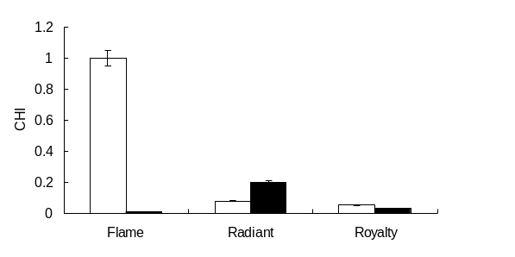
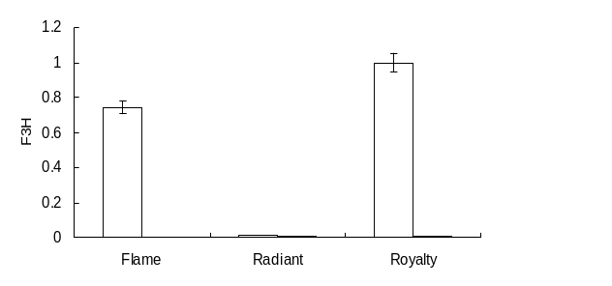
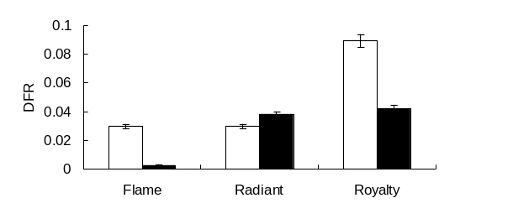
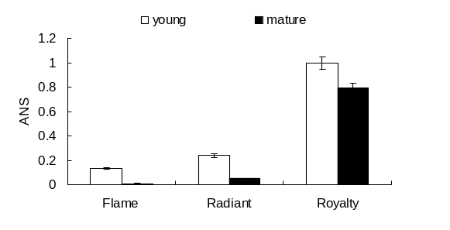
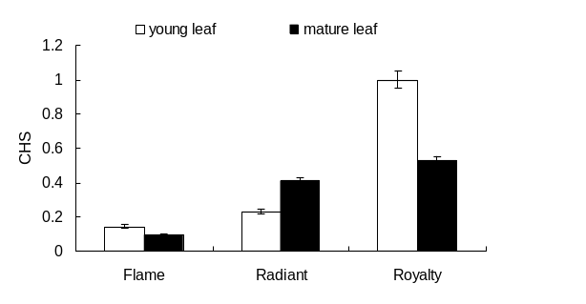

Relative expression of structure genes in Malus Crabapple

Fig. 6 Expression of structure genes in anthocyanin biosynthesis in different color leaves
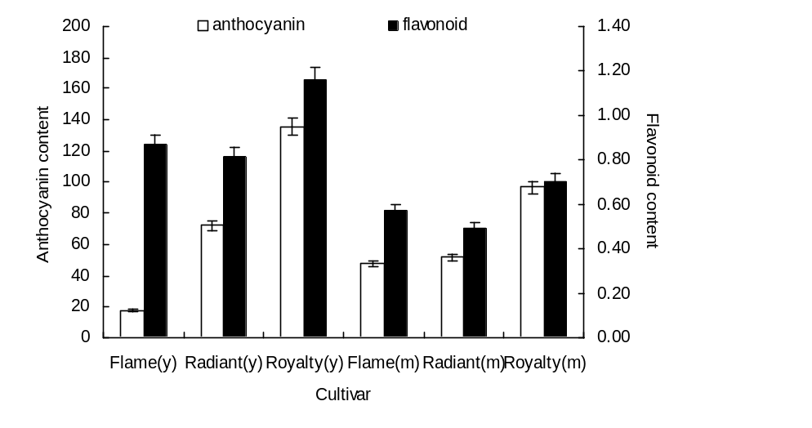
Fig. 7 Comparison of canthocyanins and flavonoids content among different leaf colored M. crabapples cultivars
Note: ‘y’ stands for young and ‘m’ stands for mature
Relationship of anthocyanins content and color hue
Color intensity and hue were quantified by measurement with a Minolta chromometer using the L*a*b* system (Fig. 8). The change from negative toward positive indicated a shift from green to red. It should be noted that there was a variability of pigmentation in different cultivars and ages，particularly among different color leaves. The color hue in red and mauve leaves was significantly smaller than that in green leaves during the two stages of leaf development. The color hue in young leaf significantly was smaller than that in mature leaf, and ‘Flame’ was an exceptional circumstance, which had an approximate value with hue between two periods. The results showed color hue was correspond with the anthocyanins content, and proved the anthocyanins content as the main reason for formation of colorful leaf and validity of this study design.
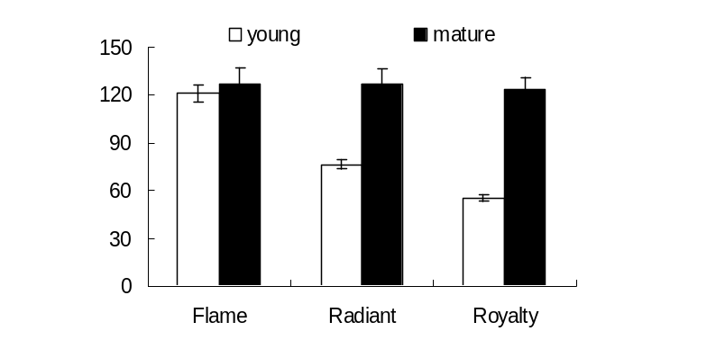
The value of color hue
Fig. 8 Color hue in leaf of different cultivars of M. crabapple
Discussion
In order to determining the character of structure genes in flavonoid pathway we cloned five full-length cDNA of anthocyanin structure genes in M.crabapple leaves and submitted to GenBank, which named respectively as: McCHS, McCHI, McF3H, McDFR, McANS. Amino acid sequences analysis of these genes showed that they shared homology with those of anthocyanin genes from other species, and they had the same active sites and conserved residues with the known sequences. For example, the active sites of McCHS and McCHI in the study were consistent with the reported sequences of orange and grape ( Jez& Noe,l 2000; Li et al., 2006). Phylogenetic analysis indicated that there were similar results in the amino acid sequences comparison, and the five genes of M. crabapple had a conserved characteristics and closely genetic-relationship with other species, such as pear and strawberry (Fisher C et al., 2007). Whereas the BLAST results of the intron sequences of these five genes revealed that they had the same cleave sites, but the intron sequences were highly varied, we almost didn’t find a similar intron sequences in NCBI. The above-mentioned results presumed that anthocyanin structure genes in M. crabapple leaves had the function of anthocyanin biosynthesis and the dual features of conservation and variation.
The red-colored leaf is an important target in Malus crabapple breeding, because people generally prefer colorful leaves and fruits which have a higher ornamental value and market prospect. Many studies indicated that the most of structure genes in the anthocyanin biosynthetic pathway, and particularly chalcone synthase (CHS), dihydroflavonol 4-reductase (DFR) and anthocyanin synthase (ANS) positively induced and improved the accumulation of anthocyanins in apple (Honda et al. 2002). Expression analysis of the five genes showed the expression level of most anthocyanin pathway genes were consistent with the accumulation of anthocyanins, including McCHS, McDFR and McANS. As the expression of McCHS was significantly higher in the mauve leaf than green leaf, so we speculated that the regulation of upstream genes were critical in M. crabapple leaf coloring mechanism, and the similar results have been obtained in the developmental studies of pea (Pisum sativum), snapdragon (Antirrhinum majus), and petunia (Petunia hybrida) flowers (Jackson et al., 1992; Quattrocchio et al., 1993; Uimari and Strommer, 1998). The substrate specificity of the DFR often determined by which anthocyanins accumulated in plants (Forkmann and Heller 1999). The DFR of some species, such as iris and gentian, which mainly accumulated delphinidin and lacked pelargonidin, was expected to have a similar substrate to petunia DFR, which efficiently reduced dihydromyricetin. The expression of anthocyanin pathway genes was specifically up-regulated at the period of leaf growth, all the genes expression was higher in young leaf than that in mature leaf. In mature leaf, the expression level started to drop. Interestingly, McDFR expression was clearly higher in mauve leaf than that in green leaf, but McF3H expression was high obviously in young leaf of ‘Flame’ and‘Royalty’, which was little expression in other cases. It was conjectured McDFR induction was not correlated with a modification of McF3H expression. Whether high McDFR gene expression can be related to the McANS expression in ‘red leaf’ remains to be investigated.
The visible accumulation of anthocyanins and flavonoids usually reflected the activity of biosynthetic enzymes functioning in the pathway (Koes et al., 1994). According to our results, it was possible that low anthocyanins concentrations would favor McCHI expression, whereas higher concentrations would restrict McCHI activities and lead to anthocyanin biosynthesis in contrary.
The results obtained in this study provided additional evidence for the correlation between the expression of anthocyanin structural genes and anthocyanins production in different color M. crabapple leaf. On the other hand, the way the anthocyanin genes in M. crabapple were expressed at the beginning of the leaf development (young leaf) was similar to what has been found in strawberry (Manning, 1998) and in grape berry (Boss et al., 1996; Kobayashi et al., 2001).
In addition, the cloned cDNAs of M. crabapple McCHS, McCHI, McF3H, McDFR and McANS allow metabolic engineering aimed at plants with higher contents of anthocyanidin and proanthocyanidins (Xie et al. 2006), making use of M. crabapple cDNAs rather than foreign sequences for overexpression or silencing strategies in M. crabapple. It was recognized that public acceptance of ornamental plants is better when the color of the same species are used. Recent research results showed that the plants and fruit perianth coloring process in addition affected not only by transcription factor, but also by the structure genes, light receptors and optical signal transduction factors were closely related to anthocyanin biosynthesis (Mano et al., 2007; Kneissl et al., 2008). So future research with the anthocyanin biosynthesis, we will pay close attention to the functions of anthocyanin structure genes and transcription factors from different tissue in M. crabapple.

Acknowledgement
The ﬁnancial support provided by the Funding Project for Academic Human Resources Development in Institutions of Higher Learning Under the Jurisdiction of Beijing Municipality (PHR20110515) and the projects of scientific research quality improvement of Beijing University ofAgriculture ( QKM2012002 ). Also this work was supported by Fruit Tree Key Laboratory of Beijing University of Agriculture (BUA) and Beijing Key Laboratory for Agricultural Application and New Technique.
References
Bohm B (1998) Introduction of flavonoids. Harwood A cademic Publishers, Singapore
Boss PK, Davies C, Robinson SP (1996) Expression of anthocyanin biosynthesis pathway genes in red and white grapes. Plant Mol Biol 32:565–569
Chomczynski P, Sacchi N (1987) Single-step method of RNA isolation by acid guanidinium thiocyanate–phenolchloroform extraction. Anal Biochem 162: 156–159
CIE (1986) Colorimetry, 2nd edn. Vienna: Central Bureau of the Commission Internationale de L’Eclairage (CIE Publication Number 15.2 )
Devic M, Guilleminot J, Debeaujon I, Bechtold N, Bensaude E, Koornneef M, Pelletier G, Delseny M (1999) The BANYULS gene encodes a DFR-like protein and is a marker of early seed coat development. Plant J 19: 387–398
Fischer TC, Gosch C, Pfeiffer J, Halbwirth H, Halle C, Stich K, Forkmann G (2007) Flavonoid genes of pear (Pyrus communis). Trees 21:521–529
Forkmann G, Heller W (1999) Comprehensive natural products chemistry. Elsevier science publishers B.V., 713-748, Amsterdam
Harborne J, Williams C (2000) Advances in flavonoid research since 1992. Phytochemistry 55:481–504
Honda C, Kotoda N, Wada M, Kondo S, Kobayashi S, Soejima J, Zhang Z, Tsuda T, Moriguchi T (2002) Anthocyanin biosynthetic genes are coordinately expressed during red coloration in apple skin. Plant Physiol Biochem 40:955–962
Jackson D, Roberts K, Martin C (1992) Temporal and spatial control of expression of anthocyanin biosynthetic genes in developing flowers of Anthirrum majus. Plant J 2:425–434
Jez JM, Bowman ME, Dixon RA, Noel JP (2000) Structure and mechanism of the evolutionarily unique plant enzyme chalcone isomerase. Nat Struct Biol 7:786–791
Kobayashi S, Ishimaru M, Hiraoka K, Honda C (2002) Myb-related genes of the Kyoho grape (Vitis labruscana) regulate anthocyanin biosynthesis. Planta 215:924–933
Kobayashi S, Goto YN, Hirochika H (2004) Retrotransposon-induced mutations in grape skin color. Science 304: 982
Koes RE, Quattrocchio F, Mol JNM (1994) The flavonoid biosynthetic pathway in plants: function and evolution. BioEssays 16:123–132
Kneissl J, Shinomura T, Furuya M, Bolle C (2008) A rice phytochrome A in Arabidopsis: the role of the N-terminus under red and far-red light. Mol Plant 1 (1): 84-102
Kumar CG, LeDuc R, Gong G, Roinishivili L, Lewin HA, Liu L(2004) ESTIMA, a tool for EST management in a multiproject environment. BMC Bioinformatics, 5:176
Li F, Jin Z, Qu W, Zhao D, Ma F ( 2006) Cloning of a cDNA encoding the Saussurea medusa chalcone isomerase and its expression in transgenic tobacco. Plant Physiol Biochem 44: 455-461
Manning K (1998) Isolation of a set of ripening-related genes from strawberry: their identification and possible relationship to fruit quality traits. Planta 205: 622–631
Mano H, Ogasawara F, Sato K, Higo H, Minobe Y (2007) Isolation of a Regulatory Gene of Anthocyanin Biosynthesis in Tuberous Roots of Purple-Fleshed Sweet Potato. Plant Physiol 1252–1268
Mathews H, Clendennen SK, Caldwell CG, Liu XL, Connors K, Matheis N, Schuster DK, Menasco DJ, Wagoner W, Lightner J, Wagner DR (2003) Activation Tagging in Tomato Identifies a Transcriptional Regulator of Anthocyanin Biosynthesis. The Plant Cell 15:1689-1703
Napoli CA, Fahy D, Wang HY, Taylor LP (1999) White anther: a Petunia mutant that abolishes pollen ﬂavonol accumulation, induces male sterility, and is complemented by a chalcone synthase transgene. Plant Physiol 120: 615–622
Piccaglia R, Marotti M, Baldoni G (2002) Factors influencing anthocyanin content in red cabbage (Brassica oleracea var capitata L f rubra (L) Thell). J Sci Food Agric 82: 1504–1509
Pirie A, Mullins MG (1976). Changes in anthocyanin and phenolics content of grapevine leaf and fruit tissue treated with sucrose, nitrate and abscisic acid. Plant Physiol, 58:468-472
Quattrocchio F, Wing JF, Leppen HTC, Mol JNM, Koes RE (1993) Regulatory genes controlling anthocyanin pigmentation are functionally conserved among plant species and have distinct sets of target genes. Plant Cell 5: 1497–1512
Schijlen EGWM, Ric de VCH, Van TAJ, Bovy AG (2004) Modification of flavonoid biosynthesis in crop plants. Phytochemistry 65:2631–2648
Siegelman HW, Hendricks SB (1958) Photocontrol of anthocyanin synthesis in apple skin. Plant Physiol 33: 185–190
Takos AM, Jaffé FW, Jacob SR, Bog J, Robinson SP, Walker AR (2006) Light-Induced Expression of a MYB Gene Regulates Anthocyanin Biosynthesis in Red Apples. Plant Physiol 142:1216–1232
Uimari A, Strommer J (1998) Anthocyanin regulatory mutations in pea: effects on gene expression and complementation by R-like genes of maize. Mol Gen Genet 257:198–204
Xie DY, Sharma SB, Wright E, Wang ZY, Dixon RA (2006) Metabolic engineering of proanthocyanidins through coexpression of anthocyanidin reductase and the PAP1 MYB transcription factor. Plant J 45: 895–907
Zhang N, Shen HX, Gao XH, Wang Y, Feng YQ, Yao YC (2007) Phylogenetic Relationship Between Ornamental and Wild Species of Malus in China. Acta Horticulturae Sinica 34 (5): 1227-1234, China

Yao Yuncong coresponding author. Email : yaoyc_20@126.com

