Changes in photosynthetic pigments, antioxidative enzymes and cytokinin influence on Micropropagation system of Dianthus caryophyllus L.

I. SIDDIQUE^{1*}, V. YADAV² and M. ANIS²

¹Department of Botany and Microbiology, College of Science, Female Centre for Scientific and Medical Colleges, King Saud University, P.O. Box 22452, Riyadh 11495, Saudi Arabia
²Plant Biotechnology Laboratory, Department of Botany, Aligarh Muslim University, Aligarh - 202 002, India
*Corresponding author: siddiqueiram@gmail.com
Abstract
An efficient, rapid and improved plant regeneration protocol was successfully developed for Dianthus caryophyllus using nodal explants excised from a 2 years old mature plant. Of the three cytokinins, 6-benzyladenine (BA), Kinetin (Kin) and thidiazuron (TDZ) evaluated as supplements to Murashige and Skoog (MS) medium, the highest rate of shoot multiplication was achieved on MS medium supplemented with 5.0 µM BA and 1.0 µM α- naphthalene -acetic acid (NAA). The regenerated shoots when subcultured on plant growth regulator free MS medium considerably increased the rate of shoot multiplication (44.8 ± 3.5) and shoot length (7.5 ± 0.29 cm) without any sign of decline even after fifth passage. The regenerated shoots were rooted best on half strength MS medium supplemented with 1.0 µM indole-3- butyric acid (IBA). The in vitro raised plantlets with well developed shoot and roots were successfully established in earthen pots containing garden soil and grown in greenhouse with 90% survival rate. Growth performance of 2 months old in vitro raised plant was compared with in vivo seedlings of the same age. Changes in photosynthetic pigments, net photosynthetic rate (P_{N}), superoxide dismutase (SOD) and catalase (CAT) in D. caryophyllus indicated the adaptation of micropropagated plants to ex vitro conditions.
Additional Key words: carnation, carotenoids, growth performance, superoxide dismutase, subculture.
Abbreviations:
BA- 6-benzyladenine; CAT- catalase; Chl- chlorophyll; IBA- indole-3-butyric acid; Kin- Kinetin; MS- Murashige and Skoog medium; NAA- α-naphthalene-acetic acid; P_{N}- net photosynthetic rate; RWC- relative water content; SOD- superoxide dismutase; TDZ- thidiazuron.
Acknowledgements:
This research project was supported by a grant from the research center of the center for female scientific and medical colleges in King Saud University.
Introduction
Dianthus caryophyllus L. (Carnation) is a member of the family Caryophyllaceae, cultivated throughout the world for its use as cut flowers and other ornamental purposes. The importance of this ornamental flower is due to its beauty, diversity of colors, excellent keeping quality, and wide range of different forms (Ali et al. 2008, Kanwar and Kumar 2009). The carnation flower is a wonderful accent to bouquets and carnation home floral arrangements. It has been used as an unconventional food in salad garnishing, in fruit salads and for flavoring fruits etc. The flower heads are dried and used in cosmetic and sachats. Carnation flowers are considered to be alexiteric, antispasmodic, cardiotonic, diaphoretic and nervine (Chopra et al. 1986).
In recent years, there has been an increased interest for in vitro culture techniques which offer a viable tool for mass multiplication and germplasm preservation of rare, endangered, aromatic and medicinal plants (Faisal et al. 2006, Siddique et al. 2010). These technologies could be a cost effective means of high volume production of the elite planting material throughout the year, without any seasonal constraints. Efficient systems have been reported for the regeneration of plants from leaf and stem segments (Van Altvorst 1994, 1995, Kantia and Kothari 2002) and for the induction of direct somatic embryogenesis from leaf, petal and anther explants (Pareek and Kothari 2003, Karami et al. 2006, XiaoPeng et al. 2008) in Dianthus.
The in vitro grew conditions can result in the formation of plantlets of abnormal morphology, anatomy and physiology which resulted in high percentage of plantlets death because of sudden changes after their ex vitro transfer (Desjardins 1995, Pospisilova et al. 2000, Faisal and Anis 2010). The physiological status of in vitro grown plantlets during acclimatization is an important factor determining success rates (Van Huylenbroeck and Debergh 1996) and is a crucial step for many species, requiring time and expensive installation that restrict the commercial application of the micropropagation processes. Sudden changes in environmental conditions during acclimatization of tissue culture raised plants generate stress through the formation of reactive oxygen species (ROS) (Santamaria et al. 1993, Chai et al. 2005). These include superoxide radicals (O₂∙–), singlet oxygen (¹O₂), hydrogen peroxide (H₂O₂) and hydroxyl radical (OH˙), which cause tissue injury (Foyer et al. 1994). To combat the danger posed by the presence of ROS, plant cells have evolved defense antioxidant mechanism. To scavenge these ROS, different mechanisms, both enzymatic and non enzymatic are present in plants (Inze and Van Montagu 1995). Among the enzymatics, SOD and CAT are efficient antioxidant enzymes (Scandalios 1993) and their joint action prevents cellular damages caused by O₂., H₂O₂ and OH⁻. Changes in catalase and SOD activity in response to adverse environmental conditions have been reported by Sgherri and Navari-Izzo (1995).
As far as we know, very few reports exist on successful application of TDZ for rapid and efficient propagation of Carnation (Frey and Janick 1991, Ahmad et al. 2006; Casas et al. 2010), and the existing protocol yielded low number of shoots that cannot be fulfilled the demand of this plant on large scale. Therefore, present study has been undertaken to demonstrate the relative efficiency of TDZ, BA and Kin with those of earlier reports for in vitro plant regeneration from nodal explants and to find the optimal concentration of cytokinins exposure for maximum shoot production and establishment of complete plantlets and to optimize the changes in photosynthetic and antioxidative enzymes activities during acclimatization of micropropagated plants.
Materials and Methods
Plant material and surface sterilization
The nodal portion of a nursery grown 2 years old healthy plant of Dianthus was taken as explants. They were thoroughly washed with tap water for ½ h followed by soaking in 5 % (v/v) solution of a detergent Labolene (Qualigens, Mumbai, India) for 5 min. Following repeated washes with sterile distilled water, the explants were surface sterilized with freshly prepared 0.1% (m/v) mercuric chloride (Qualigens, Mumbai, India) for 5 min followed by repeated washing with sterile distilled water.
Culture media and culture conditions
Murashige and Skoog (MS, 1962) medium with 3% (m/v) sucrose (Qualigens, Mumbai, India) and 0. 8% agar (m/v) or 0.25% (m/v) gelrite (Sigma Aldrich Ltd, USA) was used throughout the experiment. Plant growth regulators and their combinations were added to the medium as specified below. The pH of the medium was adjusted to 5.8 using 1N NaOH or 1N HCl prior to autoclaving at 121 ºC for 15 min. All cultures were maintained at 25 ± 2 ºC under a 16/8 h light /dark regime, under a photo flux density of 50 µ mol m⁻² s⁻¹ provided by cool white fluorescent tubes (40 W, Phillips, India) and at 55± 5% relative humidity.
Multiple shoot induction and proliferation
For multiple shoot induction, nodal segments were placed on MS medium supplemented with BA, Kin and TDZ at 0.5, 2.5, 5.0, 7.5 and 10.0 µM either singly or in combination with α- naphthalene- acetic acid (NAA) (0.1, 0.5 and 1.0 µM). Data for shoot induction and multiplication were recorded after 4 and 8 weeks of inoculation.
In vitro rooting
Elongated healthy shoots (3-4 cm) were excised and cultured on root induction media comprising full and half strength MS medium augmented with IBA at different concentrations (0.5, 1.0, 1.5 and 2.0 µM). Data were recorded on percentage of rooting, number and length of roots after 4 weeks of culture.
Hardening and acclimatization
Plantlets with well developed shoot (5-6 cm) and roots (4-5 cm) were removed from the culture medium and washed thoroughly in running tap water. They were then transferred to plastic pots containing sterile soilrite (Keltech Pvt. Ltd, Bangalore, India) under diffuse light (16/8 h photoperiod) conditions. Potted plantlets were covered with transparent plastic bags to ensure high humidity and watered every 3 d with half strength MS salt solution for 2 weeks. Plastic bags were opened after 2 weeks in order to acclimatize the plants to field conditions. After 4 weeks, acclimatized plants were transferred to pots containing normal garden soil and maintained in greenhouse under normal day length conditions.
Physiological and biochemical studies
Plant growth was recorded by total shoot and root length, shoot, root fresh and dry mass and number of leaves per plant determined after 2 months of transplanting of in vitro propagated plants and compared with control plants of same age.
Relative water content (RWC) of micropropagated plants were determined after 2 months of transplanting and compared with control plants of same age by using the formula
RWC (%) = (FM-DM) X 100/(SM-DM), where FM= Fresh mass, DM=Dry mass and SM= Saturated mass
A set of tissue culture raised healthy plantlets were transplanted in sterile soilrite and placed in culture room at 24 ± 2 °C and 16/8 h photoperiod at 55-60% relative humidity under controlled conditions. Leaf samples were taken at transplantation day (0), and after 7, 14, 21 and 28 d and stored in liquid nitrogen for physiological and biochemical studies.
P_{N} was measured on fully expanded leaves using portable Infra Red Gas Analyzer (IRGA, LI-COR 6400, Lincoln, USA) on the basis of net exchange of CO₂ between leaf and atmosphere by enclosing the leaf in the leaf chamber, and monitoring the rate at which the CO₂ concentration changed over a short time intervals. The net photosynthetic rate was expressed as µmol CO₂ m⁻² s ⁻¹.
The Chlorophyll (Chl) a and b and carotenoid contents were estimated by the method of Mckinney (1941) and McLachlan and Zalik (1963) respectively.
SOD and CAT activity was measured by the method of Dhinsa et al. (1981) and Aebi (1984) with slight modifications.
The total soluble protein content of the leaves of regenerated plants was estimated following the method of Bradford (1976) using Bovine Serum Albumin (BSA, Sigma, USA) as standard.
Statistical analysis
All the experiments were conducted with a minimum of 20 replicates per treatment. The experiments were repeated three times. The data was analyzed statistically using SPSS Ver. 14 (SPSS Inc., Chicago, USA). The significance of differences among means were carried out using Duncan’s multiple range test at P = 0.05. The results are expressed as a means ± SE of three experiments.
Result and Discussion
Multiplication phase
The morphogenetic response of nodal explants to various cytokinins (BA, Kin and TDZ) either alone or in combination with an auxin (NAA) is summarized in Table 1 & 2. No shoot induction was observed when nodal explants were cultured on growth regulator free MS medium. However, a differential response with regard to shoot induction was observed on medium supplemented with different cytokinins- BA, TDZ and Kin (0.5-10 µM). TDZ was found more effective than other cytokinins and 5.0 µM concentration was found to be optimum for inducing maximum percent regeneration (88%), number of shoots (15.0 ± 0.89) and shoot length (5.1 ± 0.23 cm) (Fig. 3A, B). The stimulating effect of TDZ on multiple shoot formation has been reported earlier for different ornamental species (Nontaswatsri et al. 2002, Sivenesan et al. 2011). The frequency of shoot induction, number of shoots and shoot length per explant increased gradually with an increase in cytokinin concentration from 0.5- 5.0 µM. MS medium containing BA induced 5.3 ± 0.26 shoots in 80% cultures, while Kin at same concentration produced 3.6 ± 0.35 shoots with 71% regeneration frequency (Table 1). All regenerated shoots were free from any basal callusing at their proximal ends. The percentage of regeneration, number of shoots and shoot length declined with an increase in each cytokinin concentration beyond the optimal level.
For further enhancement of shoot multiplication, NAA at different concentrations (0.1, 0.5 and 1.0 µM) was tested with MS medium supplemented with optimal concentration (5.0 µM) of BA and Kin (Table 2). Addition of NAA with cytokinin stimulated production of new shoots with well developed leaves during subculture. Among all cytokinin-auxin combinations, the maximum number of shoots (15.2 ± 0.53) and shoot length (5.8 ± 0.20 cm) per explant was obtained at 5.0 µM BA and 1.0 µM NAA. This was considered to be optimal growth regulator combination for maximum shoot regeneration and multiplication in all BA, Kin and NAA combinations. Results obtained here showed consistency with other studies where BA and NAA promoted the proliferation and multiplication of shoots in number of plants (Miller et al. 1991, Kantia and Kothari 2002, Remya et al. 2013).
Shoots induced from nodal segment on TDZ containing media didn’t elongate and resulted in a rosette of shoots when continued to be cultured on the same medium. TDZ commonly stimulate shoot proliferation and inhibit their elongation may be consistent with its high cytokinin activity. The problem of shoot elongation was overcome by transfer of shoot clusters to secondary medium lacking TDZ where the multiple shoots elongated further within four weeks of subculture.
The effect of subculture passages was also evaluated on shoot multiplication in MS medium supplemented with TDZ after transfer to MS basal medium without TDZ (Figure 1). The cultures grown continuously on TDZ containing media formed fasciated and distorted shoots. The deleterious effect of continued presence of TDZ on the growth and multiplication has been reported in several plant species (Ahmad et al. 2006, Siddique et al. 2013). In the present study, the number of shoots per explant (44.8 ± 3.5) and shoot length (7.5 ± 0.29 cm) (Fig. 3C, D) continued to increase through fifth subculture passages without any sign of decline. Similar results were recorded by Tiwari et al. (2001) and Siddique and Anis (2007).
Rooting of microshoots
Well developed shoots (3-4 cm) were excised and transferred to full and half strength MS medium augmented with different concentration of IBA (0.5, 1.0, 1.5 and 2.0 µM) (Table 3). Half strength MS medium was superior to full strength MS medium and ½ MS medium supplemented with 1.0 µM IBA produced 4.4 roots in 89% cultures after 4 weeks of culture (Fig. 3E). The effectiveness of IBA for rooting have been reported by Siddique and Anis 2007, Anis et al. 2010.
Acclimatization
Plantlets with 4-6 fully expanded leaves and well developed roots were successfully hardened off inside the culture room using sterile soilrite for 4 weeks, and were eventually established in natural soil (Fig. 3F). About 90% of the micropropagated plants were survived following transfer from soilrite to natural soil and did not show any detectable variation in respect to morphology or growth characteristics.
Growth performance
Comparative data on some morphological features and relative water content of in vitro propagated plants and seedlings is summarized in Table 4. Slight reduction in the morphology of in vitro propagated plants in terms of shoot, root length and dry and fresh mass and leaf number were observed in comparison to control plants after considerable period of establishment in the green house. The plantlets dehydrated quickly and experienced water stress as soon as they were transferred from the culture tubes to field conditions. RWC was decreased due to wiltness of plantlets under low humidity. However, regenerants slowly recovered from water stress with the passage of time and obtained higher relative water content than in vivo seedlings. Similar results have also been reported in pepper plantlets (Estrada Luna et al. 2001, Siddique and Anis 2006).
Photosynthetic pigments and net photosynthetic rate
Photosynthetic parameters viz., Chl a, Chl b, carotenoid and P_{N} were evaluated in regenerated plantlets of D. caryophyllus at 0 (control), 7, 14, 21 and 28 d of acclimatization (Fig. 2A). Content of Chl a and Chl b showed an increasing trend over control plantlets throughout the study while Carotenoid content first dropped from 0-14 d due to the sudden changes in environmental conditions and thereafter showed an increasing trend from 14-28 d of acclimatization. An increase in carotenoid level is reported to be involved in protecting the photosynthetic machinery form photo oxidative damage (Ali et al. 2005, Faisal and Anis 2009). P_{N} decreased from 0 to 7 d and thereafter showed an increasing trend with the formation of new leaves from 7-28 d of acclimatization. Photosynthetically active in vitro leaves have also been observed in Spathiphyllum floribundum plantlets (Van Huylenbroeck et al. 1998). After one week, P_{N} showed increasing trend and was found to be associated with the formation of new leaves (Estrada Luna et al. 2001).
Antioxidative enzymes activities
Acclimatized plantlets of D. caryophyllus showed a time dependant increase in both SOD and CAT activity. SOD activity was dropped first from 0-14 d and thereafter showed an increasing trend and reached maximum at 28th d of acclimatization (Fig. 2B). Higher SOD activity was therefore associated with better protection against stress induced oxidative injury. Similar results were reported by Van Huylenbroeck et al. (1998) and Chai et al. (2005). However CAT activity increased significantly during 0-28 d of acclimatization (Fig. 2B). Positive changes in CAT activity have often been observed in relation to mild water stress (Siddique and Anis 2009, Jana and Shekhawat 2012, Mitrovic et al. 2012).Thus increment in SOD and CAT activity can be considered as the protection against ROS possibly generated during acclimatization.
References
Aebi, H.: Catalase in vitro methods.- Enzymol. 105: 121-126, 1984.
Ahmad, N., Srivastava, R., Anis, M.: Improvement in carnation shoot multiplication using thidiazuron in vitro.- Prop. Orn. Plants 6: 109-113, 2006.
Ahmad, N., Siddique, I., Anis, M.: Improved plant regeneration in Capsicum annuum L. from nodal segments.- Biol. Plant. 50: 701-704, 2006.
Ali, M.B., Hahn, E.J., Paek, K.Y.: Effects of light intensities on antioxidant enzymes and malondialdehyde content during short term acclimatization on micropropagated Phalaenopsis plantlet. - Environ. Exp. Bot. 54: 109–120, 2005.
Ali, A., Afrasiab, H., Naz Rauf, M., Iqbal, J.: An efficient protocol for in vitro propagation of Carnation (Dianthus caryophyllus). – Pak. J. Bot. 40: 11-12, 2008.
Anis, M., Varshney, A., Siddique, I.: In vitro clonal propagation of Balanites aegyptiaca (L.) Del. - Agr. Syst. 78: 151-158, 2010.
Bradford, M.M.: A rapid and sensitive method for the quantification of microgram quantities of protein utilizing the principle of protein dye binding. - Annals Biochem. 72: 248-254, 1976.
Casas, J.L., Olmas, E., Piqueras, A.: In vitro propagation of carnation (Dianthus caryophyllus).-In: Jain, S.M., Ochatt S.J.(eds.).: Protocols for In Vitro Propagation of Ornamental Plants. Pp 109-116. Springer Protocols, Humana Press, New York, USA, 2010.
Chai, T.T., Fadzillah, N.M., Kusnan, M., Mahmood, M.: Water stress induced oxidative damage and antioxidant responses in micropropagated banana plantlets. - Biol. Plant. 49: 153-156, 2005.
Chopra, R.N., Mayar, S.L., Chopra, I.C.: Glossary of Indian Medicinal Plants (Including the supplement). Council of Scientific and Industrial Research (CSIR), New Delhi, India, 1986.
Desjardins, Y.: Photosynthesis in vitro-on the factors regulating CO₂ assimilation in micropropagation systems. - Acta Hort. 393: 45-61, 1995.
Dhinsa P.S., Plumb-Dhinsa, P., Thorpe, T.A.: Leaf senescence: correlated with increased levels of membrane permeability and lipid peroxidation and decreased levels of superoxide dismutase and catalase.- J. Exp. Bot. 32: 93-101, 1981.
Estrada-Luna, A.A., Davies Jr, F.T., Egilla, J.N.: Physiological changes and growth of micropropagated Chile ancho pepper plantlets during acclimatization and post acclimatization. -Plant Cell Tiss. Org. Cult. 66: 17-24, 2001.
Faisal, M., Siddique, I., Anis, M.: An efficient plant regeneration system for Mucuna pruriens L. (DC.) using cotyledonary node explants.- In Vitro Cell. Dev. Biol. Plants 42: 59–64, 2006.

Faisal, M., Anis, M.: Changes in photosynthetic activity, pigment composition, electrolyte leakage, lipid peroxidation, and antioxidant enzymes during ex vitro establishment of micropropagated Rauvolfia tetraphylla plantlets. - Plant Cell Tiss. Org. Cult. 99: 125-132, 2009.

Faisal, M., Anis, M.: Effect of light irradiations on photosynthetic machinery and antioxidative enzymes during ex vitro acclimatization of Tylophora indica plantlets. – J. Plant Interaction 5: 21-27, 2010.
Frey, L., Janick, J.: Organogenesis in carnation. – J. Amer. Soc. HortScience 116: 1108–1112, 1991.
Foyer, C.H., Lelandais, M., Kunert, K.J.: Photooxidative stress in plants.- Physiol. Plant. 92: 696-717, 1994.
Inze, D., Van Montagu, M.: Oxidative stress in plants.- Curr. Opinion Biotech. 6: 153-158, 1995.

Jana, S., Shekhawat, G.S.: In vitro regeneration of Anethum graveolens, antioxidative enzymes during organogenesis and RAPD analysis for clonal fidelity.- Biol. Plant. 56: 9-14, 2012.

Kantia, A., Kothari, S.L.: High frequency adventitious shoot bud formation and plant regeneration from leaf explants of Dianthus chinensis L. -Sci. Hort. 96: 205-212, 2002.
Kanwar, J.K., Kumar, S.: Influence of growth regulators and explants on shoot regeneration in carnation. - HortScience 36: 140-146, 2009.
Karami, O., Deljou, A., Esna-Ashari, M., Ostad-Ahmadi, P.: Effect of sucrose concentrations on somatic embryogenesis in carnation (Dianthus caryophyllus L.). Sci. Hort. 110: 340–344, 2006.
Mckinney, G.: Absorption of light by chlorophyll solution. - J. Biol. Chem. 140: 315-322, 1941
McLachlan, S., Zalik, S.: Plastid structure, chlorophyll concentration and free amino acid composition of chlorophyll mutant by barley.- Canadian J. Bot. 41: 1053-1062, 1963.
Miller, M.R., Kaul, V., Hutchinson, F.J., Maheswaran, G., Richards, D.: Shoot regeneration from flower buds of carnation (Dianthus caryophyllus). -Ann. Botany 68: 563-568, 1991.

Mitrovic, A., Janosevic, D., Budimir, S., Pristov, J.B.: Changes in antioxidative enzymes activities during Tacitus bellus direct shoot organogenesis.-Biol. Plant. 56: 357-361, 2012.
Murashige, T., Skoog, F.: A revised medium for rapid growth and bioassays with tobacco tissue cultures. - Physiol. Plant. 15: 473-497, 1962.
Nontaswatsri, C., Fukai, S., Touma, T., Goi, M.: Comparison of adventitious shoot formation from node and leaf explants of various carnations (Dianthus caryophyllus L.) cultivars.- J. Hort. Sci. Biotechnol. 77: 520-525, 2002.
Pareek, A., Kothari, S.L.: Direct somatic embryogenesis and plant regeneration from leaf cultures of ornamental species of Dianthus. Sci. Hort. 98: 449–459, 2003.
Pospisilova, J., Haisel, D., Synkova, H., Catsky, J., Wilhelmova, N., Plzakova, S., Prochazkova, D., Sramek, F.: Photosynthetic pigments and gas exchange during ex vitro acclimation of tobacco plants as affected by CO₂ supply and abscisic acid. -Plant Cell Tiss. Org. Cult. -61: 125-133, 2000.

Remya, M., Bai, V.N., Mutharaian, V.N.: In vitro regeneration of Aristolochia tagala and production of artificial seeds.- Biol. Plant. 57: 210-218, 2013.
Santamaria, J.M., Davies, W.J., Atkinson, C.J.: Stomata from micropropagated Delphinium plants responded to ABA, CO₂, water potential and light but fail to close fully. J.- Exp. Bot. 44: 99-107, 1993.
Scandalios, J.G.: Oxygen stress and superoxide dismutase.- Plant Physiol. 101: 7-12, 1993.
Sgherri, C.L.M., Navari-Izzo, F.: Sunflower seedlings subjected to increasing water deficit stress: oxidative stress and defense mechanisms. - Physiol. Plant. 93: 25-30, 1995.
Siddique, I., Anis, M.: Thidiazuron induced high frequency shoot bud formation and plant regeneration from cotyledonary node explants of Capsicum annuum L. - Indian J. Biotechnol. 5: 303-308, 2006.
Siddique, I., Anis, M.: Rapid micropropagation of Ocimum basilicum using shoot tip explants pre-cultured in thidiazuron supplemented liquid medium. - Biol. Plant. 51: 787–790, 2007.

Siddique, I., Anis, M.: Morphogenic response of the alginate encapsulated nodal segment and antioxidative enzymes analysis during acclimatization of Ocimum basilicum L.- J. Crop Sci. Biotechnol. 12: 229-234, 2009.
Siddique, I., Anis, M., Aref, I.M.: In vitro adventitious shoot regeneration via indirect organogenesis from petiole explants of Cassia angustifolia Vahl. - a potential medicinal plant. - Appl. Biochem. Biotechnol. 162: 2067-2074, 2010.
Siddique, I., Bukhari, N.A., Perveen, K., Siddiqui, I., Anis, M.: Pre-culturing of nodal explants in thidiazuron supplemented liquid medium improves in vitro shoot multiplication of Cassia angustifolia.- Acta Biol. Hungaric. In Press, 2013.
Sivanesan, I., Song, J.Y., Hwang, S.J., Jeong, B.R.: Micropropagation of Cotoneaster wilsonii Nakai-a rare endemic ornamental plant.- Plant Cell Tiss. Org. Cult. 105: 55–63, 2011.
Tiwari, V., Tiwari, K.N., Singh, B.D.: Comparative studies of cytokinins on in vitro propagation of Bacopa monniera.- Plant Cell Tiss. Org. Cult. 66: 9-16, 2001.
Van Altvorst, A.C., Koehorst, H.J.J., Bruinsna, T., Dons, J.J.M.: Improvement of adventitious shoot formation from carnation leaf explants. - Plant Cell Tiss. Org. Cult. 37: 514-518, 1994.
Van Altvorst, A.C., Yancheva, S., Dons, H.: Cell within the nodal region of carnation shoots exhibits a high potential for adventitious shoot formation. - Plant Cell Tiss. Org. Cult. 40: 151-157, 1995.
Van Huylenbroeck, J.M., Debergh, P.C.: Impact of sugar concentration in vitro on photosynthesis and carbon metabolism during ex vitro acclimatization of Spathiphyllum plantlets. - Physiol. Plant. 96: 298-304, 1996.
Van Huylenbroeck, J.M., Van Laere, I.M.B., Piqueras, A., Debergh, P.C., Bueno, P.: Time course of catalase and superoxide dismutase during acclimatization and growth of micropropagated Calathea and Spathiphyllum plants. - Plant Growth Regul. 26: 7-14, 1998.
Xiaopeng, F., Shul Hua, Y., Man Zhu, B.: Factors affecting somatic embryogenesis in anther cultures of Chinese pink (Dianthus chinensis L.). - In Vitro Cell. Dev. Biol. Plants 44: 194–202, 2008.

Table 1. Effect of Plant growth regulators on shoot regeneration from nodal explants of D. caryophyllus in MS Medium after 4 weeks of culture. Values represent means ± SE. Means followed by the same letter within columns are not significantly different (P = 0.05) using Duncan’s multiple range test.

Plant growth regulators (µM) % regeneration Mean number of Mean shoot
BA Kin TDZ shoots/explant length (cm)

0.0 0.0 0.0 0.0 0.0^{j} 0.0^{g}
0.5 60 1.9 ± 0.31^{hi} 1.9 ± 0.31^{def}
2.5 69 3.1 ± 0.34^{g} 2.6 ± 0.29^{cd}
5.0 80 5.3 ± 0.26e 3.7 ± 0.29^{b}
7.5 71 3.8 ± 0.26^{fg} 2.8 ± 0.37^{cd}
10.0 64 1.4 ± 0.23^{hi} 1.5 ± 0.20^{f}
0.5 55 1.3 ± 0.20^{hi} 1.6 ± 0.35^{ef}
2.5 62 2.1 ± 0.23^{h} 3.0 ± 0.23^{bc}
5.0 71 3.6 ± 0.35^{fg} 3.8 ± 0.25^{b}
7.5 63 1.9 ± 0.17^{hi} 2.7 ± 0.23^{cd}
10.0 56 1.0 ± 0.26^{i} 1.2 ± 0.08^{f}
0.5 68 4.3 ± 0.29^{f} 2.4 ± 0.26de
2.5 77 6.5 ± 0.40^{d} 3.5 ± 0.23^{bc}
5.0 88 15.0 ± 0.89ª 5.1 ± 0.23ª 7.5 70 13.5 ± 0.37^{b} 4.7 ± 0.35^{b} 10.0 61 10.6 ± 0.49^{c} 4.2 ± 0.20^{b}
Table 2. Effect of different concentrations of NAA with optimal concentration of BA and Kin (5.0 µM) on shoot multiplication and elongation from nodal explants of D. caryophyllus in MS Medium after 8 weeks of culture. Values represent means ± SE. Means followed by the same letter within columns are not significantly different (P = 0.05) using Duncan’s multiple range test.

Plant growth regulators Mean number of Mean shoot
(µM) shoots/explant length (cm)

BA (5.0) + NAA (0.1) 8.3 ± 0.51^{c} 4.1 ± 014^{bc}
BA (5.0) + NAA (0.5) 11.1 ± 0.43^{b} 4.9 ± 0.20^{b}
BA (5.0) +NAA (1.0) 15.2 ± 0.53ª 5.8 ± 0.32ª
Kin (5.0) + NAA (0.1) 6.0 ± 0.55^{d} 3.5 ± 0.17^{c}
Kin (5.0) + NAA (0.5) 7.6 ± 0.60^{c} 3.8 ± 0.35^{c}
Kin (5.0) + NAA (1.0) 8.9 ± 0.71^{c} 4.3 ± 0.35^{bc}

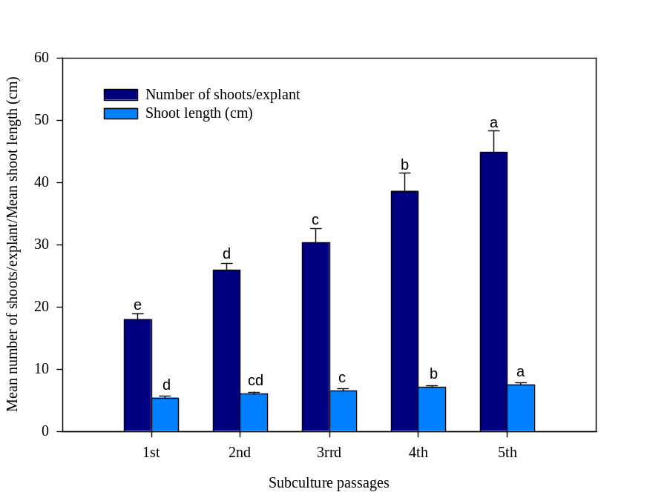

Fig. 1. The evaluation of morphogenetic potential of shoot culture obtained from TDZ (5.0 µM) after being tested for five subculture passages on growth regulator free MS medium. Bars represent mean ± SE. Means followed by the same letter are not significantly different (P = 0.05) using Duncan’s multiple range test.

Table 3. Effect of MS strength and IBA concentration on root induction from in vitro raised shoots of D. caryophyllus after 4 weeks of culture. Values represent means ± SE. Means followed by the same letter within columns are not significantly different (P = 0.05) using Duncan’s multiple range test.

Treatment % Rooting Mean no. of roots Mean root /shoot length (cm)

MS 60 1.8 ± 0.11^{d} 1.2 ± 0.14^{d}
(1/2)MS 72 3.1 ± 0.14^{bc} 2.0 ± 0.12^{c}
(1/2)MS + IBA (0.5 µM) 79 3.5 ± 0.17^{b} 2.8 ± 0.17^{b}
(1/2)MS + IBA (1.0 µM) 89 4.4 ± 0.23ª 4.0 ± 0.29ª
(1/2)MS + IBA (1.5 µM) 80 3.2 ± 0.27^{b} 3.6 ± 0.17ª
(1/2)MS + IBA (2.0 µM) 70 2.5 ± 0.20^{c} 3.0 ± 0.20^{b}

Table 4. Comparison of some morphological features between micropropagated plants and seedlings of D. caryophyllus.

Parameters Micropropagated plants Seedlings

Root length (cm) 5.84 ± 0.21 6.96± 0.34
Shoot length (cm) 12.31 ± 0.48 15.81 ± 0.67
Root fresh mass (g) 0.12 ± 0.11 0.16 ± 0.13
Shoot fresh mass (g) 1.36 ± 0.10 1.75 ± 0.14
Root dry mass (g) 0.05 ± 0.03 0.09 ± 0.02
Shoot dry mass (g) 0.45 ± 0.01 0.60 ± 0.04
Leaf dry mass g plant ⁻¹ 0.25 ± 0.02 0.32 ± 0.01
Leaf number/plant 20.12 ± 0.86 24.01 ± 0.95
Relative water content (%) 92.01 ± 1.63 67.53 ± 1.89

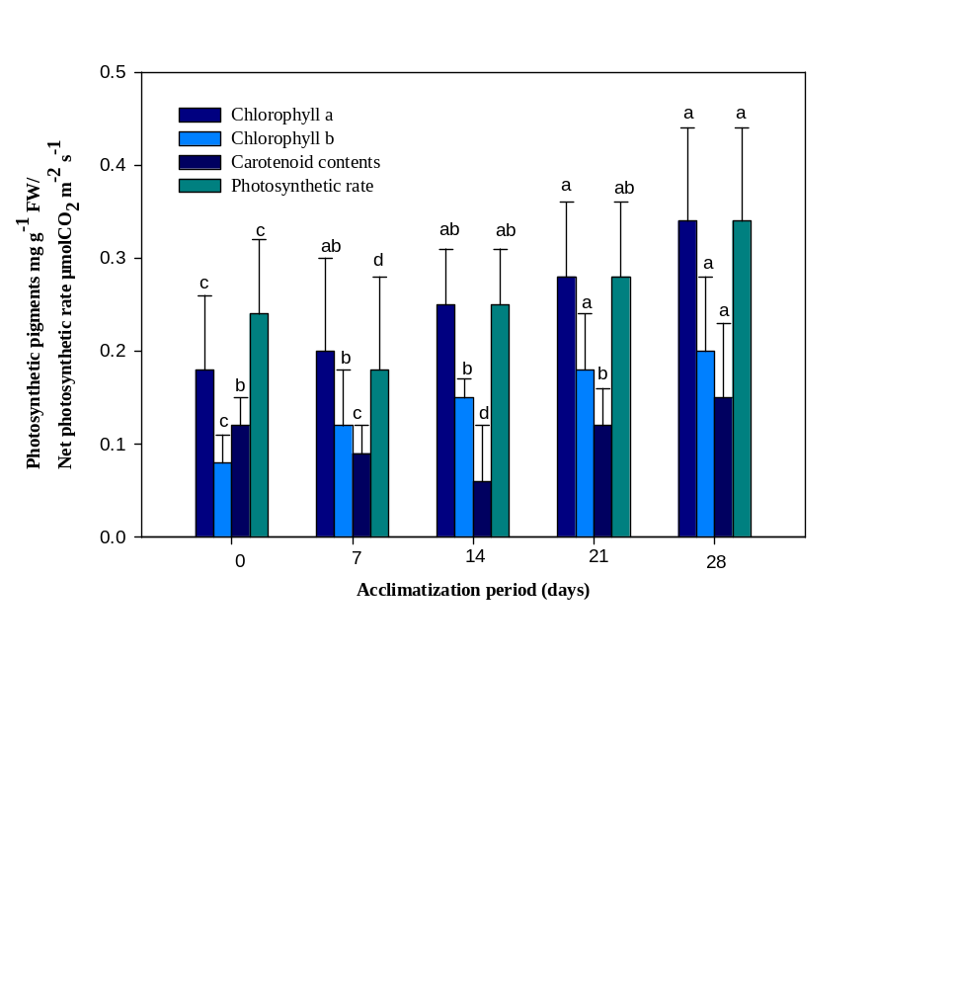

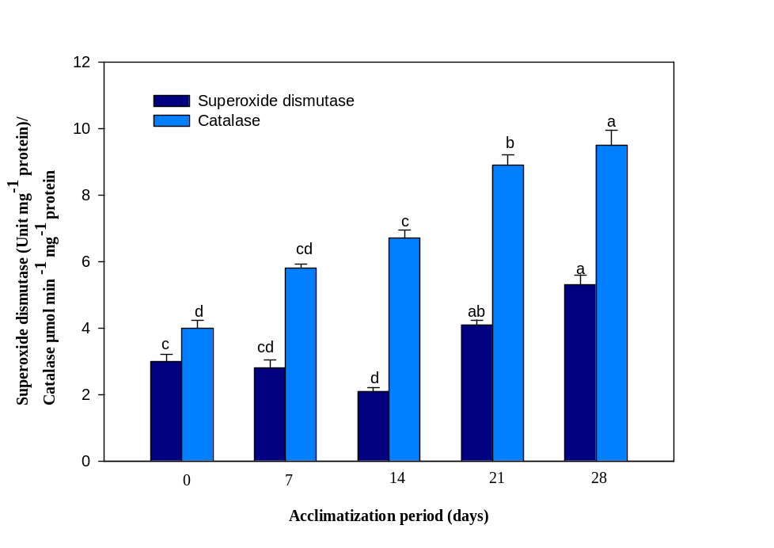A

B

Fig. 2 A & B. Changes in photosynthetic pigments, net photosynthetic rate (P_{N}), superoxide dismutase and catalase activity of micropropagated plantlets of D. caryophyllus during different days of acclimatization. Bars represents means ± SE. Bars denoted by the same letter within response variables are not significantly different (P = 0.05) using Duncan’s multiple range test.
Explanation of Fig. 3 (A-F):
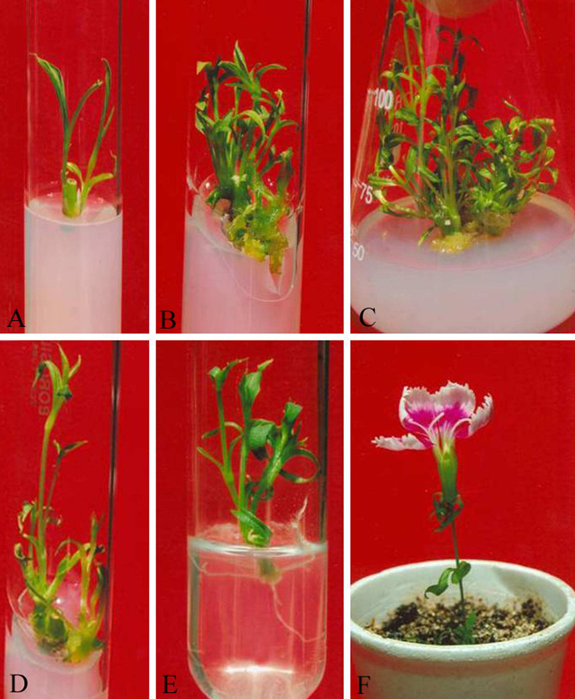
In vitro shoot multiplication and plantlet formation in D. caryophyllus. (A & B) Induction of multiple shoots on MS + TDZ (5.0 µM). (C & D) Shoot multiplication and elongation on MS medium devoid of TDZ. (E) In vitro rooting on ½ MS + IBA (1.0 µM). (F) In vitro flowering in an acclimatized micropropagated plant.

