Effects of Different Temperature and GA3 concentrition on Seed Germination and Seedling Establishment of Rhododendron purdomii Rehd. et Wils. in Qinling Mountains
Bing Zhao*
College of Forestry, Northwest A&F University, Yangling,Shaanxi , 712100 P.R.China
*Fax:029-87082216, Email:bingbing2003915@163.com
Abstract
Rhododendron purdomii Rehd. et is an endemic and important ornamental plant species in China. The effects of temperature and gibberellins (GA3) on R. purdomii seed germination and early seedling establishment were studied. The results showed that there was little difference among the effect of three temperatures on the starting germination time and germination speed ,but temperature significantly affected germination rate, germination vigor and early seedling growth. High temperature had negative effects on seed germination, and the germination vigor at 20℃ were significantly higher than those at two other temperature treatments, germination rate and germination vigor were the lowest at 30℃; and the survival rate and leaf length of the seedlings at 20℃/30℃ were far better than those at two other temperature treatments , A temperature of 30℃ was the worst temperature for seedling establishment . Compared with the controls, after the seeds were soaked for 24h in different concentrations of GA3, the starting germination time、germination rate and germination vigor were dramatically increased. the seedlings of 600 mg.l⁻¹ GA3 treatment has a much higher survival rate and growth performance. Therefore, the findings from this study would greatly help the germplasm propagation、conservation and utilization of R. purdomii.
Key words: Rhododendron purdomii, germination rate, germination vigor, temperature, gibberellin(GA3), seedling growth
INTRODUCTION
Rhododendron purdomii Rehd. et Wils. , a member of Ericaceae family, Rhododendron genus, is an endemic and evergreen shrub distributed in China. It has higher and more special ornamental value ,thus can be the most important parential source of Rhododendron crossing-breeding. What’ more, R. purdomii is also a typical genus in Qinling Mountains, which is beneficial to maintaining the stability of the ecosystem and one of the most valuable plants because of its cold-resistance and high breeding value (Gen, 2008). Recent years, R. purdomii germplasm was endangered mainly because of human being’s excessive excavation activities and poor self-renewal capacity. besides, few cultivars were cultivated and planted in modern city landscape.
To prevent R. purdomii from the extinction and maintain its diversity, and cultivate colorful landscape cultivars. There is a growing demand for conservation and breeding projects that require the implementation of active propagation measures. seed propagation might be preferable to protect germplasm, and enrich genetic diversity of one specie (Zhang et al.,2010). More importantly, as to wild resources, the seedling from seeds are more easily adapted to the new environment than transplanted seedling directly from mountains.
At present, studies on R. purdomii are mainly concentrated on chemical component (Liu et al.,2009) and morphological variation (Si et al.,2012) , but few studies were conducted about seed germination and seedling establishment of R. purdomii.
External factors such as temperature are known to affect seed germination. Studies of how this factor affects seed germination in Rododendron genus have provided various results. Some species demand higher temperature to germinate (Antonidaki-Giatromanolaki et al.,2008; sajad et al.,2012; Fan et al.,2011). While low temperature are favorable for germination for other species(Vologdina,2006; Zhang et al.,2007). As we have known, many researches had concentrated on the effect of temperatures on the seed germination of one species(Phartyal et al.2003;. Massawe et al.2003; Perez-Garcia et al.2005)
Hormone concentration is another important factor to affect seed germination. Which can be used for dormancy-breaking, Germination requirements of many Rhododendron indicate the seeds have a non-deep, simple, morphphysiological dormancy,but addition of gibberellins was also proved to increase germination rate of Rhododendron species (Tiwari et al.,2007; Tilki ,2007;Gao et al.,2010;Su et al.,2011;) and other species(Tigabu et al.2001).
Previous researches suggested that most of these factors show diverse effects on seed germination characteristics of different species. But there was no knowledge on how these factors affect the germination of this species. and many germination literatures about Rhododendron just limited to the seed germination exporation, but no further seedling establishment researches were conducted.
The objective of the present study was, therefore to explore seed germination responses and seedling establishement of R. purdomii to temperature and GA3 concentration to determine seed propagation requirements, and provide conservation strategies for R. purdomii. Such information is expected to develop standard germination procedures and provide conservation strategies suitable for R. purdomii.
Materials and Methods
Seed source
Ripe capsules of R. purdomii were harvested from Niu beiling district of Qinling Mountain at the end of November in 2012. the capsules were air-dried at room temperature until the seeds blown out, then put these seeds into paper bags and store them in dried and dark place until March 2103.
Experimental design
The experiment was designed according to a completely randomized factorial ofthree temperatures and six GA3 concentration treatments. three temperatures treatments were 20℃、30℃ and 20℃（16h）/30℃ (8h); GA3 concentration treatments were as follows: 0mg/l、200 mg/l、400 mg/l、600 mg/l、800 mg/l、1000 mg/l . Each treatment was replicated three times, every replicate was 100 seeds.
Seed germination tests
Germination tests were performed in incubators (Conviron A1000, Canada) with automatic temperature and light control . First ,seeds were immersed in GA3 for 24h ,then rinsed three times with deionized water and dried on filter paper. Finally 100 seeds were counted on and put inside 12-cm petri dish containing absorbent gauze and filter paper . To control fungal contamination, seeds were periodically transferred to clean petri dishes, and the absorbent gauze and filter paper were changed and moistened with new deionized water every day. The germination dishes were rearranged daily to avoid effects of potential temperature and light differences or gradients in the incubators.The germinated seeds were recorded everyday for 10 d. Seeds were considered to have germinated as soon as radicale broke through sccd coats. Germination performance was estimated according to the rate of germinated seeds. FGP is the rate of germinated seeds on the 14th day.
Seedling growth test
When cotyledon growed out, the seedlings were removed to the greenhouse. 48 germinated seedlings in the same development stage at evert temperature were randomly selected from all the different germination treatments , planted in the box contained humus and perlite in a farm under natural temperature and a natural light ,seedlings were watered regularly. two months later, the growth index such as the survival rate, plant height, leaf number, leaf length and leaf width of the seedlings were measured.
Statistical analysis
Germination rate and germinating vigor were calculated by the Excel software. Germination rate GR=(n／N )×100% ,where n is the number of germinated seeds ,N is the number of experimentalseeds; germinating vigor(GV) is the germination rate on the 14th day. The germination and seedling growth characteristics were subjected to analysis of variance followed by Duncan’s multiple range test using SPSS 11.5 software (SPSS Inc., Chicago, IL) and Excel 2003(Microsoft Inc.Redmond,WA).
Results
Seed germination. The germination starting time under three temperatures are all the 8th or 9th day. the germination period of R.purdomii was about 2-3 days and came to the maximum germination rate at the 10^{th-}11th day after seeding(Fig. 1). and the temperature of 20℃ has the highest germination rate and germination vigor, the germination rate and germination vigor at 30℃24h was far lower than that of at 20℃24h and 20℃8h/30℃16h , and there was significant difference among the effect of three temperatures on germination rate and germination vigor(Table 1).
The highest germination rate were obtained when GA3 concentration was 400 mg.l⁻¹ ( Table.1). Compared with control, the seeds with GA3 treatment has more higher germination rate and germination vigor, the germination rate of the control was almost zero. What’ more, there was significant difference among the effect of different GA3concentration on germination rate and germination vigor, but when GA3 concentration continued to increase, the germination rate and germination vigor began to decrease rapidly (Table1). so it was not beneficial to seed germination of R. purdomii when GA3 concentration was too high (Table1).
Seedling establishment. The performance of seedling growth were observed after transplanted for 2 months, The results showed that there was a significant difference among the effect of three temperatures on the survival rate of seedling ,plant height, leaf length, leaf width and leaf number. The survival rate and leaf length at 20℃/30℃were significantly higher than that of other two temperature treatments, and the temperature of 30℃ has the lowest survival rate and growth indexes value(Table 2,Fig.2). Meanwhile, plant height, leaf number and leaf width at 20℃ were higher than those at 20℃/30℃, but the difference was not significant. but there were significant difference among the effect of different GA3 concentration on the seedling vigor. what’more, the seedlings of 600 mg.l⁻¹ GA3 treatment has a much higher survival rate and growth indexes value (Table 2).
Discussion
Temperature is the most important environmental factor affecting growth of plants, and germination of most plants need temperature. In this study, the germination period of R. purdomii was about 10-11d , which is far shorter than other Rhododendron species such as R. delavayi( Duan et al.2007). the temperature of 30℃ has the slowest germination speed among three temperatures. While the germination study of Cynanchum bungei Decne (Zhang,2012). and R. delavayi. ( Duan et al.2007) showed that the higher the temperature, the earlier seeds of began to germinate (Zhang,2012).
the germination rate and germination vigor at 20℃ were significantly higher than that of other two temperature treatments, the germination vigor at 30℃ is the lowest( Table 1 , Figure 1). it shows that R. purdomii seeds prefer lower temperatures to germinate,maybe because low temperature ,which has the same effect with gibberellins ,can break seeds dormancy .while too high temperature will delay germination initiation time, decrease the germination speed and the germination vigor, it was hypothesized that because this species adapt to low temperature under the natural wild environment，the wild population of R. purdomii mainly growed on the mountains, which height is more than 2000 metres and the temperature is under 20℃, the lower temperature will easily facilitate seed germination. While high temperature make biochemical process and respiration of seeds vigorous , storage was seriously deplete, leading the lower germination rate. This result was in agreement with the germination trait of R. molle G.(Shi et al.,2010), R. pizewalskii (Li et al.,1998) and R.rufum Batal(Yang et al.,1997), but contradictory to that of R. irroratum Franch(Fan et al.,2011). which findings showed that the germination rate and germination vigor at 30℃ was the best. But studies on seed germination of some other species showed that low temperature was much better than high temperature for seed germination(Kochankov et al.1998;Aiazzi et al.2000; Muhl et al.2011)
Nevertheless, the growth performance of the seedlings at 20℃/30 ℃ and 20℃ were better than that at 30℃. which showed that high temperature was not only unsuitable to seed germination but was not favorable to seedling establishment of R. purdomii.
Compared with the control group, after soaked 24h with different concentration GA3, germination rate and germination vigor were all dramatically enhanced, the highest germination rate and germination vigor were gained when GA3 treatment was 400 mg.l⁻¹ .but the seedlings of 600 mg.l⁻¹ GA3 treatment has the best growth iperformence, it showed that GA3 treatment can leading to high germination rate and germination vigor, but has a positive effect on the seedling growth.
This research demonstrated seed propagation is a valuable method for the reproduction and conservation of R. purdomii. Both low temperature (20℃) and GA3 treatment can break R. purdomii seeds dormancy and promote seed germination , and the temperature of 20℃/30 ℃ has much higher germination rate and germination vigor, and it also can dramatically the survival of the seedlings. Therefore 20℃/30 ℃ was appropriate requirements for seed germination and seedling establishment. The findings will facilate genetic diversity preserving, germplasm conservation and new cultivars development of R. purdomii.
Acknowledgements
This research was conducted in woody ornamental palnts lab in The University of Georgia in American. Funding for this research was provided by National Natural Science Foundation of China (k305021110) and Shaanxi Natural Science Foundation (2012JQ3008) and construction project of Forestry Department of Shaanxi Province(Shan 2011(70)).
References
Aiazzi M. T. , Rienzo J. A. , Argüello J. A.(2000). Effects of light and temperature on the germination and seedling vigour of Atriplex cordobensis (Gandoger et Stuckert) seeds harvested in autumn and winter.Seed Science and Technology ,28 : 477-484.
Antonidaki-Giatromanolaki A. , Dragassaki M. , Papadimitriou M. , Vlahos I.(2008).Effects of stratification, temperature and light on seed germination of Colchicum macrophyllum B. L. Burtt. Propagation of Ornamental Plants, 8 : 105-107.
Duan X., Chen X., Zhao Y.Y. (2007).Study of the Seed Germination of Rhododendron delavayi．Journal of Anhui Agricultural Science, 35：9199-9200
Fan C.L.， Che，X., XingJ.N. (2011). Effects of Different Treatments on Seeds Germination of Rhododendron. Seed,30：106-108.
Gen Y.Y., (2008). The Interpretation of Rhododendron in China.
Gao G.L., Long X.Q., Hu X.J., Lu X.L., ChenX. (2010). Effect of GA on Two Species Alpine Rhododendron Seeds Germination . seed,5：22-25.
Gutterman Y. (2000).Environmental factors and survival strategies of annual plant species in the Negev Desert, Israel.Plant Species Biology,15:113-125.
Huang C. L., Zhou H.J., Chen X., Gao G.L. (2010). Effect of GA3 immersion on germination of seeds of Rhododendron decorum. Plant Physiology Communications, 46: 793-796.
Kochankov V. G. ,Grzesik M., Chojnowski M. , Nowak J.(1998). Effect of temperature, growth regulators and other chemicals on Echinacea purpurea Moench seed germination and seedling survival.Seed Science and Technology,26 :547-554.

Liu X., Gao J.D., Zhao L.(2009).Studies on Chemical component of Rhododendron purdomii. Chinese Herbal Medicines, 11:1723-1725.
Li C.H., Sun H.Q., Yang Y.W., He J.Z. (1998).A Study on Germination Percentage for Rhododendron Przewalskii Seeds.Journal of Qing hai University,16：15-17．
Moura M. , Silva L. (2010).Seed germination of Viburnum treleasei Gand., an Azorean endemic with high ornamental potential. Propagation of Ornamental Plants, 10 : 129-135.
Massawe F. J.,Azam-Ali S. N.,Roberts J.A.(2003).The impact of temperature on seed germination in bambara groundnut (Vigna subterranea (L.) Verdc) landraces .Seed Science and Technology, 31:259-273.
MuhlQ.E. ,ToitE.S.du , RobbertseP.J.(2011).Temperature effecton seed germination and seedling growth of Moringa oleifera Lam. Seed Science and Technology ,39 :208-213.
Perez-Garcia F, Gonzalez-Benito M.E.(2005).Effects of temperature and different pre-treatments on seed germination of four Halimium species . Seed Science and Technology, 33: 505-509.
Phartyal S.S., Thapliyal R.C., Nayal J.S. Rawat, M.M.S.,Joshi, G.(2003).The influences of temperatures on seed germination rate in Himalayan elm (Ulmus wallichiana) Seed Science and Technology, 31: 83-93.
RanF., Wu C.C., Peng G.Q., Korpelainen H., Li C.Y.(2010).Physiological differences in Rhododendron calophytum seedlings regenerated in mineral soil or on fallen dead wood of different decaying stages.Plant Soil,337:205-215.
Shi D.H., Chen X.( 2010). Effect of Different Treatments on Rhododendron molle G. Don Seed Germination. Seed, 9: 91-94.
Su J.L.， L，Ch., Chen L. , Liu X.Q., Chen S.P., HE L.S. (2011) .Effects of different pretreatment methods on seed germination of Rhododendron aureum and R．parvifolium. Journal of Plant Resources and Environment,20 : 64-69.
Sajad R. , Shailesh P. , Nautiyal S. (2012).Studies of seed germination in four Rhododendron species of Garhwal Himalayas.Indian Forester,138:284-288.

Si G.C. , Zhang Z.X., Zhao B. , Xu H.(2012). Phenotypic variation of natural populations in Rhododendron purdomii in Qinling Mountains.Acta Bot.Boreal.-occident.Sin, 8: 1560-1566 .
Tilki F. , Guner S.(2007).Seed germination of three provenances of Arbutus andrachne L. in response to different pretreatments, temperature and light.Propagation of Ornamental Plants, 7 : 175-179.
Tiwari O. N. , ChauhanU. K.(2007).Seed germination studies in Rhododendron maddenii Hook.f. and Rhododendron niveum Hook.f.Indian Journal of Plant Physiology, 12: 50-56.
Tigabu M; Oden P.C. (2001).Effect of scarification, gibberellic acid and temperature on seed germination of two multipurpose Albizia species from Ethiopia
Seed Science and Technology, 29 : 11-20 .
Vologdina O. S. (2006).Biology of Rhododendron dauricum, R. mucronulatum and R. sichotense (Ericaceae) seeds germination.Rastitel'nye Resursy,42:55-60.
Washitani I., Masuda M. A.(1990).Comparative study of the germination characteristics of seeds from a moist tall grassland community.Functional E cology,4:543-557.
Yang S.H. , TianX. (2007). Chemical components of Rhododendron purdomii. Acta Botanica Boreali-Occidentalia Sinica ,27 :364-370.
Yang Y.W., Sun H.Q. , Zhang Z.H.(1997).A Study on Germination Percentage for Rhododendron Rufum Seeds. Journal of Qinghai University. 15:17-19.
Zhao L., Wu D.H., Yu X.H., Zhang Y.(2010).Dihydroflavones in Rhododendron purdomii. China Journal of Chinese Materia Medica, 6: 722-724.
Zhang H.Y.(2012).Seed Germination and Early Seedling Growth of Cynanchum bungei Decne (Asclepiadaceae) in Response to Photoperiod, Temperature,and Seed Size. HORTSCIENCE, 47:1338-1341.

Zhang J.L., Wu Y.W. , Wu H.Z., Zhao H.Z., WangY.Y. (2012). Studies on seed germination of four species of Subgen.Hymeanthes (Blume) K. Koch Ericaceae in Yunnan . journal of agricultural university,27:875-881.
Zhang L.H. , Liu X.P., Wang K.H., Zhao X.H.; Wang Z.H. , Li X.H. (2007).Factors influencing seed germination and seedling survival of Rhododendron subgenus Hymenanthes. Journal of Wuhan Botanical Research ,25 : 178-184.

Table 1. Effect of different temperature and GA3 concentration on germination time、germination rate and germination vigor of R. purdomii
 | Germination rate | Gemination vigor
temperature | ** | **
20℃ | 0.8050 a | 0.7782 a
30℃ | 0.7054 b | 0.5802 b
20℃/30℃ | 0.7562 c | 0.7169 c
GA₃ concentration (mg.l-1) | ** | **
0 | 0.0056 a | 0.0000 a
200 | 0.7575 b | 0.6583 b
400 | 0.9729 cd | 0.9222 d
600 | 0.9353 c | 0.8968 cd
800 | 0.9400 c | 0.8575 cd
1000 | 0.9219 c | 0.8158 c
** Different letter has significant difference at 0.01 level.
Table 2 Survival Rate of Plant(SR)、Plant Height(PL) 、Leaf Number(LN)、 Leaf Length (LL) and Leaf Width (LW) of R. purdomii at 20 ,20/30 and 30 in 24 continuous light
factors | Survival Rate of Plants | Plant Height (cm) | leaf  number(cm) | Leaf length(cm) | leaf width(cm)
Temperature | ** | ** | ** | ** | **
30℃ | 0.5347 a | 1.0833 a | 4.6389 a | 0.8667 a | 0.5500 a
20℃/30℃ | 0.9375 b | 1.8389 b | 7.4667 b | 1.4944 b | 0.8000 b
20℃ | 0.7000 c | 2.0400 b | 9.2667 c | 1.4800 b | 0.8067 b
GA3concentration(mg.l⁻¹ ) | ** | ** | ** | ** | **
0 | 0.5000 a | 1.0000 a | 1.4000 a | 0.7500 a | 0.5500a
200 | 0.6667 bc | 1.4667 b | 6.4444 b | 1.0222b | 0.5889b
400 | 0.6250 b | 1.6778 bc | 7.6111 bc | 1.4556c | 0.7333c
600 | 0.7917 c | 2.2111d | 8.4444 d | 1.5778cd | 0.8778d
800 | 0.5833 b | 1.5222 b | 8.0000 cd | 1.1889b | 0.7667cd
1000 | 0.7778 c | 1.7000 c | 8.2222 d | 1.3444bc | 0.7111c
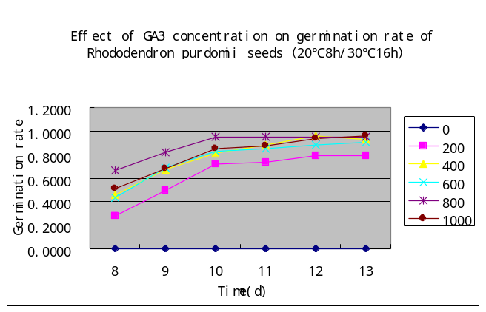
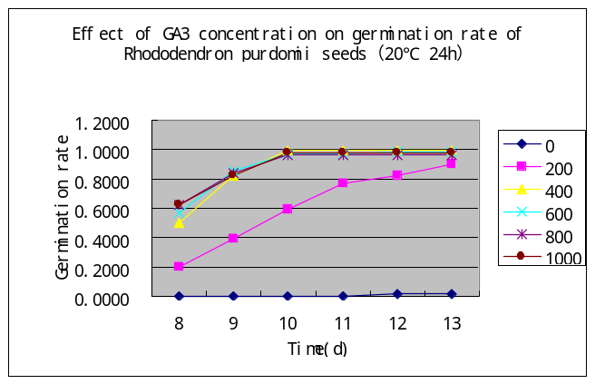
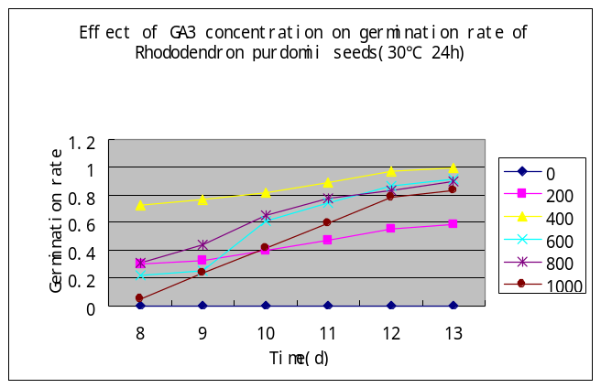
Fig. 1 Effect of GA₃ concentration under three temperatures on germination rate of R. purdomii seeds

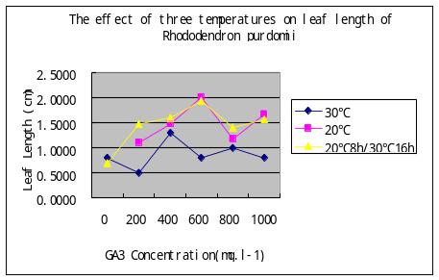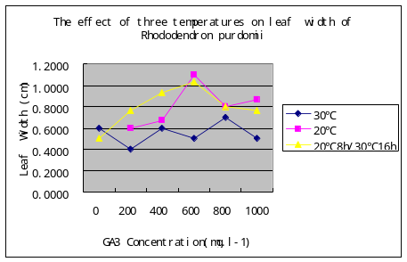
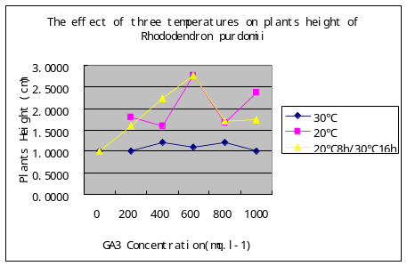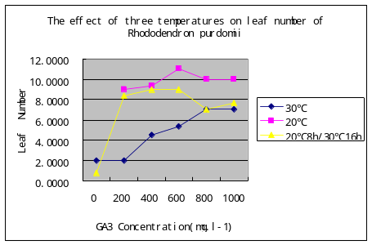
Fig. 2. The effect of three temperature on plants height、leaf length 、 leaf width and leaf number of R. purdomii

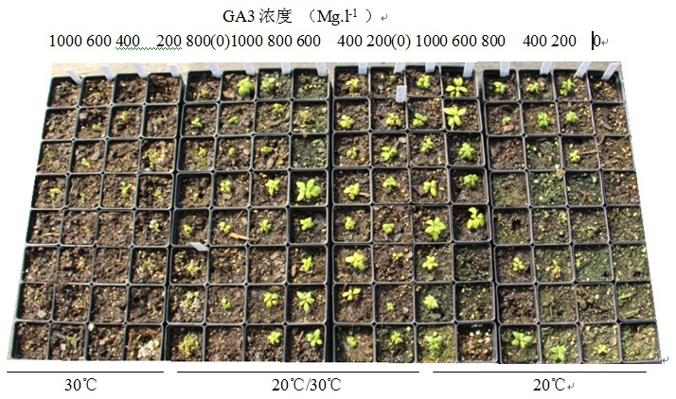
Fig. 3. Seedling establishment of R. purdomii at 20℃ ,20℃/30 ℃ and 30℃ in 24 continuous light

