EFFICIENT MASS PROPAGATION OF Origanum acutidens (HAND.-MAZZ.) IETSWAART UNDER IN VITRO CONDITIONS
Suleyman KIZIL^{1*}, Ugur SESIZ¹, Khalid Mahmood KHAWAR²
¹Department of Field Crops, Agriculture Faculty, Dicle University, 21280 Diyarbakir, TURKEY
²Department of Field Crops, Agriculture Faculty, Ankara University, 06110 Ankara, TURKEY
*Corresponding author: suleymankizil@gmail.com; Fax: +90 412 2488153
ABSTRACT
Origanum acutidens (Hand.-Mazz.) Ietswaart is an endemic species found in Eastern and South Eastern Anatolian region of Turkey. Germplasm conservation of O. acutidens under field collections could be enhanced positively if the techniques for culture of the plants like holding of the seeds in gene banks, and cultivation techniques both through traditional and biotechnological methods are developed in conservation activities interactively. The study describes germination of O. acutidens seeds followed by micropropagation from stem nodes of 45 days old seedlings that were cultured on MS basal medium containing 0.4, 0.8, 1.2, 1.6 and 2 mg/l BAP with or without 0.5 mg L⁻¹ NAA cultured at 24ºC under cool white fluorescent lights (30 000 lux) with 16 h light photoperiod. The results showed maximum number of 9.28 shoots per explant on MS medium containing 0.8 mg L⁻¹ BAP. Comparing regeneration on MS medium containing concentrations of BAP with and without 0.5 mg/l NAA; it was noted that shoot regeneration on MS medium containing BAP - NAA was partially inhibitory and induced reduced number of shoots per explant. Well developed shoots of O. acutidens on each concentration of BAP with or without NAA were rooted on MS medium supplemented with 0.75 mg L⁻¹ NAA. The rooted plantlets were acclimatised and transferred to greenhouse for flowering and seed set. The results suggest high potential of using this protocol for practical production of the plant for commercial purposes.
Keywords: Origanum acutidens; germination, plant growth regulators, micropropagation
INTRODUCTION
The genus Origanum is an important genus of the Lamiaceae family and comprises about 900 species, widespread throughout the world, out of which 22 species and 32 taxa are found in Turkey (Davis, 1982; Baser, 2002). Origanum species are of great economic importance due to its use as spicy additive for food (Kokkini, 1996) herbal teas, culinary herb to flavour food products and alcoholic beverages. O. acutidens essential oil contains carvacrol and p-cymene as major components, and its essential oil exhibit a significant antimicrobial activity against the bacteria (Cosge et al., 2008). O. acutidens (Hand.-Mazz.) Ietswaart is an endemic plant and of dispersed distribution in South-Eastern and Eastern Anatolian Regions of Turkey (Tubives, 2013).
Studies on germination of different species of Origanum (Putievsky, 1983; Thanos et al., 1995) confirm partial seed dormancy and poor germination ability in fresh seeds. There is indirect evidence that the seeds of O. majorana and O. vulgare may exhibit dormancy (Ellis et al., 1995). These characteristics can be advantageous for seed conservation, dormancy determining a condition of metabolic quiescence which holds unvaried vigour and quality of seeds thus reducing seed deterioration rate during conservation, even in adverse environmental conditions.
In addition, in vitro culture techniques can be an alternative method for the continuous provision of plantlet stocks for large scale field cultivation of important medicinal plants. Economic homogenous propagation of the plant, within each accession is desired characteristic for economic proliferation of the plant vegetatively to shorten the juvenile period and induce precocity, a factor that has been observed in Origanum (Ravid and Putievsky, 1987).
The study aimed to break partial seeds dormancy in fresh seeds and determine regeneration ability of lateral stem nodes of O. acutidens seedlings under in vitro conditions to judge the effect of different plant growth regulators on regeneration.
MATERIALS and METHODS
Plant material
The seeds of O. acutidens were collected at 1200 m altitude from district Maden of Elazıg province, Turkey during the last week of July 2009. The plants were identified in the Department of Biology, Dicle University, Diyarbakir, Turkey.
Micropropagation
Surface-sterilization of Origanum acutidens seeds was carried out for 15 min using 50% commercial bleach (containing 5% NaOCl) after addition of 0.5 ml of Tween 20 per 100 ml NaOCl followed by 3x3 min rinsing with sterile water. Thereafter, they were cultured on MS (Murashige and Skoog, 1962) regeneration medium supplemented with 3 % sucrose, 0.7% agar (Duchefa) and autoclaved at 121 ºC, under pressure of 1.05 kg cm ⁻² for 20 minutes. The pH of the medium was adjusted to 5.6-5.8 with 0.1 N KOH or HCl before autoclaving.
The seeds germinated after 13 days of culture that developed into full plantlets after 58 days of culture (Figure 1). They were used to obtain stem nodes that were cultured on MS medium (Murashige and Scoog, 1962) supplemented with 0.4, 0.8, 1.2, 1.6 and 2 mg L⁻¹ BAP (Benzyl amino purine) with and without 0.5 mg L⁻¹NAA (Naftalen acetic acid) (two factors). Cultures were maintained at 24 °C under white fluorescent light of 42 μmol·m⁻²·s⁻¹ with 16 hrs light (42 µMol photons m⁻²s⁻¹) and 8 hrs dark photoperiod set at 24±1°C.
Rooting and acclimatization
Regenerated plants were cultured on MS medium without growth regulators for 9 weeks. The cultures were incubated at 16 h light photoperiod conditions at 24 ± 1°C. Well developed shoots of O. acutidens were rooted on MS medium supplemented with 0.75 mg L⁻¹ NAA (Figure 1). The rooted plants were transferred to peat moss, and covered with polythene bags in greenhouse under ambient conditions of light (16 h light photoperiod) and temperature (24-26 ºC) for acclimatisation. Thereafter 2 weeks, when the plantlets began to show signs of growth, they were gradually exposed to reduced relative humidity by progressively removing the polythene bags over a period of three weeks.
Statistical analysis
The experiment made use of 60 explants for each treatment with 5 explants per replications (5 explants x 12 replications=60 explants). The data were statistically processed by analysis of variance (ANOVA) followed by the Duncan multiple range tests with a significance level at P < 0.05.
RESULTS
Shoot regeneration using BAP from stem node explants
The results (Table 1) of the experiment showed 80-100% shoot regeneration on MS medium containing various concentrations of BAP-NAA. Shoot regeneration percentage showed statistically insignificant differences of the effects of BAP concentrations, but had tendency of reduction with increasing concentration of BAP in numerical terms. The minimum shoot induction percentage was noted on MS medium containing 2.0 mg L⁻¹ BAP. Statistically similar number of shoots per explant was noted on MS medium containing 0.4 to 1.6 mg L⁻¹ BAP followed by sharp decrease in number of shoots per explant on MS medium containing 2. mg L⁻¹ BAP. Maximum number of 9.28 shoots per explant was noted on MS medium containing 0.8 mg L⁻¹ BAP (Table 1).
Mean shoot length ranged 1.83 to 3.25 cm. Maximum shoot length of 3.25 cm was recorded on MS medium containing 1.6 mg L⁻¹ BAP (Table 1).

Table 1 here

Well developed shoots on each medium rooted on 0.75 mg L⁻¹ NAA showed variable acclimatisation behaviour (last column Table 1). Percentage (%) of acclimatised plants ranged 60 to 100%. The minimum percentage of acclimatisation was noted on the plants regenerated on MS medium containing 2 mg L⁻¹ BAP. Cent percent acclimatisation was noted on plantlets regenerated on MS medium containing 0.4 and 1.2 mg L⁻¹ BAP (Table 1).
Shoot regeneration using BAP-NAA from stem node explants
The result showed 80 to 100% shoot regeneration on stem node explants on MS medium containing 0.4 to 2.mg L⁻¹ BAP - 0.5 mg L⁻¹ NAA (5 combinations) and showed variations among them in terms of statistics. Cent percent or statistically similar shoot regeneration was noted on MS medium containing 0.4, 0.8, 1.2 and 1.6 mg L⁻¹ BAP - 0.5 mg L⁻¹ NAA followed by sharp fall in regeneration percentage (80%) on MS medium containing 2 mg L⁻¹ BAP-0.5 mg L⁻¹ NAA (Table 2).
Maximum number of shoots per explant was regenerated on MS medium containing 0.4 mg L⁻¹ BAP-0.5 mg L⁻¹ NAA followed closely by 6.25 shoots per explant on MS medium containing 1.6 mg L⁻¹ BAP-0.5 mg L⁻¹ NAA. All other BAP-NAA combinations were inhibitory variably.
Mean shoot length ranged 0.82-2.07 cm. Minimum and maximum shoot length was recorded on MS medium containing 1.2 mg L⁻¹ BAP - 0.5 mg L⁻¹ NAA and 0.4 mg L⁻¹ BAP - 0.5 mg L⁻¹ NAA respectively. However, no statistical difference among shoot length was recorded on any variant of BAP-0.5 mg L⁻¹ NAA (5 combinations) (Table 2).
Well developed shoots that regenerated on MS medium containing different concentrations of BAP - 0.5 mg L⁻¹ NAA were rooted on MS medium containing 0.75 mg L⁻¹ NAA ( Figure 1). No problem was recorded in rooting of these shoots irrespective of their origin. Percentage of acclimatised plants ranged 57.1-100% (Table 2). Cent percent acclimatisation was noted on shoots regenerated on MS medium containing 0.4, 1.2, 1.6 and 2 mg L⁻¹ BAP-0.5 mg L⁻¹ NAA. A sharp decrease of 57.1% in acclimatisation was noted on shoots regenerated on MS medium containing 0.8 mg L⁻¹ BAP-0.5 mg L⁻¹ NAA.

Table 2 here

DISCUSSION
The study compared effects of MS medium containing 0.4, 0.8, 1.2, 1.6 and 2.0 mg L⁻¹ BAP with and without 0.5 mg L⁻¹ NAA to achieve pragmatic clonal propagation of O. acutidens on stem node explants. The basic idea was to know if this variation could induce any effect on shooting and rooting potential of the plant. Development of in vitro micropropagation protocols for medicinally important and neglected plant species is highly desirable.
Almost, similar shoot regeneration frequency on MS medium is containing different concentrations of BAP with and without 0.5 mg L⁻¹ NAA. However, a comparison in number of shoots per explant showed that addition of 0.5 mg L⁻¹ NAA to the culture medium induced partial inhibition the induction and shoots per explant. Percentage of acclimatised plants was slightly better when the culture media contained different concentrations of BAP with 0.5 mg L⁻¹ NAA. The results show compatibility with Socorro et al. (1998), Goleniowski et al. (2003) and Moreno-Fortunato and Avato (2008); who used MS medium containing BAP with and without NAA for micropropagation. Akcam and Yurekli (1993) reported callus cultures studies in O. sipyleum and Oluk and Cakir (2009) reported micropropagation of O. bastetanum using seedlings-derived explants. The researchers used shoots obtained from 17d old seedlings that were multiplied on modified MS medium containing 550 mg L⁻¹ of CaCl₂ for sustained growth. They were successful to induce multiple shoots (3.7 ± 0.3 shoot/explant) on medium containing 1 mg L⁻¹ BAP. Contrarily, this study reports higher number of shoots per explant obtained from 54 d old plants and did not need any concentration of CaCl₂ to induce shoots.
This study reports need of 0.75 mg L⁻¹ NAA in MS medium for rooting. Contrarily, Goleniowski et al. (2003) reported spontaneous rooting in shoot multiplication medium containing BA with NAA for O. vulgare. Whereas, Socorro et al. (1998) rooted micropropagated shoots of O. bastetanum, on peat substrate. Differential rooting protocols used in these studies show that rooting of different Origanum species is species dependent and may vary from situation to situation.
All rooted plants were acclimatised in the greenhouse, and they grew to flower and seed set.
CONCLUSION
This study reports in vitro approaches for propagation of valuable medicinal plant O. acutidens to help in efforts to provide high quality material for pharmaceutical, cosmetics and food industry. Multiplication of economically important medicinal plants through in vitro microproliferation techniques can have global economic and ecological impacts on conservation and maintenance of sustaining biodiversity.
LITERATURE CITED
Akcam E., Yurekli A.K. (1993). Callus culture studies on Origanum spyleum L. species. J. Fac. Sci. Ege Univ. 15: 21-25. (in Turkish)
Baser K.H.C. (2002). Aromatic biodiversity among the flowering plant taxa of Turkey. Pure Appl. Chem. 74: 527-545.
Cosge B., Turker A., Ipek A., Gurbuz B., Arslan N. (2009). Chemical Compositions and Antibacterial Activities of the Essential Oils from Aerial Parts and Corollas of Origanum acutidens (Hand.-Mazz.) Ietswaart, an Endemic Species to Turkey. Molecules, 14, 1702-1712.
Davis P.H. (1982). Flora of Turkey and the East Aegean Islands. Vol. 7. University Press, Edinburgh, pp. 297-313.
Ellis R.H., Hong T.D., Roberts E.H. (1995). Handbook of Seed Technology for Genebanks. Volume II. Compendium of Specific Germination Information and Test Recommendations. International Plant Genetic Resources Institute, Rome, Italy.
Goleniowski M.E., Flamarique C., Bima P. (2003). Micropropagation of Oregano (Origanum vulgare x 3 APPLII) from meristem tips. In vitro: Cell Dev. Biol. Plant. 39: 125-128.
Kokkini, S. (1996). Taksonomy, diversity and distribution of Oregano In: Padulosi, G. (Ed.), 4th Proceedings of the IPGRI International Workshop on Oregano, 8-12 May 1996, 61-67. Valenzano, Bari, Italy.
Moreno-Fortunato I., Avato P. (2008). Plant development and synthesis of essential oils in micropropagated and mycorrhiza inoculated plants of Origanum vulgare L. ssp. hirtum (Link) Ietswaart. Plant Cell Tiss. Org. Cult. 93:2, 139-149.
Murashige T., Skoog F. (1962). A revised medium for rapid growth and bioassays with tobacco tissue cultures. Physiol. Plant. 15: 473-497.
Oluk E.A., Cakir A. (2009). Micropropagation of Origanum sipyleum L., an endemic medicinal herb of Turkey. African Journal of Biotechnology, 8:21, 5769-5772.
Putievsky E., Ravid U. (1983). Differences in yield and essential oils of various types of Origanum vulgare L. grown under intensive cultivation conditions. Fourth International Symposium on Spice and Medicinal Plants, Angers, France. Acta Horticulturae 144: 71–76.
Raviv M., Putievsky E. (1987). Vegetative Propagation of Aromatic Plants of the Mediterranean Region. Herbs, Spices and Medicinal Plants: Recent Advances in Botany, Hoticulture and Pharmacology, (L.E. Craker and J.E. Simon, eds.). The Oryx Press Arizona, USA, 2: 159-181.
Socorro O., Tarrega I., Rivas F. (1998). Essential oils from wild and micropropagated plants of Origanum bastetanum. Phytochemistry, 48: 1347-1349.
Thanos C.A., Kadis C.C., Skarou F. (1995). Ecophysiology of germination in the aromatic plants thyme, savory and oregano (Labiatae). Seed Science Research, 5:3, 161-170.
Tubives, 2013. http://turkherb.ibu.edu.tr/index.php?sayfa=1&tax_id=7869, (accessed June 4, 2013).
Table 1. Rate of shoot induction, number of shoots per explant, shoot length and percentage of acclimatised micropropagated O. acutidens plants on MS medium containing different concentrations of BAP
BAP  (mg L⁻¹) | Shoot regeneration percentage  (%) | Number of shoots per explant | Shoot length  (cm) | Percentage (%) of acclimatised plants
0.4 | 100a | 6.66a* | 1.83b | 100.0a
0.8 | 100a | 9.28a | 2.46ab | 81.8ab
1.2 | 93.3a | 7.30a | 2.16ab | 100.0a
1.6 | 93.3a | 8.40a | 3.25a | 88.2a
2.0 | 80.0b | 2.48b | 2.26ab | 60.0c
*Mean values shown in a single column followed by different letters are significantly different at p<0.05 using Duncans multiple range test.
Table 2. Rate of shoot induction, number of shoots per explant, shoot length and percentage of acclimatised micropropagated O. acutidens plants containing different concentrations of BAP-NAA
BAP  (mg L⁻¹) | NAA  (mg L⁻¹) | Shoot regeneration percentage (%) | Number of shoots per explant | Shoot length  (cm) | Percentage (%) of acclimatised plants
0.4 | 0.5 | 100a* | 8.06a | 2.07 | 100a
0.8 | 0.5 | 100a | 4.70b | 1.92 | 57.1b
1.2 | 0.5 | 100a | 3.53b | 0.82 | 100a
1.6 | 0.5 | 93.3a | 6.25a | 1.35 | 100a
2.0 | 0.5 | 80.0b | 4.10b | 1.42 | 100a
*Mean values shown in a single column followed by different letters are significantly different at p<0.05 using Duncans multiple range test.
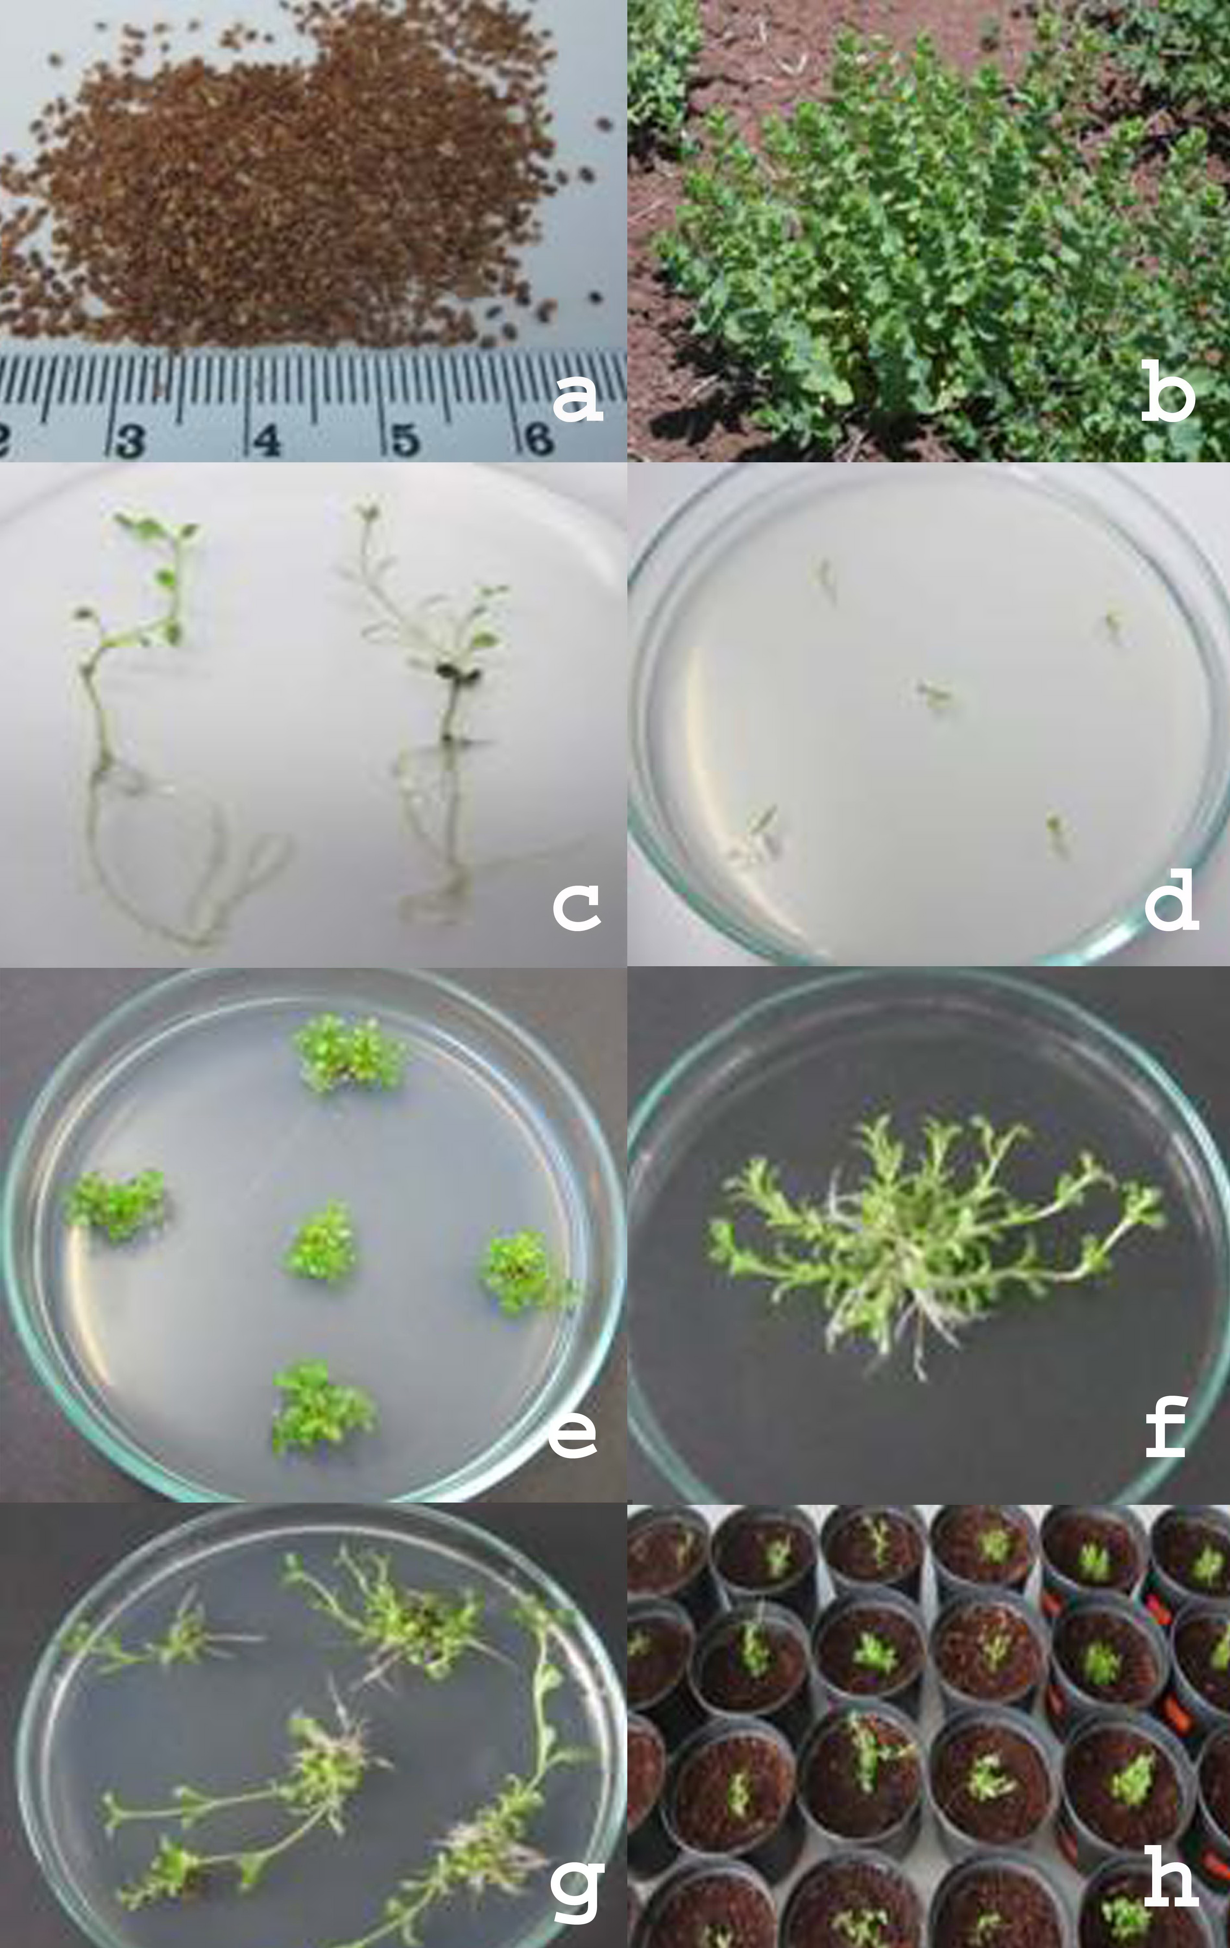
Figure 1: Plant regeneration from O. acutidens seeds; (a) seeds of the plant (b) whole plant in the field (c) germinated seedlings in the MS medium from seed (d) stem node explants sown in the MS medium contain BAP (e) regeneration from node explants (f-g) rooted explants in the MS medium containing BAP and NAA (h) rooted seedlings transplanted to pots

