Genetic Stability of Dianthus spiculifolius Schur, Endangered and Endemic Species

Victoria Cristea^{1*}, Cornelia Crăciunaş ², Delia Marcu³ and Anca Butiuc-Keul ²

¹"Babeş-Bolyai" University, "Alexandru Borza" Botanical Garden, 42 Republicii str., 400015, Cluj-Napoca, Romania, *Fax: 0040.264-592152, *E-mail: victoria.cristea@ubbcluj.ro
²"Babeş-Bolyai" University, Faculty of Biology and Geology, 5-7 Clinicilor str., 400006, Cluj-Napoca, Romania, Fax: 0040.264-431858, E-mail: ccraciunas@hasdeu.ubbcluj.ro; akeul@hasdeu.ubbcluj.ro
³"Babeş-Bolyai" University, Faculty of Environmental Science and Engineering, 33 Fântânele str., 400294, Cluj-Napoca, Romania, Fax: 0040.264-307032; E-mail: delia.marcu@yahoo.com

Abstract
Nowadays, the preservation of endangered and/or endemic plant species by biotechnological methods like in vitro culture is a complementary method of the in situ conservation. In order to develop a proper conservation program it is important to indentify the genetic polymorphism in the natural populations and then the possible somaclonal variation that could appear after in vitro culture, of ornamentally, phytogeographically and sozologically important plant species. Dianthus spiculifolius Schur is an endemic and endangered plant species from Romania with high ornamental value. SSR markers were used to investigate the genetic structure of the in situ and in vitro populations of this species. A total of five SSR primer pairs - DCAMCRBSY, DCDIA30, DINCARACC, DINGSTA and DINMADSBOX, generating clear and reproducible bands, ranging from 75 to 300 bp were used. The most polymorphic patterns were obtained with DINCARACC primer both in plants from natural habitats and in vitro plantlets. The molecular studies established that most of the individuals from natural habitats, independent on the population, belong to the same group according to Jaccard’s coefficient, except 2 individuals. The genetic variability of plants from natural habitats was conserved by in vitro culture. The genetic differences between somaclones derived from the same individual were low, so these plants could be possibly used for ex situ collections, for in situ repopulations or for production.

Key words: Dianthus spiculifolius, DINCARACC primer, genetic variability, in vitro culture, somaclonal variability, SSR markers.

Running title: Genetic stability of Dianthus spiculifolius

Introduction
The concept of sustainable development implies the biodiversity conservation both in situ and ex situ. Nowadays, we can assume that the ex situ conservation is an alternative of the present times (Cristea and Denaeyer 2004). The ex situ conservation by the micropropagation technology and in vitro collections is a viable complementary variant of the in situ conservation strategies. In order to develop a proper conservation management it is very important to know, the genetic variability of the in situ populations. In case of in vitro conservation it is also necessary to evaluate the somaclonal variability - variability of the in vitro regenerated plants, comparative with the in situ material - and to avoid the genetic uniformity. On the other hand, some authors think of over utilization of somaclonal variability in order to intensify genetic variability of small populations of endangered species, having low genetic variability populations (Bramwell 1990, Jacobsen and Dohmen 1990, Park and Son 1996, Gokhale and Bansal 2010). Molecular techniques are valuable tools used in the analysis of genetic fidelity of micropropagated plants. Among these, the SSR (Simple Sequence Repeats or microsatellites) have been found useful in establishing genetic stability of several micropropagated plants (Potter and Jones 1991, Schaal et al. 1991, Agarwal et al. 2008, Lopes et al. 2009, Bairu et al. 2011). SSR markers are able to identify certain fragments from the genome, and the comparisons are usually done regarding the presence/absence of these fragments (Gholizadeh et al. 2012, Gostimsky et al. 2005).
D. spiculifolius Schur (Caryophyllaceae) is an important endemic plant species from Eastern Carpathians Mountains (Ciocârlan 2009, Tutin 1964). Different Red Lists form Romania and abroad describe this species as Vulnerable (Dihoru and Dihoru 1994, Sârbu et al. 2003), Rare (IUCN 2006; Oltean et al. 1994) or Endangered (Sârbu et al. 2007). It is an ornamental species, having beautiful and scented flowers. Therefore, this plants species was extensively collected from in situ populations. This perennial species is caespitose, having numerous stems. The leaves are linear subulate. The flowers have white or rosy petals, slashed from 1/3 to 1/2. It is growing on calcareous rocks, from mountain to alpine area (Prodan 1953).
In vitro culture was previously obtained by different authors (Butiuc-Keul et al. 2001, Cristea et al. 2002, Holobiuc and Blindu 2006) but there are no comparative molecular studies regarding the genetic structure of in situ populations of D. spiculifolius. For a proper in vitro collection it is very important to introduce and maintain in vitro more individuals from different populations, to avoid the genetic uniformity. There are no available dates regarding genetic stability of this plant species after in vitro preservation.
The aim of this study was to evaluate the intra and interpopulational genetic variability on in situ-originating D. spiculifolius and after in vitro culture.

Material and methods

Plant material and in vitro culture
The plant material was collected from two distinct and spatially separated in situ populations of D. spiculifolius: population 1 (encoded D.s. 1) with 5 distinct individuals (1.1; 1.2; 1.3; 1.4 and 1.5), from ROSCI0027 Natura 2000 site, Hăşmaş Mountains (Romanian Oriental Carpathian, 46º44’27”N, 25º47’58” E) and population 2 (D.s. 2), with 5 distinct individuals (2.1; 2.2; 2.3; 2.4 and 2.5), from ROSCI0002 Natura 2000 site, Apuseni Natural Park, Vlădeasa Massif (Romanian Occidental Carpathian, N 46º35’45” N, 22º48’38”E). In vitro micropropagated plants were cultured on medium containing MS macro- and microelements and FeEDTA (Murashige and Skoog 1962), supplemented with thiamine 2.96 μM, pyridoxine HCl 4.86 μM, nicotinic acid 8.12 μM, myo-inozitol 0.55 mM, sucrose 2% and agar 0.7% [w/v]. During the 2 years of in vitro culture different concentrations of different plant growth regulators (PGRs) were used, as follows: the initiation medium (V1) contained 6-benzyladenine (BA) 4.44 μM and α-naphtaleneacetic acid (NAA) 5.37 μM; the multiplication medium (V2) contained BA 4.44 μM and NAA 0.54 μM and the rhysogenesis medium (V3) contained BA 0.44 μM and NAA 0.05 μM. In vitro culture was initiated from explants consisting of apices with 2-3 nodes from young shoots on V1 culture medium. For sterilization 0.2% mercuric chloride for 10 min was used. All in vitro cultures were grown at 22 ± 2ºC, under 16 h photoperiod (cool-white fluorescent lights, 50 µmol × s⁻¹ × m⁻² PPFD). After 30 days from initiation, on V1 medium, the in vitro plants were transferred on V2 and then on V3 media, during 2 years. After this period, the plants were genetically analyzed.
SSR analysis
Genomic DNA was isolated from leaves using CTAB method described by Doyle and Doyle (1987). For SSR analysis were used plants from the two in situ populations, each with 5 individuals (previously mentioned) and plant material from in vitro culture, after 2 years of culture. In vitro plants were annotated as follows: the individuals of population D.s. 1 were encoded as 1.1v1; 1.1v2; 1.2v1; 1.2v2; 1.2v3; 1.4v1; 1.4v2; 1.5.v1 (figure 3 from each individual represents the somaclone's code) and the individuals of D.s. 2 were encoded 2.2v1; 2.2v2; 2.3v1; 2.3v2; 2.3v3; 2.4v1. Amplification was performed using specific primers developed by Smulders et al. (2000) for Dianthus genus. PCR amplifications were performed in a 0.2 ml tube containing 2 mM MgCl_{2,} 1 μM of each primer, 200 μM of each dNTP, 1.5 U of Taq (Fermentas) and 25 ng of genomic DNA in a final volume of 25 μl. Amplification program: 1. T=94°C, 5 min; 2. T=94°C, 45 s; 3, primer annealing at 55°C, 45 s; 4. elongation T=72°C, 45 s; steps 2-4 were repeated 35 times. 5 primers have been tested (Table 1). Amplicons were separated on 1.5% agarose gel, stained with 0.5 μg/ml ethidium bromide. At least two independent PCR amplifications were performed for each primer.
A total of five SSR primer pairs - DCAMCRBSY, DCDIA30, DINCARACC, DINGSTA, DINMADSBOX - producing reproducible and clear bands ranging from 75 to 300 bp in size, both in plants from natural habitats and in vitro plantlets, were used. Genetic similarities between micropropagated and mother plants were measured by the Jaccard’s similarity coefficient (Jaccard 1908) with Past software. The similarity coefficients thus generated were used for constructing a UPGMA dendrogram, using the same Past software.

Results and discussions
The results showing in vitro culture and high-frequency multiple micropropagation were previously published (Cristea et al. 2013b). Thus, the percent of viable inocula after sterilization with 0.2% mercuric chloride for 10 min was 88%. The viability index after sterilization was very good - 100%. After 60 days of culture, 74 new shoots/explant for the Vlădeasa Mt. population (D.s. 2) and 26 new shoots/explant for the Hăşmaş Mt. population (D.s. 1) were generated. The rhizogenesis ratio was 10 roots/explant in population D.s. 1 and 5.3 in population D.s. 2. Vitroplants can be easily acclimatized and grown in outdoors conditions (Cristea et al. 2013a).
The results of SSR analysis performed before the initiation of in vitro culture and after 2 years of micropropagation are summarized in Table 2. All loci amplified well in nearly all individuals tested. By amplification with DCAMCRBSY primer, 1-3 fragments were obtained in plants from natural habitats and 1-2 fragments in plantlets from in vitro culture. These fragments have 175, 150 and 100 bp. The fragments of 175 and 150 bp are polymorphic, they are present only in some individuals from the two populations, but the fragment of 100 bp is present in all individuals, independent of population and culture conditions.
Amplification with DCDIA30 primer shows only one fragment of about 175 bp, which is present in all individuals from both populations but is missing in some individuals from in vitro plantlets like 1.1v1, 2.2v1 and 2.2v2.
By amplification with DINCARACC primer the most polymorphic patterns were obtained, four fragments of about 300, 275, 260 and 175 bp were observed both in plants from natural habitats and in vitro plantlets. The individuals belonging to population D.s. 1 show all the four fragments, while some of the individuals belonging to population D.s. 2 show only the fragment of about 275 bp. In vitro plantlets show only 2-3 fragments but the patterns are very polymorphic.
Amplification with DINGSTA primer shows three fragments having 250, 175 and 75 bp. The fragment of 75 bp is present in all plants from natural habitats but is missing in the in vitro plantlets. The fragment of 250 bp is missing in plants from natural habitats independent of population, but it is present in plantlets from the in vitro culture. The fragment of 175 bp is polymorphic, being present in some plants from natural habitats or in vitro culture.
By amplification with DINMADSBOX primer only one fragment of 130 bp was obtained which is present in all individuals except 2.2v1 and 2.2v2.
The Jaccard’s coefficient between plants ranged between 0.6-1.0 (Fig. 1) showing the medium level of genetic variability in the populations of this plants species.
The analysis of genetic variability of D. spiculifolius individuals belonging to Hăşmaş Mt. (D.s. 1) and Vlădeasa Mt. (D.s. 2) populations show some changes concerning the absence/presence of certain fragments in some individuals. SSR markers were used for calculation of genetic similarities between plants from natural habitats and in vitro preserved plantlets. Several differences between the SSR patterns of plants from natural habitats and in vitro plantlets were observed. As it can be seen in Fig. 1, the individuals belonging to the natural populations were divided in two distinct groups. Most of the individuals from natural habitats belong to the same group, with Jaccard’s coefficient between 0.6-1.0 except individuals 1.1 and 1.5 that are similar with individuals obtained by in vitro culture. In vitro plants belong to two distinct groups, one of them having the Jaccard’s coefficient between 0.6-1.0 and the second one between 0.68-1.0. Similar studies with Dictyospermum ovalifolium (Chandrika et al. 2008) also show the appearance of variability in micropropagated plants by the absence/presence of certain fragments, while in guava plants (Rai et al. 2012) the homogeneity of in vitro regenerated plants was showed by SSR and ISSR markers. Other molecular markers such as RAPD were also used to analyze the genetic stability of Erigeron nanus (Catană et al. 2010) or D. caryophyllus and D. chinensis (Kumawat et al. 2013), but SSR and ISSR markers are more informative, cost efficient, overcome hazards of radioactivity and require lesser amounts of DNA (Zietkiewicz et al. 1994, Bairu et al. 2011). These markers have been successfully used in analyzing the genetic fidelity of in vitro plants (Liu et al. 2011, Sharma et al. 2012). Genotyping of carnation varieties was accomplished with SSR markers (Smulders et al. 2003) and genetic diversity of Dianthus accessions was assessed using molecular marker such as SRAP and ISSR (Fu et al. 2008), but there are no previous data regarding genetic diversity of endangered and/or threatened Dianthus species and in vitro plants of these species.

Conclusions
Molecular analysis showed that the genetic variability of plants from natural habitats was conserved by in vitro culture and that the genetic differences between somaclones derived from the same individual are low. Thus, in vitro obtained plants could be used for outdoor ex situ collections, on ornamental purpose or for planting in the natural habitats when their populations are affected.

Acknowledgments
This study has been partially supported by 31-008/2007-PNCDI2-Parteneriate-CNMP project from the Romanian Ministry of Education and Research.

References
Agarwal M., Shrivastava N., Padh H. (2008). Advances in molecular marker techniques and their applications in plant sciences. Plant Cell Report, 27: 617-631.
Bairu M.W., Aremu O.A., Vanh Staden J. (2011). Somaclonal variation in plants: causes and detection methods. Plant Growth Regulators, 63: 147-173.
Bramwell D. (1990). The role of in vitro cultivation in the conservation of endangered species. In: Hernandez Bermejo J.E., Clement M., Heywood V. (Eds.) Conservation techniques in botanic gardens. Koeltz Scientific Books, Koenigstein: 27-32.
Butiuc-Keul A., Şuteu A., Munteanu-Deliu C., Deliu C. (2001). Study on the in vitro preservation of Dianthus spiculifolius Schur. Contribuţii Botanice, 36: 137-143.
Catană R., Ciucă M., Holobiuc I. (2010). Using RAPD techniques to check the genetic stability of Erigeron nanus Schur regenerants in the ex situ conservation context. Analele Universităţii din Oradea - Fascicula Biologie, 17: 230-234.
Chandrika M., Thoyajaksha, Ravishankar Rai V., Ramachandra Kini K. (2008). Assessment of genetic stability of in vitro grown Dictyospermum ovalifolium. Biologia Plantarum, 52: 735-739.
Ciocârlan V. (2009). Flora ilustrată a României, Pteridophyta et Spermatophyta. Editura Ceres, Bucureşti, 1141 pp.
Cristea V., Denaeyer S. (2004). De la biodiversitate la OGM-uri. Editura Eikon, Cluj-Napoca, 164 pp.
Cristea V., Jarda L., Holobiuc I. (2013a). Ex Situ Conservation of Three Endemic and/or Endangered Dianthus Species. Notulae Botanicae Horti Agrobotanici Cluj-Napoca, 41: 73-78.
Cristea V., Miclăuş M., Puşcaş M., Deliu C. (2002). Influence of hormone balance and in vitro photoautotrophy on Dianthus spiculifolius Schur micropropagation. Contribuţii Botanice, 37: 145-153.
Cristea V., Palada M., Jarda L., Butiuc-Keul A. (2013b). Ex situ in vitro conservation of Dianthus spiculifolius, endangered and endemic plat species. Studia Universitatis Babeş-Bolyai Biologia, 58: 57-69.
Dihoru G, Dihoru A (1994). Lista roşie a plantelor rare, ameninţate şi endemice din flora României. Acta Horti Botanici Bucurestiensis (1993-1994): 173-199.
Doyle J., Doyle J.L. (1987). A rapid DNA isolation procedure for small quantities of fresh leaf tissue. Phytochemical Bulletin, 19: 11-15.
Fu X., Ning G., Gao L., Bao M. (2008). Genetic diversity of Dianthus accessions as assessed using two molecular marker systems (SRAPs and ISSRs) and morphological traits. Scientia Horticulturae, 117: 263-270.
Gholizadeh S., Darvishzadeh R., Abdollahi Mandoulakni B., Ber Nousi I., Alavi S.R., Khar Abian Masouleh A. (2012). Molecular Characterization and Similarity Relationships among Flue-Cured Tobacco (Nicotiana tabacum L.) Genotypes Using Simple Sequence Repeat Markers. Notulae Botanicae Horti Agrobotanici Cluj-Napoca, 40: 247-253.
Gokhale M., Bansal Y.K. (2010). Somaclonal variation in Oroxylum indicum (L.) Vent - an endangered tree species. Journal of Phytology, 2: 1-7.
Gostimsky S.A., Kokaeva Z.G., Konovalov F.A. (2005). Studying plant genome variation using molecular markers. Russian Journal of Genetics, 41: 378-388.
Holobiuc I., Blîndu R. (2006). Improvement of the micropropagation and in vitro medium-term preservation of some rare Dianthus species. Contribuţii Botanice, 41: 143-151.
IUCN (2006), Release of the 2006 IUCN Red List of Threatened Species reveals ongoing decline of the status of plants and animals. http://www.natureserve.org/aboutUs/PressReleases/IUCN_Red_List_release.pdf.
Jaccard P. (1908). Nouvelles recherches sur la distribution florale. Bulletin de la Société vaudoise des sciences naturelles, 44: 223-270.
Jacobsen H.J., Dohmen G. (1990). Modern plant biotechnology as a tool for the reestablishment of genetic variability in Sophora toromiro. Courier Forschungsinstitut Senckenberg, 125: 233-237.
Kumawat S., Kachhwaha S., Lal Kothari S. (2013). Micronutrient optimization in the basal medium improves in vitro plant regeneration in carnation (Dianthus caryophyllus L.) and chinese pink (Dianthus chinensis L.). Propagation of Ornamental Plants,
13: 3-11.
Liu F., Huang L.L., Li Y.L., Reinhoud P., Jongsma M.A., Wang C.Y. (2011). Shoot organogenesis in leaf explants of Hydrangea macrophylla ‘Hyd1’ and assessing genetic stability of regenerants using ISSR markers. Plant Cell Tissue and Organ Culture, 104: 111-117.
Lopes T., Capelo A., Brito G., Loureiro J., Santos C. (2009). Genetic variability analyses of the somatic embryogenesis induction process in Olea spp. using nuclear microsatellites. Trees, 23: 29-36.
Murashige T., Skoog F. (1962). A revised medium for rapid growth and bioassay with tobacco tissue culture. Physiologia Plantarum, 15: 473-497.
Oltean M., Negrean G., Popescu A., Roman N., Dihoru G., Sanda V., Mihăilescu S. (1994). Lista Roşie a plantelor superioare din România. Studii, Sinteze, Documentaţii de Ecologie, 1: 1-52.
Park Y.G., Son S.H. (1996). Forest genetic conservation based on in vitro culture systems. In: Park Y.G., Sakamoto S. (Eds.) Biodiversity and Conservation of Plant Genetic Resources in Asia. Japan Scientific Societies Press, Tokyo: 153–173
Potter R.H., Jones M.G.K. (1991). Molecular analysis of genetic stability. In: Dodds J.H. (Ed.) In vitro methods for conservation of plant genetic resources, Chapmen & Hall, London: 71-91.
Prodan I. (1953). Genul 100. Dianthus L. In: Săvulescu T (Ed.) Flora Republicii Populare România, Editura Academiei R.P.R., Bucureşti: 217-290.
Rai M.K., Phulwaria M., Harish, Gupta A.K., Shekhawat N.S., Jaiswal U. (2012). Genetic homogeneity of guava plants derived from somatic embryogenesis using SSR and ISSR markers. Plant Cell Tissues and Organ Culture, 111: 259-264.
Sârbu A (coord.) (2003). Ghid pentru identificarea ariilor importante pentru protecţia şi conservarea plantelor din România, Editura Alo!, Bucureşti, 113 pp.
Sârbu A., Sârbu I., Oprea A. et al. (2007). Arii speciale pentru protecţia ţi conservarea plantelor în România, Editura VictorBVictor, Bucureşti, 396 pp.
Schaal B.A., Leverich W.J., Rogstad SH. (1991). A comparision of methods for assesing genetic variation in plant conservation biology. In: Falk D.A., Holsinger K.E. (Eds.) Genetics and conservation of rare plants, Oxford University Press, New York: 123-134.
Sharma N., Satsangi R, Pandey R., Singh R., Kaushik N., Tyagi R.K. (2012). In vitro conservation of Bacopa monnieri (L.) using mineral oil. Plant Cell Tissue and Organ Culture, 111: 291-301.
Smulders M.J.M., Noordijk Y., Rus-Kortekaas W., Bredemeijer M., Vosman B. (2003). Microsatellite genotyping of carnation varieties. Theoretical and Applied Genetics, 106: 1191-1195.
Smulders M.J.M., Rus-Kortekaas W., Vosman B. (2000). Microsatellite markers useful throughout the genus Dianthus. Genome, 43: 208-210.
Tutin T.G. (1964). Dianthus L. In: Tutin T.G., Heywood V.H., Burges N.A., Valentine D.H., Walters S.M., Webb D.A. (Eds) Flora Europaea, vol. I., Cambridge University Press: 182-204 .
Zietkiewicz E., Rafalski A., Labuda D. (1994). Genome fingerprinting by simple sequence repeat (SSR)-anchored polymerase chain reaction amplification. Genomics, 20: 176-183.

Table 1. Characteristics of primers used for DNA amplification (Smulders et al. 2000).
Name | Acc. no.  EMBL | Start of  repeat | Repeat motif | Forward and reverse sequence
MS-DCAMCRBSY | Z18952 | 1369 | (CAA)17 | 5′-CAACAATGACAACAACATCAG-3′  5′-TCT TCG ATTGTTGAAGCTAAG-3′
MS-DCDIA30 | X59260 | 1010 | (TA)7–1 | 5′-CACTGACGACACAGCTGATGT-3′  5′-ACTCGTCCAAACACAAACGAC-3′
MS-DINCARACC | M66619 | 0057 | (TA)8 | 5′-GGTCTTAAT TT TGTCACTTT-3′  5′-AhCCCATCAAAGTACTCCAAAT-3′
MS-DINGSTA | L05915 | 5347 | (T)23–1 | 5′-CACAAACCTGAAAGTACGATC-3′  5′-ACATTCGAGCCCTCATATAAG-3′
MS-DINMADSBOX | L40805 | 2695 | (TA)7 | 5′-ACGAGTGTCCAGGATCG-3′  5′-CCCCTATTGCAAACTGC-3′

Table 2. Fragments obtained by amplification with SSR primers.
D. spiculifolius  populations | Number of fragments per population
D. spiculifolius  populations | MS-  DCAMCRBSY | MS-  DCDIA30 | MS-  DINCARACC | MS-  DINGSTA | MS-  DINMADSBOX
D.s. 1 | 1-3 | 1 | 1-4 | 2 | 1
D.s. 2 | 1-3 | 1 | 0-1 | 1-2 | 1
In vitro plants  from D.s. 1 | 1-2 | 0-1 | 2-3 | 2 | 1
In vitro plants  from D.s. 2 | 1-2 | 0-1 | 2-3 | 0-2 | 0-1

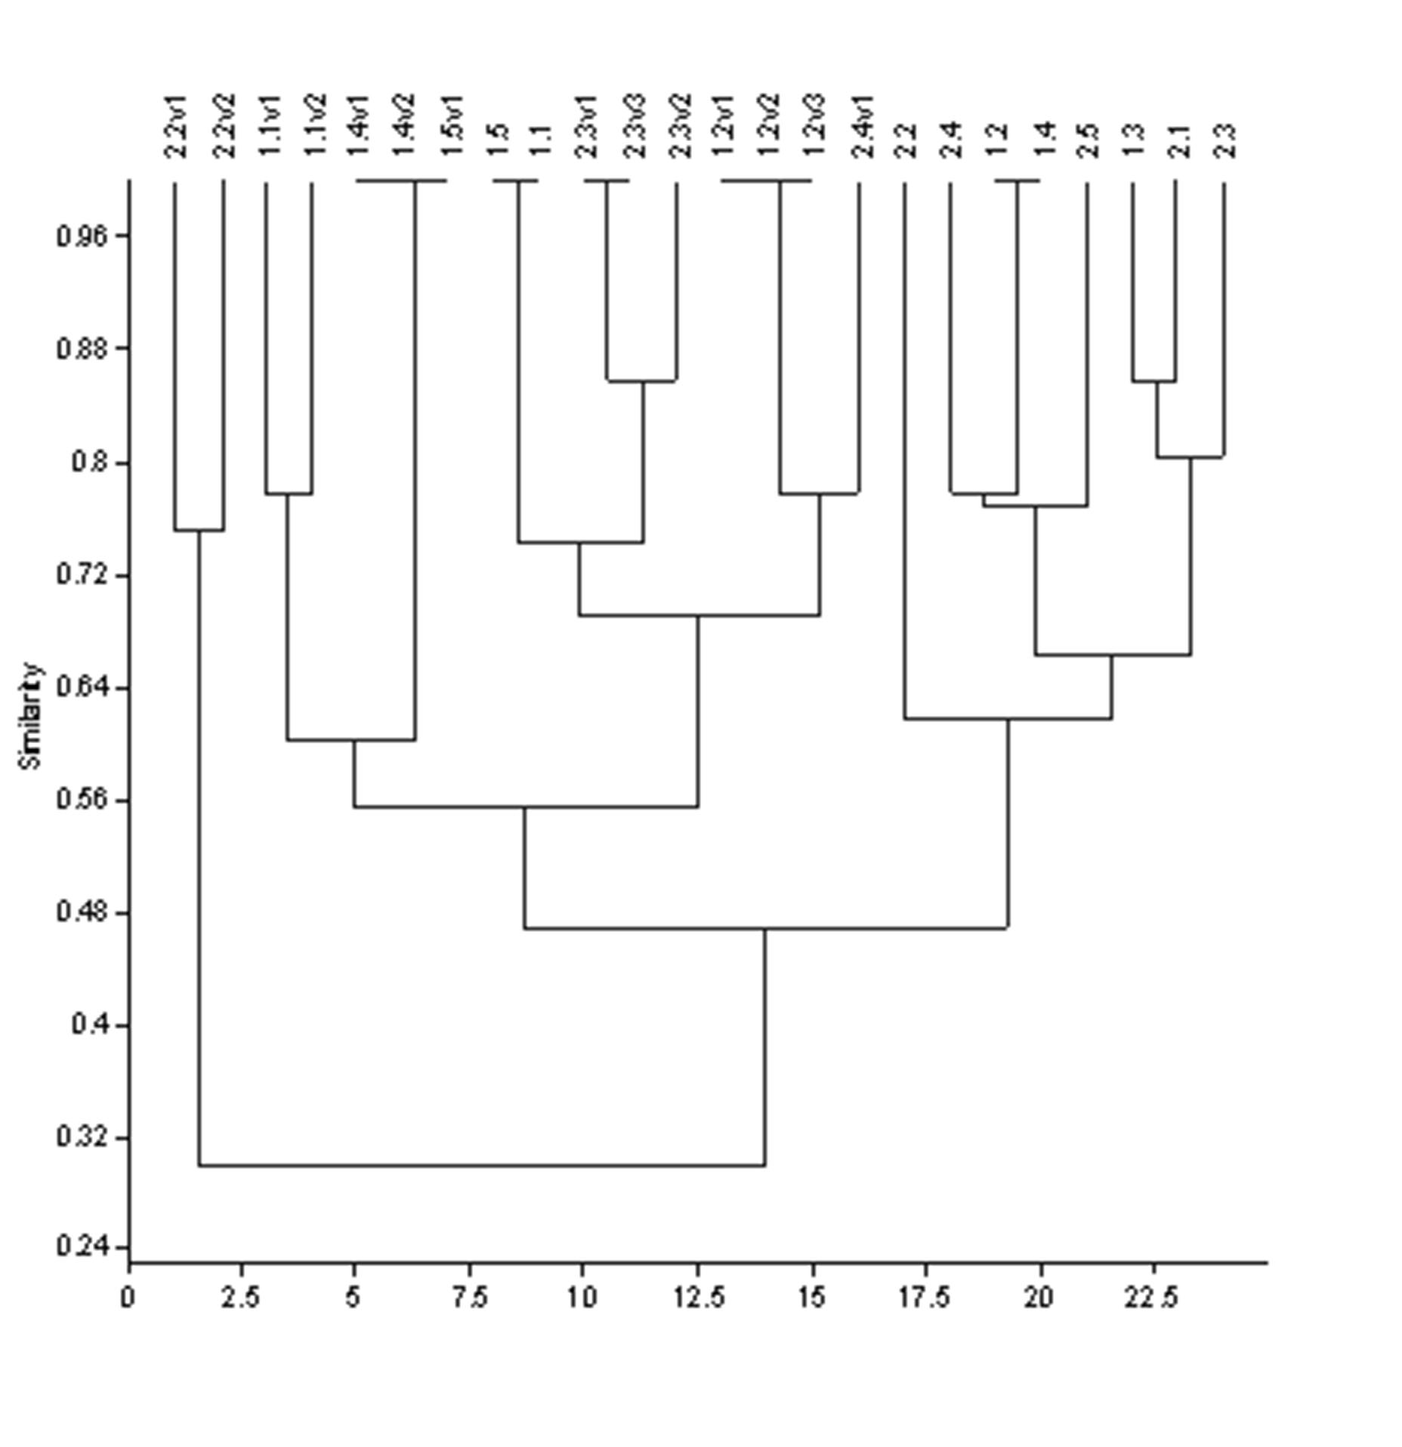

Fig. 1. Dendrogram illustrating similarities among plants from natural habitats and in vitro plantlets by the UPGMA cluster analysis calculated based on SSR marker data.

