in vitro plant reCOVERY from alginate-encapsulated chrysanthemum x grandiflorum /ramat./ kitam. shoot tips
Dariusz Kulus
University of Technology and Life Sciences in Bydgoszcz, Department of Ornamental Plants and Vegetable Crops – Laboratory of Biotechnology, Bernardyńska 6, PL-85-029 Bydgoszcz, Poland, fax: 523749505, e-mail: dkulus@gmail.com
Abstract
Shoot tips obtained from biweekly in vitro cultures of various cultivars of Chrysanthemum x grandiflorum /Ramat./ Kitam. were encapsulated in 3% calcium alginate hydrogel, containing Murashige and Skoog (1962) medium. Survival and possibility of further growth was estimated after 7, 28, 60 and 90-day storage at room temperature. Morphogenic response (formation of shoots and roots, as well as their weight and length) of encapsulated buds to various planting media was evaluated. The highest recovery rate after 90 days of culture reached 90%. The presence of cytokinins in the recovery medium was necessary to stimulate the regrowth of the shoots. Benzyladenine stimulated activation of more axillary bud primordias than kinetin, however, it inhibited rooting at the same time. The obtained results suggest that synthetic seeds technology can be valuable in protection and multiplication of chrysanthemums.
Key words: caulogenesis, Chrysanthemum x grandiflorum, cytokinins, morphogenesis, rhizogenesis
Running title: Propagation of chrysanthemum via synthetic seeds
Introduction
Chrysanthemum x grandiflorum /Ramat./ Kitam. of the Asteraceae family is one of the most popular ornamental plants on the market. It’s popularity has been growing continuously since ancient times. Today, in order to satisfy the growing demands of consumers, novel biotechnological tools are applied in the production of this beautiful species. The development of mutation breeding and possibility of stimulating organogenesis in vitro allows to produce hundreds of new cultivars every year (Zalewska et al., 2011). At the same time, due to a high level of ploidy, heterozygosis and self-incompatibility, the production and usefulness of chrysanthemum seeds is highly limited (Zalewska et al., 2007). As a result the species is mainly propagated vegetatively to maintain clonal fidelity. However, field and greenhouse collections are exposed to natural disasters and attack by pests and pathogens. Moreover, labour costs and the requirement for technical stuff are very high (Bekheet, 200). Therefore, it is important to develop more efficient methods of long-term storage of those valuable genetic resources. In vitro techniques are of great interest for the storage and multiplication of biological material. Production of synthetic seeds (i.e. explants encapsulated in a nutrient alginate-based matrix) is currently considered as the most efficient alternate technique for propagation of commercially important vegetatively-propagated plants (Daud et al., 2008). This technique was first suggested by Murashige in 1977 (Helal, 2011). Today, it is widely used with ornamental species (Ozden-Tokatli et al., 2008). After introducing a dehydration step, it can also be applied in cryoconservation of biological material at the temperature of liquid nitrogen (-196ºC) (Zalewska and Kulus, 2013). However, the presence of the capsule decreases the availability of nutrients and physically inhibits the explant growth. This phenomenon is especially noticeable with mutants and after storage in liquid nitrogen. Therefore it is recommended to supply recovery media, used after encapsulation with plant growth regulators (PGRs). However, some previous studies revealed the formation of callus tissue and the regeneration of vitrified, deformed shoots of chrysanthemum after improper selection of PGRs (Zalewska and Kulus, unpublished; Zalewska and Kulus, 2013). This is especially unwanted with chrysanthemums, for many of them, are genetically unstable chimeras (Zalewska et al., 2007).
Presumably, the use of proper recovery medium may greatly improve synseeds germination rates and the condition of produced microshoots, and consequently, expand the effectiveness of encapsulation-based multiplication and cryopreservation techniques.
The aim of the study was to investigate the influence of different cytokinins on the survival, further growth and organogenesis (caulogenesis and rhizogenesis) potential of four encapsulated chrysanthemum cultivars for the purpose of cryopreservation and propagation.
Materials and Methods
The biweekly shoot tips of Chrysanthemum x grandiflorum /Ramat./ Kitam. ‘Lady Pink’ (LP), ‘Lady Vitroflora’ (LV), ‘Lady White’ (LW) and ‘Lady Yellow’ (LY) mutants, 1 – 2 mm in length, with one or two leaf primordia, isolated with the use of microscalpels, surgical tweezers (to minimalize the injury) and a binocular microscope were used in the experiment. The experiment was, conducted September through December.
To stimulate the production of shoot tips, the single-node explants of Chrysanthemum x grandiflorum with cut-off leaves, were cultured for two weeks on the modified MS (Murashige and Skoog, 1962) medium with 0.09 M (standard 3% w/v) sucrose concentration, and additional 330 mg·dm⁻³ calcium chloride (CaCl₂·6H₂O), 13.9 mg·dm⁻³ iron (II) sulphate (FeSO₄·7H₂O) and 20.6 mg·dm⁻³ disodium ethylenediaminetetraacetic acid (Na₂EDTA·2H₂O) added, solidified with agar at the concentration of 8 g·dm⁻³, at pH 5.8 prior autoclaving in glass jars (10 explants per jar – a single replication).
All the explants were grown in the growth room at 24ºC ± 2ºC, exposed to a 16-h photoperiod and photosynthetic photon flux density of 27.40 µmol·m⁻²·s⁻¹.
The isolated shoot tips have been incubated for 10 min in 3% sodium alginate (Na-alginate) based on the modified (as above) MS salts, without CaCl₂, supplemented with 0.09 M sucrose and then dipped into 0.1 M CaCl₂ for 30 min, forming calibrated beads (4 mm in diameter), after which the beads were rinsed three times with distilled sterile water to stop the alginate polymerization.
Next, the beads were transferred on a solid modified MS medium (10 beads per jar) supplemented with 0.09 M sucrose and 0.1 mg·dm⁻³ 6-benzylaminopurine (BA); 0.1 mg·dm⁻³ kinetin (KIN); or hormone-free control (MS0) and cultured under initial temperature and lighting conditions.
After two months the microshoots were transferred on a rooting MS medium with 2 mg·dm⁻³ IAA (Indole Acetic Acid) for another month.
The regrowth potential (% of explants which remained green and showed signs of further development) was estimated 7, 28, 60 and 90 days after inoculation on the recovery media. The number, fresh weight and length of all of the shoots and roots produced was observed after 90 days.
The results (completely randomized design) were statistically analyzed with the analysis of variance (ANOVA) and the comparisons of means were made with Tukey’s Multiple Comparison Test (α <0.05) using Statistica 10.0 PL and ANALWAR-5.2-FR tools. The experiment studied 12 combinations: 3 recovery media compositions × 4 cultivars in 4 replications, 10 shoot tips in each replication.
Results and Discussion
Synthetic seeds facilitate storage, handling, transport, delivery and propagation of plants. In the past the term synseeds referred only to encapsulated somatic embryos. Today, its meaning has broaden to practically any plant organ (or its part), which can guarantee the regeneration of an entire organism. Production of synthetic seeds by encapsulating vegetative parts e.g. shoot tips or axillary buds is an even more suitable alternative to somatic embryos, which are difficult to produce and often demonstrate problems with conversion into plants (Lema-Ruminśka and Kulus, 2012).
Nowadays, the encapsulation-based cryopreservation techniques are also the most often used with ornamental species (Kaviani, 2008; Pawłowska, 2008; Mohanty et al., 2012). However, the previous results observed with chrysanthemum were rather unsatisfactory resulting in a low survival, regrowth or regeneration through callus (Halmagyi et al. 2004, Martin and Gonzalez-Benito 2009, Osorio-Saenz et al. 2011). A proper selection of recovery medium could solve this problem.
In the past, however, many authors focused on the encapsulation procedure mainly (time and concentration of Na-alginate and CaCl₂ treatment) (Naganada et al., 2011), but only few papers investigated the influence of recovery medium composition (Pandey and Chand, 2005).
Survival and possibility of explants further growth is the most important parameter determining the usefulness of the encapsulation and recovery protocols. Although a variety of natural and synthetic polymers are available for encapsulation, sodium alginate is the most commonly used gel-matrix due to its easy gelling properties, non-toxicity and low-cost (Bekheet, 2006). Different concentrations of Na-alginate can be used for different species. The described encapsulation procedure (immersion in 3% Na-alginate, followed by a 30-minute polymerization in 0.1 M CaCl₂) is the most common one, and proved to be the most suitable with encapsulated Saintpaulia ionantha Wendl. (African violet) microshoots and Vanda coerulea Grifft. ex. Lindl. protocorm-like bodies (PLBs) (Daud et al., 2008; Sarmah et al., 2010). The beads produced during the experiment were with firm coats, round shape and uniform size and in good shape for handling.
In the present experiment, seven days after inoculation, all of the explants showed similar survival, regardless of the medium composition (93-96%) and cultivar effect (88-98%, fig. 1). After longer (28 days) observation, however, a significant survival decrease was observed on the control medium, especially with ‘Lady Vitroflora’ (32% survival after 90 days). Somatic embryos of Hyoscyamus muticus L., on the other hand, germinated best on the hormone-free control (Pandey and Chand, 2005).
Similarly to chrysanthemum, also Olea europaea L. presented a significant decrease in synthetic seed germination capacity after 60-day storage (Ikhlaq et al., 2011). This, however, was not noticed with encapsulated PLBs of Vanda coerulea Grifft. ex. Lindl. (Sarmah et al., 2010). During the entire experiment ‘Lady Yellow’ proved to be the most stable in the possibility of further growth (99/90% survival after 7 and 90 days, respectively). Therefore, it should be assumed, that various cultivars have different requirements – naturally slow growing cultivars require the addition of cytokinins into the medium.
In general, after 90 days of culture approximately 82% of shoot tips grew into microshoots. Similar high result were observed with Saintpaulia ionantha microshoots (Daud et al., 2008). In comparison, encapsulated embryoids of Glossocardia bosvallea (L.f.) DC. showed about 67% germination, however, storage of capsules beyond 25 days decreased the viability of the encapsulated embryos and the germination was nil after 30-day storage (Geetha and Gopal, 2009). Also somatic embryos of Eustoma grandiflorum (Raf.) Shinn. and Genista monospermia Lam. showed low (30%) germination rates (Ruffoni et al., 1994). This confirms the suggestion that vegetative tissues are more efficient explant sources for encapsulation, than somatic embryos.
The present research confirmed, that different cytokinins stimulate various reactions of the encapsulated chrysanthemum explants. This coincides with the reports described by Faisal et al. (2006). It should be noticed, that unlike Raovolfia tetraphylla L. (Faisal et al., 2006), chrysanthemums were able to grow on a hormone-free medium, even though those microshoots together with those from the BA-supplemented medium were the shortest (35 mm and 30 mm, respectively, fig. 2). The longest microshoots were produced in the presence of KIN (45 mm). On the other hand, the biggest weight of shoots (0.18 g) was noticed on the PGRs-free control, whereas the smallest weight (0.15 g) in the presence of BA. The cultivar effect had no influence on those two parameters. As for garlic (Allium sativum L.) the presence of KIN allowed for bulblet formation of highest values of fresh and dry weight.
It was also observed that BA stimulated the formation of multiple shoots (32% of explants), more often than Kin or the control (4.3 and 0.7% explants, respectively, fig. 3). As for garlic, BA also stimulated the best proliferation of bulblets (Bekheet, 2006). With Dendrobium wardianum Warner. PLBs the formation of multiple plants was observed on both control and BA-supplemented medium (5 mg∙dm⁻³), although the later one inhibited their further development (Sharma et al., 1992). The production of multiple shoots is probably a result of activation of axillary bud primordia present in shoot tips (inactive due to apical dominance), rather than a response to meristems injury. Noticeable, during the entire experiment, no presence of callus was observed, even though its formation was present after inoculating cryopreserved explants on the BA-enriched medium (Zalewska and Kulus, unpublished).
Media with KIN and MS0 stimulated the growth of longer roots (33 and 30 mm, respectively) as compared to BA (22 mm, fig. 2). It was observed that ‘Lady Pink’ produced the longest roots (33 mm), while ‘Lady Vitroflora’ and ‘Lady White’- the shortest roots (26 and 25 mm, respectively). The medium composition and cultivar effect, however, had no influence on the roots weight (approx. 0.2 g).
In general the biggest number of shoots per one explant was observed on the medium with BA (1.5), while the lowest in the presence of KIN and on the control (1.0, fig. 4). On the other hand, the medium with KIN and control stimulated better rhizogenesis (5.4 and 4.1 roots/explant, respectively) in comparison to BA (3 roots/explant).
It was observed, that rooting was inhibited by the presence of capsule, since only 52% shoots formed roots in the best conditions (‘Lady Vitroflora’ on the medium with KIN) after 60 days of culture (Fig. 5), whereas without encapsulation 100% of chrysanthemum microshoots produce roots much faster without any PGRs (data not shown). Also Pinker and Abdel-Rahman (2005) observed regeneration of roots from 45% of encapsulated nodal segments. Explants cultured in the presence of BA produced less roots (9%), than explants on the control medium or in the presence of KIN (24-35%). It was observed, that the efficiency of rhizogenesis was also cultivar-specific, since ‘Lady Yellow’ produced more roots (34%), than ‘Lady Pink’ or ‘Lady White’ (18-19%).
Only after transferring the explants to a medium supplemented with IAA a significant increase in rooting efficiency was observed, regardless of the cultivar (80-93%). Still, the explants cultured previously on the control medium formed less roots (75%), than those from the cytokine-supplemented media (89-90%). This may be somewhat surprising for it is believed, that cytokinins inhibit rhizogenesis. Therefore, transferring the beads on the recovery media supplemented with both cytokinin and auxin could be beneficial, as shown with Begonia x hiemalis Fotch (Awal et al., 2007). As Mohanraj et al. (2009) observed IAA is the most beneficial for stimulating germination of synseeds among various auxins.
The results of the work with Feijoa sellowiana Berg. showed that the germination of the encapsulated explants is facilitated by a pre-treatment of the synthetic seed with a solution of 100 mM KNO₃ (Guerra et al., 2001). The K⁺ ions from KNO₃ replaces the Ca⁺² of the calcium alginate capsule thus allowing the softening and opening of the synthetic seed and the subsequent germination of the explants. This should be considered in the future to facilitate the access to nutrients and stimulate both rhizogenesis and caulogenesis. Also the preparation of bead matrix based on more nutritive compounds than alginate (e.g. polysaccharides) or the addition of active charcoal could be considered (Sorvari et al., 1997).
The presented successful results suggest on the possibility of adding antimicrobial agents and PGRs into the bead content and transferring them (directly or after storage) to field conditions, as done with Cymbidium giganteum Wall. (Corrie and Tandon, 1993)
In conclusion, the artificial seed production obtained from encapsulated shoot tips can be used as a potential method to solve problems of propagation of chrysanthemums, which produce few, tiny, difficult to collect seeds. The present study suggest that the production of uniform beads with high germination frequency would be useful for clonal multiplication and long-term maintenance by cryopreservation of valuable genetic resources of chrysanthemum.
References
Awal A., Taha R.M., Hasbullah N.A. (2007). In vitro formation of synthetic seed of Begonia x hiemalis fotch. International Journal of Environmental Sciences, 2: 189-192.
Bekheet S.A. (2006). A synthetic seed method through encapsulation of in vitro proliferated bulblets of garlic (Allium sativum L.). Arab Journal of Biotechnology, 3: 415-426.
Corrie S., Tandon P. (1993). Propagation of Cymbidium giganteum Wall, through high frequency conversion of encapsulated protocorms under in vivo and in vitro conditions. Indian Journal of Experimental Biology, 31: 61-64.
Daud N., Taha R.M., Hasbullah N.A. (2008). Artificial seed production from encapsulated microshoots of Saintpaulia ionantha Wendl. (African violet). Journal of applied Sciences, 8(24): 4662-4667.
Faisal M., Ahmad N., Anis M. (2006). In vitro plant regeneration alginate-encapsulated microcuttings of Rauvolfia tetraphylla L. American-Eurasian Journal of Agricultural and Environmental Sciences, 1(1): 1-6.
Geetha R., Gopal G.V. (2009). Germination of encapsulated synthetic seeds from Glossocardia bosvallea. International Journal of Plant Sciences, 4(1): 94-97.

Guerra M.P., Dal Vesco L.L., Ducroquet J.P.H.J., Nodari R.O., Dos Reis M.S. (2001). Somatic embryogenesis in Goiabeira serrana: genotype response, auxinic shock and synthetic seeds. Revista Brasileira de Fisiologia Vegetal, 13(2): 117-128.
Halmagyi A., Fischer-Kluver G., Mix-Wagner G., Schumacher H.M. (2004). Cryopreservation of Chrysanthemum morifolium (Dendranthema grandiflora Ramat.) using different approaches. Plant Cell Reports, 22: 371-375.
Helal N.A.S. (2011). The green revolution via synthetic (artificial) seeds: a review. Research Journal of Agriculture and Biological Sciences, 7(6): 464-477.
Ikhlaq M., Hafiz I.A., Micheli M., Ahmad T., Abbasi N.A. Standar A. (2011). In vitro storage of synthetic seeds: Effect of different storage conditions and intervals on their conversion ability. African Journal of Biotechnology, 9(35): 5712-5721.
Kaviani B., Safari-Motlagh M.R., Padasht-Dehkaei M.N., Darabi A.H., Rafizadeh A. (2008). Cryopreservation of lily [Lilium ledebourii (Baker) Bioss.] germplasm by encapsulation-dehydration. International Journal of Botany, 4(4): 491-493.
Martin C., Gonzalez-Benito E. (2009). Cryopreservation and genetic stability of Dendranthema grandiflora Tzvelev in vitro cultures. Agricultural and Food Science, 18: 129-135.
Mohanty P., Das M.C., Kumaria S., Tandon P. (2012). High-efficency cryopreservation of the medicinal orchid Dendrobium nobile Lindl. Plant Cell, Tissue and Organ Culture 109, 297-305.
Mohanraj R., Ananthan R., Bai V.N. (2009). Production and storage of synthetic seeds in Coelogyne breviscapa Lindl. Asian Journal of Biotechnology, 1(3): 124-128.
Murashige T., Skoog F. (1962). A revised medium for rapid growth and bio assays with tobacco tissue cultures. Physiologia Plantarum, 15: 473-497.
Nagananda G.S., Satishchandra N., Rajath S., 2011. Regeneration of encapsulated protocorm-like bodies of medicinally important vulnerable orchid Flickingeria nodosa (Dalz.) Seidenf. International Journal of Botany, 7(4): 310-313.
Osorio-Saenz A., Mascorro-Gallardo J.O., Rocío Valle-Sandoval M., González-Arnao M.T., Engelmann F. (2011). Geneticallly enginereed trehalose accumulation improves cryopreservation tolerance of chrysanthemum (Dendranthema grandiflorum Kitam.) shoot-tips. CryoLetters, 32(6): 477-86.
Lema-Rumińska J., Kulus D. (2012). Induction of somatic embryogenesis in Astrophytum asterias (Zucc.) Lem. in the aspect of light conditions and auxin 2,4-D concentrations. Acta Scientiarum Polonorum, Hortorum Cultus, 11(4): 77-87.
Pandey A., Chand S. (2009). Efficient plant regeneration from encapsulated somatic embryos of Hyoscyamus muticus L. Indian Journal of Biotechnology, 4: 546-550.
Ozden-Tokatli Y., De Carlo A., Gumusel1 F., Pignattelli S., Lambardi M. (2008). Development of encapsulation techniques for the production and conservation of synthetic seeds in ornamental species. Propagation of Ornamental Plants, 8(1): 17-22.
Pawłowska B. (2008). Employment of encapsulation-dehydration method for liquid nitrogen cryopreservation of ornamental plant explants propagated in vitro. Folia Horticulturae, 20(1): 61-71.
Pinker I., Abdel-Rahman S.S.A. (2005). Artificial seeds for propagation of Dendranthema x grandiflora (Ramat.). Propagation of Ornamental Plants, 5(4): 186-191.
Ruffoni B., Massabo F., Giovannini A. (1994). Artificial seed technology in the ornamental species Lisianthus and Genista. Acta Horticulturae, 362: 297-304.
Sarmah D.K., Borthakur M., Borua P.K. (2009). Artificial seed production from encapsulated PLBs regenerated from leaf base of Vanda coerulea Grifft. ex. Lindl. – an endangered orchid. Current Science, 98(5): 686-690.
Sharma A., Tandon P., Kumar A. (1992). Regeneration of Dendrobium wardianum Warner. (Orchidaceae) from synthetic seeds. Indian Journal of Experimental Biology, 30: 747-748.
Sorvari S., Toldi O., Viinamaki K.A.T., Hakonen T., Tahvonen R. (1997). Using polysaccharides and galactomannans as gelling agents in capsule formation of artificial seeds. Journal of the American Society for Horticultural Science, 122(6): 878-883.
Zalewska M., Kulus D. (2013). Cryopreservation of in vitro-grown shoot tips of chrysanthemum by encapsulation-dehydration. Folia Horticulturae, 25(2): 133-140.
Zalewska M., Lema-Rumińska J., Miler N. (2007). In vitro propagation using adventitious buds technique as a source of new variability in chrysanthemum. Scientia Horticulturae 113:70-73.
Zalewska M., Tymoszuk A., Miler N. (2011). New chrysanthemum cultivars as a result of in vitro mutagenesis with the application of different explant types. Acta Scientiarum Polonorum – Hortorum Cultus, 10(2): 109-123.

Fig. 1. Influence of the medium composition and cultivar effect on the chrysanthemum survival
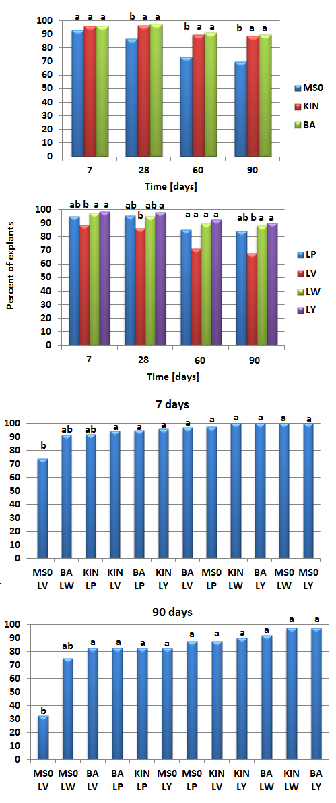
Values marked with the same letter do not differ significantly at α = 0.05
Fig. 2. Influence of the medium composition and cultivar effect on the chrysanthemum shoot/root length and weight
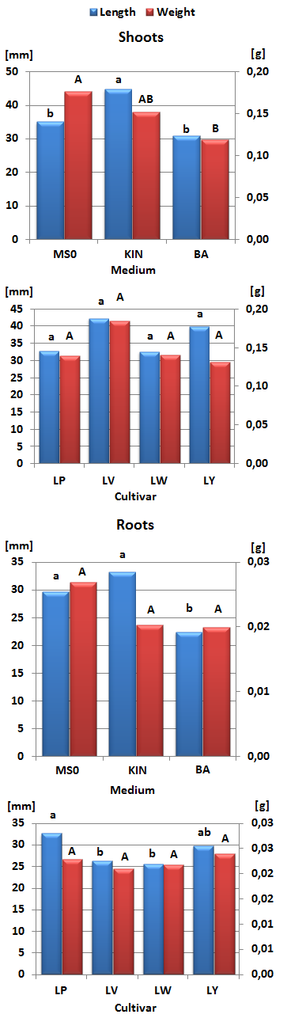
Values marked with the same letter do not differ significantly at α = 0.05, lower-case letters refer to length; upper-case letters refer to weight
Figure 3. Influence of the medium composition on the percentage of chrysanthemum explants forming multiple shoots
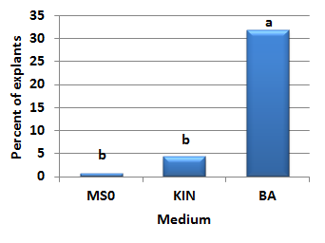
Values marked with the same letter do not differ significantly at α = 0.05

Fig. 4. Influence of the medium composition on the number of shoots and roots produced from a single chrysanthemum explant
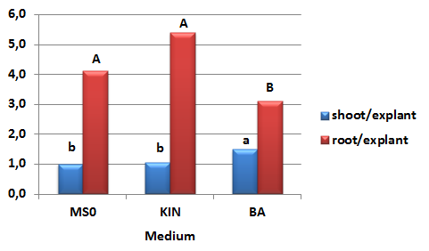
Values marked with the same letter do not differ significantly at α = 0.05

Fig. 5. Influence of the medium composition and cultivar effect on the chrysanthemum rooting efficiency
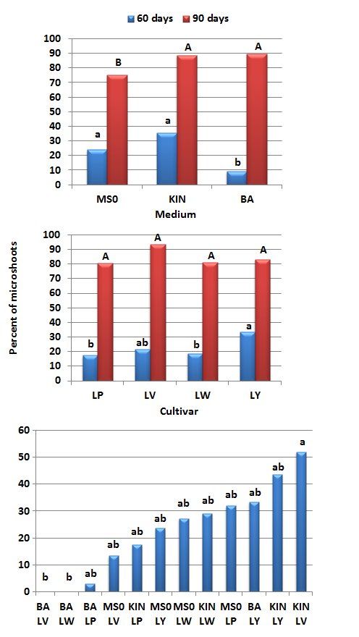
Values marked with the same letter do not differ significantly at α = 0.05, lower-case letters refer to a 60-day culture (prior transferring to medium with IAA); upper-case letters refer to a 90-day culture (after transferring to medium with IAA)

