Micropropagation of Phalaenopsis amabilis cv. Cool 'Breeze' with using of flower stalk nodes and leaves of sterile obtained from node cultures
Khosro Balilashaki¹*, Ruhangiz Naderi¹, Siamak Kalantari¹, Aboozar Soorni¹
¹Department of Horticultural Sciences, Faculty of Agriculture, University of Tehran, Karaj, Iran

*Corresponding author: khosrobali@ut.ac.ir

Abstract
Orchids are one of the most popular plant in the world and among them Phalaenopsis genus have the most sales in a Global Market, because of its hard propagation, micropropagation has been emphasized recently. In this study we try to produce this flower by micropropagation method with use of flower stalk nodes and leaves of sterile obtained from node cultures as explant. We examine different experiment such as sterilization of nodes with different concentration of sodium hypochlorite for introduction of best method for sterilization, effect of different concentration of BA and NAA on MS media for shoot formation, IAA and NAA on 1:2 MS media for root induction and NAA, BA and TDZ for the production seedlings on the Jen medium. The results shown that the best concentration for sterilization is 7% sodium hypochlorite. The highest shoot formation achieved 15.3 produced planet from one node obtained from MS medium contained 4.40 mgL-1 BA and 1 mgL-1 NAA. The best result for root induction was 2.45 roots per planet from 1:2 MS media contained 1 mgL-1 IAA. Protocorms were emerged gradually from cultivated leaf sides at the sixth week of culture. The first observation saw from treatment containing 3mg TDZ. Results showed that with augmented concentration of TDZ the production of protocorm increased but augmented concentration of TDZ had consequence of reducing the active sample. The lowest losses of protocorm (0.66) belonged to the treatment supplemented with 0.5mg/l TDZ and the highest losses achieved at treatment supplemented with 3mg/l TDZ. The best adoption (93%) achieved at second medium (cocopit, coal, industrial cartridge + the bites of yonolit in volume ratio 1+1+2+4). In the first medium (cocopit+ coal in volume ratie 5 to 1) also 90.2% of explants were survived.
Keyword: Phalaenopsis, Micropropagation, Shoot formation, Adaptation.

- Introduction
The orchid genus includes a large number of species. Not only their economical interest but they also present ecological interests by the diversity. Among many orchids, phalaenopsis is one of the important genera from a horticultural viewpoint and also play a very useful role to balance the forest ecosystems, because of its colorful big flowers attached to a long flower stalk (Kaushik 1983).
Production plantlet via micropropagation is one of major problem in culture and breeding phalaenopsis and other orchids. Not Seed germination of orchid, secretion of phenolic substances, adaptation and somaclonal variation are including the reasons non-production plantlet. Tissue culture methods are appropriate replacement for production orchid plantlet.
The major goal commercial micropropagation is to achieved, with as reduced time period and as low cost as possible, a large number of genetically identical, developmentally normal plantlets, preferably with high photosynthetic or photoautotrophic potential, and the ability to survive comparatively harsh ex vitro conditions (Jeong et al. 1995). For this reason, improving, modifying, and optimizing the culture system are always among the main purposes of commercial tissue culture. Conventional vessels have some considerable disadvantages negatively affecting the growth and development of plantlets in vitro, such as high humidity forcing plantlets grown in these vessels to open their stomata for maintaining equilibrium with the surrounding atmosphere (Losch and Tenhanen 1981; Shackel et al. 1990).
This has been accomplished in many plants including a limited number of orchid species; see recent reports on plant regeneration via somatic embryogenesis from Cymbidum ensifolium var. misericors callus (Chang and Chang 1998), and direct embryogenesis from leaf tissue of Oncidium (Chen et al. 1999). In the case of Phalaenopsis, callus initiation and culture from flower stalks (Ernst 1994), flower stalk buds (Tse et al. 1971), root tips (Tanaka et al. 1976; Lin 1981), and leaves (Lin 1980; Ishii et al. 1998) have been reported.
Unlike shoot tips, foliar explants are easy to obtain and do not require the sacrifice of the mother plant and their availability is not restricted to any season like inflorescence explants. Wimber (1965) pioneered leaf tissue culture and gave the first well-documented report on production of PLBs from Cymbidium leaves. Successful micropropagation using leaf explants depends on many factors like medium nutrient composition, the growth hormones, source of the leaf (in vitro/in vivo), part of the leaf taken, explant orientation and most importantly the age of the leaf.
In this communication, we try to produce this flower by micropropagation method with use of nodes on inflorescences (Flower stalk) as explant of Phalaenopsis amabilis and leaves of sterile obtained from node cultures, and provide useful data to improve the protocol for regenerating Phalaenopsis and other genus of orchids. Rotor’s work pointed the way and others followed by culturing inflorescence explants of several orchids including Aranda (in 1990), Dendrobium (1972), Doritaenopsis (1993 and 199), Mokara (1992), Oncidium (2000), and Phalaenopsis
- Material and method
  - Plant material and culture conditions
Two years old Phalaenopsis amabilis cv. Cool Breeze was purchased from 'Anthora' company of Holland. Flower stalk have selected from plants with flowers have maximum three open buds. Explants have moved to the lab by capsule the content of water purification.
In this study we have used of MS and 1/2 MS mediums. After the culturing, samples kept at climate chambers with temperature 25 ± 1 ° C and 16 h photoperiod by using of cold fluorescent lamps.
  - Sterilization solutions, tools and explants
Total solutions and tools have sterilized under aseptic conditions (in an autoclave for 15-20 min at 121° C). Flowers stalk have sterilized by cotton soaked in 70% ethanol thrice and then Flower stalk nods were cut in size 5-6 cm. Peduncle nods have pre-sterilized by fungicides Benomyl 1%, one drop tween and one drop bleach per liter of water for 10 minutes. After the pre-sterilized, nodes have dried and then be moved to the under laminar. For achieving to the best way of sterilization, nodes were treatment with three different concentrations of sodium Hypochlorite (3, 7 and 10 percentage) after the exposure of 70% ethanol for 20 second.
After sterilization of explants two sides of nodes which damaged due to sterilization were cutting to 1.5 cm and the resulted 1cm explant after removing the brackets on the bud were cultured at lower surface on the MS medium supplemented with 4.4 mg BA and 1mg/l NAA to produce sterile leaves. The explants were subcultured every 14 days and kept at 16 hours light and 8 hour dark condition and 25± 1˚C temperature. Explant for the production seedlings were cultured on the Jen medium supplemented with different concentrations of NAA, BA and TDZ (table. 1)
  - Evaluation different levels of the hormone on branching nodes
The two sides of the node witch damaged due to the sterilization, cut as much 1.5 cm after the sterilizing of the samples. 1.5 cm explants have cultured in five types of modified culture medium with different levels of BA and NAA, after the removal of brackets on the buds (It’s noted that explants was sub-cultured every 14 days).
  - Evaluation different levels of the hormone on rooting plants obtained from grow node
One of the problems that have arisen while the job of culturing nodes was non-root of produced plantlets in the based culture medium. For this purpose, we have definite a new experimentation to plantlets rooting. Then plantlets have been cultured in modified ½ MS culture medium with different levels of IAA and NAA after the separating of the rootstock.
  - Statistical Analysis
CRD analysis of data and mean comparison in the 5% level by using DUNCAN was done by the SAS software.
- Result and discussion
  - Sterilization plant material
After sterilizing, cultivated nodes were placed in culture room and were evaluated from viewpoint of pollution. Maximum time possible for samples contamination was estimated 9 days. After 15 days, almost all the explants in low concentrations of NaOCl were contaminated, whereas in high NaOCl concentrations, nearly all the explants lost their viability.
The sterilization procedure with 7% sodium Hypochlorite for 10 min proved to be successful, since all of the cuttings treated were undamaged and only 10% of them became infected. Treatment of 1 (3% sodium Hypochlorite) with 47% of Contamination showed the lowest healthy samples.
The best treat for sterilization flower stalk was reported using sodium Hypochlorite at concentrations of 7% during 1o min, also was expressed that removal brackets should be done after disinfection until damaged buds and nodes top of the inflorescence easily be disinfected than lower nodes (Arditti and Alec 1993). This concentration for our experiment was best and showed the best response (Fig. 1). Prior to this for disinfection, the internodes on the phalanopsis flower after taking them on the 70% ethanol, for 30 minutes were taking on the 1% hypochlorite sodium which contain 1 droplet of tween 20 and reported that this disinfection were never damaged the internodes (Chugh et al. 2009). Other investigators were suggested that removing the brackets prior to disinfection and treatment with 5% hypochlorite for 15 minutes considered suitable for sterilizing of nodes and rinsing 5 min with sterile water were found essential (Tokuhara and Mii 1993). There is a report that suggested the best node size was 2cm and the best method for disinfection of phalanopsis nodes are treatment them with 3% hypochlorite sodium for 20 min and rinsing them three times with sterile water (Park et al. 2002). One point which should be noted about disinfection of nodes is although there are many listed ways for disinfection of the explant but there are other factors which could facilitate or hinder the disinfection. One of these factors is plant age and the diameter of the inflorescence. This means that if the plant is older, the probability of the infection with the special virus or bacteria is higher. One of the reasons for our success in this experiment was used of young plants which reduced the probability of the infection, but the diameter of peduncle is very effective and the plant whatever the younger is more delicate and its peduncle diameter is low but the older plants because of the thicker peduncle , are infected easily.
  - The results of peduncle nodes shooting experiments
After cultured of nodes, the nodes showed two different states. About the second week of the culture in some treatments, the buds were swollen on the nodes and begun growth but some of them were remain in the dormant state and did not show any growth at end of experiment.
In the other study reported that if the buds on the peduncle nodes used as explant, the buds were showed three different states: are dormant or convert to the plantlet or introduce to the reproductive stage and convert to the flower shoots. Our results were confirmed this report but none of buds convert to shoot flower and showed two states (Arditti 2008). One of the problems which limited the tissue culture of the orchids is production of phenolic compound which affected the media (Chugh et al. 2009). Since the explant extensively produced phenolic compound, we had to subcultured the explants every 14 days. As mentioned, from second week the active buds have begun the growths in some treatment such as treatment 3 and 4. Explants were swollen at end part in the fourth week. This swollen was at maximum and at the fifth week the formed protocorms were seeing at their sides. But in the control treatment, the buds grew normally and converted to the plant and there was only one bud for each plant. In the treatment 5 firstly the buds were arisen vertically and individually which similar to the peduncle but in the eightieth week from lateral bud the explant were grown. One of the important points was that the explants of this treatment produced stem and from lateral bud of this stem, the plantlets were achieved. But the numbers of plantlets per node among treatments were varied. The highest plantlets were arisen at medium supplemented with 4.4 mg/l BA and 1mg/l NAA (Fig. 2). That is 15.3 plantlets per node. In an experiment which exerted for culture of peduncle nodes of phalanopsis the best yield were reported with 8.35 plantlet per node at commercial medium P6793 supplemented with 2mg/l BAP and 0.5 mg/l NAA (Kosir et al. 2004). In our experiment we reached approximately twice that number. A common feature of our experiment and that report is the number of days after culture. In that report this number were obtained in 160 days which also we reached to plantlets in that time. The minimum number of plantlets was obtaining from control treatment. Although 70 percent of the node culture were activated in control medium which be the lowest amount active node compared with treatments containing plant growth regulators (from each node only one plant were obtained). The number of active buds at medium containing BAP and NAA compared with control showed that this growth regulators have the ability to promote shooting, particularly BA, Because at two treatment 5 and 6 which containing 4.4mg and 5 mg BA all of the buds were activated and none of the buds were remained at the dormant state. This was consistent with other report which reported that BA could activate the dormant buds on the nudes (Arditti 2008). The results show that wounding sides of the buds on the nod prior to the culture causes nod shooting and nod position on the peduncle, BAP and temperature could affected the growth of nod buds of Phalaenopsis amabilis (Tanaka and Sakanishi 1978; Tanaka et al. 1998). TDZ and BAP have the best effects on production of shoots in phalaenopsis (Tanaka et al. 1998).
Other factor is explant age which influence regeneration from peduncle nodes and explants taking from youth source showed better response in orchids Oncidium, Dendrobium and Phahaenopsis. We also used the young plants. We reached good results considering yield and lack of exposure to bacterial and viral diseases (Intuwong and sagawa 1973).
Results showed that if the nodes were prepared from peduncles which all of their flower are open, only 10%, 20% and 30% of cultivated explants of Oncidium, Dendrobium and Phalaenopsis orchids formed lateral shoots. It can also be affected in our experiment. Also we used nodes from peduncles that only 1-3 florets were open and not all of them, but some of the cultivated explants were dormant and did not produce any shoots. However these researchers reported that this were not affected the orchid Aranda deborah and said that even in whole flower condition the nodes of this type of orchids have showed good regeneration capability (Goh and Wong 1990).

  - The results of plant rooting experiment from nodes
The first symptom of root emergence after culture was observed at NAA treatment and also the treatment which supplemented with IAA showed rooting at the fifth week. Considering the size and number of roots, the treatments had different effects. The treatment supplemented with IAA produced lower number of roots but have bigger roots and more growth. But at mediums supplemented with NAA the numbers of roots per plant were higher but the growth of root was lower. Among treatments, the medium containing 0.5mg/l NAA with 2.65 roots per plant was showed the highest rooting but the roots were small and thick. In medium supplemented with IAA with 2.45 roots per plantlet produced good number of roots and also the size of roots and shoots more than treatment supplemented with 0.5mg/l NAA. Treatment 2 which supplemented with 0.5 mg/l IAA produced 1.85 roots per plantlet and the growth of shoots and roots were moderate. Treatment supplemented with 1 mg/l NAA also produced 2.20 roots per plantlet but the growth of shoots and roots were severely reduced. The lowest rooting belonged to control treatment, and at this treatment none of the samples produced root. The highest percentage of rooting (90%) related to treatment 3 and the lowest (0%) related to control treatment. In terms of application, the best results were obtained at medium supplemented with 1 mg/l IAA, because this produced the good number of roots and also the growth of roots and shoots were better.
Although in all media which supplemented with IAA and NAA we had rooting, but yield in terms of growth of roots and shoots were higher in treatments supplemented with IAA (Fig. 3).
  - Evaluation of plantlet adaption produced from culture of node
For adaption of all produced plantlets after 260 days, and 5 second treatment with 1% carboxttiran fungicide solution, the plantlets were transferred to greenhouse and were cultured at 25˚C day temperature and 20˚C night temperature and cultured in medium which containing equal amount of cocopit and coal. After 45 days 98 percent of plantlets were survived.
The use of nodes existence on peduncle is good start for tissue culture of phalanopsis. Although this technique was limited by problems such as difficulty of exerting experiment but could be suitable method for micro propagation and clone production. In addition, the sterile leaves obtained from these plantlets can use as suitable explants for mass production of orchid, which showed the importance of these methods.

  - Production of plantlets from sterile leaves of phalanopsis
For production of plantlets, sterile leaf explants with 1cm length and 0.5cm width were cultivated in GEN medium supplemented with different concentrations of NAA, BA and TDZ (table. 1) and kept at 16 hours light and 8 hours dark and 25˚C temperature. The explants were subcultured every 14 days. Data gathering were exerted every week.
  - Analysis of the plantlet production from sterile leaves
Protocorms were emerged gradually from cultivated leaf sides at the sixth week of culture. The first observation saw from treatment containing 3mg TDZ. After seven weeks only protocrms were emerged at treatments which supplemented with TDZ. In the treatments supplemented with BAP and NAA there is no trace of protocrms and at the end of experiment (week 12) the explants were gradually yellowing and were died. Chen and Chang (2006) suggested that TDZ suitable for production of somatic embryo. At the experiment, that they exerted on cultivated leaves of orchid P. amabilis suggested that application of only TDZ affected the production of protocom.
In the TDZ treatment some of explants died out without even one protocorm production, commonly this include leaves which had greater size. Smaller leaves showed greater trend to production of protocorm. The highest production of protocorms observed at end part of leaves where it attaches to stem. Pengow et al (2010) have analyzed some factors which affected somatic embryogenesis from phalanopsis leaves such as explant size and it was reported that the best size for culture of leaves was 1cm and also the best part for production of prorocorm was the end of leaves which consistent with our experiment.
But the maximum active samples that produced protocorm (approximately 90%) related to treatment which supplemented with 0.5mg/l TDZ and the lowest active sample also related to the treatment which supplemented with 3mg/l TDZ. With increasing concentration of TDZ, the percentage of the active sample reduced (Fig 4 show the percentage of active sample).
Production of protocorm at each explant with increasing TDZ showed ascending growth in such way that the lowest numbers of protocorm were achieved at treatment supplemented with 0.5mg/l TDZ (6.3) and the highest numbers of production were obtained at medium supplemented with 3mg/l TDZ.
Results showed that also with augmented concentration of TDZ the production of protocorm increased but augmented concentration of TDZ had consequence of reducing the active sample. The lowest losses of protocorm (0.66) belonged to the treatment supplemented with 0.5mg/l TDZ and the highest losses achieved at treatment supplemented with 3mg/l TDZ. Chen and Chang (2006) reported the best concentration for embryogenesis from P. amabilis leaves was 3mg/l TDZ. After 12 weeks the samples transferred to 1/2MS medium without hormone which supplemented with 2gr active charcoal for 8 weeks. After growing of plantlets and production of leaf and root were separated and again were cultured at 1/2MS medium containing 2gr/l active charcoal and finally after 190 days for adoption were transferred to the greenhouse (Fig 5 shows the micro propagation process via sterile leaf).
Successful micro propagation of Orchids via leaves depending on many factors such as the nutrient composition of culture medium, plant growth regulators, source of leaves (In vitro or In situe), the cultivated part of leaves, the position of leaves on plant and plant age. Also the most reports about the tissue culture of Orchids which used leaf but for mass and commercial production of Orchids there are some limitations such as time and its high price (chug et al. 2009).
  - Adaptation of plantlets produced from the leaf
The best adoption (93%) achieved at second medium (cocopit, coal, industrial cartridge + the bites of yonolit in volume ratio 1+1+2+4). In the first medium (cocopit+ coal in volume ratie 5 to 1) also 90.2% of explants were survived.
But the important point between two medium was medium 1 hold more water than medium 2 and the cultivated plantlets often spoilt at root zone. The second medium because of the existence of industrial cartridge, coal and bites of yonolit was more porous, for this reason the cultivated plantlets at this medium had better growth and adoption. One of the factors, which can affect this medium, is the phalanopsis epiphyte nature, which showed better growth in mediums such as medium 2.

Reference
- Arditti, J. (2008). Micropropagation of Orchid. In: Usa. pp. 564-843.
- Chang, C.; Chang, W. C. (1998). Plant regeneration from callus of Cymbidium ensifolium var. misericors. Plant Cell Rep, 17:251±255.
- Chugh, H.S.; Guha, S.; Rao, U. (2009). Micropropagation of Orchid: A review on the potential of different explants. Scientia Horticulture, 122: 507- 520.
- Chen, J.; Chang, W. C. (2006). Direct Somatic embryogenensis and plant regeneration from leaf explants Phalaenopsis. Bio plant, 50:169-173.
- Ernst, R. (1994). Effect of thidiazuron on in vitro propagation of Phalaenopsis and Doritaenopsis (Orchidaceae). Plant Cell Tiss. Organ Cult, 39:273±275.
- Intuwong, O.; sagawa, Y. (1973). Clonal Propagation of sarcanthine Orchid by aseptic Culture of inflorescence. Am. Orchid Soc. Bull, 42: 209- 215.
- Ishii, Y.; Takamura, M.; Tanaka, M. (1998). Callus induction and somatic embryogenesis of Phalaenopsis. Plant Cell Rep, 17:446±450.
- Jeong, B. R.; Fujiwara, K.; Kozai, T. (1995). Environmental control and photoautotrophic micropropagation. Horticultural Reviews, 17: 12-171.
- Kaushik, P. (1983). Ecological and Anotomical Marvels of the Himalayan Orchids. Today and tomorrow’s printers and Publishers, pp124.
- Kosir, P.; Skof, S.; Luthar, Z. (2004). Direct shoot regeneration from node of Phalaenopsis Orchid. Acta agriculture Slovenia, 83: 233-242.
- Lin, R. S. (1980). Studies on the clonal propagation of Phalaenopsis by leaf tissue culture. J. Agric. Res. China, 29:195±201.
- Lin, R. S. (1981). Studies on the clonal propagation of Phalaenopsis by root tissue culture. J. Agric. Res. China, 30:141±145.
- Losch, R.; Tenhanen, J. D. (1998). Stomatal response to humidity-phenomenon and mechanism, in stomatal physiology. In: Jarvis, P. G.; Mansfield, T. A. (Eds.). Stomatal Physiology, Cambridge University Press, New York (U.S.A.), pp. 137-161.
- Park, S.; Murthy, H.; Park K. (2002). Rapid Propagation of Phalaenopsis from Floral stalk- drived leaves. Dev boil Plant, 38:168-172.
- Penggow, W.; Chang, J. T.; Chang, W. C. (2010). Enham cement of direct somatic embryogenesis and plant grow from leaf explants of Phalaenopsis by adjusting culture Periodand explants length. Acta physiol plant, 32: 621- 627.
- Shackel, K. A.; Novello, V.; Sutler, E. G. (1990). Stomatal function and cuticular conductance in whole tissue cultured apple plants. J. Amer. Soc. Hortic. Sci, 115: 468-472.
- Tanaka, M.; Senda, Y.; Hasegawa, A. (1976). Plantlet formation by root-tip culture in Phalaenopsis. Amer. Orchid Soc. Bull, 46:1022±1024.
- Tanaka, M.; Sakanishi, Y. (1978). Factor affecting the growth of in vitro cultured buds from Phalaenopsis flower stalk. Scientia Horticulture, 8: 169- 178.
- Tanaka, M.; Kumara, M.; Goi, M. (1998). Optimal conditions for shoot production from Phalaenopsis Flower stalk cuttings cultured. in vitro. Sci. Hortic, 35:117-126.
- Tokuhara, K.; Mii, M. (1993). Micropropagation of Doriyaenopsis and Phalaenopsis by Culturing shoot tip of Flower stalk buds. Plant cell Reports, 13: 7-11.
- Tse, A. T. Y.; Smith, R. J.; Hackett, W. P. (1971). Adventitious shoot formation on Phalaenopsis. Amer. Orchid Soc. Bull, 40:807±810.
- Wimber, D.E. (1965). Additional observations on clonal multiplication of cymbidiums through culture of shoot meristems. Cymbidium Soc. News, 20: 7–10.

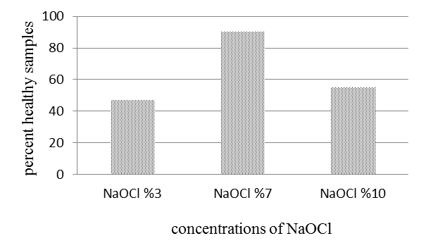
Fig 1. Effect of different concentrations of NaOCl for sterilization flower stalk.
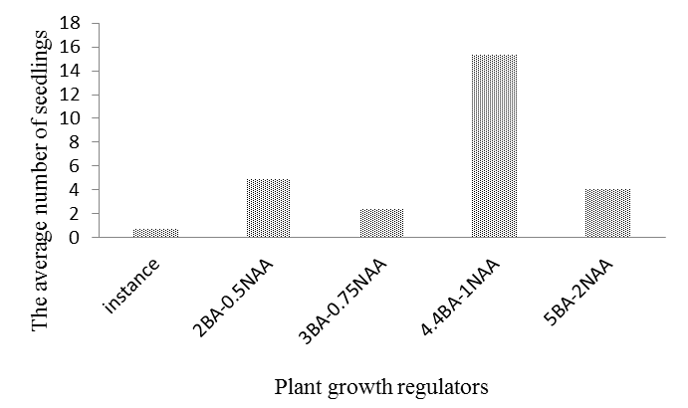
Fig 2. The effect of different concentrations of growth regulators on peduncle nodes shooting.
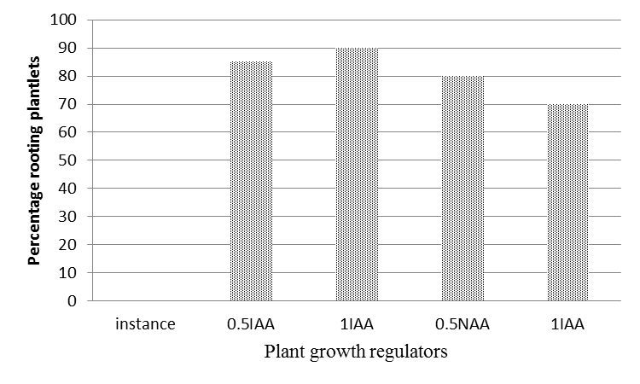
Fig 3. Percentage of rooted samples.

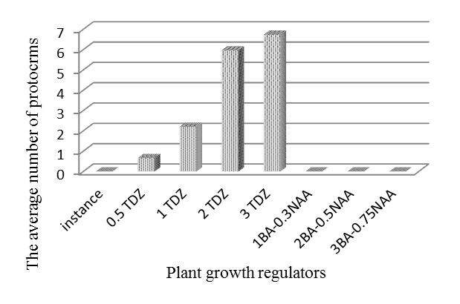
Fig 4. The average of protocrms defuncted.

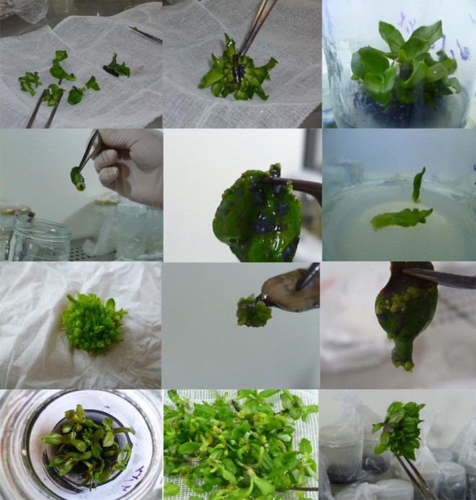
Fig 5. The micro propagation process via sterile leaf.

Table 1. Treatments evaluated in embryogenesis of sterile leaves
Culture medium | No. treatment
jen+ %2SUCROSE | 1
jen + 0/5 mg/l TDZ+%2 Sucrose | 2
jen +1 mg/l TDZ+%2 Sucrose | 3
jen +2 mg/l TDZ+%2 Sucrose | 4
jen +3 mg/l TDZ+%2 Sucrose | 5
jen+1 mg/l BA +0.3 mg/l NAA+ %2Sucrose | 6
jen+2 mg/l BA +0.5 mg/l NAA+ %2Sucrose | 7
jen+3 mg/l BA +0.75 mg/l NAA+ %2Sucrose | 8
jen+4 mg/l BA +1 mg/l NAA+ %2Sucrose | 9

