PRE-SOWING SEED TREATMENTS IMPROVE GERMINATION PERFORMANCE OF FOUR ENDEMIC SIDERITIS SPECIES OF TURKEY

Running title: Dormancy breaking in Sideritis species

Mehmet Demir KAYA¹ Engin Gökhan KULAN¹
Gönül GÜMÜŞÇÜ² Ahmet GÜMÜŞÇÜ³

1 Department of Field Crops, Faculty of Agriculture, Eskisehir Osmangazi University, 26160 Eskişehir TURKEY demirkaya76@hotmail.com
2 Bahri Dagdas International Agricultural Research Center, Karatay, Konya, TURKEY
3 Selçuk University, Çumra High Educational College, 42500, Çumra, Konya, TURKEY

Abstract: The genus Sideritis is an indigenous plant to temperate and subtropical regions of Turkey, especially Mediterranean and Aegean region, and is extensively used as herbal tea and spice. The seeds of Sideritis species have a difficulty in germination, which limits their cultivation. This study was conducted to evaluate the germination performance of 4 endemic Sideritis species (Sideritis condensata, S. libanotica ssp. linearis, S. leptoclada and S. tmolea) harvested freshly or stored for 1 and 2 years in terms of germination percentage and mean germination time and to determine the suitability of seed treatments (Hydration and GA₃ application, and their combination with pre-chilling) for overcoming germination difficulty in the species. Germination percentages of these species ranged from 28.5% to 77.0%. The lowest germination rate (28.5%) and the highest mean germination time (11.9 day) were determined in S. libanotica ssp. linearis in fresh seeds. Improved germination and shortened mean germination time were achieved using 200 ppm GA₃ application. Seed storage did not influence the germination of the Sideritis species. It was found that pre-chilling did not prerequisite for germination of the species. It was concluded that GA₃ treatment should effectively be used as a method improving germination of endemic Sideritis species regardless of seed age.
Key words: Dormancy, hydration, gibberellic acid, pre-chilling, storage, germination

INTRODUCTION

There are approximately 10.000 plant species on the flora of Turkey, about 3.000 of them are endemic. The number of plants used for medicinal purposes are 1.000-2.000 (Arslan et al. 2002). Turkey is a gene center for Lamiaceae family, which comprises a lot of aromatic plants. The family includes 546 species, 45 genus and totally 731 taxa with the endemic plant ratio of 44.2% (Ertan et al. 2000; Arslan et al. 2002; Gümüşçü 2014).
The genus Sideritis, a member of the Lamiaceae family, has more than 150 species which are distributed in temperate and tropical regions of the Northern Hemisphere (Tomas-Barberan et al., 1988). Forty six species and 53 taxa of genus Sideritis have existed and 40 of Sideritis taxa are endemic in Turkey (Davis, 1982). The genus Sideritis is naturally found in the western Anatolia. The species are annual or perennial, herbaceous or little bushy plants in the habitat. Sideritis species are often utilized in folk medicine in Turkey and Europe for their anti-inflammatory, anti-rheumatic, digestive and antimicrobial properties (Kılıç 2006). They have been traditionally consumed as herbal tea, known in Turkey as mountain tea, especially Mediterranean and Aegean regions (Uçar and Turgut, 2009). Furthermore, essential oils from Sideritis species have been used for tonic, carminative, antispasmodic, diuretic.
They have a great export potential for medicinal, aromatic and ornamental purposes while their cultivation has been limited due to low germination performance and slow seedling growth. Some reports on germination of Sideritis species showed that the germination performance was varied with temperature, light, seed treatment and species (Evstatieva and Popova 1998; Esterelles et al. 2010; Kadis et al. 2010; Yankova-Tsvetkova et al. 2013). They reported controversial results about germination behavior of different Sideritis species and have not developed a standard method. The objective of the present study was to determine the appropriate combination of seed treatments i.e. hydration, gibberellic acid (GA₃) and pre-chilling to improve germination performance of some endemic Sideritis species. Also, it was determined if their seeds required for after-ripening by using different seeds stored for 1 and 2 years.
MATERIALS AND METHODS
This study was carried out at the Department of Field Crops, Faculty of Agriculture, Eskişehir Osmangazi University, Turkey. The seeds of 4 Sideritis species (S. leptolata, S. condensata, S. libonatica ssp. linearis and S. tmolea) were collected from natural pastures in Turkey between 2009 and 2010 and planted in the experimental gardens of the division of Medicinal and Aromatic Plants in Çumra Vocational High School of Selçuk University in order to produce sufficient seed material under the same conditions. The seeds from each species were collected in 2011 (2 years storage), 2012 (1 year storage) and 2013 (used as newly harvested seeds) years and stored in paper bags in a seed storage room (temperature: 15-25 °C; humidity: 40%-60%) until the start of experiment.
Seeds from each species harvested at different years (fresh, 1 and 2 years storage) were used as control (T_{c}). Hydration was performed by soaking seeds into distilled water for 6 h (T₁); 4 days pre-chilling between moistened filter papers at 4 ± 1 °C after hydration (T₂); soaking in a gibberellic acid (GA₃) solution at 200 ppm for 6 h (T₃); 4 days pre-chilling between moistened filter papers at 4 ± 1 °C after M₃ treatment (T₄); 4 days pre-chilling at 4 ± 1 °C followed by germination between filter papers moistened with 200 ppm GA₃ solution (T₅). The treated seeds with GA₃ were thoroughly rinsed with distilled water three times. After all of the treatments, the seeds were surface-dried and dried back to their original moisture content at room temperature (about 22 °C, 45% relative humidity) determined by changes in seed weight.
Four replicates of 50 seeds from each treatment were germinated in 3 moistened, rolled filter papers using 8 mL of distilled water. Before the germination test, seeds from each species were treated with Thiram (80%) against fungal contamination. Each rolled paper was then put into a sealed plastic bag to prevent evaporation. Seeds were germinated at 20 ± 1 °C (Estrelles et al. 2010) in the dark for 14 days. A seed was considered germinated when the emerged radicle was visible. Germinated seeds were counted daily for 14 days. The germination percentage and the mean germination time (MGT) of the seeds from each species were determined at the end of the germination test (ISTA, 2003).
The experimental design was two factors arranged in a completely randomized design with 4 replications. Data given in percentages were subjected to arcsine transformation before statistical analysis. Analysis of variance was performed for all investigated parameters using SPSS 16. Significant differences among mean values were compared by Duncan’s Multiple Range test (P ≤ 0.05).
RESULTS AND DISCUSSION
Germination percentage and mean germination time of Sideritis species in relation to seed storage were shown in Figure 1. Among the Sideritis species, a significant difference was found (P ≤ 0.05) for germination percentage and mean germination time. One year storage of the species gave the lowest germination percentage except for S. libanotica ssp. linearis. Minimum germination was determined in fresh harvest seeds of S. libanotica ssp. linearis. Similarly, mean germination time varied with storage time and the species. One year stored seeds showed higher the time to germination than that of the other years. In general, seeds harvested freshly and stored two years needed longer the time to germination.
Seed treatments and seed storage significantly influenced germination percentage and mean germination time of S. condensata (Table 1). Control seeds showed that the germination percentage ranged from 41.5% to 47.0%. Seed storage did not affect germination percentage of control seeds. However, germination percentage was clearly enhanced by GA₃ treatment (M₃), and it reached to maximum values with 67.5% in fresh seeds, 82.0% in one year storage and 88.0% in seeds stored for two years. Older seeds gave better response to GA₃ treatment compared to fresh seeds. Higher mean germination time was obtained from control seeds with low germination percentage. Seed treatments shortened the mean germination time and T₄ method was the most effective to decrease germination time.

Germination percentage was apparently affected by seed storage and better performance was observed in the seeds of S. libanotica ssp. linearis stored for 1 year (Table 2). Seed treatments enhanced germination percentage and accelerated the mean germination time. GA₃ after pre-chilling (T₅) showed the highest germination in both fresh and 1 year stored seeds while older seeds was promptly influenced by T₄. Considering seed treatments GA₃ remarkably reduced the mean germination time.
Germination characteristics of S. leptoclada in relation to seed treatments and storage are shown in Table 3. Germination percentage of control seeds ranged from 55.0% to 77.0% and the minimum value was detected in 1 year stored seeds. It was improved by seed treatments and the application of 200 ppm GA₃ + pre-chilling was found as the predominant method in fresh seeds of S. leptoclada. One year stored seeds surprisingly gave lower germination percentage than fresh and two years storage. No seed treatments manage to improve the germination percentage of seeds stored for 1 and 2 years. Moreover, they were disabled for decreasing the mean germination time of seeds stored for 2 years. Among the seed treatments, the shortest mean germination time (3.36 day) was recorded in 200 ppm GA₃ followed by pre-chilling.
Control seeds of S. tmolea showed that one year storage gave the lowest germination percentage with 47.0%. The application of 200 ppm GA₃ significantly enhanced the germination percentage of S. tmolea seeds. The higher germination percentage was determined in fresh seeds compared to seed storages. Seed treatments led to decrease the mean time to germination but, the pre-chilling followed by 200 ppm GA₃ was found better than the other methods.
Germination test showed that viability of the seeds of Sideritis species stored for one and two years was different. The least average germination percentages were recorded in S. condensata with 43.5% and S. libanotica ssp. linearis with 43.7%. In addition, a clear significant difference was observed in seeds of S. libonatica ssp. linearis, S. leptoclada and S. tmolea stored for 1 year. Any significant increase or decrease trend was not detected as storage time was extended. This shows that the seeds of Sideritis species did not require ripening after harvest. Generally, the seeds harvested in 2012 gave lower germination and delayed germination time. This means that the seed quality of Sideritis species might be affected adversely by the climatic conditions like rainfall and temperature during flowering and seed development stage.
In general, all the seed treatments increased germination percentage and shortened the time to seed germination compared to that of control. However, it was found that GA₃ considerably improved germination performance in the seeds of S. condensata and S. libanotica ssp. linearis. The effectiveness of GA₃ on germination or decreasing of seed dormancy has been reported by El-Dengawy (2005) in loquat, Dissanayake et al. (2010) in guayule and Nadeem et al. (2012) in Ochradenus arabicus, İpek et al. (2008) in cumin. The seeds of S. condensata and S. libanotica ssp. linearis do not germinate sufficiently, while the seeds of S. leptoclada and S. tmolea exhibit very slow germination confirming the existence of dormancy. The reason of dormancy may be due to the presence of some inhibitors, low internal hormone or undeveloped embryos. Khan and Ungar (1997) and Dissanayake et al. (2010) reported that the application of gibberellic acid in declining innate and environment-induced dormancy by means of reducing inhibitors and increasing promoter level. GA₃ induces enhanced cell wall plasticity which cause converting the starches to simple sugars. The sugars lead to absorb high amount of water, which result in a decrease in cell water potential, finally end up cell elongation and growth (Arteca, 1996; Nadeem et al., 2012).
The superiority of pre-chilling on germination of Sideritis species was not found in the study. However, the beneficial effects of pre-chilling were reported by Yılmaz and Tonguç (2013) in Fraxinus ornus subsp. cilicica, Ali et al. (2010) in Descurainia sophia and Plantago ovata and Szewski and Folin (2009) in big bluestem (Andropogon gerardii Vitman). Its efficiency on germination of Sideritis was apparently promoted by GA₃ treatment rather than hydration. Our results are in agreement with Watkinson and Pill (1998) who observed that pre-chilling with GA₃ gave higher increase in germination of Indiangrass. Furthermore, Keshtkar et al. (2009) found that the highest germination was obtained when the seeds of Ferula assa-foetida were treated with 250 ppm GA₃ and pre-chilling.
In conclusion, the beneficial effects of gibberellic acid on germination of the investigated endemic Sideritis species were found. All the species germinated higher than 60% when either GA₃ treatment alone or together with pre-chilling were applied. It was concluded that the seeds of Sideritis species should be germinated after they were treated with 200 ppm GA₃ for 6 h.
REFERENCES

Ali T., Hossein P., Asghar F., Salman Z., Ali Z.C.M. (2010). The effect of different treatments on improving seed germination characteristics in medicinal species of Descurainia sophia and Plantago ovata. African Journal of Biotechnology, 9(39): 6588-6593.
Arslan N., Gürbüz B., Gümüşçü A., Sarıhan E.O., İpek A., Özcan S., Mirici S., Parmaksız İ. (2002). Researches on cultivation of Sternbergia candida Mathew et. Baytop. Proceedings of 14th Meeting of Plant Originated Drugs, Eskişehir, Turkey, (in turkish).
Arteca R.N. (1996). Plant growth substances: principles and applications. Chapter 3: Chemistry, biological effects and mechanism of action. Chapman & Hall 115 Fifty Avenue New York, NY 10003, p: 66.
Davis P.H. (1982). Flora of Turkey and East Eagean Island, Vol: 7, Edinburgh University Press, Edinburgh.
Dissanayake P., George D.L., Gupta M.L. (2010). Effect of light, gibberellic acid and abcsisic acid on germination of guayule (Parthenium argentatum Gray) seed. Industrial Crops and Products, 32: 111–117.
El-Dengawy E.F.A. (2005). Promotion of seed germination and subsequent seedling growth of loquat (Eriobotrya japonica, Lindl) by moist-chilling and GA₃ applications Scientia Horticulturae, 105: 331-342.
Ertan A., Azcan N., Demirci B., Baser K.H.C. (2001). Fatty acid composition of Sideritis Species. Chemistry of Natural Compounds, 37(4): 301-303.
Estrelles E., Güemes J., Riera J., Boscaiu M., Ibars A.M., Costa M. (2010). Seed germination behaviour in Sideritis from different Iberian habitats. Notulae Botanicae Horti Agrobotanici Cluj, 38(1): 9-13.
Evstatieva L., Popova I. (1998). Factors, affecting germination and seedling development of Sideritis scardica Griseb. and S. syriaca L. Proceedings of an international jubilee conference marking the 70th anniversary of the Forest Research Institute, Sofia, Bulgaria, 6-7 October, Volume 1, pp. 371-376.
Gümüşçü A. (2014). Seed germination of some endemic Sideritis species under different treatments. Medicinal and Aromatic Plants Research Journal, 2(1): 1-5.
İpek A., Kaya M.D., Gürbüz B. (2008). Effects of seed age and GA₃ application on germination of fenugreek (Trigonella foenum-graecum L.) and cumin (Cuminum cyminum L.) seeds. Tarım Bilimleri Dergisi, 14(1): 57-61.
ISTA (2003). International Seed Testing Association. International Rules for Seed Testing, Switzerland.
Kadis C., Kounnamas C., Georghioub K. (2010). Seed germination and conservation of endemic, rare, and threatened aromatic plants of Cyprus. Israel Journal of Plant Sciences, 58: 251-261.
Keshtkar H.R., Azarnivand H., Atashi H., (2009). Effect of pre-chilling and GA₃ on seed germination of Ferula assa-foetida and Prangos ferulacea. Seed Science and Technology, 37(2): 464-468.
Khan M.M., Ungar I.A. (1997). Alleviation of seed dormancy in the desert forb Zugophyllum simplex L. from Pakistan. Annals of Botany, 80: 395-400.
Kılıç T. (2006). Isolation and biological activity of new and known diterpenoids from Sideritis stricta Boiss. and Heldr. Molecules, 11: 257-262.
Nadeem M., Al-Qurainy F., Khan S., Tarroum M., Ashraf M. (2012). Effect of some chemical treatments on seed germination and dormancy breaking in an important Medicinal plant Ochradenus arabicus Chaudhary, Hill C. & A.G. Mill. Pakistan Journal of Botany, 44(3): 1037-1040.
Szewski M.W., Folin G.J. (2009). Germination responses of purple top and big bluestem caryopses subjected to distilled water or potassium nitrate, pre-chilling, sodium hypochlorite, and storage. HortScience, 44(5): 1407-1411.
Tomás-Barberán F.A., Reijdali M., Harborne J.B., Heywood V.H. (1988). External and vacuolar flavonoids from the Ibero- North African Sideritis species. A chemosystematic approach. Phytochemistry, 27: 165-170.
Uçar E., Turgut K. (2009). In vitro propagation of some mountain tea (Sideritis) species. Akdeniz University, The Journal of Agricultural Faculty, 22(1): 51-57.
Watkinson J.I., Pill W.G. (1998). Gibberellic acid and pre-sowing chilling increase seed germination of Indiangrass (Sorghastrum nutans (L.) Nash.). HortScience, 33(5): 849-851.
Yankova-Tsvetkova E., Yurukova-Grancharova P., Vitkova A. (2013). Reproductive biology of the Balkan endemic Sideritis scardica (Lamiaceae). Botanica Serbica, 37 (1): 83-87.
Yılmaz M., Tonguç F. (2013). Dormancy level and dormancy-breaking pretreatments in seeds of Fraxinus ornus subsp cilicica. Propagation of Ornamental Plants, 13(1): 40-45.

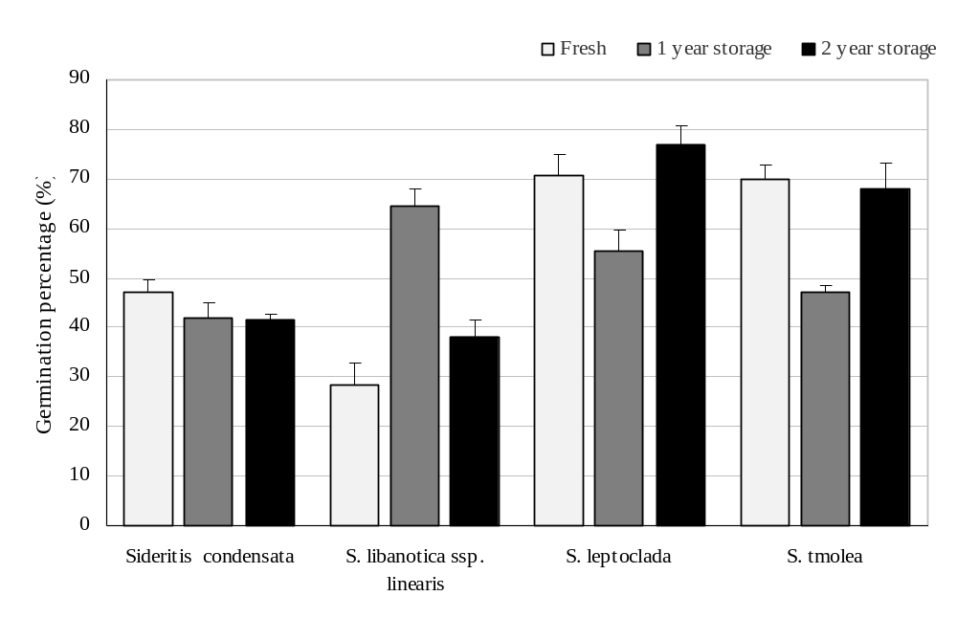
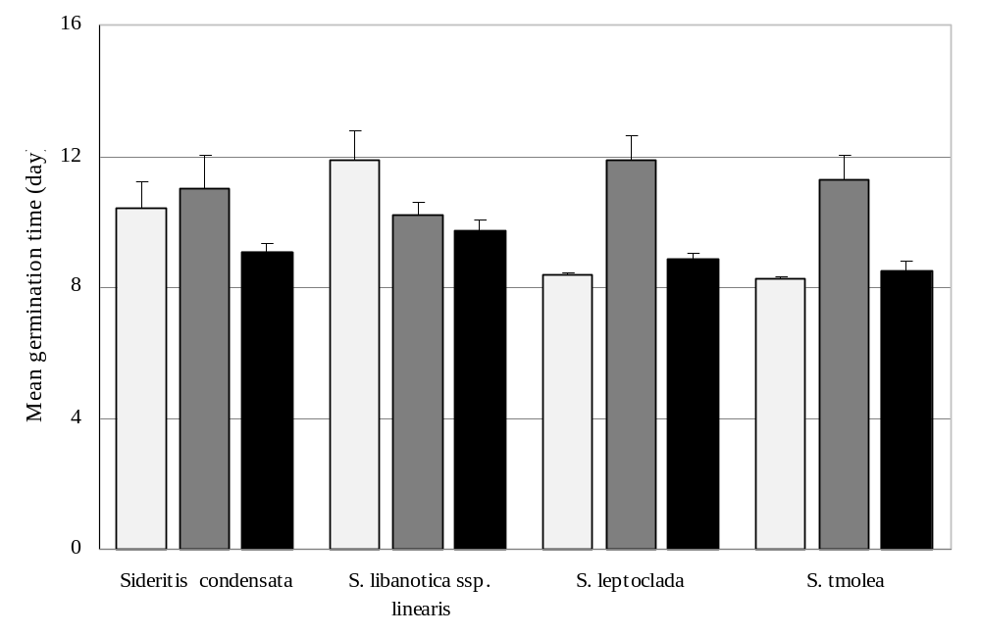
de
e
bc
f
e
ab
e
cd
a
ab
de
ab
abc
ab
cde
a
a-d
b-e
e
a
cde
e
ab
de

Figure 1. Changes in germination percentage (%) and mean germination time (day) of Sideritis species after 1 and 2 years storage.

Table 1. Effects of seed treatments on germination percentage (%) and mean germination time (day) of the seeds of Sideritis condensata harvested freshly or after storage for 1 and 2 years
Treatment | Fresh | 1 year storage | 2 year storage | Mean
Germination percentage (%)
Control (T_{c}) | 47.0^{fg} | 42.0^{g} | 41.5^{g}* | 43.5
Hydration (T₁) | 56.0^{d-g} | 56.0^{d-g} | 60.0^{def} | 57.3
Hydration + Pre-chilling (T₂) | 62.0de | 68.0^{cd} | 51.0^{efg} | 60.3
200 ppm GA₃ (T₃) | 67.5^{cd} | 82.0^{ab} | 88.0ª | 79.2
200 ppm GA₃ + Pre-chilling (T₄) | 62.0de | 68.0^{cd} | 86.0^{ab} | 72.0
Pre-chilling + 200 ppm GA₃ (T₅) | 49.0^{efg} | 76.5^{bc} | 75.5^{bc} | 67.0
Mean | 57.3 | 65.4 | 67.0
Mean germination time (day)
Control (T_{c}) | 10.42ª | 10.98ª | 9.07^{b} | 10.16
Hydration (T₁) | 5.50^{def} | 6.21^{d} | 7.65^{c} | 6.45
Hydration + Pre-chilling (T₂) | 4.90^{d-h} | 5.65^{def} | 5.75de | 5.43
200 ppm GA₃ (T₃) | 5.50^{def} | 5.44^{def} | 5.97de | 5.64
200 ppm GA₃ + Pre-chilling (T₄) | 3.70^{h} | 3.91^{gh} | 5.25^{d-g} | 4.29
Pre-chilling + 200 ppm GA₃ (T₅) | 4.55^{e-h} | 4.57^{e-h} | 4.19^{fgh} | 4.44
Mean | 5.76 | 6.13 | 6.31
*: Values show the real germination percentages but variance analysis was performed using arcsine transformed values. Means followed by the same letter(s) are not significantly different at p≤0.05.

Table 2. Effects of seed treatments on germination percentage (%) and mean germination time (day) of the seeds of S. libanotica ssp. linearis harvested freshly or after storage for 1 and 2 years
Treatment | Fresh | 1 year storage | 2 year storage | Mean
Germination percentage (%)
Control (T_{c}) | 28.5^{g} | 64.5^{c} | 38.0^{fg}* | 43.7
Hydration (T₁) | 45.0^{def} | 69.0^{bc} | 30.0^{fg} | 48.0
Hydration + Pre-chilling (T₂) | 42.0^{efg} | 65.0^{c} | 34.0^{fg} | 47.0
200 ppm GA₃ (T₃) | 65.0^{c} | 82.0^{ab} | 57.0^{cde} | 68.0
200 ppm GA₃ + Pre-chilling (T₄) | 63.0^{c} | 68.0^{bc} | 59.0^{cd} | 63.3
Pre-chilling + 200 ppm GA₃ (T₅) | 80.5^{ab} | 83.5ª | 55.0^{cde} | 73.0
Mean | 54.0 | 72.0 | 45.5
Mean germination time (day)
Control (T_{c}) | 11.86ª | 10.20^{b} | 9.72^{bc} | 10.59
Hydration (T₁) | 7.22de | 7.19de | 8.44^{cd} | 7.62
Hydration + Pre-chilling (T₂) | 5.32^{fg} | 6.25^{ef} | 7.92^{d} | 6.50
200 ppm GA₃ (T₃) | 5.13^{fgh} | 5.41^{fg} | 5.25^{fgh} | 5.26
200 ppm GA₃ + Pre-chilling (T₄) | 3.72^{gh} | 3.85^{gh} | 3.85^{gh} | 3.81
Pre-chilling + 200 ppm GA₃ (T₅) | 3.76^{gh} | 4.68^{gh} | 4.06^{gh} | 4.17
Mean | 6.17 | 6.26 | 6.54
*: Values show the real germination percentages but variance analysis was performed using arcsine transformed values. Means followed by the same letter(s) are not significantly different at p≤0.05.

Table 3. Effects of seed treatments on germination percentage (%) and mean germination time (day) of the seeds of Sideritis leptoclada harvested freshly or after storage for 1 and 2 years
Treatment | Fresh | 1 year storage | 2 year storage | Mean
Germination percentage (%)
Control (T_{c}) | 70.5^{b-e} | 55.5^{fgh} | 77.0^{abc}* | 67.7
Hydration (T₁) | 75.0^{a-d} | 52.0^{ghi} | 70.0^{b-e} | 65.7
Hydration + Pre-chilling (T₂) | 61.0^{efg} | 41.0^{i} | 64.0d^{-g} | 55.3
200 ppm GA₃ (T₃) | 81.0^{ab} | 48.0^{hi} | 73.0^{b-e} | 67.3
200 ppm GA₃ + Pre-chilling (T₄) | 84.0ª | 47.0^{hi} | 65.0^{c-f} | 65.3
Pre-chilling + 200 ppm GA₃ (T₅) | 53.0^{f-j} | 46.0^{hi} | 76.5^{abc} | 58.5
Mean | 70.8 | 48.3 | 70.9
Mean germination time (day)
Control (T_{c}) | 8.38^{bc} | 11.89ª | 8.87^{b} | 9.71
Hydration (T₁) | 4.63^{ghi} | 8.19^{bc} | 7.98^{bcd} | 6.93
Hydration + Pre-chilling (T₂) | 4.06^{hi} | 6.32^{ef} | 7.78^{bcd} | 6.05
200 ppm GA₃ (T₃) | 4.76^{gh} | 6.79^{def} | 6.66^{def} | 6.07
200 ppm GA₃ + Pre-chilling (T₄) | 3.36^{i} | 8.00^{bcd} | 7.83^{bcd} | 6.40
Pre-chilling + 200 ppm GA₃ (T₅) | 3.83^{hi} | 7.30^{cde} | 5.72^{fg} | 5.62
Mean | 4.84 | 8.08 | 7.47
*: Values show the real germination percentages but variance analysis was performed using arcsine transformed values. Means followed by the same letter(s) are not significantly different at p≤0.05.

Table 4. Effects of seed treatments on germination percentage (%) and mean germination time (day) of the seeds of Sideritis tmolea harvested freshly or after storage for 1 and 2 years
Treatment | Fresh | 1 year storage | 2 year storage | Mean
Germination percentage (%)
Control (T_{c}) | 70.0^{b-e} | 47.0^{g} | 68.0^{b-e}* | 61.7
Hydration (T₁) | 73.0^{bcd} | 55.0^{efg} | 61.0^{c-g} | 63.0
Hydration + Pre-chilling (T₂) | 70.0^{b-e} | 54.0^{efg} | 57.0^{efg} | 60.3
200 ppm GA₃ (T₃) | 92.8ª | 51.0^{fg} | 78.0^{b} | 73.9
200 ppm GA₃ + Pre-chilling (T₄) | 79.0^{b} | 58.0^{d-g} | 77.0^{b} | 71.3
Pre-chilling + 200 ppm GA₃ (T₅) | 78.0^{bc} | 66.0^{b-f} | 78.0^{b} | 74.0
Mean | 77.1 | 55.2 | 69.8
Mean germination time (day)
Control (T_{c}) | 8.25^{b} | 11.25ª | 8.51^{b} | 9.34
Hydration (T₁) | 3.36^{g} | 7.12^{c} | 5.23de | 5.24
Hydration + Pre-chilling (T₂) | 3.39^{g} | 6.23^{cd} | 4.82^{ef} | 4.81
200 ppm GA₃ (T₃) | 6.06^{cd} | 6.32^{cd} | 4.59^{ef} | 5.66
200 ppm GA₃ + Pre-chilling (T₄) | 4.07^{efg} | 4.82^{ef} | 3.75^{fg} | 4.21
Pre-chilling + 200 ppm GA₃ (T₅) | 3.18^{g} | 4.88^{ef} | 3.74^{fg} | 3.93
Mean | 4.72 | 6.77 | 5.10
*: Values show the real germination percentages but variance analysis was performed using arcsine transformed values. Means followed by the same letter(s) are not significantly different at p≤0.05.

