ASSESMENT OF GENETIC STABILITY IN SOMATIC EMBRYOS OF THE SAWARA CYPRESS (CHAMAECYPARIS PISIFERA SIEB. ET ZUCC.) BY RAPD ANALYSIS AND FIELD PERFORMANCE OF SOMATIC EMBRYO-DERIVED PLANTS
Yoshihisa Hosoi¹⁾, Noritsugu Kuramoto²⁾, and Tsuyoshi E. Maruyama¹⁾ *
¹⁾ Department of Molecular and Cell Biology, Forestry and Forest Products Research Institute,
Matsunosato 1, Tsukuba, 305-8687 Japan, *Fax: +81 29 873 1542
*⁾ E-mail: tsumaruy@ffpri.affrc.go.jp
²⁾ Forestry and Forest Products Research Institute, Forest Tree Breeding Center,
3809-1 Ishi, Juo, Hitachi, 319-1301, Japan

Abstract
An effective plant regeneration system was reported for the Sawara cypress (Chamaecyparis pisifera) via somatic embryogenesis. In addition to high somatic embryo maturation efficiency, the subsequent high germination and plant conversion frequencies attained demonstrated the high quality of the somatic embryos produced. A total of 100 RAPD primers were screened against the 12 randomly chosen cotyledonary somatic embryos. Of the 100 primers tested, 8 were selected based on their amplification products, which revealed clear DNA fragmentation; generating an average of 8.75 bands per primer. The amplification products revealed no genetic variation among the tested somatic embryos. The growth of somatic embryo-derived plants has been monitored in the field and the mean height growth was measured until the age of 10.

Keywords: Sawara cypress, Chamaecyparis pisifera, somatic embryogenesis, RAPD, genetic stability, field performance

INTRODUCTION
The Sawara cypress (Chamaecyparis pisifera), a domestic tree in Japan, is one of six species in the Chamaecyparis genus worldwide. It grows 30 m tall, with 1 m DBH and lumber which is moisture-resistant, hence it is mainly used for making barrels, buckets, and traditional bathtubs. In addition, it is also prized for ornamental uses like garden hedges. This species is also important for genetic resources and hybridization with a related valuable Hinoki cypress timber tree (Chamaecyparis obtusa) (Fukuhara, 1989).
Somatic embryogenesis has become a technique more frequently applied for large-scale propagation. Plant regeneration through somatic embryogenesis of the Sawara cypress is important; not only to effectively propagate selected trees but also for genetic transformation and somatic hybridization breeding to create disease-resistant hybrids. Several authors have reported that tissue culture propagation can trigger somaclonal variation between in-vitro derived plants. Different responses among species to in-vitro culture techniques can be valued in order of low to high genetic stability, hence the genetic stability of the tissue culture-derived progeny is important and a key concern for any propagation system. Currently, different molecular analyses can be used to assess the genetic fidelity of in-vitro derived plants, of which random amplified polymorphic DNA (RAPD) is the easiest, cheapest and most efficient (Jayanthi and Mandal, 2001).
In this paper, we report on an efficient plant regeneration system for large-scale propagation of the Sawara cypress through somatic embryogenesis from immature seeds and the assessment of genetic stability in somatic embryos using RAPD analysis. In addition, the performance of somatic embryo-derived plants has been monitored in the field and the mean height growth was measured until the age of 10.

MATERIALS AND METHODS
Somatic embryogenic culture initiation
Immature open-pollinated cones of the Sawara cypress were collected from a mother tree about 30 years old. The collected cones were subsequently disinfected by 1 min immersion in 99.5% ethanol and dried in the laminar flow cabinet before dissection. The excised seeds were disinfected with 1% (w/v available chlorine) sodium hypochlorite solution for 15 min and then rinsed five times with sterile distilled water. The explants were cultured in 24-well tissue culture plates (one per well) containing 1/2 MS medium (Murashige and Skoog medium) (Murashige and Skoog, 1962) (MS medium with half the standard concentration of basal salts but replacing all NH₄NO₃ with 1000 mg l⁻¹ glutamine), supplemented with 0.5 g l⁻¹ casein hydrolysate, 10 µM 2,4-dichlorophenoxyacetic acid (2,4-D), 5 µM 6-benzylaminopurine (BAP), 10 g l⁻¹ sucrose, and 3 g l⁻¹ gellan gum. The pH of the media was adjusted to 5.8 prior to autoclaving for 15 min at 121°C. The cultures were kept in darkness at 25±1°C. The presence or absence of the distinct early stages of embryos, characterized by an embryonal head with a suspensor system from the explants, was observed under an inverted microscope weekly for up to 3 months. Embryogenic tissues extruding from the micropylar ends of explants tended to appear after 2-4 weeks of culture, while the mean initiation frequency of embryogenic tissues from immature seeds of the Sawara cypress varied from 12.5 to 33.3% (Maruyama et al., 2002).
Embryogenic cultures were maintained and proliferated by 2 to 3-week interval subcultures on 90-mm diameter plates containing 1/2 LP medium (Aitken-Christie and Thorpe, 1984) supplemented with 30 g l⁻¹ sucrose, 3 µM 2,4-D, 1 µM BAP, and 1.5 g l⁻¹ glutamine. Embryogenic tissues proliferated readily and retained their original translucent and mucilaginous appearance. The fresh weight of embryogenic tissues on the maintenance-proliferation medium increased about 5- to 12-fold after a 2- to 3-week culture period.

Maturation of somatic embryos
Before the maturation step, about 10-20 mg Fresh Weight of embryogenic tissues from the solid medium were transferred to a 100 ml flask containing 30-40 ml of medium (with a composition equivalent to that used for maintenance and proliferation but without gellan gum) and cultured for about 2 weeks on a rotary shaker at 50-70 rpm, in darkness at 25±1°C. About 100 mg Fresh Weight of embryogenic tissues suspended in 2-3 ml of medium were placed on filter paper disks of 70-mm diameter over 90-mm diameter plates containing 30-40 ml of maturation medium containing maltose, abscisic acid (ABA), activated charcoal (AC), polyethylene glycol 4,000 (PEG), and amino acids (Smith, 1996) (g l⁻¹: glutamine 7.3, asparagine 2.1, arginine 0.7, citrulline 0.079, ornithine 0.076, lysine 0.055, alanine 0.04, and proline 0.053). The plates were sealed with Novix-II film (Iwaki Glass Co., Ltd., Chiba, Japan) and kept in darkness at 25±1°C for 6-12 weeks.

Germination of somatic embryos and plant conversion
Mature somatic embryos were transferred to germination media (modified LP medium containing basal salts reduced at half concentration from the standard, 20 g l⁻¹ sucrose, 2 g l⁻¹ activated charcoal, and solidified with 10 g l⁻¹ Wako agar). The cultures were kept at 25±1°C under a photon flux density of about 65 µmol m⁻² s⁻¹ provided by cool white fluorescent lamps (100 V, 40 W; Toshiba Co.) for 16 h daily. The number of somatic embryos germinated (root emergence) and converted to plantlets (emergence of both root and epicotyl) was recorded after 2 and 4 weeks, respectively. Emblings that showed root and epicotyl growth were transferred to 300 ml Erlenmeyer flasks containing 100 ml of growth medium (modified LP medium containing basal salts reduced at half concentration from the standard, 30 g l⁻¹ sucrose, 5 g l⁻¹ activated charcoal, and solidified with 12.5 g l⁻¹ Wako agar) and kept under the conditions described above and cultured for about 2 months before ex vitro acclimatization.

Ex vitro acclimatization and field performances of somatic embryo-derived plants
Developed emblings were transplanted into pots filled with vermiculite and acclimatized inside a growth chamber at 25°C and 80% relative humidity. During the first 2 weeks, the plants were kept in plastic boxes with transparent covers and irrigated with tap water. Subsequently, the covers were gradually opened during a further 2-week period and removed completely about 1 month after transplanting. Pots were fertilized with a nutrient solution modified from Nagao (1983) containing in mg l⁻¹: NH₄NO₃ 143, NaH₂PO₄・2H₂O 55.1, KCl 47.1, CaCl₂・2H₂O 52.5, MgSO₄・7H₂O 61, Fe-III EDTA 25, Cu EDTA 0.1, Mn EDTA 0.1, Zinc EDTA 0.1, H₃BO₃ 1.5, KI 0.01, CoCl₂・6H₂O 0.005, and MoO₃ 0.005. The acclimatized plants were transferred to a greenhouse and grown under controlled conditions for about 6 months before transplanting to the field. The plant height was measured every 2 years from age 4 to 10. The height of thirty somatic embryo-derived plants and seven seed-derived plants was measured to calculate the mean growth after a 4- to 10-year growth period.

Determination of genetic stability in somatic embryos
DNA was extracted using the modified SDS (Sodium Dodecyl Sulfate) method. Somatic embryos were placed in 200 µl of extraction buffer (0.1 M Tris-HCl pH 8.0, 10 mM EDTA, 0.5% SDS, 0.1 mg proteinase K), homogenized with a Minitor homogenizer (Minitor Co.), incubated at 37°C for 2 hours, and then extracted with TE-saturated phenol. RNase was added to a final concentration of 50 µg ml⁻¹, incubated at 37°C for 1 hour, and then extracted twice again with TE-saturated phenol. DNA was precipitated with one-tenth volume of 3 M sodium acetate (NaOAc) and 2.5 volumes of cold ethanol, washed twice with 70% ethanol, and then dissolved in 200 µl of TE.
RAPD reactions were based on a protocol modified from Williams et al. (1990). Polymerase chain reaction (PCR) amplification was performed in 10 mM Tris-HCl pH 8.0, 50 mM KCl, 2.0 mM MgCl₂, 0.2 mM dNTPs, 0.2 µM primer, 1 unit of Taq DNA polymerase, and 10 ng of genomic DNA per 15 µl using an MJ Research Thermal Cycler PTC-200. The number of primers for DNA amplifications was 100, which were purchased in a kit (OPA-01 through OPC-20 and OPAA-01 through OPAB-20) from Operon Technologies Inc. (Alameda, California). Initial denaturation was for 3 minutes at 94°C, followed by 40 cycles of 60 seconds at 94°C, 60 seconds at 37°C, 120 seconds at 72°C, and a final 3-minute extension at 72°C. PCR products of RAPD were analyzed on 2% agarose gel stained with ethidium bromide in 1xTAE buffer.

RESULTS
Production of somatic embryo-derived plants and their field performance
The initial formation of cotyledonary embryos was observed about 4 weeks after the transfer of embryogenic tissues to the maturation media, and was clearly distinct after 6 weeks of culture (Fig. 1A). The results after 2 months of culture are shown in Table 1, where the addition of PEG stimulated the somatic embryo production. A higher concentration of PEG in the medium resulted in a higher maturation frequency. The best result was obtained at a concentration of 150 g l⁻¹ with an average of 1,043 cotyledonary embryos collected per plate, in comparison with 382, 215, and 13 embryos per plate at concentrations of 75, 50, and 0 g l⁻¹, respectively. In the absence of PEG, most proembryos did not develop into cotyledonary embryos, embryogenic cell proliferation was evident and most developed into structures consisting of small embryonal heads, from which elongated suspensors extended (stage 1 somatic embryo) as described by von Arnold and Hakman (1988).
Cotyledonary somatic embryos were collected from maturation media, and transferred to germination media. The number of somatic embryos germinated (root emergence) (Fig. 1B) and converted into plantlets (emergence of both root and epicotyl) (Fig. 1C) was recorded after 2 and 4 weeks, respectively. The germination and plant conversion percentages achieved exceeded 97 and 92%, respectively (Table 1).

Table 1. Effect of PEG concentration in maturation media on the production, germination and plant conversion of the Sawara cypress somatic embryos ¹

PEG Somatic Germination Conversion
( gL⁻¹) embryos ( % ) ( % )

0 13 c 97 a 92 a
50 215 bc 98 a 93 a
75 382 b 97 a 93 a
150 1,043 a 97 a 92 a

¹ Cotyledonary embryos per plate. Means followed by the same letter do not differ significantly at p ＜ 0.05. Three plates per PEG concentration were used

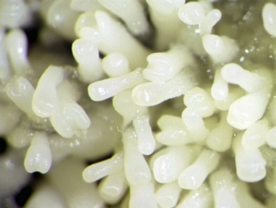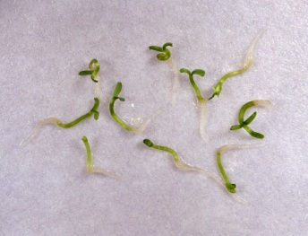
B

A

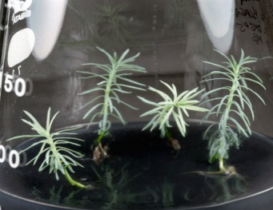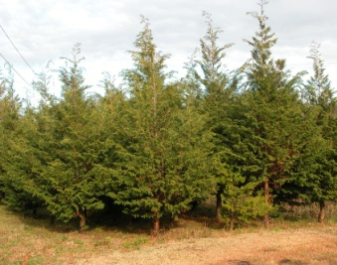
C

D

Fig. 1. Somatic embryo production and plant regeneration in Sawara cypress. A: Maturation of somatic embryos. B: Germination of somatic embryos. C: Plant regeneration from somatic embryos. D: Somatic embryo-derived plants growing out in the field. Bars 1cm (A-C), 1m (D)

Regenerated emblings were successfully acclimatized and recorded 100% survival after being transplanted to the field. The mean height of thirty somatic embryo-derived (somatic) plants and seven seed-derived plants (seedlings) after a 4- to 10-year growth period was shown in Fig. 2. Although no significant differences in the mean height until age 2 were recorded, from the age of 6, the seedling growth increment was markedly superior to the somatic plants. This difference in growth can be attributed to the different genetic origin of the plants or perhaps to the high stress applied in the process of producing the somatic plants. Similarly, Bozhkov and von Arnold (1998) reported inferior growth increment in somatic plants (produced after polyethylene glycol-maturation treatment) versus seedlings of Picea abies.

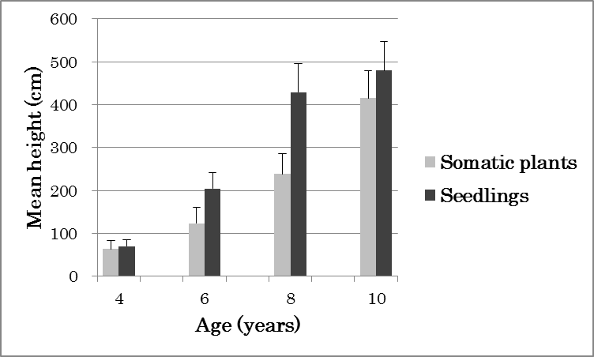
Fig. 2. Increment in the mean height of somatic embryo-derived (somatic) plants versus seed-derived plants (seedlings) of the Sawara cypress growing in the field after a 4- to 10-year growth period

Determination of genetic stability in somatic embryos
A total of 100 primers were screened against 12 randomly chosen cotyledonary somatic embryos. Of the 100 primers tested, 47% revealed reproducible amplifications. Among these, OPAA-01, OPAA-11, OPAB-01, OPAB-04, OPAB-05, OPAB-07, OPAB-08 and OPAB-10 were selected based on their amplification products which revealed clear DNA fragmentation. These 8 primers generated 70 scorable band classes, with an average of 8.75 bands per primer (Table 2).

Table 2. Number of amplification products generated with 8 selected primers in somatic embryos of the Sawara cypress

Primer Sequence No. of scorable bands Reference

OPAA-01 AGACGGCTCC 6 Operon Tech. Inc., USA
OPAA-11 ACCCGACCTG 8 Operon Tech. Inc., USA
OPAB-01 CCGTCGGTAG 9 Operon Tech. Inc., USA
OPAB-04 GGCACGCGTT 10 Operon Tech. Inc., USA
OPAB-05 CCCGAAGCGA 10 Operon Tech. Inc., USA
OPAB-07 GTAAACCGCC 11 Operon Tech. Inc., USA
OPAB-08 GTTACGGACC 7 Operon Tech. Inc., USA
OPAB-10 TTCCCTCCCA 9 Operon Tech. Inc., USA

The RAPD profile of 12 sample somatic embryos with selected primers is shown in Fig. 3. At least, from those zymograms, we could not detect any aberration in RAPD banding patterns among the tested somatic embryos. In addition, we measured the DNA content in somatic embryos randomly chosen and subject to different culture conditions using a flow cytometer. The results achieved indicated similar nuclear content among all tested embryos (data not shown).

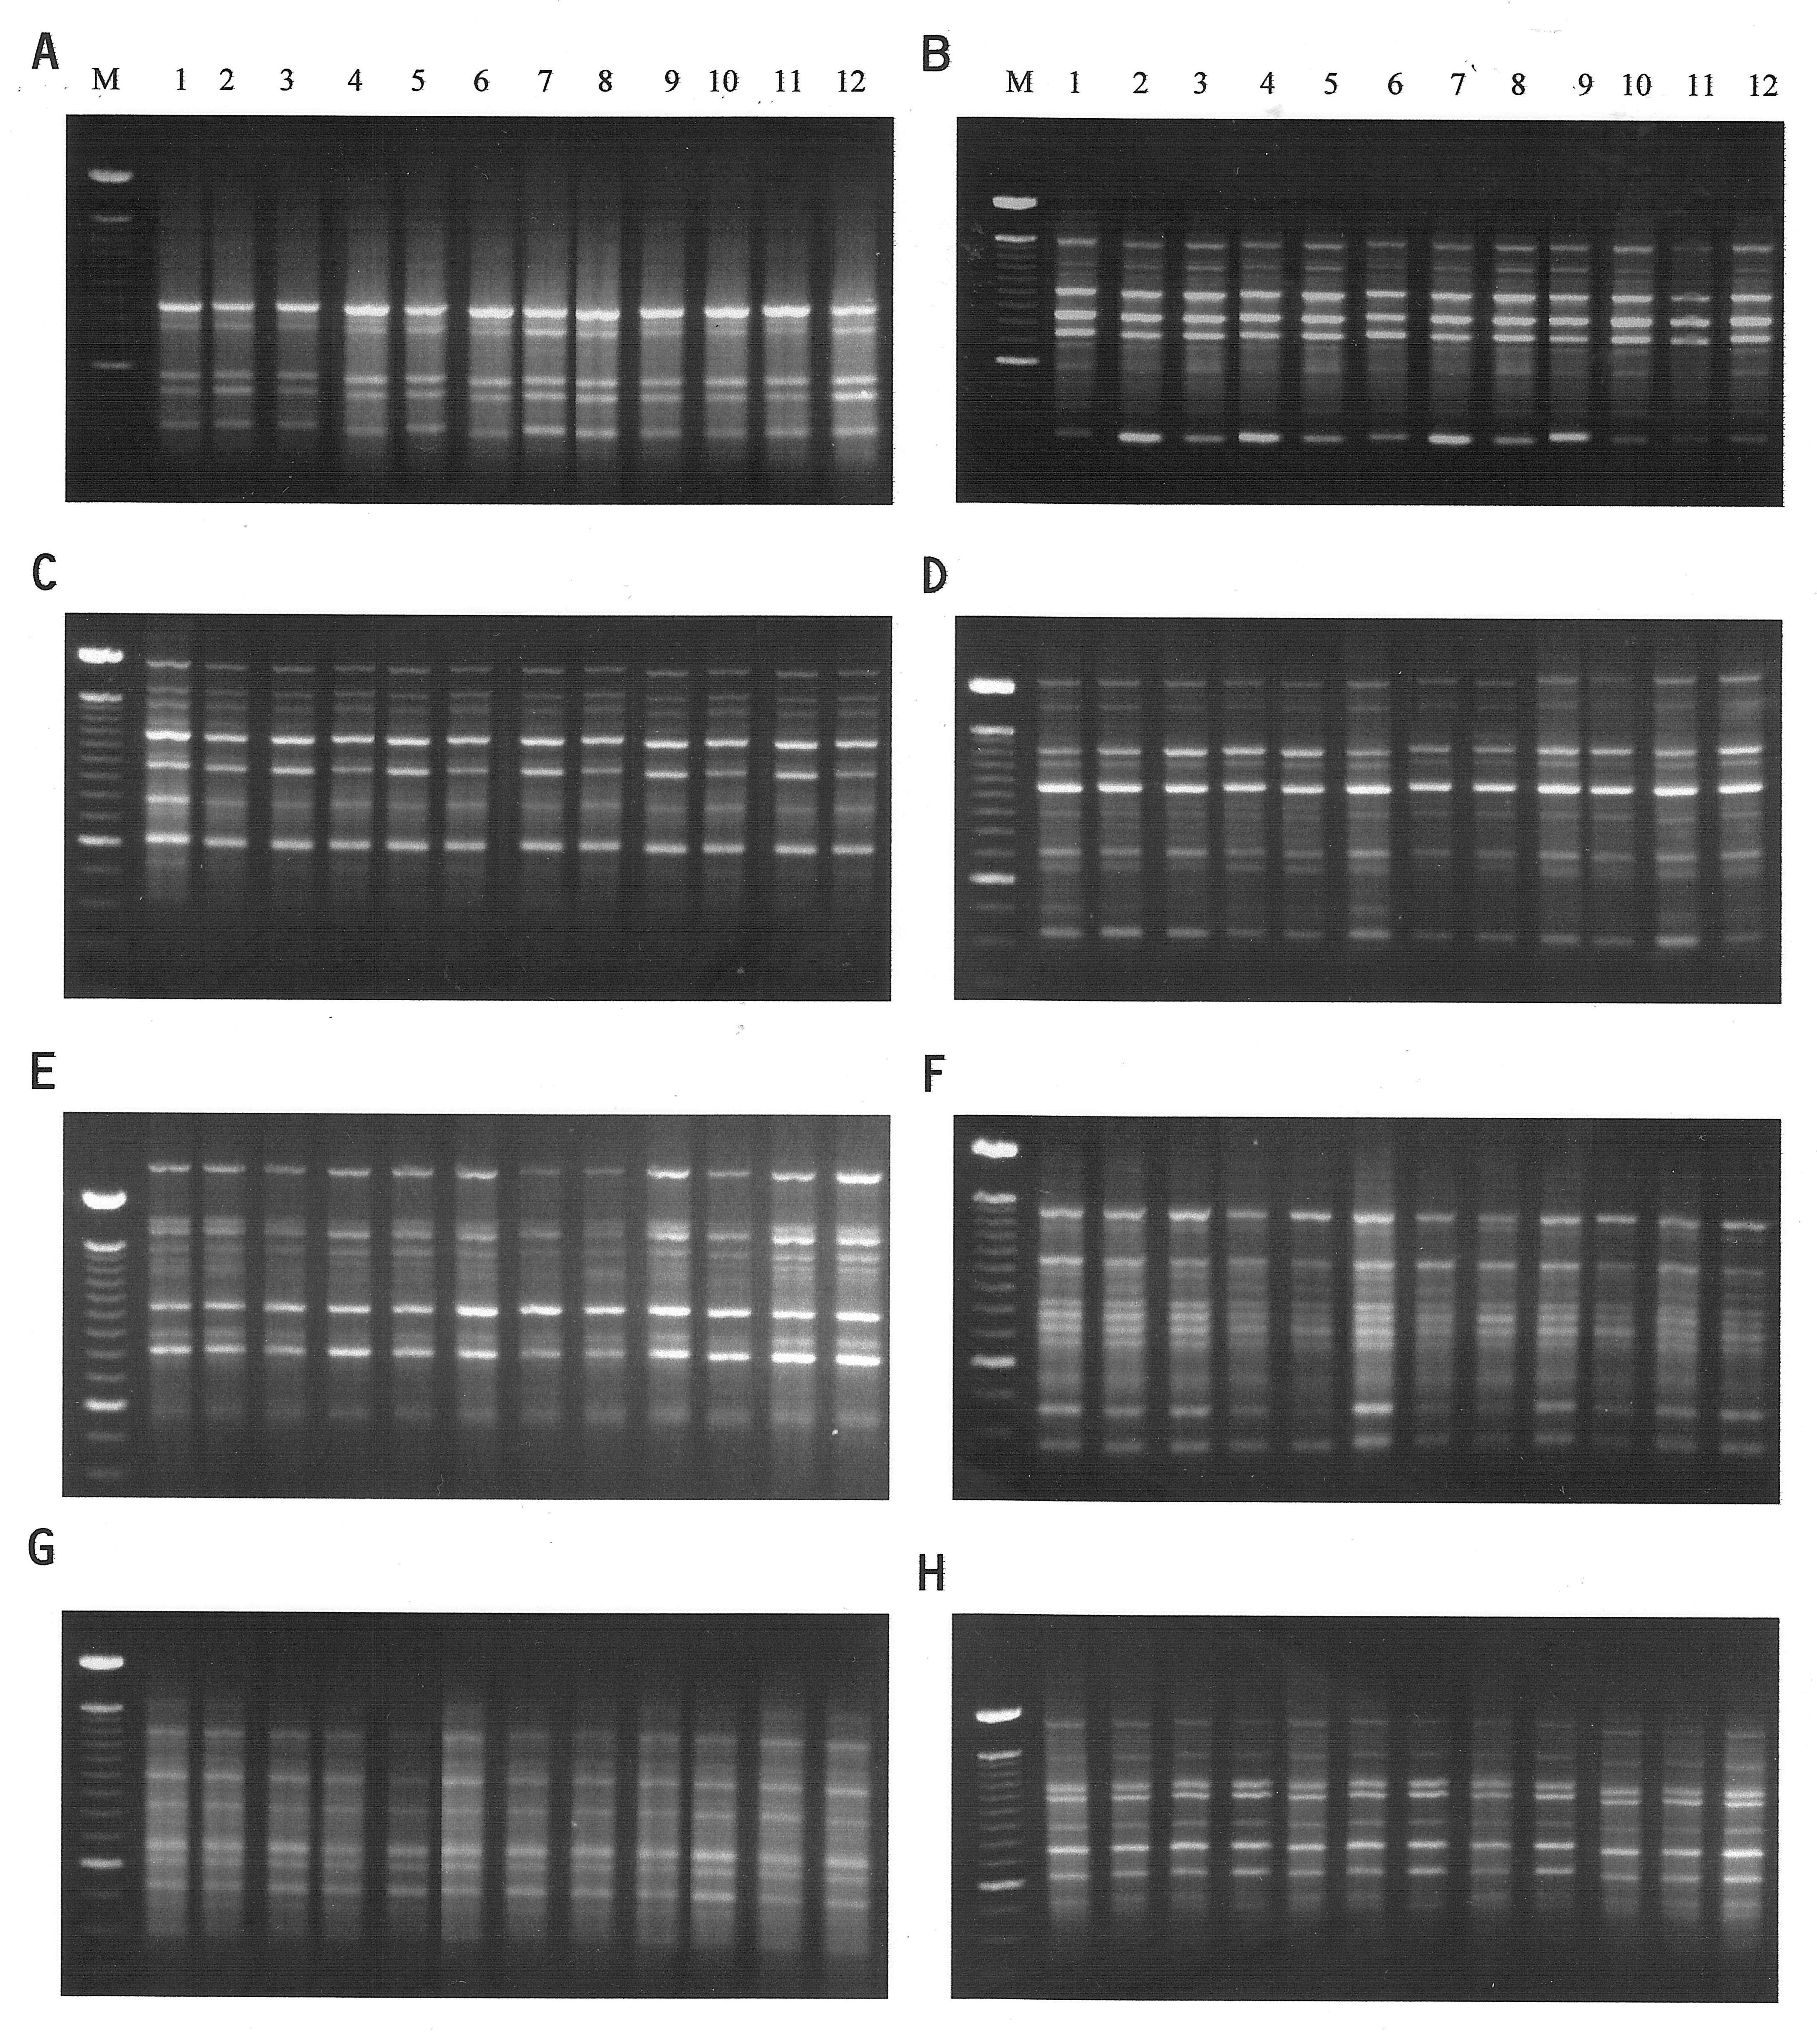
Fig. 3. Amplification DNA product patterns among 12 samples from Sawara cypress somatic embryos using RAPD markers. M is the molecular size marker (100bp ladder from BRL). RAPD primers are as follows: A: OPAA-01, B: OPAA-11, C: OPAB-01, D: OPAB-04, E: OPAB-05, F: OPAB-07, G: OPAB-08, H: OPAB-10

DISCUSSION
Currently, different molecular analytic techniques have been used to highlight somaclonal variation in tissue culture and the regenerants of several plants (Leva et al., 2012). A number of authors have also applied RAPD techniques to investigate genetic variability and found it very efficient and reliable (Goto et al., 1998). In a study of the genetic integrity of black spruce somatic embryos, RAPD markers were screened and no variation was found among somatic embryos derived from individual zygotic embryos (Isabel et al., 1993). Similar results using the RAPD technique were reported in the Norway spruce (Fourré et al., 1997), Japanese black pine (Goto et al., 1998), Japanese white oak (Thakur et al., 1999), loblolly pine (Tang, 2001), almond (Martins et al., 2004), hazelnut (Nas et al., 2004), pedunculate oak (Valladares et al., 2006), cork oak (Fernandes et al., 2011), apricot (Soliman, 2012), annato (Siril and Joseph, 2013), and seedless lemon (Goswami et al., 2013). In contrast, genetic variation detected by RAPD analysis was reported in the poplar (Ostry et al., 1994; Rani et al., 1995), white spruce (Isabel et al., 1995; Isabel et al., 1996), peach (Hashmi et al., 1997), teak (Gangopadhyay et al., 2003), Idaho locust (Ngezahayo et al., 2006), stone pine (Cuesta et al., 2010), and olive (Leva et al., 2012).
Despite the fact somaclonal variation has been extensively studied, its trigger mechanisms remain largely either unknown or subject to theoretical speculation (Skirvin et al., 1993; Skirvin et al., 1994). With regard to the origin and causes of somaclonal variation in micropropagated plants, the system by which regeneration is induced, explants sources, culture media, culture conditions, culture cycles, and the effect of genotype are some of the factors involved in inducing variation during in-vitro culture (Pierik 1987; Leva et al., 2012). In the basis for the micropropagation industry, the occurrence of uncontrolled variation during the culture process is an undesirable phenomenon (Karp, 1994). In contrast, somaclonal variation provides a valuable source of genetic variation to improve crops by selecting novel variants (Karp, 1995).
In the Sawara cypress, high embryo maturation efficiency was obtained when embryogenic cells were cultured on media supplemented with a combination of maltose, PEG, ABA and AC. More than one thousand mature cotyledonary embryos were produced from about 100 mg (FW) of inoculum on a maturation medium supplemented with 150 g l⁻¹ PEG. In addition to a highly synchronized and high-yielding maturation procedure, subsequent high germination and plant conversion frequencies attained demonstrated the “high-quality” condition of somatic embryos produced. Somatic embryos readily germinated after transfer to plant growth regulator-free media, and were subsequently converted into plantlets. Accordingly, the somatic embryo production efficiency, the quality of embryo produced and their genetic stability are key criteria to optimize an efficient plant regeneration system via somatic embryogenesis.
The result based on RAPD analysis shows a lack of somaclonal variation in our plant propagation system. Somatic embryogenesis has been considered less prone to genetic alterations as it entails the expression of many genes (Vasil, 1995). Similarly, Jain et al. (1995) emphasized how plants regenerated via somatic embryogenesis produce true-to-type progeny and minimize variation. In several cases, embryogenic cell lines are highly stable and exhibit no somaclonal variation (Isabel et al., 1993; Thakur et al., 1999). Somatic embryos derived from preembryogenic determined cells (cells of zygotic embryos) would tend to be genetically stable (Sharp et al., 1980). However, somaclonal variation can also occur in embryogenic cultures, if they are kept in cultures for an extended period, depending upon the plant species and genotype. Generally, the longer the culture phase, the greater the potential to generate somaclonal variation (Brar and Jain, 1998). In this study, over ten thousand plants were produced from a single immature zygotic embryo of the Sawara cypress within a short time protocol, and a sample was successfully acclimatized to undergo field testing (Fig. 1D). Although no phenotypic differences were observed until the age 10, the somatic embryo-derived plants showed lower growth compared with seedlings, although the specific reason was not explored in this study. Accordingly, to facilitate understanding of the growth dynamics of embryo-derived plants, the growth increments will be monitored for several more years.

REFERENCES
AITKEN-CHRISTIE J., THORPE T. A. (1984) Clonal Propagation: Gymnosperms. In: Vasil, I. K. (Ed.) Cell culture and somatic cell genetics of plants, Vol. 1. Academic Press Inc.: pp. 82-95.
BOZHKOV P. V., VON ARNOLD S. (1998) Polyethylene glycol promotes maturation but inhibits further development of Picea abies somatic embryos. Physiologia Plantarum 104: 211-224.
BRAR D. S., JAIN S. M. (1998) Somaclonal variation: mechanism and application in crop improvement. In: Jain S.M., Brar D. S., Ahloowalia B. S. (Eds.) Somaclonal variation and induced mutations in crop improvement. Kluwer Academic Publishers: pp. 15-37.
CUESTA C., ORDAS R. J., RODRIGUEZ A., FERNANDEZ B. (2010) PCR-based molecular markers for assessment of somaclonal variation in Pinus pinea clones micropropagated in-vitro. Biologia Plantarum, 54: 435-442.
FERNANDEZ P., COSTA A., ROCHA C., SANTOS C. (2011) Genetic stability evaluation of Quercus suber L. somatic embryogenesis by RAPD analysis. Pak. J. Bot., 43: 2727-2731.
FOURRE J. L., BERGER P., NIQUEST L., ANDRE P. (1997) Somatic embryogenesis and somaclonal variation in Norway spruce: morphogenetic, cytogenetic and molecular approaches. Theor. Appl. Genet., 94: 159-169.
FUKUHARA N. (1989) Fertility in interspecific-crossing between hinoki (Chamaecyparis obtusa Endl.) and Sawara (C. pisifera Endl.) and identification of the hybrids. Bulletin of the Forestry and Forest Products Research Institute, 354: 1-38.
GONGOPADHYAY G., GONGOPADHYAY S. B., PODDAR R., GUPTA S., MUKHERJEE K. K. (2003) Micropropagation of Tectona grandis: assessment of genetic fidelity. Biologia Plantarum 46: 459-461.
GOSWAMI K., SHARMA R., SINGH P.K., SINGH G. (2013) Micropropagation of seedless lemon (Citrus limon L. cv. Kaghzi Kalan) and assessment of genetic fidelity of micropropagated plants using RAPD markers. Physiol. Mol. Biol. Plants, 19: 137-145.
GOTO S., THAKUR R. C., ISHII K. (1998) Determination of genetic stability in long–term micropropagated shoots of Pinus thunbergii Parl. using RAPD markers. Plant Cell Rep., 18: 193-197.
HASHMI G., HUETTEL R., MEYOR R., KRUSBERG L., HAMMERSCHLAG F. (1997) RAPD analysis of somaclonal variants derived from embryo callus cultures of peach. Plant Cell Rep., 16: 624-627.
ISABEL N., TREMBLAY L., MICHAUD M., TREMBLAY F. M., BOUSQUET J. (1993) RAPDs as an aid to evaluate the genetic integrity of somatic embryogenesis-derivated populations of Picea mariana (Mill.). B.S.P. Thoer. Appl. Genet., 86: 81-87.
ISABEL N., BOIVIN R., LEVASSEUR C., CHAREST P. M., BOUSQUET J., TREMBLAY F. M. (1995) Evidence of somaclonal variation in somatic embryo-derived plantlets of white spruce (Picea glauca [Moench.] Voss.). In: Terzi M., Cella R., Falavinga A. (Eds.) Current issues in plant molecular and cellular biology. Kluwer Academic: pp. 247-252.
ISABEL N., BOIVIN R., LEVASSEUR C., CHAREST P. M., BOUSQUET J., TREMBLAY F. M. (1996) Occurrence of somaclonal variation among somatic embryo-derived white spruce (Picea glauca, Pinaceae). Am. J. Bot., 83: 1121-1130.
JAIN S. M., GUPTA P. K., NEWTON R. J. (Eds.) (1995) Somatic embryogenesis in woody plants, Vol. 1-3. Kluwer Academic Publishers.
JAYANTHI M., MANDAL P. K. (2001) Plant regeneration through somatic embryogenesis and RAPD analysis of regenerated plants in Tylophora indica (Burm F. Merril). In vitro Cell. Dev. Biol-Plant, 35: 576-580.
KARP A. (1994) Origins, causes and uses of variation in plant tissue cultures. In: Vasil I. K., Thorpe T. A. (Eds.) Plant cell and tissue culture. Kluwer Academic Publishers: pp. 139-152.
KARP A. (1995) Somaclonal variation as a tool for crop improvement. Euphytica 85: 295-302.
LEVA A. R., PETRUCCELLI R., RINALDI L. M. R. (2012) Somaclonal variation in tissue culture: a case study with olive. In: Leva A., Rinaldi L. M. R. (Eds.). Recent advances in plant in-vitro culture. InTech: pp. 123-150.
MARTINS M., SARMENTO D., OLIVEIRA M. M. (2004) Genetic stability of micropropagated almond plantlets, as assessed by RAPD and ISSR markers. Plant Cell Rep., 23: 492-496.
MARUYAMA E., HOSOI Y., ISHII K. (2002) Somatic embryogenesis in Sawara cypress (Chamaecyparis pisifera Sieb. et Zucc.) for stable and efficient plant regeneration, propagation and protoplast culture. J. For. Res., 7: 23-34.
MURASHIGE T., SKOOG F. (1962) A revised medium for rapid growth and bioassays with tobacco cultures. Physiol. Plant., 15: 473-497.
NAS M. N., MUTLU N., READ P. E. (2004) Random Amplified Polymorphic DNA (RAPD) analysis of long-term cultured hybrid hazelnut. HortScience, 39: 1079-1082.
NGEZAHAYO F., GUO W., GONG L., LI F., LIU B. (2006) Genomic variation in micropropagated Robinia ambigua ‘idahoensis’ revealed by RAPD markers. HortScience 41: 1466-1468.
OSTRY M., HACKETT W., MICHLER C., SERRES R., MCCOWN B. (1994) Influence of regeneration method and tissue source on the frequency of somatic variation in Populus to infection by Septoria musiva. Plant Sci., 97: 209-215.
PIERIK R. M. L. (1987) In vitro culture of higher plants. Kluwer Academic Publishers.
RANI V., PARIDA A., RAINA S. N. (1995) Random amplified polymorphic DNA (RAPD) markers for genetic analysis in micropropagated plants of Populus deltoides Marsh. Plant Cell Rep., 14: 459-462.
SHARP W. R., SONDAHL L. S., CALDAS L. S., MARAFFA S. B. (1980) The physiology of in-vitro asexual embryogenesis. Hortic. Rev., 2: 268-310.
SIRIL E. A., JOSEPH N. (2013) Micropropagation of annatto (Bixa orellana L.) from mature tree and assessment of genetic fidelity of micropropagated plants with RAPD markers. Physiol. Mol. Biol. Plants, 19: 147-155.
SKIRVIN R. M., NORTON M., MCPHEETERS K. D. (1993) Somaclonal variation: has it proved useful for plant improvement ?, Acta Horticulturae 336: 333-340.
SKIRVIN R. M., MCPHEETERS K. D., NORTON M. (1994) Sources of frequency of somaclonal variation. HortScience, 29: 1232-1237.
SMITH D. R. (1996) Growth medium. U. S. Patent No. 5,565,455.
SOLIMAN H. I. A. (2012) In vitro propagation of apricot (Prunus armeniaca L.) and assessment of genetic stability of micropropagated plants using RAPD analysis. World Appl. Sci. Journal, 19: pp. 674-687.
TANG W. (2001) In vitro regeneration of loblolly pine and random amplified DNA analyses of regenerated plantlets. Plant Cell Rep., 20: 163-168.
THAKUR R., GOTO S., ISHII K., JAIN M. (1999) Monitoring genetic stability in Quercus serrata Thunb. somatic embryopenesis using RAPD markers. J. For. Res., 4: 157-160.
VALLADARES S., SANCHEZ C., MARTINEZ M. T., BALLESTER A., VIEITZ A. M. (2006) Plant regeneration through somatic embryogenesis from tissues of mature oak trees: true-to-type conformity of plantlets by RAPD analysis. Plant Cell Rep., 25: 879-886.
VASIL I. K. (1995) Cellular and molecular genetic improvement of cereals. In: Terzi M., Cella R., Falavinga A. (Eds.) Current issues in plant molecular and cellular biology. Kluwer Academic: pp. 5-18.
VON ARNOLD S., HAKMAN I. (1988) Regulation of somatic developments in Picea abies by abscisic acid (ABA). J. Plant Physiol., 132: 164-169.
WILLIAMS J. G. K., KUBELIK A. R., LIVAK K. J., RAFALSKI J. A., TINGEY S. V. (1990) DNA polymorphism amplified by arbitrary primers are useful as genetic marker. Nuclei Acids Res., 18: 6531-6535.

