Analysis of the DNA Methylation on Camptotheca acuminata Decne Plants growing in vitro in Response to Sodium Chloride Stress

Qixiang ZHANG^{1,2†}, Huijuan LIU^{1,2†} , Hengkang Hu^{1,2}, Shunfu LI^{1,2}, Yeqing YING^{1,2*}, Jiasheng WU^{1,2*}

1.The Nurturing Station for the State Key Laboratory of Subtropical Silviculture, Zhejiang A & F University, Lin’an 311300, Zhejiang, China;
2.School of Forestry and Biotechnology, Zhejiang A & F University, 88 North Huancheng Road, Lin’an City, 311300, Zhejiang, China

† these authors contributed equally to this work
Qixiang ZHANG: Email address: qixiangzh@163.com
* corresponding author
Yeqing YING: Email address : yeqing@zafu.edu.cn, Fax:86-0571-63740809
Jiasheng WU: Email address: wujs@zafu.edu.cn , Fax: 86-0571-63740809

Abstract: Camptotheca acuminata is a well-known ornamental tree which belongs to family Nyssaceae. It is also a major natural source for the monoterpene-indole alkaloids camptothecin (CPT) and 10-hydroxycamptothecin (HCPT). Salinity is one of the major constrains to agricultural production. In this study, we sought to explore a possible relationship between sodium chloride (NaCl) stress and DNA methylation in Camptotheca acuminate because there is large amount of saline area around the world. For this purpose, we analyzed the effect of NaCl stress and DNA methylation level by Inter simple sequence repeat (ISSR). Results showed that NaCl stress significantly affected shoot proliferation and rooting in WPM medium. The effects of low NaCl concentration (30 mmol/L) on the proliferation coefficient and rooting percentage were significant higher when compared with the higher concentrations ( 45 to 120 mmol/L). The highest shoots proliferation coefficient and rooting percentage were 6.26 and 80.7% respectively. ISSR analyses showed there is a negative correlation between the NaCl concentration and the DNA methylation level in shoots proliferated and rooting, while there has a positive correlation of demethylation. Low NaCl concentration (30 mmol/L) can maintain leaves at a high methylation level in proliferation (16%) and rooting (5.2%) respectively. While under the higer NaCl concentration (45 to 120 mmol/L ), the methylation level of leaves decreased, and the seedlings growth declined dramatically.

Key words: Camptotheca acuminate Decne; Sodium Chloride; In vitro; ISSR; DNA Methylation
Introduction
Camptotheca acuminate Decne is a well-known ornamental tree which is called happy tree, cancer tree or tree of life. It belongs to the genus of medium-sized deciduous trees growing to 20 m tall, which is widely cultivated in parts of China, sometimes grown in southern California and other places. C. acuminata Decne is also potentially an efficient and environmentally friendly afforestation tree and plays an important role in sustainable forestry as well (Xie et al., 2011). This China endemic species is the major natural source for the monoterpene-indole alkaloids camptothecin (CPT) and 10-hydroxycamptothecin (HCPT), which have been identified in 1966 (Wall et al., 1966; Sankar-Thomas & Lieberei, 2011 ).
Abiotic stress is the major cause of crop loss worldwide (Saini et al.1999; Xiong et al., 2002). Salinity is one of the greatest abiotic stress to agriculture, inhibiting plant growth and reducing productivity (Hayat et al., 2010). Understanding the physiology of salt tolerance in plants is important for the effective solution of the problem of salinity in agricultural and horticultural soils. The excess concentration of ions, mainly Cl⁻ and Na⁺ leads not only to ion imbalances in the plant but also to ion toxicity. Yeo (1983) defined salt stress resistance as the ability of a plant to maintain growth and metabolism under saline conditions. A possible strategy for the solution of problems arising from salinization of agricultural and horticultural soils could be the selection of tolerant plants in vitro. Tissue culture techniques have been used for physiological investigations as well as determination of mechanisms of salt stress tolerance in potato (Rahnama et al., 2011), tomatoes (Dombrowski, 2003) and sweet potatoes (Kasukabe et al., 2006).
DNA methylation has been detected in fungi, plants and animals (Cokus et al., 2008; Tremblay et al., 1995). It plays important roles in the establishment of developmental programs and in genome defense against parasitic mobile elements. Epigenetic changes dependent on methylation of cytosine residues from genomic DNA and specifically, of promoter sequences of specific genes, regulate genome functions to a large extent. The methylated state is usually associated with inactivation of gene expression and, conversely, gene activation is associated with demethylation. Environmental stimuli, such as salt stress (Li et al., 2009; Ratna et al., 2012), aluminum (Sriram et al., 2005), heavy metals (Aina et al., 2004), and water stress (Wang et al. 2011), are known to alter cytosine methylation throughout the genome and at specific loci. Plants play epigenetic regulatory strategies, such as DNA methylation, maintain this genomic plasticity, allowing relatively rapid adaptation to new conditions without changing the DNA sequence.
However, little is known about the role of methylation alteration in the sodium chloride stress, and very few knowledge is obtained in C. acuminate Decne regarding the relationship between the salt stress and DNA methylation. For the purpose of disclosing the mechanism of NaCl-induced DNA methylation in C. acuminate Decne, the effect of NaCl on shoot propragation and rooting was evaluated and the status of cytosine methylation in the genomic DNA was also investigate using ISSR technique.

1 Materials and methods
1.1 NaCl treatments
1.5 to 2.0 cm in vitro shoots which contains 2~3 leaves were placed vertically into WPM (Lloyd & McCown, 1980) basal media supplemented with 0.5 mg l⁻¹ 6-benzyladenine (BA), and 3% sucrose (W/V), 0.22% Gelzan agar (W/V) Gelzan agar (Sigma Chemical Co.,. St. Louis, Mo., USA) and the ladder of NaCl concentrations, i.e., 0 (control), 0.5, 1.5, 2.5, 3.5, 4.5, 5.5, 6.5, 7.5 g l⁻¹ for shoot proliferation. For rooting experiment, vigorous shoots (2.0~3.0 cm) were inoculated in the same treatments but BA was placed by 0.5 mg l⁻¹ 3-indolebutyric acid (IBA). Additional transfers to same fresh medium were made at 4-week intervals. The data was collected 8 weeks later. Shoots were grown at 25±2°C with a photosynthetic photon flus density (Philips, China) of about 50 μmol m⁻² s⁻¹ and 16-h photoperiod.
1.2 Evaluation of seedlings growth
Bud length, multiplication coefficient, root percentage and root length were recorded. Ten explants were used for each treatment and experiments were repeated three times. The data were analyzed by ANOVA using statistical package of SPSS and linear regression analyses were fitted using Sigma Plot 8.0. The means were compared using Duncan’s multiple range test (95% confidence level) and the standard errors of means were calculated.
1.3 ISSR (Inter- simple sequence repeat) analysis
After 8 weeks of culture, leaves were used for DNA extraction. ISSR amplifications were performed as reported previously (Guo et al., 2006), and the primers used in this research were listed in Table 1. Before PCR amplication, genomic DNA was digested with HpaⅡor MspⅠ(Sigma, USA). ISSR amplication products were dissolved on 2% agarose gels stained with ethidium bromide.
Table 1 ISSR primers
Primer | Sequence(5´-3´) | Primer | Sequence(5´-3´)
816 | CAC ACA CAC ACA CAC AT | 842 | GAG AGA GAG AGA GAG AYG
817 | CAC ACA CAC ACA CAC AA | 843 | CTC TCT CTC TCT CTC TRA
818 | CAC ACA CAC ACA CAC AG | 844 | CTC TCT CTC TCT CTC TRC
819 | GTG TGT GTG TGT GTG TA | 846 | CAC ACA CAC ACA CAC ART
821 | GTG TGT GTG TGT GTG TT | 848 | CAC ACA CAC ACA CAC ARG
823 | TCT CTC TCT CTC TCT CC | 861 | ACC ACC ACC ACC ACC ACC
825 | ACA CAC ACA CAC ACA CT | 867 | GGC GGC GGC GGC GGC GGC
826 | ACA CAC ACA CAC ACA CC | 884 | HBH AGA GAG AGA GAG AG
827 | ACA CAC ACA CAC ACA CG | 887 | DVD TCT CTC TCT CTC TC
829 | TGT GTG TGT GTG TGT GC | 889 | DBD ACA CAC ACA CAC AC
840 | TGT GTG TGT GTG TGT GC
N = (A , G, C , T) , R = (A , G) ,Y = (C , T) , B = (C , G, T) ( I. e. not A) , D = (A , G, T) ( I. e. not C) , H = (A , C , T) ( I. e. not G) , V = (A , C , G) ( I. e. not T)

2 Results
2.1 Effect of NaCl stress on the tissue culture seedlings
2.1.1 Effect of NaCl stress on shoot proliferation
NaCl stress significantly affected buds production in WPM medium. The proliferation coefficient gradually increased with the increasing concentrations of NaCl from 0 (control) to 1.5 g l⁻¹, followed by a decrease from 2.5 to 7.5 g l⁻¹. The highest proliferation coefficient was 6.26, when the concentration of NaCl was 1.5 g l⁻¹. However, there is no significant between 0, 0.5, and 1.5 g l⁻¹ (low concentration). The effects of low NaCl concentration on the proliferation of adventitious buds of Camptotheca acuminate were significant when compared with higher concentration (2.5 to 7.5 g l⁻¹), which indicated that C. acuminate Decne has tolerance with low NaCl. With the increase of the NaCl concentration (from 1.5 to 7.5 mmol/L), the proliferation coefficient gradually decreased from 6.26 to 2.26. For bud length, there were no significant differences among the concentrations of NaCl. The bud length gradually increased with a little increasing concentration of NaCl from 0 to 1.5 g l⁻¹, followed by a decrease from 2.5 to 7.5 g l⁻¹. With the concentration of NaCl increased, more and more leaves turn into yellow and brown and fall off from the stems (Fig.1~2).

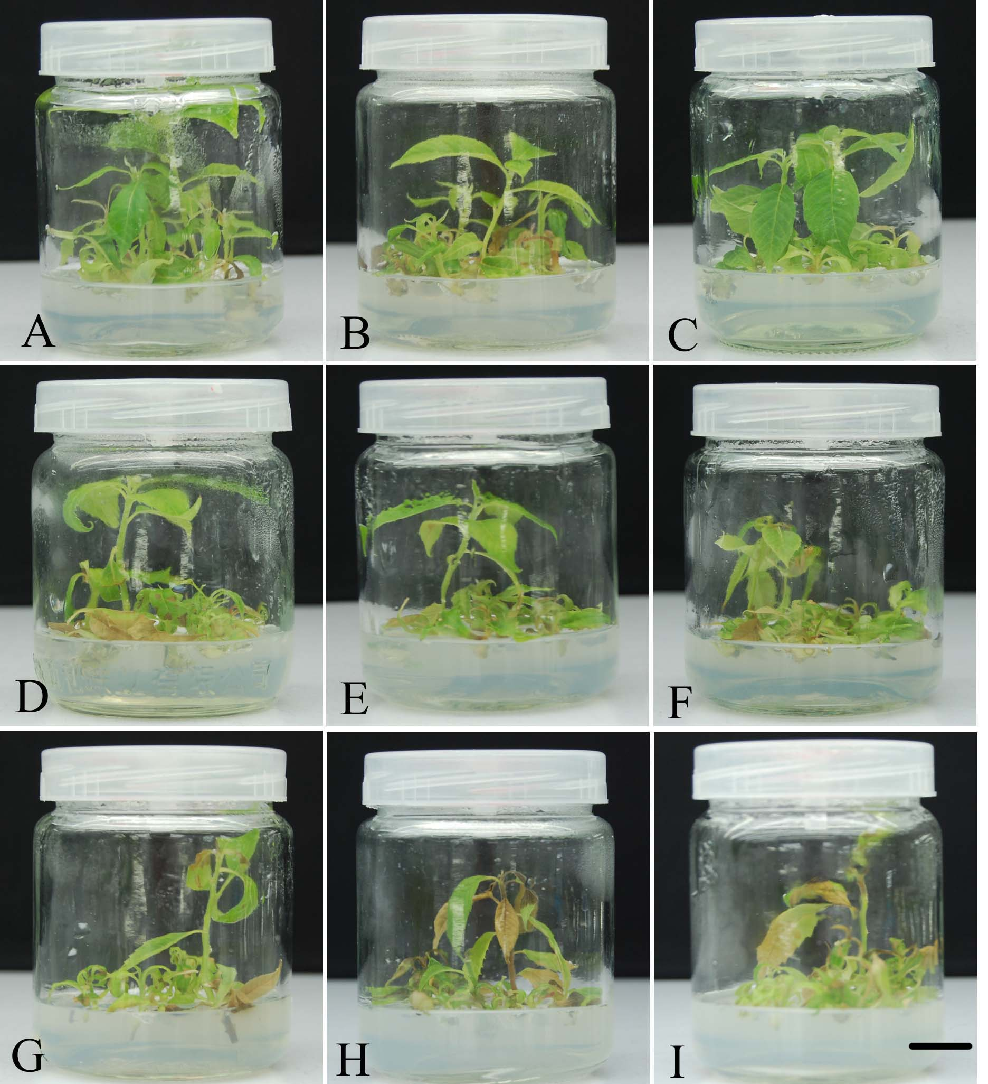
Fig. 1 Shoots proliferation on NaCl (0~7.5 g l⁻¹)
A~F Shoots proliferated on WPM media supplemented with 0.5 mg l⁻¹ BA and with 9 different concentrations of NaCl (0~7.5 g l⁻¹) (Bar 1cm)

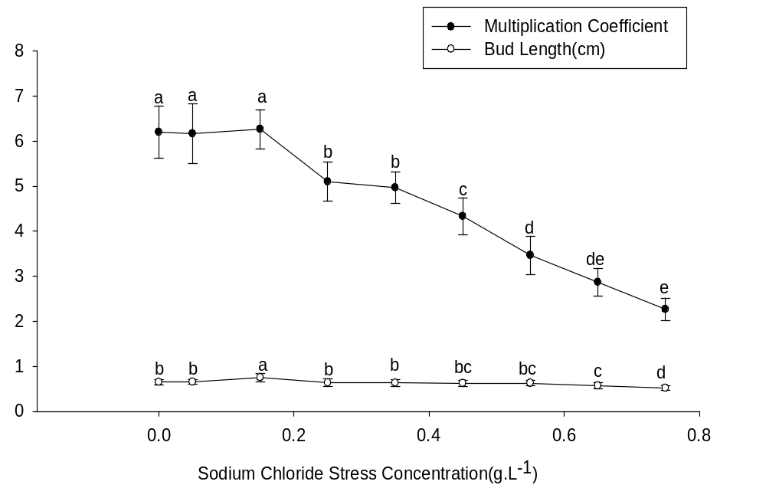
Fig.2 Effect of NaCl on shoots multiplication coefficient and bud length of C. acuminate Decne
2.1.2 Effect of NaCl stress on rooting
As the concentration of NaCl was increased, the root percentage first increased and then decreased. When the concentration of NaCl was 1.5 g l⁻¹, the root percentage and root length was the highest, reaching 80.7% and 1.7 cm, respectively. When 1.5 g l⁻¹ NaCl was used, few calli were produced on the basal of the buds, which was detrimental to the development of adventitious roots. The shoots in this treatment were the most vigorous and leaves were fresh green. While as the NaCl concentration increased, the root length first maintained and then decreased. The differences of root percentage between 1.5 g l⁻¹ NaCl and other concentrations were significant (Fig.3,4). When the concentration of NaCl was 0 to 1.5 g l⁻¹, there is no significant differences among these three treatments in root length. With the increase of the concentration of NaCl (from 1.5 to 7.5 g l⁻¹), the root length decreased dramatically (Fig.3,5).
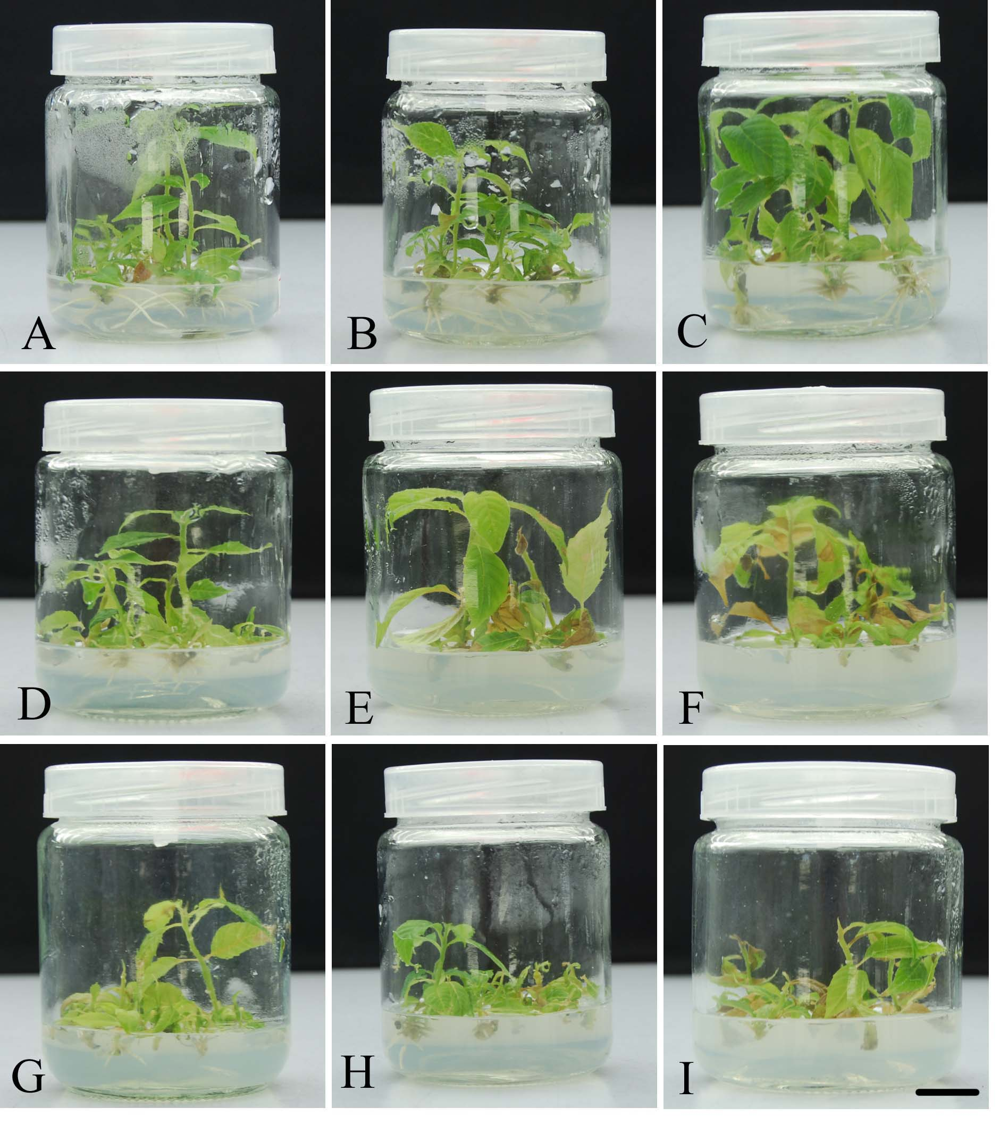
Fig. 3 Shoots rooting on NaCl (0~7.5 g l⁻¹)
A~F Shoots proliferated on WPM media supplemented with 0.5 mg l⁻¹ IBA and with 9 different concentrations of NaCl (0~7.5 g l⁻¹)
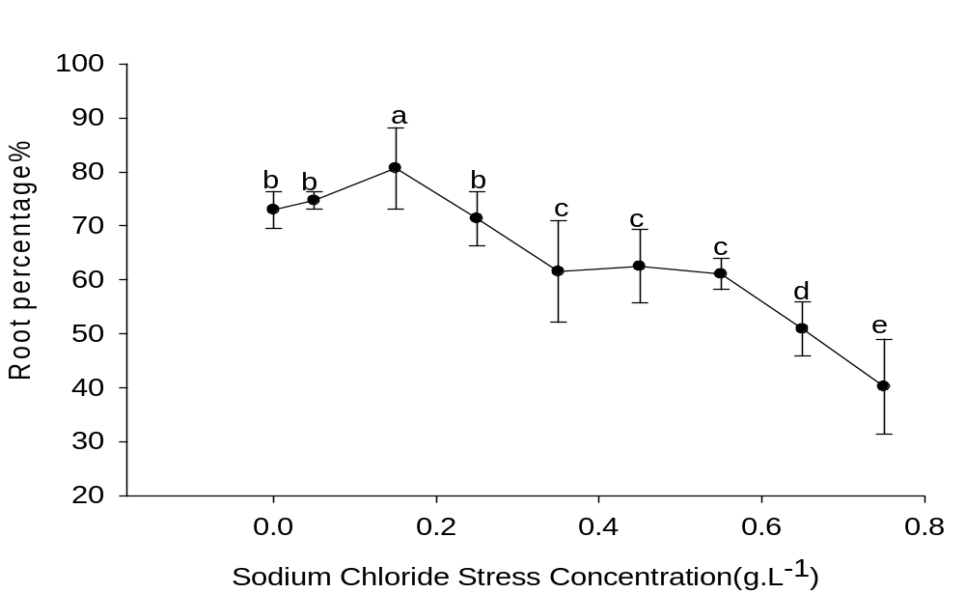
Fig.4 Effect of NaCl on root percentage of C. acuminate Decne

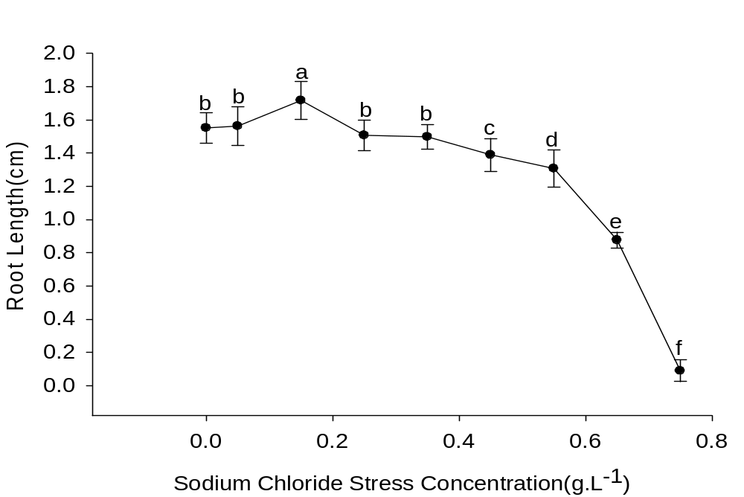
Fig.5 Effect of NaCl on root length of C.acuminate Decne

2.2 Dynamic level of DNA methylation induced by sodium chloride stress
In order to identify the inter material differences in genome and DNA methylation state, the extracted DNA from leaves of NaCl stress treatments (0, 0.5, 1.5, 2.5, 3.5, 4.5, 5.5, 6.5, 7.5 g l⁻¹) on proliferation and rooting were divided into three groups: non digested, HpaⅡ degisted and MspⅠ digested, respectively. Then ISSR analyses were performed. Twenty one ISSR primers obtained good amplification.
2.2.1 Dynamic level of DNA methylation on leaves of shoot proliferation
In the NaCl stress (0, 0.5, 1.5, 2.5, 3.5, 4.5, 5.5, 6.5, 7.5 g l⁻¹) on shoot proliferation experiment, total 218 amplified bands were detected with 21 primers, in which many sequence variations and methylation variations were detected. The total band number was 22, 25, 45, 30, 23, 28, 29, 29 in the 0.5, 1.5, 2.5, 3.5, 4.5, 5.5, 6.5, 7.5 g l⁻¹ NaCl treatments. The methylated band numbers were 6, 4, 4, 2, 1, 1, 1 and 0, demethylated band numbers were 1, 3, 6, 7, 7, 8, 9, 8 respectively. Compared with the control, either the band numbers or their percentage for methylation under NaCl stress decreased obviously. The percentages of methylation were 27%, 16%, 8%, 6.6%, 4.3%, 3.5%, 3.4% and 0 respectively. However, the percentages of demethylation were 4.5%, 12%, 13.3%, 23.3%, 30.4%, 28.5%, 31.0%, 27.5% respectively. This indicated that there were great differences in the genomic DNA methylation between the control and the NaCl stress, according to the percentage of methylation and demethylation level (Table 2, Fig7).

Table 2 Trend of DNA methylation of leaves under NaCl stress on shoot proliferation
NaCl concentraion  （g l⁻¹） | 0.5 | 1.5 | 2.5 | 3.5 | 4.5 | 5.5 | 6.5 | 7.5
Total bands | 22 | 25 | 45 | 30 | 23 | 28 | 29 | 29
Methylation  Bands (%) | 6(27.2) | 4(16) | 4(8) | 2(6.6) | 1(4.3) | 1(3.5) | 1(3.4) | 0
Demethylation  Band (%) | 1(4.5) | 3(12) | 6(13.3) | 7(23.3) | 7(30.4) | 8(28.5) | 9(31) | 8(27.5)
Total Percentage (%) | 31.7 | 28 | 21.3 | 29.9 | 34.7 | 32 | 34.4 | 27.5

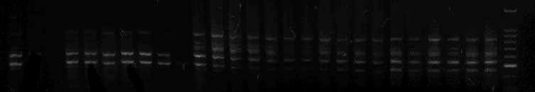
A
B
1
2
3
4
5
6
7
8
9
10
11
12
13
14
15
16
17
18
19
20
21
22
23
24
25
26
27
M
500bp
Fig.7 Examples of changing cytosine methylation patterns detected in shoot proliferation under NaCl stress by ISSR primer 816. Lanes 1~9 non degisted from 0 to 7.5 g l⁻¹; lanes 10~18 DNA degisted by MspⅠfrom 0 to 7.5 g l⁻¹; Lanes 19~27 DNA degisted by HapⅡ from 0 to 7.5 g l⁻¹; Lane M marker. A indicates methylation. B indicates demethylation.
2.2.2 Dynamic level of DNA methylation on leaves of rooting
In all 9 rooting treatments ( NaCl 0, 0.5, 1.5, 2.5, 3.5, 4.5, 5.5, 6.5, 7.5 g l⁻¹), we also detected a number of genomic variation and methylation variation. Then ISSR analyses were performed. Total 287 amplified bands were detected, in which many sequence variations and methylation variations were also detected. Compared with the control, either the band numbers or their percentage for methylation and demethylation under NaCl stress are similar with the shoot proliferation with the increasing concentrations of NaCl. The methylation percentage increased and demethylation percentage decreased with the increasing of NaCl concentration. The total percentage of methylation and demethylation gradually increased with increasing concentrations of NaCl (Tab.3, Fig.8).
Table 3 Trend of DNA methylation of leaves under NaCl stress on rooting
NaCl concentraion  （g l⁻¹） | 0.5 | 1.5 | 2.5 | 3.5 | 4.5 | 5.5 | 6.5 | 7.5
Total bands | 50 | 57 | 53 | 55 | 60 | 42 | 40 | 0
Methylation Bands (%) | 3(6) | 3(5.2) | 2(3.7) | 2(3.6) | 2(3.3) | 1(2.3) | 1(2.5) | 0
Demethylation  Bands (%) | 2(4) | 4(7) | 6(11.3) | 6(10.9) | 7(11.6) | 7(16.6) | 8(20) | 0
Total Percentate (%) | 10 | 12.2 | 15 | 14.5 | 14.9 | 18.9 | 22.5 | 0

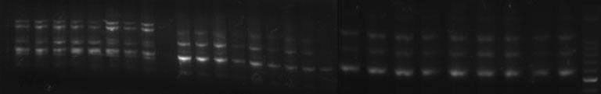
9
23
1
2
3
4
5
6
8
10
11
12
13
14
15
16
17
18
19
20
21
22
24
25
26
27
M
A
B
7
500bp
Fig.8 Examples of changing cytosine methylation patterns detected in rooting under NaCl stress by ISSR primer 861. Lanes 1~9 non degisted from 0 to 7.5 g l⁻¹; lanes 10~18 DNA degisted by MspⅠfrom 0 to 7.5 g l⁻¹; Lanes 19~27 DNA degisted by HapⅡfrom 0 to 7.5 g l⁻¹; Lane M marker. A indicates methylation. B indicates demethylation.

3 Discussion
The production and productivity of many crops continues to be adversely affected because of various biotic and abiotic stresses (Yamaguchi & Blumwald, 2005). Damages caused by these stresses are responsible for proper management strategies continue to play key role in crop improvement. In vitro culture of plant cells, tissues or organs on a medium containing selective material offers the opportunity to select and regenerate plants with desirable characteristics. The technique has been effectively utilized to induce tolerance which includes for the use of getting some desired phenotypes. Development of abiotic stress tolerant plants has been reported in a wide range of plant species including crops (Zair et al., 2003; Lee et al., 2003), vegetables (Elavumoottil et al., 2003) and fruits (Koc et al., 2009; Dziadczyk et al., 2003) and other commercially plants (Davenport et al., 2003; Rout et al., 2008). Previous studies on Camptotheca acuminate abiotic stress tolerantance were reported (Li 2002; Zhang et al., 2011; Hao et al., 2010). Li (2002) found NaCl stress in Camptotheca acuminate reduced height, weight, leaf number, and leaf length, but increased SLW (specific leaf weight) and CPT (camptothecin) concentrations in leaves and roots. Zhang et al. (2011) reported seedling height, base diameter and biomass tended to decrease and a ratio of roots to crown tended to increase with the development of salt stress with one-year-old seedlings. In this study, there is no significant among low NaCl concentrations (0, 0.5 and 1.5 g l⁻¹) in shoot proliferation (proliferation coefficient was 6.26 when the concentration of NaCl was 1.5 g l⁻¹) and rooting (root percentage was 80.7% and root length was 1.7 cm when the concentration of NaCl was 1.5 g l⁻¹), and then followed by a decreasing with the increasing of NaCl concentration gradually. This indicated that C. acuminate Decne has a resistance in low concentration of NaCl concentration. This is in agreement with the previous studies on cotton under salt stress（Li et al. 2009）. For cotton (Gossypium hirsutum L.), Li et al. (2009) determined that 100 mmol/L NaCl obviously promoted plant height and root length of cotton seedlings, but 200 mmol/L NaCl significantly inhibited plant growth.
DNA methylation is one of the important epigenetics in plants, which plays a central role in epigenetic control of gene expression. It is the most common DNA modification in plants, but the level varies in different species. Many previous studies focused on methylation under stress (Lin et al., 2009; Karan et al., 2012; Tan 2010; Sha et al., 2005). Lin et al. (2009) reported the level of global DNA methylation showed a decrease from 41.2% to 34.5% as the salt concentration increased. And there is a significantly negative correlation between the NaCl concentration and the level of DNA methylation in cotton roots. Karan et al. (2012) found the amount of DNA methylation was more in shoot compared to root and the contribution of fully methylated lici was always more than hemi-methylated loci. Feng et al. (2012) demonstrated that salt-stress caused alteration in DNA methylation pattern in the treated plants. The altered patterns persisted in selfed progenies of the stressed plants that grow under non-stress conditions. In this study there is a partly similarity with Lin et al. (2009), there is a significant negative correlation between the NaCl concentration and the level of DNA methylation in proliferated shoots and rooting, while there is a positive correlation of demethylation. That means a high methylation level is very important to maintain the seedlings growth. Similary with the control and 0.5 g l⁻¹ NaCl, 1.5 g l⁻¹ NaCl can also maintain seedling methylation at a higher level in shoot proliferation (16%) and rooting (5.2%). While under the higher NaCl concentration (2.5 to 7.5 g l⁻¹ ), the methylation level of leaves decreased, and the seedlings growth declined dramatically. However, the loci showing DNA methylation or demethylation alterations should be isolated and sequenced further to show diverse genes participating in cellular basal metabolism.

Acknowledgments
The authors acknowledge Natural Science Foundation of Zhejiang Province (LZ12C16001, Y3090091) and National Natural Science Foundation of China (31100461) for financial support.

Reference
Aina R., Sgorbati S., Santagostino A., 2004. Specific hypomethylation of DNA is induced by heavy metals in white clover and industrial hemp. Physiologia Plantarum, 121(3): 472~480.
Cokus S.J., Feng S.H., Zhang X.Y., 2008. Shotgun bisulfite sequencing of the Arabidopsis genome reveals DNA methylation patterning. Nature, 452 (7184):215~219.
Dombrowski J. E., 2003. Salt stress activation of wound-related genes in tomato plants. Plant Physiology, 132(4): 2098~2107.
Feng Q.Z., Yang C.W., Lin X.Y., 2012. Salt and alkaline stress induced transgenerational alteration in DNA methylation of rice (Oryza sativa). Australian Journal of Crop Science. 6(5): 877~883.
Hao F. G., Zhou J. G., Zhou X. M., 2010. Effect of NaCl stress on leaf physiological characteristics and growth of Camptothecin accumulation seedlings. Journal of North East Forest University. 38(1): 18~19. (in Chinese)
Hayat Q., Hayat S., Irfan M., 2010. Effect of exogenous salicylic acid under changing environment: A review. Environmental and Experimental Botany, 68:14-25
Karan R., Deleon T., Biradar H., 2012. Salt stress induced variation in DNA methylation pattern and its influence on gene expression in contrasting rice genotypes. Plos One, 7 (6): e40203.
Kasukabe Y., He L. X., Watakabe Y., 2006, Improvement of environmental stress tolerance of sweet potato by introduction of genes for spermidine synthase. Plant Biotechnology, 23: 75~83.
Li X.L., Lin Z.X., Nie Y. C., 2009. Methylation-sensitive amplification polymorphism of epigenetic changes in cotton under salt stress. Acta garonomica sinica, 35 (4) :588~596. (in Chinese)
Rahnama H., Vakilian H., Fahimi H., 2011. Enhanced salt stress tolerance in transgenic potato plants (Solanum tuberosum L.) expressing a bacterial mtlD gene. Acta Physiologiae Plantarum, 33:1521~1532.
Ratna K., Teresa D., Hanamareddy B., 2012. Salt stress induced variation in DNA methylation pattern and its influence on gene expression in contrasting rice genotypes. Plos One. 7(6) : e40203.
Saini H.S. and Westgate M.E., 1999, Reproductive development in grain crops during drought. Advances in agronomy, 68: 59-96.
Sankar-Thomas Y. D. and Lieberei R., 2011. Camptothecin accumulation in various organ cultures of Camptotheca acuminate Decne grown in different culture systems. Plant Cell Tissue Organ Culture, 106: 445~454.
Sha A.H., Lin X. H., Huang J. B. 2005. Analysis of DNA methylation related to rice adult plant resistance to bacterial blight based on methylation-sensitive AFLP (MSAP) analysis. Molecular Genetics and Genomics, 273:484~490.
Sriram G., Martinez J.A., McCabe E.R., 2005. Single gene disorders: what role could moonlighting enzymes play? American Journal Human Genetics, 76:911~924.
Tan M. P., 2010. Analysis of DAN methylation of maize in response to osmotic and salt stress based on methylation-sensitive amplified polymorphism. Plant physiology and biochemistry. 48: 21~26.
Tremblay K.D., Saam J. R., Ingram R. S.,1995. A paternal-specific methylation imprint marks the alleles of the mouse H19 gene. Nature Genetics, 9: 407~413.
Wang W.S., Pan Y.J., Zhao X.Q., 2011. Drought-induced site specific DNA methylation and its association with drought tolerance in rice (Oryza sativa L.), Journal of Experimental Botany, 62(6): 1951~1960.
Xie Y., Liu L., Xue B., Chen S.W., 2011. Research of reproductive characteristics of Capmptotheca acuminate introduced green tree species in Huainan. Journal of Hainan Normal University, 69(13): 9~11. (in Chinese)
Xiong L.M., Schumaker K.S., Zhu J.K., 2002. Cell signaling during cold, drought, and salt stress. The Plant Cell, 14: 165-183.
Zhang L.T., Wu J., Mei L., Wu J.S., 2011. Saline tolerance of Camptothecin accumulation provenances and the index selection for saline tolerance. Scientia Silvae Sinicae. 47 (11): 66~72. (in Chinese)

