EFFECTS OF COLD CATHODE FLUORESCENT LAMPS ON THE IN VITRO GROWTH CHARACTERISTICS OF ORCHID PLANTLETS

Chiachung Chen¹*, Country Huang²
¹Chiachung Chen, Professor, Department of Bio-industrial Mechatronics Engineering, National ChungHsing University, 250 Kuokuang Road, Taichung, Taiwan
2. Research Lab. Supervisor, Eig Energy Solutions Co. 111 1F., No.97, Sec. 4, Chung King N. Rd., Shihlin District, Taipei Taiwan

*Corresponding author: Chiachung Chen, Department of Bio-industrial Mechatronics Engineering, National ChungHsing University, 250 Kuokuang Road, Taichung, 40227 Taiwan phone: 886-4-22857562;
fax:886-4-22857135
e-mail:ccchen@dragon.nchu.edu.tw

Abstract
The effect of three light sources: (white fluorescent lamps, WFL and two types of cold cathode fluorescent lamps, CCFLs) on the characteristics of in vitro grown cultures of three orchid species (Phalaenopsis, Oncidium, Dendrobium nobile) was studied. The commercial criteria of plantlets were used to evaluate the effect of the light sources. Fresh weight, plantlet height, leaf area and chlorophyll index but not number of leaves and roots were affected by the light sources. The CCFL 2S was adequate for Phalaenopsis and CCFL 3S had the best performance for Dendrobium nobile. Both CCFL light sources were adequate for Oncidium.
Key word: CCFL, light source, plantlet, Phalaenopsis, Oncidium,
Dendrobium nobile.

INTRODUCTION
Plant micropropagation has become necessary to produce orchid plantlets. Medium compositions, temperature and light environment are the important factors affecting the physiological and morphological attributes (Chen, 2012).
For the light environment, light period, quantity and quality are the key factors for plantlets. The artificial light commonly used in the culture room for growth of plantlets in vessels is from white fluorescent lamps (WFLs). This type of light tube is popular and low cost. However, the disadvantages include the high power requirement, highs heat loss, poor uniformity of light intensity, short life span and high cooling cost.
Recently, two other types of light sources have been used: Light-limiting diodes (LEDs) and cold cathode fluorescent lamps (CCFLs). LEDs supply narrow bands of light intensity are energy saving and have a long life. However, the cost and low intensity are limitations. CCFLs are not novel. They are used in personal computers, liquid crystal monitoring and other devices. The CCFLs have small diameter and lower heat generation than that of WFLs.
The significant difference among the WFL, CCFL and LED is the distribution of light spectrum. However, light quality from various light sources may affect plantlets differently.
The effect of light quality on the growth characteristics of plantlets has been studied often. Hsu and Chen (2010) compared the effect of three light sources on in vitro culture of Phalaenopsis and found that the red (R) light treatment could enhance the fresh weight, dry weight and total leaf area. Baque et al. (2010) investigated the effect of auxin and light quality on adventitious root induction from leaves of Morinda citrifolia. Different light sources (fluorescent, red (R), blue (B), R plus B, and far-red) had a significant effect on the catalase and guaicacol peroxidase activities and other enzyme functions. The effect of light quality on the leaf development of Alternanthera brasiliana Kumtze in vitro was studied by Macedo et al. (2011): number, mass, thickness and density of leaves were all influenced by light quality, with and a combination of R and B light conferring the highest quality. Gu et al. (2012) evaluated the effects of five different light sources (fluorescent, R, B, yellow and R plus B) on rooting and growth of adventitious shoots of Anthurium andraeanum and found that a complex light of R plus B light had the best performance. Li et al. (2013) studied the effects of six different light sources, including fluorescent, B LEDs, R LEDs and three mixtures of R plus B LEDs for rapeseed plantlet culture in vitro. Their results revealed the B: R=3:1 LED ratio was suitable. Lu et al. (2013) investigated the effect of nitrogen sources and LED wavelength on in vitro culture of Lysionotus pauciflorus Maxim. Among light sources (R, B, orange and white LEDs), Red LEDs were suitable and orange LEDs supressesed the shoot differentiation as compared with other light sources.
Gupta and Jatothu (2013) gave a detailed review of the use of LEDs for in vitro plantlets. With the special spectra of LEDs, the morphological, anatomical and physiological attributes could be found. However, the disadvantages of this light source were its cost and low photosynthesis photon flux (PPF). The authors suggested compensating the low PPF with a longer photoperiod and higher CO₂ concentrations.
Besides of LEDs and WFLs, CCFLs began to be used for the plantlets cultures in vitro. Tanaka et al. (2009) introduced the detailed principles and units of CCFL and tested the effects of different R: B ratios on the growth of hybrid Cymbidium Forest Garden No. 6 and found that the 80:20 R: B light conferred the best fresh weight and height of plantlet. The advantages of this light source are long life, low electric consumption and easy off control of the R: B ratio. Norikanel and Tanaka (2010) tested the effect of CCFL and CO₂ enrichment on the growth response of Phalaenopsis. Four ratios of R and B of CCFLs were set. The 80: 20 R: B light treatment conferred the best shoot and root fresh weights. High CO₂ enrichment (5,000 μmol mol⁻¹) had a positive effect on clonal Phalaenopsis plantlets. Norikane et al. (2010) examined the effect of CO₂ enrichment and CCFL light sources on the clonal propagation of Cymbidium plantlets and found that high CO₂ enrichment (10,000μmol mol⁻¹) and a CCFL light source had a positive effect on the quality of plantlets cultured with adequate medium. Ding et al. (2010) observed the effect of CCFL light source on the growth of tree peony plantlets in vitro with CCFLs and five ratios of B and R light by LEDs. The CCFL positively affected the morphology and chlorophyll content of peony plantlets in vitro, with no negative effects on pigment formation or chloroplast development. Wang et al. (2011) evaluated the effect of CCFLs on the growth characteristics of Gerbera jamesonii ver. “Rui Rou” plantlets in vitro under seven light sources. Their results showed that CCFL treatment conferred good plant height, leaf chlorophyll content and root dehydrogenase activity. Norikane et al. (2013) studied the effect of CO₂ enrichment and CCFLs on the photoautotrophic growth of Orcidesa Grower Ramsey “U-1”in vitro and found that CO₂ enrichment (10,000μmol mol⁻¹) and CCFLs could enhance the efficiency and quality of clonal Orcidesa plantlets with Kyoto medium.
The aim of this research was to study the effect of the CCFLs on the growth characteristics of three in vitro cultured orchid species.
MATERIALS AND METHODS
Plant materials
1. Phalaenopsis
The rooting plantlets of Dtps. Tailin Red Angel “V31”and P. Big Annie “A15”were transplanted into conical glass vessels (500 ml, bottom diameter 100 mm), with 105 ml of medium filling into the flask. The medium was 1/2 strength MS (Murashige and Skoog, 1962) supplemented with 200 ml l⁻¹ coconut liquid, 6.5 g l⁻¹agar, 10 g l⁻¹ sucrose ,10 mg l⁻¹ 6-benzylaminopurine (BA) and 5.0 mg l⁻¹ -naphthaleneaceticacid (NAA).
2. Oncidium
The axillary shoots of Oncidium “Gower Ramsey” and “Honey Angel” were transplanted into glass vessels same as for Phalaenopsis. The medium was 1/2MS, supplemented with 50 g l⁻¹ potato liquid, 6.5 g l⁻¹ agar, 20 g l⁻¹ sucrose and 1.0 mg l⁻¹ NAA.
3. Dendrobium nobile
The multiple sheet buds of D. “Tian Mu No.1”and “Den. Tian Mu Diamond ” were transplanted into glass vessels as for the other orchids. The medium was 1/2 MS supplemented with 20 g l⁻¹ sucrose, 13 g l⁻¹agar, 2.0 mg l⁻¹BA and 0.4 mg l⁻¹ vitamin B.
Culture environment
1. Phalaenopsis
Cultures were incubated at 27℃, 14 h of light and 23℃, 10 h dark. Culture vessels were placed on horizontal shelves with different light sources. Each unit was separated by a black cloth to avoid interference from other light sources. The irradiation level at the top of the culture vessels was kept at 50μmolm⁻²s⁻¹.
2. Oncidum
Cultures were incubated at 28℃, 12 h of light and 22℃, 12 h dark. The irradiation level was kept at 45μmolm⁻²s⁻¹.
3. Dendrobium nobile
Cultures were incubated at 25℃, 12 h of light and 20℃, 12 h dark.. The irradiation level was kept at 40μmolm⁻²s⁻¹.
Light quality
Three light sources were used: WFL, the control; CCFL 2S; and CCFL 3S.
The spectral characteristics of the light sources were measured by use of a LI 1800 Li-COR spectroradiometer. The spectral characteristics of CCFL 2S and CCFL 3S are in Figs.1 and 2. CCFL 2S contains four spectral: 480, 550, 590 and 625 nm. CCFL 3S contains two spectral: 480 nm and 660 nm. The ratios of light irradiance with the different light sources are listed in Table 1.
For each treatment, there were nine vessels of Phalaenopsis and D. nobile each and six of Oncidium. The required time for producing good quality plantlets was 2.5 months for Phalaenopsis, 2.0 months for Oncidium and 3 months for D. nobile. The growth characteristics were measured at months 1.5, 2.0 and 2.5 for Phalaenopsis, months 1.0 and 2.0 for Oncidium and months 1.0, 2.0 and 3.0 for D. nobile. Three culture vessels were removed out to measure the growth characteristics of plantlets at the different times.
The growth characteristics of Phalaenopsis plantlets included fresh weight, root and shoot weight, number of leaves and roots, leaf area and chlorophyll content. The ratio of root to shoot (R/S ratio) was calculated. For Oncidium and D. nobile plantlets, the measured characteristics were fresh weight, plant height, number of leaves, and number of roots and root length.
The fresh weight was measured by use of an electronic balance (Mettler PM400, HP, Palo Alto, CA, USA). The chlorophyll content was expressed as the SPAD value of the chlorophyll index and determined by use of a chlorophyll meter (SPAD 502, Minolta Co. Osaka, Japan). The length of the root and height of plant were detected by use of an electric caliper (MT-100 Caliper, Mitutoyo Co. Tokyo, Japan). The leaf area was measured by use of an area meter (LI-300 area meter, LI-COR, Inc, Lincoln, NE, USA).
Statistical analysis
Data were analyzed by ANOVA with SigmaPlot v12.2 (SPSS Inc., Chicago, IL. USA) and post-hoc analysis with Tukey’s test. P < 0.05 was considered statistically significant.
RESULTS AND DISCUSSION
Phalaenopsis
A. P. Big Annie“A15”
The six growing conditions of the P. Big Annie“A15” at 1.5, 2.0 and 2.5 months are in Figs. 3-8. The comparison of the three light sources is in Table1.
1. Fresh weight (Fig. 3)
The fresh weight was higher with CCFL 2S than CCFL 3S and control (WFL) treatment. The fresh weight decreased in the order of CCFL 2S > CCFL 3S > WFL. The fresh weights of plantlets were significant higher with CCFL 2S and CCFL 3S than WFL (Table 2).
2. Ratio of root to shoot (R/T ratio) (Fig. 4)
The R/T ratio was lowest with CCFL 2S and highest with CCFL 3S (Table 2). t
3. Numbers of leaves (Fig. 5)
The number of leaves did not different by light treatment at different culture periods (Table 2).
4. Number of roots (Fig. 6)
Root number was greater with WFL than CCFL treatment at the 2.5 months (Table 2).
5. Leaf area (Fig. 7)
Leaf area was greater with WFL than CCFL treatments (Table 2).
6. Chlorophyll content (Fig. 8)
SPAD values were higher with CCFL 2S and CCFL 3S than WFL treatment (Table 2).
B. Dtps. Tailin Red Angel “V31”
Fresh weight was greatest with WFL and CCFL 2S treatment. At the first 1.5 month, the R/T ratio was lower for WFL than CCFL 2S and CCFL 3S treatment, with no significant difference at 2.0 and 2.5 months. Number of leaves and roots did not differ among treatments. Leaf area was greatest with WFL treatment. Chlorophyll content was highest with CCFL 2S treatment.
The criteria to select good-quality Phalaenopsis plantlets are high fresh weight and chlorophyll content, few leaves and roots, small leaf area and nearly 1.0 R/T ratio. From the results in Tables 2 and 3, CCFL 2S was more adequate than the other light sources for growth of orchid plantlets.

Oncidium
The results for Ramsey and Honey Angel are in Tables 4 and 5.
1. Ramsey
Fresh weight did not differ in the first month with the 3 light sources. After 2 months, CCFL 2S and CCFL 3S gave better results than WFL. Plant height and root length were shorter and number of leaves greater with CCFL 2S and CCFL 3S than WFL treatment, with no significant difference in number of roots.
2. Honey Angel
Like Ramsey, fresh weight did not differ in the first month with the three light sources. However, after 2 months, CCFL 2S and CCFL 3S gave better results than WFL. Plant height and root length were shorter after 2 months with the two CCFL light sources than WFL, with no significant difference in number of leaves and roots.
The quality criteria of the commercial Oncidium plantlets are high fresh weight, short plant height and root length and adequate number of leaves and roots, to be able to survive the acclimation stage. The light sources of CCFL 2S and CCFL 3S are better than WFL in conferring these qualities.

D. nobil
The results for Tian Mu No. 1 and Diamond are in Tables 6 and 7.
1. Tian Mu No. 1
Fresh weight was higher with CCFL 3S than the other two treatments, with no significant difference in plant height or number of roots and leaves at all culture times. Root length was shorter with CCFL 2S and CCFL 3S than WFL treatment at 3.0 months.
2. Tian Mu Diamond
Fresh weight was higher with CCFL 2S and CCFL 3S than WFL treatment at all culture times. Plant height was shorter with CFLL 3S than other treatments, with no consistent results for number of leaves and roots among the three treatments. Root length did not differ among the treatments.
The criteria for the commercial plantlets of D. nobil are similar to those for Oncidium. Under CCFL 3S light, these plantlets had increased fresh weight and short plant height and root length. Therefore, CCFL 3S light is suitable for growth of this orchid.

Effect of the fresh weight
Fresh weight of Phalaenopsis, Oncidium and D. nobile plantlets was promoted by CCFL 2S. The ratio of B to R light for WHL was 27.9% to 47.6% (Table 1). However, the ratio of B to R for CCFL 2S was 15.9% to 52.8%. From previous reports, the optimal ratio to enhance plantlet growth for LEDs was 80% R plus 20% B for Banana shoot (Nhut et al., 2000), 70% R plus 30% B for strawberry plantlets (Nhut et al., 2003) and 70% R plus 30% B for Tripterospermum japanicum apical shoots (Moon et al., 2006). The results of our study were similar.
Effect of the chlorophyll index
The highest chlorophyll index was for Dtps. Tailin Red Angel “V31” promoted by CCFL 2S, with no significant difference for P. Big Annie among the three light sources. Hsu and Chen (2009) found that increasing of B light significantly enhanced the chlorophyll index of Phalaenopsis Red Grandiflora ( “Ton Jy Pecan”“Ruey Lin Stripe”). Nhut et al. (2003) found R and B LEDs both decreased the chlorophyll index of strawberry plantlets. Li et al. (2001) reported that the chlorophyll content of the Gossypium hirsutum L. was increased under B LEDs. The results of Sabo et al. (1995) indicated that R light decreased the chlorophyll content of birch plantlets and B light increased it. Each species shows a specific response for chlorophyll content with different light sources.
Effect of number of leaves and roots
In this study, no significant difference could be found in number of leaves and roots under the three light sources, except for the D. nobile of Tian Mu Diamond. Heo et al. (2006) found that the number of grape nodes was not affected by three LED light sources. The root number of Anthurium andraeanum plantlets was greater with white florescent and R plus B LED light than single R, B and yellow LED light source (Budiarto, 2010).
Effect of leaf area
In this study, the leaf area of all three Phalaenopsis plantlets was reduced with the CCFL 2S and CCFL 3S light. Sabo et al. (1995) found that R light inhibited the development of leaf area and B light increased it.
Effect of plantlet height
The plantlet height of Oncidium and D. nobile were decreased with CCFL 2S and CCFL 3S treatment. Gu et al. (2012) found that B light increased plantlet height and R light decreased it.
Effect of root length
Besides of De. nobile, CCFL 2S and CCFL 3S light decreased root length. Nhut et al. (2003) found that R and B LED light reduced the root length of strawberry plantlets, however, a mixed spectrum (R plus B LED) increased it. Hsu and Chen (2009) found no significant difference in root length in Phalaenopsis plantlets with three light sources (B enhanced, R enhanced and control).
The differences between the spectra of CCFL, WFL and LEDs are obvious. The B: R ratio was higher for WFL than CCFLs. The LED source provides a narrow band of specific color. CCFL light sources have a higher proportion of R regions (Table 1). However, they still provide the B and green irradiance.
In this study, the CCFL 2S light source conferred greater higher fresh weight, more reasonable R/T ratio, smaller leaf area and higher chlorophyll index than the other sources investigated for Phalaenopsis plantlets. For the two varieties of Oncidium, the two CCFL light sources conferred higher fresh weights and shorter plant height and root length than WFL light. By evaluating the same criteria for commercial plantlets, CCFL 3S is adequate for D. nobile plantlets.

ACKNOWLEDGMENTS
The authors would like to thank the National Science Council of the Republic of China for financially supporting this research under Contract No.
101-2313-B-005 -027 -MY3.

REFERENCES

Baque Md. A., Hahn E., Paek K. (2010). Induction mechanism of adventitious root from leaf explants of Morinda citrifolia as affected by auxin and light quality. In Vitro Cellular & Developmental Biology, 46:71-80.

Budiarto K. (2010) Spectral quality affects morphogenesis on Anthurium plantlet during in vitro culture. Agrivita, 32:234–240.

Chen C. (2012). The growth model for tissue culture plantlets of Oncidium. Propagation of Ornamental Plants, 12:202-208.
Ding Y., He S., Teixeira da S., Li G., Tanaka M. (2010). Effects of a new light source
(Col cathode fluorescent lamps) on the growth of tree peony plantlets in vitro. Scientia Horticulturae, 125:167-169.

Gu A., Liu W., Ma C., Cui J., Henny R., Chen J. (2012). Regenerationof Anthurium andraeanum from leaf explants and evaluation of microcutting rooting and groth under different light qualities. HortScience, 47:88-92.

Gupta D., Jatothu B. (2013). Fundamentals and applications of light-emitting diodes (LEDs) in in vitro plant growth and morphogenesis Plant Biotechnology Report, 7:211–220.

Heo J., Shin K., Kim S., Paek K. (2006). Light quality affects in vitro growth of grape ‘Teleki 5BB7’. Journal of Plant Biology, 49:276–280.

Hsu H. and Chen C. (2010). The effect of light quality on the growth characteristics of in vitro cultures of Phalaenopsis. Propagation of Ornamental Plants, 10(1):3-8.

Li H., Xu Z., Tang C. (2010). Effect of light-emitting diodes on growth and morphogenesis of upland cotton (Gossypium hirsutum L.) plantlets in vitro. Plant Cell, Tissue Organ Culture, 103:155–163.

Li H., Tang C., Xu Z. (2013). The effects of different light qualities on rapeseed (Brassica napus L.) plantlet growth and morphogenesis in vitro. Scientia Horticulturae, 150:117-124.

Lu Y., Godo T., Fujiwara K., Guan K. (2013). Effects of nitrogen source and wavelength LED-light on organogenesis from leaf and shoot tip cultures in Lysionotus Pauciflorus Maxim. Propagation of Ornamental Plants, 13:174-180.

Macedo A., Leal-Costa M., Tavares E., Lage C., Esquibel M. (2011). The effect of light quality on leaf production and development of in vitro-cultured plants of Alternanthera brasiliana Kuntze. Environmental and Experimental Botany, 70:43-50.

Moon H., Park S., Kim Y., Kim C. (2006). Growth of Tsuru-rindo (Tripterospermum japonicum) cultured in vitro under various sources of light-emitting diode (LED) irradiation. Journal of Plant Biology, 49:174–179.
Murash ige T., Skoog F. (1962). A revised medium for rapid growth and bioassays with tobacco tissue cultures. Physiologia Plantarum, 15: 473-497.

Nhut D., Hong L., Watanabe H., Goi M., Tanaka M. (2000). Growth of banana plantlets cultured in vitro under red and blue light emitting diode (LED) irradiation source. Acta Horticulture, 575:7–23.

Nhut D., Takamura T., Watanabe H., Okamoto K., Tanaka M. (2003). Responses of strawberry plantlets cultured in vitro under superbright red and blue light-emitting diodes (LED). Plant Cell, Tissue Organ Culture, 73:43–52.

Norikane A., Takamura T., Morokuma M., Tanaka M. (2010). In vitro growth and single-leaf photosynthetic response of Cymbidium plantlets to super-elevated CO₂ under cold cathode fluorescent lamps. Plant Cell Report, 29:273-283.

Norikane A., Tanaka M. (2010). The growth response of Phalaenopsis plantlets cultured under cold cathode fluorescent lamps (CCFL) and high CO₂ enrichment. Propagation of Ornamental Plants, 10:67-74.

Norikane A., Teixeira da Silva J., Tanaka M. (2013). Growth of in vitro Orcidesa under cold cathode fluorescent lamps with super-elevated CO₂ enrichment. AoB Plants, 5: plt044; doi:10.1093/aobpla/plt044.

Sabo A., Krekling T., Appelgren M. (1995) Light quality affects photosynthesis and leaf anatomy of birch plantlets in vitro. Plant Cell, Tissue Organ Culture, 41:177-185.

Tanaka M., Norikane A., Watanabe T. (2009). Cold cathode fluorescent lamps (CCFL): Revolutionary light source for plant micropropagation. Biotechnology & Biotechnology Equipment, 23:1497-1503.

Wang Z., Li G., He S., Teixeira da Silva J., Tanaka M. (2011). Effect of cold cathode fluorescent lamps on growth of Gerbera jamesonii plantlets in vitro. Scientia Horticulturae, 130:482-484.

Table 1. The energy ratio of light spectrum

Light spectrum  Range(nm) | WFL | CCFL2S | CCFL3S
Blue  (400-470nm) | 27.9% | 15.9% | 8.7%
Green  (470-530nm) | 11.6% | 14.6% | 6.2%
Red  (530-710nm) | 47.6% | 52.8% | 82.3%

WFL, white fluorescent light; CCFL, cold cathode fluorescent lamps

Table 2. Effect of three light sources on the in vitro growth characteristics of Phalaenopsis plantlets of P. Big Annie “A15”.
-----------------------------------------------------------------------------------------------------
Fresh Root/ No. of No. of Leaf Chlorophyll
Time Light weight shoot leaves roots area content
Month source (g) ratio (cm²) (SPAD value)
--------- ---------- ------------ ------------- ----------- ----------- ------------ ------------------
WFL 2.934ª (Mean) 1.384ª 3.3ª 3.7ª 13.9ª 57.0ª
0.249 (SD) 0.103 0.286 0.261 1.03 1.13
1.5 2S 4.593^{b} 1.135^{b} 3.0ª 4.7^{b} 16.1^{b} 61.1ª
0.315 0.079 0.286 0.218 1.155 2.81
3S 3.546^{c} 1.63^{c} 3.7ª 4.4^{b} 13.3ª 65.5ª
0.207 0.0975 0.285 0.202 0.776 2.75
WFL 4.576ª 1.361ª 3.75ª 4.35ª 22.6ª 60.0ª
0.279 0.075 0.202 0.218 1.07 2.41
2.0 2S 5.581^{b} 1.11^{b} 3.6ª 4.4ª 21.42^{b} 65.5ª
0.347 0.069 0.142 0.359 0.948 2.21
3S 5.164^{b} 1.56ª 3.6ª 4.6ª 20.10ª 63.8ª
0.417 0.084 0.202 0.297 1.066 1.81
WFL 5.717ª 1.221ª 3.8ª 4.65ª 25.50ª 59.8ª
0.314 0.0616 0.202 0.297 1.237 2.05
2.5 2S 7.286^{b} 1.163ª 3.9ª 4.88^{b} 22.82^{b} 68.3ª
0.51 0.076 0.202 0.297 0.851 1.95
3S 6.871^{b} 1.670^{b} 4.1ª 4.69^{b} 23.52^{b} 65.1ª
0.471 0.092 0.143 0.368 1.697 2.15
Different letters within a column indicate significant differences at P<0.05 by Tukey’s multiple range test.

Table 3 Effect of three light sources on the in vitro growth characteristics of Phalaenopsis plantlets of Dtps. Tailin Red Angel “V31”.
-----------------------------------------------------------------------------------------------------
Fresh Root/ No. of No. of Leaf Chlorophyll
Time Light weight shoot leaves roots area content
(g) ratio (cm²) (SPAD value)
Month source
--------- ---------- ------------ ------------- ----------- ----------- ------------ ------------------
WFL 2.457ª 0.841ª 5.05ª 6.9a 18.8ª 66.8ª
0.123 0.066 0.302 0.45 0.97 1.71
1.5 2S 2.183^{b} 0.926ª 5.10ª 6.1ª 15.83^{b} 71.5^{b}
0.102 0.057 0.264 0.311 0.786 1.78b
3S 1.894^{b} 1.030^{b} 5.08ª 6.3ª 16.05^{b} 67.9ª
0.114 0.070 0.151 1.09 1.031 1.93
WFL 2.357ª 0.814ª 5.85ª 8.2ª 21.5ª 66.9ª
0.164 0.070 0.343 0.57 1.611 2.34
2.0 2S 2.613ª 0.976b 5.71ª 8.7ª 18.15^{b} 75.9^{b}
0.091 0.0067 0.189 0.34 0.753 1.33
3S 2.549ª 0.840ª 5.62ª 9.3ª 18.17^{b} 71.4ª
0.115 0.070 0.252 0.42 1.315 1.104
WFL 3.229ª 0.804ª 6.6ª 10.5ª 23.6ª 67.9ª
0.206 0.009 0.265 0.66 0.086 1.77
2.5 2S 3.277ª 0.927^{b} 6.0ª 10.0ª 21.87^{b} 75.6^{b}
0.178 0.016 0.227 0.55 1.71 1.136
3S 2.878^{b} 0.784ª 6.1ª 11.0ª 21.23^{b} 72.5ª
0.193 0.018 0.41 0.74 2.14 1.63

Table 4. Effect of three light sources on the in vitro growth characteristics of Oncidium plantlets of “Gower Ramsey”.
-----------------------------------------------------------------------------------------------------
Fresh Plant No. of No. of Root
Times Light weight height leaves roots length
Month (g) (cm) (cm)
--------- ---------- ------------ ------------- ----------- ----------- ------------ ------------------
WFL 0.483ª 8.14ª 6.35ª 3.64ª 2.025ª
0.033 0.222 0.269 0.231 0.125
1 2S 0.473ª 6.531^{b} 6.50ª 3.894ª 1.771^{b}
0.022 0.211 0.245 0.119 0.109
3S 0.521ª 6.85^{b} 7.01ª 3.579ª 1.685^{b}
0.024 0.163 0.259 0.064 0.283
WFL 0.894ª 10.63ª 8.75ª 7.06ª 3.025ª
0.040 0.38 0.14 0.34 0.27
2 2S 1.006^{b} 9.29^{b} 10.55^{b} 7.00ª 2.790^{b}
0.036 0.26 0.16 0.30 0.33
3S 0.903ª 9.17^{b} 9.15^{ab} 6.05ª 2.655^{b}
0.07 0.40 0.36 0.11 0.23

Table 5. Effect of three light sources on the in vitro growth characteristics of Oncidium plantlets of “Honey Angel”.
-----------------------------------------------------------------------------------------------------
Fresh Plant No. of No. of Root
Time Light weight height leaves roots length
Month source (g) (cm) (cm)
--------- ---------- ------------ ------------- ----------- ----------- ------------ ------------------
WFL 0.452ª 6.79ª 7.61ª 3.381ª 2.26ª
0.021 0.227 0.155 0.104 0.108
1 2S 0.445ª 6.65ª 7.95ª 3.131ª 2.21ª
0.027 0.183 0.202 0.155 0.114
3S 0.482ª 6.80ª 7.60ª 3.625ª 2.253ª
0.023 0.247 0.144 0.183 0.081
WFL 0.838ª 11.90ª 8.35ª 5.50ª 3.22ª
0.050 0.22 0.15 0.13 0.28
2 2S 0.914^{b} 10.00^{b} 8.95ª 5.51ª 2.85^{b}
0.051 0.36 0.11 0.10 0.36
3S 0.938^{b} 10.56^{b} 9.30ª 5.25ª 2.95^{b}
0.06 0.40 0.17 0.19 0.29

Table 6. Effect of three light sources on the in vitro growth characteristics of Dendrobium nobile plantlets of “Tian Mu No. 1”.
-----------------------------------------------------------------------------------------------------
Fresh Plant No. of No. of Root
Time Light weight height leaves roots length
Month source (g) (cm) (cm)
--------- ---------- ------------ ------------- ----------- ----------- ------------ ------------------
WFL 0.67ª 4.38ª 7.5ª 4.563ª 0.59ª
0.0479 0.383 0.555 0.098 0.078
1 2S 0.78^{b} 4.58ª 7.2ª 4.75ª 0.53^{b}
0.0583 0.295 0.609 0.963 0.106
3S 0.82^{b} 4.62ª 8.1ª 4.13ª 0.57ª
0.0557 0.274 0.389 1.492 0.107
WFL 1.673ª 8.353ª 12.4ª 12.07ª 2.85ª
0.086 0.643 0.998 0.908 0.139
2 2S 1.723ª 8.550ª 12.6ª 12.86ª 2.36^{b}
0.129 0.403 1.025 1.004 0.084
3S 1.820^{b} 8.780ª 13.0ª 12.87ª 2.25^{b}
0.1043 0.343 1.087 1.077 0.107
WFL 1.928ª 9.961ª 15.2ª 13.47ª 3.07ª
0.131 0.545 1.361 1.795 0.279
3 2S 1.903ª 10.07ª 16.0ª 14.6ª 2.37^{b}
0.109 0.396 1.615 2.190 0.243
3S 2.194^{b} 10.15ª 16.0ª 14.6^{b} 2.68^{b}
0.109 0.459 0.765 1.563 0.293
Table 7. Effect of three light sources on the in vitro growth characteristics of Dendrobium nobile plantlets of “Tian Mu Diamond”.
-----------------------------------------------------------------------------------------------------
Fresh Plant No. of No. of Root
Times Light weight height leaves roots length
month source (g) (cm) (cm)
--------- ---------- ------------ ------------- ----------- ----------- ------------ ------------------
WFL 0.51ª 6.6ª 8.44ª 6.67ª 1.23ª
0.112 0.62 1.081 0.17 0.071
1 2S 0.65^{b} 6.99ª 6.95^{b} 7.16ª 1.16ª
0.07 1.56 0.323 0.07 0.092
3S 0.71ª 5.13^{b} 6.56^{b} 7.63ª 1.26ª
0.085 0.5 0.93 1.1 0.126
WFL 0.87ª 8.0ª 10.5ª 10.0ª 2.14ª
0.155 0.35 1.323 1.476 0.227
2 2S 1.09^{b} 9.17ª 9.0ª 10.9ª 1.69ª
0.132 0.523 0.877 1.511 0.18
3S 1.17^{b} 7.14^{b} 8.1^{b} 10.5ª 1.61ª
0.096 0.504 0.896 1.279 0.186
WFL 1.2ª 10.7ª 13.3ª 13.5ª 2.73ª
0.106 0.65 1.436 1.31 0.208
3 2S 1.55^{b} 10.5ª 10.3^{b} 14.3^{b} 2.37^{b}
0.303 0.87 2.32 1.40 0.207
3S 1.67^{b} 9.6ª 10.0ª 14.4^{b} 2.41^{b}
0.318 0.79 1.528 1.1 0.232

Figure legend

Fig. 1. Spectral irradiance distribution of CCFL 2S

Fig. 2. Spectral irradiance distribution of CCFL 3S

Fig. 3. Effects of three light sources on fresh weight of Phalaenopsis Big Annie “A15”.

Fig. 4. Effects of three light sources on root and shoot ratio of Phalaenopsis Big Annie “A15”.

Fig. 5. Effects of three light sources on leaf number of Phalaenopsis Big Annie “A15”.

Fig. 6. Effects of three light sources on root number of Phalaenopsis Big Annie “A15”.

Fig. 7. Effects of three light sources on leaf area of Phalaenopsis Big Annie “A15”.

Fig. 8. Effects of three light sources on root number of Phalaenopsis Big Annie “A15”.

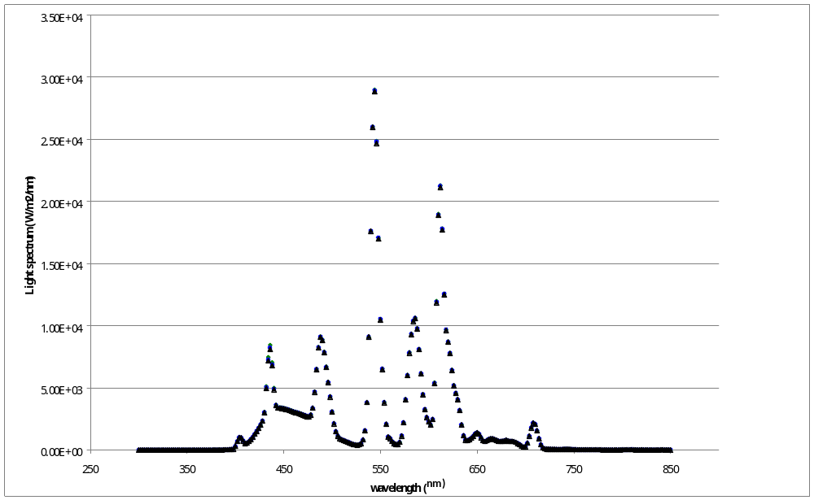

Fig. 1. Spectral irradiance distribution of CCFL 2S

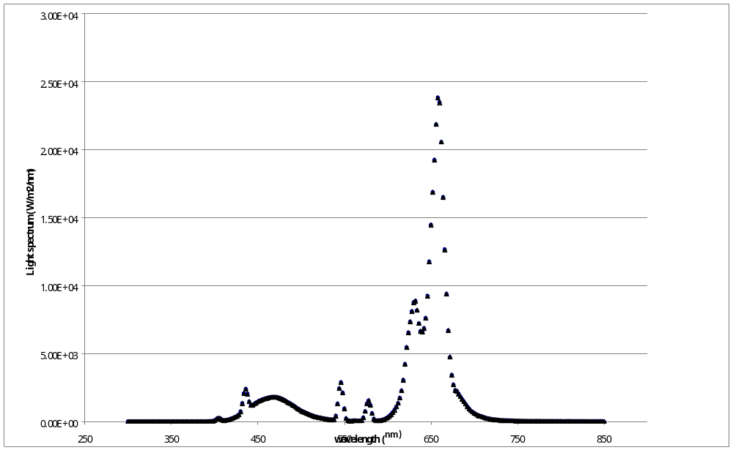
Fig. 2. Spectral irradiance distribution of CCFL 3S

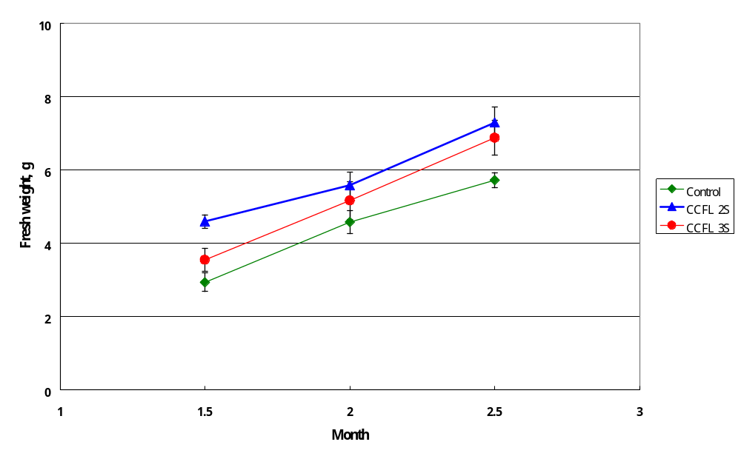

Fig. 3. Effects of three light sources on fresh weight of Phalaenopsis
Big Annie “A15”

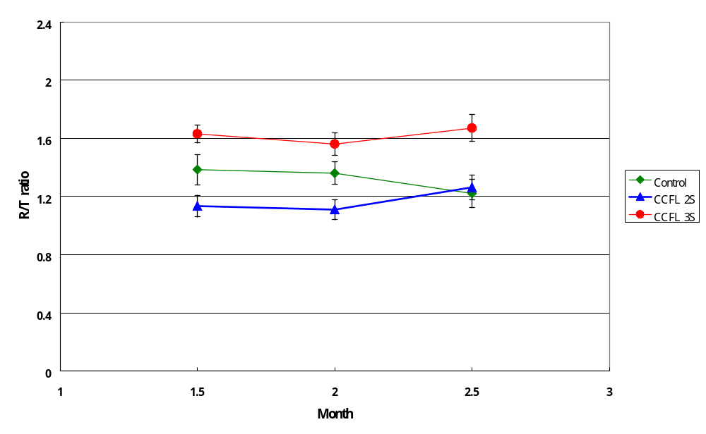
Fig. 4. Effects of three light sources on root and shoot ratio of Phalaenopsis Big Annie “A15”.

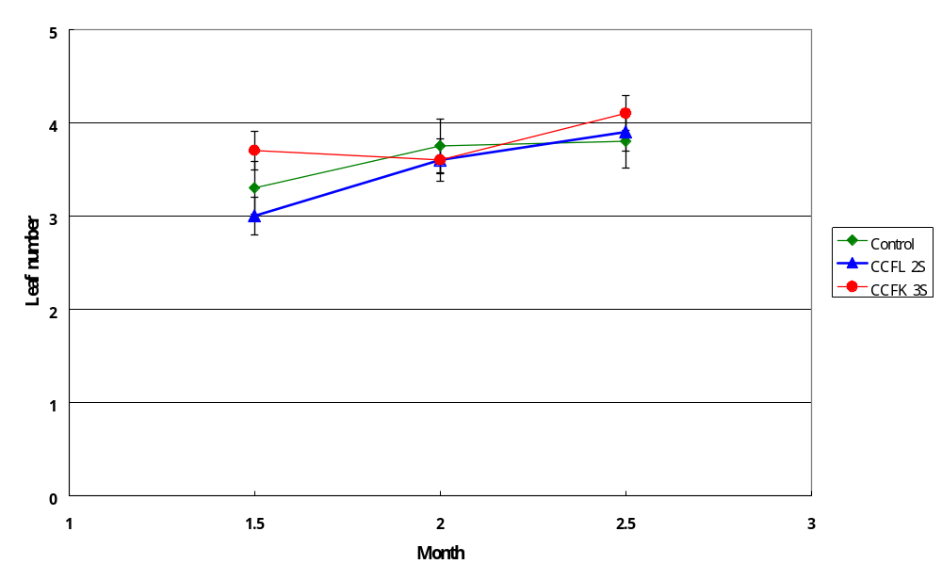

Fig. 5. Effects of three light sources on leaf number of Phalaenopsis
Big Annie “A15”.

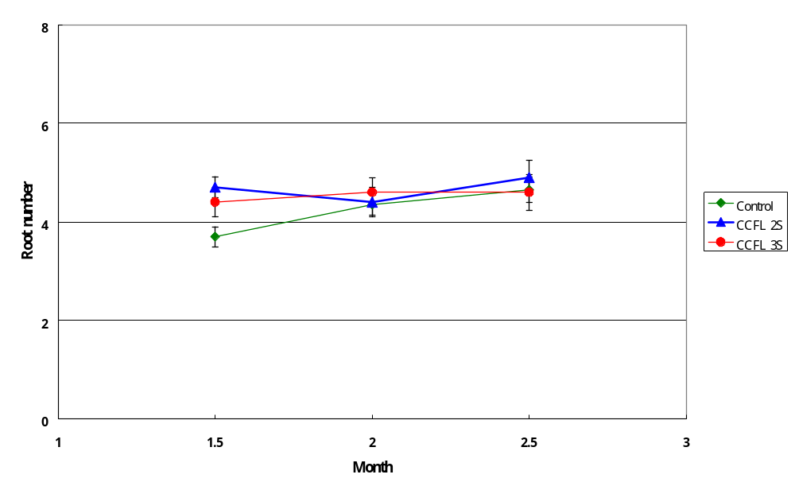

Fig. 6. Effects of three light sources on root number of Phalaenopsis
Big Annie “A15”.

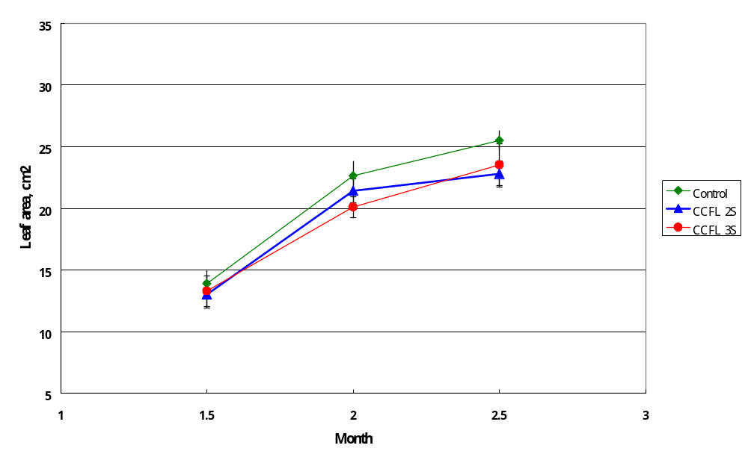

Fig. 7. Effects of three light sources on leaf area of Phalaenopsis
Big Annie “A15”.

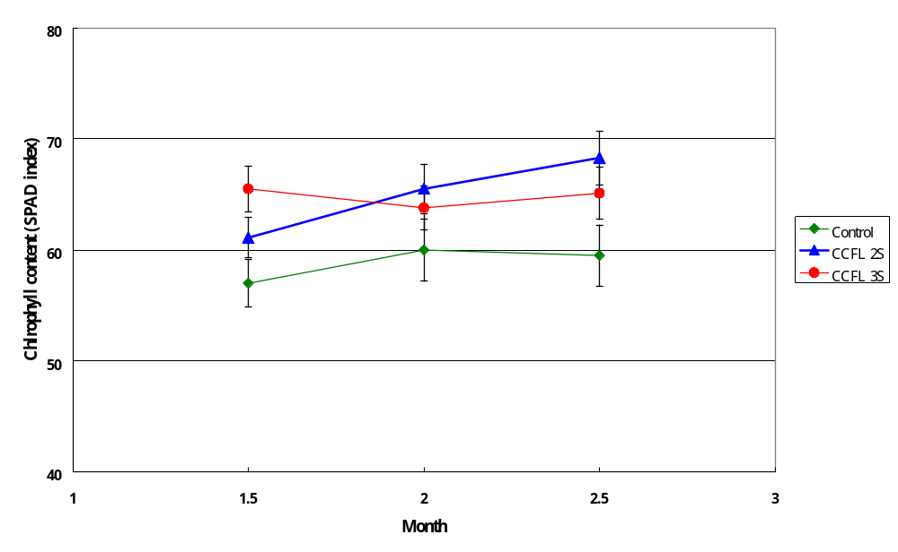
Fig. 8. Effects of three light sources on root number of Phalaenopsis Big Annie “A15.

