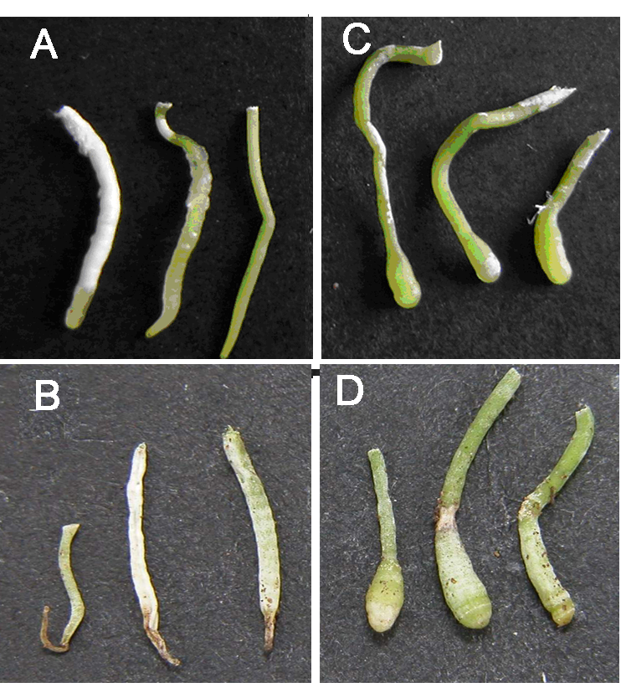
Figure 1. Effects of PBZ on the root morphology. A. roots of in vitro control seedling, B. roots of acclimatized control seedlings, C. roots of in vitro PBZ-treated seedlings, D. roots of acclimatized PBZ-treated seedlings.

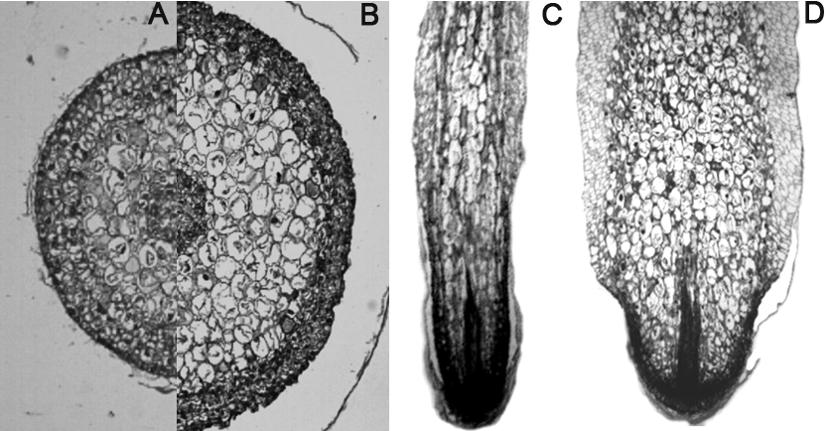
Figure 2. Transverse (A, B) and longitudinal sections (C, D) of the root tip from control (A, C) and PBZ-treated (B, D) in vitro D. nobile seedlings. (Scale bars?)

