Table 1. Rooting percentage of Platanus orientalis L. cuttings of collected at different times in year.

Cutting collection time | Rooting (%)
January | 8.27 c*
February | 2.27 d
March | 2.13 d
April | 0.0 d
May | 10.67 c
June | 1.87 d
July | 3.46 d
October | 22.53 b
November | 36.40 a
December | 23.47 b
* Values in the column followed by different letters are significantly different (P≤0.05).

Table 2. Rooting percentage of Platanus orientalis L. cuttings treated different auxin types.
Auxin type | Rooting (%)
IBA | 11.33 a*
NAA | 10.88 a
* Values in the column followed by different letters are significantly different (P≤0.05).

Table 3. Avarege root number and primary root length of P.orientalis L. cuttings of collected of different times of year.

Cutting collection time | Average root number | Primary root length (mm)
January | 2.25 c* | 28.59 bc*
February | 0.53 e | 2.09 d
March | 1.65 cd | 5.99 d
April | 0.0 e | 0.0 d
May | 3.71 b | 33.99 b
June | 0.90 de | 5.77 d
July | 1.64 cd | 22.98 c
October | 5.92 a | 33.45 b
November | 4.04 b | 51.70 a
December | 3.93 b | 58.69 a
* Values in the column followed by different letters are significantly different (P≤0.05).

Table 4. Average root number and primary root length of P.orientalis L. cuttings of treated different hormone concentrations.
Hormone concentrations (ppm) | Average root number | Primary root length (mm)
Control | 2.53 | 24.03
1000 | 2.54 | 23.80
2000 | 2.64 | 26.15
3000 | 2.16 | 24.43
4000 | 2.41 | 23.20

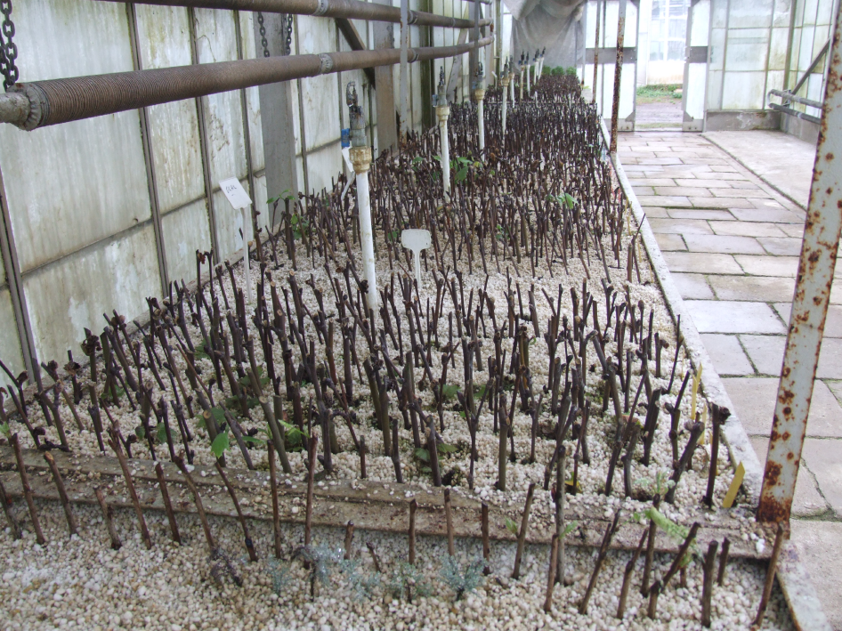
Fig. 1. Cuttings planted in mist propagation

Fig. 2. Rooting percentage of Platanus orientalis L. cuttings treated different hormone concentrations (* Values in the column followed by different letters are significantly different (P≤0.05).
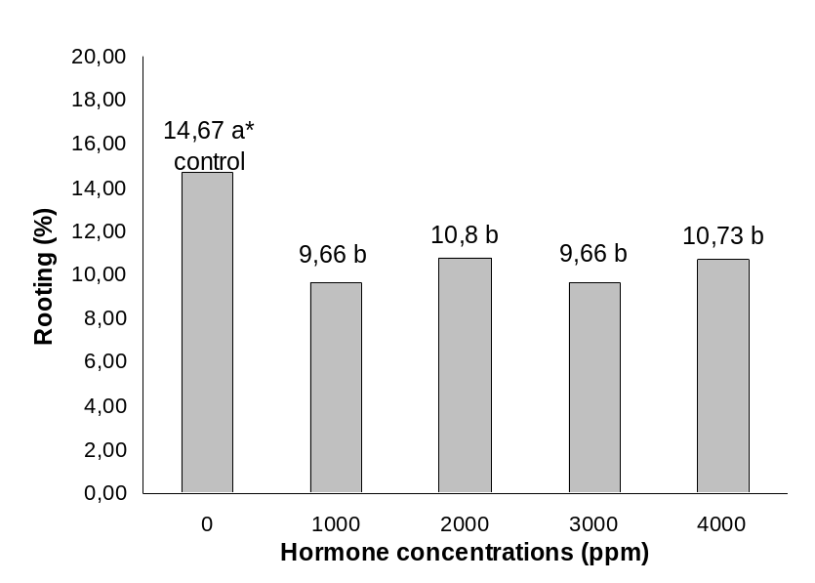

Fig. 3. Average root number of P.orientalis L. cuttings of treated different auxin types.

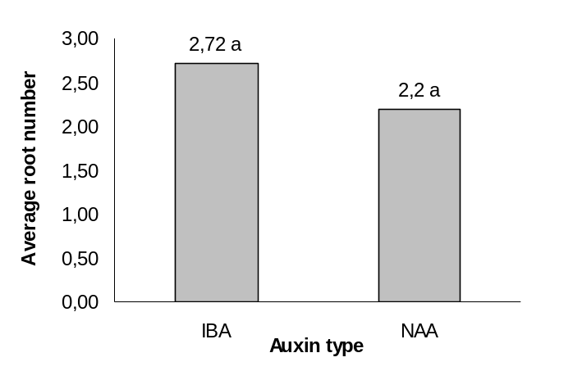
Fig. 4. Primary root length of P.orientalis L. cuttings of treated different auxin types.

