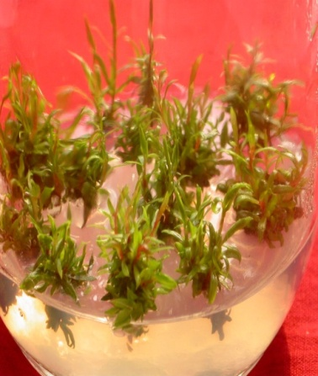

Proliferation of shoots on MS + BA (2.0 mg l⁻¹) + GA₃ (0.1 mg l⁻¹).

